COST VETTING REPORT
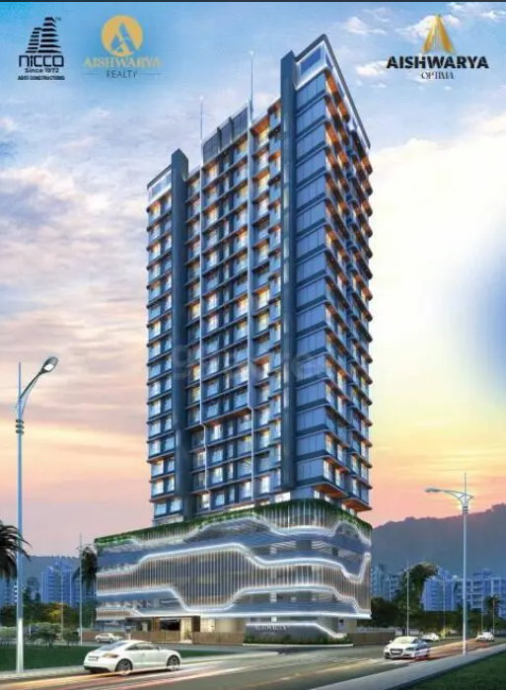

Details of the property under consideration:

Name of Project: "Aishwarya Optima"

"Aishwarya Optima", Proposed Redevelopment of building known as “Jai Alka Co-Operative Housing Society Ltd.” on Plot bearing C.T.S. No. 1132A, Murar Road, Village Mulund, Mulund (West), Mumbai – 400 080,
State – Maharashtra, Country – India.

Latitude Longitude: 19°10'30.5"N 72°56'58.8"E

Valuation Done for:
State Bank of India
Wagle Ind. Est. Branch
Regional Business Office, Region-II, Wagle Ind. Area, Plot No. B-35, 2nd Floor,
Wagle Circle, Thane (West) - 400 604, State - Maharashtra, Country - India.

Vastu/SBI/Mumbai/10/2024/11520/2308766
23/06-306-PY
Date: 25.10.2024

To,
The Branch Manager,
State Bank of India
Wagle Ind. Est. Branch
Regional Business Office, Region-II,
Wagle Ind. Area, Plot No. B-35, 2nd Floor,
Wagle Circle, Thane (West) - 400 604,
State - Maharashtra, Country - India.

Sub: Cost Vetting Report for "Aishwarya Optima " at Mulund (West), Pin Code – 400 080.

Dear Sir,
In accordance with your letter of engagement as stated above, we enclose our Report on Cost Vetting Report for "Aishwarya Optima", Proposed Redevelopment of building known as “Jai Alka Co-Operative Housing Society Ltd.” on Plot bearing C.T.S. No. 1132A, Murar Road, Village Mulund, Mulund (West), Mumbai – 400 080, State – Maharashtra, Country – India.
M/s. Aishwarya Associates LLP is proposing Proposed Redevelopment of building known as “Jai Alka Co-Operative Housing Society Ltd.” on Plot bearing C.T.S. No. 1132A, Murar Road, Village Mulund, Mulund (West), Mumbai – 400 080, State – Maharashtra, Country – India. Project is comprising Rehab cum Sale Building.
Residential of Rehab cum Sale Building is proposed of Ground Floor + 1st & 4th Podium Floor + 5th Amenity Floor + 6th Floor To 21st Upper Floor with total RERA carpet area of 49,969.88 Sq. Ft. which consists 1 RK, 1 BHK, 2 BHK & 3 BHK, with 49 nos. of Sell flats, 24 Tenant Flat providing with Society Office, & Other Amenities.
In this regard, SBI, Wagle Ind. Est. Branch Regional Business Office, Region-II, Wagle Ind. Area, Plot No. B-35, 2nd Floor, Wagle Circle, Thane (West) - 400 604 has approached Vastukala Consultants (I) Pvt. Ltd. (VCIPL) to conduct a Cost Vetting of the said project.
Our analysis of the cost vetting is enclosed in this report. This Report forms an integral whole and cannot be split in parts. The outcome of the report/ study can only lead to proper conclusions if the Report as a whole is taken into account.

The information used by Vastukala Consultants (I) Pvt. Ltd. (VCIPL) in preparing this report has been obtained from a variety of sources and other relevant documents provided by the client & bank. As agreed, we have performed our cost vetting exercise with the data available related to the business, considering the market prospects and projections. Our results are dependent on documents provided by client & bank, the underlying assumptions, which has been analyzed at a broader level by VCIPL while assessing their reasonableness.
Total Project Cost for the completion of Project will be ` 62.56 Cr.

For Vastukala Consultants (I) Pvt. Ltd.

Manoj B. Chalikwar
Registered Valuer
Chartered Engineer (India)
Reg. No. IBBI / RV / 07/2018/10366
Reg. No. CAT-I-F-1763
SBI Empanelment No.: SME/TCC/38/IBBI/3
About the Project:
Proposed Redevelopment of building known as “Jai Alka Co-Operative Housing Society Ltd.” on Plot bearing C.T.S. No. 1132A, Murar Road, Village Mulund, Mulund (West), Mumbai – 400 080. It is about 1.1 KM Travelling distance from Mulund Railway station.

Area Statement as per Approved Plan
A. | Proforma A | Sq. M.
1 | Area of Plot | 1,254.10
 | Area of Plot triangulation method | 1,254.10
2 | Deduction For | -
a. | Road Set back Area | 134.96
3 | Balance Area of Plot (1 - 2) | 1,119.14
4 | Deduction for 15% recreational ground/10% Amenity | -
 | Space (If deductible for Ind) | -
5 | Net Area of plot (3-4) | 1,119.14
6 | Additions for floor space index | -
2A. | 200% for D.P. Road set back | -
2B. | 200% for road setback | 269.92
7 | Total Areas (5+6) | 1,389.06
8 | F.S.I permissible | 3.00
9 | Permissible built-up area (1119.14 x 3.00) | 3,357.42
9A. | PTC Area [(3357.42 - 1119.14 - 269.92) x 50% = 984.18] | 984.18
9B. | Free sale area in lieu of PTC 1.00 | 984.18
9C. | Zonal FSI | 1,119.14
 | Total area Zonal FSI + Free sale (1389.06 + 984.18) | 2,373.24
10 | Permissible floor area (9A + 9B + 9C) | 3,357.42
11 | Existing Built up Area | -
12 | Total proposed built up Area | 3,332.87
13 | Total Area (11 + 12) | 3,332.87
14 | FSI Consumed on net Holding = 11/3 | 3.00
B. | Details of Residential / Non-Residential Areas | N.A.
1 | Purely Residential built-up Area | 3,332.87
2 | Remaining Non-Residential Built-Up Area | -
C. | Details of FSI Availed as per DCR 35(4)
1 | Fungible built up Area component proposed vide DCR (4) for purely residential = Or < (B1 X 0.35) Perm. On existing net BUA (1253.60*35/100 = 438.76 Sq.M)4 | 438.76
2 | Fungible built up area component proposed vide DCR 35(4) for Non-Residential = OR < (B2 x 0.35) | -
3 | Total fungible built up areawide DCR 35(4) = (C1 + C2) | 438.76
4 | Total built up area permissible including fungible (3357.42 + 438.76) | 3,796.18
5 | Total Built up area proposed including fungible (3332.87 + 438.76) | 3,771.63
6 | Balance Built up area | 24.55
D | Tenement Statement | As per Statement
1 | Proposed Area (Item, 12 Above) or C-4 | As per Statement
2 | Less Deduction of non-residential area (Shop Etc.) | As per Statement
3 | Area Available for Tenements (1-2) | As per Statement
4 | Tenements permissible (Density of tenements/Hectare) | As per Statement
5 | Tenements Proposed | As per Statement
6 | Tenements Existing | As per Statement
 | Total Tenements on the Plot | As per Statement
E | Parking Statement | As per Statement
1 | Parking Required by regulations for - CAR, Scooter/Motor Cycle/Outsiders (Visitors) | As per Statement
2 | Covered Garage permissible | As per Statement
3 | Covered Garage Proposed - CAR, Scooter / Motor Cycle / Outsiders (Visitors) | As per Statement
 | Total Parking Provided | As per Statement

Construction Area as per Approved Plan for Sale Building
Sr. No. | Floor | Built Up Area in Sq. M. | Staircase, Lift & Lobby Area in Sq. M. | Other Area in Sq. M. | Total Construction Area in Sq. M. | Total Construction Area in Sq. Ft.
1 | Basement Floor | - | 18.40 | 172.41 | 190.81 | 2,053.88
2 | Ground Floor | - | 96.25 | 717.38 | 813.63 | 8,757.91
3 | 1st Podium Floor | - | 57.51 | 706.42 | 763.93 | 8,222.94
4 | 2nd Podium Floor | - | 57.51 | 740.97 | 798.48 | 8,594.84
5 | 3rd Podium Floor | - | 57.51 | 740.97 | 798.48 | 8,594.84
6 | 4th Podium Floor | - | 56.89 | 741.58 | 798.47 | 8,594.73
7 | 5th Podium Floor | 191.07 | 55.73 | 109.59 | 356.39 | 3,836.18
8 | 6th Floor | 303.75 | 53.36 | - | 357.11 | 3,843.93
9 | 7th Floor | 229.46 | 52.98 | 90.10 | 372.54 | 4,010.02
10 | 8th Floor | 322.31 | 52.98 | - | 375.29 | 4,039.62
11 | 9th Floor | 329.15 | 52.98 | - | 382.13 | 4,113.25
12 | 10th Floor | 334.37 | 52.98 | - | 387.35 | 4,169.44
13 | 11th Floor | 340.13 | 52.98 | - | 393.11 | 4,231.44
14 | 12th Floor | 342.05 | 52.98 | - | 395.03 | 4,252.10
15 | 13th Floor | 342.05 | 52.98 | - | 395.03 | 4,252.10
16 | 14th Floor | 196.72 | 52.98 | 145.31 | 395.01 | 4,251.89
17 | 15th Floor | 342.05 | 52.98 |  | 395.03 | 4,252.10
18 | 16th Floor | 342.05 | 52.98 |  | 395.03 | 4,252.10
19 | 17th Floor | 342.05 | 52.98 |  | 395.03 | 4,252.10
20 | 18th Floor | 342.05 | 52.98 |  | 395.03 | 4,252.10
21 | 19th Floor | 342.05 | 56.89 |  | 398.94 | 4,294.19
22 | 20th Floor | 342.05 | 56.89 |  | 398.94 | 4,294.19
23 | 21st Floor | 342.05 | 56.89 |  | 398.94 | 4,294.19
24 | Terrace | - | 56.89 | 56.89 | 113.78 | 1,224.73
TOTAL |  | 5,325.41 | 1,316.48 | 4,221.62 | 10,863.51 | 1,16,934.82

Project Cost
Sr. No. | Particulars | Total Estimated Amount in ` | Total Estimated Amount  in ` Cr.
1 | Land Cost
 | Acquisition Cost of Land or Development Rights, and Legal Cost. | 56,06,245.00 | 0.56
 | Rent to Tenants, Lease premium, Lease Rent, interest cost incurred or payable on Land Cost | 4,87,68,093.00 | 4.88
 | Amount of Premium payable to obtain development rights, FSI, additional FSI, fungible area, and any other incentive under DCR from Local Authority or State Government or any Statutory Authority. | 5,48,00,000.00 | 5.48
 | Acquisition cost of PTC Transfer Cost (if any) | 13,50,00,000.00 | 13.50
2 | Cost of Construction
 | Estimated construction cost of rehab cum sale building including site development and infrastructure for the same. | 29,33,14,770.00 | 29.33
 | On site expenditure for development of entire project excluding cost of construction as per(i) above,
a. | Architect Fees & Consultant fees | 1,46,65,739.00 | 1.47
b. | Admin Cost includes salaries, site overheads, development works, cost of services (including water, electricity, sewerage, drainage, layout roads etc.), cost of machineries and equipment including its hire and maintenance cost, consumables etc. All costs directly incurred to complete the construction of the entire phase of the project registered. | 1,17,32,591.00 | 1.17
c. | Marketing Cost | 1,68,94,790.00 | 1.69
3 | Interest during the Project | 3,60,00,000.00 | 3.60
4. | Contingency Charges | 87,99,443.00 | 0.88
 | GRAND TOTAL: | 62,55,81,671.00 | 62.56

Manoj B. Chalikwar
Registered Valuer
Chartered Engineer (India)
Reg. No. IBBI / RV / 07/2018/10366
Reg. No. CAT-I-F-1763
SBI Empanelment No.: SME/TCC/38/IBBI/3
Comments on each element of Cost of Project: -
- Land Cost:
As per Present Ready Reckoner rate the Project Land Value is ` 7.19 Cr. considering Land Rate @ ` 64,240.00 per Sq. M. & Net Plot Area of 1,119.14 Sq. M.
As per document cost of land & stamp duty cost is ` 56,06,245.00 i.e., ` 0.56 Cr. which is 0.90% of Total Project Cost.
Sr. No. | Date | Document Name | Description | Total Cost in ` | Incurred Cost in `
1 | 02-03-2023 | Developer Agreement | Stamp Duty | 55,68,565.00 | 55,68,565.00
2 | 02-03-2023 | Developer Agreement | Reg. Fees | 30,000.00 | 30,000.00
3 | 02-03-2023 | Developer Agreement | Reg. Fees | 6,580.00 | 6,580.00
4 | 02-03-2023 | General Power of Attorney | Stamp Duty | 500.00 | 500.00
5 | 02-03-2023 | General Power of Attorney | Reg. Fees | 100.00 | 100.00
6 | 02-03-2023 | General Power of Attorney | Reg. Fees | 500.00 | 500.00
Total |  |  |  | 56,06,245.00 | 56,06,245.00

- Payment Payable to Rehab Tenants (Rent Cost):
Since it is a having some redevelopment flat from the date of shifting of 23 Tenants till handing over their respective new flats as per the Tenant Agreement. Further the rent keeps on increasing as per agreement. The existing Tenants has to be given total rental of ` 4,87,68,093.00 i.e., ` 4.88 Cr. Builder has paid ` 2.49 Cr. which is 7.80 % of Total Project Cost.
Existing Tenants Carpet Area & Rent per month for Flat as per below table;
Sr. No. | Particulars |  | Unit
1 | No. of Tenants | 23.00 | Nos
2 | No. of Existing Carpet Area | 12,450.54 | Sq. Ft.
3 | Rate per Sq. Ft. on Carpet Area for 1st Year | 55.00 | Rupees
4 | Rent per month per tenant for 1st Year | 6,84,780.00 | Rupees
5 | Rent per year for 1st Year | 82,17,360.00 | Rupees
6 | Rate per Sq. Ft. on Carpet Area for 2nd Year | 60.00 | Rupees
7 | Rent per month per tenant for 2nd Year | 7,47,032.00 | Rupees
8 | Rent per year for 2nd Year | 97,11,416.00 | Rupees
9 | Rate per Sq. Ft. on Carpet Area for 3rd Year | 65.00 | Rupees
10 | Rent per month per tenant for 3rd Year | 8,09,285.00 | Rupees
11 | Rent per year for 3rd Year | 1,05,20,705.00 | Rupees
12 | Rate per Sq. Ft. on Carpet Area for 3rd Year | 70.00 | Rupees
13 | Rent per month per tenant for 3rd Year | 8,71,537.80 | Rupees
14 | Rent per year for 3rd Year | 1,04,58,453.60 | Rupees
15 | Shifting Charges per tenant | 20,000.00 | Rupees
16 | Total Shifting Charges | 4,60,000.00 | Rupees
17 | Brokerage Charges | 6,84,780.00 | Rupees
18 | Rate per Sq. Ft. on Carpet Area for Hardship Compensation | 700.00 | Rupees
19 | Hardship Compensation Cost | 87,15,378.00 | Rupees
Total rent paid to tenants |  | 4,87,68,093.00 | Rupees

- PTC Transfer Cost:
The PTC Transfer Cost is ` 13,50,00,000.00 i.e., ` 13.50 Cr. which is 21.58% of Total Project Cost.
As per information provided by the developer.

- Building Cost of Construction for Sale Building:
Construction Area of Sale Building = 10,863.51 Sq. M. i.e., 1,16,934.82 Sq. Ft.
No. of Stack Car Parking = 24 Nos.
Total estimated cost for construction of Building (includes cost of RCC work, manpower, lift, material, painting, finishing work, site development, etc.) is ` 29,33,14,770.00 i.e., ` 29.33 Cr. which comes ` 27,000.00 per Sq. M. on construction area for building.
The total construction area is 10,863.51 Sq. M. i.e., 1,16,934.82 Sq. Ft., projected cost of ` 29.33 Cr is 46.89% of total project cost
VCIPL opinion the construction cost of 27,000/- Per Sq. M. which is in line with Market-Trend.
Particulars | Rate per Sq. M.
Excavation Work | 2,000.00
Total RCC Work | 12,000.00
Final Finishing Work | 7,000.00
Other Work | 6,000.00
Cost of Construction | 27,000.00

- Approval Charges:
The Total Approval Cost (Fungible Cost & Development Cess Premium & TDR Cost) as per challan provided by the developer will be ` 5,48,00,000.00 i.e., ` 5.48 Cr. which is 8.76% of Total Project Cost.
As per information provided by developer.
Sr. No. | Particulars | Estimated Cost in `
1 | Infrastructure Charges | 30,00,000.00
2 | Development Charges (Land Component) | 16,00,000.00
3 | Development Charges (Residential Component) | 69,00,000.00
4 | Open Space deficiency premium | 24,00,000.00
5 | Staircase Premium | 8,00,000.00
6 | Bank Guarantee | 3,00,000.00
7 | Labour Cess | 29,00,000.00
8 | Fungible FSI | 2,80,00,000.00
9 | Civil Aviation NOC charges | 1,00,000.00
10 | Extra water charges and extra sewerage charges | 29,00,000.00
11 | CFO Scrutiny Fees | 5,00,000.00
12 | Land under construction tax | 51,00,000.00
13 | PCO | 3,00,000.00
Total |  | 5,48,00,000.00

- Architect Cost, RCC & Other Professional Charges:
The total Architect charges of ` 1,46,65,739.00 i.e., ` 1.47 Cr. is 5.0% of total construction cost building & it is line up with Market trend.
The professional charge consists of Architect & Legal which in market is in the range of 2% - 5% of Total Construction cost of the project.

- Administrative Expenses:
Salaries, site overheads, development works, cost of services (including water, electricity, sewerage, drainage, layout roads etc.), cost of machineries and equipment including its hire and maintenance cost, consumables etc. All costs directly incurred to complete the construction of the entire phase of the project registered is estimated 4% of total construction cost Building which comes to ` 1,17,32,591.00 i.e., ` 1.17 Cr.
The admin charges which in market is in the range of 4% - 6% of Total Construction cost of the project.

- Marketing Expenses:
Marketing costs directly incurred to complete the construction of the entire phase of the project registered is estimated at 2% of total Sale income from the project which comes to ` 1,68,94,790.00 i.e., ` 1.69 Cr.
The marketing charge consists of brokerage & commission which in market is in the range of 1% - 3% of Total Sale income of the property.

- Interest Costs:
The Interest cost for the term loan is ` 3,60,00,000.00 i.e., ` 3.60 Cr., which is 5.75% of total project cost.
As per information provided by the client.

- Contingency Costs:
The contingency charges estimated at 3% of total cost of construction which comes to ` 87,99,443.00 i.e., ` 0.88 Cr.

Observation and Construction: -
Total estimated cost of project i.e., ` 62,55,81,671.00 (Rupees Sixty – Two Crore Fifty – Five Lakh Eighty – One Thousand Six Hundred Seventy – One Only) i.e., ` 62.56 Cr. is fair & reasonable.
The project cost is including land premium payable to concern authorities, Rent Cost, TDR Cost, Fungible FSI Premium, Cost of Construction of Sale Building, professional charges on site expenses including admin & marketing expenses, premiums / charges to be paid to competent authority and Bank interest, etc. we have not independently verified interest cost hence not consider in cost vetting.
As per present sanctioned building plan, permissible built-up area on the said plot is 3,771.63 Sq. M. The rehab cum sale building is presently approved for Ground Floor + 1st to 4th Podium Floor + 5th Amenity Floor + 6th Floor to 17th Upper Floors only.
The Developer has submitted the concession drawing plan to the competent authority for utilization of total permissible Built-up area and fungible FSI. The rehab cum sale building is presently sanctioned for Ground Floor + 1st to 4th Podium Floor + 5th Amenity Floor + 6th Floor to 21st Upper Floors only. The proposal seems to be feasible. Estimated cost of entire project of 21st upper floor is considered.
Total estimated cost of construction of Rehab cum Sales building is ` 29,33,14,770.00 i.e., ` 29.33 Cr. which comes ` 27,000.00 per Sq. M. on construction area for building, which is fair & reasonable considering the present status of project, type & quality of construction & specification of the building materials to be used, height of the structure, amenities to be provided in proposed building.

Assumptions & Remarks-
- The adequacy of Engineering / Structural design is beyond the scope of our assignment.
- Estimated project completion date is 30/04/2026. The cost is certified based on the assumptions that the project will be completed within time frame. Few assumptions are made regarding inflation & cost rise etc. during construction period.
Photo copy of following document is provided to us & this report should be read along with it:

- Copy of Redevelopment Agreement between Aji Alka Co-Operative Housing Society Ltd (The Society) and All Indian inhabitants who are members of Jai Alka Co-Operative Housing Society Ltd. (The Members) And Aishwarya Associates LLP. (The Developer) through registered document No. Kurla -3 / 17838 / 2021 dated 18.11.2021.
- Copy of Undertaking Cum Declaration by Ms. Aishwarya Associates LLP. through registered Doc. No. KRL – 4/6763/2024 Dated 29.03.2024.
- Copy of Property Card.
- Copy of Title Search Report date 25.02.2022 issued by Shree Ekveera Investigator.
- Copy of Approved Plan No. T/PVT/0117/20211213/AP dated 05.07.2022 issued by Slum Rehabilitation Authority.
Approved Upto: Ground Floor + 1st to 4th Podium Floor + 5th Amenity Floor + 6th Floor to 17th Upper Floor.
- Copy of Commencement Certificate No. T/PVT/0117/20211213/AP dated 12.04.2023 issued by Slum Rehabilitation Authority.
Approved Plan: (This CC is endorsed for the work for up to Ground Floor + 1st to 4th Podium Floor + 5th Amenity Floor + 6th Floor to 11th Floor only)
- Copy of Concession / Architect Drawing Plan dated 24.02.2023 submitted by M/s. Speco Architect
Drawing Upto: Ground Floor + 1st to 4th Podium Floor + 5th Amenity Floor + 6th Floor to 21st Upper Floor.
- Copy of Architect’s certificate dated 30.06.2024 issued by Speco Architect.
- Copy of CA Certificate dated 18.06.2024 issued by Esha Bhanushali & Company.
- Copy of RERA Certificate No. P51800050999 dated 19.05.2023 issued by Maharashtra Real Estate Regulatory Authority (MAHRERA).

Actual Site Photographs
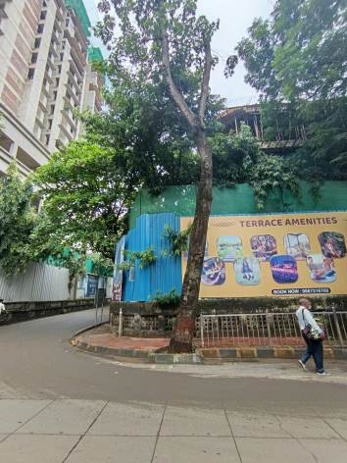
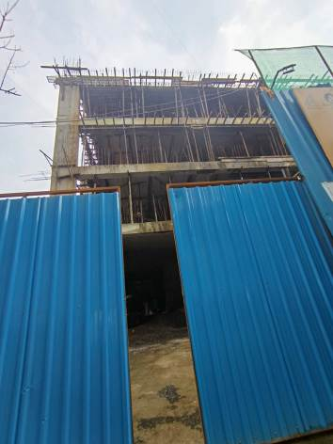
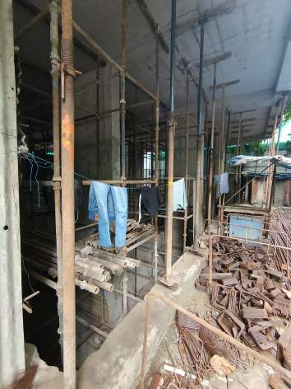

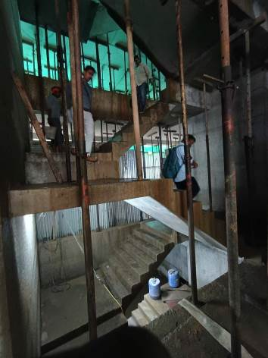
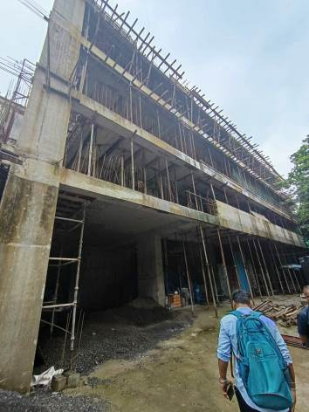
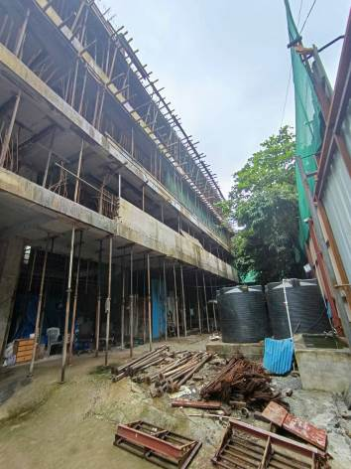

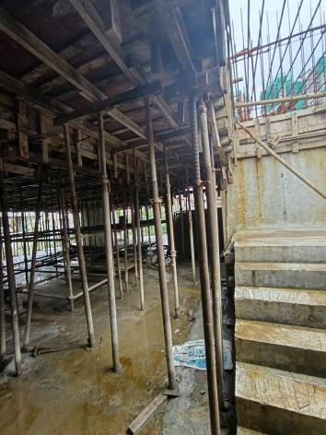
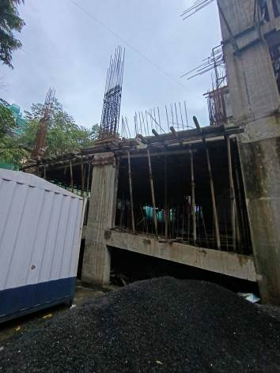
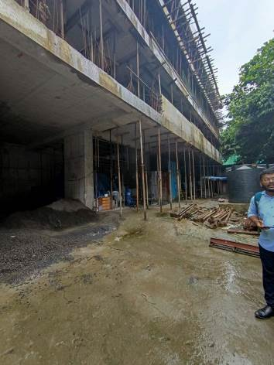

Actual Site Photographs
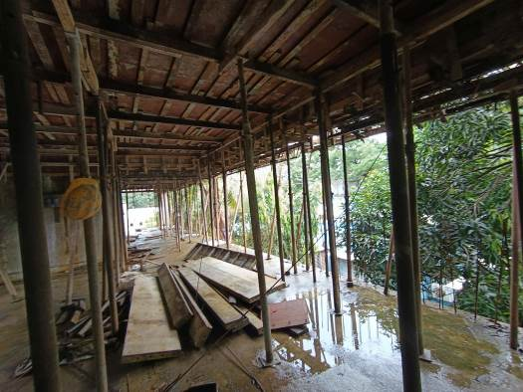
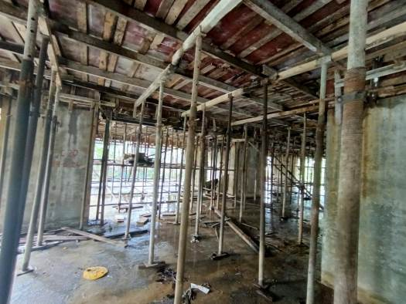
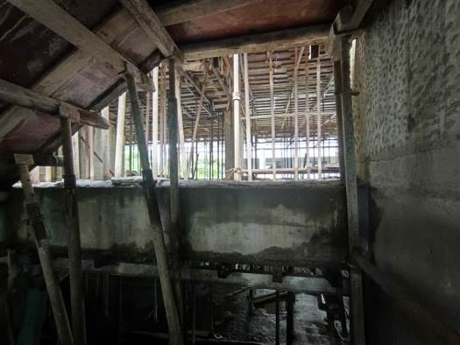
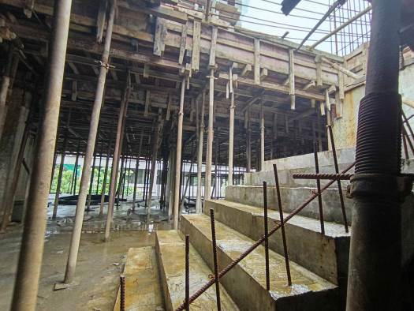

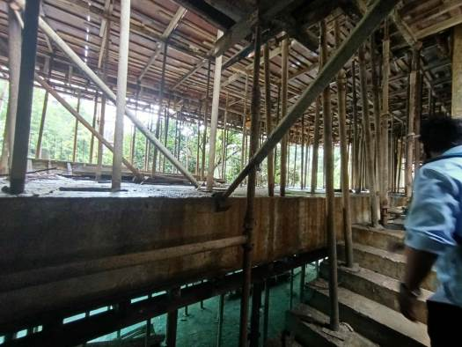

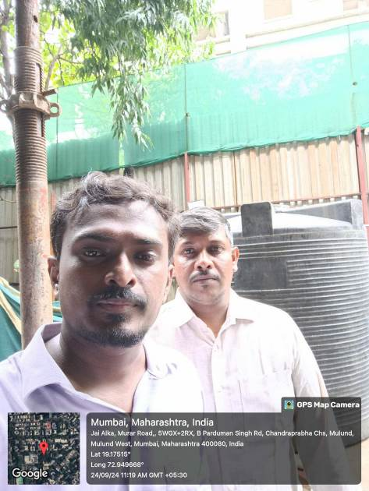

Route Map of the property
Site u/r
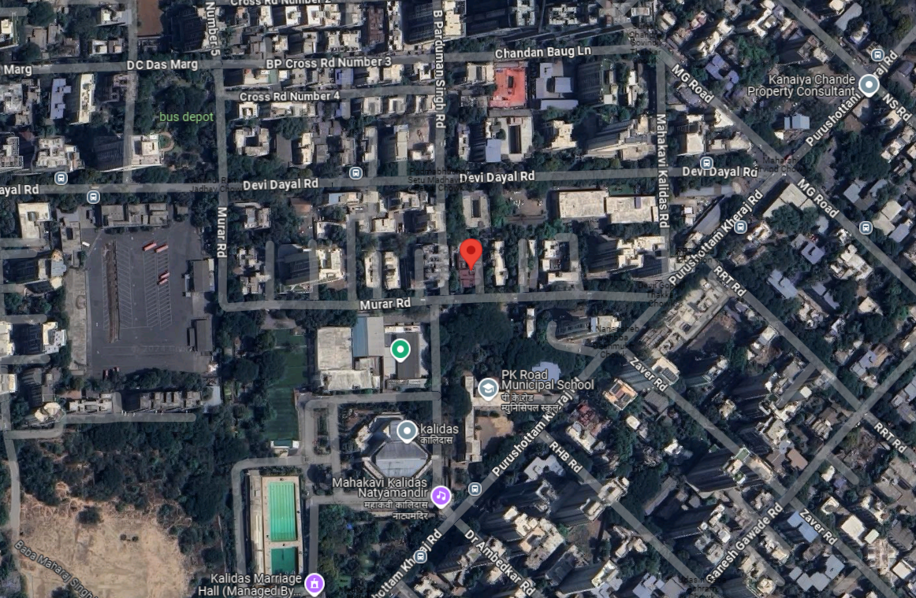

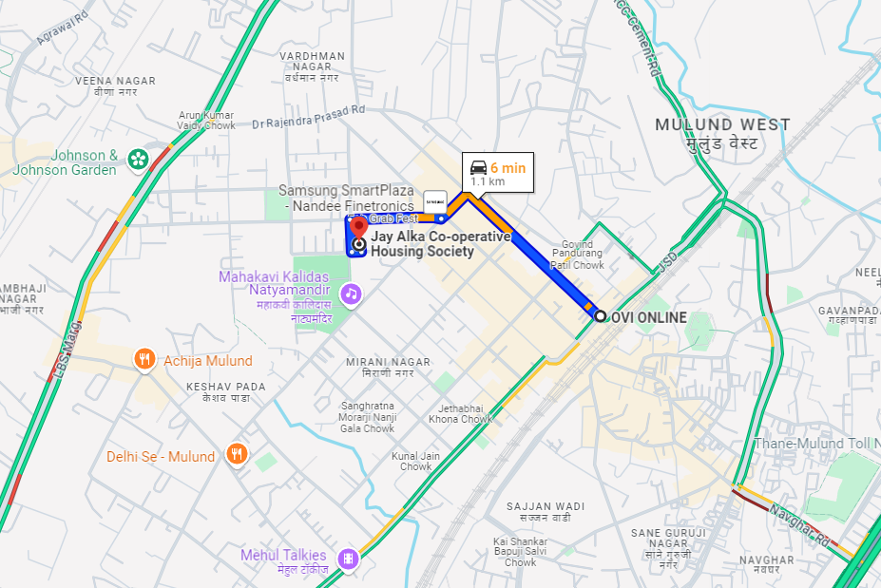

Latitude Longitude: 19°10'30.5"N 72°56'58.8"E
Note: The Blue line shows the route to site from nearest railway station (Mulund – 1.1 KM)

