COST VETTING REPORT

Details of the property under consideration:

Name of Project: "Nandikesh CHSL"

"Navnath Nandikesh", Proposed redevelopment of building known as “Nandikesh C.H.S.L.” on plot bearing C.T.S. No. 232/A, P/S ward, Naikwadi Road, Village – Pahadi Goregaon (East), Goregaon (East),
Mumbai – 400 063, State – Maharashtra, Country – India.

Latitude Longitude: 19°10'03.0"N 72°51'06.9"E

Valuation Done for:
State Bank of India
Vasai Tal. Ind. Est. Branch
Gavrai Pada, Vasai (East), Taluka – Vasai, District – Palghar,
Pin Code – 401 201, State - Maharashtra, Country - India.

Vastu/SBI/Mumbai/01/2025/11513/2310029
13/09-148-PY
Date: 13.01.2025

To,
The Branch Manager,
State Bank of India
State Bank of India
Vasai Tal. Ind. Est. Branch
Gavrai Pada, Vasai (East),
Taluka – Vasai, District – Palghar,
Pin Code – 401 201,
State - Maharashtra, Country – India

Sub: Cost Vetting Report for "Navnath Nandikesh" at Goregaon (East), Pin Code – 400 063.

Dear Sir,
In accordance with your letter of engagement as stated above, we enclose our Report on Cost Vetting Report for "Navnath Nandikesh", Proposed redevelopment of building known as “Nandikesh C.H.S.L.” on plot bearing C.T.S. No. 232/A, P/S ward, Naikwadi Road, Village – Pahadi Goregaon (East), Goregaon (East), Mumbai – 400 063, State – Maharashtra, Country – India.
M/s. Navnath Infrastructure Private Limited is Proposed redevelopment of building known as “Nandikesh C.H.S.L.” on plot bearing C.T.S. No. 232/A, of P/S ward at Naikwadi Road, Village – Pahadi Goregaon (East), Goregaon (East), Mumbai – 400 063, State – Maharashtra, Country – India. Project is comprising Rehab cum Sale Building.
Residential of Sale Building is proposed of Ground Floor + 1st to 13th Upper Floor with total RERA carpet area of 26,669.21 Sq. Ft. which consists 1 BHK, 2 BHK & 3 BHK with 16 nos. of Sell flats, 20 Tenant Flat providing with Society Office & Other Amenities.
In this regard, SBI, Vasai Tal. Ind. Est. Branch, Gavrai Pada, Vasai (East), Taluka – Vasai, District – Palghar, Pin Code – 401 201has approached Vastukala Consultants (I) Pvt. Ltd. (VCIPL) to conduct a Cost Vetting of the said project.
Our analysis of the cost vetting is enclosed in this report. This Report forms an integral whole and cannot be split in parts. The outcome of the report/ study can only lead to proper conclusions if the Report as a whole is taken into account.

The information used by Vastukala Consultants (I) Pvt. Ltd. (VCIPL) in preparing this report has been obtained from a variety of sources and other relevant documents provided by the client & bank. As agreed, we have performed our cost vetting exercise with the data available related to the business, considering the market prospects and projections. Our results are dependent on documents provided by client & bank, the underlying assumptions, which has been analyzed at a broader level by VCIPL while assessing their reasonableness.
Total Project Cost for the completion of Project will be ` 25.44 Cr.

For Vastukala Consultants (I) Pvt. Ltd.

Manoj B. Chalikwar
Registered Valuer
Chartered Engineer (India)
Reg. No. IBBI / RV / 07/2018/10366
Reg. No. CAT-I-F-1763
SBI Empanelment No.: SME/TCC/38/IBBI/3
About the Project:
Proposed redevelopment of building known as “Nandikesh C.H.S.L.” on plot bearing C.T.S. No. 232/A, P/S ward, Naikwadi Road, Village – Pahadi Goregaon (East), Goregaon (East), Mumbai – 400 063. It is about 400 Meter walking distance from Goregaon Railway station.

Area Statement as per Approved Plan
A | Area Statement | Sq. M.
1 | Area of the plot (As per P.R. Card) | 991.70
2 | Deduction For | -
a. | Road set back area to be handed over (100%) (Regulation No 16) | 84.70
b. | proposed D P Road to be handed over (100%) (Regulation No 16) | -
c. | Reservation Area | -
3 | Total Deduction (a + b + c) | 84.70
4 | Balance area of plot (1-3) | 907.00
5 | Permissible Zonal (basic) FSI | 1.00
6 | a. Permissible Built-up area as per Zonal (basic) FSI (4*5) | 907.00
 | b. Permissible BUA as per DCR 30[C] Protected FSI | -
 | c. Permissible BUA as per for development (6a or 6b Whichever is more) | 907.00
7 | Built up area due to "Additional FSI on payment of premium" as per Table No 12 of Regulation No 30A) and 32 on remaining / balance plot | 453.50
8 | Built up area due to admissible "TDR" as per Table No 12 Regulation No 30A and 32 on remaining / Balanced plot. a. DRC NO. RES/0029/2023 = 162.80 Sq.M. b. DRC NO. RES/1501/Const. = 90.70 Sq.M. | 253.50
9 | BUA due to admissible 200% of Setback Area as per Reg. No. 32(4) | 169.40
10 | BUA due to admissible as per Reg. No. 33(7) (B) = 10 Sq.M x 20 Tenants | 200.00
11 | Total permissible Built-up Area | 1,983.40
12 | Existing Built up Area | -
13 | Proposed floor area | 1,983.40
14 | Total Built up Area (12 + 13) | 1,983.40
15 | FSI consumed on net holding = 14/4 | 2.19
B. | Details of Residential / Non - Residential Areas
1 | Purely residential built-up area | 1,983.40
2 | Remaining non-residential built-up area | -
C. | Details of FSI availed as per DCR 31(3)
1 | Permissible Fungible Compensatory area
a. | Residential (1983.40x0.35) = OR < (B1x0.35) | 694.19
b. | Non-Residential (---x0.35) =OR< (B2x0.35) | -
2 | Proposed fungible compensatory area
a. | Residential | 694.19
b. | Non-Residential | -
3 | Fungible Compensatory area availed for Rehab Compo. Without charging premium
a. | Residential | 337.09
b. | Non-Residential | -
4 | Fungible Compensatory area availed for Sale Compo. by charging premium
a. | Residential | 357.10
b. | Non-Residential | -
5 | Total built up area proposed including FCA (A14 +C2(i) +C2(ii) | 2,677.59
D. | Tenement Statement
a. | Proposed built up area | 2,677.59
b. | Less non-residential area | -
c. | Area available for tenants (i)-(ii) | 2,677.59
d. | Tenements Permissible (450/hectare) | 120.00
e. | Tenements proposed | 36.00
f. | Tenements existing | -
g. | Total tenements on the plot | 36.00
E. | Parking Statement
a. | Total Parking required | 34 Nos.
b. | Total parking proposed | 36 Nos.

Construction Area as per Approved Plan for Sale Building

Sr. No. | Floor | Built Up Area in Sq. M. | Staircase, Lift & Lobby Area in Sq. M. | Other Area in Sq. M. | Total Area in Sq. M.
1 | Ground Floor | - | 48.10 | 212.20 | 260.30
2 | 1st Floor | 212.20 | 48.10 | - | 260.30
3 | 2nd Floor | 222.04 | 48.10 | - | 270.14
4 | 3rd Floor | 222.04 | 48.10 | - | 270.14
5 | 4th Floor | 224.01 | 48.10 | - | 272.11
6 | 5th Floor | 226.84 | 48.10 | - | 274.94
7 | 6th Floor | 217.80 | 48.10 | - | 265.90
8 | 7th Floor | 160.47 | 48.10 | 57.47 | 266.04
9 | 8th Floor | 217.94 | 48.10 | - | 266.04
10 | 9th Floor | 217.94 | 48.10 | - | 266.04
11 | 10th Floor | 226.84 | 48.10 | - | 274.94
12 | 11th Floor | 230.10 | 48.10 | - | 278.20
13 | 12th Floor | 230.10 | 48.10 | - | 278.20
14 | 13th Floor | 69.13 | 49.53 | 159.54 | 278.20
15 | Terrace | - | 49.53 | - | -
TOTAL |  | 2,677.45 | 724.36 | 429.21 | 3,781.49
No. of Puzzle Car Parking |  |  |  |  | 36.00

Project Cost
Sr. No. | Particulars | Total Estimated Amount in ` | Total Estimated Amount  in ` Cr.
1 | Land Cost
 | Acquisition Cost of Land or Development Rights, and Legal Cost. | 46,91,600.00 | 0.47
 | Rent to Tenants, Lease premium, Lease Rent, interest cost incurred or payable on Land Cost | 3,66,52,896.00 | 3.67
 | Amount of Premium payable to obtain development rights, FSI, additional FSI, fungible area, and any other incentive under DCR from Local Authority or State Government or any Statutory Authority. | 5,57,54,416.00 | 5.58
 | Acquisition cost of TDR (if any) | 71,35,120.00 | 0.71
2 | Cost of Construction
 | Estimated construction cost of rehab cum sale building including site development and infrastructure for the same. | 12,43,50,614.00 | 12.44
 | On site expenditure for development of entire project excluding cost of construction as per(i) above,
a. | Architect Fees & Consultant fees | 62,17,531.00 | 0.62
b. | Admin Cost includes salaries, site overheads, development works, cost of services (including water, electricity, sewerage, drainage, layout roads etc.), cost of machineries and equipment including its hire and maintenance cost, consumables etc. All costs directly incurred to complete the construction of the entire phase of the project registered. | 49,74,025.00 | 0.50
c. | Marketing Cost | 33,75,802.00 | 0.34
3 | Interest during the Project | 1,12,00,000.00 | 1.12
4. | Contingency Charges | - | -
 | GRAND TOTAL: | 25,43,52,004.00 | 25.44

Manoj B. Chalikwar
Registered Valuer
Chartered Engineer (India)
Reg. No. IBBI / RV / 07/2018/10366
Reg. No. CAT-I-F-1763
SBI Empanelment No.: SME/TCC/38/IBBI/3
Comments on each element of Cost of Project: -
- Land Cost:
As per Present Ready Reckoner rate the Project Land Value is ` 5.75 Cr. considering Land Rate @ ` 63,420.00 per Sq. M. & Net Plot Area of 907.00 Sq. M.
As per developer agreement land stamp duty cost is ` 46,91,600.00 i.e., ` 0.47 Cr. which is 1.84% of Total Project Cost.
Sr. No. | Date | Document Name | Description | Total Cost in ` | Incurred Cost in `
1 | 02-03-2023 | Developer Agreement | Stamp Duty | 46,56,500.00 | 46,56,500.00
2 | 02-03-2023 | Developer Agreement | Reg. Fees | 30,000.00 | 30,000.00
3 | 02-03-2023 | Developer Agreement | Reg. Fees | 4,000.00 | 4,000.00
4 | 02-03-2023 | General Power of Attorney | Stamp Duty | 500.00 | 500.00
5 | 02-03-2023 | General Power of Attorney | Reg. Fees | 100.00 | 100.00
6 | 02-03-2023 | General Power of Attorney | Reg. Fees | 500.00 | 500.00
Total |  |  |  | 46,91,600.00 | 46,91,600.00

- Payment Payable to Rehab Tenants (Rent Cost):
Since it is a having some redevelopment flat from the date of shifting of 20 Tenants till handing over their respective new flats as per the Tenant Agreement. Further the rent keeps on increasing as per agreement. The existing Tenants has to be given total rental of ` 3,66,52,896.00 i.e., ` 3.67 Cr. Builder has paid ` 0.78 Cr. which is 14.41 % of Total Project Cost.
Existing Tenants Carpet Area & Rent per month for Flat as per below table;
Sr. No. | Particulars |  | Unit
1 | No. of Tenants | 20.00 | Nos
2 | No. of Existing Carpet Area | 10,720.00 | Sq. Ft.
3 | Rate per Sq. Ft. on Carpet Area for July 24 to June 25 | 60.00 | Rupees
4 | Rent per month per tenant for July 24 to June 25 | 6,43,200.00 | Rupees
5 | Rent per year for July 24 to June 25 | 77,18,400.00 | Rupees
6 | Rate per Sq. Ft. on Carpet Area for July 25 to June 26 | 66.00 | Rupees
7 | Rent per month per tenant for July 25 to June 26 | 7,07,520.00 | Rupees
8 | Rent per year for July 25 to June 26 | 91,97,760.00 | Rupees
9 | Rate per Sq. Ft. on Carpet Area for July 26 to June 27 | 72.60 | Rupees
10 | Rent per month per tenant for July 26 to June 27 | 7,78,272.00 | Rupees
11 | Rent per year for July 26 to June 27 | 1,01,17,536.00 | Rupees
12 | Shifting Charges per tenant | 20,000.00 | Rupees
13 | Total Shifting Charges | 4,00,000.00 | Rupees
14 | Brokerage Charges | 6,43,200.00 | Rupees
15 | Rate per Sq. Ft. on Carpet Area for Hardship Compensation | 800.00 | Rupees
16 | Hardship Compensation Cost | 85,76,000.00 | Rupees
Total rent paid to tenants |  | 3,66,52,896.00 | Rupees

- TDR Charges:
The TDR charges is ` 71,35,120.00 i.e., ` 0.71 Cr. which is 2.81% of Total Project Cost.
Sr. No. | Date | DRC No. | Description | Area in Sq. M. | Total Cost in ` | Incurred Cost in `
1 | 06-10-2023 | SRA/1501/Const. | Purchase | 61.10 | 29,00,000.00 | 29,00,000.00
2 | 06-10-2023 | SRA/1501/Const. | Stamp Duty | 61.10 | 87,000.00 | 87,000.00
3 | 06-10-2023 | SRA/1501/Const. | Reg. Fees | 61.10 | 300.00 | 300.00
4 | 17-08-2023 | RES/0029/2023 | Purchase | 146.89 | 40,26,710.00 | 40,26,710.00
5 | 17-08-2023 | RES/0029/2023 | Stamp Duty | 146.89 | 1,20,810.00 | 1,20,810.00
6 | 17-08-2023 | RES/0029/2023 | Reg. Fees | 146.89 | 300.00 | 300.00
TOTAL |  |  |  |  | 71,35,120.00 | 71,35,120.00
As per TDR Purchase Agreement.

- Building Cost of Construction for Sale Building:
Construction Area of Rehab cum Sale Building = 3,781.49 Sq. M. i.e., 40,703.96 Sq. Ft.
No. of Stack Car Parking = 36 Nos.
Total estimated cost for construction of Building (includes cost of RCC work, manpower, lift, material, painting, finishing work, site development, etc.) is ` 9,83,18,740.00 i.e., ` 9.83 Cr. which comes ` 26,000.00 per Sq. M. on construction area for building, cost of construction for deep excavation & piling work is ` 98,31,874.00 i.e., ` 0.98 Cr. which is 10% of Cost of Construction and cost for stack parking is ` 1,62,00,000.00 i.e., ` 1.62 Cr. which comes ` 4,50,000.00 per stack parking.
Hence, total construction cost (Cost of construction of building + Cost of Construction of deep excavation & piling work + Cost of stack parking) (` 9,83,18,740.00 + ` 98,31,874.00 + ` 1,62,00,000.00) = ` 12,43,50,614.00 i.e., ` 12.44 Cr.
The total construction area is 3,781.49 Sq. M. i.e., 40,703.96 Sq. Ft., projected cost of ` 12.44 Cr is 48.89% of total project cost
VCIPL opinion the construction cost of 26,000/- Per Sq. Ft. which is in line with Market-Trend.
Particulars | Rate per Sq. M.
Excavation Work | 2,000.00
Total RCC Work | 12,000.00
Final Finishing Work | 6,500.00
Other Work | 5,500.00
Cost of Construction | 26,000.00
Deep Excavation & Piling Work | 10% of Cost of Construction
Stack Car Parking Cost | 4,50,000.00 per parking

- Approval Charges:
The Total Approval Cost (Fungible Cost & Development Cess Premium & TDR Cost) as per challan provided by the developer will be ` 5,57,54,416.00 i.e., ` 5.58 Cr. which is 21.92% of Total Project Cost.
As per information provided by developer.
Sr. No. | Particulars | Total Amount in `
1 | Scrutiny Fees | 2,01,600.00
2 | IOD Deposit | 28,900.00
3 | Debris Deposit | 45,000.00
4 | Development Charges | 73,67,800.00
5 | Labour Welfare Cess | 11,88,900.00
6 | Development Cess | 27,30,700.00
7 | Parking FOS | 17,000.00
8 | 0.50 Additional FSI (25% BMC) | 35,95,200.00
9 | Fungible FSI (50% BMC) | 56,61,900.00
10 | Staircase, Lift & Lobby Area Premium | 87,58,200.00
11 | Deficiency in Open Space | 79,69,100.00
12 | 0.50 Additional FSI (25% Govt.) | 35,95,200.00
13 | 0.50 Additional FSI (25% DRP) | 35,95,200.00
14 | 0.50 Additional FSI (25% MSRDC) | 35,95,200.00
15 | Fungible FSI (20% MSRDC) | 23,94,743.00
16 | Fungible FSI (30% Govt.) | 25,07,973.00
17 | Aviation NOC | 1,800.00
18 | CFO Completion | 25,00,000.00
19 | OC Completion Payment | -
Total |  | 5,57,54,416.00

- Architect Cost, RCC & Other Professional Charges:
The total Architect charges of ` 62,17,531.00 i.e., ` 0.62 Cr. is 5.0% of total construction cost building & it is line up with Market trend.
The professional charge consists of Architect & Legal which in market is in the range of 2% - 5% of Total Construction cost of the project.

- Administrative Expenses:
Salaries, site overheads, development works, cost of services (including water, electricity, sewerage, drainage, layout roads etc.), cost of machineries and equipment including its hire and maintenance cost, consumables etc. All costs directly incurred to complete the construction of the entire phase of the project registered is estimated 4% of total construction cost Building which comes to ` 49,74,025.00 i.e., ` 0.50 Cr.
The admin charges which in market is in the range of 4% - 6% of Total Construction cost of the project.

- Marketing Expenses:
Marketing costs directly incurred to complete the construction of the entire phase of the project registered is estimated at 1% of total Sale income from the project which comes to ` 33,75,802.00 i.e., ` 0.34 Cr.
The marketing charge consists of brokerage & commission which in market is in the range of 1% - 3% of Total Sale income of the property.

- Interest Costs:
The Interest cost for the term loan is ` 1,12,00,000.00 i.e., ` 1.12 Cr., which is 4.40% of total project cost.
As per information provided by the client.
Observation and Construction: -
Total estimated cost of project i.e., ` 25,43,52,004.00 (Rupees Twenty – Five Crore Forty – Three Lakh Fifty – Two Thousand Four Only) i.e., ` 25.44 Cr. is fair & reasonable.
The project cost is including land premium payable to concern authorities, Rent Cost, TDR Cost, Fungible FSI Premium, Cost of Construction of Sale Building, professional charges on site expenses including admin & marketing expenses, premiums / charges to be paid to competent authority and Bank interest, etc. we have not independently verified interest cost hence not consider in cost vetting.
As per present sanctioned building plan, permissible built-up area on the said plot is 2,677.59 Sq. M. The rehab cum sale building is presently approved for Ground Floor + 1st to 13th Upper Floors only.
Total estimated cost of construction of Rehab cum Sales building is ` 9,83,18,740.00 i.e., ` 9.83 Cr. which comes ` 26,000.00 per Sq. M. on construction area for building, cost of construction for deep excavation & piling work is ` 98,31,874.00 i.e., ` 0.98 Cr. which is 10% of Cost of Construction and cost for stack parking is ` 1,62,00,000.00 i.e., ` 1.62 Cr. which comes ` 4,50,000.00 per stack parking. Hence, total construction cost (Cost of construction of building + Cost of Construction of deep excavation & piling work + Cost of stack parking) (` 9,83,18,740.00 + ` 98,31,874.00 + ` 1,62,00,000.00) = ` 12,43,50,614.00 i.e., ` 12.44 Cr., which is fair & reasonable considering the present status of project, type & quality of construction & specification of the building materials to be used, height of the structure, amenities to be provided in proposed building.

Assumptions & Remarks-
- The adequacy of Engineering / Structural design is beyond the scope of our assignment.
- Estimated project completion date is 31/12/2027. The cost is certified based on the assumptions that the project will be completed within time frame. Few assumptions are made regarding inflation & cost rise etc. during construction period.
Photo copy of following document is provided to us & this report should be read along with it:
- Copy Development agreement between Nandikesh CHSL (The Society) & M/s. Navnath Infrastructure Pvt. Ltd. (The Developers) through registered agreement No. BRL 6/4377/2023 dated 02.03.2023.
- Copy of Power of Attorney from Mrs. Malan Bagul secretary of Nandikesh Co-operative housing society limited (Owner/Society) To M/s. Navnath Infrastructures Pvt. Ltd. (The Developers) through register agreement No. BRL 6/4380/2023 dated 02.03.2023.
- Copy of Agreement for Transfer/Utilisation of TDR between New world landmark LLP (Transferor/Developer) & Navnath Infrastructure Pvt. Ltd. (Transferee) dated 29.09.2023.
- Copy of Agreement for transfer/Utilisation of F.S.I between Mr. Bharat Ramchandra Patil & Others (Party of First Part) & Navnath Infrastructure Pvt. Ltd. (Party of Second Part) dated 17.08.2023.
- Copy of Report on Title of property (Title Certificate) issued by Samir K. Vaidya dated 12.08.2023.
- Copy of Property Card.
- Copy of Fire NOC registered No. P-13928/2022/(232/A)/P/S ward/Pahadi Goregaon-E-CFO/1/New, issued by Municipal Corporation of Greater Mumbai, Mumbai Fire Brigade dated 25.07.2023.
- Copy of No Objection Certificate for Height Clearance issued by Airport Authority of India Doc No JUHU / WEST / B / 101923 / 809417 dated 07.12.2023.
- Copy of Approved Plan No. P-13928 / 2022 / (232/A) / P / S Ward / Pahadi Goregaon-E, dated 12.12.2023, issued by Municipal Corporation of Greater Mumbai.
Approved Upto: Ground Floor + 1st Floor to 13th Upper Floor
- Copy of Commencement Certificate No. P – 13928 / 2022 / (232/A) / P / S Ward / Pahadi Goregaon-E / CC / 1 / New dated 13.09.2024, issued by Municipal Corporation of Greater Mumbai.
Approved Upto: (This CC is endorsed for the work for up to Plinth Level)
- Copy of RERA Application Form with Application ID No. REA51800164972.
- Copy of RERA Certificate RERA No. P51800078399 dated 11.12.2024 issued by Maharashtra Real Estate Regulatory Authority (MAHRERA).
- Copy of CA Certificate dated 02.12.2024 cost incurred till 15.11.2024 issued by M/s. Karlekar & Gokhale

Actual Site Photographs
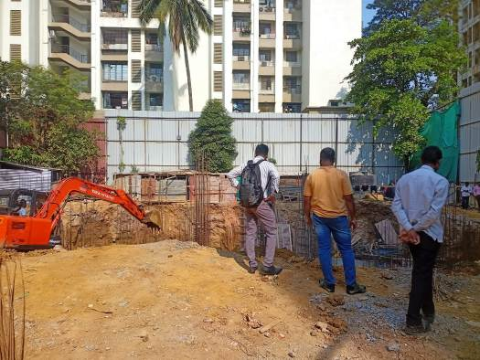
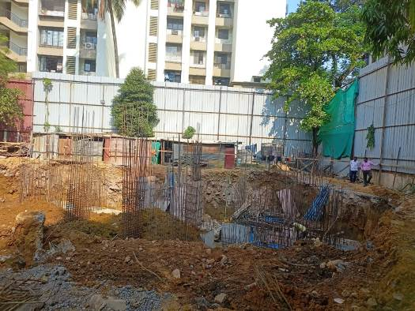
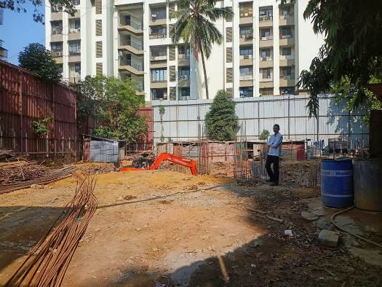
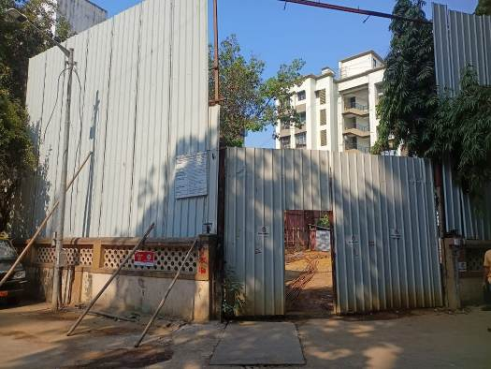

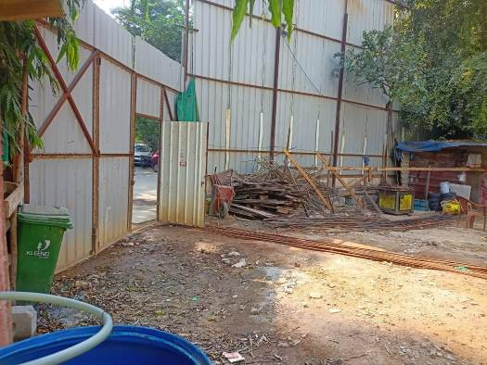

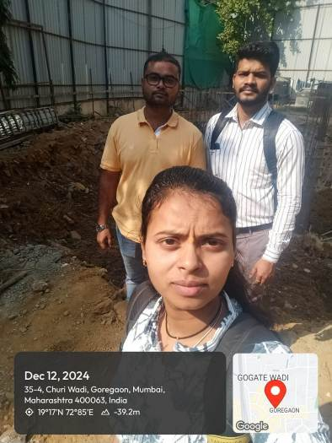

Route Map of the property
Site u/r
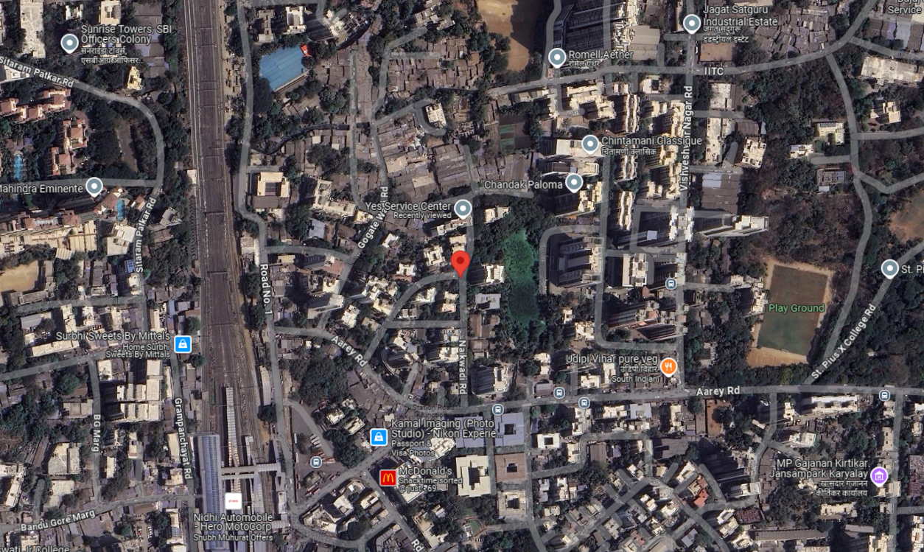

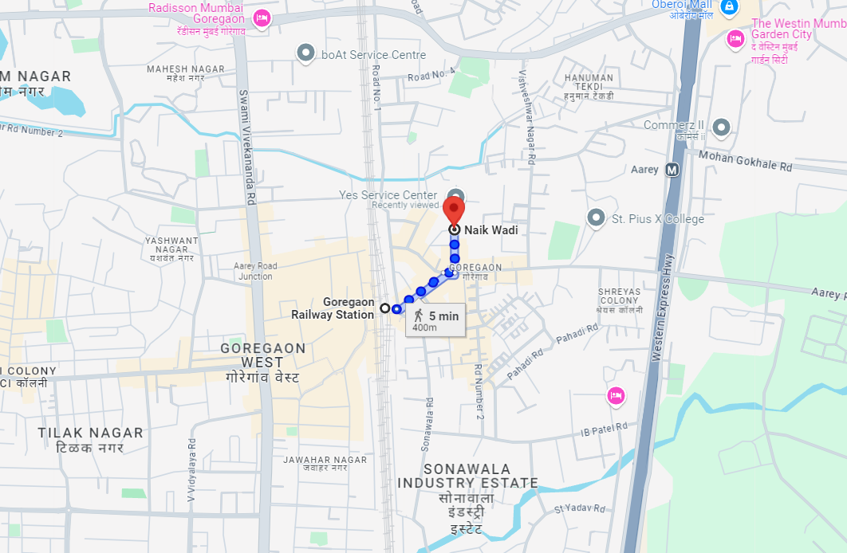

Latitude Longitude: 19°10'03.0"N 72°51'06.9"E
Note: The Blue line shows the route to site from nearest railway station (Goregaon – 400 Meter.)

