COST VETTING REPORT

Details of the property under consideration:

Name of Project: "Shanti Sadan”

"Shanti Sadan”, Proposed Redevelopment of the Existing Building Known as “Shanti Sadan Co – operative Housing Society Limited on Plot Bearing F. P. No. 50, TPS Vile Parle No. VI (1st Variation) (Final), Dadabhai Road, Navpada, Vile Parle (West), Mumbai – 400 056, State – Maharashtra, Country – India

Latitude Longitude: 19°06'22.8"N 72°50'35.5"E

Valuation Done for:
State Bank of India
SME Chembur Branch
Unit No. 11, Building No. 11, Ground Floor, Corporate Park, Sion Trombay Road,
Chembur, Mumbai, Pin Code – 400 071, State - Maharashtra, Country – India.

Vastu/SBI/Mumbai/09/2024/11511/2306571
03/03-15-PY
Date: 27.09.2024

To,
The Branch Manager,
State Bank of India
SME Chembur Branch
Unit No. 11, Building No. 11,
Ground Floor, Corporate Park,
Sion Trombay Road, Chembur,
Mumbai, Pin Code – 400 071,
State - Maharashtra, Country – India.

Sub: Cost Vetting Report for "Shanti Sadan”, Vile Parle (West), Mumbai – 400 056

Dear Sir,
In accordance with your letter of engagement as stated above, we enclose our Report on Cost Vetting for "Shanti Sadan”, Proposed Redevelopment of the Existing Building Known as “Shanti Sadan Co – operative Housing Society Limited on Plot Bearing F. P. No. 50, TPS Vile Parle No. VI (1st Variation) (Final), Dadabhai Road, Navpada, Vile Parle (West), Mumbai – 400 056, State – Maharashtra, Country – India.
M/s. Shree Hans Realtors LLP is proposing Redevelopment of the Existing Building Known as “Shanti Sadan Co – operative Housing Society Limited on Plot Bearing F. P. No. 50, TPS Vile Parle No. VI (1st Variation) (Final), Dadabhai Road, Navpada, Vile Parle (West), Mumbai – 400 056, State – Maharashtra, Country – India. Project is comprising Rehab cum Sale Building.
Residential of Rehab cum Sale Building is proposed of Ground Floor + 1st to 11th Upper Floors with total RERA carpet area of 18,427.87 Sq. Ft. which consists 1 RK, 2 BHK, 3 BHK & 4 BHK with 10 nos. of Sell flats & 12 nos. of tenant’s flats providing with Fitness Centre, Society Office, & Other Amenities.
Our analysis of the cost vetting is enclosed in this report. This Report forms an integral whole and cannot be split in parts. The outcome of the report/ study can only lead to proper conclusions if the Report as a whole is taken into account.
The information used by Vastukala Consultants (I) Pvt. Ltd. (VCIPL) in preparing this report has been obtained from a variety of sources and other relevant documents provided by the client & bank. As agreed, we have performed our cost vetting exercise with the data available related to the business, considering the market prospects and projections. Our results are dependent on documents provided by client & bank, the underlying assumptions, which has been analyzed at a broader level by VCIPL while assessing their reasonableness.

Total Project Cost for the completion of Project will be ` 29.35 Cr.

For Vastukala Consultants (I) Pvt. Ltd.

Manoj B. Chalikwar
Registered Valuer
Chartered Engineer (India)
Reg. No. IBBI / RV / 07/2018/10366
Reg. No. CAT-I-F-1763
SBI Empanelment No.: SME/TCC/38/IBBI/3
About the Project:
Proposed Redevelopment of the Existing Building Known as “Shanti Sadan Co – operative Housing Society Limited on Plot Bearing F. P. No. 50, TPS Vile Parle No. VI (1st Variation) (Final), Dadabhai Road, Navpada, Vile Parle (West), Mumbai – 400 056. It is about 950 M. travelling distance from Vile Parle (West) Railway station.

Area Statement as per Approved Plan
A | Proforma A
i | Area Statement
1 | Area of Plot | 568.57
a | Area of Reservation in plot | -
b | Area of road set back | 3.64
c | Area of DP road | -
2 | Deduction for
A | For Reservations / Road Area
a | Road set – back area to be handed over (100%) (Regulation No. 16) | Nil
b | Proposed DP Road to be handed over (100%) (Regulation No. 16) | -
i | Reservation area plot to be handed over to (Regulation No. 17) | -
ii | Reservation area to be handed over as per AR (Regulation No. 17) | Nil
d | Any (Area of plot not in possession) | -
B | Total area under road / reservation / plot not in possession | -
 | For Amenity area to be handed over to MCGM | -
a | Area of amenity plot / plots to be handed over as per DCR 14(A) | -
b | Area of amenity plot / plots to be handed over as per DCR 14(B) | -
c | Area of amenity plot / plots to be handed over as per DCR 35 | -
 | Total Amenity area | -
C | Deduction of existing BUA to be retained if any / land component of existing BUA / Existing BUA as per regulation under which the development was allowed | -
3 | Total deductions: [2(A) + 2(B) + 2(C)] | Nil
4 | Balance area of plot (1 minus 3) | 564.93
5 | Plot area under development [Sr. No. 4 + 2(A) (c)(ii)]
6 | Zonal (basic) FSI (0.50 or 0.75 or 1 or 1.33) | 1.00
7 a) | Permissible built-up area as per zonal (basic) FSI (5 X 6) | 564.93
b) | permissible built-up area as per regulation 30 (C) (protected development) (7100.49 Sq. Ft. / 10.764 = 659.65 Sq. M.) | 91.08
c) | Permissible built-up area (7a or 7b above, whichever is more) | 656.01
8 | Built up equal to area of land handed over as per regulation 30(A) 3 (a) | -
a) | As per 2(A) and 2(B) except 2(A)(c)(ii) above with in cap of admissible TDR as column 6 of table – 12 on remaining / balance plot | -
b) | BUA for 2(A)(a) & 2(A)(b) above to be utilized over and above the permissible FSI as per column no. 7 of table 12 of regulation 30(A) and to be mentioned in table 12 A of regulation 32 (200% or 250%) | -
c) | In case of 2(A)(c)(ii) permissible over and above permissible BUA on remaining / balance plot [as per table no. 5 of regulation 17(1)] | 7.28
d) | Total Additional BUA [8(b) + 8(c)] | Nil
9 | Additional / Incentive BUA within the cap of admissible TDR as per Table 12 on balance plot
a) | In lieu of cost of construction of amenity buildings as per regulations 30(A)(3)(b) | -
b) | 50% of rehab component as per reg.33(7)(A) | -
c) | 15% of sr. no. 7b above or 10 Sq. M. per rehab tenement as per reg. 33(7) (B) (9X10) | -
d) | Total additional BUA / Incentive area
10 | Built up area due to additional FSI on payment of premium as regulation no. 30(A) on remaining / balance plot table no. 12 of (50%) | -
11 | Built up area due to admissible TDR as per table no. 12 of regulation no. 30(A) and 32 on remaining / balance ploy (90%) | -
a) | General TDR [(50% min & 80% max) of permissible TDR] | -
b) | Slum TDR [(20% min. & 50% max) of permissible TDR] | -
c) | TDR lieu of sr. no. [7(a) – 7(b)], 8(a), 8(b) & 9 above | -
d) | Total TDR | -
12 | Permissible built-up area [7(c) + 8(d) + 9(d) + 10 + 11(d)] | 663.29
13 | Proposed built up area | 209.89
14 | TDR generated if any as per regulation 30(A) and 32 | -
15 | Permissible Fungible Compensatory area as per regulation no. 31(3) I.E. (209.89 X 35% = 73.46) | 73.46
a) | i) perm. Fungible compensatory area for rehab comp. w/o charging premium | -
 | ii) fungible compensatory area availed for rehab comp. w/o charging premium | -
b) | i) Permissible fungible compensatory area by charging premium | -
 | ii) Fungible compensatory area availed on payment of premium | -
16 | Total BUA proposed including fungible compensatory area [13 + 15(a)(ii) + 15(b)(ii)] | 209.89
17 | FSI consumed on Net Plot [13/4] including setback over and above | 0.37
ii) | Other requirements
A) | Reservation / Designation
a) | Name of Reservation | N/A
b) | Area of Reservation affecting the plot | N/A
c) | Area of Reservation land to be handed / handed over as per Regulation No. 17 | N/A
d) | Built Up area of Amenity to be handed over as per Regulation No. 17 | N/A
e) | Area / Built up area of designation | N/A
B) | Plot area / built up amenity to be handed over as per regulation no.
i) | 14(A) | -
ii) | 14(B) | -
iii) | 15 | -
C) | Requirement of recreational open space in layout / plot as per regulation no. 27
i) | Requirement | -
ii) | Proposed | -
D) | Tenement Statement | -
i) | Proposed built up area (13 above) | 209.89
ii) | Less deduction of Non – residential area (Shop, etc.) | Nil
iii) | Area available for tenements [(i) minus (ii)] | 209.89
iv) | Tenements permissible (Density of tenements / hectare) | 9
v) | Total number of tenements proposed on the plot | 3 Nos.
vi) | Tenements existing | Nil
 | Total number of tenements on the plot | 03 Nos.
E) | Parking Statement
i) | Parking required by regulations for | -
 | Car | 3 Nos.
 | Scooter / Motor cycle
 | Outsiders (visitors)
ii) | Covered garages permissible
iii) | Covered garages proposed
 | Car
 | Scooter / Motor cycle
 | Outsiders (visitors)
iv) | Total parking provided | 32 Nos.
F) | Transport Vehicles Parking
i) | Spaces for transport vehicles parking required by regulations | Nil
ii) | Total no. of transport vehicles parking spaces provided | Nil

Area Statement as per Concession Drawing Plan
A | Proforma A
i | Area Statement
1 | Area of Plot | 568.57
a | Area of Reservation in plot | -
b | Area of road set back | Nil
c | Area of DP road | -
2 | Deduction for
A | For Reservations / Road Area
a | Road set – back area to be handed over (100%) (Regulation No. 16) | Nil
b | Proposed DP Road to be handed over (100%) (Regulation No. 16) | -
i | Reservation area plot to be handed over to (Regulation No. 17) | -
ii | Reservation area to be handed over as per AR (Regulation No. 17) | Nil
d | Any (Area of plot not in possession) | -
B | Total area under road / reservation / plot not in possession | -
 | For Amenity area to be handed over to MCGM | -
a | Area of amenity plot / plots to be handed over as per DCR 14(A) | -
b | Area of amenity plot / plots to be handed over as per DCR 14(B) | -
c | Area of amenity plot / plots to be handed over as per DCR 35 | -
 | Total Amenity area | -
C | Deduction of existing BUA to be retained if any / land component of existing BUA / Existing BUA as per regulation under which the development was allowed | -
3 | Total deductions: [2(A) + 2(B) + 2(C)] | Nil
4 | Balance area of plot (1 minus 3) | 568.57
5 | Plot area under development [Sr. No. 4 + 2(A) (c)(ii)]
6 | Zonal (basic) FSI (0.50 or 0.75 or 1 or 1.33) | 1.00
7 a) | Permissible built-up area as per zonal (basic) FSI (5 X 6) | 564.93
b) | permissible built-up area as per regulation 30 (C) (protected development) (7100.49 Sq. Ft. / 10.764 = 659.65 Sq. M.) | 91.08
c) | Permissible built-up area (7a or 7b above, whichever is more) | 91.08
8 | Built up equal to area of land handed over as per regulation 30(A) 3 (a) | -
a) | As per 2(A) and 2(B) except 2(A)(c)(ii) above with in cap of admissible TDR as column 6 of table – 12 on remaining / balance plot | -
b) | BUA for 2(A)(a) & 2(A)(b) above to be utilized over and above the permissible FSI as per column no. 7 of table 12 of regulation 30(A) and to be mentioned in table 12 A of regulation 32 (200% or 250%) | -
c) | In case of 2(A)(c)(ii) permissible over and above permissible BUA on remaining / balance plot [as per table no. 5 of regulation 17(1)] | -
d) | Total Additional BUA [8(b) + 8(c)] | Nil
9 | Additional / Incentive BUA within the cap of admissible TDR as per Table 12 on balance plot
a) | In lieu of cost of construction of amenity buildings as per regulations 30(A)(3)(b) | -
b) | 50% of rehab component as per reg.33(7)(A) | -
c) | 15% of sr. no. 7b above or 10 Sq. M. per rehab tenement as per reg. 33(7) (B) (9X10) | 90
d) | Total additional BUA / Incentive area | 90
10 | Built up area due to additional FSI on payment of premium as regulation no. 30(A) on remaining / balance plot table no. 12 of (50%) | 284.29
11 | Built up area due to admissible TDR as per table no. 12 of regulation no. 30(A) and 32 on remaining / balance ploy (90%) | 511.71
a) | General TDR [(50% min & 80% max) of permissible TDR] | 74.77
b) | Slum TDR [(20% min. & 50% max) of permissible TDR] | 255.85
c) | TDR lieu of sr. no. [7(a) – 7(b)], 8(a), 8(b) & 9 above | 181.08
d) | Total TDR | 511.71
12 | Permissible built-up area [7(c) + 8(d) + 9(d) + 10 + 11(d)] | 1364.57
13 | Proposed built up area | 1364.57
14 | TDR generated if any as per regulation 30(A) and 32 | -
15 | Permissible Fungible Compensatory area as per regulation no. 31(3) I.E. (1364.57 X 35% = 477.60)
a) | i) perm. Fungible compensatory area for rehab comp. w/o charging premium | 230.88
 | ii) fungible compensatory area availed for rehab comp. w/o charging premium | 230.88
b) | i) Permissible fungible compensatory area by charging premium | 246.72
 | ii) Fungible compensatory area availed on payment of premium | 246.72
16 | Total BUA proposed including fungible compensatory area [13 + 15(a)(ii) + 15(b)(ii)] | 1842.17
17 | FSI consumed on Net Plot [13/4] including setback over and above | 2.40
ii) | Other requirements
A) | Reservation / Designation
a) | Name of Reservation | N/A
b) | Area of Reservation affecting the plot | N/A
c) | Area of Reservation land to be handed / handed over as per Regulation No. 17 | N/A
d) | Built Up area of Amenity to be handed over as per Regulation No. 17 | N/A
e) | Area / Built up area of designation | N/A
B) | Plot area / built up amenity to be handed over as per regulation no.
i) | 14(A) | -
ii) | 14(B) | -
iii) | 15 | -
C) | Requirement of recreational open space in layout / plot as per regulation no. 27
i) | Requirement | -
ii) | Proposed | -
D) | Tenement Statement | -
i) | Proposed built up area (13 above) | 1842.17
ii) | Less deduction of Non – residential area (Shop, etc.) | Nil
iii) | Area available for tenements [(i) minus (ii)] | 1842.17
iv) | Tenements permissible (Density of tenements / hectare) | 83
v) | Total number of tenements proposed on the plot | 22 Nos.
vi) | Tenements existing | Nil
 | Total number of tenements on the plot | 22 Nos.
E) | Parking Statement
i) | Parking required by regulations for | -
 | Car | 32 Nos.
 | Scooter / Motor cycle
 | Outsiders (visitors)
ii) | Covered garages permissible
iii) | Covered garages proposed
 | Car
 | Scooter / Motor cycle
 | Outsiders (visitors)
iv) | Total parking provided | 32 Nos.
F) | Transport Vehicles Parking
i) | Spaces for transport vehicles parking required by regulations | Nil
ii) | Total no. of transport vehicles parking spaces provided | Nil

Construction Area as per Concession Drawing Plan for Rehab cum Sale Building

Sr. No. | Floor | Built Up Area in Sq. M. | Staircase, Lift & Lobby Area in Sq. M. | Chhajja Area in Sq. M. | Other Area in Sq. M. | Total Area in Sq. M. | Total Area in Sq. Ft.
1 | Ground | - | 35.53 |  | 204.51 | 240.04 | 2,583.79
2 | 1st Floor | 174.36 | 35.53 | 25.35 | 4.80 | 240.04 | 2,583.79
3 | 2nd Floor | 175.31 | 34.58 | 25.35 | 4.80 | 240.04 | 2,583.79
4 | 3rd Floor | 175.31 | 34.58 | 25.35 | 4.80 | 240.04 | 2,583.79
5 | 4th Floor | 175.31 | 34.58 | 25.35 | 4.80 | 240.04 | 2,583.79
6 | 5th Floor | 175.31 | 34.58 | 25.35 | 4.80 | 240.04 | 2,583.79
7 | 6th Floor | 123.90 | 35.53 | 25.35 | 55.26 | 240.04 | 2,583.79
8 | 7th Floor | 141.43 | 34.58 | 25.35 | 45.84 | 247.20 | 2,660.86
9 | 8th Floor | 175.31 | 34.58 | 25.35 | 4.80 | 240.04 | 2,583.79
10 | 9th Floor | 175.31 | 34.58 | 25.35 | 4.80 | 240.04 | 2,583.79
11 | 10th Floor | 175.31 | 34.58 | 25.35 | 4.80 | 240.04 | 2,583.79
12 | 11th Floor | 175.31 | 34.58 | 25.35 | 4.80 | 240.04 | 2,583.79
13 | Terrace | - | 35.53 | - | - | 35.53 | 382.44
TOTAL |  | 1,842.17 | 453.34 | 278.85 | 348.81 | 2,923.17 | 31,465.00
No. of Puzzle Car Parking |  |  |  |  |  | 32.00

Project Cost
Sr. No. | Particulars | Total Estimated Amount in ` | Total Estimated Amount  in ` Cr.
1 | Land Cost
 | Acquisition Cost of Land or Development Rights, and Legal Cost. | 51,33,885.00 | 0.51
 | Rent to Tenants, Lease premium, Lease Rent, interest cost incurred or payable on Land Cost | 3,49,14,979.00 | 3.49
 | Amount of Premium payable to obtain development rights, FSI, additional FSI, fungible area, and any other incentive under DCR from Local Authority or State Government or any Statutory Authority. | 6,44,17,226.00 | 6.44
 | Acquisition cost of TDR (if any) | 2,62,00,000.00 | 2.62
2 | Cost of Construction
 | Estimated construction cost of rehab cum sale building including site development and infrastructure for the same. | 12,30,34,507.00 | 12.30
 | On site expenditure for development of entire project excluding cost of construction as per(i) above,
a. | Architect Fees & Consultant fees | 61,51,725.00 | 0.62
b. | Admin Cost includes salaries, site overheads, development works, cost of services (including water, electricity, sewerage, drainage, layout roads etc.), cost of machineries and equipment including its hire and maintenance cost, consumables etc. All costs directly incurred to complete the construction of the entire phase of the project registered. | 49,21,380.00 | 0.49
c. | Marketing Cost | 74,35,373.00 | 0.74
3 | Interest during the Project | 1,76,00,000.00 | 1.76
4. | Contingency Charges | 36,91,035.00 | 0.37
 | GRAND TOTAL: | 29,35,00,110.00 | 29.35

Manoj B. Chalikwar
Registered Valuer
Chartered Engineer (India)
Reg. No. IBBI / RV / 07/2018/10366
Reg. No. CAT-I-F-1763
SBI Empanelment No.: SME/TCC/38/IBBI/3
Comments on each element of Cost of Project: -
- Land Cost:
As per Present Ready Reckoner rate the Project Land Value is ` 6.64 Cr. considering Land Rate @ ` 1,16,770.00 per Sq. M. & Net Plot Area of 568.57 Sq. M.
As per document purchase cost of land & stamp duty cost is ` 51,33,885.00 i.e., ` 0.51 Cr. which is 1.75% of Total Project Cost.
Sr. No. | Date | Document Name | Description | Total Cost in ` | Incurred Cost in `
1 | 28/04/2023 | Developer Agreement | Stamp Duty | 51,00,045.00 | 51,00,045.00
2 | 28/04/2023 | Developer Agreement | Reg. Fees | 30,000.00 | 30,000.00
3 | 28/04/2023 | Developer Agreement | Reg. Fees | 2,600.00 | 2,600.00
4 | 28/04/2023 | General Power of Attorney | Stamp Duty | 500.00 | 500.00
5 | 28/04/2023 | General Power of Attorney | Reg. Fees | 100.00 | 100.00
6 | 28/04/2023 | General Power of Attorney | Reg. Fees | 640.00 | 640.00
TOTAL |  |  |  | 51,33,885.00 | 51,33,885.00

- Payment Payable to Rehab Tenants:
Since it is a Redevelopment project under Sec (33)7 from the date of shifting of 14 Tenants till handing over their respective new flats as per the Tenant Agreement. Further the rent keeps on increasing 10% each year. The existing Tenants has to be given total rental of ` 3,49,14,979.00 i.e., ` 3.49 Cr. Builder has paid ` 0.44 Cr. which is 11.90% of Total Project Cost.
Existing Tenants Carpet Area & Rent per month for Flat are as follows:
Sr. No. | Particulars |  | Units
1 | No. of Tenants | 14.00 | Nos
2 | No. of Existing Carpet Area | 7,248.41 | Sq. Ft.
3 | Rate per Sq. Ft. on Carpet Area for Dec 23 to Nov 24 | 100.00 | Rupees
4 | Rent per month per tenant for Dec 23 to Nov 24 | 7,24,841.00 | Rupees
5 | Rent per year for Dec 23 to Nov 24 | 86,98,092.00 | Rupees
6 | Rate per Sq. Ft. on Carpet Area for Dec 25 to Dec 26 | 110.00 | Rupees
7 | Rent per month per tenant for Dec 25 to Dec 26 | 7,97,325.00 | Rupees
8 | Rent per year for Dec 25 to Dec 26 | 1,03,65,226.00 | Rupees
9 | Shifting Charges per tenant | 20,000.00 | Rupees
10 | Total Shifting Charges | 2,80,000.00 | Rupees
11 | Brokerage Charges | 7,24,841.00 | Rupees
12 | Rate per Sq. Ft. on Carpet Area for Hardship Compensation | 2,000.00 | Rupees
13 | Hardship Compensation Cost | 1,44,96,820.00 | Rupees
14 | Sinking Fund per Tenant | 25,000.00 | Rupees
15 | Total Sinking Fund Cost | 3,50,000.00 | Rupees
Total Rent Cost (5 + 8 + 10 + 11 + 13 + 15) |  | 3,49,14,979.00 | Rupees

- TDR Charges:
The TDR charges is ` 2,62,00,000.00 i.e., ` 2.62 Cr. which is 8.93% of Total Project Cost.
Sr.  No. | Particulars | Estimate Amount in ` | Incurred Amount in `
1 | TDR Purchase Cost | 2,62,00,000.00 | -
TOTAL |  | 2,62,00,000.00 | -
As per information & data provided by the developer.

- Building Cost of Construction for Sale Building:
Construction Area of Sale Building = 2,923.17 Sq. M. i.e., 31,465.00 Sq. Ft.
No. of Stack Car Parking = 32 Nos.
Total estimated cost for construction of Building (includes cost of RCC work, manpower, lift, material, painting, finishing work, site development, etc.) is ` 9,43,95,006.00 i.e., ` 9.44 Cr. which comes ` 3,000.00 per Sq. Ft. on construction area for building, deep excavation & piling cost is ` 94,39,501.00 i.e., ` 0.94 Cr. which comes 10% of cost of construction and cost for stack parking is ` 1,92,00,000.00 i.e., ` 1.92 Cr. which comes ` 6,00,00,000.00 per stack parking.
Hence, total construction cost (Cost of construction of building + Cost of Deep Excavation 35& Piling Cost + Cost of stack parking) (` 9,43,95,006.00 + ` 94,39,501.00 + ` 1,92,00,000.00) = ` 12,30,34,507.00 i.e., ` 12.30 Cr.
The total construction area is 2,923.17 Sq. M. i.e., 31,465.00 Sq. Ft., projected cost of ` 12.30 Cr is 41.92% of total project cost
VCIPL opinion the construction cost of 3,000/- Per Sq. Ft. which is in line with Market-Trend.
Particulars | Rate per Sq. Ft
Excavation Work | 250.00
Total RCC Work | 1,500.00
Final Finishing Work | 700.00
Other Work | 550.00
Cost of Construction | 3,000.00
Deep Excavation & Piling Cost | 10% of Cost of Construction
Stack Car Parking Cost | 6,00,000.00 per parking

- Approval Charges:
The Total Approval Cost (Fungible Cost & Development Cess Premium Cost) as per architect letter will be ` 6,44,17,226.00 i.e., ` 6.44 Cr. which is 21.95% of Total Project Cost.
As per information & data provided by developer.
Sr. No. | Particulars | Estimated Cost in `
1 | Scrutiny Fees | 5,20,600.00
2 | IOD Deposit | 16,000.00
3 | Debris Deposit | 30,150.00
4 | Staircase Premium | 96,04,000.00
5 | Development Charges | 77,68,000.00
6 | Development Cess | 18,65,000.00
7 | Labour Welfare Charges | 8,26,226.00
8 | Fungible Compensatory Area | 1,69,32,750.00
9 | Open Space Deficiency Premium | 1,73,34,000.00
Total Estimated Approval Cost |  | 6,44,17,226.00

- Architect Cost, RCC & Other Professional Charges:
The total Architect charges of ` 61,51,725.00 i.e., ` 0.628 Cr. is 5.0% of total construction cost building & it is line up with Market trend.
The professional charge consists of Architect & Legal which in market is in the range of 2% - 5% of Total Construction cost of the project.

- Administrative Expenses:
Salaries, site overheads, development works, cost of services (including water, electricity, sewerage, drainage, layout roads etc.), cost of machineries and equipment including its hire and maintenance cost, consumables etc. All costs directly incurred to complete the construction of the entire phase of the project registered is estimated 4% of total construction cost Building which comes to ` 49,21,380.00 i.e., ` 0.49 Cr.
The admin charges which in market is in the range of 4% - 6% of Total Construction cost of the project.

- Marketing Expenses:
Marketing costs directly incurred to complete the construction of the entire phase of the project registered is estimated at 2% of total Sale income from the project which comes to ` 74,35,373.00 i.e., ` 0.74 Cr.
The marketing charge consists of brokerage & commission which in market is in the range of 1% - 3% of Total Sale income of the property.

- Interest Costs:
The Interest cost for the term loan is ` 1,76,00,000.00 i.e., ` 1.76 Cr., which is 6.00% of total project cost.
As per information provided by the client.

- Contingency Costs:
The contingency charges estimated at 3% of total cost of construction which comes to ` 36,91,035.00 i.e., ` 0.37 Cr.
Observation and Construction: -
Total estimated cost of project i.e., ` 29,35,00,110.00 (Rupees Twenty – Nine Crore Thirty – Five Lakh One Hundred Eleven Only) i.e., ` 29.35 Cr. is fair & reasonable.
The project cost is including land premium payable to concern authorities, Rent Cost, TDR Cost, Fungible FSI Premium, Cost of Construction of Rehab cum Sale Building, professional charges on site expenses including admin & marketing expenses, premiums / charges to be paid to competent authority and Bank interest, etc. we have not independently verified interest cost hence not consider in cost vetting.
As per present sanctioned building plan, permissible built-up area on the said plot is 209.89 Sq. M. The rehab cum sale building is presently approved for Ground Floor + 1st Upper Floors only. The Developer has submitted the concession drawing plan to the competent authority for utilization of total permissible Built-up area and fungible FSI. The rehab cum sale building is presently under sanction for Ground Floor + 1st to 11th Upper Floors only. Estimated cost of entire project of 11th upper floors are considered.
Total estimated cost of construction of Rehab cum Sales building is ` 9,43,95,006.00 i.e., ` 9.44 Cr. which comes ` 3,000.00 per Sq. Ft. on construction area for building, deep excavation & piling cost is ` 94,39,501.00 i.e., ` 0.94 Cr. which comes 10% of cost of construction and cost for stack parking is ` 1,92,00,000.00 i.e., ` 1.92 Cr. which comes ` 6,00,00,000.00 per stack parking. Hence, total construction cost (Cost of construction of building + Cost of Deep Excavation 35& Piling Cost + Cost of stack parking) (` 9,43,95,006.00 + ` 94,39,501.00 + ` 1,92,00,000.00) = ` 12,30,34,507.00 i.e., ` 12.30 Cr., which is fair & reasonable considering the present status of project, type & quality of construction & specification of the building materials to be used, height of the structure, amenities to be provided in proposed building.

Assumptions & Remarks-
- The adequacy of Engineering / Structural design is beyond the scope of our assignment.
- Estimated project completion date is 31/12/2026. The cost is certified based on the assumptions that the project will be completed within time frame. Few assumptions are made regarding inflation & cost rise etc. during construction period.

Photo copy of following document is provided to us & this report should be read along with it:
- Copy of Developer Agreement dated 28.04.2023 between M/s. Shanti Sadan Co -operative Housing Society Limited (Society) and M/s. Shree Hans Realtors LLP (Developers) through registered agreement Doc. No. BDR-1/6109/2023 dated 28.04.2023.
- Copy of General Power of Attorney Agreement dated 28.04.2023 between M/s. Shanti Sadan Co -operative Housing Society Limited (Society) and M/s. Shree Hans Realtors LLP (Attorney) through registered agreement Doc. No. BDR – 1/6109/2023 dated 28.04.2023.
- Copy of Permanent Alternative Accommodation Agreement dated 29.08.2024 between M/s. Shree Hans Relators LLP (Developers) and Dr. (Mrs.) Nandini Ajay Shah & Mr. Ajay Vinod Shah (The Members) through registered agreement Doc. No. BDR – 1/11747/2024 dated 29.08.2024. (For Flat No. 101)
- Copy of Permanent Alternative Accommodation Agreement dated 29.08.2024 between M/s. Shree Hans Relators LLP (Developers) and Mr. Ankit Pramod Thakkar (The Members) through registered agreement Doc. No. BDR – 1/11746/2024 dated 29.08.2024. (For Flat No. 102)
- Copy of Permanent Alternative Accommodation Agreement dated 30.08.2024 between M/s. Shree Hans Relators LLP (Developers) and Mrs. Sarala Purshotamdas Thakkar (The Members) through registered agreement Doc. No. BDR – 1/11808/2024 dated 30.08.2024. (For Flat No. 103)
- Copy of Permanent Alternative Accommodation Agreement dated 29.08.2024 between M/s. Shree Hans Relators LLP (Developers) and Miss. Surangi Kishorbhai Jadav (The Members) through registered agreement Doc. No. BDR – 1/11548/2024 dated 29.08.2024. (For Flat No. 201)
- Copy of Permanent Alternative Accommodation Agreement dated 28.08.2024 between M/s. Shree Hans Relators LLP (Developers) and Mr. Naresh Himatlal Goradia & Mrs. Nayna N. Goradia (The Members) through registered agreement Doc. No. BDR – 1/11716/2024 dated 28.08.2024. (For Flat No. 401)
- Copy of Permanent Alternative Accommodation Agreement dated 28.08.2024 between M/s. Shree Hans Relators LLP (Developers) and Mr. Kirti Kantilal Doshi & Mrs. Kalpana Kirti Doshi (The Members) through registered agreement Doc. No. BDR – 1/11722/2024 dated 28.08.2024. (For Flat No. 402)
- Copy of Permanent Alternative Accommodation Agreement dated 30.08.2024 between M/s. Shree Hans Relators LLP (Developers) and Mrs. Ranjanben Chimanlal Choksi (The Members) through registered agreement Doc. No. BDR – 1/11813/2024 dated 30.08.2024. (For Flat No. 601)
- Copy of Permanent Alternative Accommodation Agreement dated 30.08.2024 between M/s. Shree Hans Relators LLP (Developers) and Mrs. Ranjanben Chimnalal Choksi (The Members) through registered agreement Doc. No. BDR – 1/11812/2024 dated 30.08.2024. (For Flat No. 602)
- Copy of Permanent Alternative Accommodation Agreement dated 29.08.2024 between M/s. Shree Hans Relators LLP (Developers) and Mr. Vijay Harshadrai Baxi & Mr. Aditya Vijay Baxi (The Members) through registered agreement Doc. No. BDR – 1/11749/2024 dated 29.08.2024. (For Flat No. 902)
- Copy of Permanent Alternative Accommodation Agreement dated 13.09.2024 between M/s. Shree Hans Relators LLP (Developers) and Mr. Girish Bhavanji Gala & Mrs. Kalpana Girish Gala (The Members) through registered agreement Doc. No. BDR – 1/12282/2024 dated 13.09.2024. (For Flat No. 701)
- Copy of Intimation of Disapproval (IOD) Letter No. P-16851 / 2023 / K/W Ward / FP / IOD / 1 / New dated 06.02.2024 issued by Municipal Corporation of Greater Mumbai (MCGM).
- Copy of Approved Plan No. P – 16851 / (2023) / K/W Ward / FP / 337 / 1 / New dated 06.02.2024 issued by Municipal Corporation of Greater Mumbai (MCGM).
Approved upto: Ground Floor + 1st Upper Floors
- Copy of Commencement Certificate No. P – 16851 / (2023) / K/W Ward / FP / CC / 1 / New dated 08.04.2024 valid upto 07.04.2025 issued by Municipal Corporation of Greater Mumbai (MCGM).
(This CC is endorsed for the work for up to plinth level as per approved plan dated 06.02.2024)
- Copy of Concession Drawing Plan No. P – 16851 / (2023) / K/W Ward / FP / 337 / 1 / New Dated 28.08.2023 submitted to Municipal Corporation of Greater Mumbai (MCGM).
Approval upto: Ground Floor + 1st to 11th Upper Floors
- Copy of No Objection Certificate for Height Clearance Noc ID No. JUHU/WEST/B/101422/702617 dated 10.11.2022 valid upto 09.11.2030 issued Airports Authority of India.
- Copy of CA Certificate dated 12.06.2024 issued by M/s. Shyam Prajapati & Associates.
- Copy of RERA Certificate RERA No. P51800056441 dated 31.05.2024 issued by Maharashtra Real Estate Regulatory Authority (MAHRERA).
- Copy of Estimated BMC approval cost bifurcation issued by M/s. Shree Hans Realtors LLP.
Actual Site Photographs
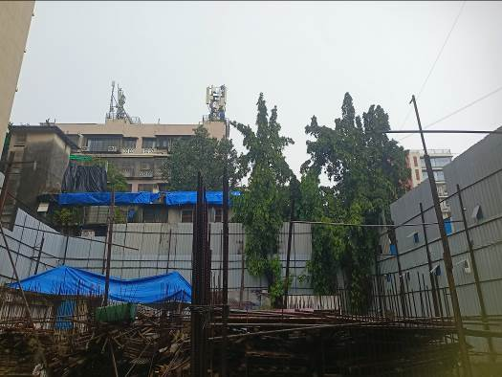
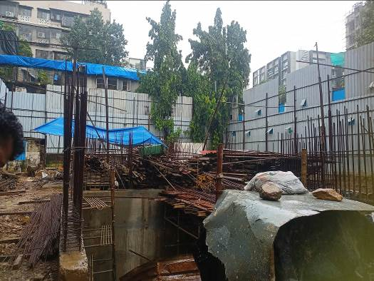
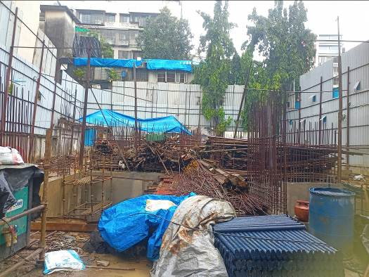
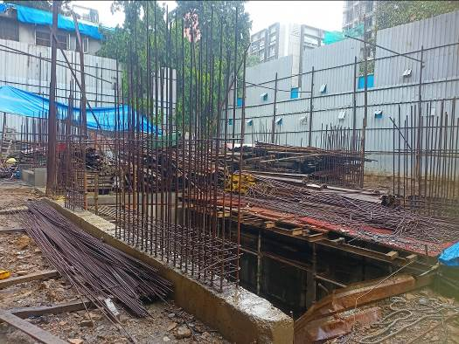
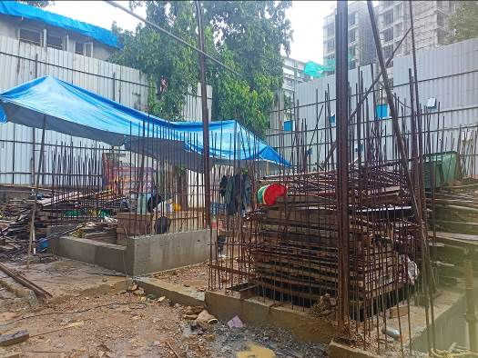

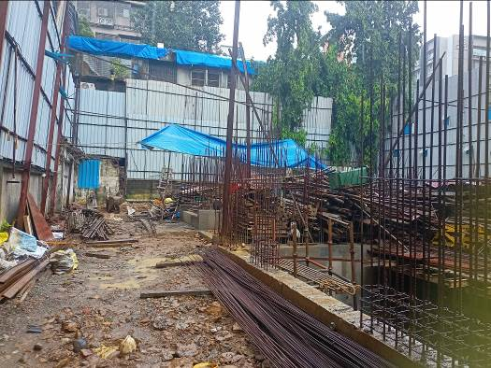
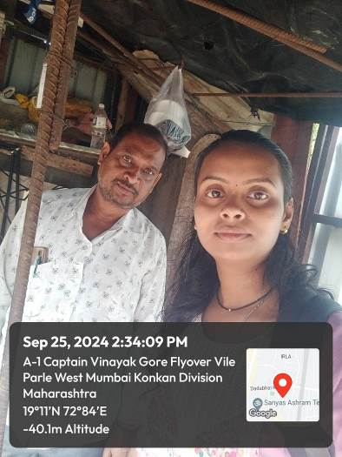
Route Map of the property
Site u/r
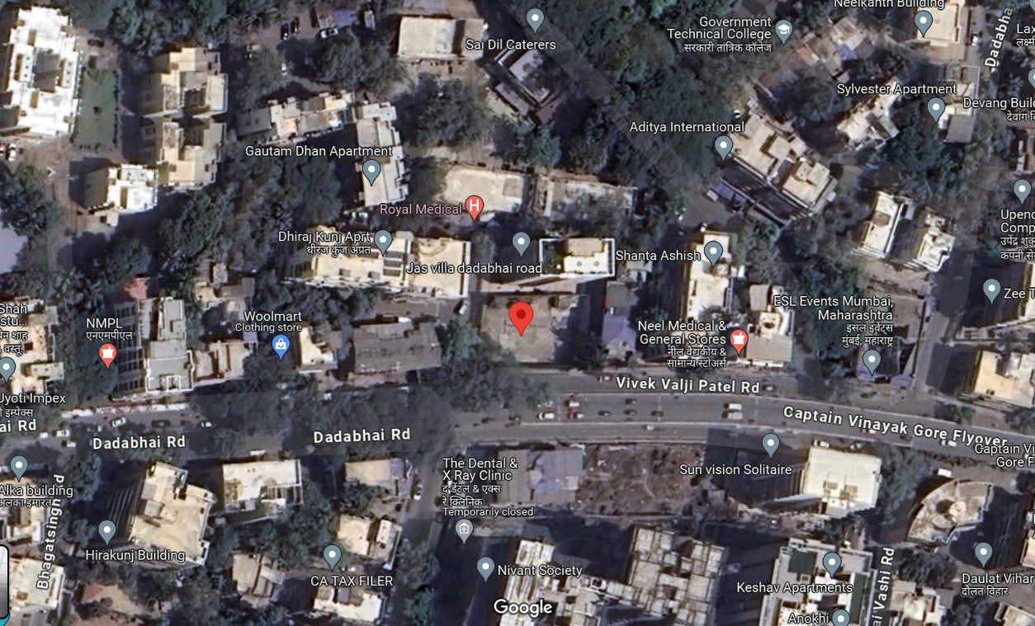

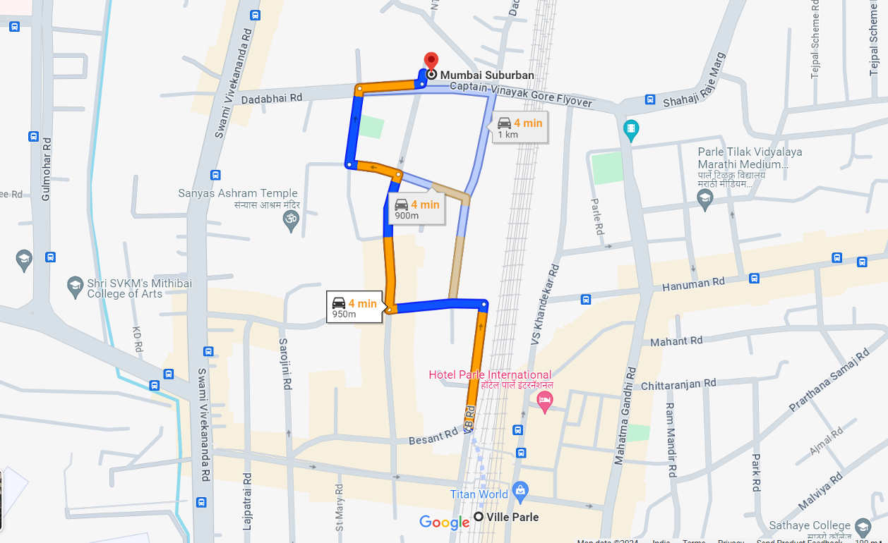

Latitude Longitude: 19°06'22.8"N 72°50'35.5"E
Note: The Blue line shows the route to site from nearest railway station (Vile Parle – 950 M.)

