Vastu/Nashik/07/2024/0010070/2307330
22/7-334-RPBS
Date: 27.09.2024

To, `
The Branch Manager,
Bank of Baroda
Regional Office Nashik Road Branch
BSNL Building, Datta Mandir Road, Nashik Road,
Nashik -422 101, State - Maharashtra, Country - India.

Sub: Vetting of Extra Amenities

Sir,

With reference to above subject, we have evaluated the Extra Amenities for Residential Flat No. B-5, Ground Floor + First Floor , "Rudra Greenfield Row Bungalow" , Survey No.27/1/2, Opposite Vasundhara Nursery, Village - Manur, Taluka & District - Nashik, PIN Code - 422 101, State - Maharashtra, Country - lndia belongs to Sau. Nanda Anil Gosavi & Shri. Kunal Anilgiri Gosavi

We have verified the rates quoted as per current market rates. Details of work and Extra Amenities considered as per copy of Agreement for Extra Amenities issued by to Sau. Nanda Anil Gosavi & Shri. Kunal Anilgiri Gosavi (First Party) and Shri. Yuvraj Vilas Pekhale (Second Party) received on dated 19.08.2024. The Extra Amenities amount is Rs.7,00,000/- (Rupees Seven Lakh Only.)

The said Cost Vetting Certificate is valid upto next 6 months Only.

Thanking you

Sincerely yours

Manoj B. Chalikwar
Registered Valuer
Chartered Engineer (India)
Reg. No. CAT-I-F-1763
Reg. No. IBBI/RV/07/2018/10366
BOB Empanelment No.: ZO:MZ:ADV:46:941
Encl: Valuation report.

Agreement for Extra Amenities
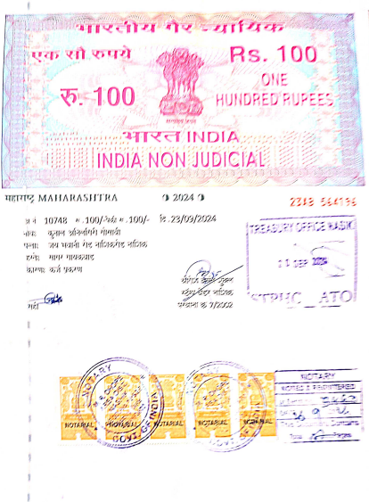
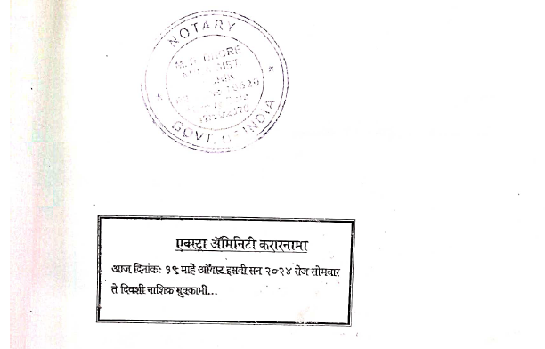

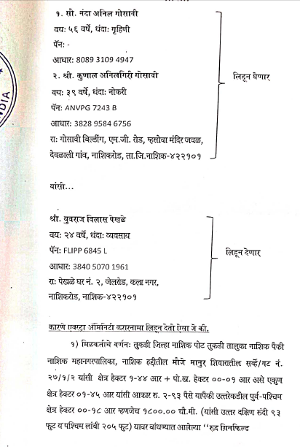

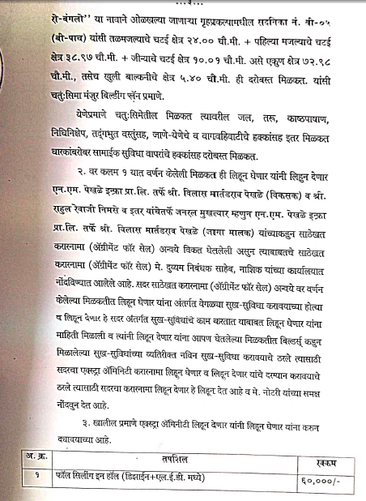
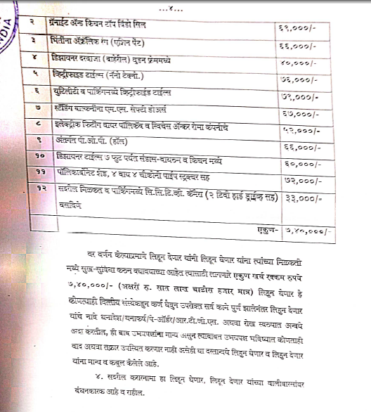

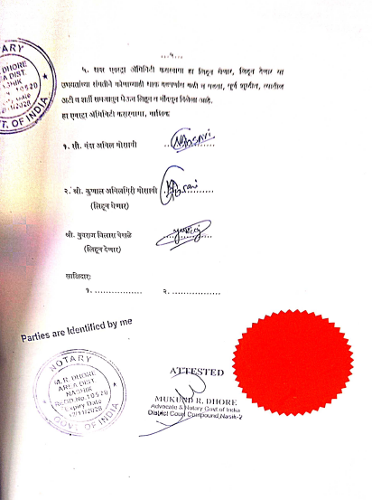

The Extra Amenities amount is Rs.7,00,000/- (Rupees Seven Lakh Only.)

