LENDERS INDEPENDENT ENGINEER REPORT
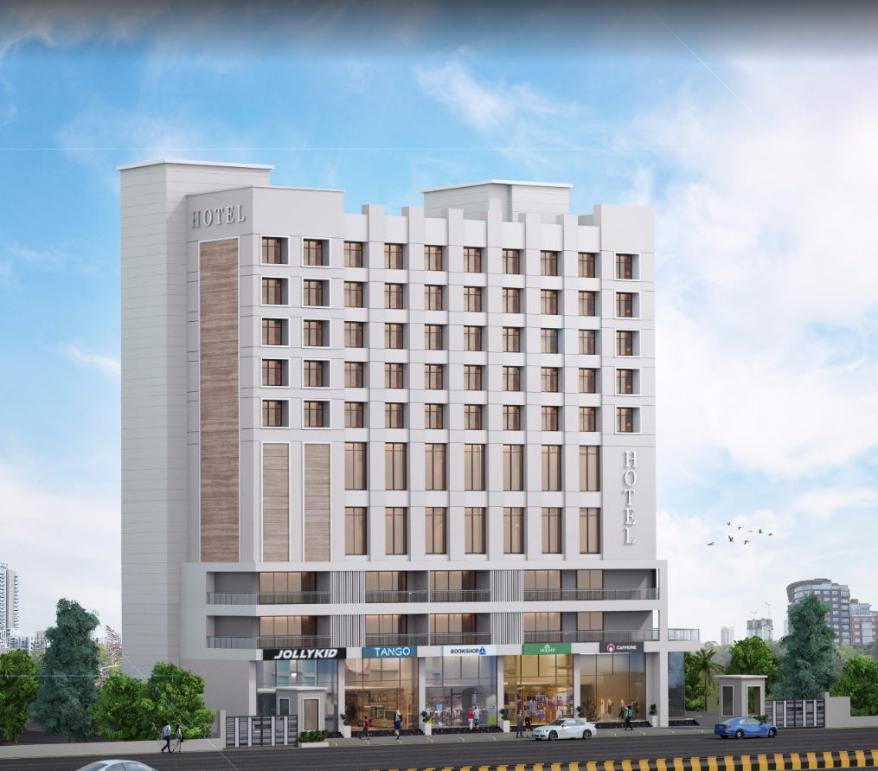

Details of the property under consideration:

Name of Owner: M/s. Gillani Hospitality Pvt. Ltd.

Proposed Commercial Cum Residential (3 Star Hotel) building on plot bearing Survey No. 804 / A / 9 / 1 & 2, Plot No. 1 & 2, Mumbai – Agra Road, Govind Nagar, Village – Nashik, Taluka & District – Nashik, Pin Code – 422 009, State – Maharashtra, Country – India

Latitude Longitude: 19°58'55.8"N 73°46'53.4"E

Intended User for:

Union Bank of India
Govind Nagar Branch
1,2,3,4 Thakkar Enclave, B/H/ Karmayogi Nagar, Govind Nagar,
Nashik - 422 008, State – Maharashtra, Country – India.

Vastu/UBI/Nashik/10/2024/11473/2307584
07/07-62-PY
Date: - 28.10.2024

LENDERS INDEPENDENT ENGINEER REPORT

To,
Union Bank of India
Govind Nagar Branch
1,2,3,4 Thakkar Enclave,
B/H/ Karmayogi Nagar,
Govind Nagar, Nashik - 422 008,
State – Maharashtra, Country – India.

Subject: Construction of Proposed Commercial Cum Residential (3 Star Hotel) building on plot bearing Survey No. 804 / A / 9 / 1 & 2, Plot No. 1 & 2, Mumbai – Agra Road, Govind Nagar, Village – Nashik, Taluka & District – Nashik, Pin Code – 422 009, State – Maharashtra, Country – India

Ref: You’re Request for Lenders Independent Engineer Report of under Construction Building.
Dear Sir,
- As per your instruction, we have inspected the under construction 3 Star Hotel Building project situated on plot bearing Survey No. 804 / A / 9 / 1 & 2, Plot No. 1 & 2, Mumbai – Agra Road, Govind Nagar, Village – Nashik, Taluka & District – Nashik, Pin Code – 422 009, State – Maharashtra, Country – India which is being developed by M/s. Gillani Hospitality Pvt. Ltd. in order to give the physical progress at site and to certify cost incurred towards project as on 31/03/2024 as per amended approved plan having 125 Hotel Rooms for additional loan requested to UBI for completion of the project.

- While Certifying cost incurred toward project as on 30/09/2024, various important factors such as type & Quality of proposed construction, Specification of building material to be used, grade of the building, height, lead & lift condition, current market price of similar type etc. were given due consideration.

- As per cost incurred certificate issued by CA Certificate actual total expenditure occurred as on 30/09/2024 is ` 89.09 Cr. for the 2 Basement + Lower Ground Floor + Ground Floor + 1st to 13th Upper Floor having 125 hotel rooms.

- Hence, considering current status & progress at site, the total cost incurred as on 30/09/2024 towards the project is fair & reasonable up to ` 88.68 Cr. for the 2 Basement + Lower Ground Floor + Ground Floor + 1st to 13th Upper Floor which is including land & site development, cost of building construction, cost of miscellaneous fixed assets, consultant fees, preliminary & pre-operative expenses, advances to suppliers & material laying at site etc. This is verified by observing the actual progress of the construction work at site.

- As per Bank Sanctioned Letter the loan was sanctioned for 41.90 Cr. Which was sub-divided into Hard cost, soft cost & Interest Cost as below:
Particulars | As per Revised  Sanctioned Letter | Incurred Cost as on 30.09.2024 | Disturbs Amount till date
Hard Cost (Land Cost + COC + PM + FF) | 80.07 | 75.16 | 41.58
Interest Cost | 5.22 | 5.37 | -
Soft Cost (Approval + Professional + Contingency) | 9.66 | 8.15 | -
TOTAL | 94.95 | 88.68 | 41.58

As sanctioned amount fully disturbs further disturb should be done after the approval from committee of UBI.

- Overall progress of the project site as on 30/09/2024 is 93.40% and overall financial progress as per C.A. certificate including land cost as on 30/09/2024 is 93.83% estimated cost of project.

- Overall physical progress of the building construction as on 25/09/2024 is 92.75% as per physical site inspection, Plant & machinery, furniture & fixture and other cost, is considered as per CA Certificate.

DECLARATION
- The information furnished in the report is based on our site visit Dated 07/04/2024 & Document Provided by Client.
- Vastukala Consultants (I) Pvt. Ltd. Previous LIE Report of the project dated 07/08/2024 for 125 Hotel Rooms.
- Resurgent India Ltd. Draft TEV Report and site inspection date was 08.08.2023 for 125 Hotel Rooms.
- Resurgent India Ltd. Draft Cost Vetting Report draft submission dated 25.09.2023 for 125 Hotel Rooms.
- I have no direct and indirect interest in the property examined for report.
- I have not been found guilty of misconduct in my professional capacity.

Sharadkumar B. Chalikwar
Govt. Reg. Valuer
Chartered Engineer (India)
Reg. No. (N) CCIT/1-14/52/2008-09

Encl.: LIE report

Purpose & Methodology
• Union Bank of India Banks and financial institutions require monitoring & an independent review of the progress of the sanctioned projects
VCIPL undertakes such study to independently review the progress of the project and put forward a comprehensive analysis

Advantages:
- Assurance on present practices
- Identification of risk
- Analyzing the performance of third parties
- Recommendations

The Methodology
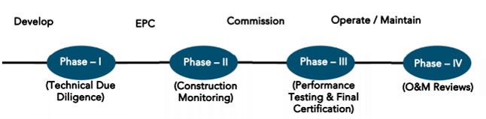
LENDERS INDEPENDENT ENGINEER REPORT
OF
"M/s. Gillani Hospitality Pvt. Ltd."
Proposed Commercial Cum Residential (3 Star Hotel) building on plot bearing Survey No. 804 / A / 9 / 1 & 2, Plot No. 1 & 2, Mumbai – Agra Road, Govind Nagar, Village – Nashik, Taluka & District – Nashik, Pin Code – 422 009, State – Maharashtra, Country – India

Latitude Longitude: 19°58'55.8"N 73°46'53.4"E

NAME OF DEVELOPER: M/s. Gillani Hospitality Pvt. Ltd.
Pursuant to instructions from Union Bank of India, Govind Nagar Branch, Nashik we have duly visited, inspected, surveyed & assessed the above said property on 25th September 2024 to determine the fair & reasonable market value of the said property/project as on Quarter ending 30th September 2024 for LIE purpose.

1. Location Details:
Proposed Commercial Cum Residential (3 Star Hotel) building on plot bearing Survey No. 804 / A / 9 / 1 & 2, Plot No. 1 & 2, Mumbai – Agra Road, Govind Nagar, Village – Nashik, Taluka & District – Nashik, Pin Code – 422 009. It is about 8.80 Km. travelling distance from Nashik Road Railway station. Surface transport to the property is by buses, taxis & private vehicles. The property is in developed locality. All the amenities like shops, banks, hotels, markets, schools, hospitals, etc. are all available in the surrounding locality. The area is higher middle class & developed.
2. Developer Details:
Name of Developer | M/s. Gillani Hospitality Pvt. Ltd.
Project Rera Registration Number | N. A.
Registered office address | 46, Aminabad Building, 7th Floor, Aga Hall, Nesbit Road, Mazgaon, Mumbai, Pin Code – 400 010, State – Maharashtra, Country – India
Contact details | Contact Person:  Mr. Zaheer Jamal  Mobile No. +91 9892216700
E – mail ID and website
3. Boundaries of the Property:
Direction | Particulars
On or towards North | Yashika Plaza
On or towards South | Open Plot
On or towards East | Mumbai – Agra Road
On or towards West | Internal Road

Introduction
As per Information on site M/s. Gillani Hospitality Pvt. Ltd. has acquired land by Conveyance Deed dated 18.02.2016 registered vide No. NSN-3-1638-2016 & registered vide No. NSN-3-1639-2016 admeasuring total area is 2405.00 Sq. M. bearing Survey No. 804/A/9/1 & 2. For the Proposed Commercial cum Residential (3 Star Hotel) Building.

Area Statement:

Land:
Date | Particular | Area in Sq. M.
18.02.2016 | Survey No. 804/A/9/1 | 1,202.50
18.02.2016 | Survey No. 804/A/9/2 | 1,202.50
TOTAL |  | 2,405.00

- Copy of Developer Agreement dated 18.02.2016 between Mr. K. Vasudev Vadiraj Rao & Mrs. Seeta Vasudev Rao (The Vendors) and M/s. Gilani Foods Pvt. Ltd. (The Purchaser) registered vide No. NSN-3-1638-2016 dated 18.02.2016.
- Copy of Developer Agreement dated 18.02.2016 between Mr. K. Shriniwas Vadiraj Shahbhag & Mr. Ravindra Shriniwas Shanbhag (The Vendors) and M/s. Gilani Foods Pvt. Ltd. (The Purchaser) registered vide No. NSN-3-1639-2016 dated 18.02.2016.
- Copy of Change of Ownership Name from M/s. Gilani Foods Private Limited to Gillani Hospitality Private Limited dated 31.03.2022.

Building Area As per Approved Plan:
 | PROFORMA
A | AREA STATEMENT | Sq.mt.
 | AREA OF THE PLOT AS PER AS PER 7/12 (1+2) | 2,405.00
 | (Minimum area of a, b, c to be considered)
a | As per ownership document (7/12 CTS extract) | 2,405.00
b | as per measurement sheet (AS PER F.P RECORD) | 2,405.00
c | as per site | 2,405.00
2 | Deductions for
a | Proposed D.P./D.P. Road widening Area
b | Any M.S.E.B. Reservation area
 | (Total a + b)
3 | GROSS AREA OF THE PLOT (1-2) Mr. | 2,405.00
4 | Recreational Open space
a | Required
b | Proposed | 270.00
5 | Amenity space
 | Required - Proposed-
6 | Service road and highway widening
7 | Internal Road area
8 | Net Area of Plot = [3-5 (b)] | 2,405.00
9 | Built up area with reference to basic FSI as per front road width (sr. no. 8x1.1) | 2,645.50
10 | Addition of area for F.SI.
a | In-situ area against D. P. road [1.1 x sr. no. 2 (a)], if any | NIL
b | in-situ area against amenity space
C | Premium FSI area (subject to maximum of 0.5 of sr.no.8) | 1,202.50
d | TDR area (1.40 of sr. no.8) | 3,367.00
e | additional HOTEL FSI as per rule no-23(D)=1.9 | 4,569.50
 | (Total of a + b + c + d + e) | 11,784.50
11 | Total area available (9+10) | 11,784.50
12 | Maximum utilization of FSI Permissible (as per Road width as per regulation no. 15.4) (3 + 1.9) | 4.90
13 | Total built-up Area in proposal.
 | (Excluding area at sr. no. 15.b)
a | Existing Built-up Area. | 895.36
b | proposed built-up area | 9,402.46
c | excess balcony area counted in F.S.I.
d | excess double height terraces area counted in FSI
 | (Total of a + b + c + d) | 10,297.82
14 | FSI consumed (13/11) (should not be more than serial no. 12 above.) | 0.87%
15 | area for inclusive housing if any
a | Required (20% of sr. no.9)
b | Proposed
16 | TOTAL T.D.R. PURCHASED AREA | 3,350.16
17 | TOTAL PROPOSED T.D.R. AREA | 3,350.00

Floor wise Built – Up Area Statement as per amended approved building plan is as below –
Floors | Built Up Area as per earlier sanction approved plan in Sq. M. | Built Up Area as per revised approved plan in Sq. M.
Basement - 2 | 120.52 | 120.52
Basement - 1 | 337.19 | 435.78
Lower Ground Floor | 247.95 | 402.51
Ground Floor | 664.71 | 791.05
1st Floor | 491.95 | 503.79
2nd Floor | 701.62 | 689.37
3rd Floor | 696.83 | 696.83
4th Floor | 572.20 | 573.42
5th Floor | 572.20 | 573.42
6th Floor | 572.20 | 573.42
7th Floor | 572.20 | 573.42
8th Floor | 572.20 | 573.42
9th Floor | 572.20 | 573.42
10th Floor | 577.08 | 578.30
11th Floor | - | 823.32
12th Floor | - | 1,233.66
13th Floor | - | 553.61
Terrace & OHT & LMR Area | 28.56 | 28.56
TOTAL | 7,299.61 | 10,297.82

Floor wise Total Construction Area Statement as per revised / amended approved building plan is as below –
Floors | FSI Area in Sq. M. | Non - FSI Area in Sq. M. | Total Construction Area in Sq. M.
Basement - 2 | 120.52 | 1,494.08 | 1,614.60
Basement - 1 | 435.78 | 1,221.76 | 1,657.54
Lower Ground Floor | 402.51 | 1,185.65 | 1,588.16
Ground Floor | 791.05 | 168.43 | 959.48
1st Floor | 503.79 | 160.63 | 664.42
2nd Floor | 689.37 | 203.18 | 892.55
3rd Floor | 696.83 | 203.18 | 900.01
4th Floor | 573.42 | 203.18 | 776.60
5th Floor | 573.42 | 203.18 | 776.60
6th Floor | 573.42 | 194.90 | 768.32
7th Floor | 573.42 | 194.90 | 768.32
8th Floor | 573.42 | 194.90 | 768.32
9th Floor | 573.42 | 203.18 | 776.60
10th Floor | 578.30 | 203.18 | 781.48
11th Floor | 823.32 | 194.90 | 1,018.22
12th Floor | 1,233.66 | 194.90 | 1,428.56
13th Floor | 553.61 | 203.18 | 756.79
Terrace & OHT | 28.56 | 728.23 | 756.79
TOTAL | 10,297.82 | 7,355.54 | 17,653.36

List of Approvals:
- Copy of Revised Approved Plan No. A41RBP/237/2022 dated 21.10.2022 issued by Nashik Municipal Corporation.
Approved upto: 2 Basement + Lower Ground Floor + Ground Floor + 1st to 13th Upper Floor.
- Copy of 1st Commencement Certificate No. LND/BP/A4/RBP/237/2022 dated 21.10.2022 issued by Nashik Municipal Corporation.
(This CC is endorsed for the work upto 2 Basement + Lower Ground Floor + Ground Floor + 1st to 13th Upper Floor)

LEVEL OF COMPLETION:

Construction of Building
Sr. No | Floor No. | Construction Area in Sq. M. | Completed Area in Sq. M. | Percentage of work completed | Work Completion as on 25.09.2024
1 | Excavation & Shore Piling |  |  | 100% | Work is Completed
2 | Basement – 2 Floor | 1,614.60 | 1,614.60 | 95.00% | Slab Work, Block work, Plaster work, Fire Fighting, Water proofing, Electrical, Plumbing, Flooring, toilet dado, sanitary fitting & painting work staircase flooring & grilling works is completed Door are installed. Final Finishing work is in progress
3 | Basement – 1 Floor | 1,657.54 | 1,657.54 | 95.00% | Slab Work, Block work, Plaster work, Fire Fighting, Water proofing, Electrical, Plumbing, Flooring, toilet dado, sanitary fitting & painting work staircase flooring & grilling works is completed Door are installed. Final Finishing work is in progress
4 | Lower Ground Floor | 1,588.16 | 1,588.16 | 95.00% | Slab Work, Block work, Plaster work, Fire Fighting, Water proofing, Electrical, Plumbing, Flooring, toilet dado, sanitary fitting & painting work staircase flooring & grilling works is completed Door are installed. Final Finishing work is in progress
5 | Ground Floor | 959.48 | 959.48 | 95.00% | Slab Work, Block work, Plaster work, Fire Fighting, Water proofing, Electrical, Plumbing, Flooring, toilet dado, sanitary fitting & painting work staircase flooring & grilling works is completed Door are installed. Final Finishing work is in progress
6 | 1st Floor | 664.42 | 664.42 | 95.00% | Slab Work, Block work, Plaster work, Fire Fighting, Water proofing, Electrical, Plumbing, Flooring, toilet dado, sanitary fitting & painting work staircase flooring & grilling works is completed Door are installed. Final Finishing work is in progress
7 | 2nd Floor | 892.55 | 892.55 | 95.00% | Slab Work, Block work, Plaster work, Fire Fighting, Water proofing, Electrical, Plumbing, Flooring, toilet dado, sanitary fitting & painting work staircase flooring & grilling works is completed Door are installed. Final Finishing work is in progress
8 | 3rd Floor | 900.01 | 900.01 | 85.00% | Slab Work, Block work, Plaster work, Door Frame & Window Frame, Gypsum work, Plumbing, Water proofing, flooring, toilet dado, firefighting work, external painting work, staircase flooring & grilling work is completed
9 | 4th Floor | 776.60 | 776.60 | 85.00% | Slab Work, Block work, Plaster work, Door Frame & Window Frame, Gypsum work, Plumbing, Water proofing, flooring, toilet dado, firefighting work, external painting work, staircase flooring & grilling work is completed
10 | 5th Floor | 776.60 | 776.60 | 85.00% | Slab Work, Block work, Plaster work, Door Frame & Window Frame, Gypsum work, Plumbing, Water proofing, flooring, toilet dado, firefighting work, external painting work, staircase flooring & grilling work is completed
11 | 6th Floor | 768.32 | 768.32 | 85.00% | Slab Work, Block work, Plaster work, Door Frame & Window Frame, Gypsum work, Plumbing, Water proofing, flooring, toilet dado, firefighting work, external painting work, staircase flooring & grilling work is completed
12 | 7th Floor | 768.32 | 768.32 | 95.00% | Slab Work, Block work, Plaster work, Fire Fighting, Water proofing, Electrical, Plumbing, Flooring, toilet dado, sanitary fitting & painting work staircase flooring & grilling works is completed Door are installed. Final Finishing work is in progress
13 | 8th Floor | 768.32 | 768.32 | 95.00% | Slab Work, Block work, Plaster work, Fire Fighting, Water proofing, Electrical, Plumbing, Flooring, toilet dado, sanitary fitting & painting work staircase flooring & grilling works is completed Door are installed. Final Finishing work is in progress
14 | 9th Floor | 776.60 | 776.60 | 95.00% | Slab Work, Block work, Plaster work, Fire Fighting, Water proofing, Electrical, Plumbing, Flooring, toilet dado, sanitary fitting & painting work staircase flooring & grilling works is completed Door are installed. Final Finishing work is in progress
15 | 10th Floor | 781.48 | 781.48 | 95.00% | Slab Work, Block work, Plaster work, Fire Fighting, Water proofing, Electrical, Plumbing, Flooring, toilet dado, sanitary fitting & painting work staircase flooring & grilling works is completed Door are installed. Final Finishing work is in progress
16 | 11th Floor | 1,018.22 | 1,018.22 | 95.00% | Slab Work, Block work, Plaster work, Fire Fighting, Water proofing, Electrical, Plumbing, Flooring, toilet dado, sanitary fitting & painting work staircase flooring & grilling works is completed Door are installed. Final Finishing work is in progress
17 | 12th Floor | 1,428.56 | 1,428.56 | 95.00% | Slab Work, Block work, Plaster work, Fire Fighting, Water proofing, Electrical, Plumbing, Flooring, toilet dado, sanitary fitting & painting work staircase flooring & grilling works is completed Door are installed. Final Finishing work is in progress
18 | 13th Floor | 756.79 | 756.79 | 95.00% | Slab Work, Block work, Plaster work, Fire Fighting, Water proofing, Electrical, Plumbing, Flooring, toilet dado, sanitary fitting & painting work staircase flooring & grilling works is completed Door are installed. Final Finishing work is in progress
19 | Terrace Floor & OHT & LMR Area | 756.79 | 756.79 | 85.00% | Terrace slab work, OHT, LMR Area, parapet wall, plaster work, partly flooring work is completed. Staircase flooring & grilling & external painting work is completed. Partly flooring work is in progress & final finishing work is in progress
Total |  | 17,653.36 | 17,653.36 | 92.75%

Plant and Machinery
Particulars | Work Completion as on 25.09.2024
Air – Conditioning | 100% work is completed & checking is also done.
Lifts | All the 5 lifts order is placed, 4 Lifts are installed & in working status. 5th Lift installation work is in progress.
Kitchen & Refrigeration Equipment’s | 100% material received on site & installed is done and final checking in pending.
Gym Equipment’s | Order is placed.
Fire Fighting Equipment’s, Sprinkler & Smoke Detector Systems | 100% work is completed & NOC is received
DG Set | 100% work is completed & installation is done.
Sewage Treatment Plant | 100% work is completed & installation is done.
ELV Systems | Installation is done & final checking is in progress.
IT Equipment & Software | Order is placed.
Crockery, Cutlery & Glassware | Order is placed.
Housekeeping Supplies, Linens & Uniform | Order is placed.

Furniture and Fixture
Particulars | Work Completion as on 25.09.2024
FF for 125 keys | 80 rooms work are completed, other rooms material received on site and interior work is in progress.
FF for Restaurant | Materials has received on site and fixation is done only; final finishing is pending.
FF for Banquet | Materials has received on site and fixation is done only; final finishing is pending.
FF for Reception | Materials has received on site and fixation is done only; final finishing is pending.
FF for Meeting Rooms | Order is placed & some material received on site and work is in progress.
FF for Roof Top Bar | Order is placed & some material received on site and work is in progress.
FF for Other Public Area | Materials has received on site and fixation is done only; final finishing is pending.
FF for BOH | Materials has received on site and fixation is done only; final finishing is pending.

Details of the Project as Financed By UBI:

Estimate of the project
Project expenses | Revised Cost as per Revised Draft TEV Report / Draft Cost vetting report dated 25.09.2023 in `
Land Cost | 6.89
Construction Cost of Building (including Civil work, Plumbing & Sanitation & Electrification, etc.) | 46.04
Plant and Machinery | 13.29
Furniture and Fixture | 13.85
Approval & TDR Cost | 5.71
Architect Cost, RCC & other Professional fees | 2.49
Contingencies Expenses | 1.46
Interest Cost | 5.22
Total Cost | 94.95

Project Cost: (as per C.A. Certificate)
Particulars | Incurred Cost (In ` Cr.) till 30.09.2024 dated 21.10.2024 by M/s. Amogh Ghule & Associates
Land Cost | 6.89
Construction Cost of Building (including Civil work, Plumbing & Sanitation & Electrification, etc.) | 48.79
Plant and Machinery | 9.42
Furniture and Fixture | 10.48
Approval & TDR Cost | 6.50
Architect Cost, RCC & other Professional fees | 1.76
Contingencies Expenses | -
Interest Cost | 5.25
Total | 89.09

- The Builder has incurred about 6.89 Cr. for land cost, 48.79 Cr. for construction cost including the construction cost of shops, 9.42 Cr. for Plant & Machinery cost, 10.48 Cr. As Furniture & Fixture cost, 6.50 Cr. for approval of project, 1.76 Cr. for Architect Cost, RCC & other Professional fees & 5.25 Cr. for interest cost till 30.09.2024 as per C.A. certificate issued by M/s. Amogh Ghule & Associates dated 21.10.2024. All the cost incurred is for the 2 Basement + Lower Ground Floor + Ground Floor + 1st to 13th Upper Floor.
- In CA Certificate incurred Interest cost is revised because interest cost already incurred for L&T finance loan amount is not considered, only UBI loan interest is considered.

Project Cost: (as per Bills):
Particulars | Incurred Cost (in Cr.)
 | 30.09.2024 as per Bill (Inclusive GST)
Land Cost | 6.90
Construction Cost of Building (including Civil work, Plumbing & Sanitation & Electrification, etc.) | 43.72
Plant and Machinery | 12.67
Furniture and Fixture | 11.88
Approval & TDR Cost | 4.76
Architect Cost, RCC & other Professional fees | 1.48
Contingencies Expenses | 1.91
Interest Cost | 5.37
Total | 88.68
Note: We have considered the Land cost as per agreement, Bank loan processing & stamp duty cost in the LIE report. All the cost incurred is for the 2 Basement + Lower Ground Floor + Ground Floor + 1st to 13th Upper Floor.
As per discussion with the client & banker interest cost for L&T loan is not considered in this LIE Report only UBI Loan interest incurred cost is considered.

Land Cost:
Sr. No. | Date | Particulars | Description | Total Cost in ` | Incurred Cost in `
1 | 16.02.2016 | Survey No. 804/A/9/1 | Purchase Cost | 3,25,00,000.00 | 3,25,00,000.00
2 |  |  | Stamp Duty | 19,50,000.00 | 19,50,000.00
3 |  |  | Reg. Fees | 30,000.00 | 30,000.00
4 |  |  |  | 580.00 | 580.00
5 | 16.02.2016 | Survey No. 804/A/9/2 | Purchase Cost | 3,25,00,000.00 | 3,25,00,000.00
6 |  |  | Stamp Duty | 19,50,000.00 | 19,50,000.00
7 |  |  | Reg. Fees | 30,000.00 | 30,000.00
8 |  |  |  | 580.00 | 580.00
Total |  |  |  | 6,89,61,160.00 | 6,89,61,160.00
As per conveyance agreement.
Summary of Bills
Sr. No. | Particulars | Amount in `  (Till 30.09.2024) | Amount in ` (in Cr.)
1 | Construction Cost of Building (including Civil work, Plumbing & Sanitation & Electrification, etc.) | 43,71,77,086.82 | 43.72
2 | Plant and Machinery | 12,66,51,881.97 | 12.67
3 | Furniture and Fixture | 11,88,45,427.20 | 11.88
4 | Approval & TDR Cost | 4,75,60,776.00 | 4.76
5 | Architect Cost, RCC & other Professional fees | 1,47,92,985.50 | 1.48
6 | Contingencies Expenses | 1,91,44,431.50 | 1.91
TOTAL |  | 76,41,72,588.99 | 76.42
- Note: Bills were provided by the client up to 30.09.2024 for the 2 Basement + Lower Ground Floor + Ground Floor + 1st to 13th Upper Floor.

Interest Cost:
Sr. No | Particulars | Revised Cost as per Revised Draft TEV Report / Draft Cost vetting report dated 25.09.2023 in ` | Incurred Amount in ` (till 30.09.2024) | Balance Amount in `
1 | Interest Cost | 5,22,00,000.00 | 5,37,08,421.00 | -15,08,421.00
TOTAL |  | 5,22,00,000.00 | 5,37,08,421.00 | -15,08,421.00

Cost of Construction as on 25th September 2024:

Construction Cost of Building:
Floors | Total Construction Area in Sq. M. | Completed Area in Sq. M. | Revised Rate / Sq. M. | Full Value after completion | Percentage of work completed | Actual Expenditure till date in `
Basement - 2 | 1,614.60 | 1,614.60 | 26,080.00 | 42,108,768.00 | 95.00% | 4,00,03,329.60
Basement - 1 | 1,657.54 | 1,657.54 | 26,080.00 | 43,228,643.20 | 95.00% | 4,10,67,211.04
Lower Ground Floor | 1,588.16 | 1,588.16 | 26,080.00 | 41,419,212.80 | 95.00% | 3,93,48,252.16
Ground Floor | 959.48 | 959.48 | 26,080.00 | 25,023,238.40 | 95.00% | 2,37,72,076.48
1st Floor | 664.42 | 664.42 | 26,080.00 | 17,328,073.60 | 95.00% | 1,64,61,669.92
2nd Floor | 892.55 | 892.55 | 26,080.00 | 23,277,704.00 | 95.00% | 2,21,13,818.80
3rd Floor | 900.01 | 900.01 | 26,080.00 | 23,472,260.80 | 85.00% | 1,99,51,421.68
4th Floor | 776.60 | 776.60 | 26,080.00 | 20,253,728.00 | 85.00% | 1,72,15,668.80
5th Floor | 776.60 | 776.60 | 26,080.00 | 20,253,728.00 | 85.00% | 1,72,15,668.80
6th Floor | 768.32 | 768.32 | 26,080.00 | 20,037,785.60 | 85.00% | 1,70,32,117.76
7th Floor | 768.32 | 768.32 | 26,080.00 | 20,037,785.60 | 95.00% | 1,90,35,896.32
8th Floor | 768.32 | 768.32 | 26,080.00 | 20,037,785.60 | 95.00% | 1,90,35,896.32
9th Floor | 776.60 | 776.60 | 26,080.00 | 20,253,728.00 | 95.00% | 1,92,41,041.60
10th Floor | 781.48 | 781.48 | 26,080.00 | 20,380,998.40 | 95.00% | 1,93,61,948.48
11th Floor | 1,018.22 | 1,018.22 | 26,080.00 | 26,555,177.60 | 95.00% | 2,52,27,418.72
12th Floor | 1,428.56 | 1,428.56 | 26,080.00 | 37,256,844.80 | 95.00% | 3,53,94,002.56
13th Floor | 756.79 | 756.79 | 26,080.00 | 19,737,083.20 | 95.00% | 1,87,50,229.04
Terrace & OHT | 756.79 | 756.79 | 26,080.00 | 19,737,083.20 | 85.00% | 1,67,76,520.72
TOTAL | 17,653.36 | 17,653.36 |  | 46,03,99,628.80 | 92.75% | 42,70,04,188.80

Plant and Machinery:
Particulars | Revised Cost as per Revised Draft TEV Report / Draft Cost vetting report dated 25.09.2023 in ` | Percentage of work completed | Actual Expenditure till date in `
Air - Conditioning | 45,907,000.00 | 100.00% | 12,66,51,881.97
Lifts | 15,694,000.00 | 85.00%
Kitchen & Refrigeration Equipment’s | 17,999,000.00 | 100.00%
Gym Equipment’s | 1,350,000.00 | 0.00%
Fire Fighting Equipment’s, Sprinkler & Smoke Detector Systems | 11,046,000.00 | 100.00%
DG Set | 9,450,000.00 | 100.00%
Sewage Treatment Plant | 1,988,000.00 | 100.00%
ELV Systems | 12,017,000.00 | 100.00%
IT Equipment & Software | 12,000,000.00 | 0.00%
Crockery, Cutlery & Glassware | 2,700,000.00 | 0.00%
Housekeeping Supplies, Linens & Uniform | 2,700,000.00 | 0.00%
TOTAL | 13,28,51,000.00 | 95.33% | 12,66,51,881.97

Furniture & Fixture:
Particulars | Revised Cost as Revised Draft TEV Report / Draft Cost vetting report dated 25.09.2023 in ` | Percentage of work completed | Actual Expenditure till date in `
FF for 125 Rooms keys | 55,000,000.00 | 70.00% | 11,88,45,427.00
FF for Restaurant | 10,000,000.00 | 100.00%
FF for Banquet | 6,000,000.00 | 100.00%
FF for Reception | 8,000,000.00 | 100.00%
FF for Meeting Rooms | 7,500,000.00 | 100.00%
FF for Roof Top Bar | 4,000,000.00 | 0.00%
FF for Other Public Area | 25,000,000.00 | 0.00%
FF for BOH | 23,000,000.00 | 100.00%
TOTAL | 138,500,000.00 | 85.81% | 11,88,45,427.00

Note: Details of work completed is as per site visit dated 25.09.2024 but LIE report is prepared for quarter ending on 30th Septemeber 2024.

Project expenses | Revised Cost as per Revised Draft TEV Report / Draft Cost vetting report dated 25.09.2023 in ` | Incurred Cost as per Bill till 30.09.2024 | Incurred Cost as per Bill till 31.03.2024 | Difference between the both bills
Land Cost | 6.89 | 6.90 | 6.90 | -
Construction Cost of Building (including Civil work, Plumbing and Sanitation & Electrification, etc.) | 46.04 | 43.72 | 39.69 | 4.03
Plant and Machinery | 13.29 | 12.67 | 12.71 | -0.04
Furniture and Fixture | 13.85 | 11.88 | 9.89 | 1.99
Approval & TDR Cost | 5.71 | 4.76 | 4.75 | 0.01
Architect Cost, RCC & other Professional fees | 2.49 | 1.48 | 1.43 | 0.05
Contingencies Expenses | 1.46 | 1.91 | 1.26 | 0.65
Interest Cost | 5.22 | 5.37 | 2.91 | 2.46
Total Cost | 94.95 | 88.68 | 79.53 | 9.15
Note:
We have considered Bank Processing fees & Stamp Duty in Contingencies Expenses but CA has not considered this cost.
We have considered Land Cost & Stamp Duty, as per Sale Agreement but CA has considered deprecation on land purchase cost.
Construction cost is increase by 66.63% due to change of construction area in new amended plan approx. 40% Built – up area is increase from 7,299.61 Sq. M. to 10,297.82 Sq. M. even cost of material, cost of construction rate is increase in the market.
Plant & Machinery cost is increase by 39.89% due to change of construction area in new amended plan approx. 40% Built – up area is increase from 7,299.61 Sq. M. to 10,297.82 Sq. M.
Furniture and Fixture cost is increase by 52.53% due to change of construction area in new amended plan approx. 40% Built – up area is increase from 7,299.61 Sq. M. to 10,297.82 Sq. M. and Meeting rooms and Roof Top Bar items are added in interior works.
Hence, overall project cost is increase by 53% and total revised project cost is coming upto ` 94.45Cr.
As per discussion with the client & banker interest cost for L&T loan is not considered in this LIE Report only UBI Loan interest incurred cost is considered.

Particulars | Revised Cost as per Revised Draft TEV Report / Draft Cost vetting report dated 25.09.2023 in ` | Reasonable Cost certified as per Bill till 30.09.2024 | Client  Contribution | Bank  Loan
Hard Cost (Land Cost + COC + PM + FF) | 80.27 | 75.16 | 33.58 | 41.58
Interest Cost | 5.22 | 5.37 | 5.37 | -
Soft Cost (Approval + Professional + Contingency) | 9.66 | 8.15 | 8.15 | -
TOTAL | 94.95 | 88.68 | 47.10 | 41.58

% of Fund Utilised till 30th September 2024
Particulars | Revised Cost as per Revised Draft TEV Report / Draft Cost vetting report dated 25.09.2023 in ` | % Project cost | Reasonable Cost as per Bills till 30.09.2023 | Cost incurred as % total cost of that Component | Cost incurred as % of cost incurred as on 30.09.2024
Land Cost | 6.89 | 7.26% | 6.90 | 100.09% | 7.26%
Construction Cost of Building (including Civil work, Plumbing and Sanitation & Electrification, etc.) | 46.04 | 48.49% | 43.72 | 94.96% | 46.04%
Plant and Machinery | 13.29 | 14.00% | 12.67 | 95.30% | 13.34%
Furniture and Fixture | 13.85 | 14.59% | 11.88 | 85.81% | 12.52%
Approval & TDR Cost | 5.71 | 6.01% | 4.76 | 83.29% | 5.01%
Architect Cost, RCC & other Professional fees | 2.49 | 2.62% | 1.48 | 59.41% | 1.56%
Contingencies Expenses | 1.46 | 1.54% | 1.91 | 131.13% | 2.02%
Interest Cost | 5.22 | 5.50% | 5.37 | 102.89% | 5.66%
Total | 94.95 | 100% | 88.68 | 93.40% | 93.40%
Based on above Calculation it is found that total Project cost incurred is 93.40 % of the of sanction Project cost.

Means of Finance:
Sr. No. | Particulars | Exp. Cumulative (Cr.)
 | Equity share capital / Quassi Loan from Promoter | 11.18
 | Unsecured Loan | 28.32
 | Sales (Advance from customer) | 8.00
 | Bank Laon Amount | 41.58
 | Total | 89.09
The Details of the Means of Finance are provided by Client as on 30.09.2024.

Mandatory Arrangements:
Sr. No. | Particulars | Status
 | Rainwater Harvesting | To be executed after RCC Structure
 | Firefighting System | To be executed after RCC Structure
 | Solid Waste Management | To be executed after RCC Structure

Quality of Construction:
Sr. No. | Particulars | Status
 | Soundness of Structures | Executing as per approved Structural Design
 | Look of Structures | Good
 | Quality of Material Used | Good
 | Safety Measures for Construction/labour | Taken Care by Contractor

Schedule V/s. Actual Progress:
Activity | Date of Implementation | Date of Completion | Status
Land |  |  | Completed
Development of Land |  |  | Completed
Foundation Work |  |  | Completed
Ground Floor Slab |  |  | Slab work is Completed
1st Floor Slab |  |  | Slab work is Completed
2nd Floor Slab |  |  | Slab work is Completed
3rd Floor Slab |  |  | Slab work is Completed
4th Floor Slab |  |  | Slab work is Completed
5th Floor Slab |  |  | Slab work is Completed
6th Floor Slab |  |  | Slab work is Completed
7th Floor Slab |  |  | Slab work is Completed
8th Floor Slab |  |  | Slab work is Completed
9th Floor Slab |  |  | Slab work is Completed
10th Floor Slab |  |  | Slab work is Completed
11th Floor Slab |  |  | Slab work is Completed
12th Floor Slab |  |  | Slab work is Completed
13th Floor Slab |  |  | Slab work is Completed
Block work / Internal Plaster work |  |  | Blockwork is completed
Terrace Parapet wall / Overhead water tank / Lift Machine room / compound wall / External Plaster work |  |  | Work is completed
Electric Work |  |  | Work is completed
Water Proofing |  |  | Work is completed
Plumbing Work |  |  | Work is completed
Tiling / Marble Flooring |  |  | Work is completed
Door Frames |  |  | Work is completed
Window Installation |  |  | Work is completed
Staircase Flooring |  |  | Work is completed
Staircase Railing |  |  | Work is completed
Refuge Area Flooring |  |  | Work is completed
Internal Painting |  |  | Work is in progress
External Painting |  |  | Work is in progress
Lift Work |  |  | All the 5 lifts order is placed, 4 Lifts are installed & in working status. 5th Lift installation work is in progress.
Fire Fighting Installation |  |  | Work is completed
Stack Parking |  |  | Work is in progress
CP Fitting & Sanitary Work |  |  | Work is completed
Final Finishing & Fitting |  |  | Work is in progress

Action initiated to complete the project in time:
For 3 Star Hotel Building: RCC work is completed. Interior work & Final Finishing work is in progress.

Comments related to cost overrun if any:
The cost of 3-star Hotel Building as per Revised Sanction Letter was 94.95 Cr.

Balance investment required for completion of project:
We opinion amount of ` 6.27 Cr. Will be required to complete the Project.

Mandatory Approval Status:
Sr. No. | Particulars | Name of Department | Status | Order Details
1 | IOD of Building | Nashik Municipal Corporation | Obtained and available at site | P-6954/2021/(669)/K/E Ward/Andheri dated 11.01.2022
1A | 1st Amended | Nashik Municipal Corporation | Obtained and available at site | P-6954/2021/(669)/K/E Ward/Andheri dated 13.04.2022
2A | First C.C. | Nashik Municipal Corporation | Obtained and available at site | P – 6954 / 2021 / (669) / K / E Ward / Andheri / FCC / New dated 21.10.2022 valid till 22.10.2023. This CC is endorsed for the work upto Ground for Parking + 1st to 10th Upper Floor of Wing A & B
2B | Second C.C. | Nashik Municipal Corporation | Obtained and available at site | P – 6954 / 2021 / (669) / K / E Ward / Andheri / FCC / 1 / Amend dated 09.11.2022 valid till 08.11.2023. This CC is endorsed for the work upto Ground for Parking + 1st to 10th Upper Floor of Wing A & B
3B | Occupancy | Nashik Municipal Corporation | Pending (Project is not completed)

Status Insurance Coverage:
Information not provided

Observations & Conclusion:
- Overall Physical progress of the project site as on 30/09/2024 is 93.40% of construction cost and overall financial progress as per C.A. certificate including land cost as on 30/09/2023 is 93.83% estimated cost of project, which doesn’t include additional area not sanctioned by the UBI.
- As per cost incurred certificate issued by CA Certificate actual total expenditure occurred as on 30/09/2023 is ` 89.09 Cr. for the 2 Basement + Lower Ground Floor + Ground Floor + 1st to 13th Upper Floor however.
- Hence, considering current status & progress at site, the total cost incurred as on 30/09/2024 towards the project is fair & reasonable up to ` 88.68 Cr. for the 2 Basement + Lower Ground Floor + Ground Floor + 1st to 13th Upper Floor which is including land & site development, cost of building construction, cost of miscellaneous fixed assets, consultant fees, preliminary & pre-operative expenses, advances to suppliers & material laying at site etc. This is verified by observing the actual progress of the construction work at site.
- Building revised Plan is sanction for entire development of 2 Basement + Lower Ground Floor + Ground Floor + 1st to 13th Upper Floor. Construction work was in progress as per 1st Commencement Certificate No. LND/BP/A4/RBP/237/2022 dated 21.10.2022 issued by Nashik Municipal Corporation.
- It is important to observe all provisions of the various relevant codes of the Bureau of Indian Standards (BIS) during the stage of engineering- design as well as during the stage of construction. It will be advisable to have on the record of the bank a certificate from any licensed structural engineer that such BIS code provisions are followed during the ‘design’ as well as during the ‘construction’ stage of the project so as to ensure the safety and stability of the structure.

Assumptions & Remarks:
- The adequacy of Engineering / Structural design is beyond the scope of our assignment.
As per the discussion with the client the project completion will be done in two portion such as
- Basement 1 + Basement 2 + Lower Ground Floor + Ground Floor + 1st & 2nd Floor + 7th to 13th Floor & Terrace Floor final finishing and checking by Marriott group will be done till 31st October 2024. Operation of the hotel will start in 4th Quarter of year 2024.
- 3rd to 6th Floor work will be completed in 1st Quarter of year 2025 and final finishing & operation will be start by Marriott group in 1st Quarter of year 2025.
- We opinion that the project will be completed as per schedule or timeline proposed by the client.

Sharadkumar B. Chalikwar
Govt. Reg. Valuer
Chartered Engineer (India)
Reg. No. (N) CCIT/1-14/52/2008-09

About the Project:
1. Introduction
a) | Project Name  (With Address & Phone Nos.) | Proposed Commercial Cum Residential (3 Star Hotel) building on plot bearing Survey No. 804 / A / 9 / 1 & 2, Plot No. 1 & 2, Mumbai – Agra Road, Govind Nagar, Village – Nashik, Taluka & District – Nashik, Pin Code – 422 009, State – Maharashtra, Country – India  Contact Person:  Mr. Zaheer Jamal  Mobile No. +91 98922 16700
b) | Purpose of Valuation | As per request from Union Bank of India, Govind Nagar Branch, Nashik to assess fair market value of the Project for LIE purpose.
c) | Date of Inspection of Property | 25.09.2024
d) | Date of LIE Report | 28.10.2024
e) | Name of the Developer of Property  (in case of developer built properties) | M/s. Gillani Hospitality Pvt. Ltd.  46, Aminabad Building, 7th Floor, Aga Hall, Nesbit Road, Mazgaon, Mumbai, Pin Code – 400 010, State – Maharashtra, Country – India
2. Physical Characteristics of the Property
a) | Location of the Property | Proposed Commercial Cum Residential (3 Star Hotel) building on plot bearing Survey No. 804 / A / 9 / 1 & 2, Plot No. 1 & 2, Mumbai – Agra Road, Govind Nagar, Village – Nashik, Taluka & District – Nashik, Pin Code – 422 009, State – Maharashtra, Country – India
 | Brief description of the property
TYPE OF THE BUILDING
- Commercial cum Residential (3 Star Hotel) Building

No. of Floors | 2 Basement + Lower Ground Floor + Ground Floor + 1st to 13th Upper Floor.
Building type | Commercial cum Residential (3 Star Hotel) building

Commercial cum Residential (3 Star Hotel) Building work is given on contract based for RCC contract. Developer has grant to the contractor do the work of construction and completion includes Concrete work, Reinforcement work, Masonry, Internal Plaster, External Plaster and other miscellaneous work such as repairing, joints b/w concrete and masonry surface, etc. Bill must be paid on measurement of construction area exclusive of Steel, Cement & other construction material.
Lift & lift installation contract is not finalized till now.
Firefighting work contract is not finalized.

PROPOSED DATE OF COMPLETION & FUTURE LIFE:
Expected completion date as per developer is 31st March 2025
 | Nearby landmark | Near Mumbai – Agra Road
 | Postal Address of the Property | Proposed Commercial Cum Residential (3 Star Hotel) building on plot bearing Survey No. 804 / A / 9 / 1 & 2, Plot No. 1 & 2, Mumbai – Agra Road, Govind Nagar, Village – Nashik, Taluka & District – Nashik, Pin Code – 422 009, State – Maharashtra, Country – India
 | Area of the plot/land  (Supported by a plan) | Plot Area: 2,405.00 Sq. M.
 | Type of Land: Solid, Rocky, Marsh land, reclaimed land, Water-logged, Land locked. | Solid land
 | Independent access/approach to the property etc. | Yes
 | Google Map Location of the Property with a neighborhood layout map | Provided
 | Details of roads abutting the property | East Side – 30 M. wide road  West Side – 12 M. wide road
 | Description of adjoining property | Located in Higher Middle-class locality
 | Plot No. Survey No. | Survey No. 804 / A / 9 / 1 & 2, Plot No. 1 & 2
 | Ward/Village/Taluka | Village – Nashik, Taluka – Nashik
 | Sub-Registry/Block | Nashik
 | District | District – Nashik
b) | Boundaries of the Plot
 | As per Agreement | Actual
North | CTS No. 665 | Yashika Plaza
South | CTS No. 670 | Open Plot
East | Proposed 13.20 M. wide D. P. Road & presently bearing CTS No. 668. | Mumbai – Agra Road
West | Private Road bearing CTS No. 672 leading from Sahar Road | Internal Road

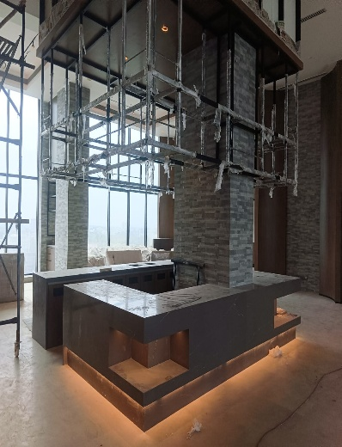
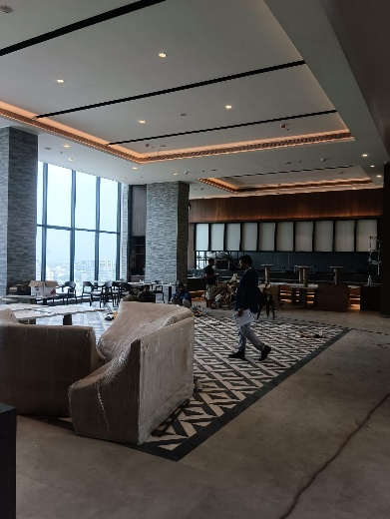
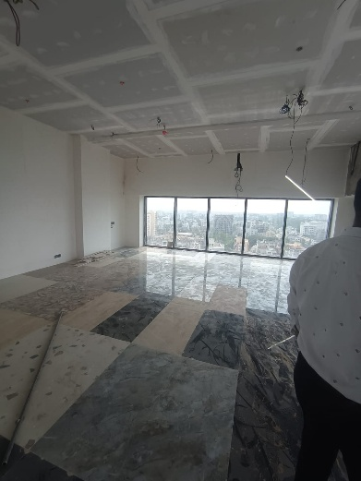
Actual Site Photographs as on 25.09.2024

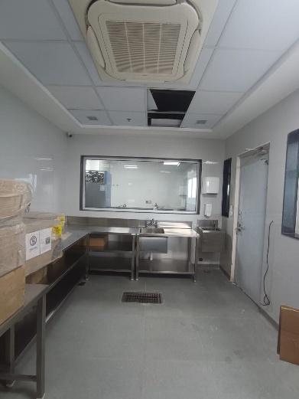
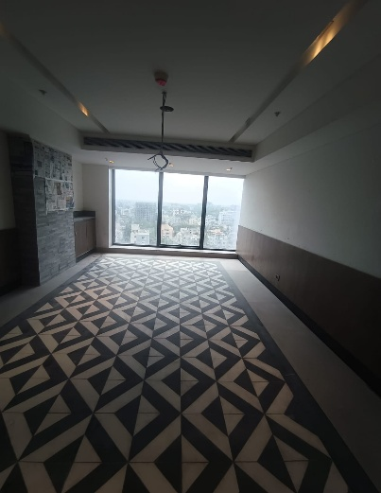
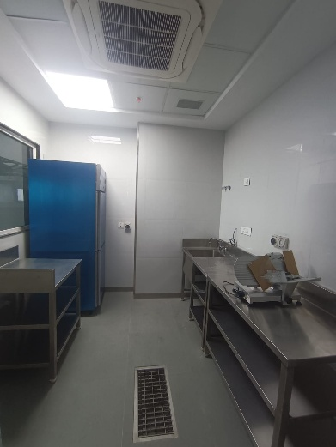

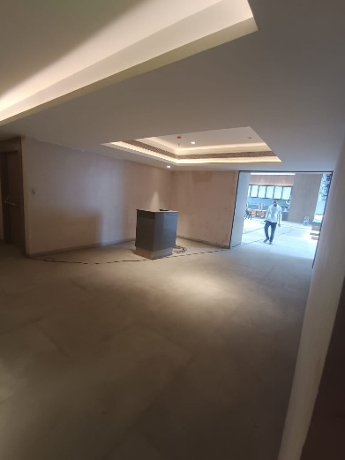
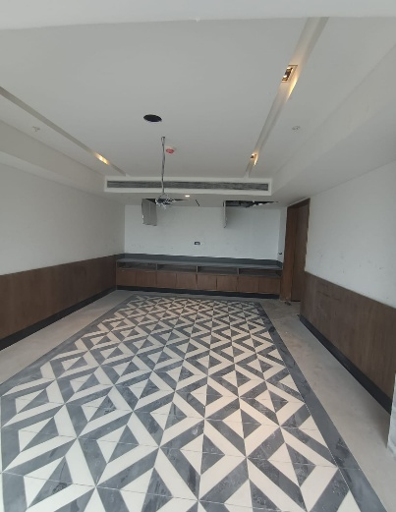
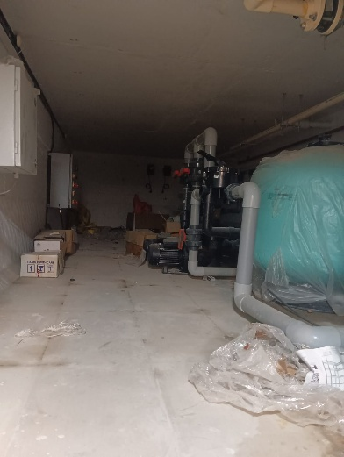

Actual Site Photographs as on 25.09.2024
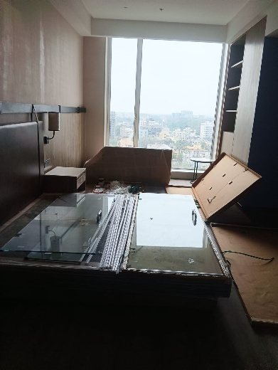
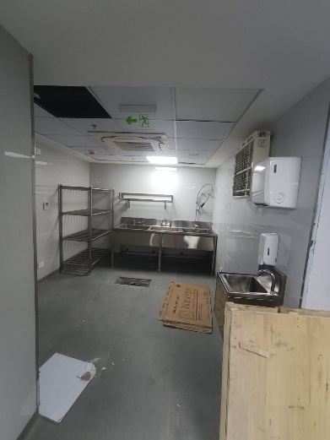
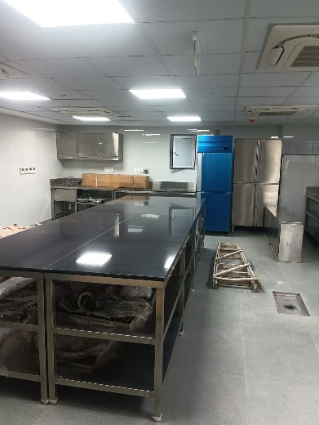

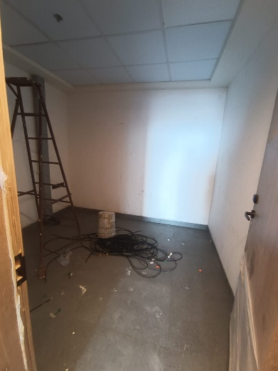
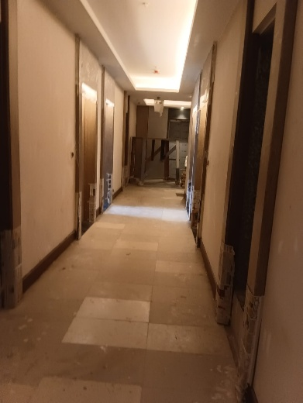
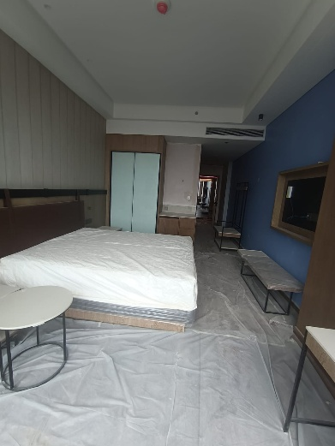

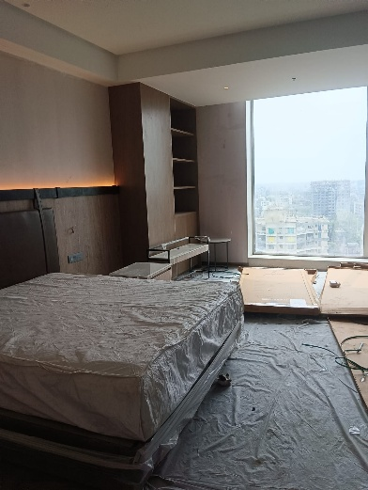
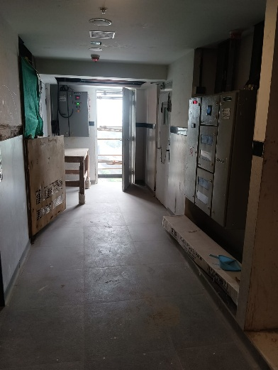
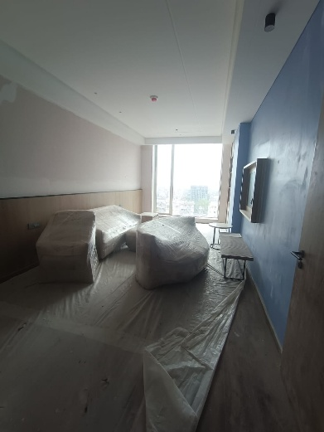

Actual Site Photographs as on 25.09.2024
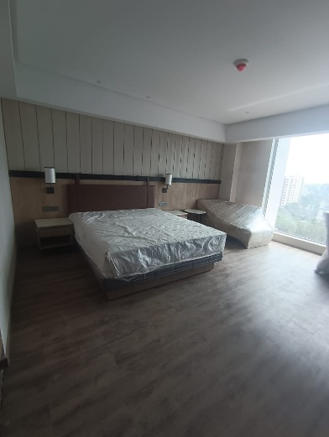
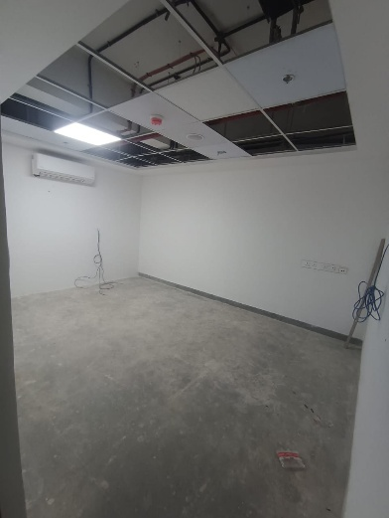
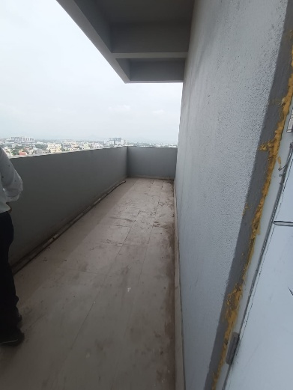

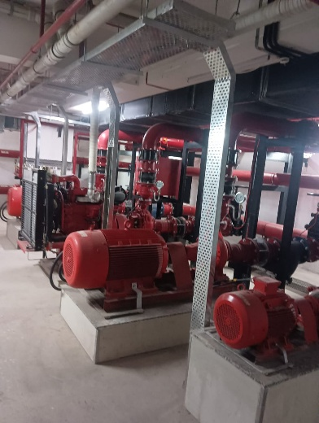
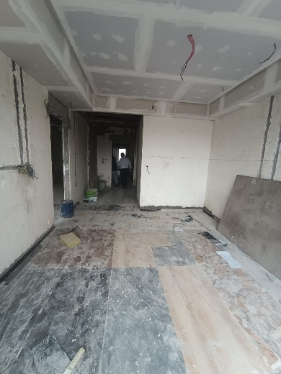
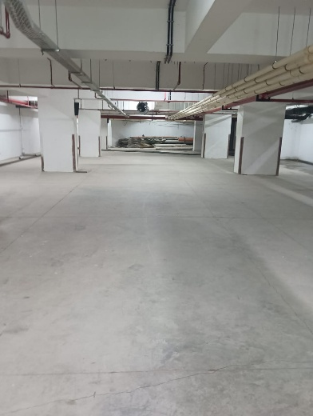

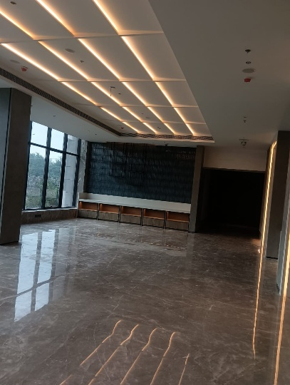
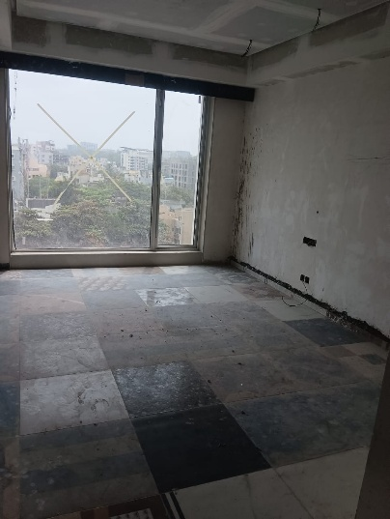
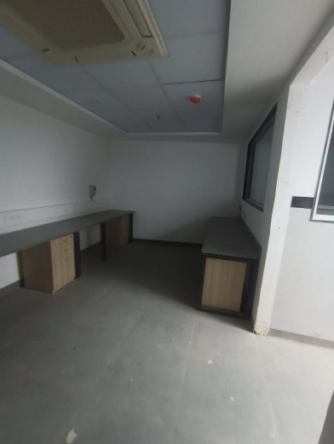

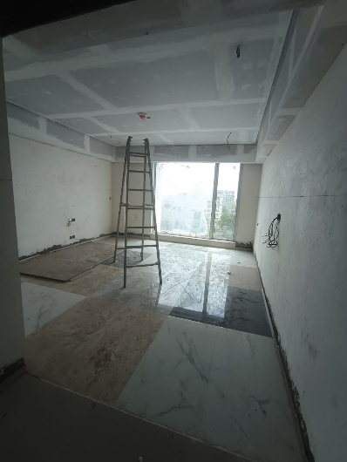
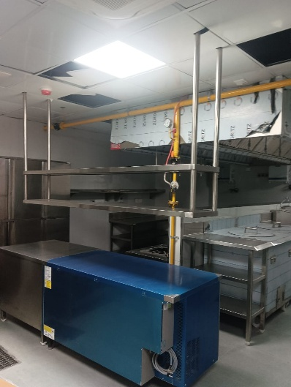
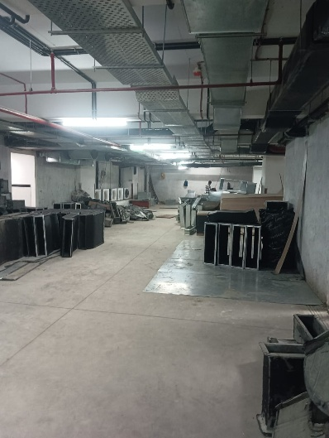
Actual Site Photographs as on 25.09.2024

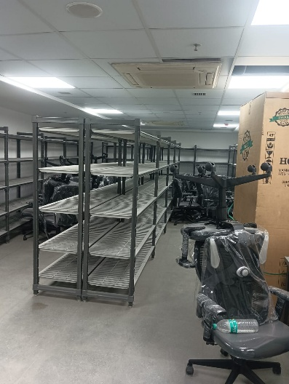
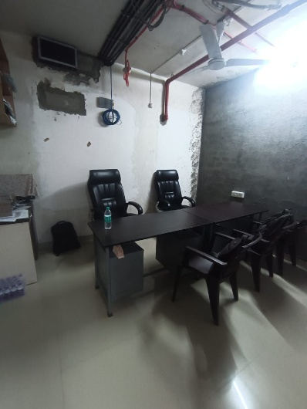
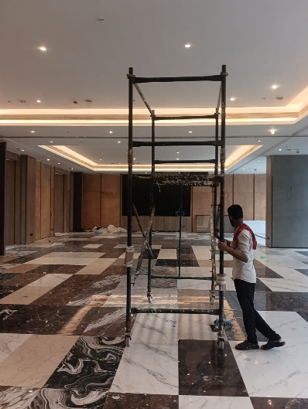

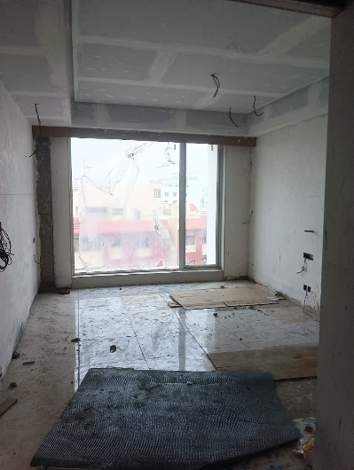
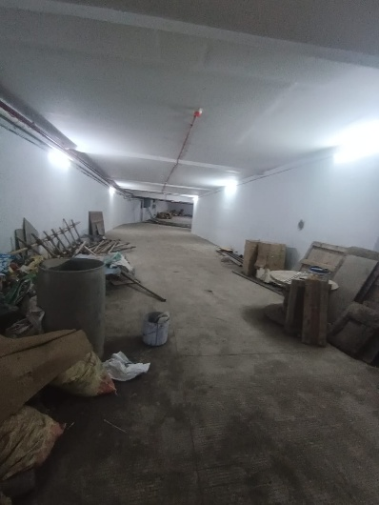
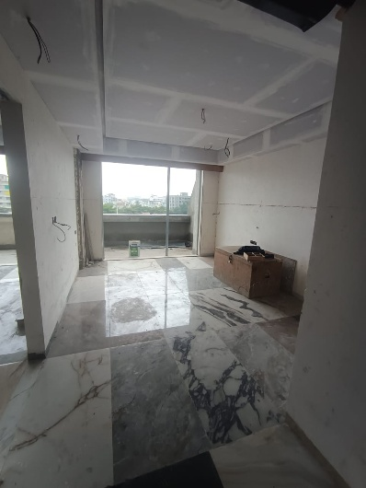

Actual Site Photographs as on 25.09.2024
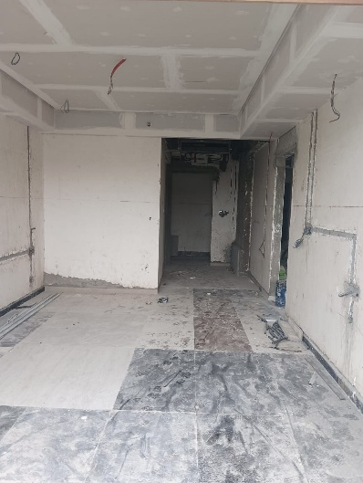
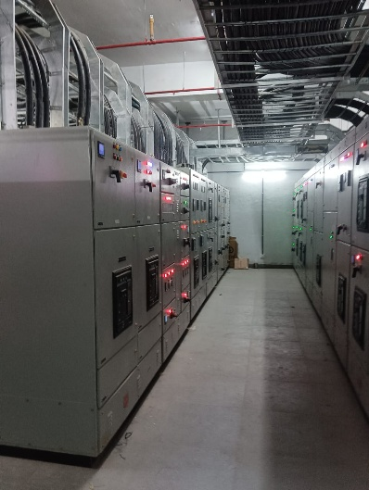
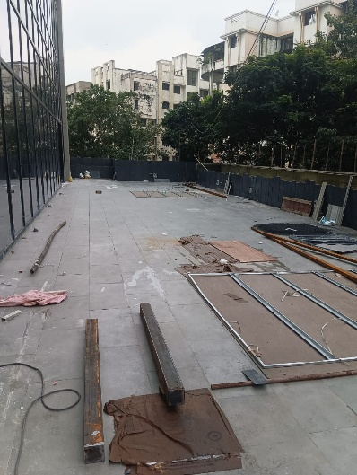

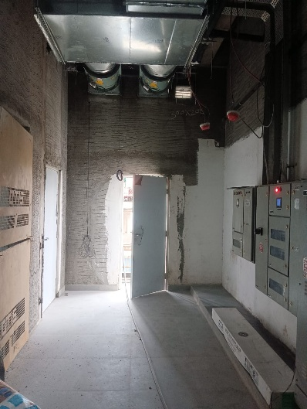
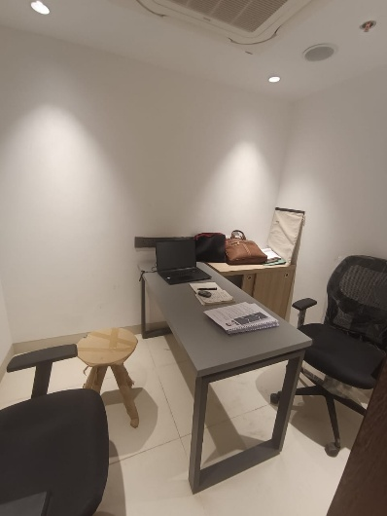
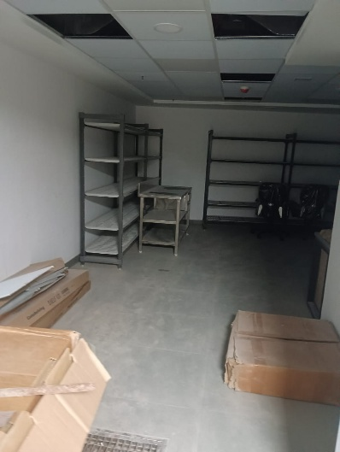

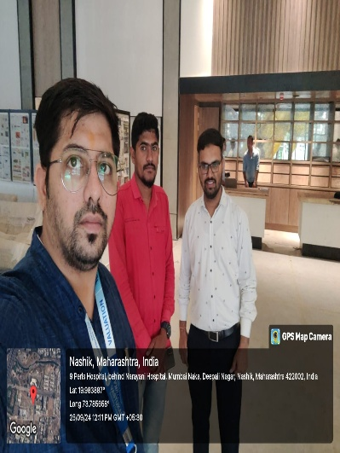
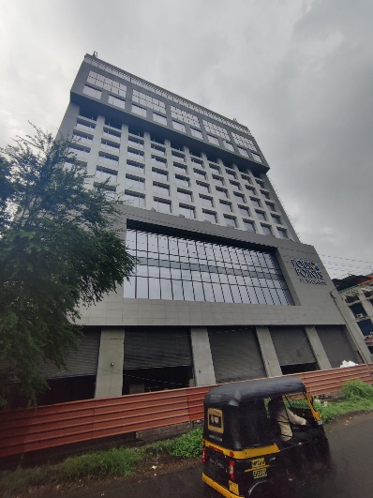
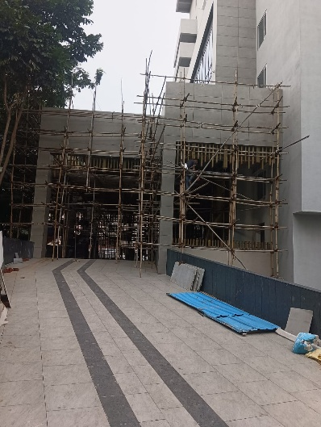

Route Map of the property
Site u/r
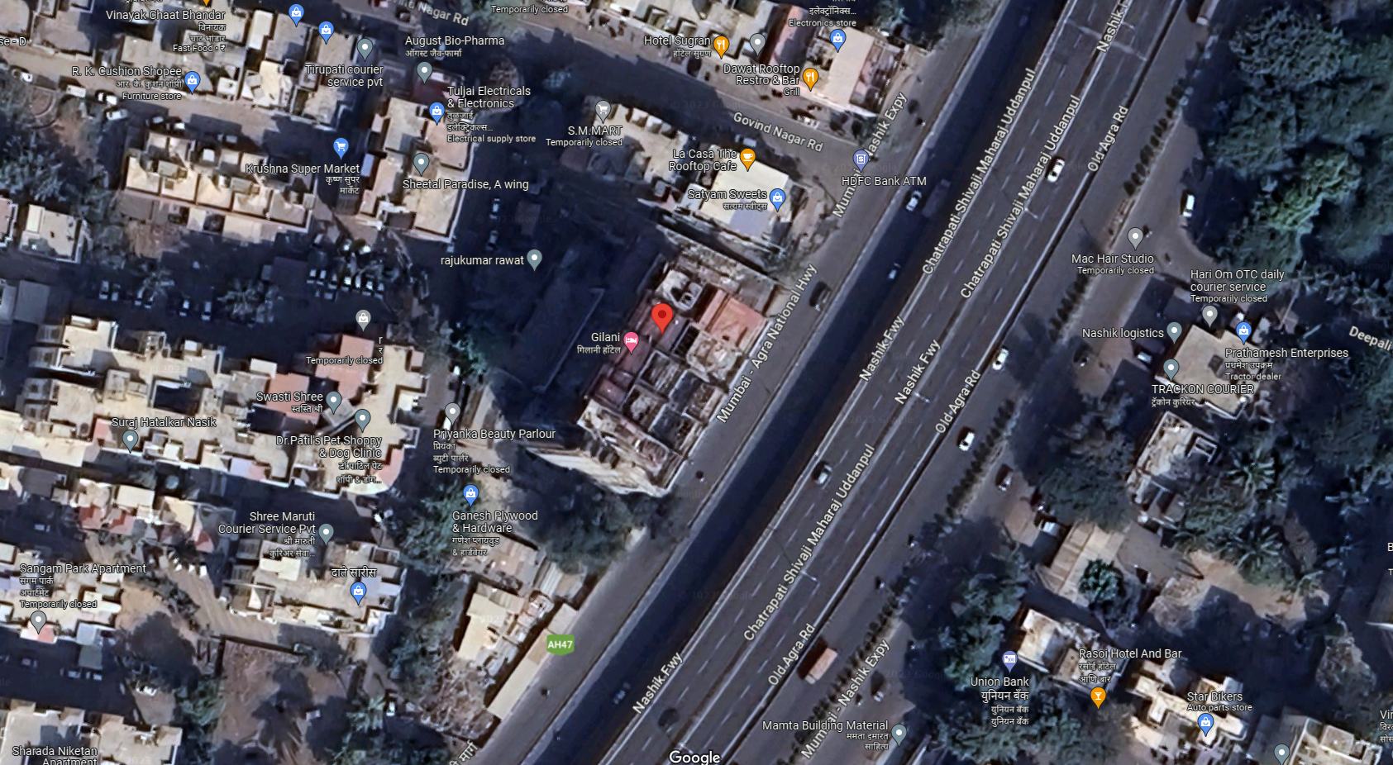

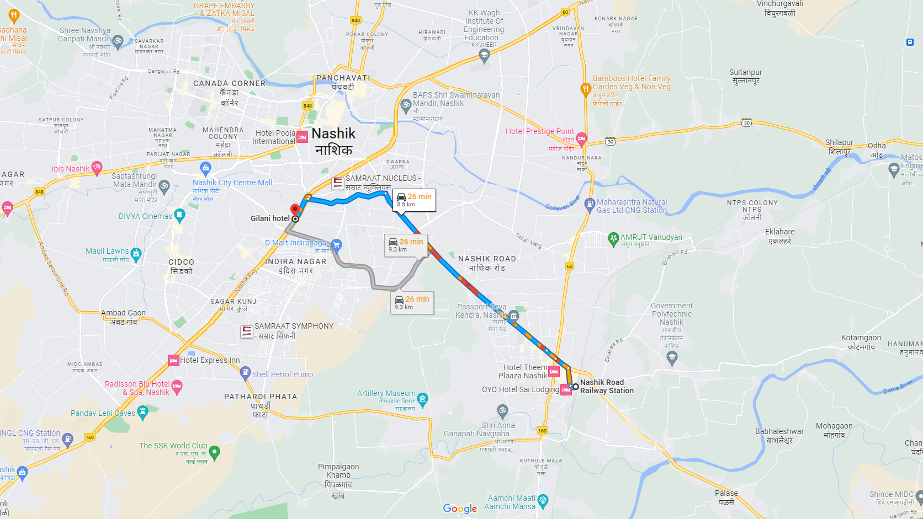

Latitude Longitude: 19°58'55.8"N 73°46'53.4"E
Note: The Blue line shows the route to site from nearest railway station (Nashik Road – 8.80 Km.)

