WORK PROGRESS REPORT
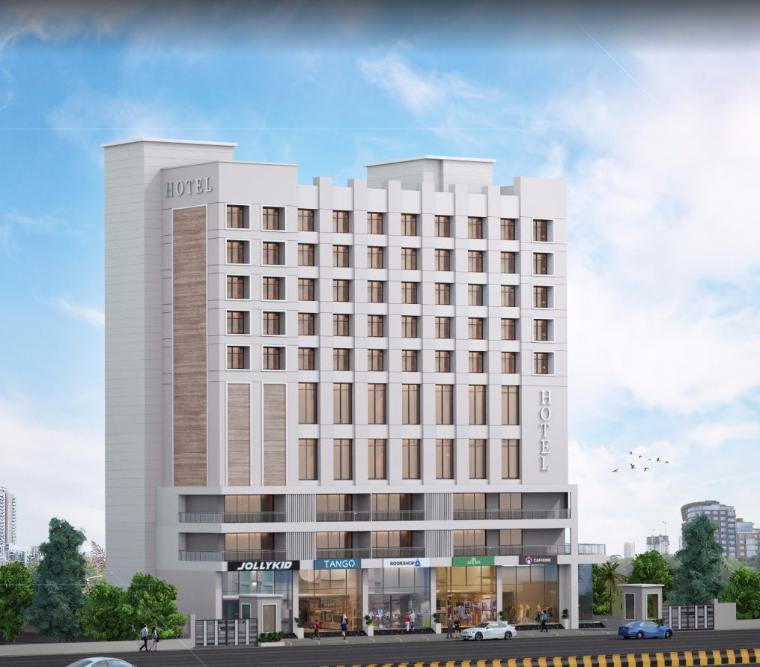

Details of the property under consideration:

Name of Owner: M/s. Gillani Hospitality Pvt. Ltd.

Proposed Commercial Cum Residential (3 Star Hotel) building on plot bearing Survey No. 804 / A / 9 / 1 & 2, Plot No. 1 & 2, Mumbai – Agra Road, Govind Nagar, Village – Nashik, Taluka & District – Nashik, Pin Code – 422 009, State – Maharashtra, Country – India

Latitude Longitude: 19°58'55.8"N 73°46'53.4"E

Intended User for:

Union Bank of India
Govind Nagar Branch
1,2,3,4 Thakkar Enclave, B/H/ Karmayogi Nagar, Govind Nagar,
Nashik - 422 008, State – Maharashtra, Country – India.

Vastu/UBI/Nashik/09/2024/11472/2307584
07/07-62-PYU
Date: - 25.09.2024

WORK PROGRESS REPORT
OF
"M/s. Gillani Hospitality Pvt. Ltd."
Proposed Commercial Cum Residential (3 Star Hotel) building on plot bearing Survey No. 804 / A / 9 / 1 & 2, Plot No. 1 & 2, Mumbai – Agra Road, Govind Nagar, Village – Nashik, Taluka & District – Nashik,
Pin Code – 422 009, State – Maharashtra, Country – India

Latitude Longitude: 19°58'55.8"N 73°46'53.4"E

NAME OF DEVELOPER: M/s. Gillani Hospitality Pvt. Ltd.
Pursuant to instructions from Union Bank of India, Govind Nagar Branch, Nashik we have duly visited, inspected, surveyed & assessed the above said property on 25th September 2024 for work progress report.

1. Location Details:
Proposed Commercial Cum Residential (3 Star Hotel) building on plot bearing Survey No. 804 / A / 9 / 1 & 2, Plot No. 1 & 2, Mumbai – Agra Road, Govind Nagar, Village – Nashik, Taluka & District – Nashik, Pin Code – 422 009. It is about 8.80 Km. travelling distance from Nashik Road Railway station. Surface transport to the property is by buses, taxis & private vehicles. The property is in developed locality. All the amenities like shops, banks, hotels, markets, schools, hospitals, etc. are all available in the surrounding locality. The area is higher middle class & developed.
2. Developer Details:
Name of Developer | M/s. Gillani Hospitality Pvt. Ltd.
Project Rera Registration Number | N. A.
Registered office address | 46, Aminabad Building, 7th Floor, Aga Hall, Nesbit Road, Mazgaon, Mumbai, Pin Code – 400 010, State – Maharashtra, Country – India
Contact details | Contact Person:  Mr. Zaheer Jamal  Mobile No. +91 9892216700
E – mail ID and website
3. Boundaries of the Property:
Direction | Particulars
On or towards North | Yashika Plaza
On or towards South | Open Plot
On or towards East | Mumbai – Agra Road
On or towards West | Internal Road

LEVEL OF COMPLETION:

Construction of Building
Sr. No | Floor No. | Construction Area in Sq. M. | Completed Area in Sq. M. | Percentage of work completed | Work Completion as on 25.09.2024
1 | Excavation & Shore Piling |  |  | 100% | Work is Completed
2 | Basement – 2 Floor | 1,614.60 | 1,614.60 | 95.00% | Slab Work, Block work, Plaster work, Fire Fighting, Water proofing, Electrical, Plumbing, Flooring, toilet dado, sanitary fitting & painting work staircase flooring & grilling works is completed Door are installed. Final Finishing work is in progress
3 | Basement – 1 Floor | 1,657.54 | 1,657.54 | 95.00% | Slab Work, Block work, Plaster work, Fire Fighting, Water proofing, Electrical, Plumbing, Flooring, toilet dado, sanitary fitting & painting work staircase flooring & grilling works is completed Door are installed. Final Finishing work is in progress
4 | Lower Ground Floor | 1,588.16 | 1,588.16 | 95.00% | Slab Work, Block work, Plaster work, Fire Fighting, Water proofing, Electrical, Plumbing, Flooring, toilet dado, sanitary fitting & painting work staircase flooring & grilling works is completed Door are installed. Final Finishing work is in progress
5 | Ground Floor | 959.48 | 959.48 | 95.00% | Slab Work, Block work, Plaster work, Fire Fighting, Water proofing, Electrical, Plumbing, Flooring, toilet dado, sanitary fitting & painting work staircase flooring & grilling works is completed Door are installed. Final Finishing work is in progress
6 | 1st Floor | 664.42 | 664.42 | 95.00% | Slab Work, Block work, Plaster work, Fire Fighting, Water proofing, Electrical, Plumbing, Flooring, toilet dado, sanitary fitting & painting work staircase flooring & grilling works is completed Door are installed. Final Finishing work is in progress
7 | 2nd Floor | 892.55 | 892.55 | 95.00% | Slab Work, Block work, Plaster work, Fire Fighting, Water proofing, Electrical, Plumbing, Flooring, toilet dado, sanitary fitting & painting work staircase flooring & grilling works is completed Door are installed. Final Finishing work is in progress
8 | 3rd Floor | 900.01 | 900.01 | 85.00% | Slab Work, Block work, Plaster work, Door Frame & Window Frame, Gypsum work, Plumbing, Water proofing, flooring, toilet dado, firefighting work, external painting work, staircase flooring & grilling work is completed
9 | 4th Floor | 776.60 | 776.60 | 85.00% | Slab Work, Block work, Plaster work, Door Frame & Window Frame, Gypsum work, Plumbing, Water proofing, flooring, toilet dado, firefighting work, external painting work, staircase flooring & grilling work is completed
10 | 5th Floor | 776.60 | 776.60 | 85.00% | Slab Work, Block work, Plaster work, Door Frame & Window Frame, Gypsum work, Plumbing, Water proofing, flooring, toilet dado, firefighting work, external painting work, staircase flooring & grilling work is completed
11 | 6th Floor | 768.32 | 768.32 | 85.00% | Slab Work, Block work, Plaster work, Door Frame & Window Frame, Gypsum work, Plumbing, Water proofing, flooring, toilet dado, firefighting work, external painting work, staircase flooring & grilling work is completed
12 | 7th Floor | 768.32 | 768.32 | 95.00% | Slab Work, Block work, Plaster work, Fire Fighting, Water proofing, Electrical, Plumbing, Flooring, toilet dado, sanitary fitting & painting work staircase flooring & grilling works is completed Door are installed. Final Finishing work is in progress
13 | 8th Floor | 768.32 | 768.32 | 95.00% | Slab Work, Block work, Plaster work, Fire Fighting, Water proofing, Electrical, Plumbing, Flooring, toilet dado, sanitary fitting & painting work staircase flooring & grilling works is completed Door are installed. Final Finishing work is in progress
14 | 9th Floor | 776.60 | 776.60 | 95.00% | Slab Work, Block work, Plaster work, Fire Fighting, Water proofing, Electrical, Plumbing, Flooring, toilet dado, sanitary fitting & painting work staircase flooring & grilling works is completed Door are installed. Final Finishing work is in progress
15 | 10th Floor | 781.48 | 781.48 | 95.00% | Slab Work, Block work, Plaster work, Fire Fighting, Water proofing, Electrical, Plumbing, Flooring, toilet dado, sanitary fitting & painting work staircase flooring & grilling works is completed Door are installed. Final Finishing work is in progress
16 | 11th Floor | 1,018.22 | 1,018.22 | 95.00% | Slab Work, Block work, Plaster work, Fire Fighting, Water proofing, Electrical, Plumbing, Flooring, toilet dado, sanitary fitting & painting work staircase flooring & grilling works is completed Door are installed. Final Finishing work is in progress
17 | 12th Floor | 1,428.56 | 1,428.56 | 95.00% | Slab Work, Block work, Plaster work, Fire Fighting, Water proofing, Electrical, Plumbing, Flooring, toilet dado, sanitary fitting & painting work staircase flooring & grilling works is completed Door are installed. Final Finishing work is in progress
18 | 13th Floor | 756.79 | 756.79 | 95.00% | Slab Work, Block work, Plaster work, Fire Fighting, Water proofing, Electrical, Plumbing, Flooring, toilet dado, sanitary fitting & painting work staircase flooring & grilling works is completed Door are installed. Final Finishing work is in progress
19 | Terrace Floor & OHT & LMR Area | 756.79 | 756.79 | 85.00% | Terrace slab work, OHT, LMR Area, parapet wall, plaster work, partly flooring work is completed. Staircase flooring & grilling & external painting work is completed. Partly flooring work is in progress & final finishing work is in progress
Total |  | 17,653.36 | 17,653.36 | 80.00%

Plant and Machinery
Particulars | Work Completion as on 07.04.2024
Air – Conditioning | 100% work is completed & checking is also done.
Lifts | All the 5 lifts order is placed, 4 Lifts are installed & in working status. 5th Lift installation work is in progress.
Kitchen & Refrigeration Equipment’s | 100% material received on site & installed is done and final checking in pending.
Gym Equipment’s | Order is placed.
Fire Fighting Equipment’s, Sprinkler & Smoke Detector Systems | 100% work is completed & NOC is received
DG Set | 100% work is completed & installation is done.
Sewage Treatment Plant | 100% work is completed & installation is done.
ELV Systems | Installation is done & final checking is in progress.
IT Equipment & Software | Order is placed.
Crockery, Cutlery & Glassware | Order is placed.
Housekeeping Supplies, Linens & Uniform | Order is placed.

Furniture and Fixture
Particulars | Work Completion as on 07.04.2024
FF for 125 keys | 80 rooms work are completed, other rooms material received on site and interior work is in progress.
FF for Restaurant | Materials has received on site and fixation is done only, final finishing is pending.
FF for Banquet | Materials has received on site and fixation is done only, final finishing is pending.
FF for Reception | Materials has received on site and fixation is done only, final finishing is pending.
FF for Meeting Rooms | Order is placed & some material received on site and work is in progress.
FF for Roof Top Bar | Order is placed & some material received on site and work is in progress.
FF for Other Public Area | Materials has received on site and fixation is done only, final finishing is pending.
FF for BOH | Materials has received on site and fixation is done only, final finishing is pending.

Cost of Construction as on 25th September 2024:

Construction Cost of Building:
Floors | Total Construction Area in Sq. M. | Completed Area in Sq. M. | Revised Rate / Sq. M. | Full Value after completion | Percentage of work completed | Actual Expenditure till date in `
Basement - 2 | 1,614.60 | 1,614.60 | 26,080.00 | 42,108,768.00 | 95.00% | 4,00,03,329.60
Basement - 1 | 1,657.54 | 1,657.54 | 26,080.00 | 43,228,643.20 | 95.00% | 4,10,67,211.04
Lower Ground Floor | 1,588.16 | 1,588.16 | 26,080.00 | 41,419,212.80 | 95.00% | 3,93,48,252.16
Ground Floor | 959.48 | 959.48 | 26,080.00 | 25,023,238.40 | 95.00% | 2,37,72,076.48
1st Floor | 664.42 | 664.42 | 26,080.00 | 17,328,073.60 | 95.00% | 1,64,61,669.92
2nd Floor | 892.55 | 892.55 | 26,080.00 | 23,277,704.00 | 95.00% | 2,21,13,818.80
3rd Floor | 900.01 | 900.01 | 26,080.00 | 23,472,260.80 | 85.00% | 1,99,51,421.68
4th Floor | 776.60 | 776.60 | 26,080.00 | 20,253,728.00 | 85.00% | 1,72,15,668.80
5th Floor | 776.60 | 776.60 | 26,080.00 | 20,253,728.00 | 85.00% | 1,72,15,668.80
6th Floor | 768.32 | 768.32 | 26,080.00 | 20,037,785.60 | 85.00% | 1,70,32,117.76
7th Floor | 768.32 | 768.32 | 26,080.00 | 20,037,785.60 | 95.00% | 1,90,35,896.32
8th Floor | 768.32 | 768.32 | 26,080.00 | 20,037,785.60 | 95.00% | 1,90,35,896.32
9th Floor | 776.60 | 776.60 | 26,080.00 | 20,253,728.00 | 95.00% | 1,92,41,041.60
10th Floor | 781.48 | 781.48 | 26,080.00 | 20,380,998.40 | 95.00% | 1,93,61,948.48
11th Floor | 1,018.22 | 1,018.22 | 26,080.00 | 26,555,177.60 | 95.00% | 2,52,27,418.72
12th Floor | 1,428.56 | 1,428.56 | 26,080.00 | 37,256,844.80 | 95.00% | 3,53,94,002.56
13th Floor | 756.79 | 756.79 | 26,080.00 | 19,737,083.20 | 95.00% | 1,87,50,229.04
Terrace & OHT | 756.79 | 756.79 | 26,080.00 | 19,737,083.20 | 85.00% | 1,67,76,520.72
TOTAL | 17,653.36 | 17,653.36 |  | 46,03,99,628.80 | 92.75% | 42,70,04,188.80

Plant and Machinery:
Particulars | Percentage of work completed
Air – Conditioning | 100%
Lifts | 85%
Kitchen & Refrigeration Equipment’s | 100%
Gym Equipment’s | 0%
Fire Fighting Equipment’s, Sprinkler & Smoke Detector Systems | 100%
DG Set | 100%
Sewage Treatment Plant | 100%
ELV Systems | 100%
IT Equipment & Software | 0%
Crockery, Cutlery & Glassware | 0%
Housekeeping Supplies, Linens & Uniform | 0%

Furniture & Fixture:
Particulars | Percentage of work completed
FF for 125 Rooms keys | 70%
FF for Restaurant | 100%
FF for Banquet | 100%
FF for Reception | 100%
FF for Meeting Rooms | 0%
FF for Roof Top Bar | 0%
FF for Other Public Area | 100%
FF for BOH | 100%

Note: Details of work completed is as per site visit dated 25.09.2024.

Timeline for Completion of Project:
As per the discussion with the client the project completion will be done in two portion such as
- Basement 1 + Basement 2 + Lower Ground Floor + Ground Floor + 1st & 2nd Floor + 7th to 13th Floor & Terrace Floor final finishing and checking by Marriott group will be done till 31st October 2024. Operation of the hotel will start in 4th Quarter of year 2024.
- 3rd to 6th Floor work will be completed in 1st Quarter of year 2025 and final finishing & operation will be start by Marriott group in 1st Quarter of year 2025.

Sharadkumar B. Chalikwar
Govt. Reg. Valuer
Chartered Engineer (India)
Reg. No. (N) CCIT/1-14/52/2008-09

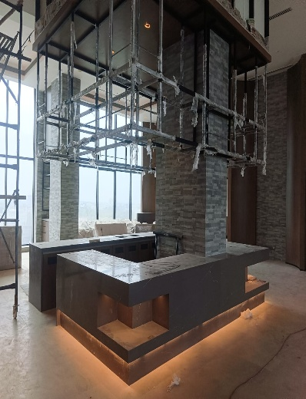
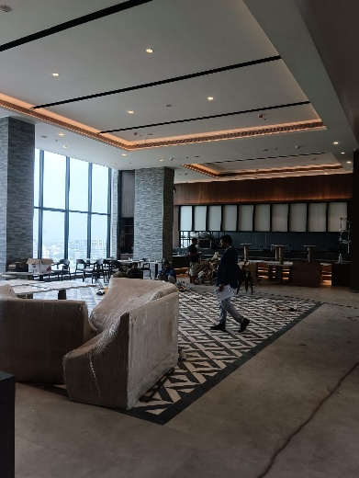
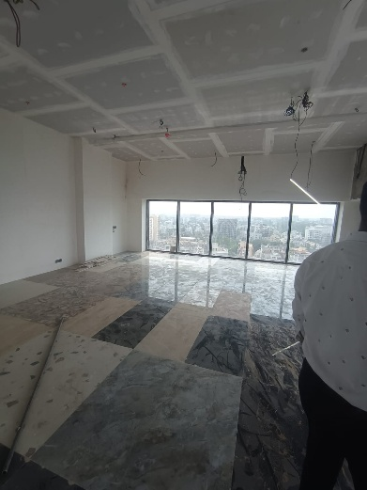
Actual Site Photographs as on 25.09.2024

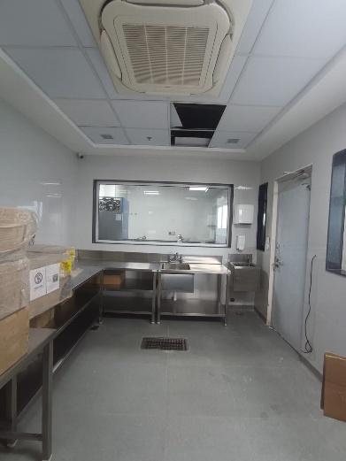
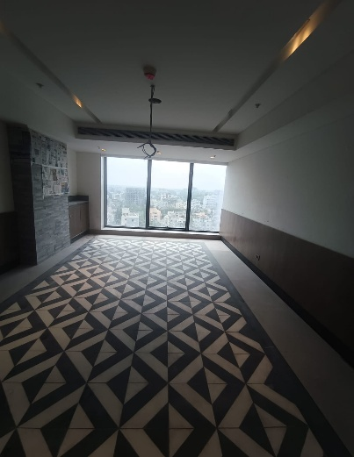
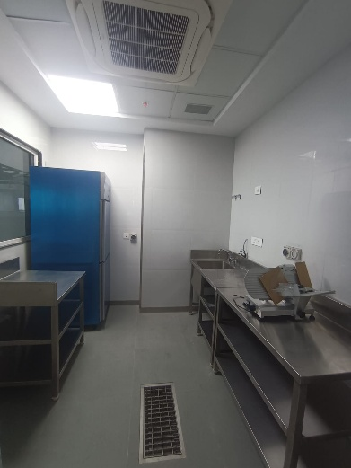

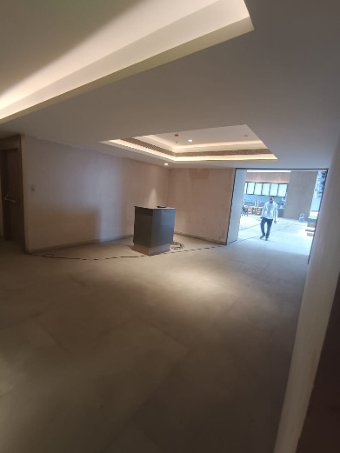
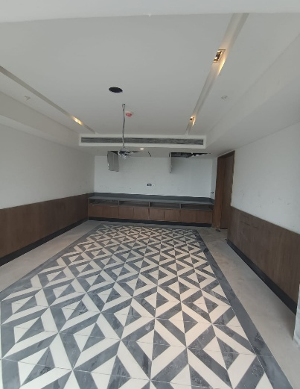
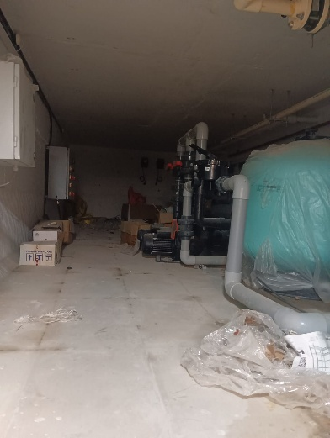

Actual Site Photographs as on 25.09.2024
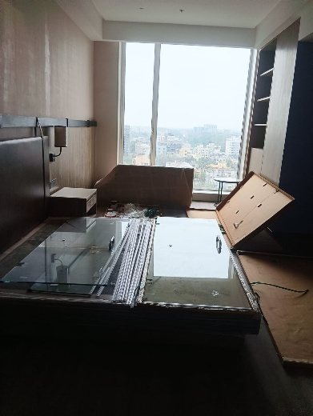
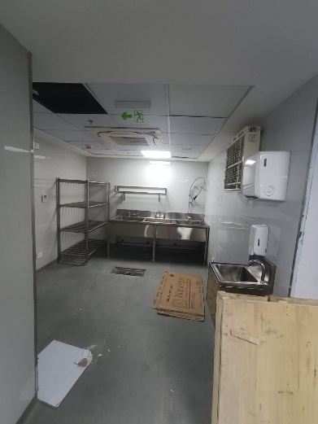
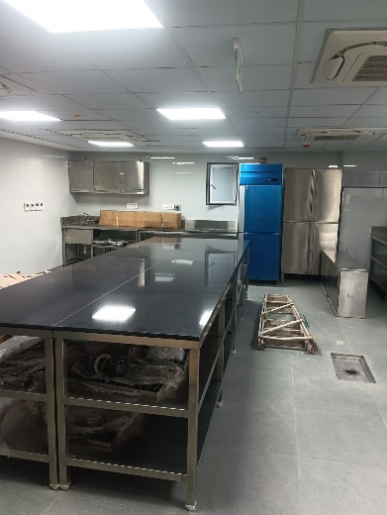

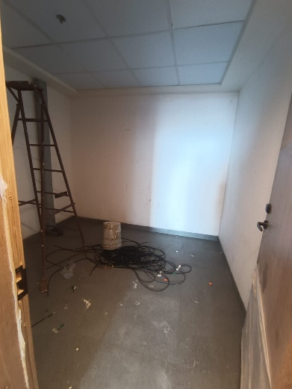
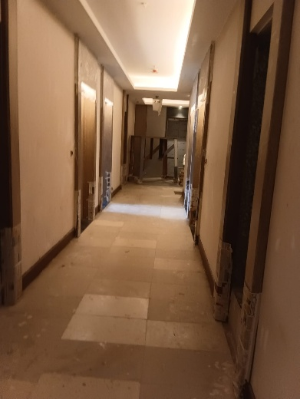
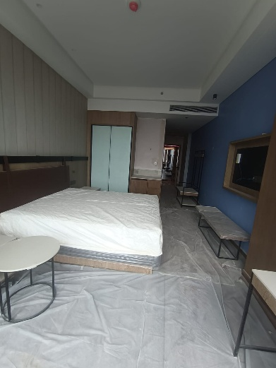

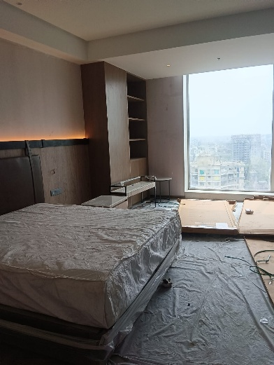
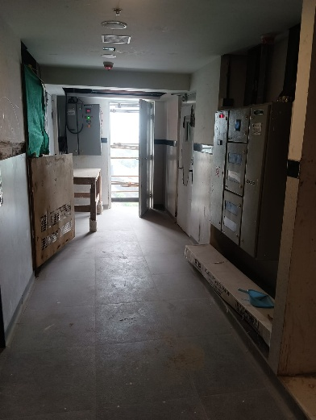
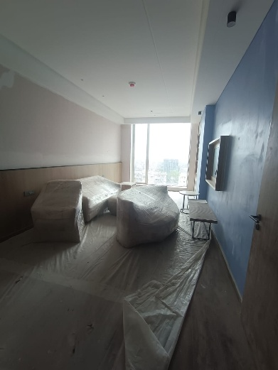

Actual Site Photographs as on 25.09.2024
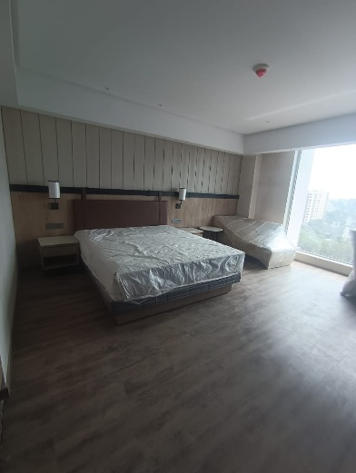
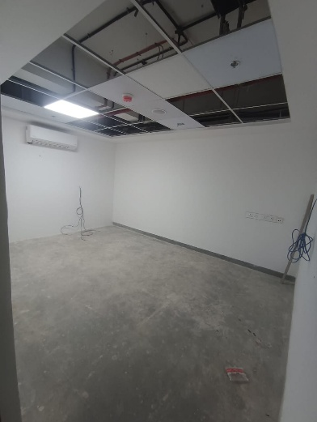
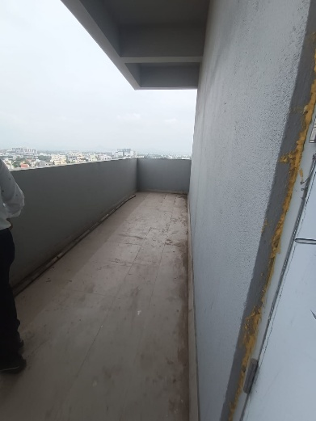

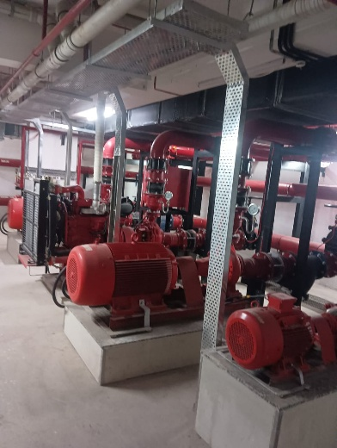
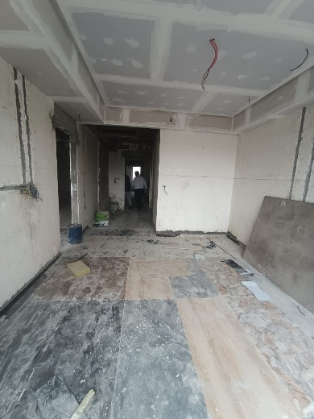
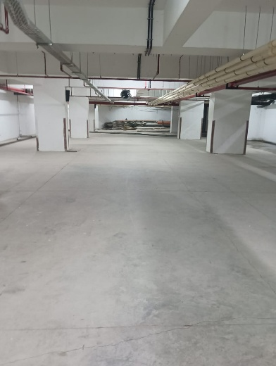

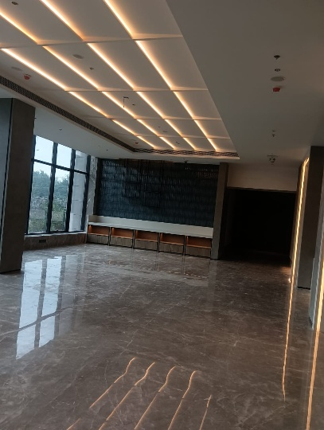
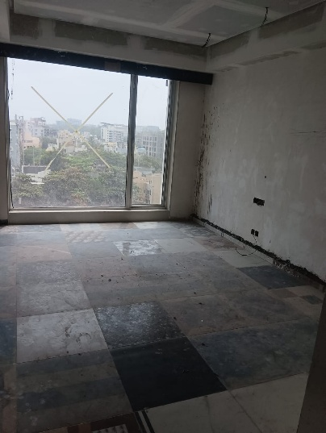
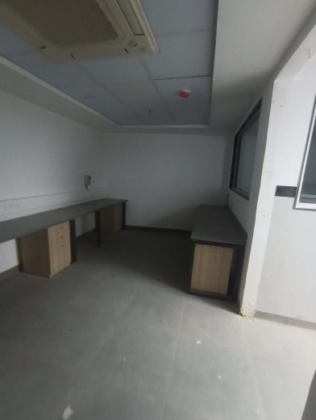

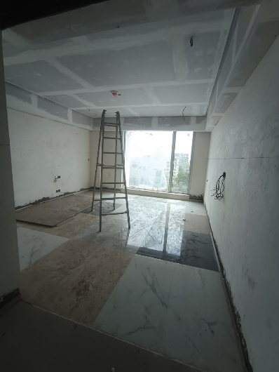
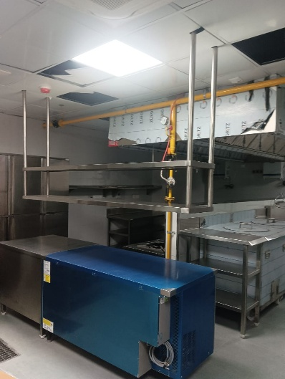
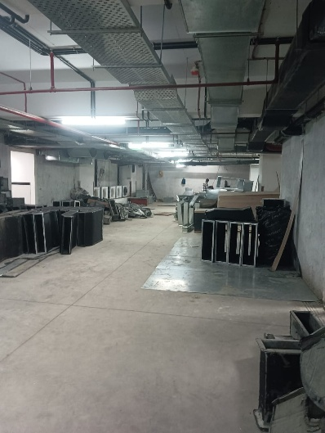
Actual Site Photographs as on 25.09.2024

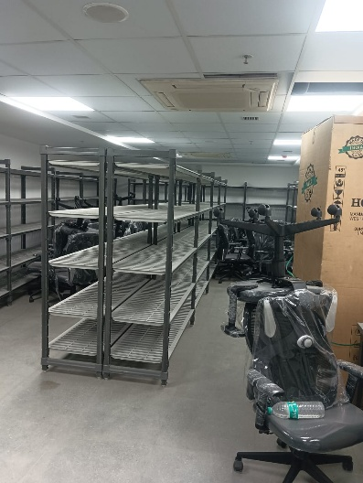
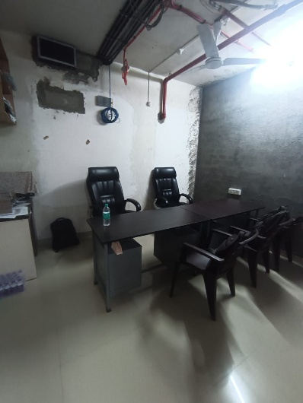
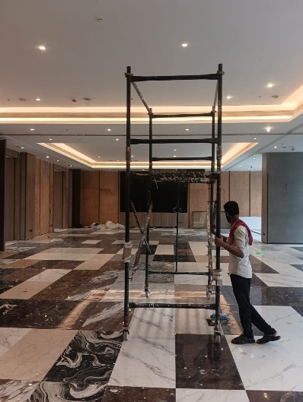

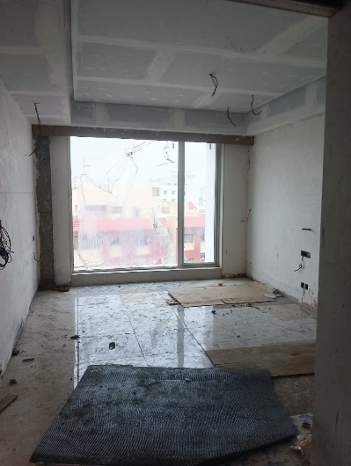
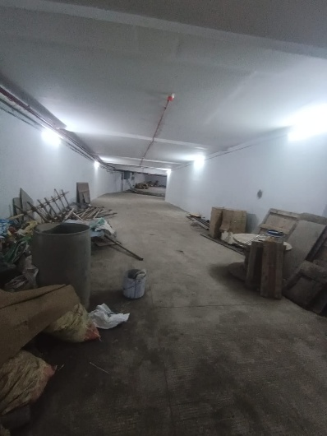
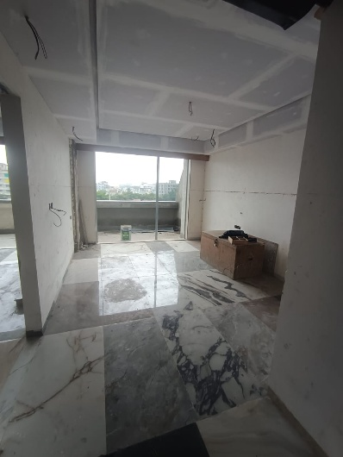

Actual Site Photographs as on 25.09.2024
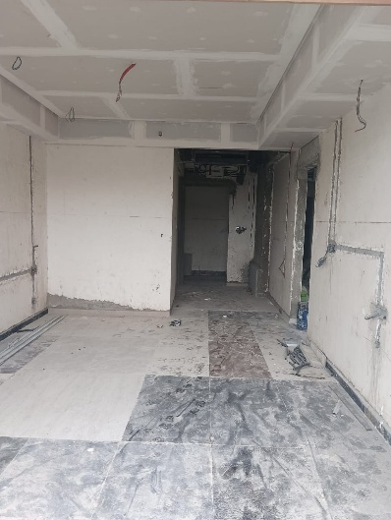
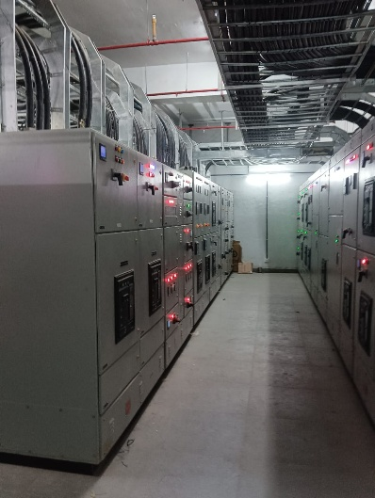
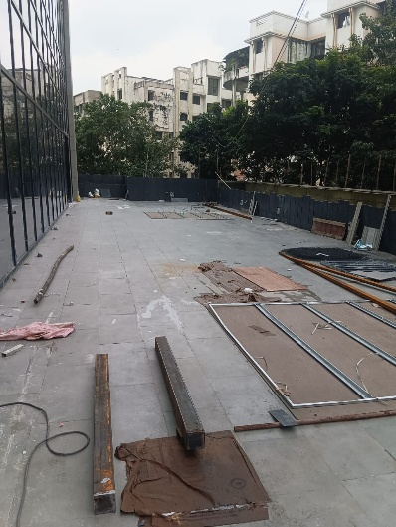

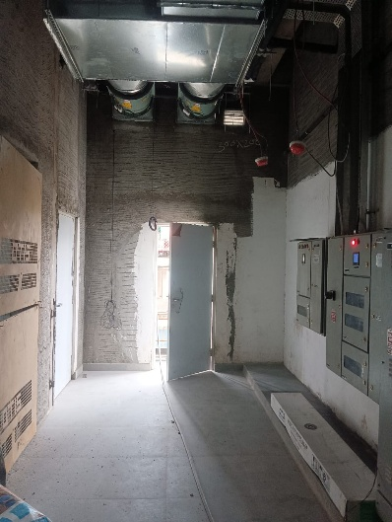
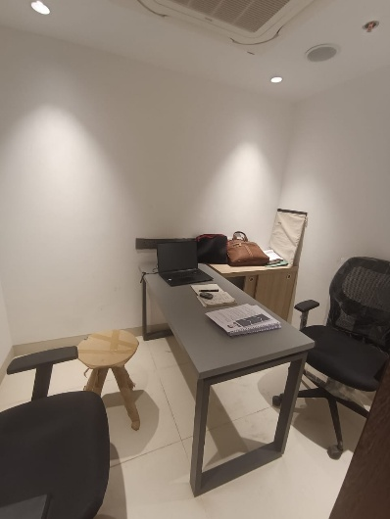
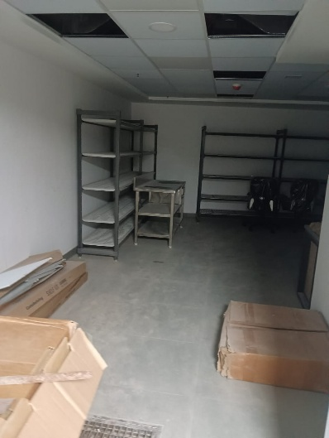

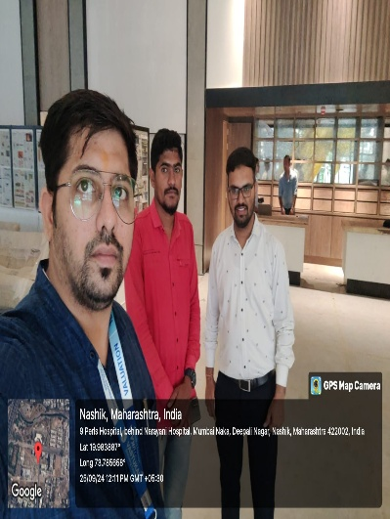
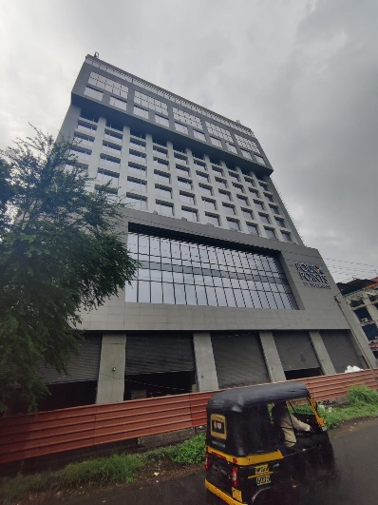
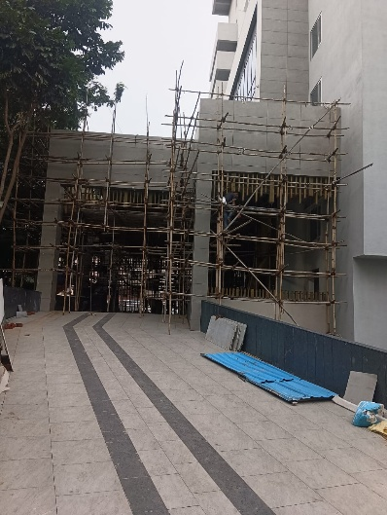

Route Map of the property
Site u/r
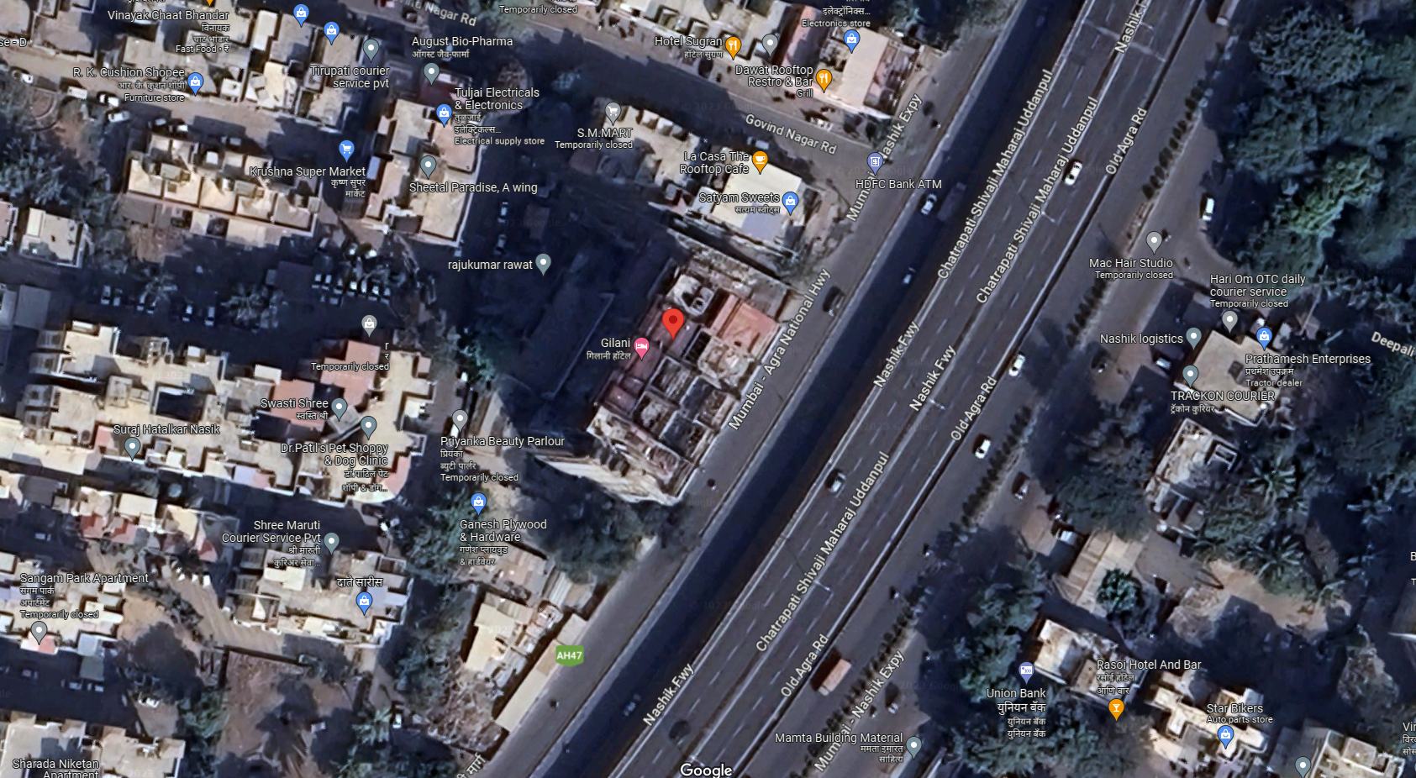

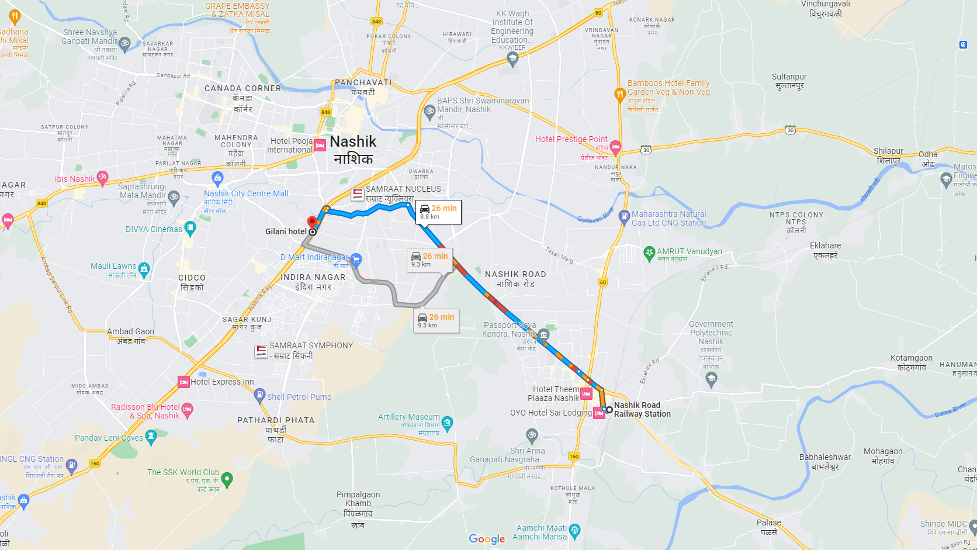

Latitude Longitude: 19°58'55.8"N 73°46'53.4"E
Note: The Blue line shows the route to site from nearest railway station (Nashik Road – 8.80 Km.)

