Vastu/Nashik/09/2024/011442 /2308336 24/19-342-RPBS Date: 24.09.2024

**Structural Stability Report**

Residential Duplex Flat No. 10/A, House No. 240/11, Ground Floor & Flat No. 10/A, House No. 1477, 1st Floor, **"Sant Kanawarram Co-Op. Housing Society"**, Survey No.151/B2/2, 151/B/2/1A & 151/B2/3A., Near Supermans Garden, Anand Road, Anand Nagar, Village - Sansari, Taluka & District - Nashik, PIN Code – 422001, State – Maharashtra, Country – India belongs to **Mr. Hari Pokardas Sachdev.**

This is to certify that on visual inspection, it appears that the structure of **"Sant Kanawarram Co-Op. Housing Society"** is in Poor condition and the future life can be reasonably takes under normal condition and with proper periodic repairs & maintenance is about 22 years.

**General Information**:

|  |  |  |
| --- | --- | --- |
| **A.** | **Introduction** | |
| 1 | Name of Building | **"Sant Kanawarram Co-Op. Housing Society"** |
| 2 | Property Address | Residential Duplex Flat No. 10/A, House No. 240/11, Ground Floor & Flat No. 10/A, House No. 1477, 1st Floor, **"Sant Kanawarram Co-Op. Housing Society"**, Survey No.151/B2/2, 151/B/2/1A & 151/B2/3A., Near Supermans Garden, Anand Road, Anand Nagar, Village - Sansari, Taluka & District - Nashik, PIN Code – 422001, State – Maharashtra, Country – India. |
| 3 | Type of Building | Residential |
| 4 | No. of Floors | Ground Floor + First Floor |
| 5 | Whether stilt / podium / open parking provided | Open Car Parking |
| 6 | Type of Construction | R.C.C. Framed Structure |
| 7 | Type of Foundation | R.C.C. Footing |
| 8 | Thickness of the External Walls | 6’ thick brick walls both sides plastered |
| 9 | Type of Compound | Brick Masonry Walls |
| 10 | Year of Construction | 1986 (Approx.) |
| 11 | Present age of building | 38 years |
| 12 | Residual age of the building | 22 years Subject to proper, preventive periodic maintenance & structural repairs. |
| 13 | No. of Units | Residential Duplex Flat No. 10/A, House No. 240/11, Ground Floor & Flat No. 10/A, House No. 1477, 1st Floor |
| 14 | Methodology adopted | As per visual site inspection |

|  |  |  |  |
| --- | --- | --- | --- |
| **B.** | | **External Observation of the Building** | |
| 1 | | Plaster | Average |
| 2 | | Chajjas | Average |
| 3 | | Plumbing | Average |
| 4 | | Cracks on the external walls | Not Found |
| 5 | | Filling cracks on the external walls | Not Found |
| 6 | | Cracks on columns & beams | Not Found |
| 7 | | Vegetation | Not Found |
| 8 | | Leakages of water in the drainage pipes or water pipes | Not Found |
| 9 | | Dampness external in the wall due to leakages | Not Found |
| 10 | | Any other observation about the condition of external side of the building | The external condition of the structure is in Poor condition |
| **C** | | **Internal Observation of the common areas of the building and captioned premises** | |
| 1 | | Beams (Cracks & Leakages) | Not Found |
| 2 | | Columns (Cracks & Leakages) | Not Found |
| 3 | | Ceiling (Cracks & Leakages) | Not Found |
| 4 | | Leakages inside the property | Not Found |
| 5 | | Painting inside the property | Good |
| 6 | | Maintenance of staircase & cracks | Good |
| **D** | **Common Observation** | | |
| 1 | Structural Audit of the Building Under Bye – Laws No. 77 of the Model Bye Laws (Co-Operative Societies Act / Rules) | | As per bye Laws No. 77 of Co-Op. Societies bye Laws under the Act the society shall conduct a Structural Audit of the building of the society as follows |
| 2 | Remark | | Structure Condition is Very Poor. |

|  |  |
| --- | --- |
| **E** | **Conclusion** |
| The captioned Flat is having Groundfloor + First Floor which are constructed in year 1986 (Approx). Estimated future life under present circumstances is about 22 years’ subject to proper, preventive periodic maintenance & structural repairs.  The inspection dated 23.09.2024 reveals no structural damage or deterioration to the building. The building as well as the property is maintained in Poor condition & will stand future life subject to proper, preventive periodic maintenance & Average structural repairs.  Our Observations about the structure are given above.  The above assessment is based on visual inspection only. | |

**Manoj B. Chalikwar**

Registered Valuer

Chartered Engineer (India)

Reg. No. CAT-I-F-1763

Reg. No. IBBI/RV/07/2018/10366

BOB Empanelment No.: ZO:MZ:ADV:46:941

Encl: Valuation Report.

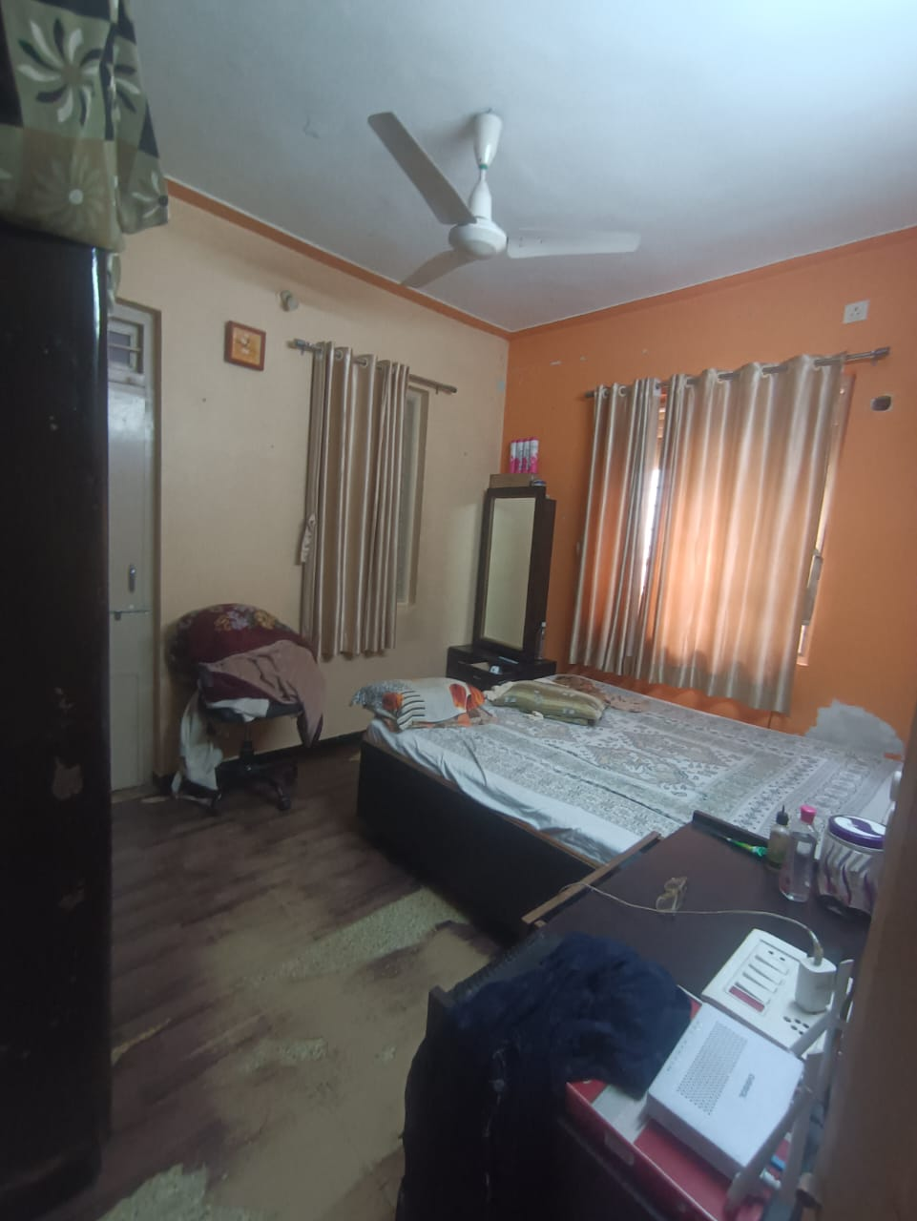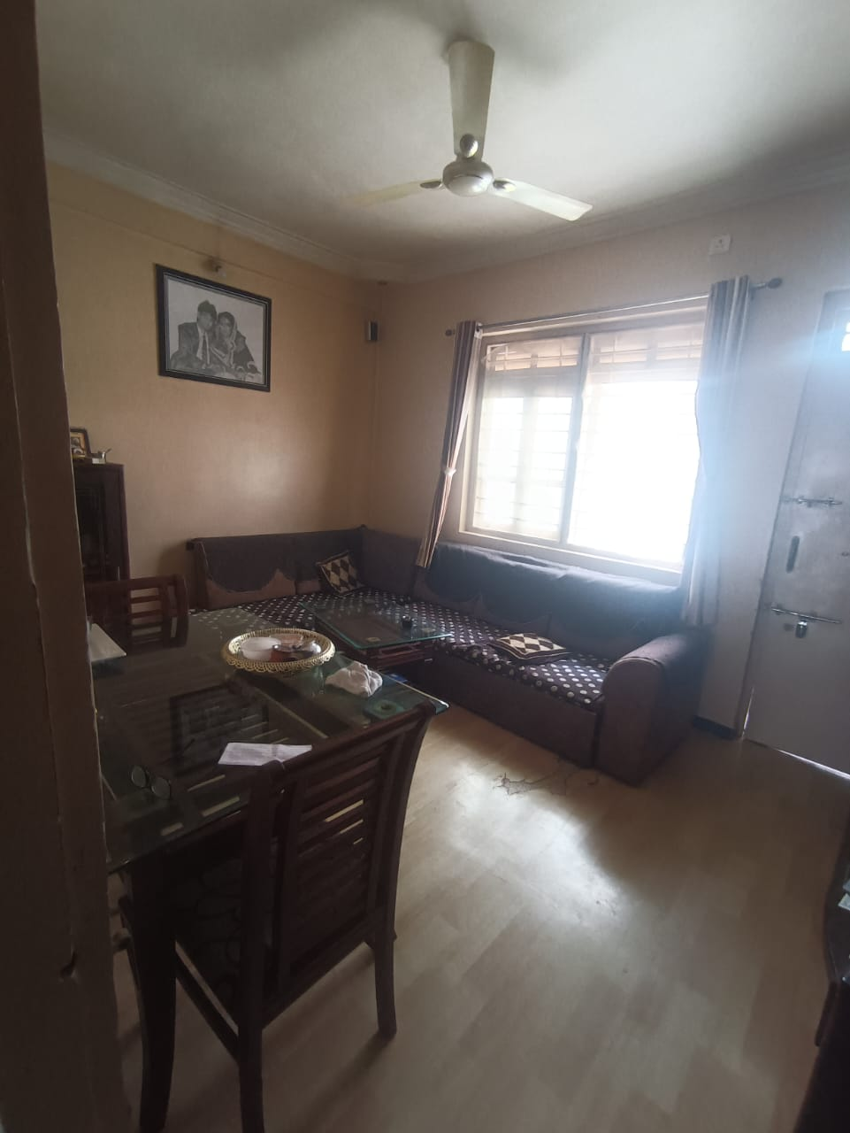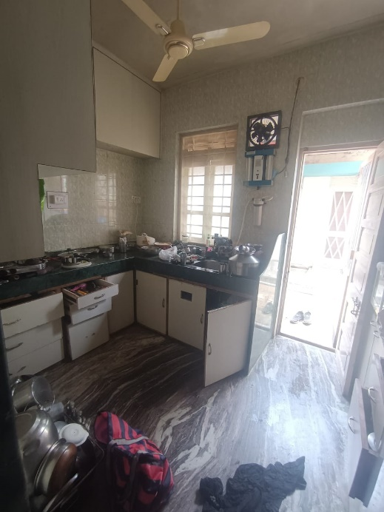**Actual site photographs**

