Vastu/Nashik/09/2024/011428 /2308325
24/8-331-RYBS
Date: 24.09.2024

To,
The Branch Manager,
Bank of Baroda
Regional Office
BSNL Building, Datta Mandir Road, Nashik Road,
Nashik, PIN – 422 101, State - Maharashtra, Country - India.

Sub: Vetting of Extra Work

Sir,

With reference to above subject, we have evaluated the Extra Work For Residential Flat No. 103, 1st Floor, " Aaradhya Lily ", Near Ebenezer International School, Chandashi Road, Village - Chandashi, Taluka - Nashik, District - Nashik, 422003, State - Maharashtra, Country -India belongs to M/s. Shreyash Construction. Name of Proposed Purchaser is Shri. Santosh Ratan Giri.

We have verified the rates quoted as per current market rates. Details of Extra Work considered as per copy of Extra Work Agreement between Mr. Santosh Ratan Giri (First Party). Mr. Fakira Dagadu Ingle (Second Party) received on dated.19.09.2024. The Extra Work amount is Rs. 4,30,000/- (Rupees Four Lakh Thirty Thousand Only)

The said Cost Vetting Certificate is valid upto next 6 months Only.

Thanking you

Sincerely yours

Manoj B. Chalikwar
Registered Valuer
Chartered Engineer (India)
Reg. No. CAT-I-F-1763
Reg. No. IBBI/RV/07/2018/10366
BOB Empanelment No.: ZO:MZ:ADV:46:941
Encl: Valuation report.

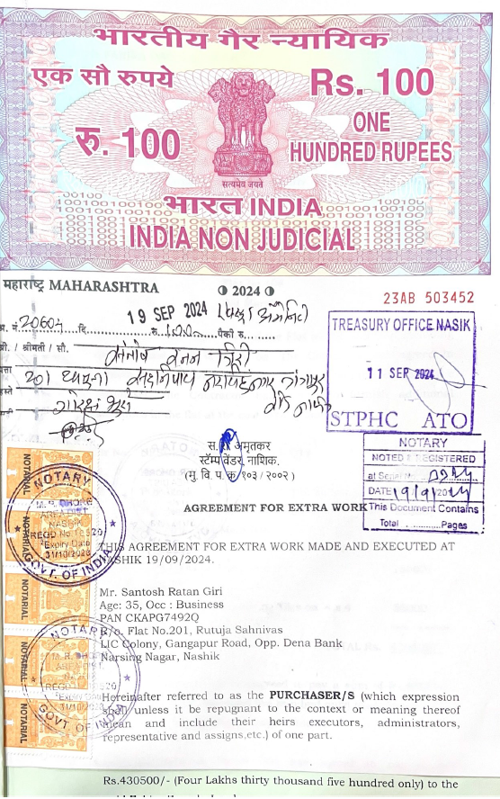
Agreement for Extra Work
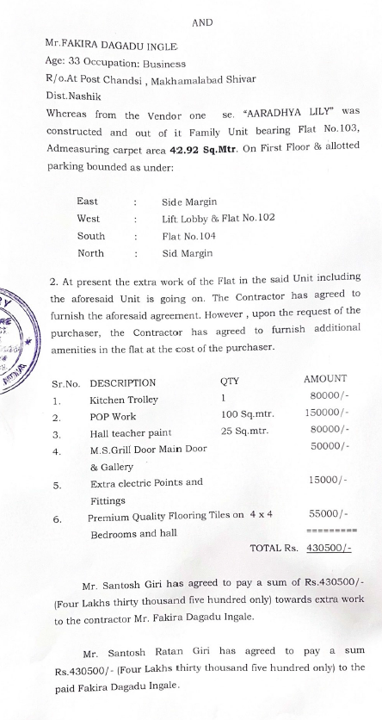

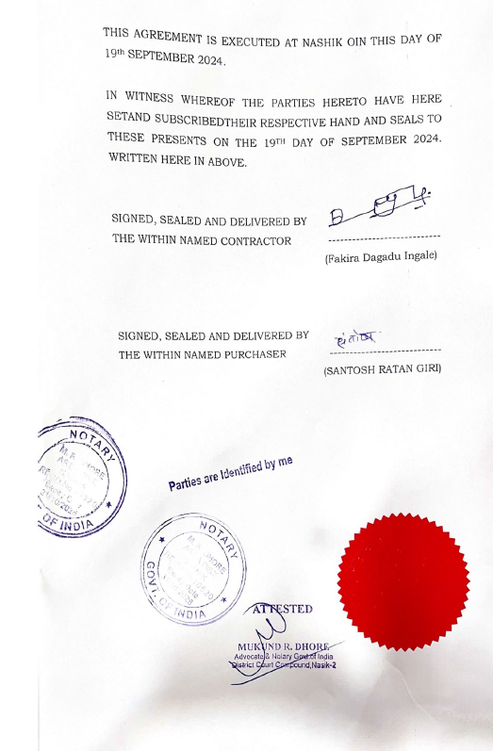

The Extra Work amount is Rs. 4,30,000/- (Rupees Four Lakh Thirty Thousand Only)

