**Remarks**

1. As per Development Agreement dated 25.01.1996, The Plan for construction of four separate buildings / Wings on the said Plot No. 100 was issued by Collector, thane vide Order No. REV / DESK – 1 / T – 9 / Qust / C.R. / 138 / 88 dated 22.11.1988.
2. Out of Above Four building/Wings Owner have constructed a building “Ambika” having total Built up area of 25,100.00 Sq. Ft. and M/s. Bhoomi Enterprise to whom the owners had granted rights have constructed building known and described as “Gauri” having total Built up area of 26,500.00 Sq. Ft. The said 2 buildings are respectively marked with the alphabet "A" and "B" on the said plan - Annexure A (Attached). & M/s. Vora Developers have requested the owners to grant the developers the right to construct the said two buildings/Wings “C” and “D” by consuming the said balance FSI of 28,268.00 Sq, ft, and the owners have agreed to do so on the rems and conditions.
3. As per Part Occupancy Certificate received for commercial building having 46 Nos. shops and 54 Nos. of offices in **“1 No. of Building”. The Said unit is a part of above part Occupancy.**
4. As per site inspection the subject property Unit no. 207 is located in Vora Plaza "A wing" but as per Document it is mentioned as “A-207, Vora Plaza C-wing”.
5. The loading between measured Carpet area to Agreement Built up area is 42%. We have adjusted the rate accordingly.

**Annexure – A – Plan**

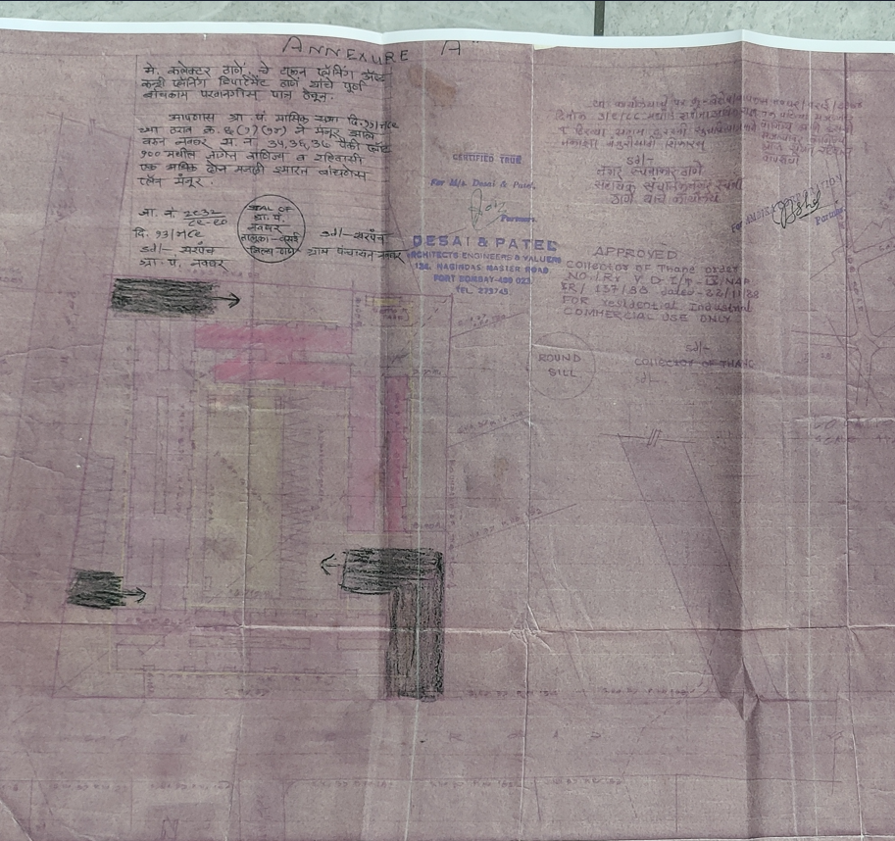

Out of Above Four building/Wings Owner have constructed a building “Ambika” having total Built up area of 25,100.00 Sq. Ft. and M/s. Bhoomi Enterprise to whom the owners had granted rights have constructed building known and described as “Gauri” having total Built up area of 26,500.00 Sq. Ft. & M/s. Vora Developers have requested the owners to grant the developers the right to construct the said two buildings/Wings “C” and “D” by consuming the said balance FSI of 28,268.00 Sq, ft, and the owners have agreed to do so on the rems and conditions (Pink Colour) & Black is Right of Excess shown in Black)

**Block Plan**

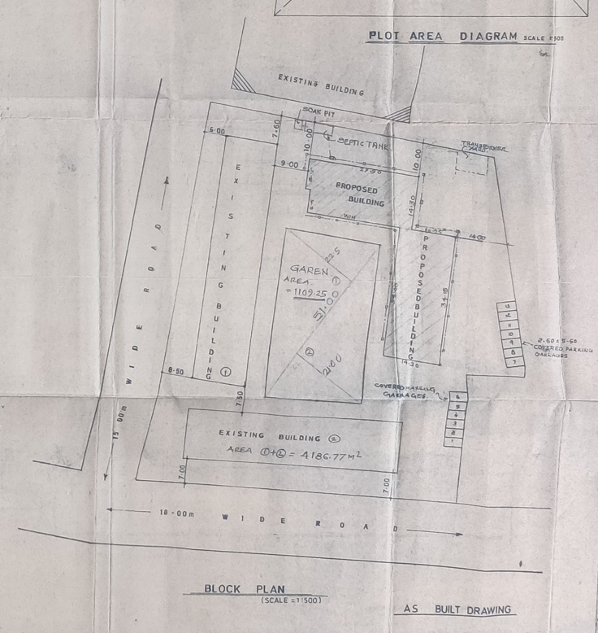

As per Part Occupancy Certificate received for commercial building having 46 Nos. shops and 54 Nos. of offices in **“1 No. of Building”. The Said unit is a part of above part Occupancy.**

**Typical Floor Plan Wing A & B**

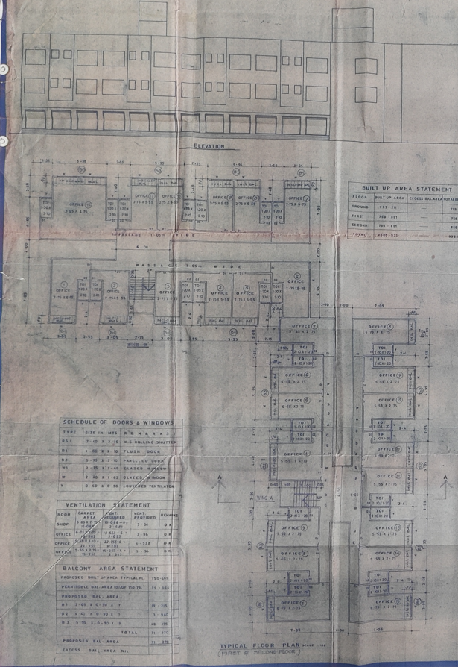

**Floor Plan Wing A & B & Area Statement**

