Vastu/Nashik/09/2024/011401/2308301
23/6-307-RYBS
Date: 23.09.2024

To,
The Branch Manager,
Bank of Baroda
Regional Office Nashik Road Branch
BSNL Building, Datta Mandir Road, Nashik Road,
Nashik - 422 101, State - Maharashtra, Country - India.

Sub: Vetting of Extra Work

Sir,

With reference to above subject, we have evaluated the Extra Work for Residential Row House No. 01, Ground Floor, Survey No. 64/ A, Plot No. 72/ 2, Near Shree Durga Apartment, Ambedkar Nagar, Aanand Vatika Road, Village – Chunchale, Taluka & District - Nashik, PIN Code - 422 010, State - Maharashtra, Country - India. belongs Name of Proposed Purchaser: Shri. Brajmohan Balchandra Prajapati & Sau. Poonam Prajapati. Name of Owner: Sushiladevi Rambhau Pandit & 2 Others.

We have verified the rates quoted as per current market rates. Details of Extra Work considered as per copy of Extra Work Agreement between Shri. Brajmohan Balchandra Prajapati & Sau. Poonam Prajapati (First Party). Shri. Lalu Munilal Pandit (Second Party) received on dated 19.09.2024. The Extra Work amount is Rs. 4,50,000/- (Rupees Four Lakh Fifty Thousand Only)

The said Cost Vetting Certificate is valid upto next 6 months Only.

Thanking you

Sincerely yours

Sharadkumar B. Chalikwar
Govt. Reg. Valuer
Chartered Engineer (India)
Reg. No. (N) CCIT/1-14/52/2008-09.

Agreement for Extra Work

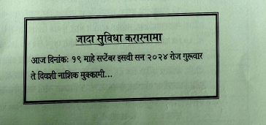
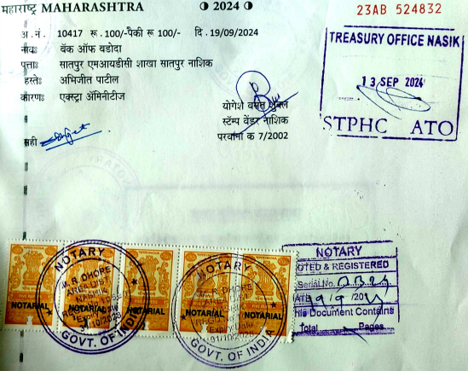

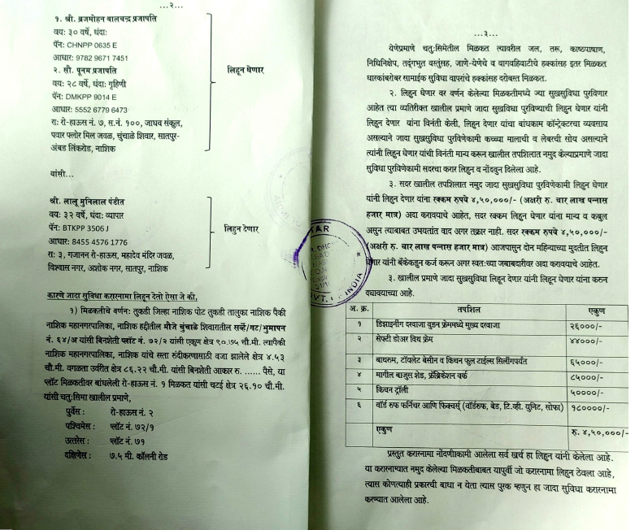

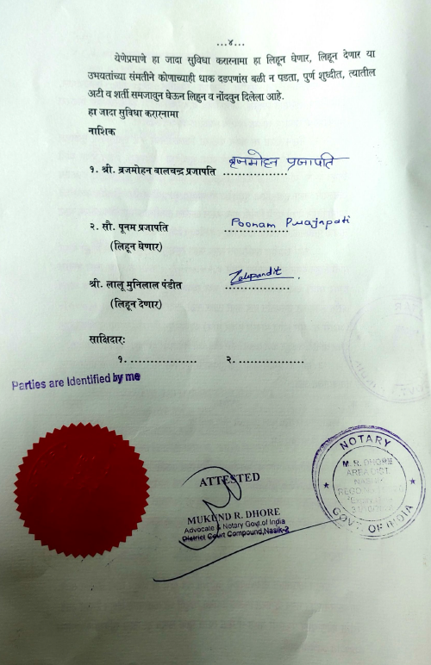

The Extra Work amount is Rs. 4,50,000/- (Rupees Four Lakh Fifty Thousand Only)

