Vastu/Nashik/08/2024/010634/2307731
17/3-209 -RPBS
Date: 21.09.2024

To, `
The Branch Manager,
Bank of Baroda
Regional Office Nashik Road Branch
BSNL Building, Datta Mandir Road, Nashik Road,
Nashik -422 101, State - Maharashtra, Country - India.

Sub: Vetting of Extra Amenities

Sir,

With reference to above subject, we have evaluated the Extra Amenities for Residential Land and Row House No.1,“ Shriram Row Houses ”,Survey No.554/6, Plot No.47+48, Near Nandanvan Lawns , Chinchkhed Road, Village - Pimpalgaon Baswant , Taluka & District - Nashik, PIN Code – 422 209, State – Maharashtra, Country – India. belongs to Shri.Chandarram Balkumar Ram & Shri.Chandrika Bhikhi Sav. Name of Proposed Purchaser: Shri.Vishal Vijay Jadhav & Sau.Sonali Vishal Jadhav

We have verified the rates quoted as per current market rates. Details of work and Extra Amenities considered as per copy of Agreement for Extra Amenities Between Shri.Vishal Vijay Jadhav & Sau.Sonali Vishal Jadhav. (First Party) and Shri.Vijay Bajirao Jadhav (Second Party) received on dated 19.09.2024. The Extra Amenities amount is Rs.5,40,000/- (Rupees Five Lakh Forty Thousand Only.)

The said Cost Vetting Certificate is valid upto next 6 months Only.

Thanking you

Sincerely yours

Manoj B. Chalikwar
Registered Valuer
Chartered Engineer (India)
Reg. No. CAT-I-F-1763
Reg. No. IBBI/RV/07/2018/10366
BOB Empanelment No.: ZO:MZ:ADV:46:941
Encl: Valuation report.
Agreement for Extra Amenities
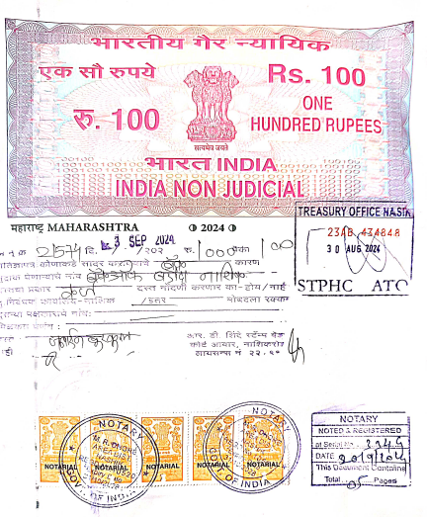
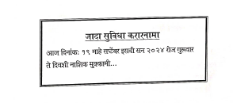

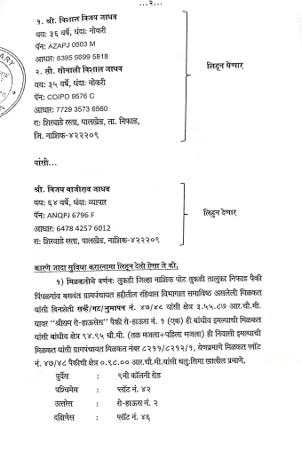

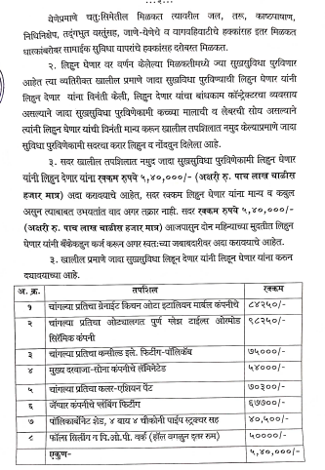
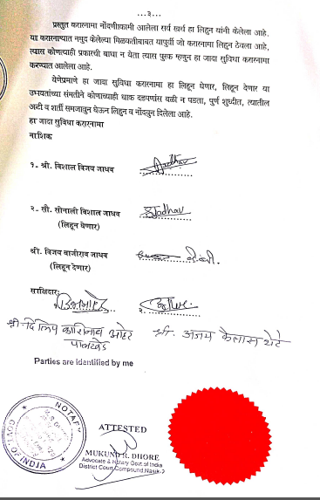

The Extra Amenities amount is Rs.5,40,000/- (Rupees Five Lakh Forty Thousand Only.)

