Vastu/Nashik/07/2024/0010070/2307330
22/7-334-RPBS
Date: 21.09.2024

To, `
The Branch Manager,
Bank of Baroda
Regional Office Nashik Road Branch
BSNL Building, Datta Mandir Road, Nashik Road,
Nashik -422 101, State - Maharashtra, Country - India.

Sub: Vetting of Extra Amenities

Sir,

With reference to above subject, we have evaluated the Extra Amenities for Residential Flat No. B-4, 1st Floor, "Samarth Park", Behind Diamond Residency, Plot No. 58 to 71, Sanju Nagar, off Ambad Satpur Link Rd, Village - Chunchale, Taluka - Nashik, District - Nashik, Nashik, 422007, State - Maharashtra, India belongs to Shri. Ajay Lalbahadur Jaisawal & Sau. Sunita Ajay Jaisval.

We have verified the rates quoted as per current market rates. Details of work and Extra Amenities considered as per copy of Agreement for Extra Amenities issued by to Shri. Ajay Lalbahadur Jaisawal & Sau. Sunita Ajay Jaisval (First Party) and Shri. Om Shivram Bansode (Second Party) received on dated 20.09.2024. The Extra Amenities amount is Rs.3,00,000/- (Rupees Three Lakh Only.)

The said Cost Vetting Certificate is valid upto next 6 months Only.

Thanking you

Sincerely yours

Manoj B. Chalikwar
Registered Valuer
Chartered Engineer (India)
Reg. No. CAT-I-F-1763
Reg. No. IBBI/RV/07/2018/10366
BOB Empanelment No.: ZO:MZ:ADV:46:941
Encl: Valuation report.

Agreement for Extra Amenities
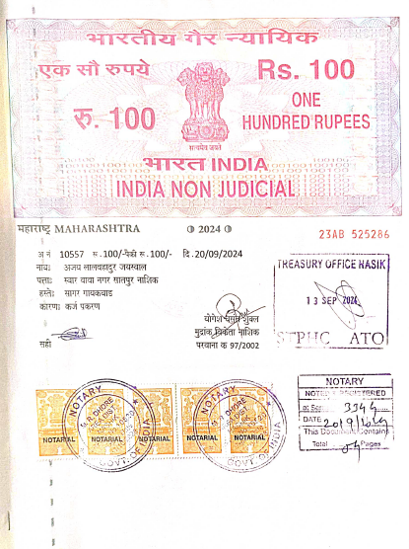
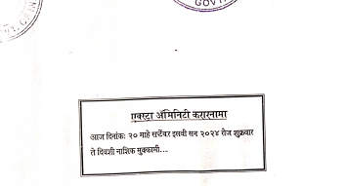

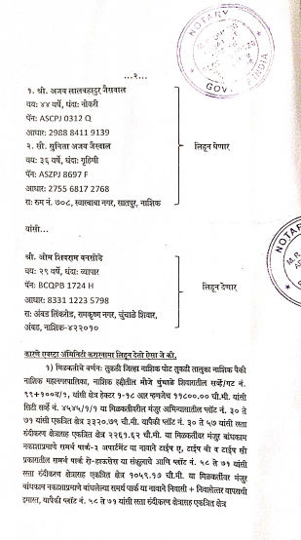

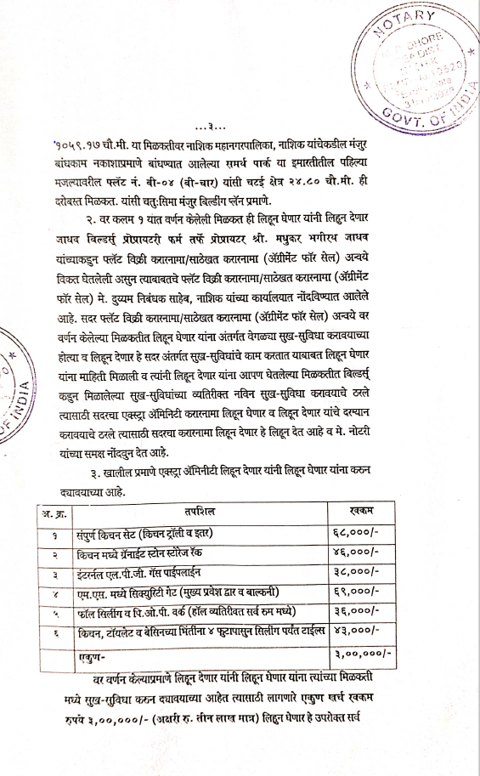
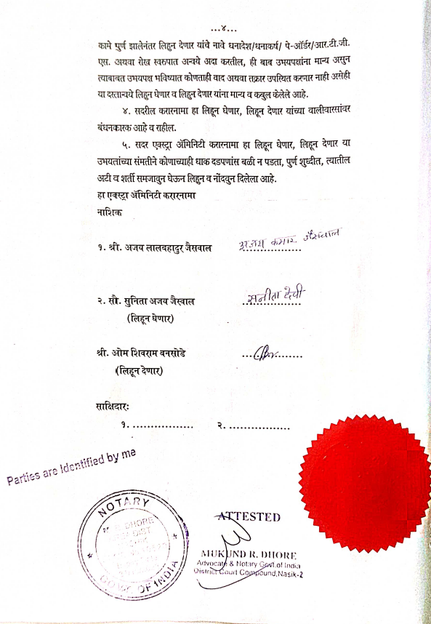

The Extra Amenities amount is Rs.3,00,000/- (Rupees Three Lakh Only.)

