Vastu/Nashik/04/2024/008419/2306108
26/11-247-RPBS
Date: 26.04.2024

To,
The Assistant General Manager,
Bank of Baroda
RO Nashik
BSNL Building, Datta Mandir Road, Nashik Road, Nashik
422101.

Sub: Vetting of Estimate

Sir,

With reference to above subject, we have evaluated the Estimate for Residential Flat No. C-1806 & C-1807 , 18th Floor, Wing - C, Omkar Towers, Near Audumbar Lawns, Gayatri Nagar, Plot No. 33+34+35+36, off Meri - Rasbihari Link Rd, Village - 33+34+35+36, Taluka - Nashik, District - Nashik, Nashik, 422003, State - Maharashtra, India Belongs to Name of Owner: Mr. Machindra Margu Chaughule.

We have verified the rates quoted as per current market rates. Details of Estimate considered as per copy of Estimate Provided by Architect Suresh N. Patel received on dated.18.09.2024. The Estimate amount is Rs. 44,25,840/- (Rupees Forty Four Lakh Twenty Five Thousand Eight Hundred Forty Only.)

Note:1) The said Cost Vetting Certificate is valid upto next 6 months Only.

Thanking you

Sincerely yours

Manoj B. Chalikwar
Registered Valuer
Chartered Engineer (India)
Reg. No. CAT-I-F-1763
Reg. No. IBBI/RV/07/2018/10366
BOB Empanelment No.: ZO:MZ:ADV:46:941
Encl: Valuation Report

Estimate
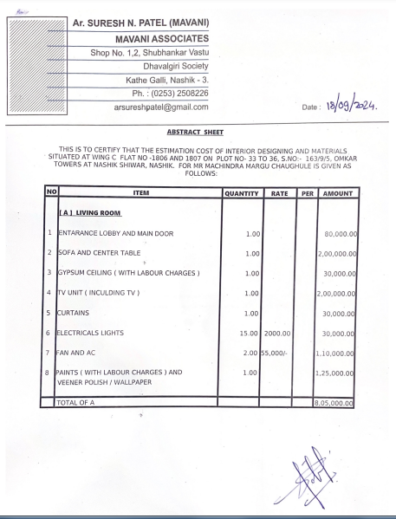

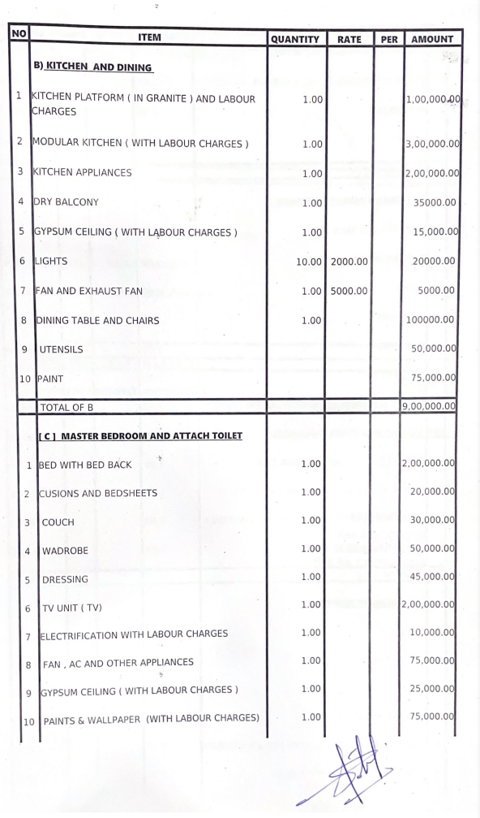
Estimate

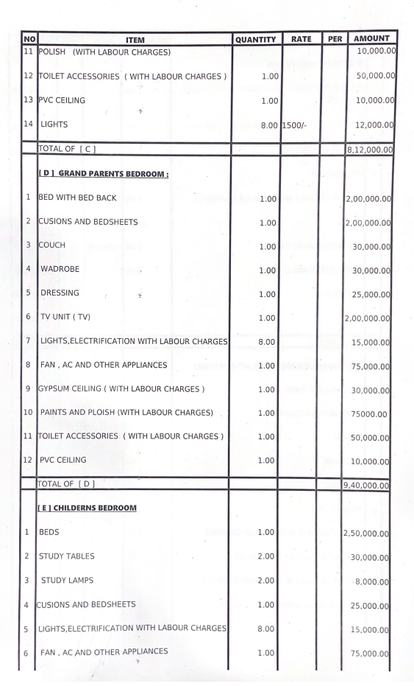
Estimate

Estimate
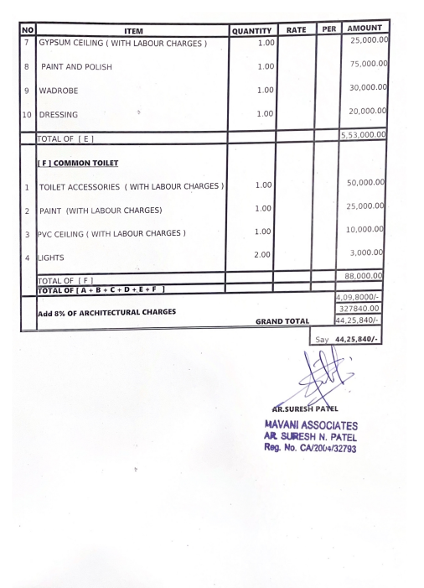

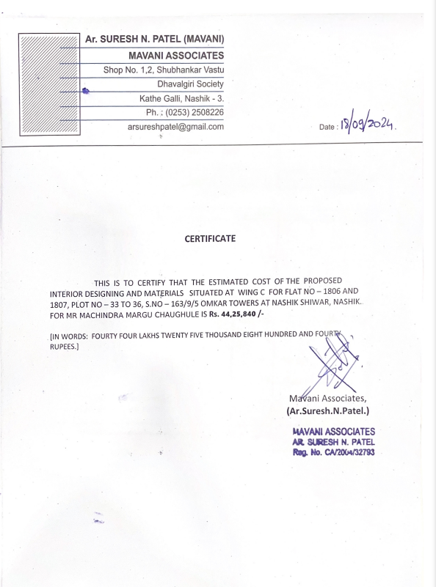

The Estimate amount is Rs. 44,25,840/- (Rupees Forty Four Lakh Twenty Five Thousand Eight Hundred Forty Only.)

