Vastu/Nashik/09/2024/011305/2308246
19/20-252-RPBS
Date: 19.09.2024

To, `
The Branch Manager,
State Bank of India
RACC Nashik Branch
RBO.2, the Wave Building opposite Shell Petrol Pump, First
Floor, Pathardi Road Nashik.422010, State – Maharashtra,
Country – India.

Sub: Vetting of Extra Amenities

Sir,

With reference to above subject, we have evaluated the Extra Amenities for Residential Flat No. 205, 2nd Floor, "Mani Vista", Near Sanklecha Apartment, Swami Samarth Nagar, Plot No. 48/60/ 61/ 7 To 18, Jatra - Nandur Road, Village - Adgaon, Taluka - Nashik, District - Nashik, Nashik, PIN Code - 422 003, State - Maharashtra, India belongs to Sau. Manisha Madhukar Umbare.

We have verified the rates quoted as per current market rates. Details of work and Extra Amenities considered as per copy of Agreement for Extra Amenities issued by to Sau. Manisha Madhukar Umbare (First Party) and Shri. Kalu Kondiram Ahire (Second Party) received on dated 05.09.2024. The Extra Amenities amount is Rs.3,90,000/- (Rupees Three Lakh Ninety Thousand Only.)

The said Cost Vetting Certificate is valid upto next 6 months Only.

Thanking you

Sincerely yours

Manoj B. Chalikwar
Registered Valuer
Chartered Engineer (India)
Reg. No. CAT-I-F-1763
Reg. No. IBBI/RV/07/2018/10366
BOB Empanelment No.: ZO:MZ:ADV:46:941
Encl: Valuation report.

Agreement for Extra Amenities
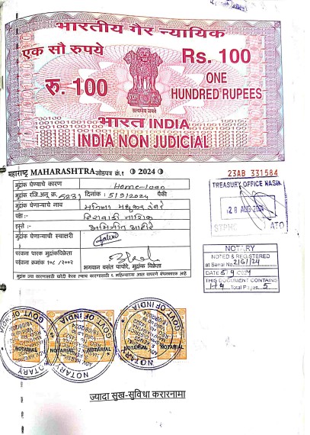
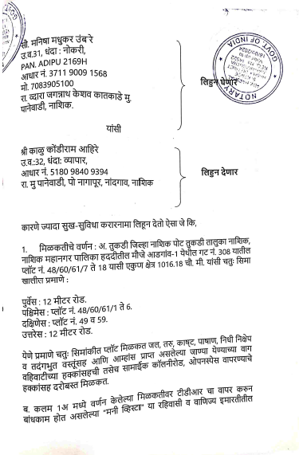

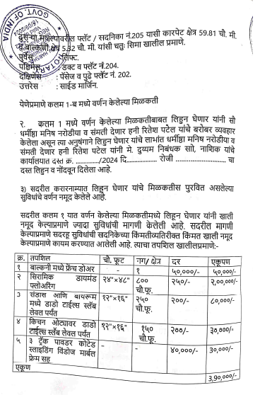
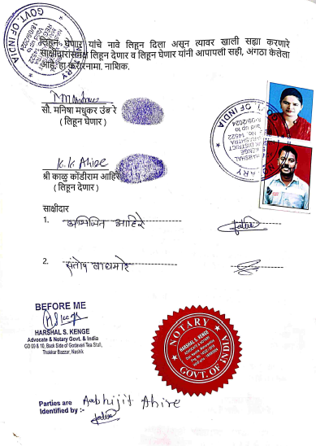

The Extra Amenities amount is Rs.3,90,000/- (Rupees Three Lakh Ninety Thousand Only.)

