Valuation Report of the Immovable Property
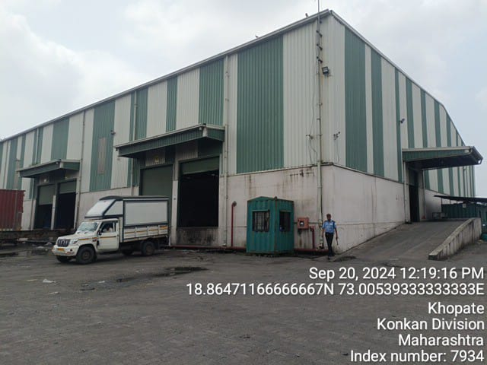

Details of the property under consideration:

Name of Client: M/s. Virgo Distriparks Pvt. Ltd.

Warehouse located on land bearing Survey No. 5/1, 5/2, 6/2A, 6/2B, 6/3, 6/4, 7/1, 7/2, 7/4, 10/1A1, 10/2, 10/3, 10/4, 48/8, 49/2, 49/4, 59/4, 60/1A, 60/1B, 60/3A, 60/3B, 60/4, 61/2A2, 62/1A, 62/1B, 62/2A, 62/2B1, 62/2B2, 62/3B, Village – Khopate, Taluka – Uran, District – Raigad, Pin Code – 410 206, Maharashtra, India

Longitude Latitude: 18°51'51.0"N 73°00'18.0"E

Intended User:

Private Clients

1. VALUATION OPINION REPORT 3
2. VALUATION REPORT (IN RESPECT OF WAREHOUSE) 4
3. TOTAL ABSTRACT OF THE ENTIRE PROPERTY 9
4. Actual Site Photographs 10
5. ROUTE MAP OF THE PROPERTY 12
6. ASSUMPTIONS, DISCLAIMERS, LIMITATIONS & QUALIFICATIONS 15
7. ASSUMPTIONS, CAVEATS, LIMITATION AND DISCLAIMERS 17
8. DEFINITION OF VALUE FOR THIS SPECIFIC PURPOSE 18

This report contains total 18 pages

Vastu/SBI/Mumbai/11/2024/11296/2301957
08/09-103-PY
Date: 05.11.2024

VALUATION OPINION REPORT

This is to certify that the Warehouse located on land bearing Survey No5/1, 5/2, 6/2A, 6/2B, 6/3, 6/4, 7/1, 7/2, 7/4, 10/1A1, 10/2, 10/3, 10/4, 48/8, 49/2, 49/4, 59/4, 60/1A, 60/1B, 60/3A, 60/3B, 60/4, 61/2A2, 62/1A, 62/1B, 62/2A, 62/2B1, 62/2B2, 62/3B, Village – Khopate, Taluka – Uran, District – Raigad, Pin Code – 410 206, Maharashtra, India belongs M/s. Virgo Distriparks Pvt. Ltd.
Boundaries of the property
North | : | Khopate - JNPT Port Road
South | : | Road and New Transindia Logistic Pvt. Ltd.
East | : | Main Road
West | : | Open plot and Khopate Village
Considering various parameters recorded, existing economic scenario, and the information that is available with reference to the development of neighborhood and method selected for valuation, we are of the opinion that, the property premises can be assessed and Depreciated Replacement Cost of the structure (warehouse) for this particular purpose at ` 7,46,49,604.00 (Rupees Seven Crore Forty Six Lakh Forty Nine Thousand Six Hundred Four Only).

The valuation of the property is based on the documents produced by the concern. Legal aspects have not been taken into considerations while preparing this valuation report.

Hence certified

Manoj B. Chalikwar
Registered Valuer
Chartered Engineer (India)
Reg. No. IBBI/RV/07/2018/10366
Encl: Valuation Report

Vastukala Consultants (I) Pvt. Ltd.
B1-001, U/B Floor, Boomerang, Chandivali Farm Road, Powai, Andheri (East), Mumbai – 400 072

To,
M/s. Virgo Distriparks Pvt. Ltd.

VALUATION REPORT (IN RESPECT OF WAREHOUSE)

I | General
1. | Purpose for which the valuation is made |  |  | : | As per the request from Client to assess depreciated replacement cost of the structure (warehouse) for transferring the structure to land owner.
2. | a) | Date of inspection |  | : | 20.09.2024
 | b) | Date on which the valuation is made |  | : | 07.11.2024
3. | List of documents produced for perusal
- Copy of Architect Drawing Plan dated 14.11.2019 issued by M/s. Anil Shah & Associates.
- Copy of Property Tax Letter No. 64/2024 dated 29.04.2024 issued by Group Grampanchayat Bandhapada (Khopte).
- Copy of Insurance Policy No. 0000000034689248 dated 23.08.2023 for period of insurance from 02.08.2023 to 01.08.2024 issued by SBI General Insurance.
- Copy of N. A. Order vide No. Masha / LNA 1 (B) / S.R.38 / 2015 dated 31.03.2017 issued by Office of District Collector, Raigad – Alibag.
- Copy of N. A. Remarks vide No. CIDCO / NAINA / Khopta (Kacherpada) / NOC NA – 13634 / 2016 / 5240 dated 23.12.2016 issued by CIDCO for proposed Commercial Use.
- Copy of 7/12 Revenue Extract of all Survey Number.
4. | Name of the client and his / their address (es) with Phone no. (details of share of each owner in case of joint ownership) |  |  | : | M/s. Virgo Distriparks Pvt. Ltd.  Address:  Warehouse located on land bearing Survey No. 5/1, 5/2, 6/2A, 6/2B, 6/3, 6/4, 7/1, 7/2, 7/4, 10/1A1, 10/2, 10/3, 10/4, 48/8, 49/2, 49/4, 59/4, 60/1A, 60/1B, 60/3A, 60/3B, 60/4, 61/2A2, 62/1A, 62/1B, 62/2A, 62/2B1, 62/2B2, 62/3B, Village – Khopate, Taluka – Uran, District – Raigad, Pin Code – 410 206, Maharashtra, India  Contact Person:  Mr. Dharmil P. Sheth (Company’s Representative)  Mb. No.: +91 – 98333 92860  Structure comes under Company Ownership
5. | Brief description of the property (Including Leasehold / freehold etc.):
The property is located in a developing industrial area having good infrastructure, well connected by road and train. The immovable property comprises of warehouse excluding land. It is located at about 9.40 Km travelling distance from Uran Railway Station & 9.70 Km. travelling distance from Uran Bus Station. Logistics parks are coming up in nearby locality due to development of Jawaharlal Nehru Port.

Land:
As per 7/12 Revenue Extract Plot area are as under:
Sr. No. | Survey No. | Hissa No. | Plot Area As per 7/12 Extract  (Area in H.R.) | Plot Area As per 7/12 Extract (Area in Sq. M.) | Land Owner Name
1 | 5 | 1 | 0.3190 | 3,190.00 | Mr. Pankaj Mukundrai Sheth and Mrs. Asha Pankaj Sheth
2 | 5 | 2 | 0.2880 | 2,880.00 | Mr. Pankaj Mukundrai Sheth and Mrs. Asha Pankaj Sheth
3 | 6 | 2A | 0.3300 | 3,300.00 | Mr. Pankaj Mukundrai Sheth
4 | 6 | 2B | 0.4820 | 4,820.00 | Mr. Pankaj Mukundrai Sheth and Mrs. Asha Pankaj Sheth
5 | 6 | 3 | 0.5920 | 5,920.00 | Mrs. Asha Pankaj Sheth
6 | 6 | 4 | 0.1820 | 1,820.00 | Mr. Pankaj Mukundrai Sheth and Mrs. Asha Pankaj Sheth
7 | 7 | 1 | 0.0180 | 180.00 | Mr. Pankaj Mukundrai Sheth and Mrs. Asha Pankaj Sheth
8 | 7 | 2 | 0.0100 | 100.00 | Mrs. Asha Pankaj Sheth
9 | 7 | 4 | 0.2400 | 2,400.00 | Mr. Pankaj Mukundrai Sheth and Mrs. Asha Pankaj Sheth
10 | 10 | 1A1 | 0.1830 | 1,830.00 | Mrs. Asha Pankaj Sheth
11 | 10 | 2 | 0.4330 | 4,330.00 | Mrs. Asha Pankaj Sheth
12 | 10 | 3 | 0.2000 | 2,000.00 | Mrs. Asha Pankaj Sheth
13 | 10 | 4 | 0.2300 | 2,300.00 | Mrs. Asha Pankaj Sheth
14 | 48 | 8 | 0.2600 | 2,600.00 | Mr. Pankaj Mukundrai Sheth and Mrs. Asha Pankaj Sheth
15 | 49 | 2 | 0.3440 | 3,440.00 | Mrs. Asha Pankaj Sheth
16 | 49 | 4 | 0.8730 | 8,730.00 | Mr. Pankaj Mukundrai Sheth and Mrs. Asha Pankaj Sheth
17 | 59 | 4 | 0.3110 | 3,110.00 | Mr. Pankaj Mukundrai Sheth and Mrs. Asha Pankaj Sheth
18 | 60 | 1A | 0.2220 | 2,220.00 | Mr. Pankaj Mukundrai Sheth and Mrs. Asha Pankaj Sheth
19 | 60 | 1B | 0.1600 | 1,600.00 | Mr. Pankaj Mukundrai Sheth
20 | 60 | 3A | 0.3010 | 3,010.00 | Mr. Pankaj Mukundrai Sheth and Mrs. Asha Pankaj Sheth
21 | 60 | 3B | 0.3020 | 3,020.00 | Mr. Pankaj Mukundrai Sheth and Mrs. Asha Pankaj Sheth
22 | 60 | 4 | 0.6050 | 6,050.00 | Mr. Pankaj Mukundrai Sheth and Mrs. Asha Pankaj Sheth
23 | 61 | 2A2 | 0.3300 | 3,300.00 | Mr. Pankaj Mukundrai Sheth and Mrs. Asha Pankaj Sheth
24 | 62 | 1A | 0.2250 | 2,250.00 | Mr. Pankaj Mukundrai Sheth and Mrs. Asha Pankaj Sheth
25 | 62 | 1B | 0.2200 | 2,200.00 | Mr. Pankaj Mukundrai Sheth and Mrs. Asha Pankaj Sheth
26 | 62 | 2A | 0.3440 | 3,440.00 | Mr. Pankaj Mukundrai Sheth and Mrs. Asha Pankaj Sheth
27 | 62 | 2B1 | 0.24 | 2,390.00 | Mrs. Asha Pankaj Sheth
28 | 62 | 2B2 | 0.24 | 2,360.00 | Mr. Pankaj Mukundrai Sheth and Mrs. Asha Pankaj Sheth
29 | 62 | 3B | 0.34 | 3,360.00 | Mr. Pankaj Mukundrai Sheth
TOTAL |  |  | 8.82 | 88,150.00

Structure:

As per information provided by the client construction of the structure on the above land was done by M/s. Virgo Distriparks Pvt. Ltd. for logistics purpose.

As per the architect drawing plan the warehouse area is 7,457.50 Sq. M. and same is considered for the valuation.

At the time of site inspection, warehouse was used by M/s. Virgo Distriparks Pvt. Ltd. use for logistics purpose and approval for the same is not provide by the client hence, we have considered area as per architect drawing plan only.
6. | Location of property |  |  | :
 | a) | Plot No. / Survey No. |  | : | Survey No. 5/1, 5/2, 6/2A, 6/2B, 6/3, 6/4, 7/1, 7/2, 7/4, 10/1A1, 10/2, 10/3, 10/4, 48/8, 49/2, 49/4, 59/4, 60/1A, 60/1B, 60/3A, 60/3B, 60/4, 61/2A2, 62/1A, 62/1B, 62/2A, 62/2B1, 62/2B2, 62/3B
 | b) | Door No. |  | : | Not applicable
 | c) | C.T.S. No. / Village |  | : | Village – Khopate
 | d) | Ward / Taluka |  | : | Taluka – Uran
 | e) | Mandal / District |  | : | District – Raigad
7. | Postal address of the property |  |  | : | Warehouse located on land bearing Survey No. 5/1, 5/2, 6/2A, 6/2B, 6/3, 6/4, 7/1, 7/2, 7/4, 10/1A1, 10/2, 10/3, 10/4, 48/8, 49/2, 49/4, 59/4, 60/1A, 60/1B, 60/3A, 60/3B, 60/4, 61/2A2, 62/1A, 62/1B, 62/2A, 62/2B1, 62/2B2, 62/3B, Village – Khopate, Taluka – Uran, District – Raigad, Pin Code – 410 206, Maharashtra, India
8. | City / Town |  |  | : | Village – Khopate, Uran
 | Residential area |  |  | : | No
 | Commercial area |  |  | : | Yes
 | Industrial area |  |  | : | No
9. | Classification of the area |  |  | :
 | i) High / Middle / Poor |  |  | : | Middle Class
 | ii) Urban / Semi Urban / Rural |  |  | : | Rural
10. | Coming under Corporation limit / Village Panchayat / Municipality |  |  | : | Village – Khopate
11. | Whether covered under any State / Central Govt. enactments (e.g., Urban Land Ceiling Act) or notified under agency area/ scheduled area / cantonment area |  |  | : | No
12. | In Case it is Agricultural land, any conversion to house site plots is contemplated |  |  | : | N.A.
13. | Boundaries of the property
 | As per Document | As per Actual Boundaries
North | Information not available | Khopate - JNPT Port Road
South | Information not available | Road and New Transindia Logistic Pvt. Ltd.
East | Information not available | Main Road
West | Information not available | Open plot and Khopate Village

14.1 | Dimensions of the site |  |  |  | N. A. as the plot under consideration is irregular in shape.
14.2 | Latitude, Longitude & Co-ordinates of property |  |  | : | 18°51'51.0"N 73°00'18.0"E
14. | Extent of the site |  |  | : | Warehouse area = 7,457.50 Sq. M.  (As per Plan)
15. | Extent of the site considered for Valuation (least of 14A& 14B) |  |  | :
16 | Whether occupied by the owner / tenant? If occupied by tenant since how long? Rent received per month. |  |  | : | Warehouse is occupied by M/s. Virgo Distriparks Pvt. Ltd.
II | CHARACTERSTICS OF THE SITE
 | Classification of locality |  |  | : | Middle Class
 | Development of surrounding areas |  |  | : | Normal
 | Possibility of frequent flooding/ sub-merging |  |  | : | No
 | Feasibility to the Civic amenities like School, Hospital, Bus Stop, Market etc. |  |  | : | All available near by
 | Level of land with topographical conditions |  |  | : | Plain
 | Shape of land |  |  | : | Irregular Shape
 | Type of use to which it can be put |  |  | : | For Commercial purpose
 | Any usage restriction |  |  | : | Commercial
 | Is plot in town planning approved layout? |  |  | : | N.A.
 | Corner plot or intermittent plot? |  |  | : | Intermittent
 | Road facilities |  |  | : | Yes
 | Type of road available at present |  |  | : | B.T. Road
 | Width of road – is it below 20 ft. or more than 20 ft. |  |  | : | 9 M wide road
 | Is it a Land – Locked land? |  |  | : | No
 | Water potentiality |  |  | : | Available
 | Underground sewerage system |  |  | : | Connected to sewer line
 | Is Power supply is available in the site |  |  | : | Yes
 | Advantages of the site |  |  | : | Located in developing area
 | Special remarks, if any like threat of acquisition of land for publics service purposes, road widening or applicability of CRZ provisions etc. (Distance from sea-cost / tidal level must be incorporated) |  |  | : | No
Part – A (Valuation of land) |  |  |  |  |  | Not Applicable, as we are doing valuation for depreciated replacement cost of the structure (warehouse) for transferring the structure to land owner
1 | Size of plot |  | :
 | North & South |  | :
 | East & West |  | :
2 | Total extent of the plot |  | :
3 | Prevailing market rate (Along With details / reference of at least two latest deals / transactions with respect to adjacent properties in the areas) |  | :
4 | Govt. Ready Reckoner rate obtained from the Circle Rate for Land |  | :
 | In case of variation of 20% or more in the valuation proposed by the valuer and the Guideline value provided in the State Govt. notification or Income Tax Gazette justification on variation has to be given. |  | :
5 | Assessed / adopted rate of valuation |  | :
6 | Estimated value of land |  | :
Part – B (Valuation of Building)
1 | Technical details of the building |  | :
 | - Type of Building (Residential / Commercial / Industrial) |  | : |  |  | Commercial (Warehouse)
 | - Type of construction (Load bearing / RCC / Steel Framed) |  | : |  |  | RCC footing with GI Sheet Structure for wall and roofing
 | - Year of construction |  | : |  |  | Approx. 2019 (As per information from client)
 | - Number of floors and height of each floor including basement, if any |  | : |  |  | Ground Floor Structure
 | - Plinth area floor-wise |  | : |  |  | Warehouse area = 7,457.50 Sq. M.  (As per Plan)
 | - Condition of the building |  | :
 | - Exterior – Excellent, Good, Normal, Poor |  | : |  |  | Good
 | - Interior – Excellent, Good, Normal, Poor |  | : |  |  | Good
 | - Date of issue and validity of layout of approved map |  | : |  |  | Copy of Architect Drawing Plan dated 14.11.2019 issued by M/s. Anil Shah & Associates.
 | - Approved map / plan issuing authority |  | :
 | - Whether genuineness or authenticity of approved map / plan is verified |  | : |  |  | Not Applicable
 | - Any other comments by our empanelled valuers on authentic of approved plan |  | : |  |  | No

Specifications of construction (floor-wise) in respect of
Sr.  No. | Description
 | Foundation | : | RCC Foundation
 | Basement | : | No
 | Superstructure | : | RCC Footing with GI Sheet Structure for wall and roofing, PCC flooring
 | Joinery / Doors & Windows (Please furnish details about size of frames, shutters, glazing, fitting etc. and specify the species of timber | :
 | RCC Works | :
 | Plastering | :
 | Flooring, Skirting, dado | :
 | Special finish as marble, granite, wooden paneling, grills etc. | : | -
 | Roofing including weatherproof course | : | GI Sheet Roofing
 | Drainage | : | Connected to Sewerage line
2. | Compound Wall | :
 | Height | : | 5'.6" High, R.C.C. columns with B. B. Masonry wall.
 | Length | : | 5'.6" High, R.C.C. columns with B. B. Masonry wall.
 | Type of construction | : | 5'.6" High, R.C.C. columns with B. B. Masonry wall.
3. | Electrical installation | :
 | Type of wiring | : | Open wiring
 | Class of fittings (superior / ordinary / poor) | : | Ordinary
 | Number of light points | : | Provided as per requirement
 | Fan points | : | Provided as per requirement
 | Spare plug points | : | Provided as per requirement
 | Any other item | : | -
4. | Plumbing installation
 | - No. of water closets and their type | : | Provided as per requirement
 | - No. of wash basins | : | Provided as per requirement
 | - No. of urinals | : | Provided as per requirement
 | - No. of bath tubs | : | Provided as per requirement
 | - Water meters, taps etc. | : | Provided as per requirement
 | - Any other fixtures | : | Provided as per requirement

Value of the Warehouse:

Floor | Built Up Area | Year Of Const. | Valuation Year | Total Life of Structure | Full Rate | Age Of Build. | Final Depreciated Rate to be considered | Final Depreciated Value / Market Value to be considered
 | in Sq. M. | Year |  | Year | in ` |  | in ` | in `
Ground | 7,457.50 | 2019 | 2024 | 50 | 11,000.00 | 5 | 10,010.00 | 7,46,49,604.00
TOTAL | 7,457.50 |  |  |  |  |  |  | 7,46,49,604.00

TOTAL ABSTRACT OF THE ENTIRE PROPERTY

Part – A | Land | : | -
Part – B | Building / Warehouse | : | ` 7,46,49,604.00
In - Situ Value / Depreciated Replacement Cost of Structure |  | : | ` 7,46,49,604.00
Ex – Situ Value (20% of in – situ value) |  | : | ` 1,49,29,921.00
Remarks:

Actual Site Photographs
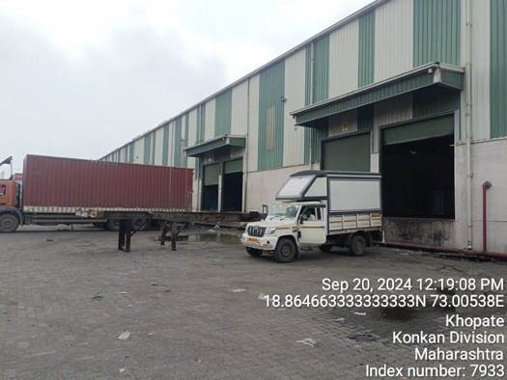
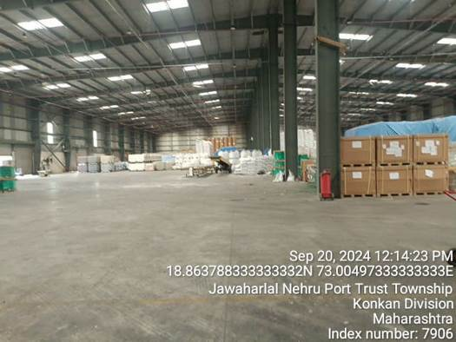
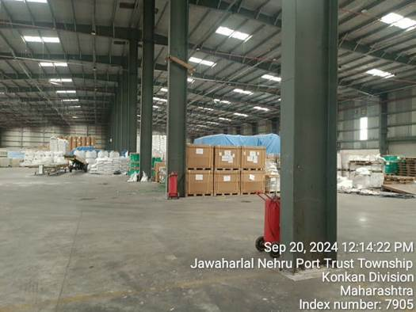
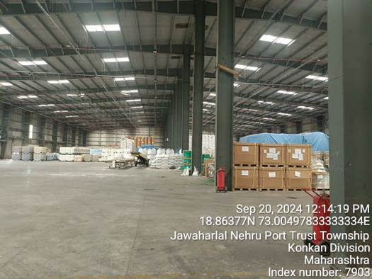
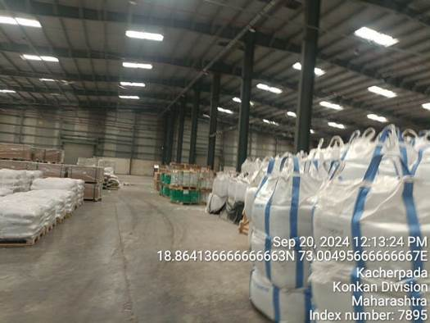
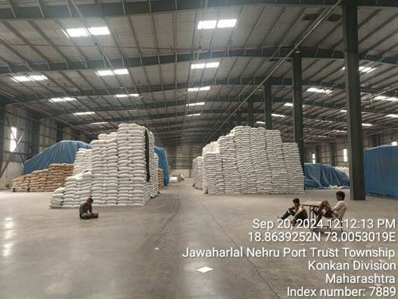
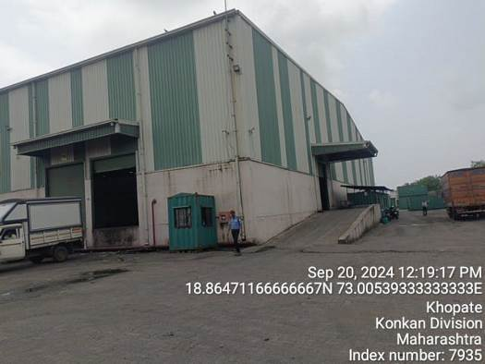
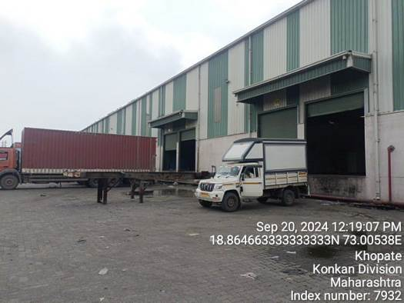
Actual Site Photographs
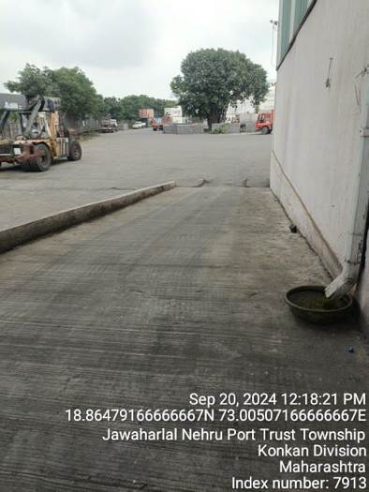
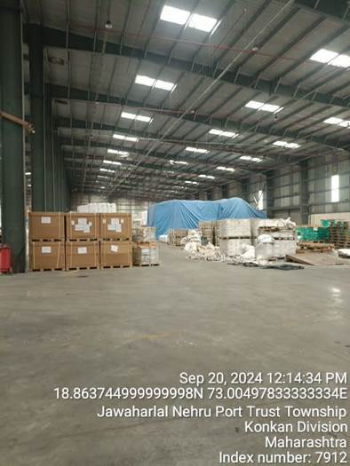
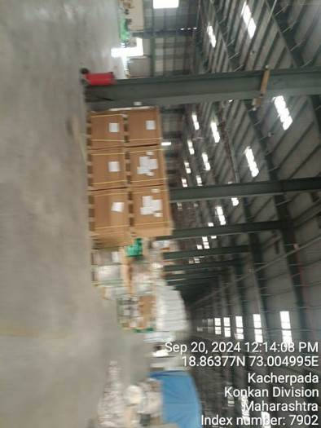
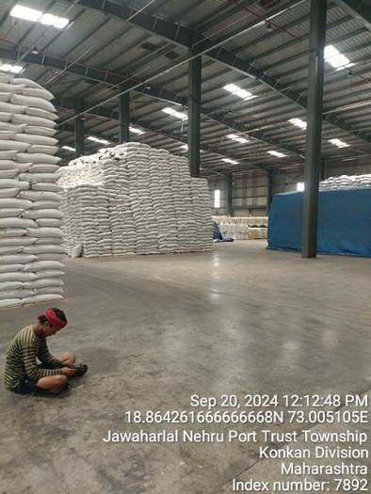
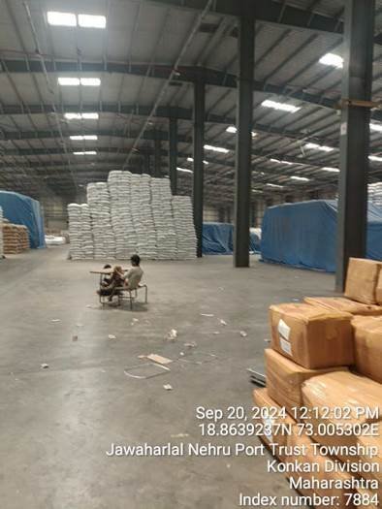
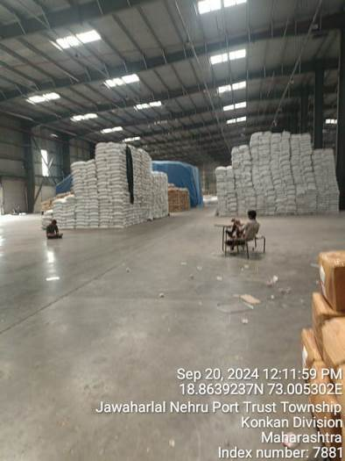

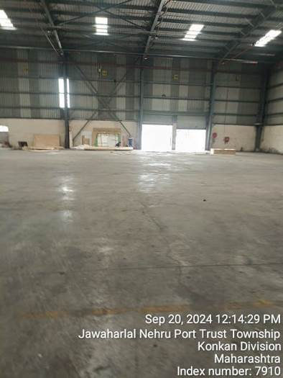
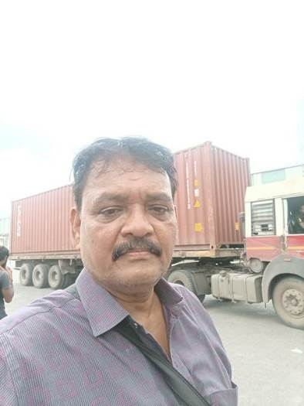

ROUTE MAP OF THE PROPERTY
Site u/r
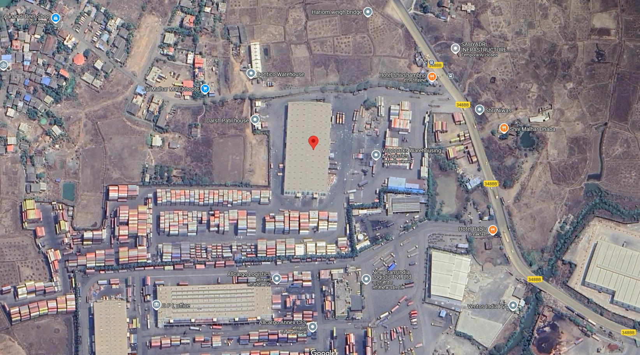

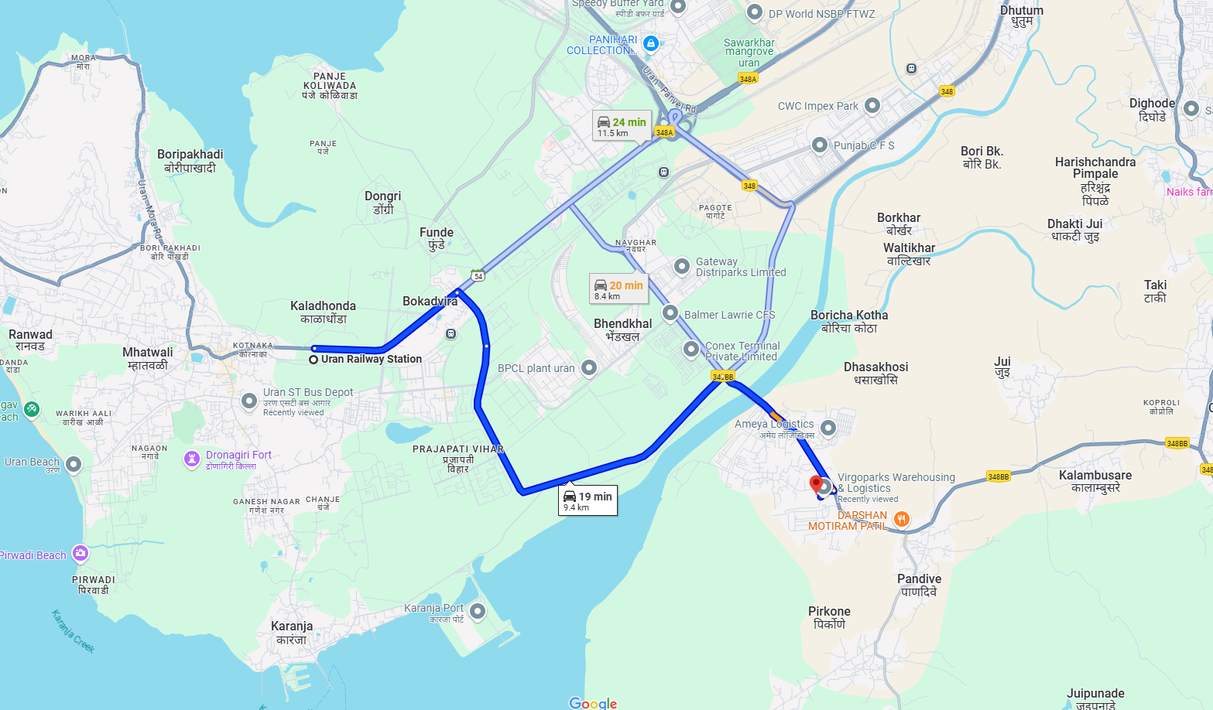

Latitude Longitude: 18°51'51.0"N 73°00'18.0"E
Note: The Blue line shows the route to site from nearest Railway Station (Uran – 9.40 Km.)

As a result of my appraisal and analysis, it is my considered opinion that the depreciated replacement cost of the structure (warehouse) for this particular purpose at ` 7,46,49,604.00 (Rupees Seven Crore Forty Six Lakh Forty Nine Thousand Six Hundred Four Only).

Place: Mumbai
Date: 07.11.2024

Manoj B. Chalikwar
Registered Valuer
Chartered Engineer (India)
Reg. No. IBBI/RV/07/2018/10366

Sr. | Particulars | Valuer comment
 | Background information of the asset being valued; | Warehouse is constructed by M/s. Virgo Distriparks Pvt. Ltd.
 | Purpose of valuation and appointing authority | As per the request from Client to assess depreciated replacement cost of the structure (warehouse) for transferring the structure to land owner.
 | Identity of the Valuer and any other experts involved in the valuation; | Manoj B. Chalikwar – Regd. Valuer  Umang Patel – Regd. Valuer  Prayush P. Parekh – Senior Valuation Engineer  Rajesh Ghadi – Valuation Engineer
 | Disclosure of Valuer interest or conflict, if any; | We have no interest, either direct or indirect, in the property valued. Further to state that we do not have relation or any connection with property owner / applicant directly or indirectly. Further to state that we are an independent Valuer and in no way related to property owner / applicant
 | Date of appointment, valuation date and date of report; | Date of Appointment – 18.09.2023  Valuation Date – 07.11.2024  Date of Report – 07.11.2024
 | Inspections and/or investigations undertaken; | Physical Inspection done on date 20.09.2023
 | Nature and sources of the information used or relied upon; | Existing data of Valuation assignments carried out by us
 | Procedures adopted in carrying out the valuation and valuation standards followed; | Cost Approach - Straight Line Deprecation Method (Depreciated Replacement Building Cost)
 | Restrictions on use of the report, if any; | This valuation is for the use of the party to whom it is addressed and for no other purpose. No responsibility is accepted to any third party who may use or rely on the whole or any part of this valuation. The valuer has no pecuniary interest that would conflict with the proper valuation of the property.
 | Major factors that were taken into account during the valuation; | Type of Construction, Age of Building & Other Factors, etc.
 | Caveats, limitations and disclaimers to the extent they explain or elucidate the limitations faced by valuer, which shall not be for the purpose of limiting his responsibility for the valuation report. | Attached

ASSUMPTIONS, DISCLAIMERS, LIMITATIONS & QUALIFICATIONS

Value Subject to Change
The subject appraisal exercise is based on prevailing market dynamics as on 07th November 2024 and does not take into account any unforeseeable developments which could impact the same in the future.

Our Investigations
We are not engaged to carry out all possible investigations in relation to the subject property. Where in our report we identify certain limitations to our investigations, this is to enable the reliant party to instruct further investigations where considered appropriate or where we recommend as necessary prior to reliance. Vastukala Consultants India Pvt. Ltd. (VCIPL) is not liable for any loss occasioned by a decision not to conduct further investigations

Assumptions
Assumptions are a necessary part of undertaking valuations. VCIPL adopts assumptions for the purpose of providing valuation advise because some matters are not capable of accurate calculations or fall outside the scope of our expertise, or out instructions. The reliant party accepts that the valuation contains certain specific assumptions and acknowledge and accept the risk of that if any of the assumptions adopted in the valuation are incorrect, then this may have an effect on the valuation.

Information Supplied by Others
The appraisal is based on the information provided by the client. The same has been assumed to be correct and has been used for appraisal exercise. Where it is stated in the report that another party has supplied information to VCIPL, this information is believed to be reliable but VCIPL can accept no responsibility if this should prove not to be so.

Future Matters
To the extent that the valuation includes any statement as to a future matter, that statement is provided as an estimate and/or opinion based on the information known to VCIPL at the date of this document. VCIPL does not warrant that such statements are accurate or correct.

Map and Plans
Any sketch, plan or map in this report is included to assist the reader while visualizing the property and assume no responsibility in connection with such matters.

Site Details
Based on inputs received from Client's representative and site visit conducted, we understand that the subject property is currently a warehouse admeasuring 7,457.50 Sq. M. The property is constructed by M/s. Virgo Distriparks Pvt. Ltd. At present, the property is Occupied by M/s. Virgo Distriparks Pvt. Ltd. Further, VCIPL has assumed that the subject property is free from any encroachment and is available as on the date of the appraisal.

Property Title
Based on our discussion with the Client, we understand that the property is constructed by M/s. Virgo Distriparks Pvt. Ltd. For the purpose of this appraisal exercise, we have assumed that the subject property has a clear title and is free from any encumbrances, disputes and claims. VCIPL has made no further enquiries with the relevant local authorities in this regard and does not certify the property as having a clear and marketable title. Further, no legal advice regarding the title and ownership of the subject property has been obtained for the purpose of this appraisal exercise. It has been assumed that the title deeds are clear and marketable.

Environmental Conditions
We have assumed that the subject property is not contaminated and is not adversely affected by any existing or proposed environmental law and any processes which are carried out on the property are regulated by environmental legislation and are properly licensed by the appropriate authorities.

Town Planning
The permissible land use, zoning, achievable FSI, area statement adopted for purpose of this valuation is based on the information provided by the Client's representative and the same has been adopted for this valuation purpose. VCIPL has assumed the same to be correct and permissible. VCIPL has not validated the same from any authority.

Area
Based on the documents, we understand that the subject property is warehouse admeasuring 7,457.50 Sq. M.

Condition & Repair
In the absence of any information to the contrary, we have assumed that there are no abnormal ground conditions, nor archaeological remains present which might adversely affect the current or future occupation, development or value of the property. The property is free from rat, infestation, structural or latent defect. No currently known deleterious or hazardous materials or suspect techniques will be used in the construction of or subsequent alteration or additions to the property and comments made in the property details do not purport to express an opinion about, or advise upon, the condition of uninspected parts and should not be taken as making an implied representation or statement about such parts

Valuation Methodology
For the purpose of this valuation exercise, the valuation methodology used is Cost Approach Method and sub method Straight Line Deprecation Method for deriving the value of the warehouse structure.
Where reliance has been placed upon external sources of information in applying the valuation methodologies, unless otherwise specifically instructed by Client and/or stated in the valuation, VCIPL has not independently verified that information and VCIPL does not advise nor accept it as reliable. The person or entity to whom the report is addressed acknowledges and accepts the risk that if any of the unverified information in the valuation is incorrect, then this may have an effect on the valuation.

Not a Structural Survey
We state that this is a valuation report and not a structural survey

Other
All measurements, areas and ages quoted in our report are approximate

Legal
We have not made any allowances with respect to any existing or proposed local legislation relating to taxation on realization of the sale value of the subject property. VCIPL is not required to give testimony or to appear in court by reason of this appraisal report, with reference to the property in question, unless arrangement has been made thereof. Further, no legal advice on any aspects has been obtained for the purpose of this appraisal exercise

Property specific assumptions
Based on inputs received from the client and site visit conducted, we understand that the subject property is warehouse admeasuring 7,457.50 Sq. M.

ASSUMPTIONS, CAVEATS, LIMITATION AND DISCLAIMERS
- We assume no responsibility for matters of legal nature affecting the property appraised or the title thereto, nor do we render our opinion as to the title, which is assumed to be good and marketable.
- The property is valued as though under responsible ownership.
- It is assumed that the property is free of liens and encumbrances.
- It is assumed that there are no hidden or unapparent conditions of the subsoil or structure that would render it more or less valuable. No responsibility is assumed for such conditions or for engineering that might be required to discover such factors.
- There is no direct/ indirect interest in the property valued.

DEFINITION OF VALUE FOR THIS SPECIFIC PURPOSE

This exercise is to assess Market Value of the property under reference as on 07th November 2024.

The term Market Value is defined as

“The most probable price, as of a specified date, in cash, terms equivalent to cash, or in other precisely revealed terms for which the specified property rights would sell after reasonable exposure in a competitive market under all conditions requisite to a fair sale, with the buyer and seller each acting prudently knowledgeably and for self interest assuming that neither is under undue duress”.

Fundamental assumptions and conditions presumed in this definition are:

1. Buyer and seller are motivated by self-interest.
2. Buyer and seller are well informed and are acting prudently.
3. The property is exposed for a reasonable time on the open market.
4. Payment is made in cash or equivalent or in specified financing terms.
DECLARATION OF PROFESSIONAL FEES CHARGED

We hereby declare that, our professional fees are not contingent upon the valuation findings. However, if the statute AND/OR clients demands that, the fees should be charged on the percentage of assessed value then, with the full knowledge of the AND/OR end user, it is being charged accordingly.

VALUATION OF THE PROPERTY PREMISES

Considering various parameters recorded, existing economic scenario, and the information that is available with reference to the development of neighborhood and method selected for valuation, we are of the opinion that, the property premises can be assessed and depreciated replacement cost of the structure (warehouse) for this particular purpose at ` 7,46,49,604.00 (Rupees Seven Crore Forty Six Lakh Forty Nine Thousand Six Hundred Four Only).

Manoj B. Chalikwar
Registered Valuer
Chartered Engineer (India)
Reg. No. IBBI/RV/07/2018/10366

