Vastu/Nashik/07/2024/0010070/2307330
22/7-334-RPBS
Date: 19.09.2024

To, `
The Branch Manager,
Bank of Baroda
Regional Office Nashik Road Branch
BSNL Building, Datta Mandir Road, Nashik Road,
Nashik -422 101, State - Maharashtra, Country - India.

Sub: Vetting of Extra Amenities

Sir,

With reference to above subject, we have evaluated the Extra Amenities for Residential Flat No. 503, 5th Floor, Shivganga Avenue-D, Near Marigold Bungalow, Narhari Nagar, Pathardi Phata, Plot No. 17/18, Damodar Nagar, Village - Pathardi-1, Taluka - Nashik, District - Nashik, Nashik, 422010, State - Maharashtra, India belongs to Shri. Akshay Rajaram Shelar & Shri. Sagar Rajaram Shelar.

We have verified the rates quoted as per current market rates. Details of work and Extra Amenities considered as per copy of Agreement for Extra Amenities issued by to Shri. Akshay Rajaram Shelar & Shri. Sagar Rajaram Shelar (First Party) and Shri. Tirth Bharatbhai Gajipara (Second Party) received on dated 16.09.2024. The Extra Amenities amount is Rs.3,40,000/- (Rupees Three Lakh Forty Thousand Only.)

The said Cost Vetting Certificate is valid upto next 6 months Only.

Thanking you

Sincerely yours

Manoj B. Chalikwar
Registered Valuer
Chartered Engineer (India)
Reg. No. CAT-I-F-1763
Reg. No. IBBI/RV/07/2018/10366
BOB Empanelment No.: ZO:MZ:ADV:46:941
Encl: Valuation report.

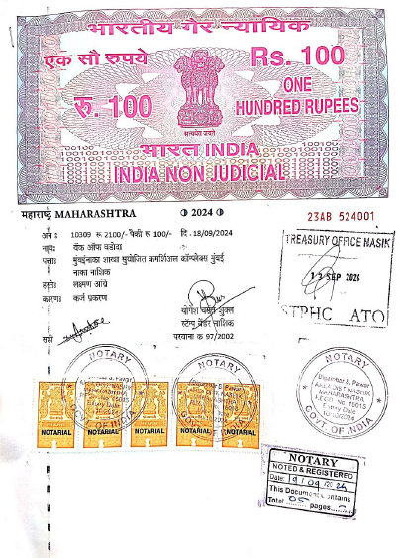
Agreement for Extra Amenities


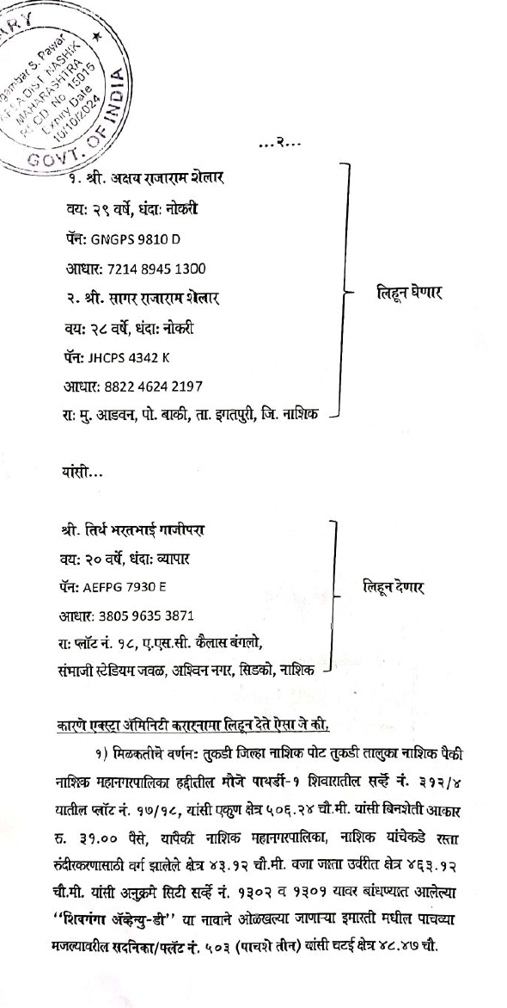

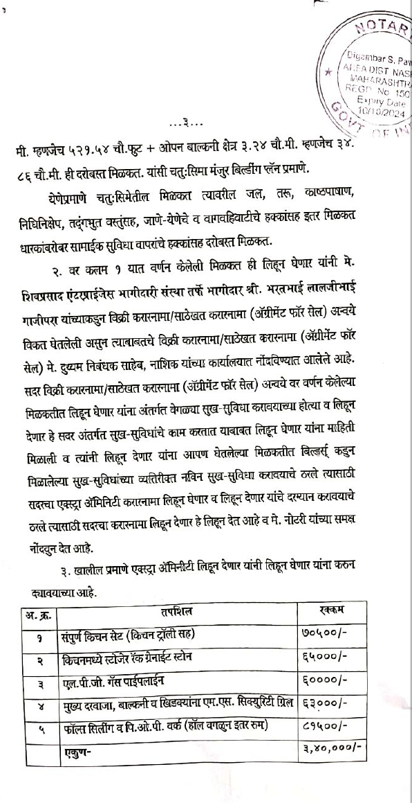
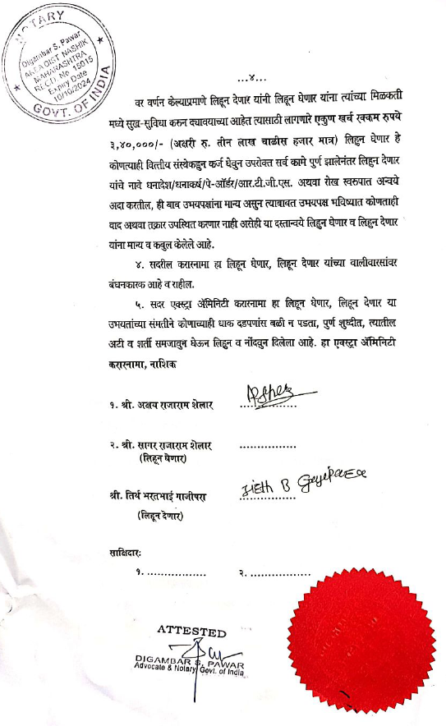

The Extra Amenities amount is Rs.3,40,000/- (Rupees Three Lakh Forty Thousand Only.)

