Valuation Report of the Immovable Property
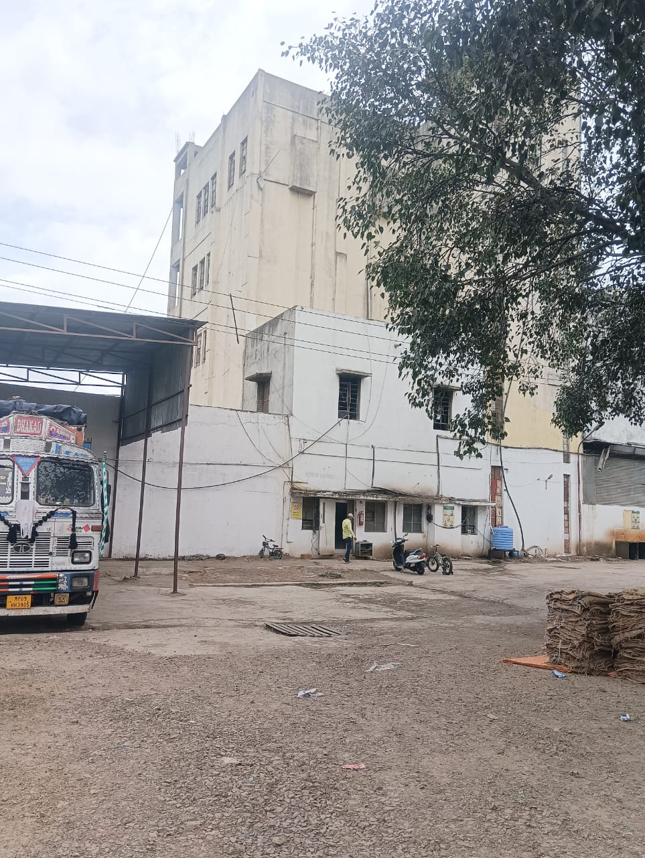

Details of the property under consideration:

Name of Owner: M/s. NR Brothers Roller Flour Mills (P) Ltd.

Industrial Land and Building on Plot No.15,19,20,21, Survey No.20/1, Near Patel Saw Mill, Burkulwadi,
Nandgaon Road, At – Manmad, PIN Code – 423 104, Taluka - Nandgaon, District – Nashik,
State – Maharashtra, Country – India.

Latitude Longitude: 20°15'56.2"N 74°27'04.2"E

Valuation Done for:
Bank of India
Main Trambak Road
Main Trimbak Road, Plot No. G-1, Midc, Industrial Estate, Satpur Colony,
Nashik-422 007, State - Maharashtra,Country - India

Vastukala Consultants (I) Pvt. Ltd.
Mumbai • Delhi NCR • Aurangabad • Nanded • Indore • Pune Raipur • Jaipur • Ahmedabad • Rajkot • Thane • Nashik

Vastu/Nashik/09/2024/011274/2308228
19/2-234-CCRJ
Date: 19.09.2024

VALUATION OPINION REPORT

This is to certify that the property bearing Industrial Land and Building on Plot No.15,19,20,21, Survey No.20/1 Near Patel Saw Mill, Burkulwadi, Nandgaon Road, At – Manmad, PIN Code – 423 104, Taluka - Nandgaon, District – Nashik, State – Maharashtra, Country – India belongs to M/s.NR Brothers Roller Flour Mills (P) Ltd.

Boundaries of the property.

 | Plot No.15 & 20 | Plot No.19 & 21
North | Open Space | Plot No.14
South | Road | Road
East | Plot No.16 & 21 | Plot No.20
West | Plot No.14 & 19 | Plot No.18

Considering various parameters recorded, existing economic scenario, and the information that is available with reference to the development of neighborhood and method selected for valuation, we are of the opinion that, the property premises can be assessed and valued for this particular purpose at ` 7,15,06,850.00 (Rupees Seven Crore Fifteen Lakh Six Thousand Eight Hundred Fifty Only).

The valuation of the property is based on the documents produced by the concern. Legal aspects have not been taken into considerations while preparing this valuation report.

Hence certified

Manoj B. Chalikwar
Registered Valuer
Chartered Engineer (India)
Reg. No. CAT-I-F-1763
BOI Empanelment No.: MNZ:C&IC:VAL19-20
Encl: Valuation report.

Vastukala Consultants (I) Pvt. Ltd.
B1-001, U/B Floor, Boomerang, Chandivali Farm Road, Powai, Andheri (East), Mumbai – 400 072

To,
The Branch Manager,
Bank of India
Main Trambak Road
Main Trimbak Road, Plot No. G-1, Midc, Industrial Estate,
Satpur Colony, Nashik-422 007, State - Maharashtra, Country - India

VALUATION REPORT (IN RESPECT OF INDUSTRIAL LAND & BUILDING)
I | General
1. | Purpose for which the valuation is made |  |  | : | To assess fair market value of the property for Banking Purpose.
2. | a) | Date of inspection |  | : | 16.09.2024
 | b) | Date on which the valuation is made |  | : | 19.09.2024
3. | List of documents produced for perusal |  |  | :
- Copy of Memorandum of Agreement of Land Lease Dated.2nd February 1982.
- Copy of Memorandum of Agreement of Land Lease Dated.1st February 2017
- Copy of Approved Building Plan No.252 Year-1991-1992 Issued by Manmad Nagar Parishad, Manmad.
- Copy of Occupancy Certificate Javak No.3602/1992 Dated.30.12.1992 Issued by Issued by Manmad Nagar Parishad, Manmad.
- Copy of 7/12 Extract
4. | Name of the owner(s) and his / their address (es) with Phone no. (details of share of each owner in case of joint ownership) |  |  | : | M/s.NR Brothers Roller Flour Mills (P)Ltd  Address – Industrial Land and Building on Plot No.15,19,20,21, Survey No.20/1, Near Patel Saw Mill, Burkulwadi , Nandgaon Road, At – Manmad , PIN Code – 423 104, Taluka - Nandgaon, District – Nashik, State – Maharashtra, Country – India  Contact Person –  Mr.Ajit Bedmutha (Owner)  Contact No. – +91 9545069914  Sole Ownership
5. | Brief description of the property (Including Leasehold / freehold etc.) |  |  | :
The property is located in a developed area well connected by road. The immovable property comprises of freehold N.A. land and structure thereof. It is located at about 23.5 Km. distance from Nashik Road Railway Station.
Plot:
The plot under valuation is Freehold Industrial plot. As per Approved Plan Plot area is 3567.44 Sq. M, which is considered for valuation

Structure:
As per Approved Plan Composition of Building are as under:
Description
RCC Framed Structure
Ground Floor- Finished Goods Go Down, Roll Body Room, Hammer Room, Wheat Silo, Office Outer Cabin, Office Main Cabin, Bardana Godown, Wheat Godown,Main Pannel Room, Staircase, Passage.
First Floor- Purifier Room, Chakki Godown, Wheat Silo, Store Room,Passage, Staircase
Second Floor- Wheat Cleaning Section, Wheat Silo, Chakki Room, Plantshifter Room, Electric Panel Room
Third Floor-Cleaning Section, Chakki Plant Shifter Room, High Pressure, Wheat Silo, Electric Panel Room, Passage, Staircase
Fourth Floor-Cleaning Section, Chakki High Pressure, Wheat Silo, Electric Panel Room, Terrace, Passage, Staircase

As per Approved Plan Built Up area is 2806.26 Sq. M., which is considered for valuation.

Floors | Built up Area  (Sq. M.)
Ground Floor | 1457.75
First Floor | 400.38
Second Floor | 358.59
Third Floor | 352.31
Fourth Floor | 237.23
Total Built up area | 2806.26

6. | Location of property |  |  | :
 | a) |  | Plot No. / Survey No. | : | Survey No.20/1, Plot No.15,19,20,21
 | b) |  | Door No. | : | Industrial Land and Building on Plot No.15,19,20,21
 | c) |  | T.S. No. / Village | : | At – Manmad
 | d) |  | Ward / Taluka | : | Taluka - Nandgaon
 | e) |  | Mandal / District | : | District – Nashik
7. | Postal address of the property |  |  | : | Industrial Land and Building on Plot No.15,19,20,21, Survey No.20/1, Near Patel Saw Mill, Burkulwadi , Nandgaon Road, At – Manmad , PIN Code – 423 104, Taluka - Nandgaon, District – Nashik, State – Maharashtra, Country – India
8. | City / Town |  |  | : | At – Manmad
 | Residential area |  |  | : | No
 | Commercial area |  |  | : | No
 | Industrial area |  |  | : | Yes
9. | Classification of the area |  |  | :
 | i) High / Middle / Poor |  |  | : | Middle Class
 | ii) Urban / Semi Urban / Rural |  |  | : | Semi Urban
10. | Coming under Corporation limit / Village Panchayat / Municipality |  |  | : | At – Manmad  Manmad Nagar Parishad, Manmad
11. | Whether covered under any State / Central Govt. enactments (e.g., Urban Land Ceiling Act) or notified under agency area/ scheduled area / cantonment area |  |  | : | No
12. | In Case it is Agricultural land, any conversion to house site plots is contemplated |  |  | : | N.A.
13. | Boundaries of the property Plot No.15 & 20 |  |  |  | As per site |  | As per documents
 | North |  |  | : | Open Space |  | Open Space
 | South |  |  | : | Road |  | Road
 | East |  |  | : | Plot No.16 & 21 |  | Plot No.16 & 21
 | West |  |  | : | Plot No.14 & 19 |  | Plot No.14 & 19
14.1 | Boundaries of the property Plot No.19 & 21 |  |  |  | N. A. as the land is irregular in shape
 |  |  |  |  | A As per the Deed | B Actuals
 | North |  |  | : | Plot No.14 | Plot No.14
 | South |  |  | : | Road | Road
 | East |  |  | : | Plot No.20 | Plot No.20
 | West |  |  | : | Plot No.18 | Plot No.18
14.2 | Latitude, Longitude & Co-ordinates of Plot |  |  | : | 20°15'56.2"N 74°27'04.2"E
15. | Extent of the site |  |  | : | Plot area – 3567.44 Sq. M.  (Area as per Approved Plan)  Built Up Area -2806.26.00 Sq. M.  (Area as per Approved Plan)
16. | Extent of the site considered for Valuation (least of 14A& 14B) |  |  | : | Plot area – 3567.44 Sq. M.  (Area as per Approved Plan)  Built Up Area -2806.26.00 Sq. M.  (Area as per Approved Plan)
17. | Whether occupied by the owner / tenant? If occupied by tenant since how long? Rent received per month. |  |  | : | Owner Occupied
II | CHARACTERSTICS OF THE SITE
 | Classification of locality |  |  | : | Located in Middle class locality
 | Development of surrounding areas |  |  | : | Developed area
 | Possibility of frequent flooding/ sub-merging |  |  | : | No
 | Feasibility to the Civic amenities like School, Hospital, Bus Stop, Market etc. |  |  | : | All available near by
 | Level of land with topographical conditions |  |  | : | Plain
 | Shape of land |  |  | : | Square
 | Type of use to which it can be put |  |  | : | For Industrial purpose
 | Any usage restriction |  |  | : | Industrial
 | Is plot in town planning approved layout? |  |  | : | Not Provided
 | Corner plot or intermittent plot? |  |  | : | Intermittent
 | Road facilities |  |  | : | Yes
 | Type of road available at present |  |  | : | B. T. Road
 | Width of road – is it below 20 ft. or more than 20 ft. |  |  | : | Below 20 ft.
 | Is it a Land – Locked land? |  |  | : | No
 | Water potentiality |  |  | : | Municipal Water supply
 | Underground sewerage system |  |  | : | Connected to Municipal sewer
 | Is Power supply is available in the site |  |  | : | Yes
 | Advantages of the site |  |  | : | Located in developed Industrial area
 | Special remarks, if any like threat of acquisition of land for publics service purposes, road widening or applicability of CRZ provisions etc.(Distance from sea-cost / tidal level must be incorporated) |  |  | : | No
Part – A (Valuation of land)
1 | Size of plot |  |  | : | Plot area – 3567.44 Sq. M.  (Area as per Approved Plan)
 | North & South |  |  | : | -
 | East & West |  |  | : | -
2 | Total extent of the plot |  |  | : | Plot area – 3567.44 Sq. M.  (Area as per Approved Plan)
3 | Prevailing market rate ( Along With details / reference of at least two latest deals / transactions with respect to adjacent properties in the areas) |  |  | : | ` 8,000.00 to ` 10,000.00 per Sq. M. for land  Details of recent transactions/online listings are attached with the report.
4 | Guideline rate obtained from the Register’s Office ( an evidence thereof to be enclosed) |  |  | : | ` 3,460.00 per Sq. M.
 | Guideline Value |  |  | : | ` 1,23,43,342.00
5 | Assessed / adopted rate of valuation |  |  | : | ` 9,000.00 per Sq. M.
6 | Estimated value of land |  |  | : | ` 3,21,06,960.00
Part – B (Valuation of Building)
1 | Technical details of the building |  |  | :
 | - Type of Building (Industrial / Industrial / Industrial) |  |  | : | Industrial
 | - Type of construction (Load bearing / RCC / Steel Framed) |  |  | : | RCC Framed Structure
 | - Year of construction |  |  | : | 1992 (As per Occupancy Certificate)
 | - Number of floors and height of each floor including basement, if any |  |  | : | Ground Floor + Fourth Floor
 | - Plinth area floor-wise |  |  | : | Built Up Area – 2806.06 Sq. M.  (Area as per Approved Plan)
 | - Condition of the building |  |  | :
 | - Exterior – Excellent, Good, Normal, Poor |  |  | : | Normal
 | - Interior – Excellent, Good, Normal, Poor |  |  | : | Normal
 | - Date of issue and validity of layout of approved map |  |  | : | N.A
 | - Approved map / plan issuing authority |  |  | : | Copy of Approved Building Plan No.252 Year-1991-1992 Issued by Manmad Nagar Parishad, Manmad  Manmad Nagar Parishad, Manmad
 | - Whether genuineness or authenticity of approved map / plan is verified |  |  | : | Yes
 | - Any other comments by our empanelled valuers on authentic of approved plan |  |  | : | No

Details of Valuation: -
Items | Area In Sq. M. | Year Of Const. | Total Life of Structure | Full Rate | Age Of Build. | Rate to be considered | Value to be considered | Value / Full Value
Ground + Fourth Floor | 2806.26 | 1992 | 60 | 27,000.00 | 32 | 14,040.00 | 3,93,99,890.00 | 7,57,69,020.00
 |  |  |  |  |  | TOTAL | 3,93,99,890.00 | 7,57,69,020.00

Specifications of construction (floor-wise) in respect of

Sr.  No. | Description
 | Foundation | : | RCC Framed Structure
 | Basement | : | N.A.
 | Superstructure | : | RCC Framed Structure
 | Joinery / Doors & Windows (Please furnish details about size of frames, shutters, glazing, fitting etc. and specify the species of timber | : | Teak wood door frame with flush doors, Rolling Shutter
 | RCC Works | : | RCC Framed Structure with AC Sheet Roofing
 | Plastering | : | Cement Plastering
 | Flooring, Skirting, dado | : | ---
 | Special finish as marble, granite, wooden paneling, grills etc. | : | ---
 | Roofing including weather proof course | : | RCC Framed Structure
 | Drainage | : | Connected to Sewerage System

2. | Compound Wall | : | Provided as per requirement
 | Height | : | Provided as per requirement
 | Length | : | Provided as per requirement
 | Type of construction | : | Provided as per requirement
3. | Electrical installation | :
 | Type of wiring | : | Provided as per requirement
 | Class of fittings (superior / ordinary / poor) | : | Provided as per requirement
 | Number of light points | : | Provided as per requirement
 | Fan points | : | Provided as per requirement
 | Spare plug points | : | Provided as per requirement
 | Any other item | : | Provided as per requirement
4. | Plumbing installation
 | - No. of water closets and their type | : | Provided as per requirement
 | - No. of wash basins | : | Provided as per requirement
 | - No. of urinals | : | Provided as per requirement
 | - No. of bath tubs | : | Provided as per requirement
 | - Water meters, taps etc. | : | Provided as per requirement
 | - Any other fixtures | : | Provided as per requirement

Part – C (Extra Items) |  | : | Amount in `
 | Portico | : | Provided as per requirement
 | Ornamental front door | : | Provided as per requirement
 | Sit out / Verandah with steel grills | : | Provided as per requirement
 | Overhead water tank | : | Provided as per requirement
 | Extra steel / collapsible gates | : | Provided as per requirement
 | Total |  | Provided as per requirement

Part – D (Amenities) |  | : | Amount in `
 | Wardrobes | : | Provided as per requirement
 | Glazed tiles | : | Provided as per requirement
 | Extra sinks and bath tub | : | Provided as per requirement
 | Marble / ceramic tiles flooring | : | Provided as per requirement
 | Interior decorations | : | Provided as per requirement
 | Architectural elevation works |  | Provided as per requirement
 | Paneling works |  | Provided as per requirement
 | Aluminum works |  | Provided as per requirement
 | Aluminum hand rails |  | Provided as per requirement
 | False ceiling |  | Provided as per requirement
 | Total

Part – E (Miscellaneous) |  | : | Amount in `
 | Separate toilet room | : | Provided as per requirement
 | Separate lumber room | : | Provided as per requirement
 | Separate water tank / sump | : | Provided as per requirement
 | Trees, gardening | : | Provided as per requirement
 | Total

Part – F (Services) |  | : | Amount in `
 | Water supply arrangements | : | Provided as per requirement
 | Drainage arrangements | : | Provided as per requirement
 | Compound wall | : | Provided as per requirement
 | C.B. deposits, fittings etc. | : | Provided as per requirement
 | Pavement |  | Provided as per requirement
 | Total

Government Value
Particulars | Area in Sq. M. | Rate in ` | Value in `
Land | 3567.44 | 3,460.00 | 1,23,43,342.00
Structure | As per valuation table |  | 3,93,99,890.00
Total |  |  | 5,17,43,232.00
Total abstract of the entire property
Part – A | Land | : | ` 3,21,06,960.00
Part – B | Building | : | ` 3,93,99,890.00
Part – C | Compound wall | :
Part - D | Amenities | :
Part – E | Pavement | :
Part – F | Services | :
 | Fair Market Value | : | ` 7,15,06,850.00
 | Realizable Value | : | ` 6,43,56,165.00
 | Distress Sale Value |  | ` 5,72,05,480.00
 | Value as per Circle Rate |  | ` 5,17,43,232.00
 | Insurable value (Full Replacement Cost – Subsoil Structure cost (15%) |  | ` 3,34,89,906.00
 | Remark: For the purpose of valuation, we have considered the land area & Built up area as per Approved Plan.

The cost approach is a Real Property Valuation method which considers the value of a property as the cost of the land plus the replacement cost of the building (construction costs) minus the physical and functional depreciation.
The cost approach is a Real Property Valuation method which considers the value of a property as the cost of the land plus the replacement cost of the building (construction costs) minus the physical and functional depreciation.
This approach is most commonly used for real estate properties that are not easily sold like schools, hospitals, government buildings and above type of property. Land cost can be estimated using the Sales Comparison Approach by studying recent sales of land close to the subject property, and these sales should be comparable in size and location with subject property. There are different ways to estimate replacement costs, the most common being finding out the cost to build a square foot of comparable properties multiplied by the total square footage of the building. The cost approach is commonly used for Industrial Building, Industrial Building and properties mentioned above. As the property is an Industrial land and building thereof, we have adopted Cost approach / Land and Building Method for the purpose of valuation. The Price for similar type of property in the nearby vicinity is in the range of ` 8,000/- to ` 10,000/- per Sq. M. for land Considering the rate with attached report, current market conditions, demand and supply position, Land size, location, sustained demand for Industrial building / Plot, all round development of Industrial and Industrial application in the locality etc.

We estimate ` 9,000/- per Sq. M. for Land with appropriate cost of construction for valuation.

The salability of the property is: Good
Likely rental values in future in: N.A.
Any likely income it may generate: Nil

Actual Site Photographs
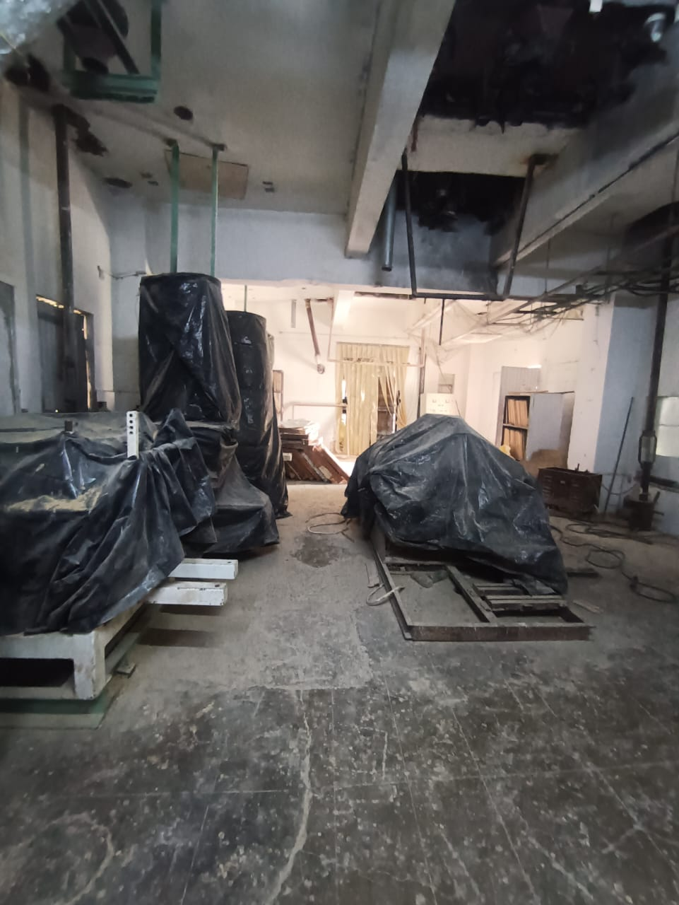
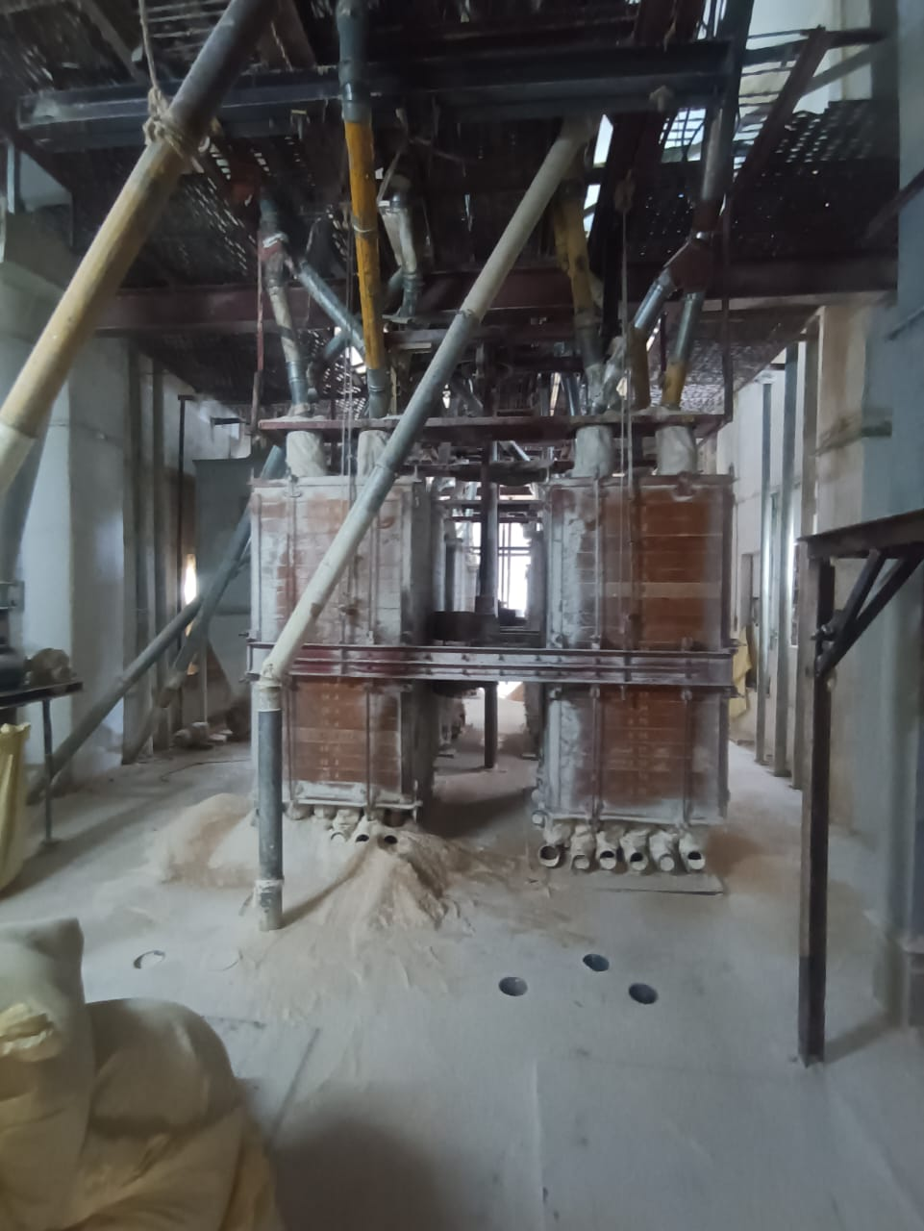

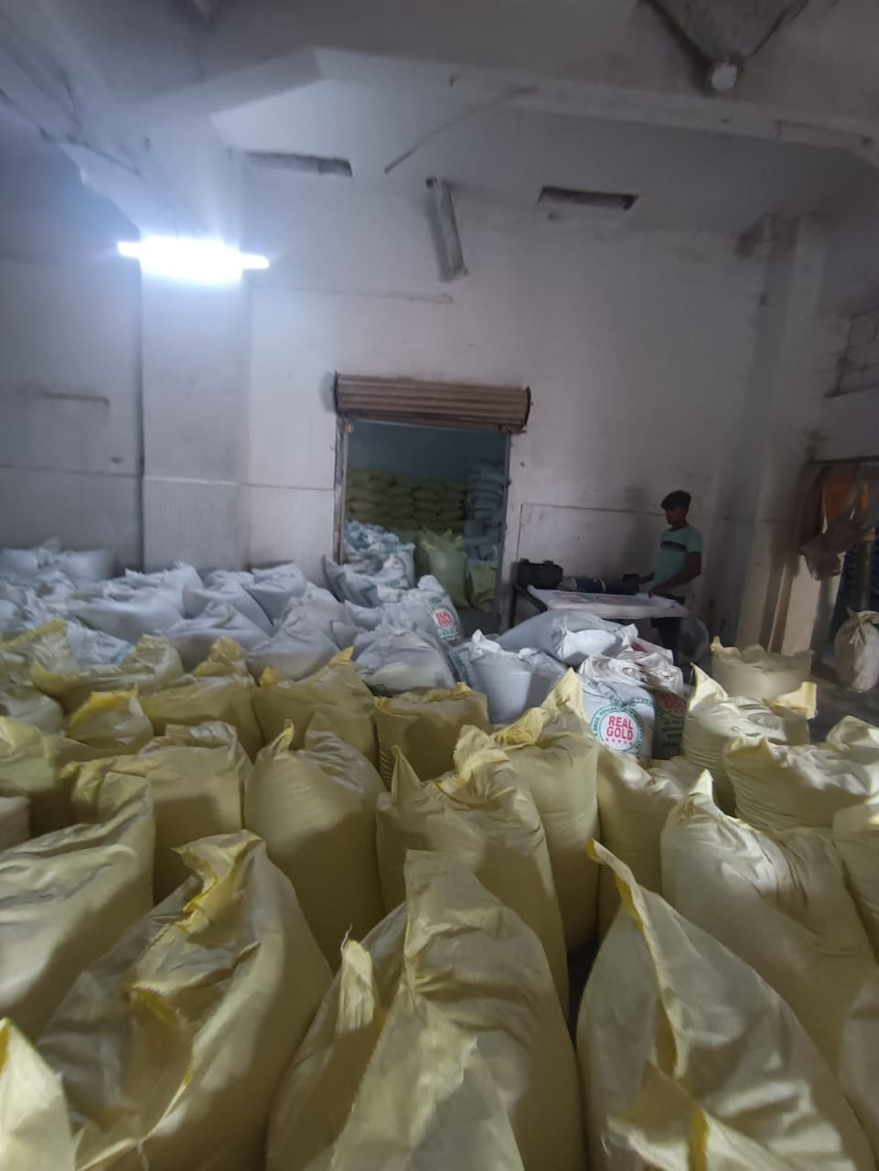
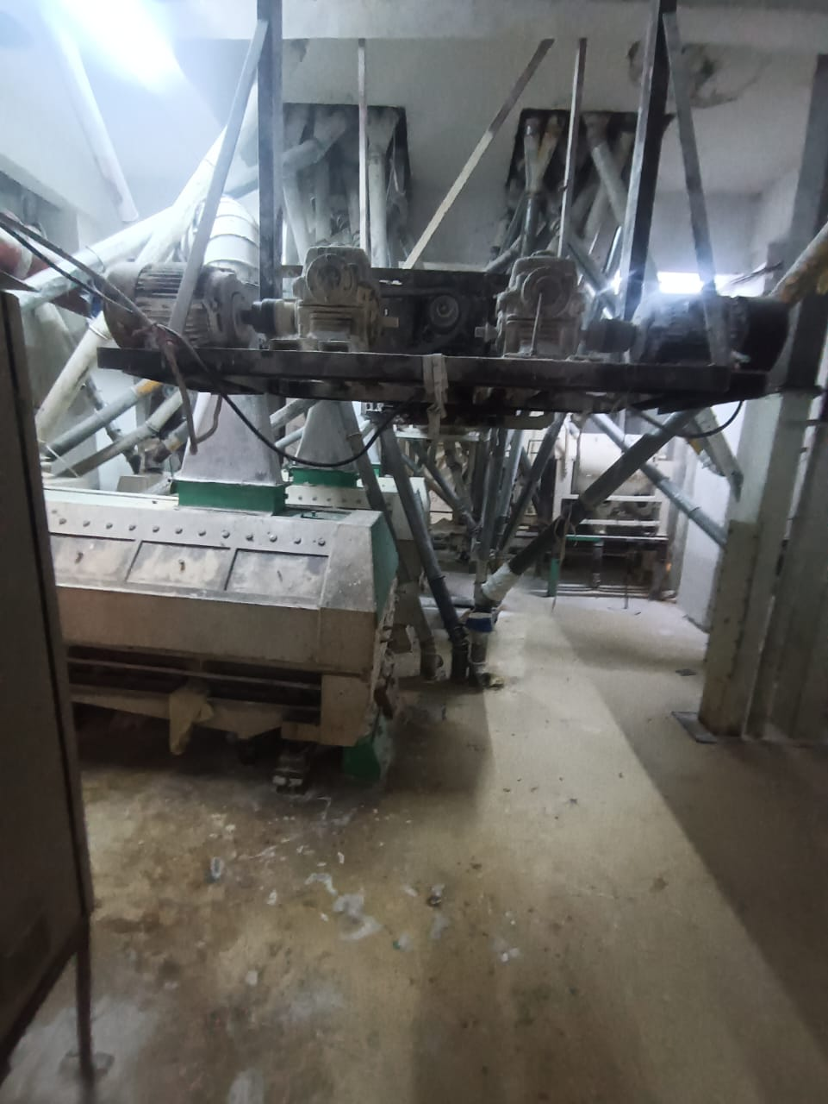

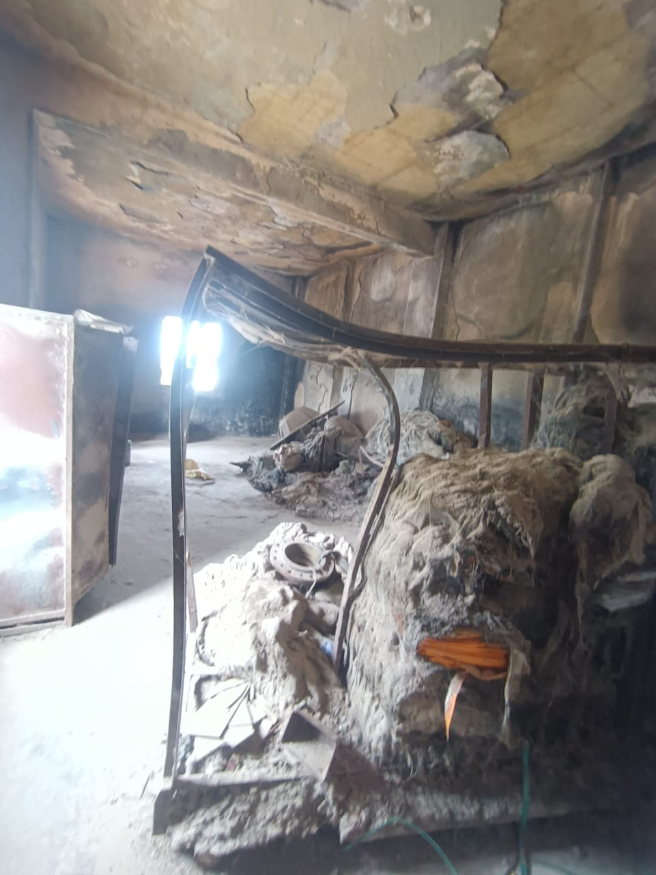
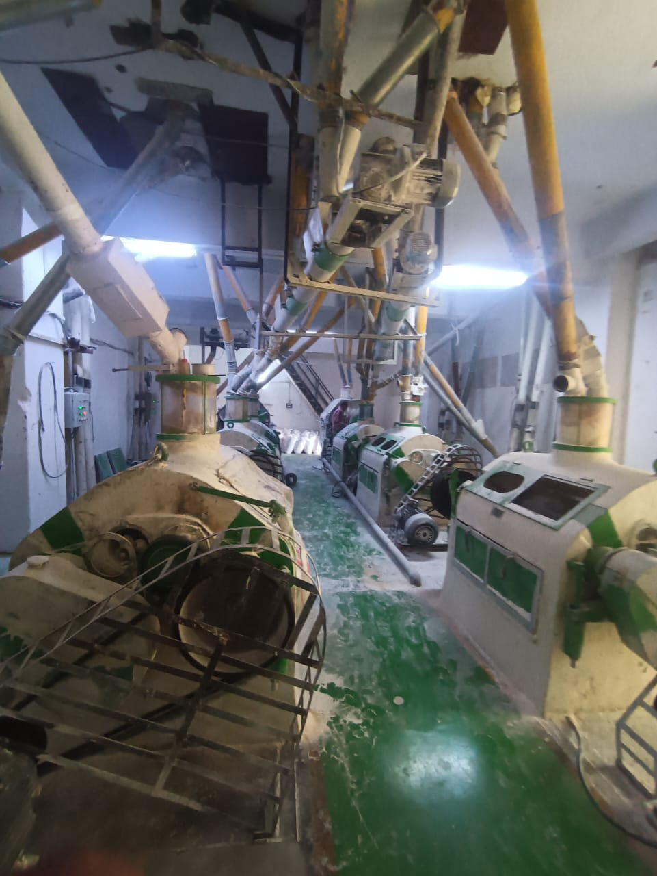

Actual Site Photographs
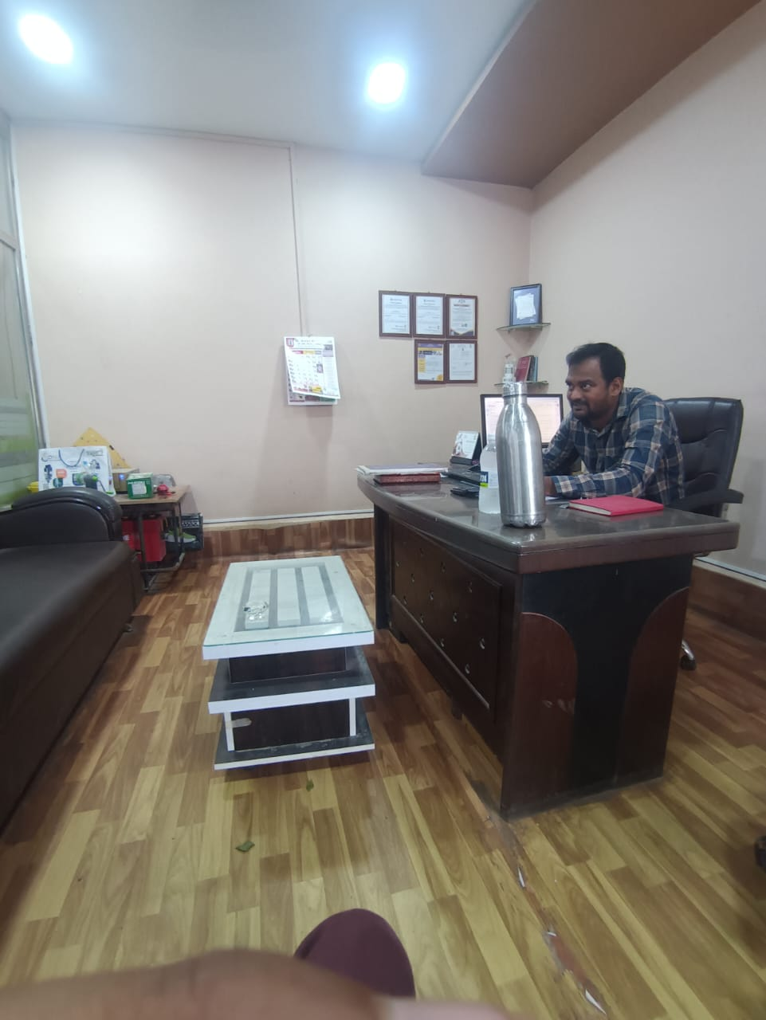
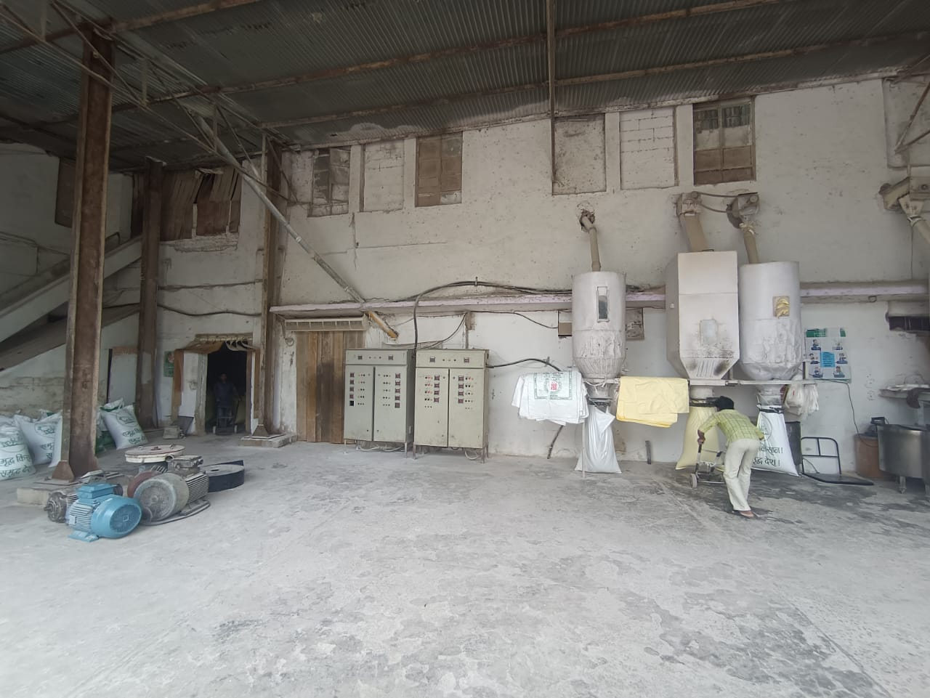

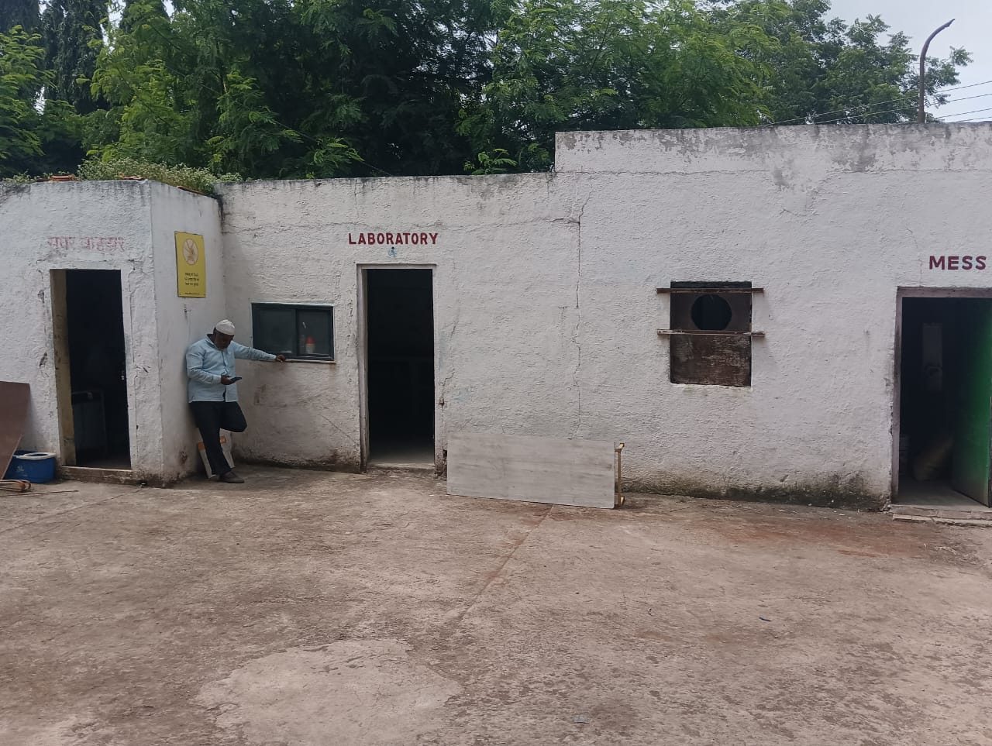
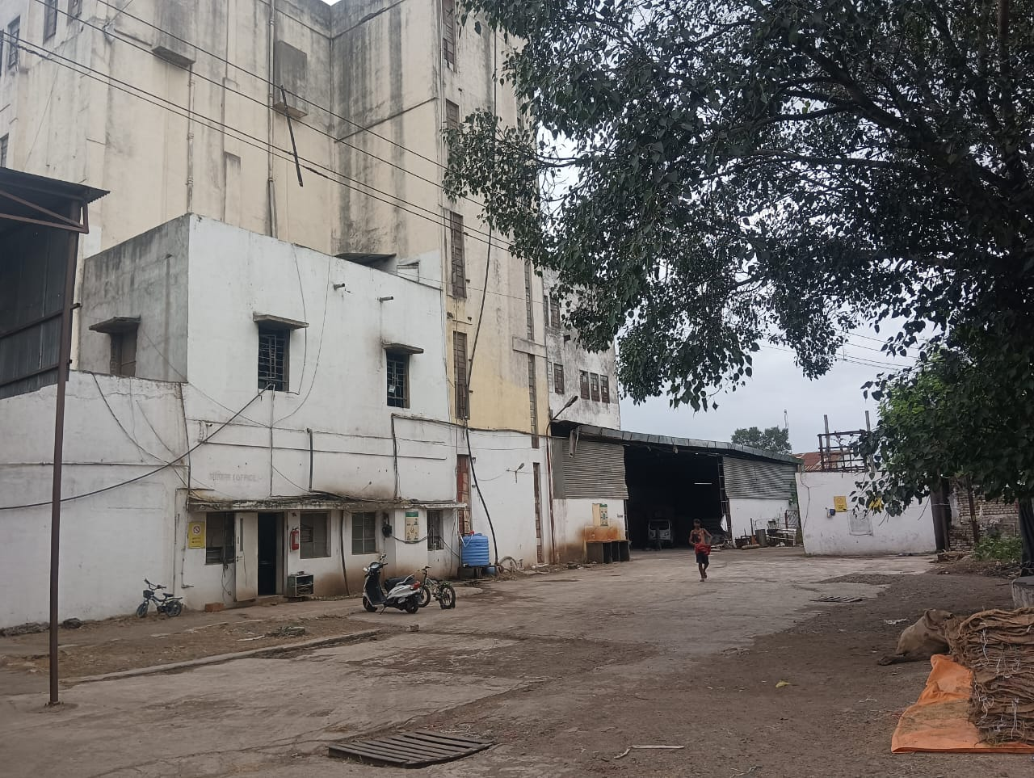


Route Map of the property
Site u/r
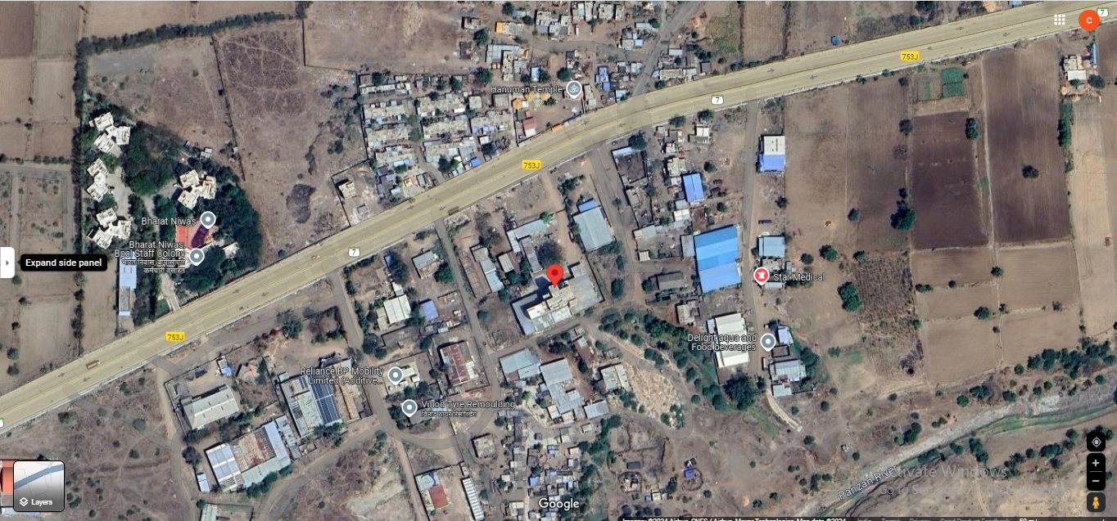

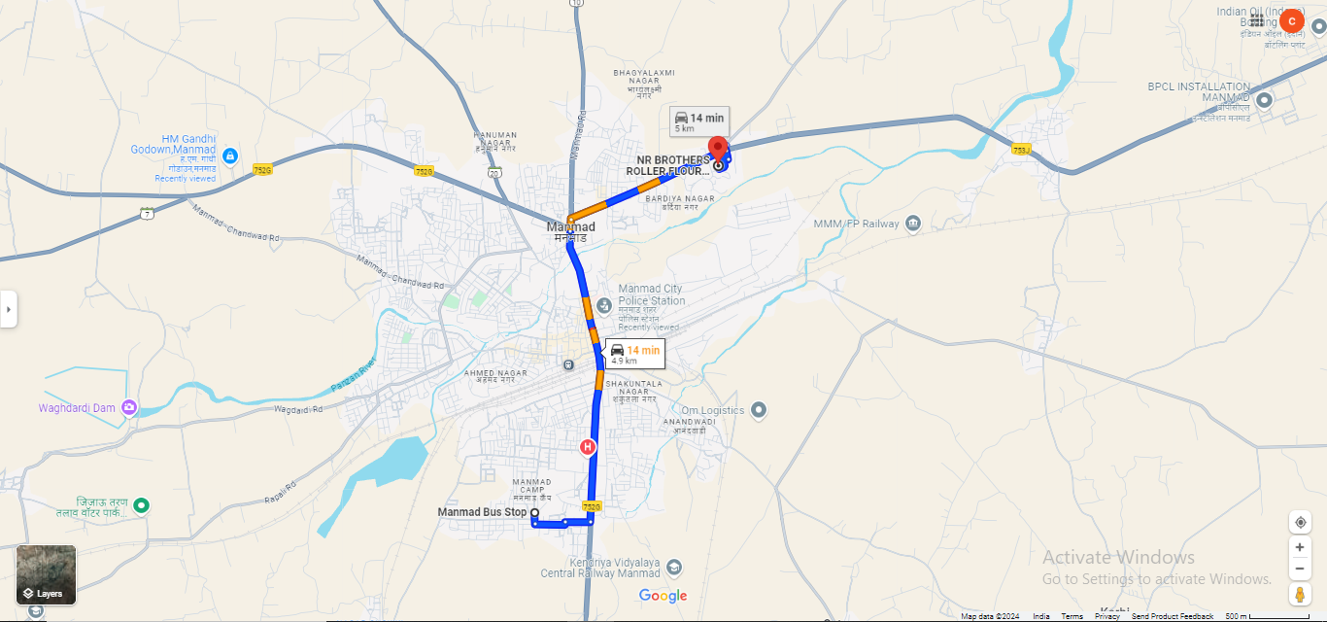

Latitude Longitude: 20°15'56.2"N 74°27'04.2"E
Note: The Blue line shows the route to site from nearest Bus Stand ( Manmad – 2.4 Km.)
Ready Reckoner Rate

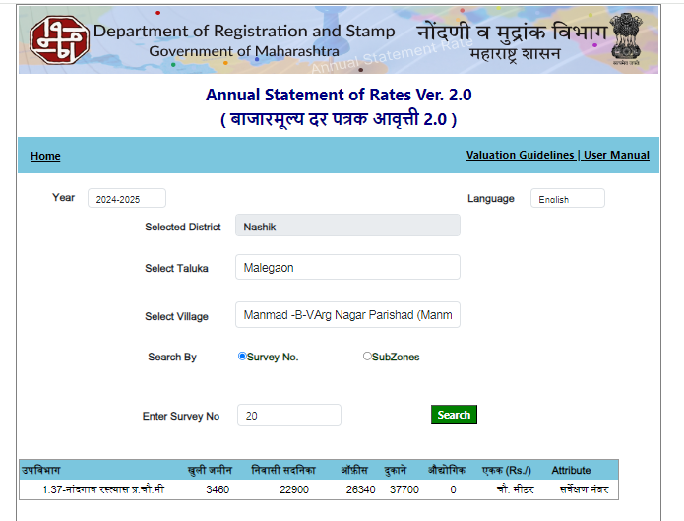

Price Indicators
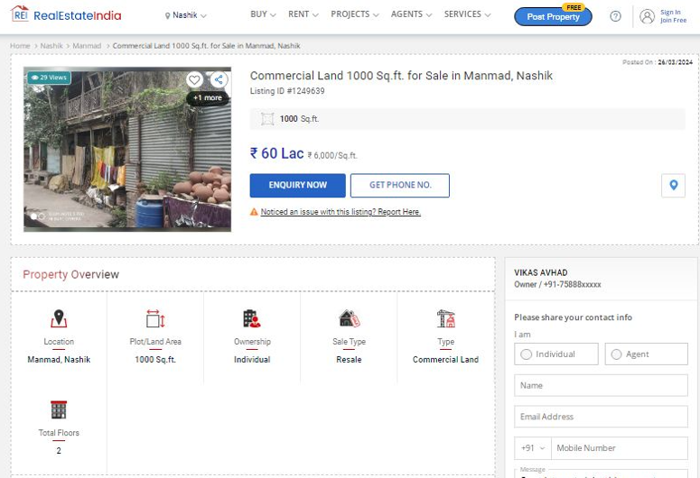

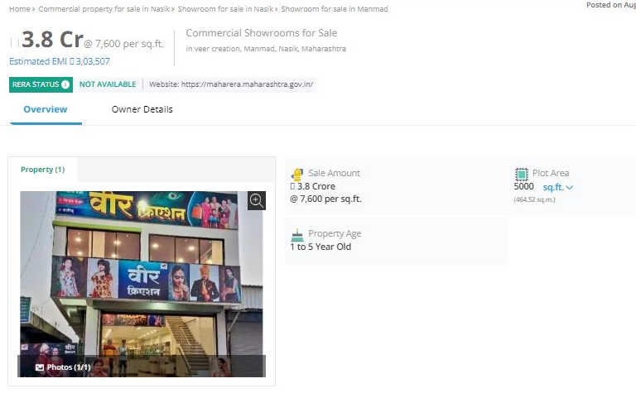

As a result of my appraisal and analysis, it is my considered opinion that the present fair market value of the above property in the prevailing condition with aforesaid specifications is ` 7,15,06,850.00 (Rupees Seven Crore Fifteen Lakh Six Thousand Eight Hundred Fifty Only). The Realizable Value of the above property is ` 6,43,56,165.00 (Rupees Six Crore Forty-Three Lakh Fifty-Six Thousand One Hundred Sixty-Five Only). The Distress Value is ` 5,72,05,480.00 (Rupees Five Crore Seventy-Two Lakh Five Thousand Four Hundred Eighty only).

Place : Nashik
Date : 19.09.2024

Manoj B. Chalikwar
Registered Valuer
Chartered Engineer (India)
Reg. No. CAT-I-F-1763
BOI Empanelment No.: MNZ:C&IC:VAL19-20

The undersigned has inspected the property detailed in the Valuation Report dated _______________________

on ____________________. We are satisfied that the fair and reasonable market value of the property is

`_________________________ (Rupees ________________________________________________________

________________________________________only).

Date
Signature
(Name of the Branch Manager with Official seal)

DECLARATION FROM VALUERS

- The information furnished in my valuation report dated 1.09.2024 is true and correct to the best of my knowledge and belief and I have made and impartial and true valuation of the property. I have valued right property.
- I have no direct or indirect interest in the property valued;
- I/We have personally inspected the property on 16.09.2024 (Mr. Sachin Raundal) the work is not sub-contracted to any other valuer and carried out by myself.
- I have not been convicted of any offence and sentenced to a term of imprisonment;
- I have not been found guilty of misconduct in my professional capacity.
- I have read the Handbook on Policy, Standard and procedure for Real Estate Valuation, 2011 of the IBA and this report is in conformity to the “Standards” enshrined for valuation in the Part-B of the above handbook to the best of my ability.
- I have read the Internal Valuation Standard (IVS) and the report submitted to the Bank for the respective asset class is in conformity to the “Standards” as enshrined for valuation in IVS in “General Standards” and “Asset Standards” as applicable.
- Past performance of Real Estate Market need not necessarily indicate the future trends. This valuation purely and estimate & has no legal or Contractual obligation on our part. Analysis & conclusions of the value of the property are based on assumptions & conditions prevailing at the time of date of valuation. The rated indicated are based on current market condition & these may vary with time.
- Encumbrances of Loan, Govt. or other dues, stamp duty, registration charges, transfer charged etc. if any, are not considered in the valuation. We have assumed that the assets are free of lien & encumbrances.
- Bank authorities are requested to contact valuers in case of any doubts or discrepancy. The opinion about valuation is true & fair to the best of our knowledge & belief. We have no direct or indirect interest in the assets valued.
- I abide by the Model Code of Conduct for empanelment of the valuer in the Bank.
- I am the proprietor / partner / authorized official of the firm / company, who is competent to sign this valuation report.
- VCIPL, by reason of this report, are not required to give testimony or attendance in court or to any Government Agency whit reference to the subject property unless prior arrangements and consent have been made.
- Further, I hereby provide the following information.

Sr.  No. | Particulars | Valuer comment
 | background information of the asset being valued; | As per Lease Deed Owner is M/s.NR Brothers Roller Flour Mills (P)Ltd
 | purpose of valuation and appointing authority | As per the request from Bank of India, Main Trambak Road, Nashik to assess value of the property for Banking purpose
 | identity of the valuer and any other experts involved in the valuation; | Manoj B. Chalikwar – Regd. Valuer  Sanjay Phadol - Regional Technical Manager  Sachin Raundal - Valuation Engineer  Rashmi Jadhav– Technical Manager  Chintamani Chaudhari – Technical Officer
 | disclosure of valuer interest or conflict, if any; | We have no interest, either direct or indirect, in the property valued. Further to state that we do not have relation or any connection with property owner / applicant directly or indirectly. Further to state that we are an independent Valuer and in no way related to property owner / applicant
 | date of appointment, valuation date and date of  report; | Date of Appointment – 16.09.2024  Valuation Date – 19.09.2024  Date of Report – 19.09.2024
 | inspections and/or investigations undertaken; | Physical Inspection done on 16.09.2024
 | nature and sources of the information used or relied upon; | - Market Survey at the time of site visit  - Ready Reckoner rates / Circle rates  - Online search for Registered Transactions  - Online Price Indicators on real estate portals  - Enquiries with Real estate consultants  - Existing data of Valuation assignments carried out by us
 | procedures adopted in carrying out the valuation and valuation standards followed; | Sales Comparison Method
 | restrictions on use of the report, if any; | This valuation is for the use of the party to whom it is addressed and for no other purpose. No responsibility is accepted to any third party who may use or rely on the whole or any part of this valuation. The valuer has no pecuniary interest that would conflict with the proper valuation of the property.
 | major factors that were taken into account during the valuation; | current market conditions, demand and supply position, Industrial Office size, location, upswing in real estate prices, sustained demand for Industrial Office, all round development of Industrial and Industrial application in the locality etc.
 | Caveats, limitations and disclaimers to the extent they explain or elucidate the limitations faced by valuer, which shall not be for the purpose of limiting his responsibility for the valuation report. | Attached
Assumptions, Disclaimers, Limitations & Qualifications
Value Subject to Change
The subject appraisal exercise is based on prevailing market dynamics as on 19th September 2024 and does not take into account any unforeseeable developments which could impact the same in the future.
Our Investigations
We are not engaged to carry out all possible investigations in relation to the subject property. Where in our report we identify certain limitations to our investigations, this is to enable the reliant party to instruct further investigations where considered appropriate or where we recommend as necessary prior to reliance. Vastukala Consultants India Pvt. Ltd. (VCIPL) is not liable for any loss occasioned by a decision not to conduct further investigations
Assumptions
Assumptions are a necessary part of undertaking valuations. VCIPL adopts assumptions for the purpose of providing valuation advise because some matters are not capable of accurate calculations or fall outside the scope of our expertise, or out instructions. The reliant party accepts that the valuation contains certain specific assumptions and acknowledge and accept the risk of that if any of the assumptions adopted in the valuation are incorrect, then this may have an effect on the valuation.
Information Supplied by Others
The appraisal is based on the information provided by the client. The same has been assumed to be correct and has been used for appraisal exercise. Where it is stated in the report that another party has supplied information to VCIPL, this information is believed to be reliable but VCIPL can accept no responsibility if this should prove not to be so.
Future Matters
To the extent that the valuation includes any statement as to a future matter, that statement is provided as an estimate and/or opinion based on the information known to VCIPL at the date of this document. VCIPL does not warrant that such statements are accurate or correct.
Map and Plans
Any sketch, plan or map in this report is included to assist the reader while visualising the property and assume no responsibility in connection with such matters.
Site Details
Based on inputs received from Client's representative and site visit conducted, we understand that the subject property is contiguous and non-agricultural land parcel admeasuring 3567.44 Sq. M. structures thereof. The property is owned by M/s.NR Brothers Roller Flour Mills (P)Ltd. Further, VCIPL has assumed that the subject property is free from any encroachment and is available as on the date of the appraisal.

Property Title
Based on our discussion with the Client, we understand that the subject property is owned by M/s.NR Brothers Roller Flour Mills (P)Ltd. For the purpose of this appraisal exercise, we have assumed that the subject property has a clear title and is free from any encumbrances, disputes and claims. VCIPL has made no further enquiries with the relevant local authorities in this regard and does not certify the property as having a clear and marketable title. Further, no legal advice regarding the title and ownership of the subject property has been obtained for the purpose of this appraisal exercise. It has been assumed that the title deeds are clear and marketable.
Environmental Conditions
We have assumed that the subject property is not contaminated and is not adversely affected by any existing or proposed environmental law and any processes which are carried out on the property are regulated by environmental legislation and are properly licensed by the appropriate authorities.
Town Planning
The permissible land use, zoning, achievable FSI, area statement adopted for purpose of this valuation is based on the information provided by the Client's representative and the same has been adopted for this valuation purpose. VCIPL has assumed the same to be correct and permissible. VCIPL has not validated the same from any authority.
Area
Based on the information provided by the Client's representative, we understand that the subject property, contiguous and non-agricultural land parcel admeasuring 3567.44 Sq. M. and structure thereof
Condition & Repair
In the absence of any information to the contrary, we have assumed that there are no abnormal ground conditions, nor archaeological remains present which might adversely affect the current or future occupation, development or value of the property. The property is free from rat, infestation, structural or latent defect. No currently known deleterious or hazardous materials or suspect techniques will be used in the construction of or subsequent alteration or additions to the property and comments made in the property details do not purport to express an opinion about, or advise upon, the condition of uninspected parts and should not be taken as making an implied representation or statement about such parts
Valuation Methodology
For the purpose of this valuation exercise, the valuation methodology used is Direct Comparison Approach Method and proposed Highest and Best Use model is used for analysing development potential.
The Direct Comparison Approach involves a comparison of the property being valued to similar properties that have actually been sold in arms - length transactions or are offered for sale. This approach demonstrates what buyers have historically been willing to pay (and sellers willing to accept) for similar properties in an open and competitive market and is particularly useful in estimating the value of the land and properties that are typically traded on a unit basis.
In case of inadequate recent transaction activity in the subject micro-market, the appraiser would collate details of older transactions. Subsequently, the appraiser would analyse rental / capital value trends in the subject micro-market in order to calculate the percentage increase / decrease in values since the date of the identified transactions. This percentage would then be adopted to project the current value of the same.
Where reliance has been placed upon external sources of information in applying the valuation methodologies, unless otherwise specifically instructed by Client and/or stated in the valuation, VCIPL has not independently verified that information and VCIPL does not advise nor accept it as reliable. The person or entity to whom the report is addressed acknowledges and accepts the risk that if any of the unverified information in the valuation is incorrect, then this may have an effect on the valuation.
Not a Structural Survey
We state that this is a valuation report and not a structural survey
Other
All measurements, areas and ages quoted in our report are approximate
Legal
We have not made any allowances with respect to any existing or proposed local legislation relating to taxation on realization of the sale value of the subject property. VCIPL is not required to give testimony or to appear in court by reason of this appraisal report, with reference to the property in question, unless arrangement has been made thereof. Further, no legal advice on any aspects has been obtained for the purpose of this appraisal exercise
Property specific assumptions
Based on inputs received from the client and site visit conducted, we understand that the subject property is contiguous and non-agricultural land parcel admeasuring 3567.44 Sq. M. and structure thereof

ASSUMPTIONS, CAVEATS, LIMITATION AND DISCLAIMERS
- We assume no responsibility for matters of legal nature affecting the property appraised or the title thereto, nor do we render our opinion as to the title, which is assumed to be good and marketable.
- The property is valued as though under responsible ownership.
- It is assumed that the property is free of liens and encumbrances.
- It is assumed that there are no hidden or unapparent conditions of the subsoil or structure that would render it more or less valuable. No responsibility is assumed for such conditions or for engineering that might be required to discover such factors.
- There is no direct/ indirect interest in the property valued.
- The rates for valuation of the property are in accordance with the Govt. approved rates and prevailing market rates

DEFINITION OF VALUE FOR THIS SPECIFIC PURPOSE

This exercise is to assess Fair Market Value of the property under reference as on 19th September 2024.

The term Fair Market Value is defined as

“The most probable price, as of a specified date, in cash, terms equivalent to cash, or in other precisely revealed terms for which the specified property rights would sell after reasonable exposure in a competitive market under all conditions requisite to a fair sale, with the buyer and seller each acting prudently knowledgeably and for self interest assuming that neither is under undue duress”.

Fundamental assumptions and conditions presumed in this definition are:

1. Buyer and seller are motivated by self-interest.
2. Buyer and seller are well informed and are acting prudently.
3. The property is exposed for a reasonable time on the open market.
4. Payment is made in cash or equivalent or in specified financing terms.
DECLARATION OF PROFESSIONAL FEES CHARGED

We hereby declare that, our professional fees are not contingent upon the valuation findings. However, if the statute AND/OR clients demands that, the fees should be charged on the percentage of assessed value then, with the full knowledge of the AND/OR end user, it is being charged accordingly.

VALUATION OF THE PROPERTY PREMISES

Considering various parameters recorded, existing economic scenario, and the information that is available with reference to the development of neighborhood and method selected for valuation, we are of the opinion that, the property premises can be assessed and Fair Market Value for this particular purpose ` 7,15,06,850.00 (Rupees Seven Crore Fifteen Lakh Six Thousand Eight Hundred Fifty Only).

Manoj B. Chalikwar
Registered Valuer
Chartered Engineer (India)
Reg. No. CAT-I-F-1763
BOI Empanelment No.: MNZ:C&IC:VAL19-20

