Vastu/Nashik/07/2024/0010070/2307330
22/7-334-RPBS
Date: 18.09.2024

To, `
The Branch Manager,
Bank of Baroda
Regional Office Nashik Road Branch
BSNL Building, Datta Mandir Road, Nashik Road,
Nashik -422 101, State - Maharashtra, Country - India.

Sub: Vetting of Extra Amenities

Sir,

With reference to above subject, we have evaluated the Extra Amenities for Residential Row House No. 2, Upper Ground Floor, Gajanan Row Houses, Near Kidzee Pre School, Nisarg Nagar, Plot No. 408+409, New/Current Survey No. 197/ 1 To 10P/ 198/ 199/ 1/ 200P/ 201, Meri - Rasbihari Link Road, Village - Mhasrul, Taluka - Nashik, District - Nashik, Nashik, 422004, State - Maharashtra, India belongs to Sau. Mangala Hemraj Patil & Shri. Hitesh Hemrai Patil.

We have verified the rates quoted as per current market rates. Details of work and Extra Amenities considered as per copy of Agreement for Extra Amenities issued by to Sau. Mangala Hemraj Patil & Shri. Hitesh Hemrai Patil. (First Party) and Shri. Dipen Vireshbhai Viramgama (Second Party) received on dated 17.09.2024. The Extra Amenities amount is Rs.8,10,000/- (Rupees Eight Lakh Ten Thousand Only.)

The said Cost Vetting Certificate is valid upto next 6 months Only.

Thanking you

Sincerely yours

Manoj B. Chalikwar
Registered Valuer
Chartered Engineer (India)
Reg. No. CAT-I-F-1763
Reg. No. IBBI/RV/07/2018/10366
BOB Empanelment No.: ZO:MZ:ADV:46:941
Encl: Valuation report.

Agreement for Extra Amenities
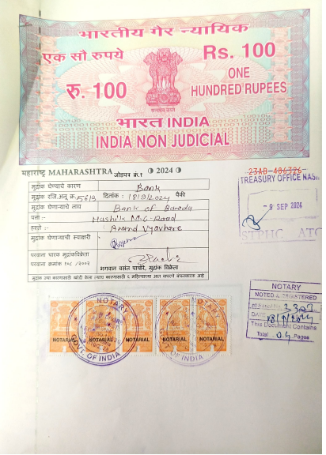


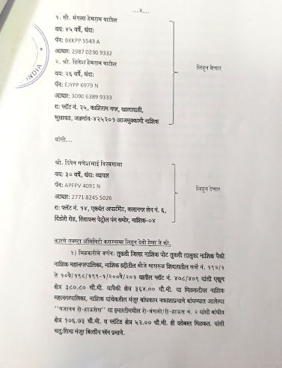

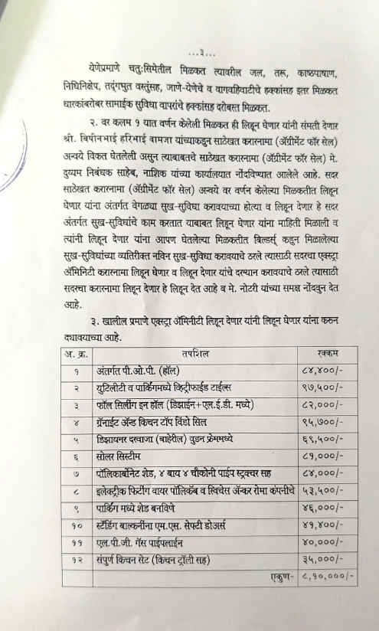
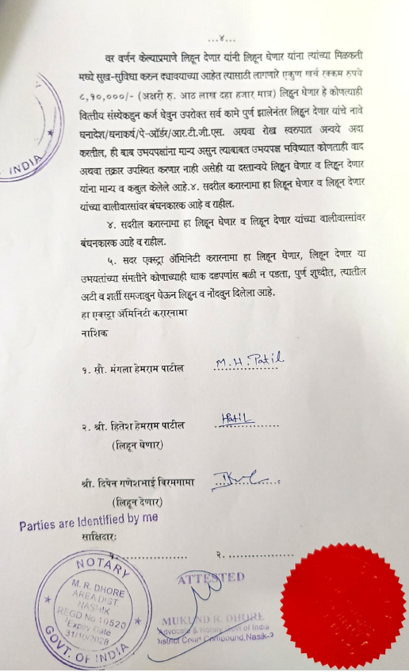

The Extra Amenities amount is Rs.8,10,000/- (Rupees Eight Lakh Ten Thousand Only.)

