COST VETTING REPORT
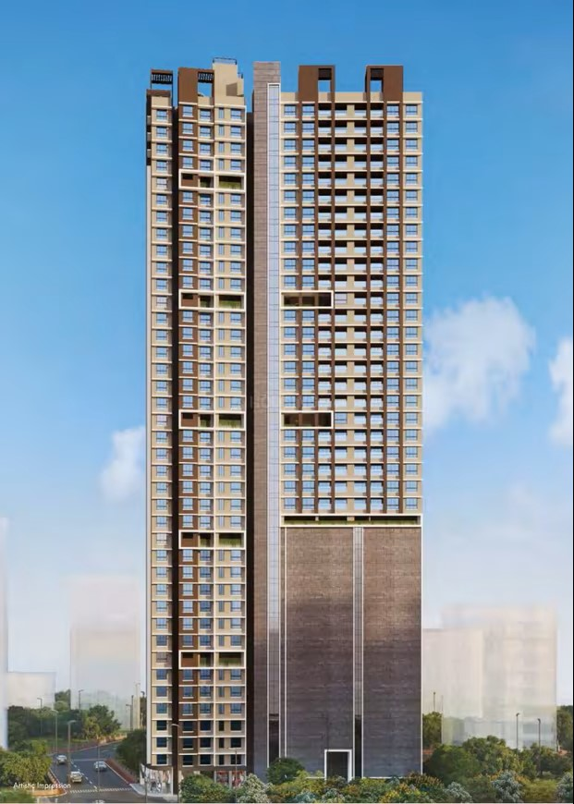

Details of the property under consideration:

Name of Project: "Evana Heights"

"Evana Heights", Proposed Redevelopment of existing building on Plot bearing C. S. No. 93/74(pt) (Plot No. 147 Pt.), C. S. No. 96/74(pt) (Plot no. 138 Pt.), C. S. No. 88/74(pt) & 97/74(pt), (Plot no. 137 Pt.), Supari Baug Estate Scheme No. 31, Dr. Ernest Borges Street, Koli Chawl, Parmar Guruji Marg, Parel – Sewere Division, Parel, Mumbai – 400 012, State – Maharashtra, Country – India

Latitude Longitude: 19°00'01.6"N 72°50'23.3"E

Valuation Done for:
State Bank of India
Wagle Ind. Est. Branch
Regional Business Office, Region-II, Wagle Ind. Area, Plot No. B-35, 2nd Floor,
Wagle Circle, Thane (West) - 400 604, State - Maharashtra, Country - India.

Vastu/SBI/Mumbai/09/2024/11239/2304891
09/11-113-PY
Date: 16.09.2024

To,
The Branch Manager,
State Bank of India
Wagle Ind. Est. Branch
Regional Business Office, Region-II,
Wagle Ind. Area, Plot No. B-35, 2nd Floor,
Wagle Circle, Thane (West) - 400 604,
State - Maharashtra, Country - India.

Sub: Cost Vetting Report for "Evana Heights" at Parel, Mumbai, Pin Code – 400 012.

Dear Sir,
In accordance with your letter of engagement as stated above, we enclose our Report on Cost Vetting for "Evana Heights", Proposed Redevelopment of existing building on Plot bearing C. S. No. 93/74(pt) (Plot No. 147 Pt.), C. S. No. 96/74(pt) (Plot no. 138 Pt.), C. S. No. 88/74(pt) & 97/74(pt), (Plot no. 137 Pt.), Supari Baug Estate Scheme No. 31, Dr. Ernest Borges Street, Koli Chawl, Parmar Guruji Marg, Parel – Sewere Division, Parel, Mumbai – 400 012, State – Maharashtra, Country – India.
M/s. GBD Infra Project LLP, is proposing redevelopment of existing building on Plot bearing C. S. No. 93/74(pt) (Plot No. 147 Pt.), C. S. No. 96/74(pt) (Plot no. 138 Pt.), C. S. No. 88/74(pt) & 97/74(pt), (Plot no. 137 Pt.), Supari Baug Estate Scheme No. 31, Dr. Ernest Borges Street, Koli Chawl, Parmar Guruji Marg, Parel – Sewere Division, Parel, Mumbai – 400 012, State – Maharashtra, Country – India. Project is comprising Commercial cum Residential of Rehab cum Sale Building.
Commercial cum Residential of Rehab cum Sale Building is proposed of Basement + Ground Floor + 1st to 39th Upper Floors with total RERA carpet area of 91,628.01 Sq. Ft. which consists 1 BHK, 2 BHK and Shops units with 69 nos. of Sell flats, 104 Tenant Flats, 2 Security to Society Flats & 2 Tenant Shops providing with Fitness Centre, Society Office, & Other Amenities. School building of Ground Floor + 1st to 7th Upper Floors.
In this regard, SBI, Wagle Ind. Est. Branch Regional Business Office, Region-II, Wagle Ind. Area, Plot No. B-35, 2nd Floor, Wagle Circle, Thane (West) - 400 604, has approached Vastukala Consultants (I) Pvt. Ltd. (VCIPL) to conduct a Cost Vetting of the said project.
Our analysis of the cost vetting is enclosed in this report. This Report forms an integral whole and cannot be split in parts. The outcome of the report/ study can only lead to proper conclusions if the Report as a whole is taken into account.
The information used by Vastukala Consultants (I) Pvt. Ltd. (VCIPL) in preparing this report has been obtained from a variety of sources and other relevant documents provided by the client & bank. As agreed, we have performed our cost vetting exercise with the data available related to the business, considering the market prospects and projections. Our results are dependent on documents provided by client & bank, the underlying assumptions, which has been analyzed at a broader level by VCIPL while assessing their reasonableness.
Total Project Cost for the completion of Project will be ` 114.08 Cr.

For Vastukala Consultants (I) Pvt. Ltd.

Manoj B. Chalikwar
Registered Valuer
Chartered Engineer (India)
Reg. No. IBBI / RV / 07/2018/10366
Reg. No. CAT-I-F-1763
SBI Empanelment No.: SME/TCC/2021-22/86/3
About the Project:
Proposed Redevelopment of existing building on Plot bearing C. S. No. 93/74(pt) (Plot No. 147 Pt.), C. S. No. 96/74(pt) (Plot no. 138 Pt.), C. S. No. 88/74(pt) & 97/74(pt), (Plot no. 137 Pt.), Supari Baug Estate Scheme No. 31, Dr. Ernest Borges Street, Koli Chawl, Parmar Guruji Marg, Parel – Sewere Division, Parel, Mumbai – 400 012. It is about 1.40 Km. travelling distance from Parel Railway station.

Area Statement as per Approved Plan
A | AREA STATEMENT | Sq. M.
1 | Area of the plot (As per P. R. Card) | 1,494.53
1a | Area of the plot on site as per CSLR Plan | 1,494.53
2 | Deduction for
a | Road Set back area | 402.79
b | Proposed Road | -
c | Any reservation | 227.81
d | R. G. | -
e | -% Amenity Space DCPR 58/57 (sub – plot_) other | -
 | Total (a to e) | 630.60
3 | Balance Area of the plot (1 – 2) | 863.93
 | - Plot area to be handed over to school | 185.73
4 | Deduction for 15% recreational ground / 10% amenity (space if deductible for incl.) | -
5 | Net Area of Plot | 863.93
6 | Additions for Floor Space Index
a | 100% for DP Road
b | 100% for Set – back | 402.79
c | 100% Any reservations | 227.81
 | 100% RG | -
7 | Total Area (5 + 6) | 1,494.53
8 | Floor Space Index Permissible | -
9 | 9 (a) Floor space index credit available by development rights (restricted to - % of the balance area vide 3 above) (DRC No. _) | -
 | Additions for Floor Space Index  9 (b) 33% as per DCPR 32  9 (c) % as per DCPR 33  9 (d) Other | -
10 | Permissible Built – Up Area
 | - Rehab Component | 3,501.75
 | Additional 15% Area of rehab component as per DCPR 33(7)(5)(a) of DCPR 2034 | 525.26
 | Total Rehab Component | 4,026.98
 | - Sale Component | 4,026.98
 | - Sale Component (as per Rev. LOI Dt. 29-09-2022) | 426.98
 | Total Sale Component | 8,480.32
 | - School Area to be handed over to MCGM (as per Rev. LOI 29-09-2022) | 836.00
 | Total Permisisble Built – up Area (A + B + C) | 8,480.32
11 | Existing Floor Area | -
12 | Proposed Built – up area – Rehab Component | 4,026.98
 | Proposed Built – up area – Sale Component | 4,451.39
13 | Excess balcony area taken in Floor Space Index | -
 | - Purely Residential Built – up Area | -
 | - Remaining Non – residential Built-up Area | -
14 | Total Built up Proposed (11 + 12 + 13) | 8,478.37
15 | FSI consumed on net holding = 14/5 | 9.81
B | Details of FSI available as per DCPR 33 (7) | DCPR 2034
 | Details of FSI available as per DCPR 33 (7) | Permissible |  | Proposed
 |  | Rehab | Sale | Rehab | Sale
1 | Fungible built – up area component proposed vide DCPR 33 (7) for purely residential = or < (12 – 14A X 1.35) | 1,400.47 | 1,558.68 | 1,387.48 | -
2 | Fungible built – up area component proposed vide DCPR 33 (7) for purely non - residential = or < (14B X 0.20) | 8.98 | - | 8.96 | -
3 | Total fungible built – up area vides DCPR 33(7) = (B1 + B2) | 2,968.13 |  | 1,396.44
4 | Total Gross Built – up Area proposed | 11,448.45 |  | 9,874.81
C | Tenement Statement
i | Proposed Area (item 12 above) | 4,026.98
ii | Less Deduction of Non – Residential area (Shop, etc.) | -
iii | Area available for tenements (i – ii) | 4,026.98
iv | Tenements permissible (Density of tenements / hectare)
v | Tenements proposed | 175 + 3 = 178
vi | Tenements existing / Total tenements on the plot | 104 + 2 = 106
 | Total Tenements on the plot
D | Parking Statement
i | Parking required by regulations for | 128
 | Car / Scooter / Motor cycle
 | Outsiders (visitors)
ii | Parking Permisisble | 128
iii | Parking Proposed | 128

Area Statement as per Concession Drawing Plan
A | AREA STATEMENT | Sq. M.
1 | Area of the plot (As per P. R. Card) | 1,494.53
1a | Area of the plot on site as per CSLR Plan | 1,494.53
2 | Deduction for
a | Road Set back area | 402.79
b | Proposed Road | -
c | Any reservation | 227.81
d | R. G. | -
e | -% Amenity Space DCPR 58/57 (sub – plot_) other | -
 | Total (a to e) | 630.60
3 | Balance Area of the plot (1 – 2) | 863.93
 | - Plot area to be handed over to school | 185.73
4 | Deduction for 15% recreational ground / 10% amenity (space if deductible for incl.) | -
5 | Net Area of Plot | 863.93
6 | Additions for Floor Space Index
a | 100% for DP Road
b | 100% for Set – back | 402.79
c | 100% Any reservations | 227.81
 | 100% RG | -
7 | Total Area (5 + 6) | 1,494.53
8 | Floor Space Index Permissible | -
9 | 9 (a) Floor space index credit available by development rights (restricted to - % of the balance area vide 3 above) (DRC No. _) | -
 | Additions for Floor Space Index  9 (b) 33% as per DCPR 32  9 (c) % as per DCPR 33  9 (d) Other | -
10 | Permissible Built – Up Area
 | - Rehab Component | 3,501.75
 | Additional 15% Area of rehab component as per DCPR 33(7)(5)(a) of DCPR 2034 | 525.26
 | Total Rehab Component | 4,026.98
 | - Sale Component | 4,026.98
 | - Sale Component (as per Rev. LOI Dt. 29-09-2022) | 426.98
 | Total Sale Component | 8,480.32
 | - School Area to be handed over to MCGM (as per Rev. LOI 29-09-2022) | 836.00
 | Total Permisisble Built – up Area (A + B + C) | 8,480.32
11 | Existing Floor Area | -
12 | Proposed Built – up area – Rehab Component | 4,026.98
 | Proposed Built – up area – Sale Component | 4,453.34
13 | Excess balcony area taken in Floor Space Index | -
 | - Purely Residential Built – up Area | -
 | - Remaining Non – residential Built-up Area | -
14 | Total Built up Proposed (11 + 12 + 13) | 8,480.32
15 | FSI consumed on net holding = 14/5 | 10.69
B | Details of FSI available as per DCPR 33 (7) | DCPR 2034
 | Details of FSI available as per DCPR 33 (7) | Permissible |  | Proposed
 |  | Rehab | Sale | Rehab | Sale
1 | Fungible built – up area component proposed vide DCPR 33 (7) for purely residential = or < (12 – 14A X 1.35) | 1,400.47 | 1,558.68 | 1,335.76 | 1,555.82
2 | Fungible built – up area component proposed vide DCPR 33 (7) for purely non - residential = or < (14B X 0.20) | 8.98 | - | 8.96 | -
3 | Total fungible built – up area vides DCPR 33(7) = (B1 + B2) | 2,968.13 |  | 2,900.54
4 | Total Gross Built – up Area proposed | 11,448.45 |  | 11,381.28
C | Tenement Statement
i | Proposed Area (item 12 above) | 4,026.98
ii | Less Deduction of Non – Residential area (Shop, etc.) | -
iii | Area available for tenements (i – ii) | 4,026.98
iv | Tenements permissible (Density of tenements / hectare)
v | Tenements proposed | 200 + 3 = 203
vi | Tenements existing / Total tenements on the plot | 104 + 2 = 106
 | Total Tenements on the plot
D | Parking Statement
i | Parking required by regulations for | 134
 | Car / Scooter / Motor cycle
 | Outsiders (visitors)
ii | Parking Permisisble | 128
iii | Parking Proposed | 128

Construction Area as per Approved Plan for Rehab cum Sale Building
Sr. No. | Floor | Built Up Area in Sq. M. | Staircase Area in Sq. M. | Other Area in Sq. M. | Total Construction Area in Sq. M.
1 | Basement Floor | 103.00 | 118.76 | - | 221.76
2 | Ground Floor | 97.50 | 142.68 | - | 240.18
3 | 1st Floor | 102.97 | 127.20 | - | 230.17
4 | 2nd Floor | 102.97 | 83.99 | - | 186.96
5 | 3rd Floor | 102.97 | 111.36 | - | 214.33
6 | 4th Floor | 169.06 | 83.99 | - | 253.05
7 | 5th Floor | 153.91 | 111.36 | - | 265.27
8 | 6th Floor | 153.91 | 111.36 | - | 265.27
9 | 7th Floor | 102.69 | 111.36 | - | 214.05
10 | 8th Floor | 153.91 | 111.36 | - | 265.27
11 | 9th Floor | 153.91 | 111.36 | - | 265.27
12 | 10th Floor | 156.24 | 120.91 | - | 277.15
13 | 11th Floor | 156.24 | 120.91 | - | 277.15
14 | 12th Floor | 156.24 | 120.91 | - | 277.15
15 | 13th Floor | 156.24 | 120.91 | - | 277.15
16 | 14th Floor | 102.69 | 146.79 | - | 249.48
17 | 15th Floor | 262.02 | 142.66 | - | 404.68
18 | 16th Floor | 403.89 | 142.66 | - | 546.55
19 | 17th Floor | 403.89 | 142.66 | - | 546.55
20 | 18th Floor | 403.89 | 142.66 | - | 546.55
21 | 19th Floor | 403.89 | 142.66 | - | 546.55
22 | 20th Floor | 403.89 | 142.66 | - | 546.55
23 | 21st Floor | 293.55 | 142.66 | - | 436.21
24 | 22nd Floor | 403.89 | 142.66 | - | 546.55
25 | 23rd Floor | 403.89 | 142.66 | - | 546.55
26 | 24th Floor | 403.89 | 142.66 | - | 546.55
27 | 25th Floor | 403.89 | 142.66 | - | 546.55
28 | 26th Floor | 403.89 | 142.66 | - | 546.55
29 | 27th Floor | 403.89 | 142.66 | - | 546.55
30 | 28th Floor | 293.55 | 142.66 | - | 436.21
31 | 29th Floor | 403.89 | 142.66 | - | 546.55
32 | 30th Floor | 403.89 | 142.66 | - | 546.55
33 | 31st Floor | 403.89 | 142.66 | - | 546.55
34 | 32nd Floor | 403.89 | 142.66 | - | 546.55
35 | 33rd Floor | 226.64 | 142.66 | - | 369.30
36 | 34th Floor | 153.91 | 93.54 | - | 247.45
37 | 35th Floor | 102.69 | 93.54 | - | 196.23
38 | 36th Floor | 153.91 | 93.54 | - | 247.45
39 | 37th Floor | 153.91 | 93.54 | - | 247.45
40 | 38th Floor | 153.91 | 93.54 | - | 247.45
41 | 39th Floor | - | 80.48 | - | 80.48
42 | Society Office | - |  | 23.10 | 23.10
43 | Fitness Center | - |  | 225.96 | 225.96
44 | Refuge Area (7th, 14th, 21st & 28th Floor) | - |  | 416.27 | 416.27
45 | Terrace / OHT / LMR / UG Tank | - |  | 447.36 | 447.36
46 | Parking & Car Parking Service Platform | - |  | 472.96 | 472.96
47 | School Building (Ground + 1st to 7th Floor) | 868.96 | 286.61 | - | 1,155.57
TOTAL |  | 10,845.85 | 5,400.54 | 1,585.65 | 17,832.04
No. of Stack Parking |  |  |  |  | 128 Nos.

Project Cost
Sr. No. | Particulars | Total Estimated Amount in ` | Total Estimated Amount  in ` Cr.
1 | Land Cost
 | Acquisition Cost of Land or Development Rights, and Legal Cost. | - | -
 | Rent to Tenants, Lease premium, Lease Rent, interest cost incurred or payable on Land Cost | 21,86,23,062.00 | 21.86
 | Amount of Premium payable to obtain development rights, FSI, additional FSI, fungible area, and any other incentive under DCR from Local Authority or State Government or any Statutory Authority. | 9,49,19,125.00 | 9.49
 | Acquisition cost of TDR (if any) | - | -
2 | Cost of Construction
 | Estimated construction cost of rehab cum sale building including site development and infrastructure for the same. | 65,24,57,320.00 | 65.25
 | On site expenditure for development of entire project excluding cost of construction as per(i) above,
a. | Architect Fees & Consultant fees | 1,30,49,146.00 | 1.30
b. | Admin Cost includes salaries, site overheads, development works, cost of services (including water, electricity, sewerage, drainage, layout roads etc.), cost of machineries and equipment including its hire and maintenance cost, consumables etc. All costs directly incurred to complete the construction of the entire phase of the project registered. | 3,26,22,866.00 | 3.26
c. | Marketing Cost | 4,78,02,685.00 | 4.78
3 | Interest during the Project | 8,13,00,000.00 | 8.13
4. | Contingency Charges | - | -
 | GRAND TOTAL: | 114,07,74,204.00 | 114.08

Manoj B. Chalikwar
Registered Valuer
Chartered Engineer (India)
Reg. No. IBBI / RV / 07/2018/10366
Reg. No. CAT-I-F-1763
SBI Empanelment No.: SME/TCC/2021-22/86/3

Comments on each element of Cost of Project: -
- Land Cost:
As per Present Ready Reckoner rate the Project Land Value is ` 7.69 Cr. considering Land Rate @ ` 88,970.00 per Sq. M. & Net Plot Area of 863.93 Sq. M.
As per document purchase cost of land & stamp duty cost is ` 0.00 i.e., ` 0.00 Cr. which is 0.00% of Total Project Cost.

- Payment Payable to Rehab Tenants (Rent Cost):
Since it is a having some redevelopment flat from the date of shifting of 106 Tenants till handing over their respective new flats as per the Tenant Agreement. Further the rent keeps on increasing as per agreement. The existing Tenants has to be given total rental of ` 21,86,23,062.00 i.e., ` 21.86 Cr. Builder has paid ` 10.29 Cr. which is 19.16 % of Total Project Cost.
Existing Tenants Carpet Area & Rent per month for Flat are as follows:
Sr. No. | Particulars | Residential Flat | Units
1 | No. of Tenants | 106.00 | Nos.
2 | Rent per tenant per month for 01.01.2022 to 31.12.2023 | 25,000.00 | Rupees
 | Extra Amount to 15 tenants | 43,20,000.00
3 | Rent per year for Jan 22 to Dec 23 | 6,79,20,000.00 | Rupees
4 | Rent per tenant per month for 01.01.2024 to 31.12.2024 | 27,500.00 | Rupees
5 | Rent per year for Jan 24 to Dec 24 | 3,49,80,000.00 | Rupees
6 | Rent per tenant per month for 01.01.2025 to 31.12.2025 | 30,250.00 | Rupees
7 | Rent per year for Jan 25 to Dec 25 | 3,84,78,000.00 | Rupees
8 | Rent per tenant per month for 01.01.2026 to 31.12.2026 | 33,275.00 | Rupees
9 | Rent per year for Jan 26 to Dec 26 | 4,23,25,800.00 | Rupees
10 | Rent per tenants per month for Jan 27 to Sept 27 | 36,603.00 | Rupees
11 | Rent per year for Jan 27 to Sept 27 | 3,49,19,262.00 | Rupees
12 | Total Rent Cost (3 + 5 + 7 + 9 + 11) | 21,86,23,062.00 | Rupees

- Building Cost of Construction for Rehab cum Sale Building:
Construction Area of Rehab cum Sale Building = 17,832.04 Sq. M. i.e., 1,91,944.08 Sq. Ft.
No. of Stack Car Parking = 128 Nos.
Total estimated cost for construction of Building (includes cost of RCC work, manpower, lift, material, painting, finishing work, site development, etc.) is ` 53,49,61,200.00 i.e., ` 53.50 Cr. which comes ` 30,000.00 per Sq. M. on construction area for building, cost for deep excavation & shore piling is ` 5,34,96,120.00 i.e., ` 5.35 Cr. which comes 10% of cost of construction of building and cost for stack parking is ` 6,40,00,000.00 i.e., ` 6.40 Cr. which comes ` 5,00,000.00 per stack parking.
Hence, total construction cost (Cost of construction of building + Cost of deep excavation & shore piling + Cost of stack parking) (` 53,49,61,200.00 + ` 5,34,96,120.00 + ` 6,40,00,000.00) = ` 65,24,57,320.00 i.e., ` 65.25 Cr.
The total construction area is 17,832.04 Sq. M. i.e., 1,91,944.08 Sq. Ft., projected cost of ` 65.25 Cr is 57.19% of total project cost
VCIPL opinion the construction cost of 30,000/- Per Sq. M. which is in line with Market-Trend.
Particulars | Rate per Sq. Ft.
Excavation Work | 1500.00
Total RCC Work | 15000.00
Final Finishing Work | 7500.00
Other Work | 6000.00
Cost of Construction | 30000.00
Deep Excavation & Shore Piling Cost | 5% of construction cost of building
Stack Car Parking Cost | 5,00,000.00 per parking

- Approval Charges:
The Total Approval Cost (Fungible Cost & Development Cess Premium & TDR Cost) as per architect letter will
be ` 9,40,49,443.00 i.e., ` 9.40 Cr. which is 8.32% of Total Project Cost. Builder has paid ` 5.66 Cr.
Sr. | Particulars | Total Cost in ` | Incurred Cost in `
1 | CFO NOC & Fire Service Fees | 14,63,160.00 | 14,63,160.00
2 | Extra Sewerages Charges | 47,58,800.00 | 47,58,800.00
3 | Revalidation Fees | 61,05,000.00 | 61,05,000.00
4 | Property Tax | 41,22,803.00 | 41,22,803.00
5 | Development Charges | 66,80,100.00 | 66,80,100.00
6 | Debris Removal Charges | 45,000.00 | 45,000.00
7 | IOD Deposit | 1,23,300.00 | 1,23,300.00
8 | Staircase & Lift Premium Charges | 1,33,700.00 | 1,33,700.00
9 | Hydraulic Engineering | 13,280.00 | 13,280.00
10 | PCO NOC | 45,000.00 | 45,000.00
11 | Scrutiny Fees | 52,10,845.00 | 52,10,845.00
12 | Royalties and Fees | 15,46,300.00 | 15,46,300.00
13 | Dewatering Charges | 20,000.00 | 20,000.00
14 | CC Revalidation | 25,120.00 | 25,120.00
15 | Property Tax | 8,92,764.00 | 8,92,764.00
16 | Advertisement | 1,94,489.00 | 1,94,489.00
17 | Scrutiny Fees | 2,923.00 | 2,923.00
18 | Open Deficiency Premium | 55,18,039.00 | 4,53,768
19 | Inadequate Size of AVS | 11,43,454.00 | 93,002.00
20 | Inadequate width of Staircase for School | 1,28,320.00 | 10,437.00
21 | Fire Evacuation Life & Lift Lobby | 12,74,678.00 | 1,23,263.00
22 | Labour Welfare Cess | 29,87,150.00 | 29,87,150.00
23 | Development Charges (Land Component) | 17,68,479.00 | 17,68,479.00
24 | Development Charges (Building Component) | 2,87,55,210.00 | 1,43,77,621.00
25 | Additional Development Cess | 2,22,66,850.00 | 1,33,60,110.00
26 | Additional Parking Charges | 65,08,160.00 | -
Total |  | 9,49,19,125.00 | 5,77,42,614.00
As per information & challan provided by developer.

- Architect Cost, RCC & Other Professional Charges:
The total Architect charges of ` 1,30,49,146.00 i.e., ` 1.30 Cr. is 2.0% of total construction cost building & it is on lower side because developer have their inhouse team for professional work.
The professional charge consists of Architect & Legal which in lower side than the market trend which is in the range of 2% - 5% of Total Construction cost of the project.

- Administrative Expenses:
Salaries, site overheads, development works, cost of services (including water, electricity, sewerage, drainage, layout roads etc.), cost of machineries and equipment including its hire and maintenance cost, consumables etc. All costs directly incurred to complete the construction of the entire phase of the project registered is estimated 5% of total construction cost Building which comes to ` 3,26,22,866.00 i.e., ` 3.26 Cr.
The admin charges which in market is in the range of 3% - 5% of Total Construction cost of the project.

- Marketing Expenses:
Marketing costs directly incurred to complete the construction of the entire phase of the project registered is estimated at 3% of total Sale income from the project which comes to ` 4,78,02,685.00 i.e., ` 4.78 Cr.
The marketing charge consists of brokerage & commission which in market is in the range of 1% - 3% of Total Sale income of the property.

- Interest Costs:
The Interest cost for the term loan is ` 8,13,00,000.00 i.e., ` 8.13 Cr., which is 7.13% of total project cost.
As per information provided by the client.
Observation and Construction: -
Total estimated cost of project i.e., ` 114,07,74,204.00 (Rupees One Hundred Fourteen Crore Seven Lakh Twenty – Four Thousand Two Hundred Four Only) i.e., ` 114.08 Cr. is fair & reasonable.
The project cost is including land premium payable to concern authorities, Fungible FSI Premium, Cost of Construction of rehab & Sale Building, on site expenses including admin & marketing expenses, premiums / charges to be paid to competent authority and Bank interest, etc. we have not independently verified interest cost hence not consider in cost vetting.
As per present sanctioned building plan, permissible built-up area on the said plot is 9,874.81 Sq. M. The rehab cum sale building is presently approved for Basement + Ground Floor + 1st to 37th Upper Floors and School building is presently approved for Ground Floor + 1st to 7th Floors only. The Developer has submitted the concession drawing plan to the competent authority for utilization of total permissible Built-up area and fungible FSI. The rehab cum sale building is presently sanctioned for Basement + Ground Floor + 1st to 39th Upper Floors and School building is presently approved for Ground Floor + 1st to 7th Floors only. Estimated cost of entire project of 39th upper floors for rehab cum sale buildings & 7th floors for school buildings are considered.
Total estimated cost of construction of Rehab cum Sales building is ` 53,49,61,200.00 i.e., ` 53.50 Cr. which comes ` 30,000.00 per Sq. M. on construction area for building, cost for deep excavation & shore piling is ` 5,34,96,120.00 i.e., ` 5.35 Cr. which comes 10% of cost of construction of building and cost for stack parking is ` 6,40,00,000.00 i.e., ` 6.40 Cr. which comes ` 5,00,000.00 per stack parking. Hence, total construction cost (Cost of construction of building + Cost of deep excavation & shore piling + Cost of stack parking) (` 53,49,61,200.00 + ` 5,34,96,120.00 + ` 6,40,00,000.00) = ` 65,24,57,320.00 i.e., ` 65.25 Cr., which is fair & reasonable considering the present status of project, type & quality of construction & specification of the building materials to be used, height of the structure, amenities to be provided in proposed building.

Assumptions & Remarks-
- The adequacy of Engineering / Structural design is beyond the scope of our assignment.
- Estimated project completion date is 30/09/2028. The cost is certified based on the assumptions that the project will be completed within time frame. Few assumptions are made regarding inflation & cost rise etc. during construction period.

Photo copy of following document is provided to us & this report should be read along with it:
- Copy of Redeveloper Agreement dated 29.01.2022 between M/s. Shree Mahapurush Co-operative Housing Society Ltd. (The Society) and M/s. GBD Infra Project LLP (The Developers) through Notary Agreement.
- Copy of Developer Agreement dated 09.11.2009 between M/s. Shree Mahapurush Co-operative Housing Society Ltd. (The Society) and M/s. Shivam Developers Pvt. Ltd. (The Developers) through Notary Agreement.
- Copy of Irrevocable Power of Attorney through notary dated 29.01.2022, M/s. Shree Mahapurush Co-operative Housing Society Ltd. (The Society) and M/s. GBD Infra Project LLP (The Developers).
- Copy of Final Offer Letter dated 03.12.2021 issued by M/s. GBD Infra Project LLP.
- Copy of DP Remark Report NO. Ch.E/DP/34202205111390929 D. P. Rev. dt. Refer Inward Number: F/S/2022/111390940 dated 06.05.2022 issued by Municipal Corporation of Greater Mumbai (MCGM).
- Copy of Intimation of Approval (IOA) Letter No. P-11105/2022/(93/74(pt) And Other)/F/South/PAREL-SEWERI/IOD/1/New dated 01.02.2023 issued by Municipal Corporation of Greater Mumbai (MCGM).
- Copy of Revised Letter of Intent (LOI) NO. AC/Estates/10167/A.E.(Imp)-I dated 29.09.2022 Municipal Corporation of Greater Mumbai (MCGM).
- Copy of Approved Plan No. P-11105/2022/(93/74(pt)AndOther)/F/South/Parel-Seweri dated 01.02.2023 issued by Municipal Corporation of Greater Mumbai (MCGM).
Approved upto: Basement + Ground Floor + 1st to 37th Upper Floors
- Copy of Building Concession Plan No. P-11105/2022/(93/74(pt)AndOther)/F/South/Parel-Seweri dated 16.12.2022 issued by Municipal Corporation of Greater Mumbai (MCGM).
Sanctioned Upto: Basement + Ground Floor + 1st to 39th Upper Floors
- Copy of 1st Commencement Certificate No. P-11105/2022/(93/74(pt)AndOther)/F/South/Parel-Seweri/CC/1/New dated 15.06.2023 valid upto 14.06.2024 issued by Municipal Corporation of Greater Mumbai (MCGM).
(This CC is granted up to Plinth level as per approved IOD dated 01.02.2023)
- Copy of Revalidation Commencement Certificate No. P-11105/2022/(93/74(pt)AndOther)/F/South/Parel-Seweri/Other/2/New dated 24.06.2024 valid upto 14.06.2025 issued by Municipal Corporation of Greater Mumbai (MCGM).
(This CC is granted up to Plinth level as per approved IOD dated 01.02.2023)
- Copy of Fire NOC Certificate dated 25.11.2022 issued Municipal Corporation of Greater Mumbai, Mumbai Fire Brigade.
- Copy of Municipal Architect NOC Certificate No. Ch.E/M.A/1040/I dated 23.08.2022 issued by Municipal Corporation of Greater Mumbai (MCGM), Municipal Architect Department.
- Copy of Geotechnical Investigation Report dated May 2022 issued by M/s. Kamlesh Pazare Consultant – Geotechnique.
- Copy of CA Certificate dated 07.02.2024 issued by M/s. N P Shetty & Co.
- Copy of CA Certificate dated 11.09.2024 issued by M/s. N P Shetty & Co
- Copy of Construction Area Statement Letter No. Ref:M&A/545/2023-2024 dated 07.12.2023 issued by M/s. Mhatre & Associates.
- Copy of RERA Certificate No. P51900053438 dated 31.10.2023 issued by Maharashtra Real Estate Regulatory Authority (MAHRERA).
- Copy of Legal Title Report dated 07.10.2023 issued by Khandeparkar & Associates.
- Copy of Property Tax Bill Clearance Certificate No. AAC/FS/TCC/844/2023-2024 dated 19.06.2023 issued by Bhrihan Mumbai Mahanagarpalika.
- Copy of Tree NOC Certificate No. FS/000901/SWA dated 18.04.2023 issued by Municipal Corporation of Greater Mumbai, Tree Department.

Actual Site Photographs
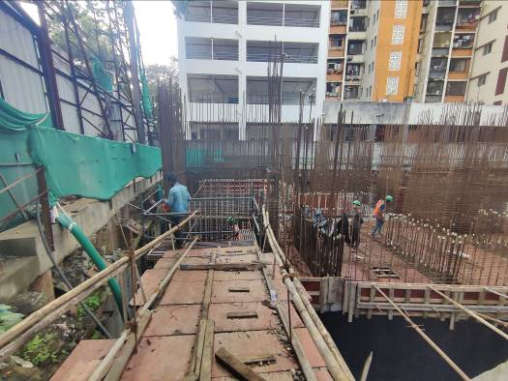
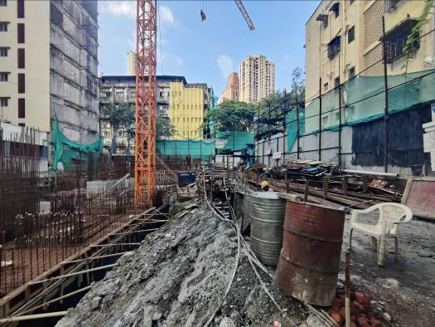
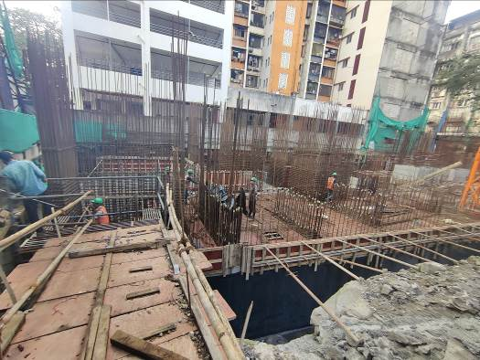
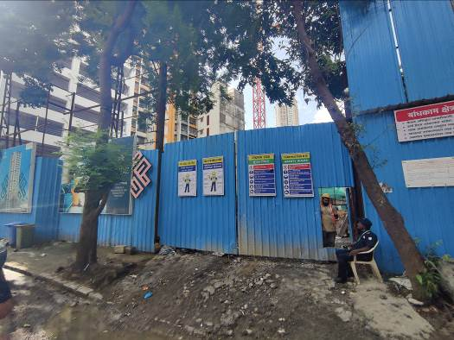
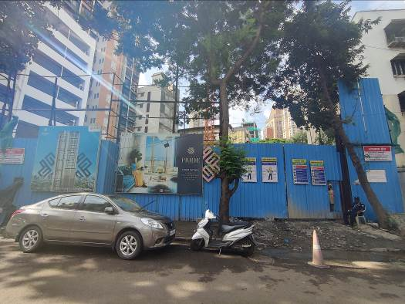
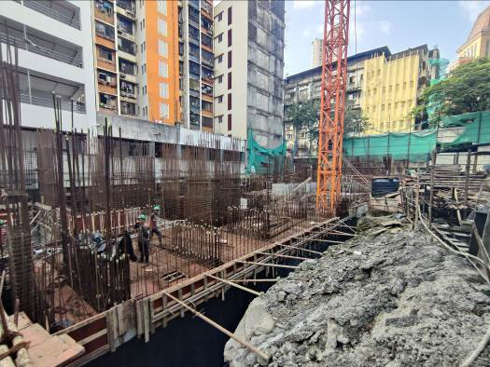

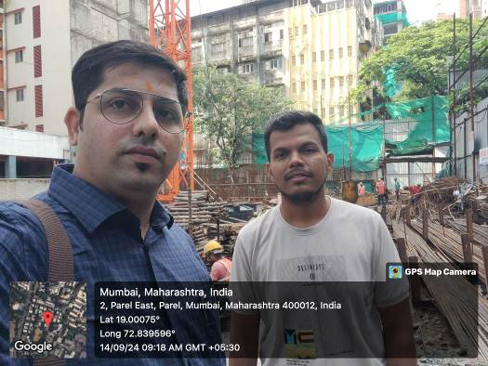
Route Map of the property
Site u/r
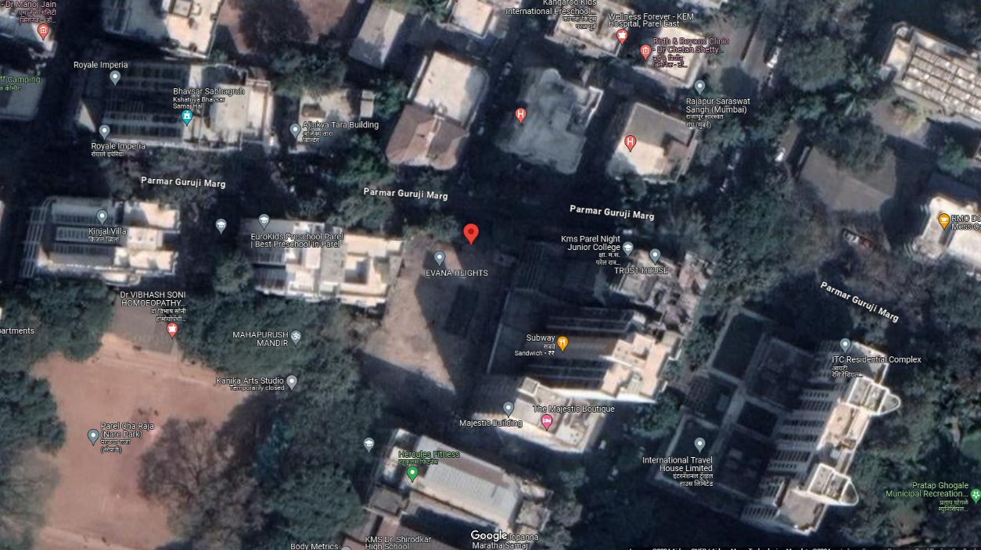

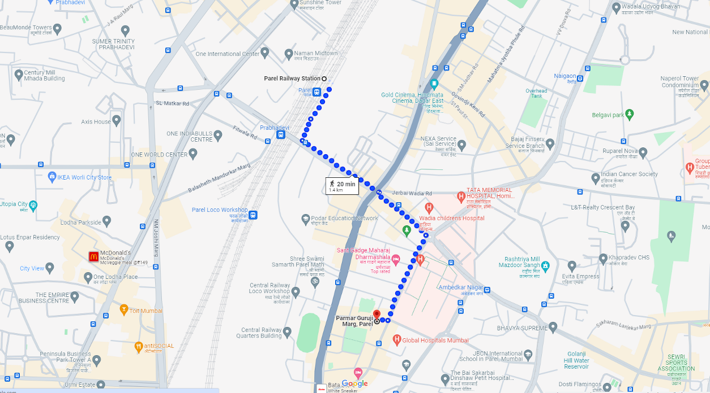

Latitude Longitude: 19°00'01.6"N 72°50'23.3"E
Note: The Blue line shows the route to site from nearest railway station (Parel – 1.40 Km.)

