PROJECT VALUATION REPORT
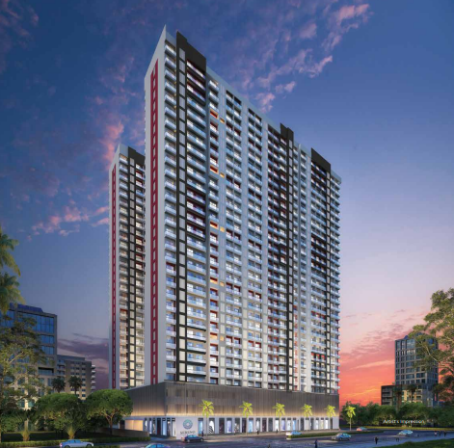

Details of the property under consideration:

Name of Project: "Sereno”

"Sereno”, Proposed Residential with Shopline, Building No. 3, Wing E & H, in Sector – III on Plot Bearing Survey No 81, Hissa No. 18, Survey No. 76, 82, Hissa No. 1, 2, 3/3, 8/1, 10, Survey No. 76,
Village – Gokhiware, Taluka – Vasai, District – Palghar, Pin Code – 401 208, Maharashtra, India.

Latitude Longitude: 19°23'44.5"N 72°50'51.1"E

Intended User:
State Bank of India
Industrial Finance Branch, Malad (West)
Industrial Finance Branch, Near Chincholi Phatak Signal, S. V. Road,
Malad (West), Mumbai - 400 064, State - Maharashtra, Country – India.

Vastu/SBI/Mumbai/12/2024/11228/2307677
13/01-155-PY
Date: 09.12.2024

To,
The Branch Manager,
State Bank of India
Industrial Finance Branch, Malad (West)
Industrial Finance Branch, Near Chincholi Phatak Signal,
S. V. Road, Malad (West), Mumbai - 400 064,
State - Maharashtra, Country – India.

Sub: Project Valuation for "Sereno”, Wing E & H, Gokhiware, Pin Code – 401 208.

Dear Sir,
In accordance with your letter of engagement as stated above, we enclose our Report on Project Valuation for "Sereno”, Proposed Residential with Shopline, Building No. 3, Wing E & H, in Sector – III on Plot Bearing Survey No 81, Hissa No. 18, Survey No. 76, 82, Hissa No. 1, 2, 3/3, 8/1, 10, Survey No. 76, Village – Gokhiware, Taluka – Vasai, District – Palghar, Pin Code – 401 208, Maharashtra, India.
M/s. TRIO Infrastructure Pvt. Ltd. is proposing Proposed Residential with Shopline, Building No. 3, Wing E & H, in Sector – III on Plot Bearing Survey No 81, Hissa No. 18, Survey No. 76, 82, Hissa No. 1, 2, 3/3, 8/1, 10, Survey No. 76, Village – Gokhiware, Taluka – Vasai, District – Palghar, Pin Code – 401 208, Maharashtra, India. Project is comprising Sale Building (Wing E to H) & Club House.
Residential of Sale Building (Wing E & H) is proposed of Ground Floor + P1 + P2 + 22nd Upper Floors with total RERA carpet area of 2,02,638.00 Sq. Ft. which consists 1 BHK & 2 BHK with 432 nos. of Sell flats & 17 nos. of Shops providing with Club House, Fitness Centre, Society Office, & Other Amenities.
In this regard, SBI, Industrial Finance Branch, Malad (West), Industrial Finance Branch, Near Chincholi Phatak Signal, S. V. Road, Malad (West), Mumbai - 400 064, has approached Vastukala Consultants (I) Pvt. Ltd. (VCIPL) to conduct a Project Valuation of the said project.
Our analysis of the project valuation is enclosed in this report. This Report forms an integral whole and cannot be split in parts. The outcome of the report/ study can only lead to proper conclusions if the Report as a whole is taken into account.

The information used by Vastukala Consultants (I) Pvt. Ltd. (VCIPL) in preparing this report has been obtained from a variety of sources and other relevant documents provided by the client & bank. As agreed, we have performed our project valuation exercise with the data available related to the business, considering the market prospects and projections. Our results are dependent on documents provided by client & bank, the underlying assumptions, which has been analysed at a broader level by VCIPL while assessing their reasonableness.
Sale Realisation from the Project is ` 195.17 Cr. and Net Present Value of the project as on date is ` 49.76 Cr.

For Vastukala Consultants (I) Pvt. Ltd.

Manoj B. Chalikwar
Registered Valuer
Chartered Engineer (India)
Reg. No. IBBI / RV / 07/2018/10366
Reg. No. CAT-I-F-1763
SBI Empanelment No.: SME/TCC/38/IBBI/3

PROJECT VALUATION REPORT
OF
"Sereno”

"Sereno”, Proposed Residential with Shopline, Building No. 3, Wing E & H, in Sector – III on Plot Bearing Survey No 81, Hissa No. 18, Survey No. 76, 82, Hissa No. 1, 2, 3/3, 8/1, 10, Survey No. 76,
Village – Gokhiware, Taluka – Vasai, District – Palghar, Pin Code – 401 208, Maharashtra, India.

Latitude Longitude: 19°23'44.5"N 72°50'51.1"E

NAME OF DEVELOPER: M/s. TRIO Infrastructure Pvt. Ltd.
Pursuant to instructions from State Bank of India, Industrial Finance Branch, Malad (West), we have duly visited, inspected, surveyed & assessed the above said property to determine the fair & reasonable market value of the said property as on 09th November 2024 for approval of project finance purpose.

- Location Details:
Residential with Shopline, Building No. 3, Wing E & H, in Sector – III on Plot Bearing Survey No 81, Hissa No. 18, Survey No. 76, 82, Hissa No. 1, 2, 3/3, 8/1, 10, Survey No. 76, Village – Gokhiware, Taluka – Vasai, District – Palghar, Pin Code – 401 208, Maharashtra, India. It is about 5.0 Km travelling distance from Vasai Railway station. Surface transport to the property is by buses, taxis & private vehicles. The property is in developed locality. All the amenities like shops, banks, hotels, markets, schools, hospitals, etc. are all available in the surrounding locality. The area is higher middle class & developed.

2. Developer Details:
Name of builder | M/s. TRIO Infrastructure Pvt. Ltd.
Project Registration Number | P99000053269
Register office address | M/s. TRIO Infrastructure Pvt. Ltd.  Shop Mo 8, Gokul Regency – II, Thakur Complex, Kandivali (East), Taluka – Borivali, District – Mumbai Suburban, Pin Code – 400 101, Maharashtra, India
Contact Numbers | Contact Person:  Mr. Suraj Singh (Sales Head)  Mobile No. 7499469249  Mr. Pratik Bodke (Site In charge)  Mobile No. 96193354656  Mr. Aftab Alam (Site Engineer)  Mobile No. 9326579997
E – mail ID and Website

3. Boundaries of the Property:
Direction | Sale Building
On or towards North | Road
On or towards South | Under Construction Building
On or towards East | Under Construction Building
On or towards West | Road

Vastukala Consultants (I) Pvt. Ltd.
B1-001, U/B Floor, Boomerang, Chandivali Farm Road, Powai, Andheri (East), Mumbai – 400 072

To,
The Branch Manager,
State Bank of India
Industrial Finance Branch, Malad (West)
Industrial Finance Branch, Near Chincholi Phatak Signal,
S. V. Road, Malad (West), Mumbai - 400 064,
State - Maharashtra, Country – India.

VALUATION REPORT (IN RESPECT OF PROJECT FINANCE)
I | General
1. | Purpose for which the valuation is made |  |  |  | : | As per request from State Bank of India, Industrial Finance Branch, Malad (West), to assess Fair Market value of the Project for bank loan purpose.
2. | a) |  | Date of inspection |  | : | 09.11.2024
 | b) |  | Date on which the valuation is made |  | : | 09.12.2024
3. | List of documents produced for perusal
 | - Copy of Development Agreement dated 24.07.2023 between M/s. Rashmi Ameya Developers Housing & Estate Realtors Pvt. Ltd (Owner No 1) and M/s. Sai Rydam Realtors Pvt Ltd. (Owner No 2) and Mr. Devendra Rajnikant Ladhani (Confirming Party No 1) & Others and M/s. TRIO Infrastructure Pvt, Ltd. (Purchaser) through registered agreement Doc. No. Vasai – 5/11399/2023 dated 06.04.2023.
 | - Copy of Power of Attorney by M/s. Rashmi Ameya Developers Housing & Estate Realtors Pvt. Ltd. To M/s. Sai Rydam Realtors Pvt Ltd. Through registered agreement Doc. No. Vasai-5/11401/2023 dated 24.07.2023.
 | - Copy of 7/12 Extract.
 | - Copy of N. A. Order No. SR 62 / 2018 dated 24.01.2019 issued by Tagasildar Vasai.
- Copy of Approved Plan office Letter No. VVCMC/TP/Amend/VP/0329,0815 & 0509/246/2023-24 dated 31.01.2024 issued by Vasai Virar City Municipal Corporation (VVCMC).
Approved upto:
Wing E – Ground Floor + 1st & 2nd Podium Floor + 1st to 22nd Residential Upper Floors
Wing H – Ground (Shops) Floor + 1st & 2nd Podium Floor + 1st to 22nd Residential Upper Floors
- Copy of Commencement Certificate No. VVCMC/TP/RDP/VP - 0329, 0815 & 0509/246/2023-24 dated 31.01.2024 issued by Vasai Virar City Municipal Corporation (VVCMC).
Sanctioned Upto:
Wing E – Ground Floor + 1st & 2nd Podium Floor + 1st to 22nd Residential Upper Floors
Wing H – Ground (Shops) Floor + 1st & 2nd Podium Floor + 1st to 22nd Residential Upper Floors
 | - Copy of Provisional Fire Safety Approval No. MFS/51/2024/237 dated 01.04.2024 issued Directorate of Maharashtra Fire Service, Government of Maharashtra.
 | - Copy of RERA Certificate RERA No. P99000053269 dated 15.04.2023 issued by Maharashtra Real Estate Regulatory Authority (MAHRERA).
 | - Copy of RERA Extension Certificate No. P99000053269 dated 15.04.2023 issued by Maharashtra Real Estate Regulatory Authority (MAHRERA).
 | Project Name  (With address & phone nos.) |  |  |  | : | "Sereno”, Residential with Shopline, Building No. 3, Wing E & H, in Sector – III on Plot Bearing Survey No 81, Hissa No. 18, Survey No. 76, 82, Hissa No. 1, 2, 3/3, 8/1, 10, Survey No. 76, Village – Gokhiware, Taluka – Vasai, District – Palghar, Pin Code – 401 208, Maharashtra, India.
4. | Name of the owner(s) and his / their address (es) with Phone no. (details of share of each owner in case of joint ownership) |  |  |  | : | M/s. TRIO Infrastructure Pvt. Ltd.  Shop Mo 8, Gokul Regency – II, Thakur Complex, Kandivali (East), Taluka – Borivali, District – Mumbai Suburban, Pin Code – 400 101, Maharashtra, India  Contact Person:  Mr. Suraj Singh (Sales Head)  Mobile No. 7499469249  Mr. Pratik Bodke (Site In charge)  Mobile No. 96193354656  Mr. Aftab Alam (Site Engineer)  Mobile No. 9326579997
5. | Brief description of the property (Including Leasehold / freehold etc.): Freehold land
About Group:
Trio Infrastructure Private Limited is one of the Group Concern of AVA Life Spaces Group, who are one of the renowned groups in the real estate sector of Vasai. The group is headed Mr. Balaji Raghavan & Mr. Manojshankar Tripathi. There are 3 partners - Balaji Raghavan, Manojshankar Ambikaprasad Tripathi & Rushabh Alok Chaubey. AVA Life Spaces Group has completed residential and commercial properties in their portfolio. The group has residential development till date with of over 8.50 lac sq. ft. area and have created homes for more than 500 families.
AVA Life Spaces Group have become a renowned name in the construction industry with a host of residential and commercial properties in their portfolio. GROUP is engaged in development of projects for upper and mid- income group offering wide range of features for qualitative and affordable living. The GROUP construct buildings providing excellence in quality of construction and exceptional elevation in recent years, with expert team of architect engineers and contractors having vast knowledge and experience in their respective fields. GROUP makes an impression with its gracious, luxurious, lush green and eco-friendly surrounding on the concept of community living. You will be amazed to find the home beautifully created in harmony with large open spaces landscaped gardens, well–lit board concrete roads adorned by foliage of trees and more.
The GROUP, today is progressing steadily mainly due to the references from thoroughly delighted customers who always have had words of praise and acknowledgment for us. We can today convincingly offer guarantees to its customers both on concrete and abstract parameters in the delivering of any assigned project. We concentrate largely on meeting customers demand for dream home and is strongly founded to continue doing so. We venture into projects with focus on innovation, integrity and trust and are well on a way to becoming one of the most trusted names in the real estate sector.
The group focus primarily on use of the most modern technologies, cost effective construction methods and for the timely completion of its projects. In addition to the latest technology, the Promoters have always focused on its social responsibilities like the preservation of environment, employee safety and activities that will benefit the society at large. Accordingly, we are continuously keeping ourselves abreast with changing global and national trends.
In an endeavour to transform the current real estate scenario and set new benchmarks for quality and satisfaction in the industry, the Group are having good name in real estate sector. They have built the Group by prioritizing stringent quality control systems, maximum customer satisfaction and timely delivery. The group plans to secure the ideals and standards set by the industry leaders, using innovative technology and modernization of operations in order to deliver an exceptional experience to every customer. Their leadership has given the company wings to fly and made many dreams a reality. The company strives to make an aspirational lifestyle a reality for all valued customers.
Key highlights of the Group:
- 10 Years of excellence
- 10+ Projects already completed
- 9 Lakhs+ sq. fts. of area constructed
- 500+ Happy Families
TYPE OF THE BUILDING:
Building | Number of Floors
"Sereno” (Wing E) | Proposed Residential Sale Building is proposed of Ground Floor + 1st & 2nd Podium Floor + 1st to 22nd Upper Floors as per approved plan and as per information from developer.
"Sereno” (Wing H) | Proposed Residential Sale Building with Shopline is proposed of Ground Floor (Shops) + 1st & 2nd Podium Floor + 1st to 22nd Upper Floors as per approved plan and as per information from developer.

LEVEL OF COMPLETEION:
Building | Present stage of Construction | % of work completion | % of construction cost incurred till date
Wing E | Excavation work is in Progress | 0.00% | 13.28%
Wing H | Excavation & Plinth work is completed & Ground Floor RCC work Completed. | 12.00% | 13.28%

PROPOSED DATE OF COMPLETION & FUTURE LIFE:
Expected completion date as informed by builder is 31.12.2027 (As per RERA Extension Certificate)
Future estimated life of the Structure is 60 years (after completion) Subject to proper, preventive periodic maintenance & Structural repairs.

PROPOSED PROJECT AMENITIES:
Vitrified flooring tiles in all rooms
Granite Kitchen platform with Stainless Steel Sink
Powder coated aluminum sliding windows with M.S. Grills
Laminated wooden flush doors with Safety door
Concealed wiring
Concealed plumbing
Fire Fighting System
Car Parking
Gym
Club House
Open Café Seating
Cafe
Chess Board
Stage with screen wall
Amphitheatre and open mini theatre
Multipurpose Lawn
Multipurpose Hall
Game room
Cricket Net
Aroma Garden
Jogging area
Sand Pit
Children Play Area
Conference Hall / Library
Yoga / Meditation Hall
Changing Rooms
Shower
Steam Room
Sauna
Lockers
Reception
Juice Bar
Party Deck
Children’s Pool
Seating with Pergola
Lawn
Sky Walkway

6. | Location of property |  |  |  | :
 | a) | Plot No. / Survey No. |  |  | : | Survey No. 81, Hissa no 18, Survey No. 76, 82, Hissa No. 1, 2, 3/3, 8/1,10
 | b) | Door No. |  |  | : | Not applicable
 | c) | C. T.S. No. / Village |  |  | : | Village – Gokhiware
 | d) | Ward / Taluka |  |  | : | Taluka – Vasai
 | e) | Mandal / District |  |  | : | District – Palghar
7. | Postal address of the property |  |  |  | : | "Sereno”, Residential with Shopline, Building No. 3, Wing E & H, in Sector – III on Plot Bearing Survey No 81, Hissa No. 18, Survey No. 76, 82, Hissa No. 1, 2, 3/3, 8/1, 10, Survey No. 76, Village – Gokhiware, Taluka – Vasai, District – Palghar, Pin Code – 401 208, Maharashtra, India.
8. | City / Town |  |  |  | : | Village – Gokhiware
 | Residential area |  |  |  | : | Yes
 | Commercial area |  |  |  | : | Yes
 | Industrial area |  |  |  | : | No
9. | Classification of the area |  |  |  | :
 | i) High / Middle / Poor |  |  |  | : | Middle Class
 | ii) Urban / Semi Urban / Rural |  |  |  | : | Rural
10. | Coming under Corporation limit / Village Panchayat / Municipality |  |  |  | : | Village – Gokhiware  Vasai Virar City Municipal Corporation (VVCMC)
11. | Whether covered under any State / Central Govt. enactments (e.g., Urban Land Ceiling Act) or notified under agency area/ scheduled area / cantonment area |  |  |  | : | No
12. | In Case it is Agricultural land, any conversion to house site plots is contemplated |  |  |  | : | N.A.
13. | Boundaries of the property |  |  | As per Agreement | As per RERA Certificate |  | As per Site
 | North |  |  | Information not available | 12.00 M. wide Road |  | Road
 | South |  |  | Information not available | Sec II, Building 2 – D Wing |  | Under Construction Building
 | East |  |  | Information not available | Sec III, Building 3, A Wing |  | Under Construction Building
 | West |  |  | Information not available | 20.00 M. wide Road |  | Road
14.1 | Dimensions of the site |  |  |  |  | N. A. as the land is irregular in shape
 |  |  |  |  |  | A (As per the Deed) |  | B (Actuals)
 | North |  |  |  | : | - |  | -
 | South |  |  |  | : | - |  | -
 | East |  |  |  | : | - |  | -
 | West |  |  |  | : | - |  | -
14.2 | Latitude, Longitude & Co-ordinates of property |  |  |  | : | 19°23'44.5"N 72°50'51.1"E
14. | Extent of the site |  |  |  | : | Net Plot area = 1,462.11.00 Sq. M.  (As per Approved Plan)  Structure - As per table attached to the report
15. | Extent of the site considered for Valuation (least of 14A& 14B) |  |  |  | : | Net Plot area = 1,462.11 Sq. M.  (As per Approved Plan)
16 | Whether occupied by the owner / tenant? If occupied by tenant since how long? Rent received per month. |  |  |  | : | N.A. Building Construction work is in progress
II | CHARACTERSTICS OF THE SITE
 | Classification of locality |  |  |  | : | Middle class
 | Development of surrounding areas |  |  |  | : | Good
 | Possibility of frequent flooding/ sub-merging |  |  |  | : | No
 | Feasibility to the Civic amenities like School, Hospital, Bus Stop, Market etc. |  |  |  | : | All available near by
 | Level of land with topographical conditions |  |  |  | : | Plain
 | Shape of land |  |  |  | : | Irregular
 | Type of use to which it can be put |  |  |  | : | For residential cum commercial purpose
 | Any usage restriction |  |  |  | : | Residential cum Commercial
 | Is plot in town planning approved layout? |  |  |  | : | Copy of Approved Plan office Letter No. VVCMC/TP/Amend/VP/0329,0815 & 0509/246/2023-24 dated 31.01.2024 issued by Vasai Virar City Municipal Corporation (VVCMC).  Approved upto:  Wing E – Ground Floor + 1st & 2nd Podium Floor + 1st to 22nd Residential Upper Floors  Wing H – Ground (Shops) Floor + 1st & 2nd Podium Floor + 1st to 22nd Residential Upper Floors
 | Corner plot or intermittent plot? |  |  |  | : | Corner Plot
 | Road facilities |  |  |  | : | Yes
 | Type of road available at present |  |  |  | : | Concrete Road
 | Width of road – is it below 20 ft. or more than 20 ft. |  |  |  | : | North Side - 12 M. Wide Road  West Side – 20 M. Wide Road
 | Is it a Land – Locked land? |  |  |  | : | No
 | Water potentiality |  |  |  | : | Municipal Water supply
 | Underground sewerage system |  |  |  | : | Connected to Municipal sewer
 | Is Power supply is available in the site |  |  |  | : | Yes
 | Advantages of the site |  |  |  | : | Located in developed area
 | Special remarks, if any like threat of acquisition of land for publics service purposes, road widening or applicability of CRZ provisions etc. (Distance from sea-cost / tidal level must be incorporated) |  |  |  | : | No
Part – A (Valuation of land)
1 | Size of plot |  |  |  | : | Net Plot area = 1,462.11 Sq. M.  (As per Approved Plan)
 | North & South |  |  |  | : | -
 | East & West |  |  |  | : | -
2 | Total extent of the plot |  |  |  | : | As per table attached to the report
3 | Prevailing market rate (Along With details / reference of at least two latest deals / transactions with respect to adjacent properties in the areas) |  |  |  | : | As per table attached to the report  Details of recent transactions/online listings are attached with the report.
4 | Guideline rate obtained from the Register’s Office (evidence thereof to be enclosed) |  |  |  | : | ` 12,300.00 per Sq. M. for Land  ` 57,700.00 per Sq. M. for Residential Flat  ₹ 73,200.00 Per Sq.M. for Shops
5 | Assessed / adopted rate of valuation |  |  |  | : | As per table attached to the report
6 | Estimated value of land |  |  |  | : | As per table attached to the report
Part – B (Valuation of Building)
1 | Technical details of the building |  |  |  | :
 | - Type of Building (Residential / Commercial / Industrial) |  |  |  | : | Residential & Commercial
 | - Type of construction (Load bearing / RCC / Steel Framed) |  |  |  | : | R.C.C. Framed structure
 | - Year of construction |  |  |  | : | Building Construction work is in progress
 | - Number of floors and height of each floor including basement, if any |  |  |  | :
Building | Number of Floors
"Sereno” (Wing E) | Proposed Residential Sale Building is proposed of Ground Floor + 1st & 2nd Podium Floor + 1st to 22nd Upper Floors as per approved plan and as per information from developer.
"Sereno” (Wing H) | Proposed Residential Sale Building with Shopline is proposed of Ground Floor (Shops) + 1st & 2nd Podium Floor + 1st to 22nd Upper Floors as per approved plan and as per information from developer.

 | - Plinth area floor-wise |  |  |  | : | As per table attached to the report
 | - Condition of the building |  |  |  | :
 | - Exterior – Excellent, Good, Normal, Poor |  |  |  | : | N.A. Building Construction work is in progress
 | - Interior – Excellent, Good, Normal, Poor |  |  |  | : | N.A. Building Construction work is in progress
 | - Date of issue and validity of layout of approved map |  |  |  | : | - Copy of Approved Plan office Letter No. VVCMC/TP/Amend/VP/0329,0815 & 0509/246/2023-24 dated 31.01.2024 issued by Vasai Virar City Municipal Corporation (VVCMC).  Approved upto:  Wing E – Ground Floor + 1st & 2nd Podium Floor + 1st to 22nd Residential Upper Floors  Wing H – Ground (Shops) Floor + 1st & 2nd Podium Floor + 1st to 22nd Residential Upper Floors.  - Copy of Commencement Certificate No. VVCMC/TP/RDP/VP - 0329, 0815 & 0509/246/2023-24 dated 31.01.2024 issued by Vasai Virar City Municipal Corporation (VVCMC).  Sanctioned Upto:  Wing E – Ground Floor + 1st & 2nd Podium Floor + 1st to 22nd Residential Upper Floors  Wing H – Ground (Shops) Floor + 1st & 2nd Podium Floor + 1st to 22nd Residential Upper Floors
 | - Approved map / plan issuing authority |  |  |  | : | Vasai Virar City Municipal Corporation (VVCMC)
 | - Whether genuineness or authenticity of approved map / plan is verified |  |  |  | : | Verified
 | - Any other comments by our empanelled valuers on authentic of approved plan |  |  |  | : | N.A.

Specifications of construction (floor-wise) in respect of
Sr. No. | Description
 | Foundation | : | Proposed R.C.C. Footing
 | Basement | : | No, Building Construction work is in progress
 | Superstructure | : | Proposed as per IS Code requirements
 | Joinery / Doors & Windows (Please furnish details about size of frames, shutters, glazing, fitting etc. and specify the species of timber | : | Proposed
 | RCC Works | : | N.A. Building Construction work is in progress
 | Plastering | : | N.A. Building Construction work is in progress
 | Flooring, Skirting, dado | : | N.A. Building Construction work is in progress
 | Special finish as marble, granite, wooden paneling, grills etc. | : | N.A. Building Construction work is in progress
 | Roofing including weather proof course | : | N.A. Building Construction work is in progress
 | Drainage | : | Proposed
2. | Compound Wall | :
 | Height | : | N.A. Building Construction work is in progress
 | Length | : | N.A. Building Construction work is in progress
 | Type of construction | : | N.A. Building Construction work is in progress
3. | Electrical installation | : | N.A. Building Construction work is in progress
 | Type of wiring | : | N.A. Building Construction work is in progress
 | Class of fittings (superior / ordinary / poor) | : | N.A. Building Construction work is in progress
 | Number of light points | : | N.A. Building Construction work is in progress
 | Fan points | : | N.A. Building Construction work is in progress
 | Spare plug points | : | N.A. Building Construction work is in progress
 | Any other item | : | -
4. | Plumbing installation
 | - No. of water closets and their type | : | N.A. Building Construction work is in progress
 | - No. of wash basins | : | N.A. Building Construction work is in progress
 | - No. of urinals | : | N.A. Building Construction work is in progress
 | - No. of bath tubs | : | N.A. Building Construction work is in progress
 | - Water meters, taps etc. | : | N.A. Building Construction work is in progress
 | - Any other fixtures | : | N.A. Building Construction work is in progress
Remarks:
- As the developer has executed the development agreement with the owners and confirming parties. Developer has received the development rights on the said plot. Building construction approval has been applied and received by the owners and confirming parties. They cost towards the same is incurred by the owners and confirming parties. Hence, approval cost is not considered in the project cost.

Part – C (Extra Items) |  | : | Amount in `
 | Portico | : | N.A. Building Construction work is in progress
 | Ornamental front door | : | N.A. Building Construction work is in progress
 | Sit out / Verandah with steel grills | : | N.A. Building Construction work is in progress
 | Overhead water tank | : | N.A. Building Construction work is in progress
 | Extra steel / collapsible gates | : | N.A. Building Construction work is in progress
 | Total |  | N.A. Building Construction work is in progress
Part – D (Amenities) |  | : | Amount in `
 | Wardrobes | : | N.A. Building Construction work is in progress
 | Glazed tiles | : | N.A. Building Construction work is in progress
 | Extra sinks and bath tub | : | N.A. Building Construction work is in progress
 | Marble / ceramic tiles flooring | : | N.A. Building Construction work is in progress
 | Interior decorations | : | N.A. Building Construction work is in progress
 | Architectural elevation works |  | N.A. Building Construction work is in progress
 | Paneling works |  | N.A. Building Construction work is in progress
 | Aluminum works |  | N.A. Building Construction work is in progress
 | Aluminum hand rails |  | N.A. Building Construction work is in progress
 | False ceiling |  | N.A. Building Construction work is in progress
 | Total |  | N.A. Building Construction work is in progress
Part – E (Miscellaneous) |  | : | Amount in `
 | Separate toilet room | : | N.A. Building Construction work is in progress
 | Separate lumber room | : | N.A. Building Construction work is in progress
 | Separate water tank / sump | : | N.A. Building Construction work is in progress
 | Trees, gardening | : | N.A. Building Construction work is in progress
 | Total |  | N.A. Building Construction work is in progress
Part – F (Services) |  | : | Amount in `
 | Water supply arrangements | : | N.A. Building Construction work is in progress
 | Drainage arrangements | : | N.A. Building Construction work is in progress
 | Compound wall | : | N.A. Building Construction work is in progress
 | C.B. deposits, fittings etc. | : | N.A. Building Construction work is in progress
 | Pavement |  | N.A. Building Construction work is in progress
 | Total |  | N.A. Building Construction work is in progress

Total abstract of the entire property

Part – A | Land | : | As per below table attached in the report
Part – B | Building | : | As per below table attached in the report
 | Land development |  | As per below table attached in the report
Part – C | Compound wall | : | As per below table attached in the report
Part - D | Amenities | : | As per below table attached in the report
Part – E | Pavement | : | As per below table attached in the report
Part – F | Services | : | As per below table attached in the report

Construction Area as per Approved Plan
Total Construction Area (Wing E & H):
Sr. | Floor | FSI Area in Sq. M. | NON FSI Area in Sq. M. | Refuge Area in Sq. M. | Podium Area in Sq. M. | Lift Well Area in Sq. M. | Open to Sky Area in Sq. M. | A. P. Area in Sq. M. | Total Construction Area in Sq. M.
1 | Ground Floor | 177.51 | 106.50 | - | 1,023.31 | 42.80 | 40.05 | 59.28 | 1,449.45
2 | Podium - I Floor | - | - | - | 1,357.25 | 42.80 | - | - | 1,400.05
3 | Podium - II Floor | - | - | - | 1,357.25 | 42.80 | - | - | 1,400.05
4 | 1st Floor | 737.89 | 442.74 | - | - | 42.80 | 119.95 | 72.05 | 1,415.43
5 | 2nd Floor | 737.89 | 442.74 | - | - | 42.80 | - | 144.06 | 1,367.49
6 | 3rd Floor | 737.89 | 442.74 | - | - | 42.80 | - | 144.06 | 1,367.49
7 | 4th Floor | 737.89 | 442.74 | - | - | 42.80 | - | 144.06 | 1,367.49
8 | 5th Floor | 702.55 | 421.53 | 64.29 | - | 42.80 | - | 135.88 | 1,367.05
9 | 6th Floor | 737.89 | 442.74 | - | - | 42.80 | - | 144.06 | 1,367.49
10 | 7th Floor | 737.89 | 442.74 | - | - | 42.80 | - | 144.06 | 1,367.49
11 | 8th Floor | 737.89 | 442.74 | - | - | 42.80 | - | 144.06 | 1,367.49
12 | 9th Floor | 737.89 | 442.74 | - | - | 42.80 | - | 144.06 | 1,367.49
13 | 10th Floor | 702.55 | 421.53 | 64.29 | - | 42.80 | - | 135.88 | 1,367.05
14 | 11th Floor | 737.89 | 442.74 | - | - | 42.80 | - | 144.06 | 1,367.49
15 | 12th Floor | 737.89 | 442.74 | - | - | 42.80 | - | 144.06 | 1,367.49
16 | 13th Floor | 737.89 | 442.74 | - | - | 42.80 | - | 144.06 | 1,367.49
17 | 14th Floor | 737.89 | 442.74 | - | - | 42.80 | - | 144.06 | 1,367.49
18 | 15th Floor | 702.55 | 421.53 | 64.29 | - | 42.80 | - | 135.88 | 1,367.05
19 | 16th Floor | 737.89 | 442.74 | - | - | 42.80 | - | 144.06 | 1,367.49
20 | 17th Floor | 737.89 | 442.74 | - | - | 42.80 | - | 144.06 | 1,367.49
21 | 18th Floor | 737.89 | 442.74 | - | - | 42.80 | - | 144.06 | 1,367.49
22 | 19th Floor | 737.89 | 442.74 | - | - | 42.80 | - | 144.06 | 1,367.49
23 | 20th Floor | 702.55 | 421.53 | 64.29 | - | 42.80 | - | 135.88 | 1,367.05
24 | 21st Floor | 737.89 | 442.74 | - | - | 42.80 | - | 144.06 | 1,367.49
25 | 22nd Floor | 737.89 | 442.74 | - | - | 42.80 | - | 144.06 | 1,367.49
26 | LMR / OHT / Terrace | - | 442.74 | - | - | 42.80 | - | 144.06 | 629.60
TOTAL |  | 16,269.73 | 10,204.68 | 257.16 | 3,737.81 | 1,112.80 | 160.00 | 3,267.93 | 35,010.11

The floor wise Area Statement of the Project is as table below:

Sale Building (Wing E):
Sr. | Wing | Floor | Flat No. | Comp. | RERA Carpet Area in Sq. Ft. | Balcony Area in Sq. Ft. | Covered Balcony Area in Sq. Ft. | Total Carpet Area in Sq. Ft. | Sold / Unsold Inventory
1 | E | 1st Floor | 101 | 1 BHK | 308.28 | 83.42 | - | 392.00 | Unsold
2 | E | 1st Floor | 102 | 1 BHK | 308.28 | 83.42 | - | 392.00 | Unsold
3 | E | 1st Floor | 103 | 2 BHK | 514.73 | 31.22 | 8.50 | 554.00 | Unsold
4 | E | 1st Floor | 104 | 2 BHK | 517.53 | 31.22 | 8.50 | 557.00 | Unsold
5 | E | 1st Floor | 105 | 1 BHK | 308.17 | 86.65 | - | 395.00 | Unsold
6 | E | 1st Floor | 106 | 1 BHK | 304.08 | 86.65 | - | 391.00 | Unsold
7 | E | 1st Floor | 107 | 1 BHK | 315.60 | 75.46 | - | 391.00 | Unsold
8 | E | 1st Floor | 108 | 2 BHK | 533.68 | 32.40 | 8.50 | 575.00 | Unsold
9 | E | 1st Floor | 109 | 2 BHK | 531.74 | 31.22 | 8.50 | 571.00 | Unsold
10 | E | 1st Floor | 110 | 1 BHK | 321.52 | 69.64 | - | 391.00 | Unsold
11 | E | 2nd Floor | 201 | 1 BHK | 308.28 | 83.42 | - | 392.00 | Unsold
12 | E | 2nd Floor | 202 | 1 BHK | 308.28 | 83.42 | - | 392.00 | Unsold
13 | E | 2nd Floor | 203 | 2 BHK | 514.73 | 31.22 | 8.50 | 554.00 | Unsold
14 | E | 2nd Floor | 204 | 2 BHK | 517.53 | 31.22 | 8.50 | 557.00 | Unsold
15 | E | 2nd Floor | 205 | 1 BHK | 308.17 | 86.65 | - | 395.00 | Unsold
16 | E | 2nd Floor | 206 | 1 BHK | 304.08 | 86.65 | - | 391.00 | Unsold
17 | E | 2nd Floor | 207 | 1 BHK | 315.60 | 75.46 | - | 391.00 | Unsold
18 | E | 2nd Floor | 208 | 2 BHK | 533.68 | 32.40 | 8.50 | 575.00 | Unsold
19 | E | 2nd Floor | 209 | 2 BHK | 531.74 | 31.22 | 8.50 | 571.00 | Unsold
20 | E | 2nd Floor | 210 | 1 BHK | 321.52 | 69.64 | - | 391.00 | Unsold
21 | E | 3rd Floor | 301 | 1 BHK | 308.28 | 83.42 | - | 392.00 | Unsold
22 | E | 3rd Floor | 302 | 1 BHK | 308.28 | 83.42 | - | 392.00 | Unsold
23 | E | 3rd Floor | 303 | 2 BHK | 514.73 | 31.22 | 8.50 | 554.00 | Unsold
24 | E | 3rd Floor | 304 | 2 BHK | 517.53 | 31.22 | 8.50 | 557.00 | Unsold
25 | E | 3rd Floor | 305 | 1 BHK | 308.17 | 86.65 | - | 395.00 | Unsold
26 | E | 3rd Floor | 306 | 1 BHK | 304.08 | 86.65 | - | 391.00 | Unsold
27 | E | 3rd Floor | 307 | 1 BHK | 315.60 | 75.46 | - | 391.00 | Unsold
28 | E | 3rd Floor | 308 | 2 BHK | 533.68 | 32.40 | 8.50 | 575.00 | Unsold
29 | E | 3rd Floor | 309 | 2 BHK | 531.74 | 31.22 | 8.50 | 571.00 | Unsold
30 | E | 3rd Floor | 310 | 1 BHK | 321.52 | 69.64 | - | 391.00 | Unsold
31 | E | 4th Floor | 401 | 1 BHK | 308.28 | 83.42 | - | 392.00 | Unsold
32 | E | 4th Floor | 402 | 1 BHK | 308.28 | 83.42 | - | 392.00 | Unsold
33 | E | 4th Floor | 403 | 2 BHK | 514.73 | 31.22 | 8.50 | 554.00 | Unsold
34 | E | 4th Floor | 404 | 2 BHK | 517.53 | 31.22 | 8.50 | 557.00 | Unsold
35 | E | 4th Floor | 405 | 1 BHK | 308.17 | 86.65 | - | 395.00 | Unsold
36 | E | 4th Floor | 406 | 1 BHK | 304.08 | 86.65 | - | 391.00 | Unsold
37 | E | 4th Floor | 407 | 1 BHK | 315.60 | 75.46 | - | 391.00 | Unsold
38 | E | 4th Floor | 408 | 2 BHK | 533.68 | 32.40 | 8.50 | 575.00 | Unsold
39 | E | 4th Floor | 409 | 2 BHK | 531.74 | 31.22 | 8.50 | 571.00 | Unsold
40 | E | 4th Floor | 410 | 1 BHK | 321.52 | 69.64 | - | 391.00 | Unsold
41 | E | 5th Floor | 501 | 1 BHK | 308.28 | 83.42 | - | 392.00 | Unsold
42 | E | 5th Floor | 502 | 1 BHK | 308.28 | 83.42 | - | 392.00 | Unsold
43 | E | 5th Floor | 503 | 2 BHK | 514.73 | 31.22 | 8.50 | 554.00 | Unsold
44 | E | 5th Floor | 504 | 2 BHK | 517.53 | 31.22 | 8.50 | 557.00 | Unsold
45 | E | 5th Floor | 506 | 2 BHK | 402.47 | 86.65 | - | 489.00 | Unsold
46 | E | 5th Floor | 507 | 1 BHK | 315.60 | 75.46 | - | 391.00 | Unsold
47 | E | 5th Floor | 508 | 2 BHK | 533.68 | 32.40 | 8.50 | 575.00 | Unsold
48 | E | 5th Floor | 509 | 2 BHK | 531.74 | 31.22 | 8.50 | 571.00 | Unsold
49 | E | 5th Floor | 510 | 1 BHK | 321.52 | 69.64 | - | 391.00 | Unsold
50 | E | 6th Floor | 601 | 1 BHK | 308.28 | 83.42 | - | 392.00 | Unsold
51 | E | 6th Floor | 602 | 1 BHK | 308.28 | 83.42 | - | 392.00 | Unsold
52 | E | 6th Floor | 603 | 2 BHK | 514.73 | 31.22 | 8.50 | 554.00 | Unsold
53 | E | 6th Floor | 604 | 2 BHK | 517.53 | 31.22 | 8.50 | 557.00 | Unsold
54 | E | 6th Floor | 605 | 1 BHK | 308.17 | 86.65 | - | 395.00 | Unsold
55 | E | 6th Floor | 606 | 1 BHK | 304.08 | 86.65 | - | 391.00 | Unsold
56 | E | 6th Floor | 607 | 1 BHK | 315.60 | 75.46 | - | 391.00 | Unsold
57 | E | 6th Floor | 608 | 2 BHK | 533.68 | 32.40 | 8.50 | 575.00 | Unsold
58 | E | 6th Floor | 609 | 2 BHK | 531.74 | 31.22 | 8.50 | 571.00 | Unsold
59 | E | 6th Floor | 610 | 1 BHK | 321.52 | 69.64 | - | 391.00 | Unsold
60 | E | 7th Floor | 701 | 1 BHK | 308.28 | 83.42 | - | 392.00 | Unsold
61 | E | 7th Floor | 702 | 1 BHK | 308.28 | 83.42 | - | 392.00 | Unsold
62 | E | 7th Floor | 703 | 2 BHK | 514.73 | 31.22 | 8.50 | 554.00 | Unsold
63 | E | 7th Floor | 704 | 2 BHK | 517.53 | 31.22 | 8.50 | 557.00 | Unsold
64 | E | 7th Floor | 705 | 1 BHK | 308.17 | 86.65 | - | 395.00 | Unsold
65 | E | 7th Floor | 706 | 1 BHK | 304.08 | 86.65 | - | 391.00 | Unsold
66 | E | 7th Floor | 707 | 1 BHK | 315.60 | 75.46 | - | 391.00 | Unsold
67 | E | 7th Floor | 708 | 2 BHK | 533.68 | 32.40 | 8.50 | 575.00 | Unsold
68 | E | 7th Floor | 709 | 2 BHK | 531.74 | 31.22 | 8.50 | 571.00 | Unsold
69 | E | 7th Floor | 710 | 1 BHK | 321.52 | 69.64 | - | 391.00 | Unsold
70 | E | 8th Floor | 801 | 1 BHK | 308.28 | 83.42 | - | 392.00 | Unsold
71 | E | 8th Floor | 802 | 1 BHK | 308.28 | 83.42 | - | 392.00 | Unsold
72 | E | 8th Floor | 803 | 2 BHK | 514.73 | 31.22 | 8.50 | 554.00 | Unsold
73 | E | 8th Floor | 804 | 2 BHK | 517.53 | 31.22 | 8.50 | 557.00 | Unsold
74 | E | 8th Floor | 805 | 1 BHK | 308.17 | 86.65 | - | 395.00 | Unsold
75 | E | 8th Floor | 806 | 1 BHK | 304.08 | 86.65 | - | 391.00 | Unsold
76 | E | 8th Floor | 807 | 1 BHK | 315.60 | 75.46 | - | 391.00 | Unsold
77 | E | 8th Floor | 808 | 2 BHK | 533.68 | 32.40 | 8.50 | 575.00 | Unsold
78 | E | 8th Floor | 809 | 2 BHK | 531.74 | 31.22 | 8.50 | 571.00 | Unsold
79 | E | 8th Floor | 810 | 1 BHK | 321.52 | 69.64 | - | 391.00 | Unsold
80 | E | 9th Floor | 901 | 1 BHK | 308.28 | 83.42 | - | 392.00 | Unsold
81 | E | 9th Floor | 902 | 1 BHK | 308.28 | 83.42 | - | 392.00 | Unsold
82 | E | 9th Floor | 903 | 2 BHK | 514.73 | 31.22 | 8.50 | 554.00 | Unsold
83 | E | 9th Floor | 904 | 2 BHK | 517.53 | 31.22 | 8.50 | 557.00 | Unsold
84 | E | 9th Floor | 905 | 1 BHK | 308.17 | 86.65 | - | 395.00 | Unsold
85 | E | 9th Floor | 906 | 1 BHK | 304.08 | 86.65 | - | 391.00 | Unsold
86 | E | 9th Floor | 907 | 1 BHK | 315.60 | 75.46 | - | 391.00 | Unsold
87 | E | 9th Floor | 908 | 2 BHK | 533.68 | 32.40 | 8.50 | 575.00 | Unsold
88 | E | 9th Floor | 909 | 2 BHK | 531.74 | 31.22 | 8.50 | 571.00 | Unsold
89 | E | 9th Floor | 910 | 1 BHK | 321.52 | 69.64 | - | 391.00 | Unsold
90 | E | 10th Floor | 1001 | 1 BHK | 308.28 | 83.42 | - | 392.00 | Unsold
91 | E | 10th Floor | 1002 | 1 BHK | 308.28 | 83.42 | - | 392.00 | Unsold
92 | E | 10th Floor | 1003 | 2 BHK | 514.73 | 31.22 | 8.50 | 554.00 | Unsold
93 | E | 10th Floor | 1004 | 2 BHK | 517.53 | 31.22 | 8.50 | 557.00 | Unsold
94 | E | 10th Floor | 1006 | 2 BHK | 402.47 | 86.65 | - | 489.00 | Unsold
95 | E | 10th Floor | 1007 | 1 BHK | 315.60 | 75.46 | - | 391.00 | Unsold
96 | E | 10th Floor | 1008 | 2 BHK | 533.68 | 32.40 | 8.50 | 575.00 | Unsold
97 | E | 10th Floor | 1009 | 2 BHK | 531.74 | 31.22 | 8.50 | 571.00 | Unsold
98 | E | 10th Floor | 1010 | 1 BHK | 321.52 | 69.64 | - | 391.00 | Unsold
99 | E | 11th Floor | 1101 | 1 BHK | 308.28 | 83.42 | - | 392.00 | Unsold
100 | E | 11th Floor | 1102 | 1 BHK | 308.28 | 83.42 | - | 392.00 | Unsold
101 | E | 11th Floor | 1103 | 2 BHK | 514.73 | 31.22 | 8.50 | 554.00 | Unsold
102 | E | 11th Floor | 1104 | 2 BHK | 517.53 | 31.22 | 8.50 | 557.00 | Unsold
103 | E | 11th Floor | 1105 | 1 BHK | 308.17 | 86.65 | - | 395.00 | Unsold
104 | E | 11th Floor | 1106 | 1 BHK | 304.08 | 86.65 | - | 391.00 | Unsold
105 | E | 11th Floor | 1107 | 1 BHK | 315.60 | 75.46 | - | 391.00 | Unsold
106 | E | 11th Floor | 1108 | 2 BHK | 533.68 | 32.40 | 8.50 | 575.00 | Unsold
107 | E | 11th Floor | 1109 | 2 BHK | 531.74 | 31.22 | 8.50 | 571.00 | Unsold
108 | E | 11th Floor | 1110 | 1 BHK | 321.52 | 69.64 | - | 391.00 | Unsold
109 | E | 12th Floor | 1201 | 1 BHK | 308.28 | 83.42 | - | 392.00 | Unsold
110 | E | 12th Floor | 1202 | 1 BHK | 308.28 | 83.42 | - | 392.00 | Unsold
111 | E | 12th Floor | 1203 | 2 BHK | 514.73 | 31.22 | 8.50 | 554.00 | Unsold
112 | E | 12th Floor | 1204 | 2 BHK | 517.53 | 31.22 | 8.50 | 557.00 | Unsold
113 | E | 12th Floor | 1205 | 1 BHK | 308.17 | 86.65 | - | 395.00 | Unsold
114 | E | 12th Floor | 1206 | 1 BHK | 304.08 | 86.65 | - | 391.00 | Unsold
115 | E | 12th Floor | 1207 | 1 BHK | 315.60 | 75.46 | - | 391.00 | Unsold
116 | E | 12th Floor | 1208 | 2 BHK | 533.68 | 32.40 | 8.50 | 575.00 | Unsold
117 | E | 12th Floor | 1209 | 2 BHK | 531.74 | 31.22 | 8.50 | 571.00 | Unsold
118 | E | 12th Floor | 1210 | 1 BHK | 321.52 | 69.64 | - | 391.00 | Unsold
119 | E | 13th Floor | 1301 | 1 BHK | 308.28 | 83.42 | - | 392.00 | Unsold
120 | E | 13th Floor | 1302 | 1 BHK | 308.28 | 83.42 | - | 392.00 | Unsold
121 | E | 13th Floor | 1303 | 2 BHK | 514.73 | 31.22 | 8.50 | 554.00 | Unsold
122 | E | 13th Floor | 1304 | 2 BHK | 517.53 | 31.22 | 8.50 | 557.00 | Unsold
123 | E | 13th Floor | 1305 | 1 BHK | 308.17 | 86.65 | - | 395.00 | Unsold
124 | E | 13th Floor | 1306 | 1 BHK | 304.08 | 86.65 | - | 391.00 | Unsold
125 | E | 13th Floor | 1307 | 1 BHK | 315.60 | 75.46 | - | 391.00 | Unsold
126 | E | 13th Floor | 1308 | 2 BHK | 533.68 | 32.40 | 8.50 | 575.00 | Unsold
127 | E | 13th Floor | 1309 | 2 BHK | 531.74 | 31.22 | 8.50 | 571.00 | Unsold
128 | E | 13th Floor | 1310 | 1 BHK | 321.52 | 69.64 | - | 391.00 | Unsold
129 | E | 14th Floor | 1401 | 1 BHK | 308.28 | 83.42 | - | 392.00 | Unsold
130 | E | 14th Floor | 1402 | 1 BHK | 308.28 | 83.42 | - | 392.00 | Unsold
131 | E | 14th Floor | 1403 | 2 BHK | 514.73 | 31.22 | 8.50 | 554.00 | Unsold
132 | E | 14th Floor | 1404 | 2 BHK | 517.53 | 31.22 | 8.50 | 557.00 | Unsold
133 | E | 14th Floor | 1405 | 1 BHK | 308.17 | 86.65 | - | 395.00 | Unsold
134 | E | 14th Floor | 1406 | 1 BHK | 304.08 | 86.65 | - | 391.00 | Unsold
135 | E | 14th Floor | 1407 | 1 BHK | 315.60 | 75.46 | - | 391.00 | Unsold
136 | E | 14th Floor | 1408 | 2 BHK | 533.68 | 32.40 | 8.50 | 575.00 | Unsold
137 | E | 14th Floor | 1409 | 2 BHK | 531.74 | 31.22 | 8.50 | 571.00 | Unsold
138 | E | 14th Floor | 1410 | 1 BHK | 321.52 | 69.64 | - | 391.00 | Unsold
139 | E | 15th Floor | 1501 | 1 BHK | 308.28 | 83.42 | - | 392.00 | Unsold
140 | E | 15th Floor | 1502 | 1 BHK | 308.28 | 83.42 | - | 392.00 | Unsold
141 | E | 15th Floor | 1503 | 2 BHK | 514.73 | 31.22 | 8.50 | 554.00 | Unsold
142 | E | 15th Floor | 1504 | 2 BHK | 517.53 | 31.22 | 8.50 | 557.00 | Unsold
143 | E | 15th Floor | 1506 | 2 BHK | 402.47 | 86.65 | - | 489.00 | Unsold
144 | E | 15th Floor | 1507 | 1 BHK | 315.60 | 75.46 | - | 391.00 | Unsold
145 | E | 15th Floor | 1508 | 2 BHK | 533.68 | 32.40 | 8.50 | 575.00 | Unsold
146 | E | 15th Floor | 1509 | 2 BHK | 531.74 | 31.22 | 8.50 | 571.00 | Unsold
147 | E | 15th Floor | 1510 | 1 BHK | 321.52 | 69.64 | - | 391.00 | Unsold
148 | E | 16th Floor | 1601 | 1 BHK | 308.28 | 83.42 | - | 392.00 | Unsold
149 | E | 16th Floor | 1602 | 1 BHK | 308.28 | 83.42 | - | 392.00 | Unsold
150 | E | 16th Floor | 1603 | 2 BHK | 514.73 | 31.22 | 8.50 | 554.00 | Unsold
151 | E | 16th Floor | 1604 | 2 BHK | 517.53 | 31.22 | 8.50 | 557.00 | Unsold
152 | E | 16th Floor | 1605 | 1 BHK | 308.17 | 86.65 | - | 395.00 | Unsold
153 | E | 16th Floor | 1606 | 1 BHK | 304.08 | 86.65 | - | 391.00 | Unsold
154 | E | 16th Floor | 1607 | 1 BHK | 315.60 | 75.46 | - | 391.00 | Unsold
155 | E | 16th Floor | 1608 | 2 BHK | 533.68 | 32.40 | 8.50 | 575.00 | Unsold
156 | E | 16th Floor | 1609 | 2 BHK | 531.74 | 31.22 | 8.50 | 571.00 | Unsold
157 | E | 16th Floor | 1610 | 1 BHK | 321.52 | 69.64 | - | 391.00 | Unsold
158 | E | 17th Floor | 1701 | 1 BHK | 308.28 | 83.42 | - | 392.00 | Unsold
159 | E | 17th Floor | 1702 | 1 BHK | 308.28 | 83.42 | - | 392.00 | Unsold
160 | E | 17th Floor | 1703 | 2 BHK | 514.73 | 31.22 | 8.50 | 554.00 | Unsold
161 | E | 17th Floor | 1704 | 2 BHK | 517.53 | 31.22 | 8.50 | 557.00 | Unsold
162 | E | 17th Floor | 1705 | 1 BHK | 308.17 | 86.65 | - | 395.00 | Unsold
163 | E | 17th Floor | 1706 | 1 BHK | 304.08 | 86.65 | - | 391.00 | Unsold
164 | E | 17th Floor | 1707 | 1 BHK | 315.60 | 75.46 | - | 391.00 | Unsold
165 | E | 17th Floor | 1708 | 2 BHK | 533.68 | 32.40 | 8.50 | 575.00 | Unsold
166 | E | 17th Floor | 1709 | 2 BHK | 531.74 | 31.22 | 8.50 | 571.00 | Unsold
167 | E | 17th Floor | 1710 | 1 BHK | 321.52 | 69.64 | - | 391.00 | Unsold
168 | E | 18th Floor | 1801 | 1 BHK | 308.28 | 83.42 | - | 392.00 | Unsold
169 | E | 18th Floor | 1802 | 1 BHK | 308.28 | 83.42 | - | 392.00 | Unsold
170 | E | 18th Floor | 1803 | 2 BHK | 514.73 | 31.22 | 8.50 | 554.00 | Unsold
171 | E | 18th Floor | 1804 | 2 BHK | 517.53 | 31.22 | 8.50 | 557.00 | Unsold
172 | E | 18th Floor | 1805 | 1 BHK | 308.17 | 86.65 | - | 395.00 | Unsold
173 | E | 18th Floor | 1806 | 1 BHK | 304.08 | 86.65 | - | 391.00 | Unsold
174 | E | 18th Floor | 1807 | 1 BHK | 315.60 | 75.46 | - | 391.00 | Unsold
175 | E | 18th Floor | 1808 | 2 BHK | 533.68 | 32.40 | 8.50 | 575.00 | Unsold
176 | E | 18th Floor | 1809 | 2 BHK | 531.74 | 31.22 | 8.50 | 571.00 | Unsold
177 | E | 18th Floor | 1810 | 1 BHK | 321.52 | 69.64 | - | 391.00 | Unsold
178 | E | 19th Floor | 1901 | 1 BHK | 308.28 | 83.42 | - | 392.00 | Unsold
179 | E | 19th Floor | 1902 | 1 BHK | 308.28 | 83.42 | - | 392.00 | Unsold
180 | E | 19th Floor | 1903 | 2 BHK | 514.73 | 31.22 | 8.50 | 554.00 | Unsold
181 | E | 19th Floor | 1904 | 2 BHK | 517.53 | 31.22 | 8.50 | 557.00 | Unsold
182 | E | 19th Floor | 1905 | 1 BHK | 308.17 | 86.65 | - | 395.00 | Unsold
183 | E | 19th Floor | 1906 | 1 BHK | 304.08 | 86.65 | - | 391.00 | Unsold
184 | E | 19th Floor | 1907 | 1 BHK | 315.60 | 75.46 | - | 391.00 | Unsold
185 | E | 19th Floor | 1908 | 2 BHK | 533.68 | 32.40 | 8.50 | 575.00 | Unsold
186 | E | 19th Floor | 1909 | 2 BHK | 531.74 | 31.22 | 8.50 | 571.00 | Unsold
187 | E | 19th Floor | 1910 | 1 BHK | 321.52 | 69.64 | - | 391.00 | Unsold
188 | E | 20th Floor | 2001 | 1 BHK | 308.28 | 83.42 | - | 392.00 | Unsold
189 | E | 20th Floor | 2002 | 1 BHK | 308.28 | 83.42 | - | 392.00 | Unsold
190 | E | 20th Floor | 2003 | 2 BHK | 514.73 | 31.22 | 8.50 | 554.00 | Unsold
191 | E | 20th Floor | 2004 | 2 BHK | 517.53 | 31.22 | 8.50 | 557.00 | Unsold
192 | E | 20th Floor | 2006 | 2 BHK | 402.47 | 86.65 | - | 489.00 | Unsold
193 | E | 20th Floor | 2007 | 1 BHK | 315.60 | 75.46 | - | 391.00 | Unsold
194 | E | 20th Floor | 2008 | 2 BHK | 533.68 | 32.40 | 8.50 | 575.00 | Unsold
195 | E | 20th Floor | 2009 | 2 BHK | 531.74 | 31.22 | 8.50 | 571.00 | Unsold
196 | E | 20th Floor | 2010 | 1 BHK | 321.52 | 69.64 | - | 391.00 | Unsold
197 | E | 21st Floor | 2101 | 1 BHK | 308.28 | 83.42 | - | 392.00 | Unsold
198 | E | 21st Floor | 2102 | 1 BHK | 308.28 | 83.42 | - | 392.00 | Unsold
199 | E | 21st Floor | 2103 | 2 BHK | 514.73 | 31.22 | 8.50 | 554.00 | Unsold
200 | E | 21st Floor | 2104 | 2 BHK | 517.53 | 31.22 | 8.50 | 557.00 | Unsold
201 | E | 21st Floor | 2105 | 1 BHK | 308.17 | 86.65 | - | 395.00 | Unsold
202 | E | 21st Floor | 2106 | 1 BHK | 304.08 | 86.65 | - | 391.00 | Unsold
203 | E | 21st Floor | 2107 | 1 BHK | 315.60 | 75.46 | - | 391.00 | Unsold
204 | E | 21st Floor | 2108 | 2 BHK | 533.68 | 32.40 | 8.50 | 575.00 | Unsold
205 | E | 21st Floor | 2109 | 2 BHK | 531.74 | 31.22 | 8.50 | 571.00 | Unsold
206 | E | 21st Floor | 2110 | 1 BHK | 321.52 | 69.64 | - | 391.00 | Unsold
207 | E | 22nd Floor | 2201 | 1 BHK | 308.28 | 83.42 | - | 392.00 | Unsold
208 | E | 22nd Floor | 2202 | 1 BHK | 308.28 | 83.42 | - | 392.00 | Unsold
209 | E | 22nd Floor | 2203 | 2 BHK | 514.73 | 31.22 | 8.50 | 554.00 | Unsold
210 | E | 22nd Floor | 2204 | 2 BHK | 517.53 | 31.22 | 8.50 | 557.00 | Unsold
211 | E | 22nd Floor | 2205 | 1 BHK | 308.17 | 86.65 | - | 395.00 | Unsold
212 | E | 22nd Floor | 2206 | 1 BHK | 304.08 | 86.65 | - | 391.00 | Unsold
213 | E | 22nd Floor | 2207 | 1 BHK | 315.60 | 75.46 | - | 391.00 | Unsold
214 | E | 22nd Floor | 2208 | 2 BHK | 533.68 | 32.40 | 8.50 | 575.00 | Unsold
215 | E | 22nd Floor | 2209 | 2 BHK | 531.74 | 31.22 | 8.50 | 571.00 | Unsold
216 | E | 22nd Floor | 2210 | 1 BHK | 321.52 | 69.64 | - | 391.00 | Unsold
TOTAL |  |  |  |  | 86,360.65 | 13,101.73 | 748.31 | 1,00,210.00

Sale Building (Wing H):
Sr. | Wing | Floor | Flat No. | Comp. | RERA Carpet Area in Sq. Ft. | Balcony Area in Sq. Ft. | Covered Balcony Area in Sq. Ft. | Total Carpet Area in Sq. Ft. | Sold / Unsold Inventory
1 | H | Ground Floor | S-1 | SHOP | 174.59 | - | - | 175.00 | Sold
2 | H | Ground Floor | S-2 | SHOP | 145.96 | - | - | 146.00 | Sold
3 | H | Ground Floor | S-3 | SHOP | 184.06 | - | - | 184.00 | Sold
4 | H | Ground Floor | S-4 | SHOP | 228.30 | - | - | 228.00 | Sold
5 | H | Ground Floor | S-5 | SHOP | 192.68 | - | - | 193.00 | Unsold
6 | H | Ground Floor | S-6 | SHOP | 110.01 | - | - | 110.00 | Sold
7 | H | Ground Floor | S-7 | SHOP | 120.99 | - | - | 121.00 | Sold
8 | H | Ground Floor | S-8 | SHOP | 120.99 | - | - | 121.00 | Sold
9 | H | Ground Floor | S-9 | SHOP | 111.95 | - | - | 112.00 | Sold
10 | H | Ground Floor | S-10 | SHOP | 192.68 | - | - | 193.00 | Sold
11 | H | Ground Floor | S-11 | SHOP | 189.66 | - | - | 190.00 | Unsold
12 | H | Ground Floor | S-12 | SHOP | 102.26 | - | - | 102.00 | Sold
13 | H | Ground Floor | S-13 | SHOP | 178.36 | - | - | 178.00 | Sold
14 | H | Ground Floor | S-14 | SHOP | 122.82 | - | - | 123.00 | Sold
15 | H | Ground Floor | S-15 | SHOP | 240.36 | - | - | 240.00 | Sold
16 | H | Ground Floor | S-16 | SHOP | 145.96 | - | - | 146.00 | Sold
17 | H | Ground Floor | S-17 | SHOP | 174.59 | - | - | 175.00 | Sold
18 | H | 1st Floor | 101 | 1 BHK | 321.52 | 69.64 | - | 391.00 | Unsold
19 | H | 1st Floor | 102 | 2 BHK | 531.74 | 31.22 | 8.50 | 571.00 | Unsold
20 | H | 1st Floor | 103 | 2 BHK | 533.68 | 32.40 | 8.50 | 575.00 | Sold
21 | H | 1st Floor | 104 | 1 BHK | 315.60 | 75.46 | - | 391.00 | Unsold
22 | H | 1st Floor | 105 | 1 BHK | 299.78 | 96.98 | - | 397.00 | Unsold
23 | H | 1st Floor | 106 | 1 BHK | 298.27 | 96.98 | - | 395.00 | Unsold
24 | H | 1st Floor | 107 | 2 BHK | 517.53 | 31.22 | 8.50 | 557.00 | Unsold
25 | H | 1st Floor | 108 | 2 BHK | 514.73 | 31.22 | 8.50 | 554.00 | Unsold
26 | H | 1st Floor | 109 | 1 BHK | 308.28 | 83.42 | - | 392.00 | Unsold
27 | H | 1st Floor | 110 | 1 BHK | 308.28 | 83.42 | - | 392.00 | Unsold
28 | H | 2nd Floor | 201 | 1 BHK | 321.52 | 69.64 | - | 391.00 | Unsold
29 | H | 2nd Floor | 202 | 2 BHK | 531.74 | 31.22 | 8.50 | 571.00 | Unsold
30 | H | 2nd Floor | 203 | 2 BHK | 533.68 | 32.40 | 8.50 | 575.00 | Sold
31 | H | 2nd Floor | 204 | 1 BHK | 315.60 | 75.46 | - | 391.00 | Unsold
32 | H | 2nd Floor | 205 | 1 BHK | 299.78 | 96.98 | - | 397.00 | Unsold
33 | H | 2nd Floor | 206 | 1 BHK | 298.27 | 96.98 | - | 395.00 | Unsold
34 | H | 2nd Floor | 207 | 2 BHK | 517.53 | - | 8.50 | 526.00 | Unsold
35 | H | 2nd Floor | 208 | 2 BHK | 514.73 | 31.22 | 8.50 | 554.00 | Unsold
36 | H | 2nd Floor | 209 | 1 BHK | 308.28 | 83.42 | - | 392.00 | Unsold
37 | H | 2nd Floor | 210 | 1 BHK | 308.28 | 83.42 | - | 392.00 | Unsold
38 | H | 3rd Floor | 301 | 1 BHK | 321.52 | 69.64 | - | 391.00 | Unsold
39 | H | 3rd Floor | 302 | 2 BHK | 531.74 | 31.22 | 8.50 | 571.00 | Unsold
40 | H | 3rd Floor | 303 | 2 BHK | 533.68 | 32.40 | 8.50 | 575.00 | Sold
41 | H | 3rd Floor | 304 | 1 BHK | 315.60 | 75.46 | - | 391.00 | Sold
42 | H | 3rd Floor | 305 | 1 BHK | 299.78 | 96.98 | - | 397.00 | Unsold
43 | H | 3rd Floor | 306 | 1 BHK | 298.27 | 96.98 | - | 395.00 | Sold
44 | H | 3rd Floor | 307 | 2 BHK | 517.53 | - | 8.50 | 526.00 | Sold
45 | H | 3rd Floor | 308 | 2 BHK | 514.73 | 31.22 | 8.50 | 554.00 | Sold
46 | H | 3rd Floor | 309 | 1 BHK | 308.28 | 83.42 | - | 392.00 | Unsold
47 | H | 3rd Floor | 310 | 1 BHK | 308.28 | 83.42 | - | 392.00 | Unsold
48 | H | 4th Floor | 401 | 1 BHK | 321.52 | 69.64 | - | 391.00 | Sold
49 | H | 4th Floor | 402 | 2 BHK | 531.74 | 31.22 | 8.50 | 571.00 | Unsold
50 | H | 4th Floor | 403 | 2 BHK | 533.68 | 32.40 | 8.50 | 575.00 | Sold
51 | H | 4th Floor | 404 | 1 BHK | 315.60 | 75.46 | - | 391.00 | Sold
52 | H | 4th Floor | 405 | 1 BHK | 299.78 | 96.98 | - | 397.00 | Unsold
53 | H | 4th Floor | 406 | 1 BHK | 298.27 | 96.98 | - | 395.00 | Unsold
54 | H | 4th Floor | 407 | 2 BHK | 517.53 | - | 8.50 | 526.00 | Sold
55 | H | 4th Floor | 408 | 2 BHK | 514.73 | 31.22 | 8.50 | 554.00 | Unsold
56 | H | 4th Floor | 409 | 1 BHK | 308.28 | 83.42 | - | 392.00 | Unsold
57 | H | 4th Floor | 410 | 1 BHK | 308.28 | 83.42 | - | 392.00 | Unsold
58 | H | 5th Floor | 501 | 1 BHK | 321.52 | 69.64 | - | 391.00 | Unsold
59 | H | 5th Floor | 502 | 2 BHK | 531.74 | 31.22 | 8.50 | 571.00 | Sold
60 | H | 5th Floor | 503 | 2 BHK | 533.68 | 32.40 | 8.50 | 575.00 | Sold
61 | H | 5th Floor | 504 | 1 BHK | 315.60 | 75.46 | - | 391.00 | Sold
62 | H | 5th Floor | 505 | 2 BHK | 408.39 | 86.65 | - | 495.00 | Sold
63 | H | 5th Floor | 507 | 2 BHK | 517.53 | - | 8.50 | 526.00 | Sold
64 | H | 5th Floor | 508 | 2 BHK | 514.73 | 31.22 | 8.50 | 554.00 | Unsold
65 | H | 5th Floor | 509 | 1 BHK | 308.28 | 83.42 | - | 392.00 | Unsold
66 | H | 5th Floor | 510 | 1 BHK | 308.28 | 83.42 | - | 392.00 | Unsold
67 | H | 6th Floor | 601 | 1 BHK | 321.52 | 69.64 | - | 391.00 | Sold
68 | H | 6th Floor | 602 | 2 BHK | 531.74 | 31.22 | 8.50 | 571.00 | Unsold
69 | H | 6th Floor | 603 | 2 BHK | 533.68 | 32.40 | 8.50 | 575.00 | Unsold
70 | H | 6th Floor | 604 | 1 BHK | 315.60 | 75.46 | - | 391.00 | Unsold
71 | H | 6th Floor | 605 | 1 BHK | 299.78 | 96.98 | - | 397.00 | Sold
72 | H | 6th Floor | 606 | 1 BHK | 298.27 | 96.98 | - | 395.00 | Unsold
73 | H | 6th Floor | 607 | 2 BHK | 517.53 | - | 8.50 | 526.00 | Unsold
74 | H | 6th Floor | 608 | 2 BHK | 514.73 | 31.22 | 8.50 | 554.00 | Sold
75 | H | 6th Floor | 609 | 1 BHK | 308.28 | 83.42 | - | 392.00 | Sold
76 | H | 6th Floor | 610 | 1 BHK | 308.28 | 83.42 | - | 392.00 | Unsold
77 | H | 7th Floor | 701 | 1 BHK | 321.52 | 69.64 | - | 391.00 | Unsold
78 | H | 7th Floor | 702 | 2 BHK | 531.74 | 31.22 | 8.50 | 571.00 | Sold
79 | H | 7th Floor | 703 | 2 BHK | 533.68 | 32.40 | 8.50 | 575.00 | Sold
80 | H | 7th Floor | 704 | 1 BHK | 315.60 | 75.46 | - | 391.00 | Unsold
81 | H | 7th Floor | 705 | 1 BHK | 299.78 | 96.98 | - | 397.00 | Unsold
82 | H | 7th Floor | 706 | 1 BHK | 298.27 | 96.98 | - | 395.00 | Sold
83 | H | 7th Floor | 707 | 2 BHK | 517.53 | - | 8.50 | 526.00 | Sold
84 | H | 7th Floor | 708 | 2 BHK | 514.73 | 31.22 | 8.50 | 554.00 | Unsold
85 | H | 7th Floor | 709 | 1 BHK | 308.28 | 83.42 | - | 392.00 | Unsold
86 | H | 7th Floor | 710 | 1 BHK | 308.28 | 83.42 | - | 392.00 | Unsold
87 | H | 8th Floor | 801 | 1 BHK | 321.52 | 69.64 | - | 391.00 | Sold
88 | H | 8th Floor | 802 | 2 BHK | 531.74 | 31.22 | 8.50 | 571.00 | Sold
89 | H | 8th Floor | 803 | 2 BHK | 533.68 | 32.40 | 8.50 | 575.00 | Sold
90 | H | 8th Floor | 804 | 1 BHK | 315.60 | 75.46 | - | 391.00 | Sold
91 | H | 8th Floor | 805 | 1 BHK | 299.78 | 96.98 | - | 397.00 | Sold
92 | H | 8th Floor | 806 | 1 BHK | 298.27 | 96.98 | - | 395.00 | Unsold
93 | H | 8th Floor | 807 | 2 BHK | 517.53 | - | 8.50 | 526.00 | Sold
94 | H | 8th Floor | 808 | 2 BHK | 514.73 | 31.22 | 8.50 | 554.00 | Unsold
95 | H | 8th Floor | 809 | 1 BHK | 308.28 | 83.42 | - | 392.00 | Unsold
96 | H | 8th Floor | 810 | 1 BHK | 308.28 | 83.42 | - | 392.00 | Unsold
97 | H | 9th Floor | 901 | 1 BHK | 321.52 | 69.64 | - | 391.00 | Unsold
98 | H | 9th Floor | 902 | 2 BHK | 531.74 | 31.22 | 8.50 | 571.00 | Sold
99 | H | 9th Floor | 903 | 2 BHK | 533.68 | 32.40 | 8.50 | 575.00 | Unsold
100 | H | 9th Floor | 904 | 1 BHK | 315.60 | 75.46 | - | 391.00 | Sold
101 | H | 9th Floor | 905 | 1 BHK | 299.78 | 96.98 | - | 397.00 | Sold
102 | H | 9th Floor | 906 | 1 BHK | 298.27 | 96.98 | - | 395.00 | Sold
103 | H | 9th Floor | 907 | 2 BHK | 517.53 | - | 8.50 | 526.00 | Sold
104 | H | 9th Floor | 908 | 2 BHK | 514.73 | 31.22 | 8.50 | 554.00 | Unsold
105 | H | 9th Floor | 909 | 1 BHK | 308.28 | 83.42 | - | 392.00 | Unsold
106 | H | 9th Floor | 910 | 1 BHK | 308.28 | 83.42 | - | 392.00 | Unsold
107 | H | 10th Floor | 1001 | 1 BHK | 321.52 | 69.64 | - | 391.00 | Sold
108 | H | 10th Floor | 1002 | 2 BHK | 531.74 | 31.22 | 8.50 | 571.00 | Sold
109 | H | 10th Floor | 1003 | 2 BHK | 533.68 | 32.40 | 8.50 | 575.00 | Sold
110 | H | 10th Floor | 1004 | 1 BHK | 315.60 | 75.46 | - | 391.00 | Sold
111 | H | 10th Floor | 1005 | 2 BHK | 408.39 | 86.65 | - | 495.00 | Sold
112 | H | 10th Floor | 1007 | 2 BHK | 517.53 | - | 8.50 | 526.00 | Sold
113 | H | 10th Floor | 1008 | 2 BHK | 514.73 | 31.22 | 8.50 | 554.00 | Sold
114 | H | 10th Floor | 1009 | 1 BHK | 308.28 | 83.42 | - | 392.00 | Unsold
115 | H | 10th Floor | 1010 | 1 BHK | 308.28 | 83.42 | - | 392.00 | Unsold
116 | H | 11th Floor | 1101 | 1 BHK | 321.52 | 69.64 | - | 391.00 | Sold
117 | H | 11th Floor | 1102 | 2 BHK | 531.74 | 31.22 | 8.50 | 571.00 | Sold
118 | H | 11th Floor | 1103 | 2 BHK | 533.68 | 32.40 | 8.50 | 575.00 | Unsold
119 | H | 11th Floor | 1104 | 1 BHK | 315.60 | 75.46 | - | 391.00 | Sold
120 | H | 11th Floor | 1105 | 1 BHK | 299.78 | 96.98 | - | 397.00 | Sold
121 | H | 11th Floor | 1106 | 1 BHK | 298.27 | 96.98 | - | 395.00 | Sold
122 | H | 11th Floor | 1107 | 2 BHK | 517.53 | - | 8.50 | 526.00 | Unsold
123 | H | 11th Floor | 1108 | 2 BHK | 514.73 | 31.22 | 8.50 | 554.00 | Unsold
124 | H | 11th Floor | 1109 | 1 BHK | 308.28 | 83.42 | - | 392.00 | Sold
125 | H | 11th Floor | 1110 | 1 BHK | 308.28 | 83.42 | - | 392.00 | Unsold
126 | H | 12th Floor | 1201 | 1 BHK | 321.52 | 69.64 | - | 391.00 | Unsold
127 | H | 12th Floor | 1202 | 2 BHK | 531.74 | 31.22 | 8.50 | 571.00 | Sold
128 | H | 12th Floor | 1203 | 2 BHK | 533.68 | 32.40 | 8.50 | 575.00 | Sold
129 | H | 12th Floor | 1204 | 1 BHK | 315.60 | 75.46 | - | 391.00 | Sold
130 | H | 12th Floor | 1205 | 1 BHK | 299.78 | 96.98 | - | 397.00 | Sold
131 | H | 12th Floor | 1206 | 1 BHK | 298.27 | 96.98 | - | 395.00 | Unsold
132 | H | 12th Floor | 1207 | 2 BHK | 517.53 | - | 8.50 | 526.00 | Sold
133 | H | 12th Floor | 1208 | 2 BHK | 514.73 | 31.22 | 8.50 | 554.00 | Sold
134 | H | 12th Floor | 1209 | 1 BHK | 308.28 | 83.42 | - | 392.00 | Sold
135 | H | 12th Floor | 1210 | 1 BHK | 308.28 | 83.42 | - | 392.00 | Unsold
136 | H | 13th Floor | 1301 | 1 BHK | 321.52 | 69.64 | - | 391.00 | Unsold
137 | H | 13th Floor | 1302 | 2 BHK | 531.74 | 31.22 | 8.50 | 571.00 | Unsold
138 | H | 13th Floor | 1303 | 2 BHK | 533.68 | 32.40 | 8.50 | 575.00 | Sold
139 | H | 13th Floor | 1304 | 1 BHK | 315.60 | 75.46 | - | 391.00 | Unsold
140 | H | 13th Floor | 1305 | 1 BHK | 299.78 | 96.98 | - | 397.00 | Sold
141 | H | 13th Floor | 1306 | 1 BHK | 298.27 | 96.98 | - | 395.00 | Unsold
142 | H | 13th Floor | 1307 | 2 BHK | 517.53 | - | 8.50 | 526.00 | Sold
143 | H | 13th Floor | 1308 | 2 BHK | 514.73 | 31.22 | 8.50 | 554.00 | Sold
144 | H | 13th Floor | 1309 | 1 BHK | 308.28 | 83.42 | - | 392.00 | Sold
145 | H | 13th Floor | 1310 | 1 BHK | 308.28 | 83.42 | - | 392.00 | Sold
146 | H | 14th Floor | 1401 | 1 BHK | 321.52 | 69.64 | - | 391.00 | Sold
147 | H | 14th Floor | 1402 | 2 BHK | 531.74 | 31.22 | 8.50 | 571.00 | Sold
148 | H | 14th Floor | 1403 | 2 BHK | 533.68 | 32.40 | 8.50 | 575.00 | Sold
149 | H | 14th Floor | 1404 | 1 BHK | 315.60 | 75.46 | - | 391.00 | Sold
150 | H | 14th Floor | 1405 | 1 BHK | 299.78 | 96.98 | - | 397.00 | Unsold
151 | H | 14th Floor | 1406 | 1 BHK | 298.27 | 96.98 | - | 395.00 | Sold
152 | H | 14th Floor | 1407 | 2 BHK | 517.53 | - | 8.50 | 526.00 | Sold
153 | H | 14th Floor | 1408 | 2 BHK | 514.73 | 31.22 | 8.50 | 554.00 | Unsold
154 | H | 14th Floor | 1409 | 1 BHK | 308.28 | 83.42 | - | 392.00 | Unsold
155 | H | 14th Floor | 1410 | 1 BHK | 308.28 | 83.42 | - | 392.00 | Sold
156 | H | 15th Floor | 1501 | 1 BHK | 321.52 | 69.64 | - | 391.00 | Unsold
157 | H | 15th Floor | 1502 | 2 BHK | 531.74 | 31.22 | 8.50 | 571.00 | Sold
158 | H | 15th Floor | 1503 | 2 BHK | 533.68 | 32.40 | 8.50 | 575.00 | Unsold
159 | H | 15th Floor | 1504 | 1 BHK | 315.60 | 75.46 | - | 391.00 | Unsold
160 | H | 15th Floor | 1505 | 2 BHK | 408.39 | 86.65 | - | 495.00 | Sold
161 | H | 15th Floor | 1507 | 2 BHK | 517.53 | - | 8.50 | 526.00 | Sold
162 | H | 15th Floor | 1508 | 2 BHK | 514.73 | 31.22 | 8.50 | 554.00 | Sold
163 | H | 15th Floor | 1509 | 1 BHK | 308.28 | 83.42 | - | 392.00 | Unsold
164 | H | 15th Floor | 1510 | 1 BHK | 308.28 | 83.42 | - | 392.00 | Unsold
165 | H | 16th Floor | 1601 | 1 BHK | 321.52 | 69.64 | - | 391.00 | Unsold
166 | H | 16th Floor | 1602 | 2 BHK | 531.74 | 31.22 | 8.50 | 571.00 | Sold
167 | H | 16th Floor | 1603 | 2 BHK | 533.68 | 32.40 | 8.50 | 575.00 | Sold
168 | H | 16th Floor | 1604 | 1 BHK | 315.60 | 75.46 | - | 391.00 | Unsold
169 | H | 16th Floor | 1605 | 1 BHK | 299.78 | 96.98 | - | 397.00 | Sold
170 | H | 16th Floor | 1606 | 1 BHK | 298.27 | 96.98 | - | 395.00 | Unsold
171 | H | 16th Floor | 1607 | 2 BHK | 517.53 | - | 8.50 | 526.00 | Sold
172 | H | 16th Floor | 1608 | 2 BHK | 514.73 | 31.22 | 8.50 | 554.00 | Unsold
173 | H | 16th Floor | 1609 | 1 BHK | 308.28 | 83.42 | - | 392.00 | Unsold
174 | H | 16th Floor | 1610 | 1 BHK | 308.28 | 83.42 | - | 392.00 | Unsold
175 | H | 17th Floor | 1701 | 1 BHK | 321.52 | 69.64 | - | 391.00 | Unsold
176 | H | 17th Floor | 1702 | 2 BHK | 531.74 | 31.22 | 8.50 | 571.00 | Unsold
177 | H | 17th Floor | 1703 | 2 BHK | 533.68 | 32.40 | 8.50 | 575.00 | Sold
178 | H | 17th Floor | 1704 | 1 BHK | 315.60 | 75.46 | - | 391.00 | Sold
179 | H | 17th Floor | 1705 | 1 BHK | 299.78 | 96.98 | - | 397.00 | Unsold
180 | H | 17th Floor | 1706 | 1 BHK | 298.27 | 96.98 | - | 395.00 | Unsold
181 | H | 17th Floor | 1707 | 2 BHK | 517.53 | - | 8.50 | 526.00 | Sold
182 | H | 17th Floor | 1708 | 2 BHK | 514.73 | 31.22 | 8.50 | 554.00 | Sold
183 | H | 17th Floor | 1709 | 1 BHK | 308.28 | 83.42 | - | 392.00 | Unsold
184 | H | 17th Floor | 1710 | 1 BHK | 308.28 | 83.42 | - | 392.00 | Unsold
185 | H | 18th Floor | 1801 | 1 BHK | 321.52 | 69.64 | - | 391.00 | Unsold
186 | H | 18th Floor | 1802 | 2 BHK | 531.74 | 31.22 | 8.50 | 571.00 | Unsold
187 | H | 18th Floor | 1803 | 2 BHK | 533.68 | 32.40 | 8.50 | 575.00 | Sold
188 | H | 18th Floor | 1804 | 1 BHK | 315.60 | 75.46 | - | 391.00 | Sold
189 | H | 18th Floor | 1805 | 1 BHK | 299.78 | 96.98 | - | 397.00 | Unsold
190 | H | 18th Floor | 1806 | 1 BHK | 298.27 | 96.98 | - | 395.00 | Unsold
191 | H | 18th Floor | 1807 | 2 BHK | 517.53 | - | 8.50 | 526.00 | Unsold
192 | H | 18th Floor | 1808 | 2 BHK | 514.73 | 31.22 | 8.50 | 554.00 | Sold
193 | H | 18th Floor | 1809 | 1 BHK | 308.28 | 83.42 | - | 392.00 | Unsold
194 | H | 18th Floor | 1810 | 1 BHK | 308.28 | 83.42 | - | 392.00 | Unsold
195 | H | 19th Floor | 1901 | 1 BHK | 321.52 | 69.64 | - | 391.00 | Unsold
196 | H | 19th Floor | 1902 | 2 BHK | 531.74 | 31.22 | 8.50 | 571.00 | Unsold
197 | H | 19th Floor | 1903 | 2 BHK | 533.68 | 32.40 | 8.50 | 575.00 | Unsold
198 | H | 19th Floor | 1904 | 1 BHK | 315.60 | 75.46 | - | 391.00 | Unsold
199 | H | 19th Floor | 1905 | 1 BHK | 299.78 | 96.98 | - | 397.00 | Sold
200 | H | 19th Floor | 1906 | 1 BHK | 298.27 | 96.98 | - | 395.00 | Sold
201 | H | 19th Floor | 1907 | 2 BHK | 517.53 | - | 8.50 | 526.00 | Unsold
202 | H | 19th Floor | 1908 | 1 BHK | 514.73 | 31.22 | 8.50 | 554.00 | Sold
203 | H | 19th Floor | 1909 | 1 BHK | 308.28 | 83.42 | - | 392.00 | Unsold
204 | H | 19th Floor | 1910 | 1 BHK | 308.28 | 83.42 | - | 392.00 | Unsold
205 | H | 20th Floor | 2001 | 1 BHK | 321.52 | 69.64 | - | 391.00 | Unsold
206 | H | 20th Floor | 2002 | 2 BHK | 531.74 | 31.22 | 8.50 | 571.00 | Unsold
207 | H | 20th Floor | 2003 | 2 BHK | 533.68 | 32.40 | 8.50 | 575.00 | Unsold
208 | H | 20th Floor | 2004 | 1 BHK | 315.60 | 75.46 | - | 391.00 | Unsold
209 | H | 20th Floor | 2005 | 2 BHK | 408.39 | 86.65 | - | 495.00 | Sold
210 | H | 20th Floor | 2007 | 2 BHK | 517.53 | - | 8.50 | 526.00 | Sold
211 | H | 20th Floor | 2008 | 2 BHK | 514.73 | 31.22 | 8.50 | 554.00 | Sold
212 | H | 20th Floor | 2009 | 1 BHK | 308.28 | 83.42 | - | 392.00 | Unsold
213 | H | 20th Floor | 2010 | 1 BHK | 308.28 | 83.42 | - | 392.00 | Unsold
214 | H | 21st Floor | 2101 | 1 BHK | 321.52 | 69.64 | - | 391.00 | Unsold
215 | H | 21st Floor | 2102 | 2 BHK | 531.74 | 31.22 | 8.50 | 571.00 | Sold
216 | H | 21st Floor | 2103 | 2 BHK | 533.68 | 32.40 | 8.50 | 575.00 | Sold
217 | H | 21st Floor | 2104 | 1 BHK | 315.60 | 75.46 | - | 391.00 | Sold
218 | H | 21st Floor | 2105 | 1 BHK | 299.78 | 96.98 | - | 397.00 | Sold
219 | H | 21st Floor | 2106 | 1 BHK | 298.27 | 96.98 | - | 395.00 | Sold
220 | H | 21st Floor | 2107 | 2 BHK | 517.53 | - | 8.50 | 526.00 | Sold
221 | H | 21st Floor | 2108 | 2 BHK | 514.73 | 31.22 | 8.50 | 554.00 | Unsold
222 | H | 21st Floor | 2109 | 1 BHK | 308.28 | 83.42 | - | 392.00 | Sold
223 | H | 21st Floor | 2110 | 1 BHK | 308.28 | 83.42 | - | 392.00 | Sold
224 | H | 22nd Floor | 2201 | 1 BHK | 321.52 | 69.64 | - | 391.00 | Unsold
225 | H | 22nd Floor | 2202 | 2 BHK | 531.74 | 31.22 | 8.50 | 571.00 | Unsold
226 | H | 22nd Floor | 2203 | 2 BHK | 533.68 | 32.40 | 8.50 | 575.00 | Unsold
227 | H | 22nd Floor | 2204 | 1 BHK | 315.60 | 75.46 | - | 391.00 | Sold
228 | H | 22nd Floor | 2205 | 1 BHK | 299.78 | 96.98 | - | 397.00 | Sold
229 | H | 22nd Floor | 2206 | 1 BHK | 298.27 | 96.98 | - | 395.00 | Sold
230 | H | 22nd Floor | 2207 | 2 BHK | 517.53 | - | 8.50 | 526.00 | Unsold
231 | H | 22nd Floor | 2208 | 2 BHK | 514.73 | 31.22 | 8.50 | 554.00 | Sold
232 | H | 22nd Floor | 2209 | 1 BHK | 308.28 | 83.42 | - | 392.00 | Sold
233 | H | 22nd Floor | 2210 | 1 BHK | 308.28 | 83.42 | - | 392.00 | Sold
TOTAL |  |  |  |  | 88,864.79 | 12,818.20 | 748.31 | 1,02,428.00

Unsold Flats Inventory
Sale Building (Wing E):
Sr. | Wing | Floor | Flat No. | Comp. | Total Carpet Area in Sq. Ft. | Rate / Sq. Ft. on Carpet Area | Value in `
1 | E | 1st Floor | 101 | 1 BHK | 392.00 | 9,500.00 | 37,24,000.00
2 | E | 1st Floor | 102 | 1 BHK | 392.00 | 9,500.00 | 37,24,000.00
3 | E | 1st Floor | 103 | 2 BHK | 554.00 | 9,500.00 | 52,63,000.00
4 | E | 1st Floor | 104 | 2 BHK | 557.00 | 9,500.00 | 52,91,500.00
5 | E | 1st Floor | 105 | 1 BHK | 395.00 | 9,500.00 | 37,52,500.00
6 | E | 1st Floor | 106 | 1 BHK | 391.00 | 9,500.00 | 37,14,500.00
7 | E | 1st Floor | 107 | 1 BHK | 391.00 | 9,500.00 | 37,14,500.00
8 | E | 1st Floor | 108 | 2 BHK | 575.00 | 9,500.00 | 54,62,500.00
9 | E | 1st Floor | 109 | 2 BHK | 571.00 | 9,500.00 | 54,24,500.00
10 | E | 1st Floor | 110 | 1 BHK | 391.00 | 9,500.00 | 37,14,500.00
11 | E | 2nd Floor | 201 | 1 BHK | 392.00 | 9,500.00 | 37,24,000.00
12 | E | 2nd Floor | 202 | 1 BHK | 392.00 | 9,500.00 | 37,24,000.00
13 | E | 2nd Floor | 203 | 2 BHK | 554.00 | 9,500.00 | 52,63,000.00
14 | E | 2nd Floor | 204 | 2 BHK | 557.00 | 9,500.00 | 52,91,500.00
15 | E | 2nd Floor | 205 | 1 BHK | 395.00 | 9,500.00 | 37,52,500.00
16 | E | 2nd Floor | 206 | 1 BHK | 391.00 | 9,500.00 | 37,14,500.00
17 | E | 2nd Floor | 207 | 1 BHK | 391.00 | 9,500.00 | 37,14,500.00
18 | E | 2nd Floor | 208 | 2 BHK | 575.00 | 9,500.00 | 54,62,500.00
19 | E | 2nd Floor | 209 | 2 BHK | 571.00 | 9,500.00 | 54,24,500.00
20 | E | 2nd Floor | 210 | 1 BHK | 391.00 | 9,500.00 | 37,14,500.00
21 | E | 3rd Floor | 301 | 1 BHK | 392.00 | 9,500.00 | 37,24,000.00
22 | E | 3rd Floor | 302 | 1 BHK | 392.00 | 9,500.00 | 37,24,000.00
23 | E | 3rd Floor | 303 | 2 BHK | 554.00 | 9,500.00 | 52,63,000.00
24 | E | 3rd Floor | 304 | 2 BHK | 557.00 | 9,500.00 | 52,91,500.00
25 | E | 3rd Floor | 305 | 1 BHK | 395.00 | 9,500.00 | 37,52,500.00
26 | E | 3rd Floor | 306 | 1 BHK | 391.00 | 9,500.00 | 37,14,500.00
27 | E | 3rd Floor | 307 | 1 BHK | 391.00 | 9,500.00 | 37,14,500.00
28 | E | 3rd Floor | 308 | 2 BHK | 575.00 | 9,500.00 | 54,62,500.00
29 | E | 3rd Floor | 309 | 2 BHK | 571.00 | 9,500.00 | 54,24,500.00
30 | E | 3rd Floor | 310 | 1 BHK | 391.00 | 9,500.00 | 37,14,500.00
31 | E | 4th Floor | 401 | 1 BHK | 392.00 | 9,500.00 | 37,24,000.00
32 | E | 4th Floor | 402 | 1 BHK | 392.00 | 9,500.00 | 37,24,000.00
33 | E | 4th Floor | 403 | 2 BHK | 554.00 | 9,500.00 | 52,63,000.00
34 | E | 4th Floor | 404 | 2 BHK | 557.00 | 9,500.00 | 52,91,500.00
35 | E | 4th Floor | 405 | 1 BHK | 395.00 | 9,500.00 | 37,52,500.00
36 | E | 4th Floor | 406 | 1 BHK | 391.00 | 9,500.00 | 37,14,500.00
37 | E | 4th Floor | 407 | 1 BHK | 391.00 | 9,500.00 | 37,14,500.00
38 | E | 4th Floor | 408 | 2 BHK | 575.00 | 9,500.00 | 54,62,500.00
39 | E | 4th Floor | 409 | 2 BHK | 571.00 | 9,500.00 | 54,24,500.00
40 | E | 4th Floor | 410 | 1 BHK | 391.00 | 9,500.00 | 37,14,500.00
41 | E | 5th Floor | 501 | 1 BHK | 392.00 | 9,500.00 | 37,24,000.00
42 | E | 5th Floor | 502 | 1 BHK | 392.00 | 9,500.00 | 37,24,000.00
43 | E | 5th Floor | 503 | 2 BHK | 554.00 | 9,500.00 | 52,63,000.00
44 | E | 5th Floor | 504 | 2 BHK | 557.00 | 9,500.00 | 52,91,500.00
45 | E | 5th Floor | 506 | 2 BHK | 489.00 | 9,500.00 | 46,45,500.00
46 | E | 5th Floor | 507 | 1 BHK | 391.00 | 9,500.00 | 37,14,500.00
47 | E | 5th Floor | 508 | 2 BHK | 575.00 | 9,500.00 | 54,62,500.00
48 | E | 5th Floor | 509 | 2 BHK | 571.00 | 9,500.00 | 54,24,500.00
49 | E | 5th Floor | 510 | 1 BHK | 391.00 | 9,500.00 | 37,14,500.00
50 | E | 6th Floor | 601 | 1 BHK | 392.00 | 9,500.00 | 37,24,000.00
51 | E | 6th Floor | 602 | 1 BHK | 392.00 | 9,500.00 | 37,24,000.00
52 | E | 6th Floor | 603 | 2 BHK | 554.00 | 9,500.00 | 52,63,000.00
53 | E | 6th Floor | 604 | 2 BHK | 557.00 | 9,500.00 | 52,91,500.00
54 | E | 6th Floor | 605 | 1 BHK | 395.00 | 9,500.00 | 37,52,500.00
55 | E | 6th Floor | 606 | 1 BHK | 391.00 | 9,500.00 | 37,14,500.00
56 | E | 6th Floor | 607 | 1 BHK | 391.00 | 9,500.00 | 37,14,500.00
57 | E | 6th Floor | 608 | 2 BHK | 575.00 | 9,500.00 | 54,62,500.00
58 | E | 6th Floor | 609 | 2 BHK | 571.00 | 9,500.00 | 54,24,500.00
59 | E | 6th Floor | 610 | 1 BHK | 391.00 | 9,500.00 | 37,14,500.00
60 | E | 7th Floor | 701 | 1 BHK | 392.00 | 9,750.00 | 38,22,000.00
61 | E | 7th Floor | 702 | 1 BHK | 392.00 | 9,750.00 | 38,22,000.00
62 | E | 7th Floor | 703 | 2 BHK | 554.00 | 9,750.00 | 54,01,500.00
63 | E | 7th Floor | 704 | 2 BHK | 557.00 | 9,750.00 | 54,30,750.00
64 | E | 7th Floor | 705 | 1 BHK | 395.00 | 9,750.00 | 38,51,250.00
65 | E | 7th Floor | 706 | 1 BHK | 391.00 | 9,750.00 | 38,12,250.00
66 | E | 7th Floor | 707 | 1 BHK | 391.00 | 9,750.00 | 38,12,250.00
67 | E | 7th Floor | 708 | 2 BHK | 575.00 | 9,750.00 | 56,06,250.00
68 | E | 7th Floor | 709 | 2 BHK | 571.00 | 9,750.00 | 55,67,250.00
69 | E | 7th Floor | 710 | 1 BHK | 391.00 | 9,750.00 | 38,12,250.00
70 | E | 8th Floor | 801 | 1 BHK | 392.00 | 9,750.00 | 38,22,000.00
71 | E | 8th Floor | 802 | 1 BHK | 392.00 | 9,750.00 | 38,22,000.00
72 | E | 8th Floor | 803 | 2 BHK | 554.00 | 9,750.00 | 54,01,500.00
73 | E | 8th Floor | 804 | 2 BHK | 557.00 | 9,750.00 | 54,30,750.00
74 | E | 8th Floor | 805 | 1 BHK | 395.00 | 9,750.00 | 38,51,250.00
75 | E | 8th Floor | 806 | 1 BHK | 391.00 | 9,750.00 | 38,12,250.00
76 | E | 8th Floor | 807 | 1 BHK | 391.00 | 9,750.00 | 38,12,250.00
77 | E | 8th Floor | 808 | 2 BHK | 575.00 | 9,750.00 | 56,06,250.00
78 | E | 8th Floor | 809 | 2 BHK | 571.00 | 9,750.00 | 55,67,250.00
79 | E | 8th Floor | 810 | 1 BHK | 391.00 | 9,750.00 | 38,12,250.00
80 | E | 9th Floor | 901 | 1 BHK | 392.00 | 9,750.00 | 38,22,000.00
81 | E | 9th Floor | 902 | 1 BHK | 392.00 | 9,750.00 | 38,22,000.00
82 | E | 9th Floor | 903 | 2 BHK | 554.00 | 9,750.00 | 54,01,500.00
83 | E | 9th Floor | 904 | 2 BHK | 557.00 | 9,750.00 | 54,30,750.00
84 | E | 9th Floor | 905 | 1 BHK | 395.00 | 9,750.00 | 38,51,250.00
85 | E | 9th Floor | 906 | 1 BHK | 391.00 | 9,750.00 | 38,12,250.00
86 | E | 9th Floor | 907 | 1 BHK | 391.00 | 9,750.00 | 38,12,250.00
87 | E | 9th Floor | 908 | 2 BHK | 575.00 | 9,750.00 | 56,06,250.00
88 | E | 9th Floor | 909 | 2 BHK | 571.00 | 9,750.00 | 55,67,250.00
89 | E | 9th Floor | 910 | 1 BHK | 391.00 | 9,750.00 | 38,12,250.00
90 | E | 10th Floor | 1001 | 1 BHK | 392.00 | 9,750.00 | 38,22,000.00
91 | E | 10th Floor | 1002 | 1 BHK | 392.00 | 9,750.00 | 38,22,000.00
92 | E | 10th Floor | 1003 | 2 BHK | 554.00 | 9,750.00 | 54,01,500.00
93 | E | 10th Floor | 1004 | 2 BHK | 557.00 | 9,750.00 | 54,30,750.00
94 | E | 10th Floor | 1006 | 2 BHK | 489.00 | 9,750.00 | 47,67,750.00
95 | E | 10th Floor | 1007 | 1 BHK | 391.00 | 9,750.00 | 38,12,250.00
96 | E | 10th Floor | 1008 | 2 BHK | 575.00 | 9,750.00 | 56,06,250.00
97 | E | 10th Floor | 1009 | 2 BHK | 571.00 | 9,750.00 | 55,67,250.00
98 | E | 10th Floor | 1010 | 1 BHK | 391.00 | 9,750.00 | 38,12,250.00
99 | E | 11th Floor | 1101 | 1 BHK | 392.00 | 9,750.00 | 38,22,000.00
100 | E | 11th Floor | 1102 | 1 BHK | 392.00 | 9,750.00 | 38,22,000.00
101 | E | 11th Floor | 1103 | 2 BHK | 554.00 | 9,750.00 | 54,01,500.00
102 | E | 11th Floor | 1104 | 2 BHK | 557.00 | 9,750.00 | 54,30,750.00
103 | E | 11th Floor | 1105 | 1 BHK | 395.00 | 9,750.00 | 38,51,250.00
104 | E | 11th Floor | 1106 | 1 BHK | 391.00 | 9,750.00 | 38,12,250.00
105 | E | 11th Floor | 1107 | 1 BHK | 391.00 | 9,750.00 | 38,12,250.00
106 | E | 11th Floor | 1108 | 2 BHK | 575.00 | 9,750.00 | 56,06,250.00
107 | E | 11th Floor | 1109 | 2 BHK | 571.00 | 9,750.00 | 55,67,250.00
108 | E | 11th Floor | 1110 | 1 BHK | 391.00 | 9,750.00 | 38,12,250.00
109 | E | 12th Floor | 1201 | 1 BHK | 392.00 | 9,750.00 | 38,22,000.00
110 | E | 12th Floor | 1202 | 1 BHK | 392.00 | 9,750.00 | 38,22,000.00
111 | E | 12th Floor | 1203 | 2 BHK | 554.00 | 9,750.00 | 54,01,500.00
112 | E | 12th Floor | 1204 | 2 BHK | 557.00 | 9,750.00 | 54,30,750.00
113 | E | 12th Floor | 1205 | 1 BHK | 395.00 | 9,750.00 | 38,51,250.00
114 | E | 12th Floor | 1206 | 1 BHK | 391.00 | 9,750.00 | 38,12,250.00
115 | E | 12th Floor | 1207 | 1 BHK | 391.00 | 9,750.00 | 38,12,250.00
116 | E | 12th Floor | 1208 | 2 BHK | 575.00 | 9,750.00 | 56,06,250.00
117 | E | 12th Floor | 1209 | 2 BHK | 571.00 | 9,750.00 | 55,67,250.00
118 | E | 12th Floor | 1210 | 1 BHK | 391.00 | 9,750.00 | 38,12,250.00
119 | E | 13th Floor | 1301 | 1 BHK | 392.00 | 10,000.00 | 39,20,000.00
120 | E | 13th Floor | 1302 | 1 BHK | 392.00 | 10,000.00 | 39,20,000.00
121 | E | 13th Floor | 1303 | 2 BHK | 554.00 | 10,000.00 | 55,40,000.00
122 | E | 13th Floor | 1304 | 2 BHK | 557.00 | 10,000.00 | 55,70,000.00
123 | E | 13th Floor | 1305 | 1 BHK | 395.00 | 10,000.00 | 39,50,000.00
124 | E | 13th Floor | 1306 | 1 BHK | 391.00 | 10,000.00 | 39,10,000.00
125 | E | 13th Floor | 1307 | 1 BHK | 391.00 | 10,000.00 | 39,10,000.00
126 | E | 13th Floor | 1308 | 2 BHK | 575.00 | 10,000.00 | 57,50,000.00
127 | E | 13th Floor | 1309 | 2 BHK | 571.00 | 10,000.00 | 57,10,000.00
128 | E | 13th Floor | 1310 | 1 BHK | 391.00 | 10,000.00 | 39,10,000.00
129 | E | 14th Floor | 1401 | 1 BHK | 392.00 | 10,000.00 | 39,20,000.00
130 | E | 14th Floor | 1402 | 1 BHK | 392.00 | 10,000.00 | 39,20,000.00
131 | E | 14th Floor | 1403 | 2 BHK | 554.00 | 10,000.00 | 55,40,000.00
132 | E | 14th Floor | 1404 | 2 BHK | 557.00 | 10,000.00 | 55,70,000.00
133 | E | 14th Floor | 1405 | 1 BHK | 395.00 | 10,000.00 | 39,50,000.00
134 | E | 14th Floor | 1406 | 1 BHK | 391.00 | 10,000.00 | 39,10,000.00
135 | E | 14th Floor | 1407 | 1 BHK | 391.00 | 10,000.00 | 39,10,000.00
136 | E | 14th Floor | 1408 | 2 BHK | 575.00 | 10,000.00 | 57,50,000.00
137 | E | 14th Floor | 1409 | 2 BHK | 571.00 | 10,000.00 | 57,10,000.00
138 | E | 14th Floor | 1410 | 1 BHK | 391.00 | 10,000.00 | 39,10,000.00
139 | E | 15th Floor | 1501 | 1 BHK | 392.00 | 10,000.00 | 39,20,000.00
140 | E | 15th Floor | 1502 | 1 BHK | 392.00 | 10,000.00 | 39,20,000.00
141 | E | 15th Floor | 1503 | 2 BHK | 554.00 | 10,000.00 | 55,40,000.00
142 | E | 15th Floor | 1504 | 2 BHK | 557.00 | 10,000.00 | 55,70,000.00
143 | E | 15th Floor | 1506 | 2 BHK | 489.00 | 10,000.00 | 48,90,000.00
144 | E | 15th Floor | 1507 | 1 BHK | 391.00 | 10,000.00 | 39,10,000.00
145 | E | 15th Floor | 1508 | 2 BHK | 575.00 | 10,000.00 | 57,50,000.00
146 | E | 15th Floor | 1509 | 2 BHK | 571.00 | 10,000.00 | 57,10,000.00
147 | E | 15th Floor | 1510 | 1 BHK | 391.00 | 10,000.00 | 39,10,000.00
148 | E | 16th Floor | 1601 | 1 BHK | 392.00 | 10,000.00 | 39,20,000.00
149 | E | 16th Floor | 1602 | 1 BHK | 392.00 | 10,000.00 | 39,20,000.00
150 | E | 16th Floor | 1603 | 2 BHK | 554.00 | 10,000.00 | 55,40,000.00
151 | E | 16th Floor | 1604 | 2 BHK | 557.00 | 10,000.00 | 55,70,000.00
152 | E | 16th Floor | 1605 | 1 BHK | 395.00 | 10,000.00 | 39,50,000.00
153 | E | 16th Floor | 1606 | 1 BHK | 391.00 | 10,000.00 | 39,10,000.00
154 | E | 16th Floor | 1607 | 1 BHK | 391.00 | 10,000.00 | 39,10,000.00
155 | E | 16th Floor | 1608 | 2 BHK | 575.00 | 10,000.00 | 57,50,000.00
156 | E | 16th Floor | 1609 | 2 BHK | 571.00 | 10,000.00 | 57,10,000.00
157 | E | 16th Floor | 1610 | 1 BHK | 391.00 | 10,000.00 | 39,10,000.00
158 | E | 17th Floor | 1701 | 1 BHK | 392.00 | 10,000.00 | 39,20,000.00
159 | E | 17th Floor | 1702 | 1 BHK | 392.00 | 10,000.00 | 39,20,000.00
160 | E | 17th Floor | 1703 | 2 BHK | 554.00 | 10,000.00 | 55,40,000.00
161 | E | 17th Floor | 1704 | 2 BHK | 557.00 | 10,000.00 | 55,70,000.00
162 | E | 17th Floor | 1705 | 1 BHK | 395.00 | 10,000.00 | 39,50,000.00
163 | E | 17th Floor | 1706 | 1 BHK | 391.00 | 10,000.00 | 39,10,000.00
164 | E | 17th Floor | 1707 | 1 BHK | 391.00 | 10,000.00 | 39,10,000.00
165 | E | 17th Floor | 1708 | 2 BHK | 575.00 | 10,000.00 | 57,50,000.00
166 | E | 17th Floor | 1709 | 2 BHK | 571.00 | 10,000.00 | 57,10,000.00
167 | E | 17th Floor | 1710 | 1 BHK | 391.00 | 10,000.00 | 39,10,000.00
168 | E | 18th Floor | 1801 | 1 BHK | 392.00 | 10,000.00 | 39,20,000.00
169 | E | 18th Floor | 1802 | 1 BHK | 392.00 | 10,000.00 | 39,20,000.00
170 | E | 18th Floor | 1803 | 2 BHK | 554.00 | 10,000.00 | 55,40,000.00
171 | E | 18th Floor | 1804 | 2 BHK | 557.00 | 10,000.00 | 55,70,000.00
172 | E | 18th Floor | 1805 | 1 BHK | 395.00 | 10,000.00 | 39,50,000.00
173 | E | 18th Floor | 1806 | 1 BHK | 391.00 | 10,000.00 | 39,10,000.00
174 | E | 18th Floor | 1807 | 1 BHK | 391.00 | 10,000.00 | 39,10,000.00
175 | E | 18th Floor | 1808 | 2 BHK | 575.00 | 10,000.00 | 57,50,000.00
176 | E | 18th Floor | 1809 | 2 BHK | 571.00 | 10,000.00 | 57,10,000.00
177 | E | 18th Floor | 1810 | 1 BHK | 391.00 | 10,000.00 | 39,10,000.00
178 | E | 19th Floor | 1901 | 1 BHK | 392.00 | 10,250.00 | 40,18,000.00
179 | E | 19th Floor | 1902 | 1 BHK | 392.00 | 10,250.00 | 40,18,000.00
180 | E | 19th Floor | 1903 | 2 BHK | 554.00 | 10,250.00 | 56,78,500.00
181 | E | 19th Floor | 1904 | 2 BHK | 557.00 | 10,250.00 | 57,09,250.00
182 | E | 19th Floor | 1905 | 1 BHK | 395.00 | 10,250.00 | 40,48,750.00
183 | E | 19th Floor | 1906 | 1 BHK | 391.00 | 10,250.00 | 40,07,750.00
184 | E | 19th Floor | 1907 | 1 BHK | 391.00 | 10,250.00 | 40,07,750.00
185 | E | 19th Floor | 1908 | 2 BHK | 575.00 | 10,250.00 | 58,93,750.00
186 | E | 19th Floor | 1909 | 2 BHK | 571.00 | 10,250.00 | 58,52,750.00
187 | E | 19th Floor | 1910 | 1 BHK | 391.00 | 10,250.00 | 40,07,750.00
188 | E | 20th Floor | 2001 | 1 BHK | 392.00 | 10,250.00 | 40,18,000.00
189 | E | 20th Floor | 2002 | 1 BHK | 392.00 | 10,250.00 | 40,18,000.00
190 | E | 20th Floor | 2003 | 2 BHK | 554.00 | 10,250.00 | 56,78,500.00
191 | E | 20th Floor | 2004 | 2 BHK | 557.00 | 10,250.00 | 57,09,250.00
192 | E | 20th Floor | 2006 | 2 BHK | 489.00 | 10,250.00 | 50,12,250.00
193 | E | 20th Floor | 2007 | 1 BHK | 391.00 | 10,250.00 | 40,07,750.00
194 | E | 20th Floor | 2008 | 2 BHK | 575.00 | 10,250.00 | 58,93,750.00
195 | E | 20th Floor | 2009 | 2 BHK | 571.00 | 10,250.00 | 58,52,750.00
196 | E | 20th Floor | 2010 | 1 BHK | 391.00 | 10,250.00 | 40,07,750.00
197 | E | 21st Floor | 2101 | 1 BHK | 392.00 | 10,250.00 | 40,18,000.00
198 | E | 21st Floor | 2102 | 1 BHK | 392.00 | 10,250.00 | 40,18,000.00
199 | E | 21st Floor | 2103 | 2 BHK | 554.00 | 10,250.00 | 56,78,500.00
200 | E | 21st Floor | 2104 | 2 BHK | 557.00 | 10,250.00 | 57,09,250.00
201 | E | 21st Floor | 2105 | 1 BHK | 395.00 | 10,250.00 | 40,48,750.00
202 | E | 21st Floor | 2106 | 1 BHK | 391.00 | 10,250.00 | 40,07,750.00
203 | E | 21st Floor | 2107 | 1 BHK | 391.00 | 10,250.00 | 40,07,750.00
204 | E | 21st Floor | 2108 | 2 BHK | 575.00 | 10,250.00 | 58,93,750.00
205 | E | 21st Floor | 2109 | 2 BHK | 571.00 | 10,250.00 | 58,52,750.00
206 | E | 21st Floor | 2110 | 1 BHK | 391.00 | 10,250.00 | 40,07,750.00
207 | E | 22nd Floor | 2201 | 1 BHK | 392.00 | 10,250.00 | 40,18,000.00
208 | E | 22nd Floor | 2202 | 1 BHK | 392.00 | 10,250.00 | 40,18,000.00
209 | E | 22nd Floor | 2203 | 2 BHK | 554.00 | 10,250.00 | 56,78,500.00
210 | E | 22nd Floor | 2204 | 2 BHK | 557.00 | 10,250.00 | 57,09,250.00
211 | E | 22nd Floor | 2205 | 1 BHK | 395.00 | 10,250.00 | 40,48,750.00
212 | E | 22nd Floor | 2206 | 1 BHK | 391.00 | 10,250.00 | 40,07,750.00
213 | E | 22nd Floor | 2207 | 1 BHK | 391.00 | 10,250.00 | 40,07,750.00
214 | E | 22nd Floor | 2208 | 2 BHK | 575.00 | 10,250.00 | 58,93,750.00
215 | E | 22nd Floor | 2209 | 2 BHK | 571.00 | 10,250.00 | 58,52,750.00
216 | E | 22nd Floor | 2210 | 1 BHK | 391.00 | 10,250.00 | 40,07,750.00
TOTAL |  |  |  |  | 1,00,210.00 |  | 98,61,17,000.00

Sale Building (Wing H):
Sr. | Wing | Floor | Flat No. | Comp. | Total Carpet Area in Sq. Ft. | Rate / Sq. Ft. on Carpet Area | Value in `
1 | H | 1st Floor | 101 | 1 BHK | 391.00 | 9,500.00 | 37,14,500.00
2 | H | 1st Floor | 102 | 2 BHK | 571.00 | 9,500.00 | 54,24,500.00
3 | H | 1st Floor | 104 | 1 BHK | 391.00 | 9,500.00 | 37,14,500.00
4 | H | 1st Floor | 105 | 1 BHK | 397.00 | 9,500.00 | 37,71,500.00
5 | H | 1st Floor | 106 | 1 BHK | 395.00 | 9,500.00 | 37,52,500.00
6 | H | 1st Floor | 107 | 2 BHK | 557.00 | 9,500.00 | 52,91,500.00
7 | H | 1st Floor | 108 | 2 BHK | 554.00 | 9,500.00 | 52,63,000.00
8 | H | 1st Floor | 109 | 1 BHK | 392.00 | 9,500.00 | 37,24,000.00
9 | H | 1st Floor | 110 | 1 BHK | 392.00 | 9,500.00 | 37,24,000.00
10 | H | 2nd Floor | 201 | 1 BHK | 391.00 | 9,500.00 | 37,14,500.00
11 | H | 2nd Floor | 202 | 2 BHK | 571.00 | 9,500.00 | 54,24,500.00
12 | H | 2nd Floor | 204 | 1 BHK | 391.00 | 9,500.00 | 37,14,500.00
13 | H | 2nd Floor | 205 | 1 BHK | 397.00 | 9,500.00 | 37,71,500.00
14 | H | 2nd Floor | 206 | 1 BHK | 395.00 | 9,500.00 | 37,52,500.00
15 | H | 2nd Floor | 207 | 2 BHK | 526.00 | 9,500.00 | 49,97,000.00
16 | H | 2nd Floor | 208 | 2 BHK | 554.00 | 9,500.00 | 52,63,000.00
17 | H | 2nd Floor | 209 | 1 BHK | 392.00 | 9,500.00 | 37,24,000.00
18 | H | 2nd Floor | 210 | 1 BHK | 392.00 | 9,500.00 | 37,24,000.00
19 | H | 3rd Floor | 301 | 1 BHK | 391.00 | 9,500.00 | 37,14,500.00
20 | H | 3rd Floor | 302 | 2 BHK | 571.00 | 9,500.00 | 54,24,500.00
21 | H | 3rd Floor | 305 | 1 BHK | 397.00 | 9,500.00 | 37,71,500.00
22 | H | 3rd Floor | 309 | 1 BHK | 392.00 | 9,500.00 | 37,24,000.00
23 | H | 3rd Floor | 310 | 1 BHK | 392.00 | 9,500.00 | 37,24,000.00
24 | H | 4th Floor | 402 | 2 BHK | 571.00 | 9,500.00 | 54,24,500.00
25 | H | 4th Floor | 405 | 1 BHK | 397.00 | 9,500.00 | 37,71,500.00
26 | H | 4th Floor | 406 | 1 BHK | 395.00 | 9,500.00 | 37,52,500.00
27 | H | 4th Floor | 408 | 2 BHK | 554.00 | 9,500.00 | 52,63,000.00
28 | H | 4th Floor | 409 | 1 BHK | 392.00 | 9,500.00 | 37,24,000.00
29 | H | 4th Floor | 410 | 1 BHK | 392.00 | 9,500.00 | 37,24,000.00
30 | H | 5th Floor | 501 | 1 BHK | 391.00 | 9,500.00 | 37,14,500.00
31 | H | 5th Floor | 508 | 2 BHK | 554.00 | 9,500.00 | 52,63,000.00
32 | H | 5th Floor | 509 | 1 BHK | 392.00 | 9,500.00 | 37,24,000.00
33 | H | 5th Floor | 510 | 1 BHK | 392.00 | 9,500.00 | 37,24,000.00
34 | H | 6th Floor | 602 | 2 BHK | 571.00 | 9,500.00 | 54,24,500.00
35 | H | 6th Floor | 603 | 2 BHK | 575.00 | 9,500.00 | 54,62,500.00
36 | H | 6th Floor | 604 | 1 BHK | 391.00 | 9,500.00 | 37,14,500.00
37 | H | 6th Floor | 606 | 1 BHK | 395.00 | 9,500.00 | 37,52,500.00
38 | H | 6th Floor | 607 | 2 BHK | 526.00 | 9,500.00 | 49,97,000.00
39 | H | 6th Floor | 610 | 1 BHK | 392.00 | 9,500.00 | 37,24,000.00
40 | H | 7th Floor | 701 | 1 BHK | 391.00 | 9,750.00 | 38,12,250.00
41 | H | 7th Floor | 704 | 1 BHK | 391.00 | 9,750.00 | 38,12,250.00
42 | H | 7th Floor | 705 | 1 BHK | 397.00 | 9,750.00 | 38,70,750.00
43 | H | 7th Floor | 708 | 2 BHK | 554.00 | 9,750.00 | 54,01,500.00
44 | H | 7th Floor | 709 | 1 BHK | 392.00 | 9,750.00 | 38,22,000.00
45 | H | 7th Floor | 710 | 1 BHK | 392.00 | 9,750.00 | 38,22,000.00
46 | H | 8th Floor | 806 | 1 BHK | 395.00 | 9,750.00 | 38,51,250.00
47 | H | 8th Floor | 808 | 2 BHK | 554.00 | 9,750.00 | 54,01,500.00
48 | H | 8th Floor | 809 | 1 BHK | 392.00 | 9,750.00 | 38,22,000.00
49 | H | 8th Floor | 810 | 1 BHK | 392.00 | 9,750.00 | 38,22,000.00
50 | H | 9th Floor | 901 | 1 BHK | 391.00 | 9,750.00 | 38,12,250.00
51 | H | 9th Floor | 903 | 2 BHK | 575.00 | 9,750.00 | 56,06,250.00
52 | H | 9th Floor | 908 | 2 BHK | 554.00 | 9,750.00 | 54,01,500.00
53 | H | 9th Floor | 909 | 1 BHK | 392.00 | 9,750.00 | 38,22,000.00
54 | H | 9th Floor | 910 | 1 BHK | 392.00 | 9,750.00 | 38,22,000.00
55 | H | 10th Floor | 1009 | 1 BHK | 392.00 | 9,750.00 | 38,22,000.00
56 | H | 10th Floor | 1010 | 1 BHK | 392.00 | 9,750.00 | 38,22,000.00
57 | H | 11th Floor | 1103 | 2 BHK | 575.00 | 9,750.00 | 56,06,250.00
58 | H | 11th Floor | 1107 | 2 BHK | 526.00 | 9,750.00 | 51,28,500.00
59 | H | 11th Floor | 1108 | 2 BHK | 554.00 | 9,750.00 | 54,01,500.00
60 | H | 11th Floor | 1110 | 1 BHK | 392.00 | 9,750.00 | 38,22,000.00
61 | H | 12th Floor | 1201 | 1 BHK | 391.00 | 9,750.00 | 38,12,250.00
62 | H | 12th Floor | 1206 | 1 BHK | 395.00 | 9,750.00 | 38,51,250.00
63 | H | 12th Floor | 1210 | 1 BHK | 392.00 | 9,750.00 | 38,22,000.00
64 | H | 13th Floor | 1301 | 1 BHK | 391.00 | 10,000.00 | 39,10,000.00
65 | H | 13th Floor | 1302 | 2 BHK | 571.00 | 10,000.00 | 57,10,000.00
66 | H | 13th Floor | 1304 | 1 BHK | 391.00 | 10,000.00 | 39,10,000.00
67 | H | 13th Floor | 1306 | 1 BHK | 395.00 | 10,000.00 | 39,50,000.00
68 | H | 14th Floor | 1405 | 1 BHK | 397.00 | 10,000.00 | 39,70,000.00
69 | H | 14th Floor | 1408 | 2 BHK | 554.00 | 10,000.00 | 55,40,000.00
70 | H | 14th Floor | 1409 | 1 BHK | 392.00 | 10,000.00 | 39,20,000.00
71 | H | 15th Floor | 1501 | 1 BHK | 391.00 | 10,000.00 | 39,10,000.00
72 | H | 15th Floor | 1503 | 2 BHK | 575.00 | 10,000.00 | 57,50,000.00
73 | H | 15th Floor | 1504 | 1 BHK | 391.00 | 10,000.00 | 39,10,000.00
74 | H | 15th Floor | 1509 | 1 BHK | 392.00 | 10,000.00 | 39,20,000.00
75 | H | 15th Floor | 1510 | 1 BHK | 392.00 | 10,000.00 | 39,20,000.00
76 | H | 16th Floor | 1601 | 1 BHK | 391.00 | 10,000.00 | 39,10,000.00
77 | H | 16th Floor | 1604 | 1 BHK | 391.00 | 10,000.00 | 39,10,000.00
78 | H | 16th Floor | 1606 | 1 BHK | 395.00 | 10,000.00 | 39,50,000.00
79 | H | 16th Floor | 1608 | 2 BHK | 554.00 | 10,000.00 | 55,40,000.00
80 | H | 16th Floor | 1609 | 1 BHK | 392.00 | 10,000.00 | 39,20,000.00
81 | H | 16th Floor | 1610 | 1 BHK | 392.00 | 10,000.00 | 39,20,000.00
82 | H | 17th Floor | 1701 | 1 BHK | 391.00 | 10,000.00 | 39,10,000.00
83 | H | 17th Floor | 1702 | 2 BHK | 571.00 | 10,000.00 | 57,10,000.00
84 | H | 17th Floor | 1705 | 1 BHK | 397.00 | 10,000.00 | 39,70,000.00
85 | H | 17th Floor | 1706 | 1 BHK | 395.00 | 10,000.00 | 39,50,000.00
86 | H | 17th Floor | 1709 | 1 BHK | 392.00 | 10,000.00 | 39,20,000.00
87 | H | 17th Floor | 1710 | 1 BHK | 392.00 | 10,000.00 | 39,20,000.00
88 | H | 18th Floor | 1801 | 1 BHK | 391.00 | 10,000.00 | 39,10,000.00
89 | H | 18th Floor | 1802 | 2 BHK | 571.00 | 10,000.00 | 57,10,000.00
90 | H | 18th Floor | 1805 | 1 BHK | 397.00 | 10,000.00 | 39,70,000.00
91 | H | 18th Floor | 1806 | 1 BHK | 395.00 | 10,000.00 | 39,50,000.00
92 | H | 18th Floor | 1807 | 2 BHK | 526.00 | 10,000.00 | 52,60,000.00
93 | H | 18th Floor | 1809 | 1 BHK | 392.00 | 10,000.00 | 39,20,000.00
94 | H | 18th Floor | 1810 | 1 BHK | 392.00 | 10,000.00 | 39,20,000.00
95 | H | 19th Floor | 1901 | 1 BHK | 391.00 | 10,250.00 | 40,07,750.00
96 | H | 19th Floor | 1902 | 2 BHK | 571.00 | 10,250.00 | 58,52,750.00
97 | H | 19th Floor | 1903 | 2 BHK | 575.00 | 10,250.00 | 58,93,750.00
98 | H | 19th Floor | 1904 | 1 BHK | 391.00 | 10,250.00 | 40,07,750.00
99 | H | 19th Floor | 1907 | 2 BHK | 526.00 | 10,250.00 | 53,91,500.00
100 | H | 19th Floor | 1909 | 1 BHK | 392.00 | 10,250.00 | 40,18,000.00
101 | H | 19th Floor | 1910 | 1 BHK | 392.00 | 10,250.00 | 40,18,000.00
102 | H | 20th Floor | 2001 | 1 BHK | 391.00 | 10,250.00 | 40,07,750.00
103 | H | 20th Floor | 2002 | 2 BHK | 571.00 | 10,250.00 | 58,52,750.00
104 | H | 20th Floor | 2003 | 2 BHK | 575.00 | 10,250.00 | 58,93,750.00
105 | H | 20th Floor | 2004 | 1 BHK | 391.00 | 10,250.00 | 40,07,750.00
106 | H | 20th Floor | 2009 | 1 BHK | 392.00 | 10,250.00 | 40,18,000.00
107 | H | 20th Floor | 2010 | 1 BHK | 392.00 | 10,250.00 | 40,18,000.00
108 | H | 21st Floor | 2101 | 1 BHK | 391.00 | 10,250.00 | 40,07,750.00
109 | H | 21st Floor | 2108 | 2 BHK | 554.00 | 10,250.00 | 56,78,500.00
110 | H | 22nd Floor | 2201 | 1 BHK | 391.00 | 10,250.00 | 40,07,750.00
111 | H | 22nd Floor | 2202 | 2 BHK | 571.00 | 10,250.00 | 58,52,750.00
112 | H | 22nd Floor | 2203 | 2 BHK | 575.00 | 10,250.00 | 58,93,750.00
113 | H | 22nd Floor | 2207 | 2 BHK | 526.00 | 10,250.00 | 53,91,500.00
TOTAL |  |  |  |  | 50,342.00 |  | 49,42,82,750.00

Unsold Shops Inventory
Sale Building (Wing H):
Sr. | Wing | Floor | Flat No. | Comp. | Total Carpet Area in Sq. Ft. | Rate / Sq. Ft. on Carpet Area | Value in `
1 | H | Ground Floor | S-5 | SHOP | 192.68 | 15,000.00 | 28,95,000.00
2 | H | Ground Floor | S-11 | SHOP | 189.66 | 15,000.00 | 28,50,000.00
TOTAL |  |  |  |  | 382.34 |  | 57,45,000.00

Sold Flats Inventory
Sale Building (Wing H):
Sr. | Wing | Floor | Flat No. | Comp. | Total Carpet Area in Sq. Ft. | Agreement Value in ` | Received Amount in ` | Receivable Amount in `
1 | H | 1st Floor | 103 | 2 BHK | 575.00 | 53,45,200.00 | 18,17,478.00 | 35,27,722.00
2 | H | 2nd Floor | 203 | 2 BHK | 575.00 | 52,97,505.00 | 4,50,000.00 | 48,47,505.00
3 | H | 3rd Floor | 303 | 2 BHK | 575.00 | 59,33,300.00 | 5,34,000.00 | 53,99,300.00
4 | H | 3rd Floor | 304 | 1 BHK | 391.00 | 32,64,850.00 | 11,42,698.00 | 21,22,152.00
5 | H | 3rd Floor | 306 | 1 BHK | 395.00 | 39,40,000.00 | 3,94,000.00 | 35,46,000.00
6 | H | 3rd Floor | 307 | 2 BHK | 526.00 | 44,90,000.00 | 15,64,524.00 | 29,25,476.00
7 | H | 3rd Floor | 308 | 2 BHK | 554.00 | 46,34,250.00 | 16,21,988.00 | 30,12,262.00
8 | H | 4th Floor | 401 | 1 BHK | 391.00 | 39,50,000.00 | 13,82,500.00 | 25,67,500.00
9 | H | 4th Floor | 403 | 2 BHK | 575.00 | 48,87,500.00 | 14,93,125.00 | 33,94,375.00
10 | H | 4th Floor | 404 | 1 BHK | 391.00 | 33,32,000.00 | 10,69,800.00 | 22,62,200.00
11 | H | 4th Floor | 407 | 2 BHK | 526.00 | 44,90,000.00 | 15,71,499.00 | 29,18,501.00
12 | H | 5th Floor | 502 | 2 BHK | 571.00 | 49,70,000.00 | 11,22,500.00 | 38,47,500.00
13 | H | 5th Floor | 503 | 2 BHK | 575.00 | 49,90,000.00 | 11,22,500.00 | 38,67,500.00
14 | H | 5th Floor | 504 | 1 BHK | 391.00 | 33,05,000.00 | 11,66,665.00 | 21,38,335.00
15 | H | 5th Floor | 505 | 2 BHK | 495.00 | 41,38,200.00 | 14,38,778.00 | 26,99,422.00
16 | H | 5th Floor | 507 | 2 BHK | 526.00 | 44,90,000.00 | 15,65,049.00 | 29,24,951.00
17 | H | 6th Floor | 601 | 1 BHK | 391.00 | 32,59,267.00 | 11,40,743.00 | 21,18,524.00
18 | H | 6th Floor | 605 | 1 BHK | 397.00 | 33,74,500.00 | 51,001.00 | 33,23,499.00
19 | H | 6th Floor | 608 | 2 BHK | 554.00 | 44,90,000.00 | 15,71,500.00 | 29,18,500.00
20 | H | 6th Floor | 609 | 1 BHK | 392.00 | 33,43,050.00 | 11,70,068.00 | 21,72,982.00
21 | H | 7th Floor | 702 | 2 BHK | 571.00 | 53,00,000.00 | 18,55,000.00 | 34,45,000.00
22 | H | 7th Floor | 703 | 2 BHK | 575.00 | 44,90,000.00 | 15,71,500.00 | 29,18,500.00
23 | H | 7th Floor | 706 | 1 BHK | 395.00 | 34,00,000.00 | 2,00,000.00 | 32,00,000.00
24 | H | 7th Floor | 707 | 2 BHK | 526.00 | 44,90,000.00 | 15,82,634.00 | 29,07,366.00
25 | H | 8th Floor | 801 | 1 BHK | 391.00 | 32,53,600.00 | 10,90,707.00 | 21,62,893.00
26 | H | 8th Floor | 802 | 2 BHK | 571.00 | 48,70,000.00 | 5,41,000.00 | 43,29,000.00
27 | H | 8th Floor | 803 | 2 BHK | 575.00 | 44,90,000.00 | 14,99,521.00 | 29,90,479.00
28 | H | 8th Floor | 804 | 1 BHK | 391.00 | 32,45,300.00 | 1,62,265.00 | 30,83,035.00
29 | H | 8th Floor | 805 | 1 BHK | 397.00 | 39,60,000.00 | 7,92,000.00 | 31,68,000.00
30 | H | 8th Floor | 807 | 2 BHK | 526.00 | 44,90,000.00 | 8,73,000.00 | 36,17,000.00
31 | H | 9th Floor | 902 | 2 BHK | 571.00 | 60,25,000.00 | 11,37,000.00 | 48,88,000.00
32 | H | 9th Floor | 904 | 1 BHK | 391.00 | 32,45,300.00 | 8,81,530.00 | 23,63,770.00
33 | H | 9th Floor | 905 | 1 BHK | 397.00 | 32,95,100.00 | 11,63,170.00 | 21,31,930.00
34 | H | 9th Floor | 906 | 1 BHK | 395.00 | 32,78,500.00 | 11,57,311.00 | 21,21,189.00
35 | H | 9th Floor | 907 | 2 BHK | 526.00 | 44,90,000.00 | 15,71,500.00 | 29,18,500.00
36 | H | 10th Floor | 1001 | 1 BHK | 391.00 | 32,63,400.00 | 17,15,968.00 | 15,47,432.00
37 | H | 10th Floor | 1002 | 2 BHK | 571.00 | 47,49,578.00 | 16,62,352.00 | 30,87,226.00
38 | H | 10th Floor | 1003 | 2 BHK | 575.00 | 47,72,500.00 | 16,70,375.00 | 31,02,125.00
39 | H | 10th Floor | 1004 | 1 BHK | 391.00 | 32,45,300.00 | 3,13,530.00 | 29,31,770.00
40 | H | 10th Floor | 1005 | 2 BHK | 495.00 | 41,08,500.00 | 14,37,975.00 | 26,70,525.00
41 | H | 10th Floor | 1007 | 2 BHK | 526.00 | 44,90,000.00 | 6,20,255.00 | 38,69,745.00
42 | H | 10th Floor | 1008 | 2 BHK | 554.00 | 44,90,000.00 | 15,26,500.00 | 29,63,500.00
43 | H | 11th Floor | 1101 | 1 BHK | 391.00 | 32,85,123.00 | 11,49,793.00 | 21,35,330.00
44 | H | 11th Floor | 1102 | 2 BHK | 571.00 | 48,53,500.00 | 2,42,675.00 | 46,10,825.00
45 | H | 11th Floor | 1104 | 1 BHK | 391.00 | 32,53,600.00 | 11,38,760.00 | 21,14,840.00
46 | H | 11th Floor | 1105 | 1 BHK | 397.00 | 33,94,000.00 | 11,87,900.00 | 22,06,100.00
47 | H | 11th Floor | 1106 | 1 BHK | 395.00 | 32,78,500.00 | 11,82,782.00 | 20,95,718.00
48 | H | 11th Floor | 1109 | 1 BHK | 392.00 | 33,32,000.00 | 11,66,200.00 | 21,65,800.00
49 | H | 12th Floor | 1202 | 2 BHK | 571.00 | 60,25,000.00 | 11,37,000.00 | 48,88,000.00
50 | H | 12th Floor | 1203 | 2 BHK | 575.00 | 47,72,500.00 | 17,15,247.00 | 30,57,253.00
51 | H | 12th Floor | 1204 | 1 BHK | 391.00 | 32,53,600.00 | 11,38,760.00 | 21,14,840.00
52 | H | 12th Floor | 1205 | 1 BHK | 397.00 | 39,60,000.00 | 13,86,000.00 | 25,74,000.00
53 | H | 12th Floor | 1207 | 2 BHK | 526.00 | 44,80,000.00 | 15,68,000.00 | 29,12,000.00
54 | H | 12th Floor | 1208 | 2 BHK | 554.00 | 44,90,000.00 | 15,60,500.00 | 29,29,500.00
55 | H | 12th Floor | 1209 | 1 BHK | 392.00 | 32,53,600.00 | 11,38,760.00 | 21,14,840.00
56 | H | 13th Floor | 1303 | 2 BHK | 575.00 | 44,90,000.00 | 18,22,500.00 | 26,67,500.00
57 | H | 13th Floor | 1305 | 1 BHK | 397.00 | 33,74,500.00 | 11,98,525.00 | 21,75,975.00
58 | H | 13th Floor | 1307 | 2 BHK | 526.00 | 47,54,400.00 | 13,26,320.00 | 34,28,080.00
59 | H | 13th Floor | 1308 | 2 BHK | 554.00 | 46,48,060.00 | 16,30,834.00 | 30,17,226.00
60 | H | 13th Floor | 1309 | 1 BHK | 392.00 | 32,45,300.00 | 4,86,795.00 | 27,58,505.00
61 | H | 13th Floor | 1310 | 1 BHK | 392.00 | 32,45,300.00 | 8,11,325.00 | 24,33,975.00
62 | H | 14th Floor | 1401 | 1 BHK | 391.00 | 32,53,600.00 | 11,38,760.00 | 21,14,840.00
63 | H | 14th Floor | 1402 | 2 BHK | 571.00 | 47,96,400.00 | 17,62,677.00 | 30,33,723.00
64 | H | 14th Floor | 1403 | 2 BHK | 575.00 | 44,90,000.00 | 15,71,500.00 | 29,18,500.00
65 | H | 14th Floor | 1404 | 1 BHK | 391.00 | 32,53,600.00 | 11,38,760.00 | 21,14,840.00
66 | H | 14th Floor | 1406 | 1 BHK | 395.00 | 33,57,330.00 | 11,86,816.00 | 21,70,514.00
67 | H | 14th Floor | 1407 | 2 BHK | 526.00 | 44,90,000.00 | 15,71,500.00 | 29,18,500.00
68 | H | 14th Floor | 1410 | 1 BHK | 392.00 | 32,59,480.00 | 11,40,818.00 | 21,18,662.00
69 | H | 15th Floor | 1502 | 2 BHK | 571.00 | 44,90,000.00 | 15,71,500.00 | 29,18,500.00
70 | H | 15th Floor | 1505 | 2 BHK | 495.00 | 42,31,765.00 | 12,18,540.00 | 30,13,225.00
71 | H | 15th Floor | 1507 | 2 BHK | 526.00 | 44,90,000.00 | 16,71,500.00 | 28,18,500.00
72 | H | 15th Floor | 1508 | 2 BHK | 554.00 | 48,09,000.00 | 2,24,500.00 | 45,84,500.00
73 | H | 16th Floor | 1602 | 2 BHK | 571.00 | 49,75,000.00 | 4,49,000.00 | 45,26,000.00
74 | H | 16th Floor | 1603 | 2 BHK | 575.00 | 49,62,500.00 | 4,50,000.00 | 45,12,500.00
75 | H | 16th Floor | 1605 | 1 BHK | 397.00 | 33,05,819.00 | 3,09,582.00 | 29,96,237.00
76 | H | 16th Floor | 1607 | 2 BHK | 526.00 | 44,90,000.00 | 15,71,500.00 | 29,18,500.00
77 | H | 17th Floor | 1703 | 2 BHK | 575.00 | 44,90,000.00 | 11,96,000.00 | 32,94,000.00
78 | H | 17th Floor | 1704 | 1 BHK | 391.00 | 33,45,300.00 | 11,35,855.00 | 22,09,445.00
79 | H | 17th Floor | 1707 | 2 BHK | 526.00 | 44,90,000.00 | 15,71,500.00 | 29,18,500.00
80 | H | 17th Floor | 1708 | 2 BHK | 554.00 | 49,00,000.00 | 51,000.00 | 48,49,000.00
81 | H | 18th Floor | 1803 | 2 BHK | 575.00 | 50,00,000.00 | 17,50,000.00 | 32,50,000.00
82 | H | 18th Floor | 1804 | 1 BHK | 391.00 | 40,09,500.00 | 14,03,325.00 | 26,06,175.00
83 | H | 18th Floor | 1808 | 2 BHK | 554.00 | 56,15,000.00 | 5,23,050.00 | 50,91,950.00
84 | H | 19th Floor | 1905 | 1 BHK | 397.00 | 34,64,950.00 | 9,68,743.00 | 24,96,207.00
85 | H | 19th Floor | 1906 | 1 BHK | 395.00 | 34,64,950.00 | 12,63,731.00 | 22,01,219.00
86 | H | 19th Floor | 1908 | 1 BHK | 554.00 | 44,90,000.00 | 15,71,500.00 | 29,18,500.00
87 | H | 20th Floor | 2005 | 2 BHK | 495.00 | 42,08,500.00 | 14,72,975.00 | 27,35,525.00
88 | H | 20th Floor | 2007 | 2 BHK | 526.00 | 44,90,000.00 | 15,71,500.00 | 29,18,500.00
89 | H | 20th Floor | 2008 | 2 BHK | 554.00 | 48,09,000.00 | 2,24,500.00 | 45,84,500.00
90 | H | 21st Floor | 2102 | 2 BHK | 571.00 | 48,39,300.00 | 17,18,755.00 | 31,20,545.00
91 | H | 21st Floor | 2103 | 2 BHK | 575.00 | 48,64,200.00 | 17,12,470.00 | 31,51,730.00
92 | H | 21st Floor | 2104 | 1 BHK | 391.00 | 33,53,600.00 | 11,92,000.00 | 21,61,600.00
93 | H | 21st Floor | 2105 | 1 BHK | 397.00 | 34,74,500.00 | 1,00,000.00 | 33,74,500.00
94 | H | 21st Floor | 2106 | 1 BHK | 395.00 | 35,50,000.00 | 1,11,000.00 | 34,39,000.00
95 | H | 21st Floor | 2107 | 2 BHK | 526.00 | 44,90,000.00 | 21,51,092.00 | 23,38,908.00
96 | H | 21st Floor | 2109 | 1 BHK | 392.00 | 34,13,400.00 | 7,61,010.00 | 26,52,390.00
97 | H | 21st Floor | 2110 | 1 BHK | 392.00 | 34,13,400.00 | 7,12,010.00 | 27,01,390.00
98 | H | 22nd Floor | 2204 | 1 BHK | 391.00 | 33,53,600.00 | 11,73,760.00 | 21,79,840.00
99 | H | 22nd Floor | 2205 | 1 BHK | 397.00 | 38,77,000.00 | 16,40,100.00 | 22,36,900.00
100 | H | 22nd Floor | 2206 | 1 BHK | 395.00 | 38,58,800.00 | 16,51,320.00 | 22,07,480.00
101 | H | 22nd Floor | 2208 | 2 BHK | 554.00 | 44,90,000.00 | 15,71,500.00 | 29,18,500.00
102 | H | 22nd Floor | 2209 | 1 BHK | 392.00 | 39,00,000.00 | 6,20,000.00 | 32,80,000.00
103 | H | 22nd Floor | 2210 | 1 BHK | 392.00 | 39,00,000.00 | 1,90,000.00 | 37,10,000.00
TOTAL |  |  |  |  | 49,349.00 | 42,69,65,177.00 | 11,83,89,834.00 | 30,85,75,343.00

Sold Shops Inventory
Sale Building (Wing H):
Sr. | Wing | Floor | Flat No. | Comp. | Total Carpet Area in Sq. Ft. | Agreement Value in ` | Received Amount in ` | Receivable Amount in `
1 | H | Ground Floor | S-1 | SHOP | 175.00 | 41,76,000.00 | 1,00,000.00 | 40,76,000.00
2 | H | Ground Floor | S-2 | SHOP | 146.00 | 20,88,000.00 | 4,68,600.00 | 16,19,400.00
3 | H | Ground Floor | S-3 | SHOP | 184.00 | 31,28,000.00 | 51,000.00 | 30,77,000.00
4 | H | Ground Floor | S-4 | SHOP | 228.00 | 38,76,000.00 | 7,50,000.00 | 31,26,000.00
5 | H | Ground Floor | S-6 | SHOP | 110.00 | 18,70,000.00 | 51,000.00 | 18,19,000.00
6 | H | Ground Floor | S-7 | SHOP | 121.00 | 14,40,000.00 | 1,00,000.00 | 13,40,000.00
7 | H | Ground Floor | S-8 | SHOP | 121.00 | 14,03,600.00 | 1,30,921.00 | 12,72,679.00
8 | H | Ground Floor | S-9 | SHOP | 112.00 | 12,99,200.00 | 1,40,359.00 | 11,58,841.00
9 | H | Ground Floor | S-10 | SHOP | 193.00 | 25,40,160.00 | 5,00,000.00 | 20,40,160.00
10 | H | Ground Floor | S-12 | SHOP | 102.00 | 17,34,000.00 | - | 17,34,000.00
11 | H | Ground Floor | S-13 | SHOP | 178.00 | 30,26,000.00 | 6,05,200.00 | 24,20,800.00
12 | H | Ground Floor | S-14 | SHOP | 123.00 | 20,74,000.00 | 3,14,800.00 | 17,59,200.00
13 | H | Ground Floor | S-15 | SHOP | 240.00 | 40,80,000.00 | 9,16,000.00 | 31,64,000.00
14 | H | Ground Floor | S-16 | SHOP | 146.00 | 37,70,000.00 | 1,00,000.00 | 36,70,000.00
15 | H | Ground Floor | S-17 | SHOP | 175.00 | 20,88,000.00 | 3,17,600.00 | 17,70,400.00
TOTAL |  |  |  |  | 2,354.00 | 3,85,92,960.00 | 45,45,480.00 | 3,40,47,480.00

TOTAL SUMMARY
Particulars | No. of Unit | Total Carpet Area in Sq. Ft. | Average Rate in ₹ | Market Value in ` | Received Amount in ` | Balance Amount in `
Unsold Flat of Wing E | 216.00 | 1,00,210.00 | 9,840.50 | 98,61,17,000.00 | - | -
Unsold Flat of Wing H | 113.00 | 50,342.00 | 9,818.50 | 49,42,82,750.00 | - | -
Unsold Shop of Wing H | 2.00 | 383.00 | 15,000.00 | 57,45,000.00 | - | -
Sold Flat of Wing H | 103.00 | 49,349.00 | 8,651.95 | 42,69,65,177.00 | 11,83,89,834.00 | 30,85,75,343.00
Sold Shop of Wing H | 15.00 | 2,354.00 | 16,394.63 | 3,85,92,960.00 | 45,45,480.00 | 3,40,47,480.00
Total | 449.00 | 2,02,638.00 |  | 1,95,17,02,887.00 | 12,29,35,314.00 | 34,26,22,823.00
Total Income from Sale in Cr. |  |  |  | 195.17 | 12.29 | 34.26

COST OF PROJECT
Project expenses | Incurred Cost in ` till date | To be Incurred Cost in ` | Total (` in Cr.)
Land Cost + Stamp Duty | 21.26 | 8.89 | 30.15
Construction Cost of Building | 12.68 | 82.83 | 95.51
Approval Cost | - | - | -
Professional Cost | - | 0.60 | 0.60
Project Overheads & Admin Exps. | 0.15 | 4.03 | 4.18
Marketing Cost | 0.19 | 3.71 | 3.90
Interest Cost | - | 10.85 | 10.85
Total Cost | 34.28 | 110.91 | 145.19

- Land Cost:
As per Present Ready Reckoner rate the Project Land Value is ` 1.79 Cr. considering Land Rate @ ` 12,300.00 per Sq. M. & Net Plot Area of 1,462.11 Sq. M.
As per document purchase cost of land & stamp duty cost is ` 28,56,60,000.00 i.e., ` 28.57 Cr. which is 20.77% of Total Project Cost.
Sr. | Dated | Agreement | Particulars | Amount in `
1 | 06-04-2023 | Developer Agreement | Purchase Cost | 28,56,60,000.00
2 | 06-04-2023 | Developer Agreement | Stamp Duty | 1,52,28,600.00
3 | 06-04-2023 | Developer Agreement | Reg. Fees | 33,120.00
4 | 06-04-2023 | Developer Agreement | Penalties Charges | 6,09,200.00
5 | 24-07-2023 | Power of Attorney | Stamp Duty | 500.00
6 | 24-07-2023 | Power of Attorney | Reg. Fees | 1,420.00
TOTAL |  |  |  | 30,15,32,840.00

- Building Cost of Construction for Sale Building:
Total Construction Area of Sale Building = 35,010.11 Sq. M. i.e., 3,76,848.82 Sq. Ft.
Total estimated cost for construction of Building (includes cost of RCC work, manpower, lift, material, painting, finishing work, site development, etc.) is ` 86,82,50,728.00 i.e., ` 86.83 Cr. which comes ` 24,800.00 per Sq. M. on construction area for building and deep excavation & piling cost is ` 8,68,25,073.00 i.e., ` 8.68 Cr. which comes 10% of cost of construction.
Hence, total construction cost (Cost of construction of building + Cost of Deep Excavation Cost) (` 86,82,50,728.00 + ` 8,68,25,073.00) = ` 95,50,75,801.00 i.e., ` 95.51 Cr.
The total construction area is 35,010.11 Sq. M. i.e., 3,76,848.82 Sq. Ft., projected cost of ` 95.51 Cr is 65.78% of total project cost
VCIPL opinion the construction cost of 24,800/- Per Sq. M. which is in line with Market-Trend.
Particulars | Rate per Sq. Ft
Excavation Work | 1,400.00
Total RCC Work | 12,000.00
Final Finishing Work | 6,000.00
Other Work | 5,400.00
Cost of Construction | 24,800.00
Deep Excavation & Piling Cost | 10% of Cost of Construction

- Professional Cost:
The total Architect charges of ` 59,69,224.00 i.e., ` 0.60 Cr. is 0.625% of total construction cost building & it is less than Market trend.
The professional charge consists of Architect & Legal which in market is in the range of 2% - 5% of Total Construction cost of the project but developer has inhouse team i.e., professional cost is less than market range.

- Project Overheads & Admin Exps.:
Salaries, site overheads, development works, cost of services (including water, electricity, sewerage, drainage, layout roads etc.), cost of machineries and equipment including its hire and maintenance cost, consumables etc. All costs directly incurred to complete the construction of the entire phase of the project registered is estimated 4.38% of total construction cost Building which comes to ` 4,18,32,320.00 i.e., ` 4.18 Cr.
The admin charges which in market is in the range of 4% - 6% of Total Construction cost of the project.

- Marketing Cost:
Marketing costs directly incurred to complete the construction of the entire phase of the project registered is estimated at 2% of total Sale income from the project which comes to ` 3,90,34,058.00 i.e., ` 3.9 Cr.
The marketing charge consists of brokerage & commission which in market is in the range of 1% - 3% of Total Sale income of the property.

- Interest Costs:
The Interest cost for the term loan is ` 10,85,00,000.00 i.e., ` 10.85 Cr., which is 7.47% of total project cost.
As per information provided by the client.

PROFIT FROM THE PROJECT:

Particulars | Amount (` in Cr.)
Gross Estimated Revenue | 195.17
Less: Total projected Expenses | 145.19
Estimated Surplus | 49.98
Project Cost and Developer Profit
Developer Profit @ 30% of estimated surplus | 14.99
Net Surplus (3-4) | 34.99
PV (discounted @ 8% for 3 years) | Rs. 27.77
Add:
Expenses already incurred as on date | 34.28
(As per the certified Trial Balance Sheet of the project)
Less: | 12.29
Present Value of the project potential/ Land Value as on Date | Rs. 49.76
The realizable value of the property | Rs. 44.78
Distress value of the property | Rs. 39.81
Actual Site Photographs
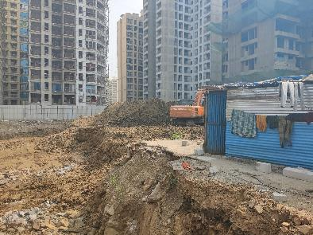
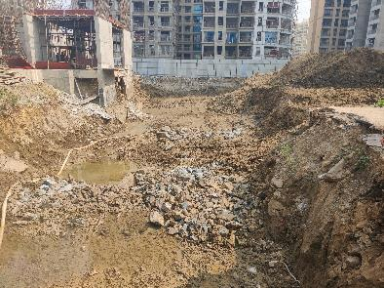
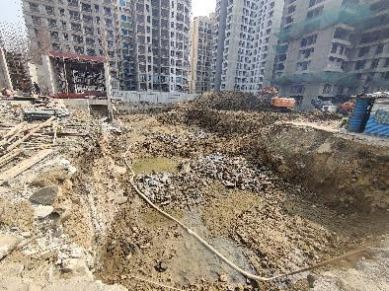
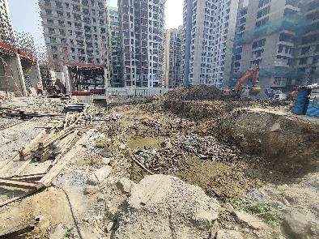
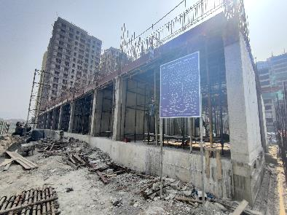
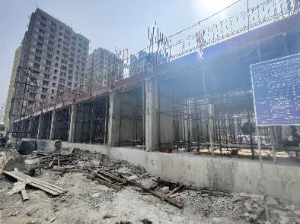
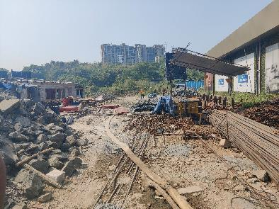
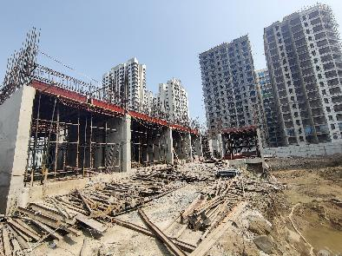
Actual Site Photographs
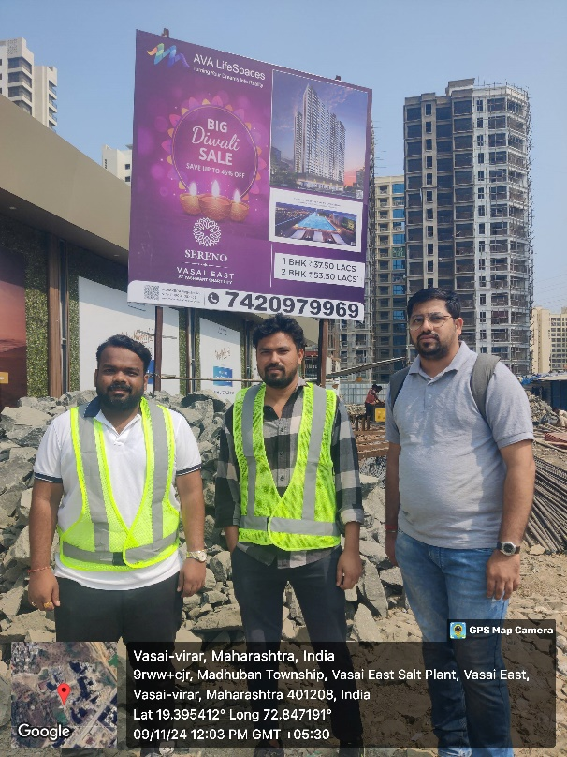
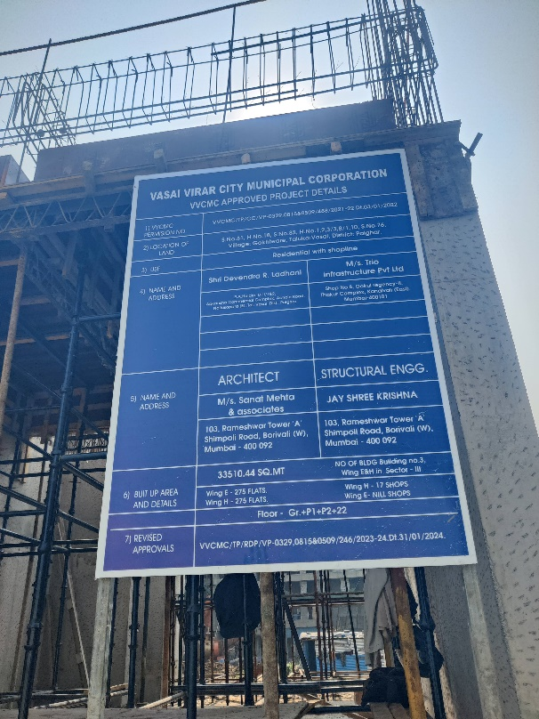
Route Map of the property
Site u/r
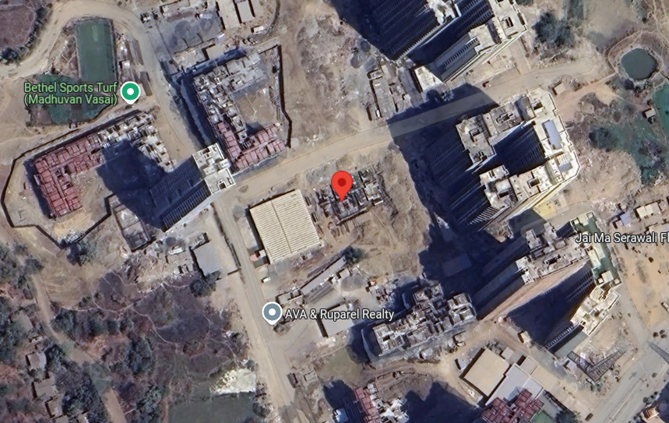

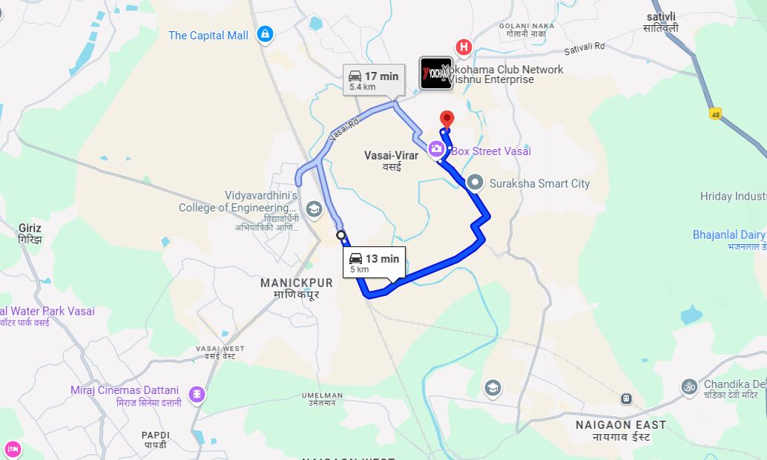

Latitude Longitude: 19°23'44.5"N 72°50'51.1"E
Note: The Blue line shows the route to site from nearest railway station (Vasai – 5.0 Km)

Ready Reckoner 2024 – 2025
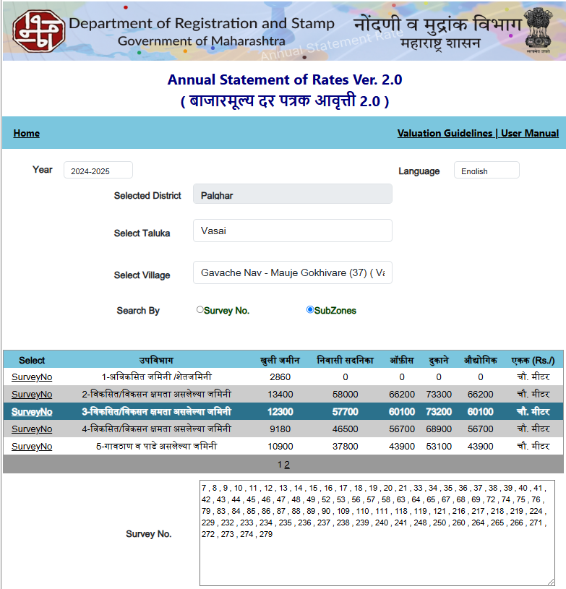

Registered Sales Instances
Regd. Doc. No. | Date | Agreement Value in ` | Carpet Area in Sq. M. | Carpet Area in Sq. Ft. | Rate / Sq. Ft. on Carpet Area
16940/2024 | 23.08.2024 | 56,15,000.00 | - | 554.00 | 10,135.00
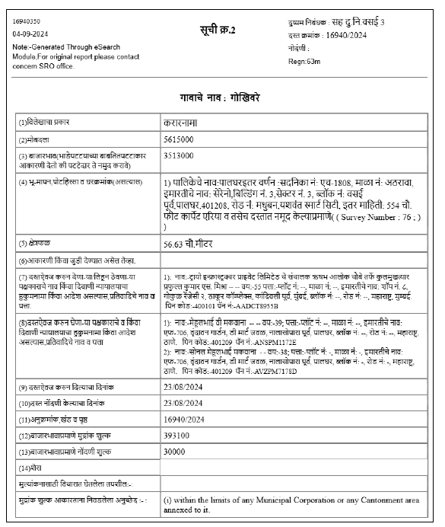

Registered Sales Instances
Regd. Doc. No. | Date | Agreement Value in ` | Carpet Area in Sq. M. | Carpet Area in Sq. Ft. | Rate / Sq. Ft. on Carpet Area
16448/2024 | 16.08.2024 | 56,85,000.00 | - | 571.00 | 9,956.22
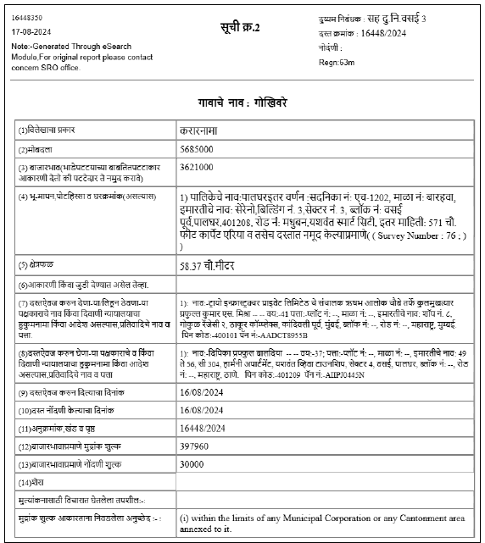

Price Indicators for Flats

Sr. No. | Project Name | Developer Name | RERA No. | Carpet Area in Sq. Ft. | Value in ` | Rate / Sq. Ft. on Carpet Area
1 | Samaira Opulence | Samaira Buildcon | P99000049301 | 487.00 | 51,20,000.00 | 10,513.00
2 | Imperial Splendora | Imperial Lifestyle | P9900027833 | 410.00 | 49,06,000.00 | 11,966.00
3 | Techton Akhand | Techton Lifespaces | P99000053393 | 466.08 | 47,52,000.00 | 10,197.00
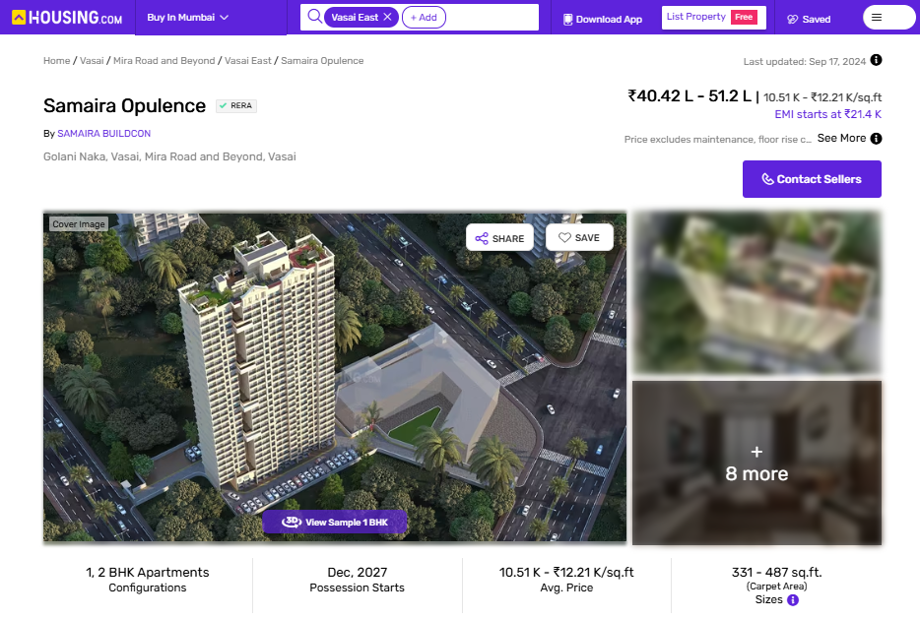

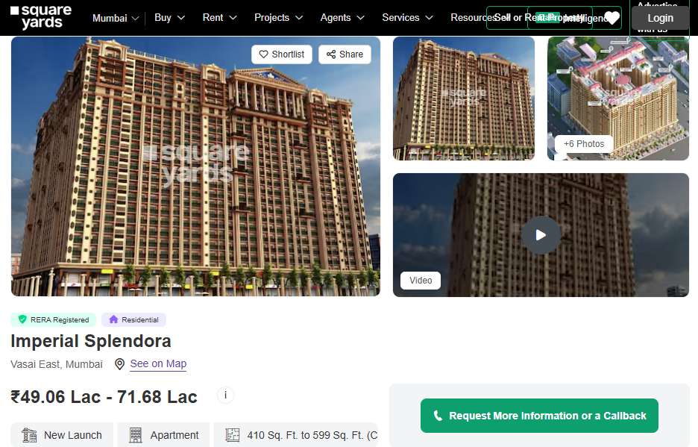

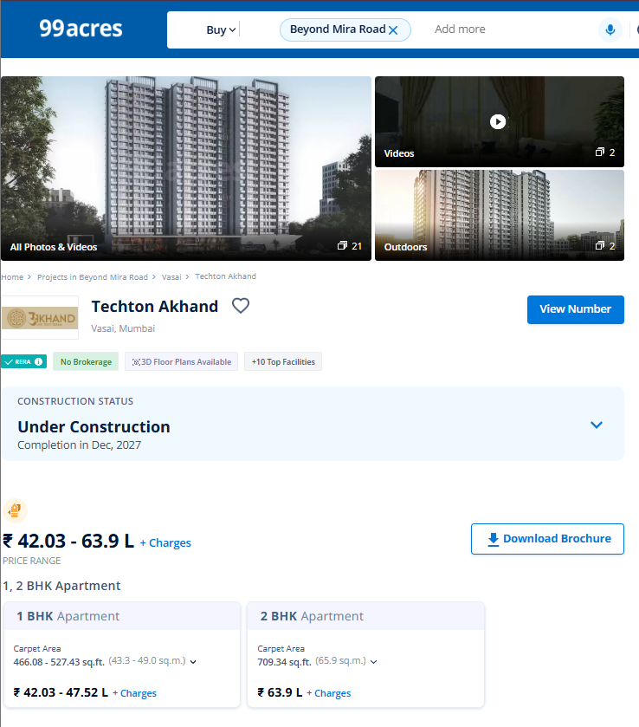
Price Indicators for Flats

Justification for price /rate

The Market Value of the property is based on facts of markets discovered by us during our enquiries, however the government rate value in this case is less than the market value arrived by us. We are of the opinion that the value arrive by us will prove to be correct if an Auction of the subject property is carried out. As far as Market Value in Index II is concerned, it is not possible to comment on same, may be government rates are fixed by sampling during same point of time in part and whereas, Market values change every month.

In most of the cases the actual deal amount or Transaction value is not reflected in Index II because of various Market practices. As Valuer, we always try to give a value which is correct reflection of actual transaction value irrespective of any factors in market.

We hope this will satisfy your requirements.
As a result of my appraisal and analysis, it is my considered opinion that the realizable Value of the above property in the prevailing condition with aforesaid specification is (As per table attached to the report)

Place: Mumbai
Date: 09.12.2024

Manoj B. Chalikwar
Registered Valuer
Chartered Engineer (India)
Reg. No. IBBI / RV / 07/2018/10366
Reg. No. CAT-I-F-1763
SBI Empanelment No.: SME/TCC/38/IBBI/3

Enclosures
 | Declaration-cum-undertaking from the valuer (Annexure- I) | Attached
 | Model code of conduct for valuer - (Annexure - II) | Attached
(Annexure-I)

DECLARATION-CUM-UNDERTAKING

I, Manoj Chalikwar son of Shri. Baburao Chalikwar do hereby solemnly affirm and state that:

- I am a citizen of India.

- I will not undertake valuation of any assets in which I have a direct or indirect interest or become so interested at any time during a period of three years prior to my appointment as valuer or three years after the valuation of assets was conducted by me.

- The information furnished in my valuation report dated 09.12.2024 is true and correct to the best of my knowledge and belief and I have made an impartial and true valuation of the property.

- I/ my authorized representative have personally inspected the property on 09.11.2024. The work is not sub - contracted to any other valuer and carried out by myself.

- Valuation report is submitted in the format as prescribed by the bank.

- I have not been depanelled / delisted by any other bank and in case any such depanelment by other banks during my empanelment with you, I will inform you within 3 days of such depanelment.

- I have not been removed / dismissed from service / employment earlier.

- I have not been convicted of any offence and sentenced to a term of imprisonment

- I have not been found guilty of misconduct in my professional capacity.

- I have not been declared to be unsound mind

- I am not an undischarged bankrupt, or has not applied to be adjudicated as a bankrupt;

- I am not an undischarged insolvent.

- I have not been levied a penalty under section 271J of Income-tax Act, 1961 (43 of 1961) and time limit for filing appeal before Commissioner of Income-tax (Appeals) or Income-tax Appellate Tribunal, as the case may be has expired, or such penalty has been confirmed by Income-tax Appellate Tribunal, and five years have not elapsed after levy of such penalty

- I have not been convicted of an offence connected with any proceeding under the Income Tax Act 1961, Wealth Tax Act 1957 or Gift Tax Act 1958 and

- My PAN Card number as applicable is AERPC9086P

- I undertake to keep you informed of any events or happenings which would make me ineligible for empanelment as a valuer

- I have not concealed or suppressed any material information, facts and records and I have made a complete and full disclosure

- I have read the Handbook on Policy, Standards and procedure for Real Estate Valuation, 2011 of the IBA and this report is in conformity to the "Standards" enshrined for valuation in the Part - B of the above handbook to the best of my ability.

- I have read the International Valuation Standards (IVS) and the report submitted to the Bank for the respective asset class is in conformity to the "Standards" as enshrined for valuation in the IVS in "General Standards" and "Asset Standards" as applicable. The valuation report is submitted in the prescribed format of the bank.

- I abide by the Model Code of Conduct for empanelment of valuer in the Bank. (Annexure V - A signed copy of same to be taken and kept along with this declaration)

- I am valuer registered with Insolvency & Bankruptcy Board of India (IBBI)

- My CIBIL Score and credit worthiness is as per Bank's guidelines.

- I am Chairman & Managing Director of the company, who is competent to sign this valuation report.

- I will undertake the valuation work on receipt of Letter of Engagement generated from the system (i.e., LLMS / LOS) only.

- Further, I hereby provide the following information.

 | Particulars | Valuer comment
 | Background information of the asset being valued; | The property under consideration is developed by M/s. Trio Infrastructure Pvt. Ltd.
 | Purpose of valuation and appointing authority | As per request from State Bank of India, Industrial Finance Branch, Malad (West) to assess Fair Market value of the Project for bank loan purpose.
 | Identity of the Valuer and any other experts involved in the valuation; | Manoj B. Chalikwar – Regd. Valuer  Prayush P. Parekh – Senior Valuation Engineer  Saiprasad Patil – Valuation Engineer
 | Disclosure of Valuer interest or conflict, if any; | We have no interest, either direct or indirect, in the property valued. Further to state that we do not have relation or any connection with property owner / applicant directly or indirectly. Further to state that we are an independent Valuer and in no way related to property owner / applicant
 | Date of appointment, valuation date and date of report; | Date of Appointment – 07.11.2024  Valuation Date – 09.12.2024  Date of Report – 09.12.2024
 | Inspections and/or investigations undertaken; | Physical Inspection done on date 09.11.2024
 | Nature and sources of the information used or relied upon; | - Market Survey at the time of site visit  - Ready Reckoner rates / Circle rates  - Online search for Registered Transactions  - Online Price Indicators on real estate portals  - Enquiries with Real estate consultants  - Existing data of Valuation assignments carried out by us
 | Procedures adopted in carrying out the valuation and valuation standards followed; | Sales Comparative Method
 | Restrictions on use of the report, if any; | This valuation is for the use of the party to whom it is addressed and for no other purpose. No responsibility is accepted to any third party who may use or rely on the whole or any part of this valuation. The valuer has no pecuniary interest that would conflict with the proper valuation of the property.
- . | Major factors that were taken into account during the valuation; | Current market conditions, demand and supply position, residential land size, location, sustained demand for residential land, all round development of commercial and residential application in the locality etc.
 | Caveats, limitations and disclaimers to the extent they explain or elucidate the limitations faced by valuer, which shall not be for the purpose of limiting his responsibility for the valuation report. | Attached

Assumptions, Disclaimers, Limitations & Qualifications
Value Subject to Change
The subject appraisal exercise is based on prevailing market dynamics as on 09th December 2024 and does not take into account any unforeseeable developments which could impact the same in the future.
Our Investigations
We are not engaged to carry out all possible investigations in relation to the subject property. Where in our report we identify certain limitations to our investigations, this is to enable the reliant party to instruct further investigations where considered appropriate or where we recommend as necessary prior to reliance. Vastukala Consultants India Pvt. Ltd. (VCIPL) is not liable for any loss occasioned by a decision not to conduct further investigations
Assumptions
Assumptions are a necessary part of undertaking valuations. VCIPL adopts assumptions for the purpose of providing valuation advise because some matters are not capable of accurate calculations or fall outside the scope of our expertise, or out instructions. The reliant party accepts that the valuation contains certain specific assumptions and acknowledge and accept the risk of that if any of the assumptions adopted in the valuation are incorrect, then this may have an effect on the valuation.
Information Supplied by Others
The appraisal is based on the information provided by the client. The same has been assumed to be correct and has been used for appraisal exercise. Where it is stated in the report that another party has supplied information to VCIPL, this information is believed to be reliable but VCIPL can accept no responsibility if this should prove not to be so.
Future Matters
To the extent that the valuation includes any statement as to a future matter, that statement is provided as an estimate and/or opinion based on the information known to VCIPL at the date of this document. VCIPL does not warrant that such statements are accurate or correct.
Map and Plans
Any sketch, plan or map in this report is included to assist the reader while visualising the property and assume no responsibility in connection with such matters.
Site Details
Based on documents / information received from Client's representative and site visit conducted, we understand that the subject property is currently a Building Under Construction work is in progress contiguous and non-agricultural land parcel admeasuring as per table attached to the report and in the name of M/s. Trio Infrastructure Pvt. Ltd. Further, VCIPL has assumed that the subject property is free from any encroachment and is available as on the date of the appraisal.
Property Title
Based on our discussion with the Client, we understand that the subject property is owned by M/s. Trio Infrastructure Pvt. Ltd. For the purpose of this appraisal exercise, we have assumed that the subject property has a clear title and is free from any encumbrances, disputes and claims. VCIPL has made no further enquiries with the relevant local authorities in this regard and does not certify the property as having a clear and marketable title. Further, no legal advice regarding the title and ownership of the subject property has been obtained for the purpose of this appraisal exercise. It has been assumed that the title deeds are clear and marketable.
Environmental Conditions
We have assumed that the subject property is not contaminated and is not adversely affected by any existing or proposed environmental law and any processes which are carried out on the property are regulated by environmental legislation and are properly licensed by the appropriate authorities.

Town Planning
The permissible land use, zoning, achievable FSI, area statement adopted for purpose of this valuation is based on the documents / information provided by the Client's representative and the same has been adopted for this valuation purpose. VCIPL has assumed the same to be correct and permissible. VCIPL has not validated the same from any authority.
Area
Based on the document provided by the Client's representative, we understand that the subject property is a Building Under Construction work is in progress, contiguous and non-agricultural land parcel admeasuring as per table attached to the report.
Condition & Repair
In the absence of any information to the contrary, we have assumed that there are no abnormal ground conditions, nor archaeological remains present which might adversely affect the current or future occupation, development or value of the property. The property is free from rat, infestation, structural or latent defect. No currently known deleterious or hazardous materials or suspect techniques will be used in the construction of or subsequent alteration or additions to the property and comments made in the property details do not purport to express an opinion about, or advise upon, the condition of uninspected parts and should not be taken as making an implied representation or statement about such parts
Valuation Methodology
For the purpose of this valuation exercise, the valuation methodology used is Direct Comparison Approach Method and proposed Highest and Best Use model is used for analysing development potential.
The Direct Comparison Approach involves a comparison of the property being valued to similar properties that have actually been sold in arms - length transactions or are offered for sale. This approach demonstrates what buyers have historically been willing to pay (and sellers willing to accept) for similar properties in an open and competitive market and is particularly useful in estimating the value of the land and properties that are typically traded on a unit basis.
In case of inadequate recent transaction activity in the subject micro-market, the appraiser would collate details of older transactions. Subsequently, the appraiser would analyse rental / capital value trends in the subject micro-market in order to calculate the percentage increase / decrease in values since the date of the identified transactions. This percentage would then be adopted to project the current value of the same.
Where reliance has been placed upon external sources of information in applying the valuation methodologies, unless otherwise specifically instructed by Client and/or stated in the valuation, VCIPL has not independently verified that information and VCIPL does not advise nor accept it as reliable. The person or entity to whom the report is addressed acknowledges and accepts the risk that if any of the unverified information in the valuation is incorrect, then this may have an effect on the valuation.
Not a Structural Survey
We state that this is a valuation report and not a structural survey
Other
All measurements, areas and ages quoted in our report are approximate
Legal
We have not made any allowances with respect to any existing or proposed local legislation relating to taxation on realization of the sale value of the subject property. VCIPL is not required to give testimony or to appear in court by reason of this appraisal report, with reference to the property in question, unless arrangement has been made thereof. Further, no legal advice on any aspects has been obtained for the purpose of this appraisal exercise

Property specific assumptions
Based on inputs received from the client and site visit conducted, we understand that the subject property is currently Building Under Construction work is in progress, contiguous and non-agricultural land parcel admeasuring area as per table attached to the report.

ASSUMPTIONS, CAVEATS, LIMITATION AND DISCLAIMERS
- We assume no responsibility for matters of legal nature affecting the property appraised or the title thereto, nor do we render our opinion as to the title, which is assumed to be good and marketable.
- The property is valued as though under responsible ownership.
- It is assumed that the property is free of liens and encumbrances.
- It is assumed that there are no hidden or unapparent conditions of the subsoil or structure that would render it more or less valuable. No responsibility is assumed for such conditions or for engineering that might be required to discover such factors.
- There is no direct/ indirect interest in the property valued.
- The rates for valuation of the property are in accordance with the Govt. approved rates and prevailing market rates.
(Annexure - II)
MODEL CODE OF CONDUCT FOR VALUERS
Integrity and Fairness
- A valuer shall, in the conduct of his/its business, follow high standards of integrity and fairness in all his/its dealings with his/its clients and other valuers.
- A valuer shall maintain integrity by being honest, straightforward, and forthright in all professional relationships.
- A valuer shall endeavour to ensure that he/it provides true and adequate information and shall not misrepresent any facts or situations.
- A valuer shall refrain from being involved in any action that would bring disrepute to the profession.
- A valuer shall keep public interest foremost while delivering his services.
Professional Competence and Due Care
- A valuer shall render at all times high standards of service, exercise due diligence, ensure proper care and exercise independent professional judgment.
- A valuer shall carry out professional services in accordance with the relevant technical and professional standards that may be specified from time to time.
- A valuer shall continuously maintain professional knowledge and skill to provide competent professional service based on up-to-date developments in practice, prevailing regulations / guidelines and techniques.
- In the preparation of a valuation report, the valuer shall not disclaim liability for his/its expertise or deny his/its duty of care, except to the extent that the assumptions are based on statements of fact provided by the company or its auditors or consultants or information available in public domain and not generated by the valuer.
- A valuer shall not carry out any instruction of the client insofar as they are incompatible with the requirements of integrity, objectivity and independence.
- A valuer shall clearly state to his client the services that he would be competent to provide and the services for which he would be relying on other valuers or professionals or for which the client can have a separate arrangement with other valuers.
Independence and Disclosure of Interest
- A valuer shall act with objectivity in his/its professional dealings by ensuring that his/its decisions are made without the presence of any bias, conflict of interest, coercion, or undue influence of any party, whether directly connected to the valuation assignment or not.
- A valuer shall not take up an assignment if he/it or any of his/its relatives or associates is not independent in terms of association to the company.
- A valuer shall maintain complete independence in his/its professional relationships and shall conduct the valuation independent of external influences.
- A valuer shall wherever necessary disclose to the clients, possible sources of conflicts of duties and interests, while providing unbiased services.
- A valuer shall not deal in securities of any subject company after any time when he/it first becomes aware of the possibility of his / its association with the valuation, and in accordance with the Securities and Exchange Board of India (Prohibition of Insider Trading)Regulations,2015 or till the time the valuation report becomes public, whichever is earlier.
- A valuer shall not indulge in "mandate snatching" or offering "convenience valuations" in order to cater to a company or client's needs.
- As an independent valuer, the valuer shall not charge success fee.
- In any fairness opinion or independent expert opinion submitted by a valuer, if there has been a prior engagement in an unconnected transaction, the valuer shall declare the association with the company during the last five years.
Confidentiality
- A valuer shall not use or divulge to other clients or any other party any confidential information about the subject company, which has come to his / its knowledge without proper and specific authority or unless there is a legal or professional right or duty to disclose.
Information Management
- A valuer shall ensure that he/ it maintains written contemporaneous records for any decision taken, the reasons for taking the decision, and the information and evidence in support of such decision. This shall be maintained so as to sufficiently enable a reasonable person to take a view on the appropriateness of his /its decisions and actions.
- A valuer shall appear, co-operate and be available for inspections and investigations carried out by the authority, any person authorised by the authority, the registered valuers organisation with which he/it is registered or any other statutory regulatory body.
- A valuer shall provide all information and records as may be required by the authority, the Tribunal, Appellate Tribunal, the registered valuers organisation with which he/it is registered, or any other statutory regulatory body.
- A valuer while respecting the confidentiality of information acquired during the course of performing professional services, shall maintain proper working papers for a period of three years or such longer period as required in its contract for a specific valuation, for production before a regulatory authority or for a peer review. In the event of a pending case before the Tribunal or Appellate Tribunal, the record shall be maintained till the disposal of the case.
Gifts and hospitality:
- A valuer or his / its relative shall not accept gifts or hospitality which undermines or affects his independence as a valuer.
- Explanation: For the purposes of this code the term 'relative' shall have the same meaning as defined in clause (77) of Section 2 of the Companies Act, 2013 (18 of 2013).
- A valuer shall not offer gifts or hospitality or a financial or any other advantage to a public servant or any other person with a view to obtain or retain work for himself / itself, or to obtain or retain an advantage in the conduct of profession for himself / itself.
Remuneration and Costs.
- A valuer shall provide services for remuneration which is charged in a transparent manner, is a reasonable reflection of the work necessarily and properly undertaken, and is not inconsistent with the applicable rules.
- A valuer shall not accept any fees or charges other than those which are disclosed in a written contract with the person to whom he would be rendering service.
Occupation, employability and restrictions.
- A valuer shall refrain from accepting too many assignments, if he/it is unlikely to be able to devote adequate time to each of his/ its assignments.
- A valuer shall not conduct business which in the opinion of the authority or the registered valuer organisation discredits the profession.
Miscellaneous
- A valuer shall refrain from undertaking to review the work of another valuer of the same client except under written orders from the bank or housing finance institutions and with knowledge of the concerned valuer.
- A valuer shall follow this code as amended or revised from time to time.
DEFINITION OF VALUE FOR THIS SPECIFIC PURPOSE

This exercise is to assess Master Valuation of the property under reference as on 09th December 2024

The term Fair Market Value is defined as

“The most probable price, as of a specified date, in cash, terms equivalent to cash, or in other precisely revealed terms for which the specified property rights would sell after reasonable exposure in a competitive market under all conditions requisite to a fair sale, with the buyer and seller each acting prudently knowledgeably and for self-interest assuming that neither is under undue duress”.

Fundamental assumptions and conditions presumed in this definition are:

1. Buyer and seller are motivated by self-interest.
2. Buyer and seller are well informed and are acting prudently.
3. The property is exposed for a reasonable time on the open market.
4. Payment is made in cash or equivalent or in specified financing terms.
DECLARATION OF PROFESSIONAL FEES CHARGED

We hereby declare that, our professional fees are not contingent upon the valuation findings. However, if the statute AND/OR clients demands that, the fees should be charged on the percentage of assessed value then, with the full knowledge of the AND/OR end user, it is being charged accordingly.

VALUATION OF THE PROPERTY PREMISES

Considering various parameters recorded herein above, existing economic scenario, and the information that is available with reference to the development of neighborhood and method selected for valuation, we are of the opinion that, the property premises can be assessed and valued for this particular purpose as per the details provided.

Manoj B. Chalikwar
Registered Valuer
Chartered Engineer (India)
Reg. No. IBBI / RV / 07/2018/10366
Reg. No. CAT-I-F-1763
SBI Empanelment No.: SME/TCC/38/IBBI/3

