Valuation Report of the Immovable Property

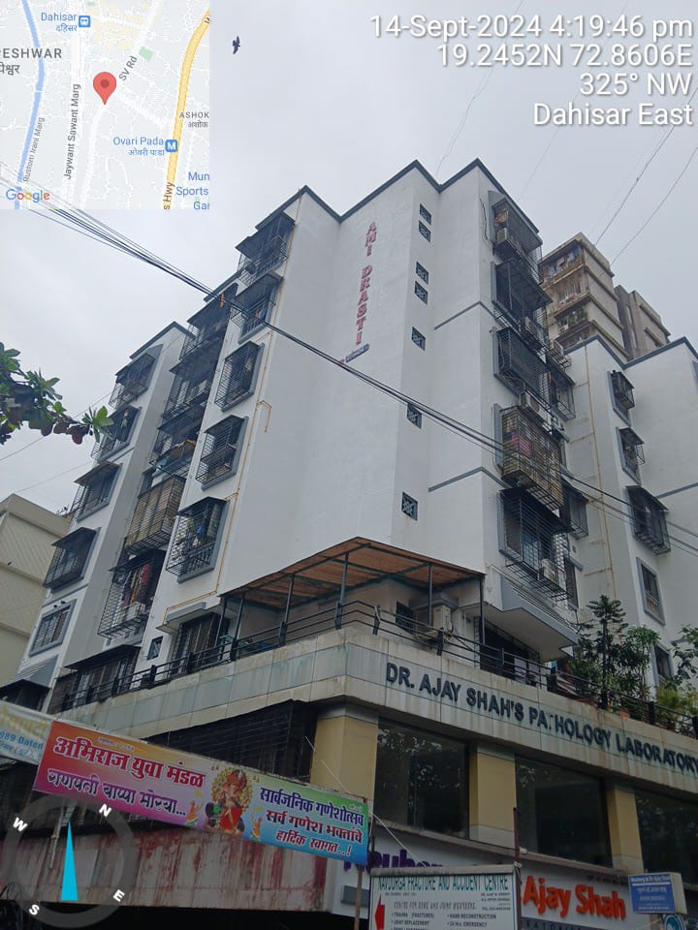

Details of the property under consideration:

Name of Owner: Mrs. Vijaya Ganesh Gurjar & Mr. Ganesh U. Gurjar

Residential Flat No. 503, 5th Floor, “Ami Drasti Co-Op. Hsg. Soc. Ltd.”, Dahisar (East), Mumbai,
PIN Code – 400 068, State – Maharashtra, Country – India

Longitude Latitude - 19°14’43.5”N 72°51’37.9”E

Intended User:
IDBI Bank Ltd.
Prahlad Nagar Branch
Shop No. 4A, Pinnacle Business Park, Opp Royal Orchid, Prahlad Nagar,
Ahmedabad, Gujrat – 380 015.

Vastu/Mumbai/09/2024/011210/2308225
18/19-231-PASH
Date: 18.09.2024

VALUATION OPINION REPORT

The property bearing Residential Flat No. 503, 5th Floor, “Ami Drasti Co-Op. Hsg. Soc. Ltd.”, Dahisar (East), Mumbai, PIN Code – 400 068, State – Maharashtra, Country – India belongs to Mrs. Vijaya Ganesh Gurjar & Mr. Ganesh U. Gurjar.

Boundaries of the property | Flat | Building
North | Lift | Sunderbaug Building
South | Flat No. 504 & Staircase | Internal Road & Slum Area
East | Lobby | S. V. Road
West | Flat No. 503 | Mukti Kamal Building

Considering various parameters recorded, existing economic scenario, and the information that is available with reference to the development of neighborhood and method selected for valuation, we are of the opinion that, the property premises can be assessed and valued for this particular purpose at ` 1,10,40,000.00 (Rupees One Crore Ten Lakh Forty Thousand Only).

The valuation of the property is based on the documents produced by the concern. Legal aspects have not been taken into considerations while preparing this valuation report.

Hence certified

Sharadkumar B. Chalikwar
Govt. Reg. Valuer
Chartered Engineer (India)
Reg. No. (N) CCIT/1-14/52/2008-09
Encl: Valuation report.
Valuation Report of Immovable Property

1. Introduction
a) |  |  | Name of the Property Owner  (With address & phone nos.) |  |  | Name of Owner / Developer:  Mrs. Vijaya Ganesh Gurjar & Mr. Ganesh U. Gurjar.  Address – Residential Flat No. 503, 5th Floor, “Ami Drasti Co-Op. Hsg. Soc. Ltd.”, Dahisar (East), Mumbai, PIN Code – 400 068, State – Maharashtra, Country – India.  Contact Details  Mrs. Vijaya Ganesh Gurjar (Owner)  Contact No.: 9920799709
b) |  |  | Purpose of Valuation |  |  | As per request from IDBI Bank Ltd., Prahlad Nagar Branch to assess fair market value of the property for bank loan purpose
c) |  |  | Date of Inspection of Property |  |  | 16.09.2024
d) |  |  | Date of Valuation Report |  |  | 18.09.2024
e) |  |  | Name of the Developer of Property  (in case of developer built properties) |  |  | M/s. Shree Rushabh Developers.
2. Physical Characteristics of the Property
a) |  |  | Location of the Property |  |  | Residential Flat No. 503, 5th Floor, “Ami Drasti Co-Op. Hsg. Soc. Ltd.”, Dahisar (East), Mumbai, PIN Code – 400 068, State – Maharashtra, Country – India.
 |  |  | Brief description of the property
The property is a residential flat. The Flat is location on 5th floor. The property is located in a developed area having good infrastructure, well connected by road and train. It is located at the Walking distance of 650 M. from Dahisar Railway Station.

The immovable property comprises of residential flat located on 5th floor. The building is constructed with Ground + 7 Upper floors.

At the time of visit, the bedroom was locked. Hence, physical measurement, inspection & internal photographs could not be taken. The composition of the flat as per previous valuation report is 1 Bedroom + Living Room + Kitchen + 2 Toilets. (i.e. 1 BHK + 2 Toilets).
 |  |  | Nearby landmark |  |  | Near Taste of Maratha Resto
 |  |  | Postal Address of the Property |  |  | Residential Flat No. 503, 5th Floor, “Ami Drasti Co-Op. Hsg. Soc. Ltd.”, Dahisar (East), Mumbai, PIN Code – 400 068, State – Maharashtra, Country – India.
 |  |  | Area of the plot/land (supported by a plan) |  |  | N.A., the property under consideration is Residential flat in an apartment.
 |  |  | Type of Land: Solid, Rocky, Marsh land, reclaimed land, Water-logged, Land locked. |  |  | Solid land
 |  |  | Independent access/approach to the property etc. |  |  | Yes
 |  |  | Google Map Location of the Property with a neighborhood layout map |  |  | Provided
 |  |  | Details of roads abutting the property |  |  | 30’ wide B.T. Road
 |  |  | Description of adjoining property |  |  | Located in Middle class locality
 |  |  | Plot No. Survey No. |  |  | Survey No. 243, Hissa No. D, Part 1,2 & 3, Survey No. 244, Tikka No. 92 & 101, CTS No. 950 & 950 / 1 to 22 of Village – Dahisar
 |  |  | Ward/Village/Taluka |  |  | Village – Dahisar, Taluka - Borivali
 |  |  | Sub-Registry/Block |  |  | Borivali No. 5
 |  |  | District |  |  | Mumbai Suburban District
 |  |  | Any other aspect |  |  | -
b) |  |  | Plinth Area, and saleable are to be mentioned separately and clarified |  |  | Carpet Area in Sq. Ft. = 488.00  (Area as per Previous Valuation Report)  Carpet Area in Sq. Ft. = 460.00  (Area as per Agreement for Sale)  Built up Area in Sq. Ft. = 552.00  (Area as per Agreement for Sale)  All the above areas are within +/- 10% of the Agreement for Sale Area. The above calculations and detail measurements taken by us prove that the Agreement for Sale are is not exorbitantly inflated. Hence, valuation is based on the Agreement for Sale area
 |  |  | Boundaries of the Flat |  |  | As per Site
 |  |  | North |  |  | Lift
 |  |  | South |  |  | Flat No. 504 & Staircase
 |  |  | East |  |  | Lobby
 |  |  | West |  |  | Flat No. 503
 |  |  | Boundaries of the Building |  |  | As per Site
 |  |  | North |  |  | Sunderbaug Building
 |  |  | South |  |  | Internal Road & Slum Area
 |  |  | East |  |  | S. V. Road
 |  |  | West |  |  | Mukti Kamal Building
3. Town Planning parameters
a) |  |  |  |  | Master Plan provisions related to property in terms of land use | Residential use
a) |  |  |  |  | FAR- Floor Area Rise/FSI- Floor Space Index permitted & consumed | As per MCGM norms
a) |  |  |  |  | Ground coverage | N.A.
a) |  |  |  |  | Comment on whether OC- Occupancy Certificate has been issued or not | N.A.
a) |  |  |  |  | Comment on unauthorized constructions if any | N.A., the property under consideration is Residential flat in an apartment.
a) |  |  |  |  | Transferability of developmental rights if any, Building by-laws provision as applicable to the property viz. setbacks, height restriction etc. | As per Documents
a) |  |  |  |  | Planning area/zone | Residential
a) |  |  |  |  | Developmental controls | Municipal Corporation of Greater Mumbai
a) |  |  |  |  | Zoning regulations | Residential
a) |  |  |  |  | Comment on the surrounding land uses and adjoining properties in terms of uses | Residential
a) |  |  |  |  | Comment on demolition proceedings if any | No
a) |  |  |  |  | Comment on compounding / regularization proceedings | Information is not available
a) |  |  |  |  | Any other Aspect | -
4. Document Details and Legal Aspects of Property
a) |  |  |  | Ownership Documents
 |  |  |  | Sale Deed, Gift Deed, Lease Deed
 |  |  |  | - Copy of Agreement for Sale dated 24.12.2007 b/w M/s. Shree Rushabh Developers (Promoters) and Mrs. Vijaya G. Gurjar & Mr. Ganesh U. Gurjar (Purchasers)
 |  |  |  | - Copy of Commencement Certificate dated 03.08.2008 Documents No. CHE / A – 3191 / BP (WS) / AP Issued by Municipal Corporation of Greater Mumbai
 |  |  |  | - Copy of Approved Plan dated 04.05.2009 issued by Municipal Corporation of Greater Mumbai
 |  |  |  | - Copy of Title Search Report dated 18.07.2006 issued by P. G. Vora & Co.
 |  |  |  | - Copy of 7/12 Extract
 |  |  |  | - Copy of Society Share Certificate No. 17 Dated 31.12.2010
 |  |  |  | - Copy of Previous Report dated 11.07.2023
 |  |  |  | TIR of the Property |  | Provided
b) |  |  |  | Name of the Owner/s |  | Name of Owner / Developer:  Mrs. Vijaya Ganesh Gurjar & Mr. Ganesh U. Gurjar
c) |  |  |  | Ordinary status of freehold or leasehold including restrictions on transfer |  | Free hold land
d) |  |  |  | Agreement of easement if any |  | Details not available
e) |  |  |  | Notification of acquisition if any |  | Details not available
f) |  |  |  | Notification of road widening if any |  | Details not available
g) |  |  |  | Heritage restriction, if any |  | No
h) |  |  |  | Comment on transferability of the property ownership |  | N. A
i) |  |  |  | Comment on existing mortgages/charges/encumbrances on the property, if any |  | N. A
j) |  |  |  | Comment on whether the owners of the property have issued any guarantee (personal or corporate) as the case may be |  | Details not available. The bank is requested to independently verify the same
k) |  |  |  | Building plan sanction: Authority approving the plan - Name of the office of the Authority - Any violation from the approved Building Plan |  | Copy of Approved Plan dated 04.05.2009 issued by Municipal Corporation of Greater Mumbai
l) |  |  |  | Whether Property is Agricultural Land if yes, any conversion is contemplated |  | N.A., Residential Land
m) |  |  |  | Whether the property is SARFAESI compliant |  | Yes
n) |  |  |  | a. All legal documents, receipts related to electricity, Water tax, Municipal tax and other building taxes to be verified and copies as applicable to be enclosed with the report. b. Observation on Dispute or Dues if any in payment of bills/taxes to be reported. |  | All the provided documents are enclosed with the valuation report.
o) |  |  |  | Whether entire piece of land on which the unit is set up / property is situated has been mortgaged or to be mortgaged. |  | As per Title Investigation Report
p) |  |  |  | Qualification in TIR/mitigation suggested if any. |  | As per TIR Report
q) |  |  |  | Any other aspect |  | -
5. Economic Aspects of the Property
a) |  |  | Reasonable letting value |  |  | N.A., as the property is owner occupied.
 |  |  | If property is occupied by tenant |  |  | N.A.
 |  |  | Number of tenants |  |  | N.A.
 |  |  | Since how long (tenant- wise) |  |  | N.A.
 |  |  | Status of tenancy right |  |  | N.A.
 |  |  | Rent received per month (tenant-wise) with a comparison of existing market rent |  |  | ` 23,000.00 Expected rental income per month
 |  |  | Taxes and other outings |  |  | N.A.
 |  |  | Property Insurance |  |  | N.A.
 |  |  | Monthly maintenance charges |  |  | N.A.
 |  |  | Security charges |  |  | N.A.
 |  |  | Any other aspect |  |  | N.A.
6. Socio-cultural Aspects of the Property
a) |  |  |  | Descriptive account of the location of the property in terms of social structure of the area, population, social stratification, regional origin, economic level, location of slums, squatter settlements nearby, etc. |  | Developed Residential Locality, Middle Class
b) |  |  |  | Whether property belongs to social infrastructure like hospital, school, old age homes etc. |  | No
7. Functional and Utilitarian Aspects of the Property
a) |  |  |  | Description of the functionality and utility of the property in terms of:
 |  |  |  | Space allocation |  | Provided
 |  |  |  | Storage Spaces |  | Provided
 |  |  |  | Utility spaces provided within the building |  | Provided
 |  |  |  | Car Parking facility |  | Covered Parking Space
 |  |  |  | Balconies, etc. |  | Yes
b) |  |  |  | Any other aspect |  | -
8. Infrastructure Availability
a) |  |  |  | Description of aqua infrastructure availability in terms of i.
 |  |  |  | Water supply |  | Municipal water supply
 |  |  |  | Sewerage/sanitation System Underground or Open |  | Underground Sewerage connected to Municipal sewer
 |  |  |  | Storm water drainage |  | Yes
b) |  |  |  | Description of other physical infrastructure facilities viz.
 |  |  |  | Solid waste management |  | Yes
 |  |  |  | Electricity |  | Yes
 |  |  |  | Road and public transport connectivity |  | All well connected with public transport like bus, auto and private vehicles.
 |  |  |  | Availability of other public utilities nearby |  | All available nearby
c) |  |  |  | Social infrastructure in terms of  - School  - Medical facilities  - Recreational facility in terms of parks and open space |  | All available nearby
9. Marketability of the Property
a) |  |  |  | Marketability of the property in terms of
 |  |  |  | Locational attributes |  | Developed Residential Area
 |  |  |  | Scarcity |  | Normal
 |  |  |  | Demand and supply of the kind of subject property |  | Normal
 |  |  |  | Comparable sale prices in the locality |  | Price indicators attached
b) |  |  |  | Any other aspect which has relevance on the value or marketability of the property |  | No
10. Engineering and Technology Aspects of the Property
a) |  |  | Type of construction |  |  | As per Brief Description
b) |  |  | Material & technology used |  |  | Good
c) |  |  | Specifications, |  |  | I.S. specifications
d) |  |  | Maintenance issues |  |  | No
e) |  |  | Age of the building |  |  | 2010 (Approx.)
f) |  |  | Total life of the building |  |  | 60 years
g) |  |  | Extent of deterioration |  |  | 46 years Subject to proper, preventive periodic Maintenance & structural repairs.
h) |  |  | Structural safety |  |  | Normal
i) |  |  | Protection against natural disaster viz. earthquakes, |  |  | Normal
j) |  |  | Visible damage in the building |  |  | No
k) |  |  | System of air-conditioning |  |  | Information not available
l) |  |  | Provision of firefighting |  |  | Information not available
m) |  |  | Copies of the plan and elevation of the building to be included |  |  | Yes
11. Environmental Factors
a) |  |  | Use of environment friendly building materials, Green Building techniques if any |  |  | No
b) |  |  | Provision of rain water harvesting |  |  | No
c) |  |  | Use of solar heating and lightening systems, etc., |  |  | No
d) |  |  | Presence of environmental pollution in the vicinity of the property in terms of industry, heavy traffic etc. |  |  | No
12. Architectural and aesthetic quality of the Property
a) |  |  | Descriptive account on whether the building is modern, old fashioned, plain looking or decorative, heritage value, presence of landscape elements etc. |  |  | Normal
13. Valuation
a) |  |  | Methodology of valuation – Procedures adopted for arriving at the valuation. Valuers may consider various approaches and state explicitly the reason for adopting particular approach and assumptions made, basis adopted with supporting data, comparable sales, and reconciliation of various factors on which final value judgment is arrived at. |  |  | Composite Method is used for this valuation report.
b) |  |  | Prevailing Market Rate/Price trend of the Property in the locality/city from property search sites viz magickbricks.com, 99acres.com, makaan.com etc. if available |  |  | ` 23,000.00 To ` 25,000.00 per Sq. Ft.
c) |  | Government Rate obtained from the online government records |  |  |  | ` 1,18,734.00 Per Sq. M.  i.e. ` 11,031.00 Per Sq. Ft.
 |  | Government Rate (after Depreciation) |  |  |  | ` 1,08,999.00 Per Sq. M.  i.e. ` 10,126.00 Per Sq. Ft.
 |  | - Government Value
 |  | Particulars |  |  |  | Area in Sq. Ft. | Rate in ` | Value in `
 |  | Built up Area |  |  |  | 552.00 | 10,126.00 | 55,89,552.00
 |  | - Fair Market Value
 |  | Particulars |  |  |  | Area in  Sq. Ft. | Rate in ` | Fair Market Value in  `
 |  | Carpet Area |  |  |  | 460.00 | 24,000.00 | 1,10,40,000.00
 | Summary of Valuation
 | Total Value of the Property |  |  |  |  | ` 1,10,40,000.00
 | Realizable Value |  |  |  |  | ` 99,36,000.00
 | Forced/ Distress Sale value |  |  |  |  | ` 88,32,000.00
 | Insurable value of the property |  |  |  |  | ` 16,56,000.00
e) | Remarks:  - At the time of visit, the bedroom was locked. Hence, physical measurement, inspection & internal photographs could not be taken.  - As per Approved Plan, the composition of flat is 1 Bedroom + Living Room + Kitchen + 2 Toilets + Enclosed Balcony Area + Dry Balcony Area. But as per Site Inspection, Balcony Area is enclosed with Living Room & Dry Balcony Area enclosed with Kitchen.  - The Carpet area as per Agreement is 460.00 Sq. Ft. but as per actual site measurement, Carpet area is 488.00 Sq. Ft. Hence, for the purpose of valuation, we have considered lower side area i.e. 460.00 Sq. Ft. as per Agreement.

14. Declaration

I hereby declare that:
- The information provided is true and correct to the best of my knowledge and belief.
- The analysis and conclusions are limited by the reported assumptions and conditions.
- I have read the Handbook on Policy, Standard and Procedures for Real Estate Valuation by Banks and HFIs in India, 2011, issued by IBA and NHB, fully understood the provisions of the same and followed the provisions of the same to the best of my ability and this report is in conformity to the Standards of Reporting enshrined in the above Handbook.
- I have no direct or indirect interest in the above property valued.
- I/ my authorized representative, has inspected the subject property on 16.09.2024
- I am a registered Valuer under Section 34AB of Wealth Tax Act, 1957, Category-I for valuing property up to no limit
- I am an approved Valuer under SARFAESI ACT-2002 and am approved by the Bank.
- I have not been depanelled or removed from any Bank/Financial Institution/Government Organization at any point of time in the past.
- I have submitted the Valuation Report (s) directly to the Bank.

Sharadkumar B. Chalikwar
Govt. Reg. Valuer
Chartered Engineer (India)
Reg. No. (N) CCIT/1-14/52/2008-09

Address:
Vastukala Consultants (I) Pvt. Ltd.
B1-001, U/B Floor, Boomerang, Chandivali Farm Road,
Powai, Andheri (East), Mumbai – 400 072.

Name of Valuer association of which I am a bonafide member in good standing: Institution of Valuers & Practicing Valuers Association of India.
Date 18.09.2024
Tel No. - +91 22 28371324 /25
Mobile No. - +91 98195 97579
Email Id – indore@vastukala.org

15. Enclosures
a) | Layout plan sketch of the area in which the property is located with latitude and longitude | Latitude and longitude provided along with satellite image of the building
b) | Building Plan | Provided
c) | Floor Plan | Provided
d) | Site Photograph of the property | Site photographs of the property is provided
e) | Certified copy of the approved / sanctioned plan wherever applicable from the concerned office | Provided
f) | Google Map location of the property | Provided
h) | Any other relevant documents/ extracts | No

[
Actual Site Photographs
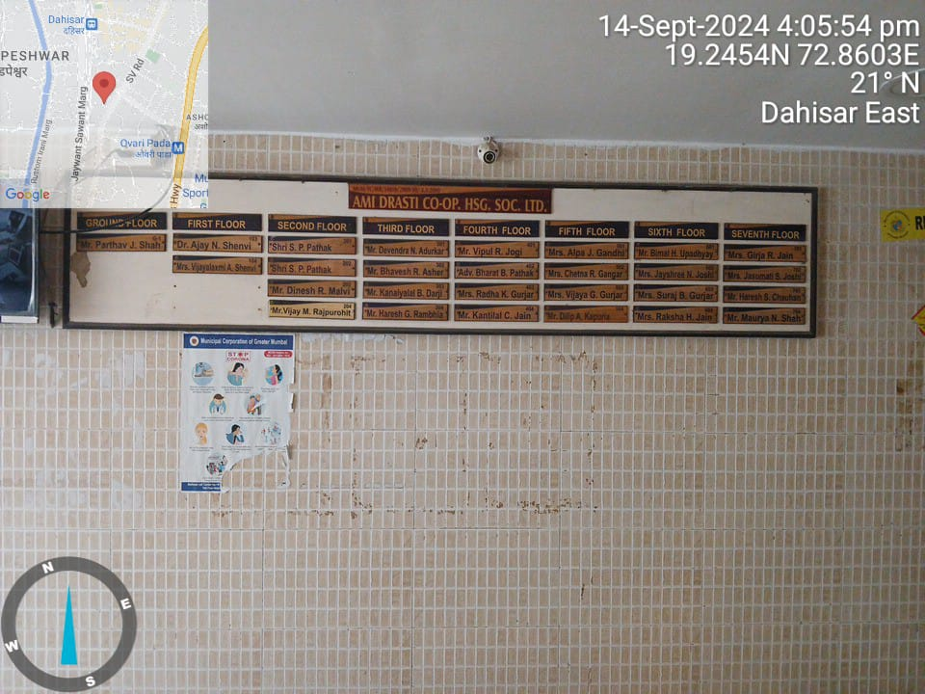
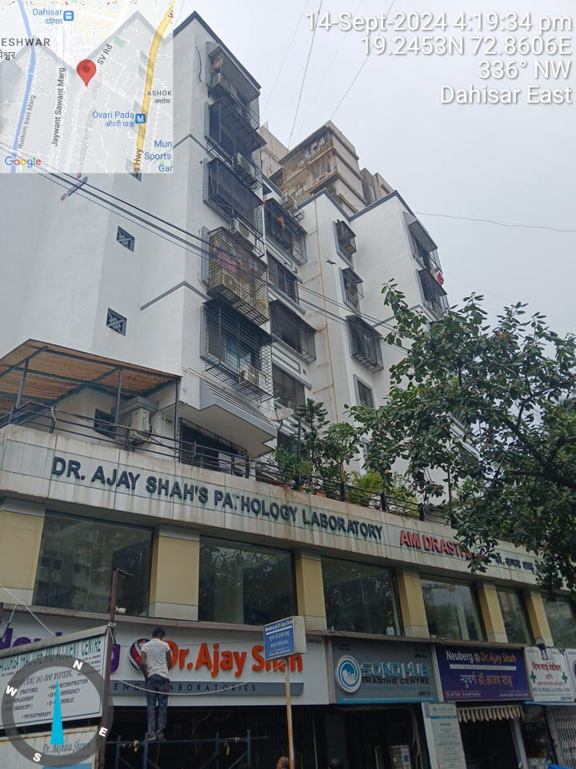
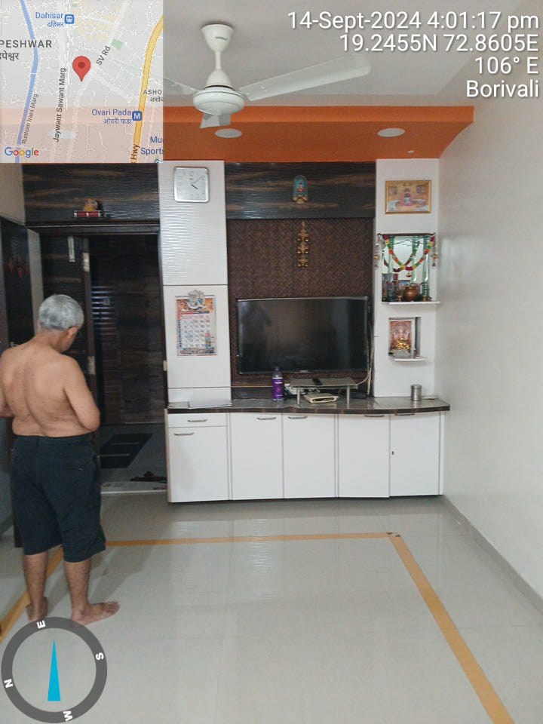
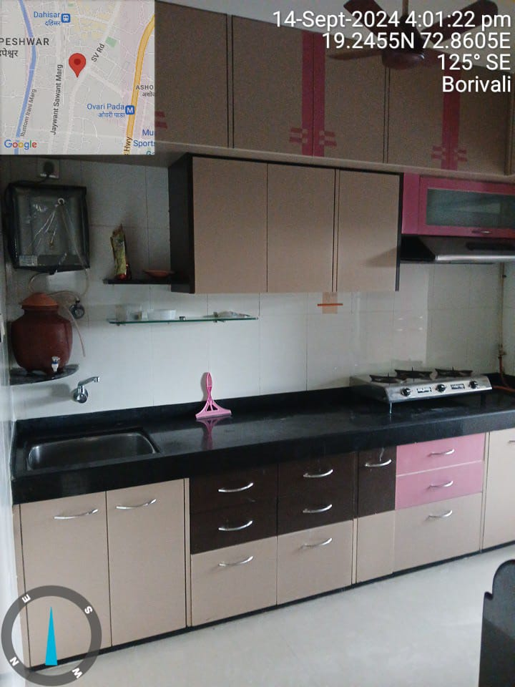
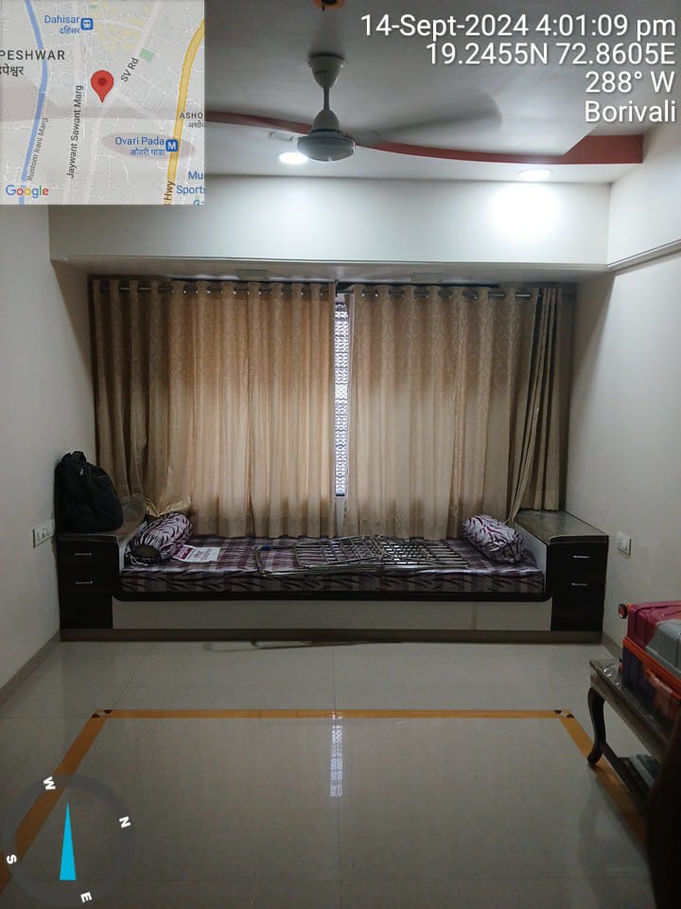
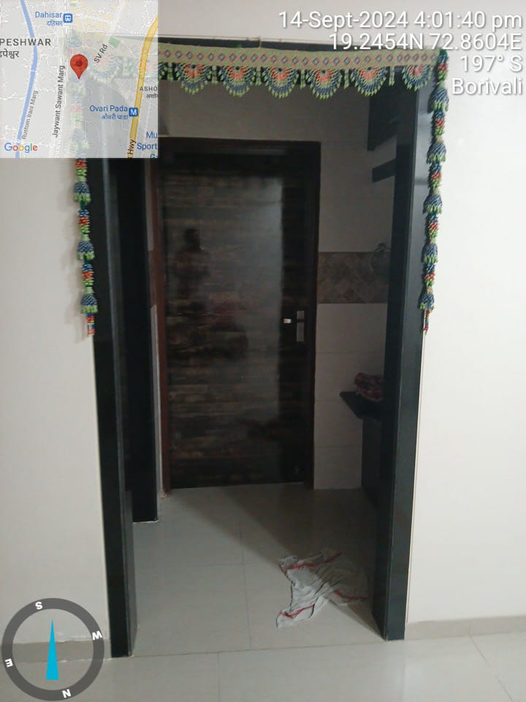
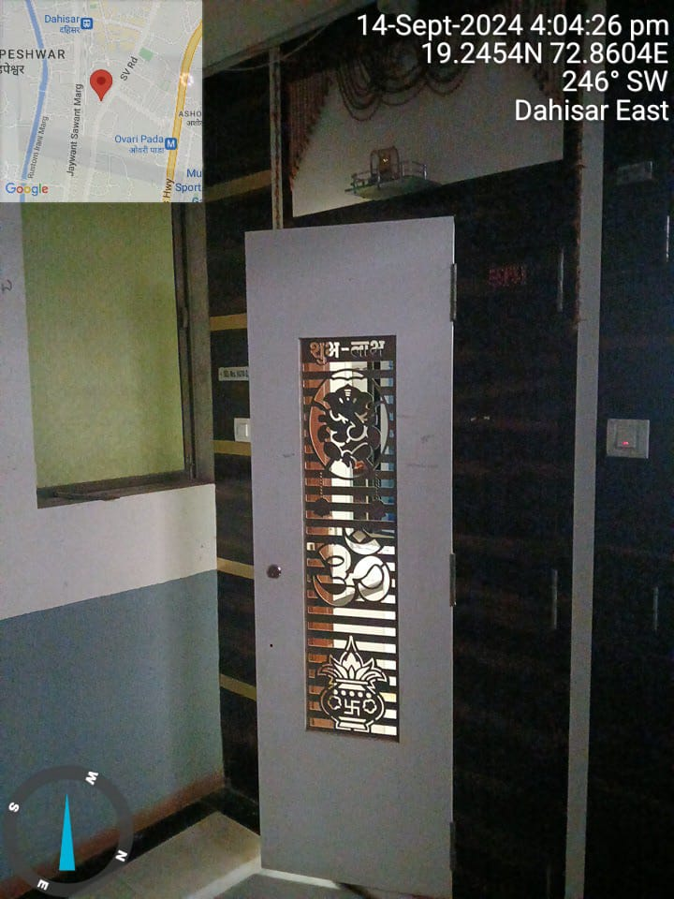

Route Map of the property
Site u/r
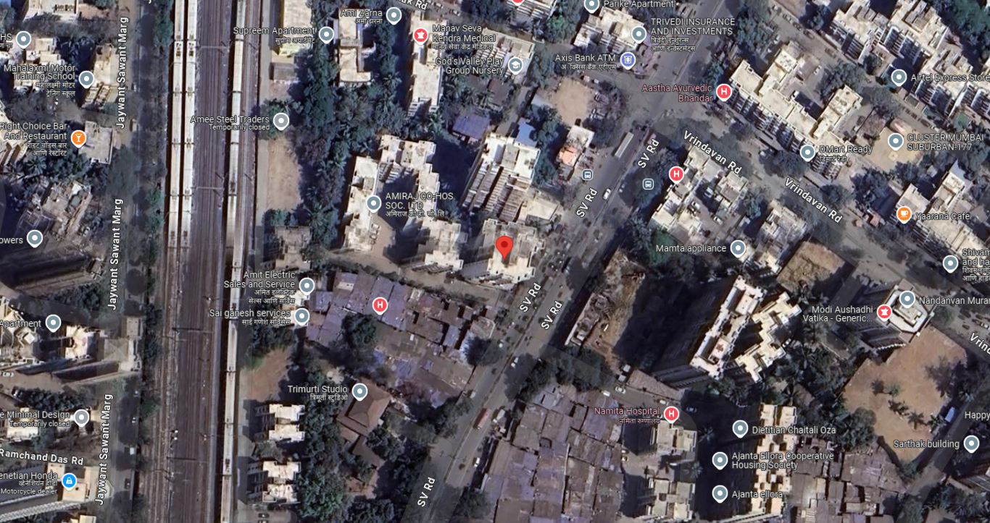

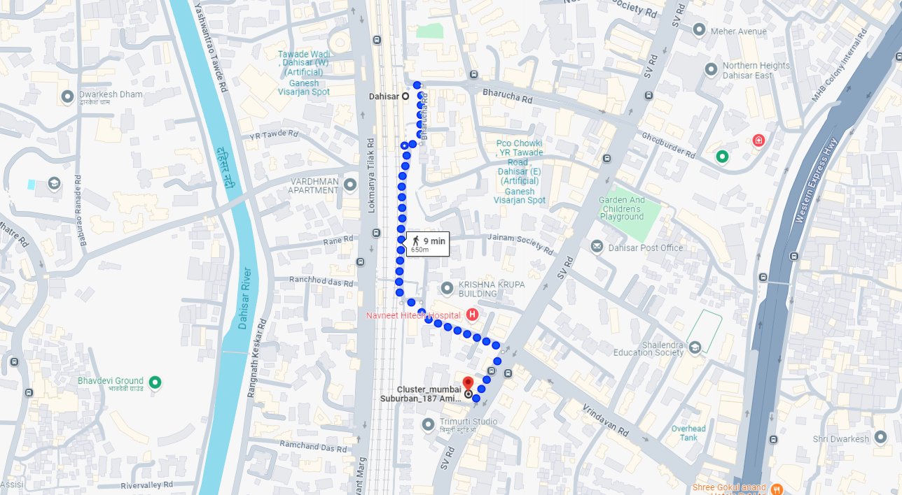

Longitude Latitude - 19°14’43.5”N 72°51’37.9”E
Note: The Blue line shows the route to site from nearest railway station (Dahisar – 650 Mt.)
Ready Reckoner Rate
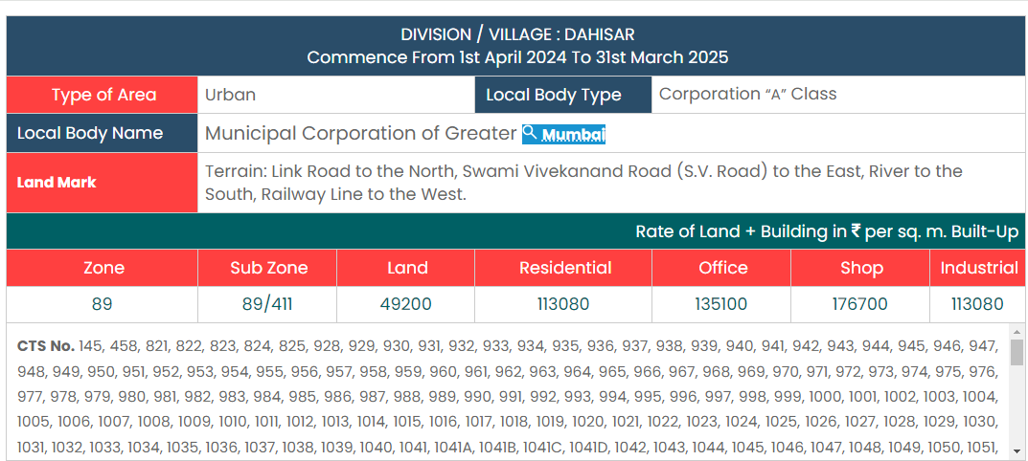

Stamp Duty Ready Reckoner Market Value Rate for Flat | 1,13,080.00
5% increase on Flat Located on 5th Floor | 5,654.00
Stamp Duty Ready Reckoner Market Value Rate (After Increase) (A) | 1,18,734.00 | Sq. Mtr. | 11,031.00 | Sq. Ft.
Stamp Duty Ready Reckoner Market Value Rate for Land (B) | 49,200.00
The difference between land rate and building rate (A – B = C) | 69,534.00
Depreciation Percentage as per table (D) [100% - 14%]  (Age of the Building – 14 Years) | 86%
Rate to be adopted after considering depreciation [B + (C x D)] | 1,08,999.00 | Sq. Mtr. | 10,126.00 | Sq. Ft.

Multi-Storied building with Lift
For residential premises / commercial unit / office on above floor in multistoried building, the rate mentioned in the ready reckoner will be increased as under:

 | Location of Flat / Commercial Unit in the building | Rate
a) | On Ground to 4 Floors | No increase for all floors from ground to 4 floors
b) | 5 Floors to 10 Floors | Increase by 5% on units located between 5 to 10 floors
c) | 11 Floors to 20 Floors | Increase by 10% on units located between 11 to 20 floors
d) | 21 Floors to 30 Floors | Increase by 15% on units located between 21 to 30 floors
e) | 31 Floors and above | Increase by 20% on units located on 31 and above floors

Depreciation Percentage Table

Completed Age of Building in Years | Value in percent after depreciation
 | R.C.C. Structure / other Pukka Structure | Cessed Building, Half or Semi – Pukka Structure & Kaccha Structure.
0 to 2 Years | 100% | 100%
Above 2 & up to 5 Years | 95% | 95%
Above 5 Years | After initial 5 year for every year 1% depreciation is to be considered. However maximum deduction available as per this shall be 70% of Market Value rate | After initial 5 year for every year 1.5% depreciation is to be considered. However maximum deduction available as per this shall be 85% of Market Value rate
Price Indicators
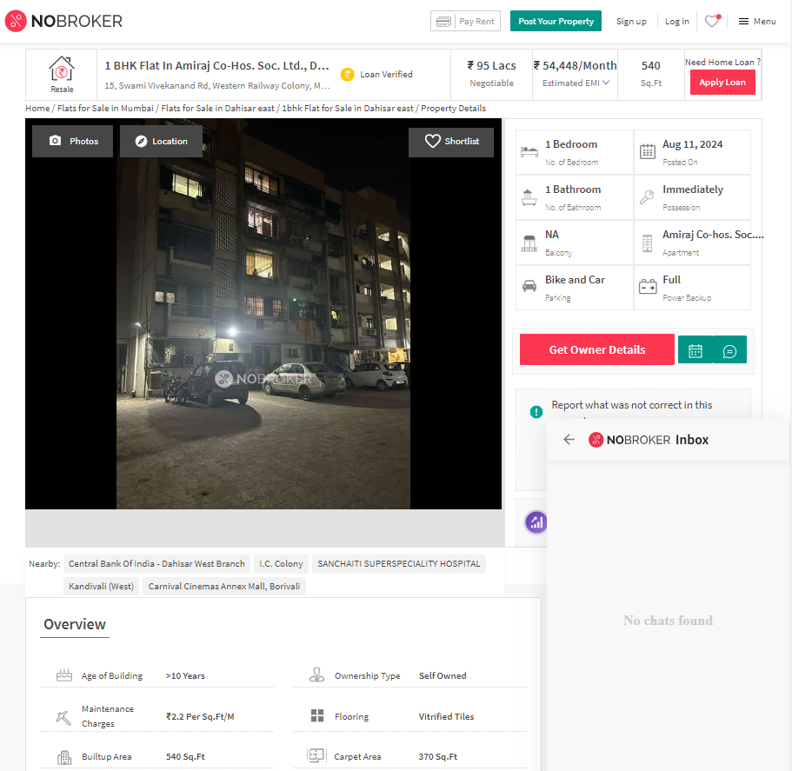

Property | Amiraj, SV Road, Dahisar East
Source | Nobroker.com
Floor | Middle
 | Carpet | Built Up | Saleable
Area | 370.00 | 444.00 | -
Percentage | - | 20% | -
Rate Per Sq. Ft. | ₹ 25,676.00 | ₹ 21,396.00 | -

Price Indicators

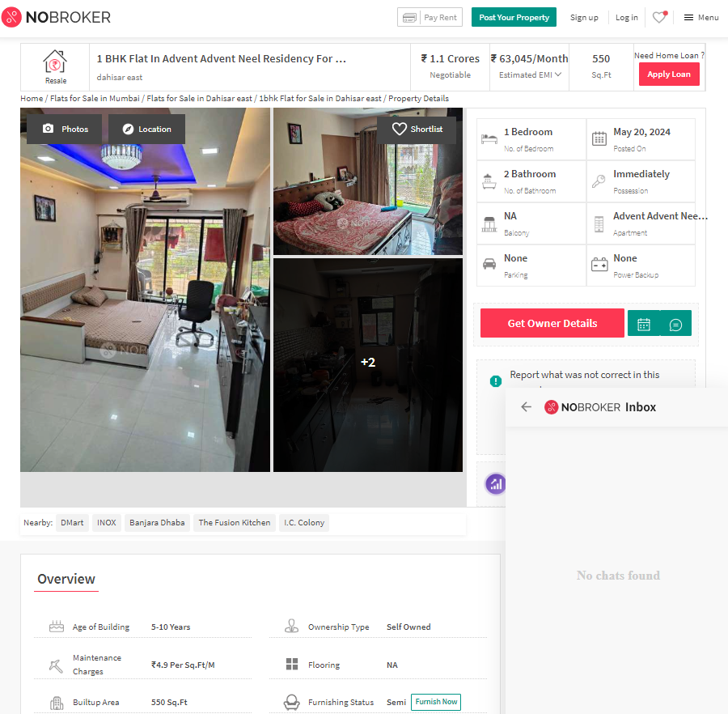

Property | Flat
Source | Nobroker.com
Floor | Middle
 | Carpet | Built Up | Saleable
Area | 458.00 | 550.00 | -
Percentage | - | 20% | -
Rate Per Sq. Ft. | ₹ 24,000.00 | ₹ 20,000.00 | -

Price Indicators
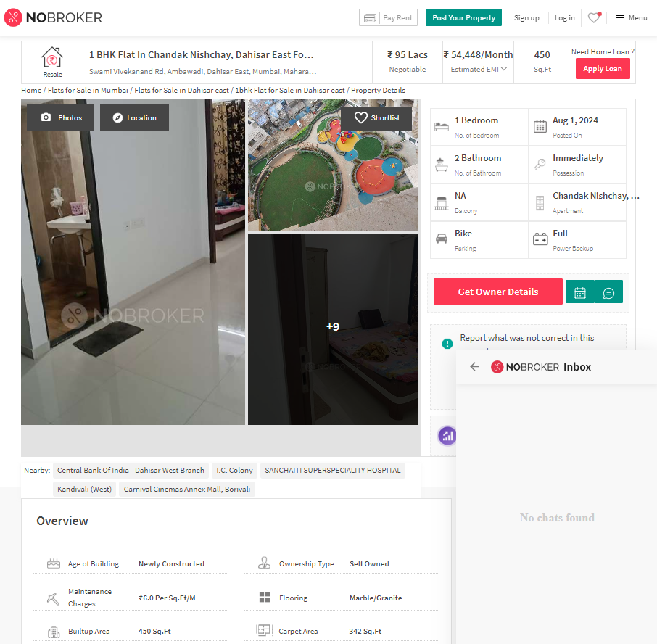

Property | Nishchay, SV Road, Dahisar East
Source | Nobroker.com
Floor | Middle
 | Carpet | Built Up | Saleable
Area | 342.00 | 410.4 | -
Percentage | - | 20% | -
Rate Per Sq. Ft. | ₹ 27,778.00 | ₹ 23,148.00 | -

Sale Instances
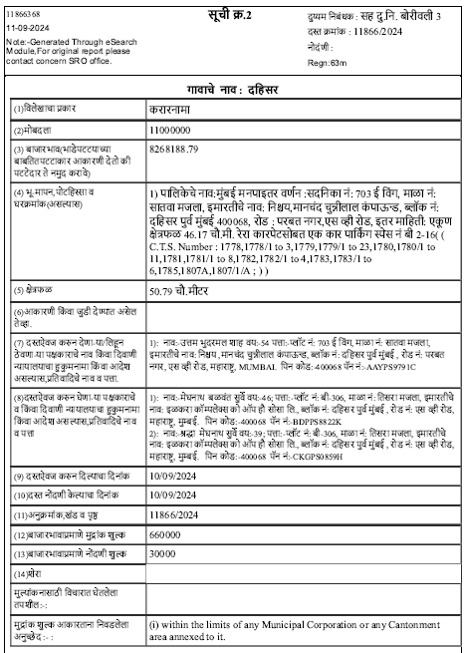

Property | Flat, Nishchay, SV Road, Dahisar East
Source | Index - II
Floor | 7
 | Carpet | Built Up | Saleable
Area | 497.00 | 596.40 | -
Percentage | - | 20% | -
Rate Per Sq. Ft. | ₹ 22,133.00 | ₹ 18,444.00 | -
Justification for price /rate

The Market Value of the property is based on facts of markets discovered by us during our enquiries, however the government rate value in this case is less than the market value arrived by us. We are of the opinion that the value arrive by us will prove to be correct if an Auction of the subject property is carried out. As far as Market Value in Index II is concerned, it is not possible to comment on same, may be government rates are fixed by sampling during same point of time in part and whereas, Market values change every month.
In most of the cases the actual deal amount or Transaction value is not reflected in Index II because of various Market practices. As Valuer, we always try to give a value which is correct reflection of actual transaction value irrespective of any factors in market.
We Hope this will satisfy your requirements.
DEFINITION OF VALUE FOR THIS SPECIFIC PURPOSE

This exercise is to assess Fair Market Value of the property under reference as on 18th September 2024.

The term Fair Market Value is defined as

“The most probable price, as of a specified date, in cash, terms equivalent to cash, or in other precisely revealed terms for which the specified property rights would sell after reasonable exposure in a competitive market under all conditions requisite to a fair sale, with the buyer and seller each acting prudently knowledgeably and for self-interest assuming that neither is under undue duress”.

Fundamental assumptions and conditions presumed in this definition are:

1. Buyer and seller are motivated by self-interest.
2. Buyer and seller are well informed and are acting prudently.
3. The property is exposed for a reasonable time on the open market.
4. Payment is made in cash or equivalent or in specified financing terms.

UNDER LYING ASSUMPTIONS
1. We assume no responsibility for matters of legal nature affecting the property appraised or the title thereto, nor do we render our opinion as to the title, which is assumed to be good and marketable.
2. The property is valued as though under responsible ownership.
3. It is assumed that the property is free of liens and encumbrances.
4. It is assumed that there are no hidden or unapparent conditions of the subsoil or structure that would render it more or less valuable. No responsibility is assumed for such conditions or for engineering that might be required to discover such factors.

DECLARATION OF PROFESSIONAL FEES CHARGED

We hereby declare that, our professional fees are not contingent upon the valuation findings. However, if the statute AND/OR clients demands that, the fees should be charged on the percentage of assessed value then, with the full knowledge of the AND/OR end user, it is being charged accordingly.

VALUATION OF THE PROPERTY PREMISES

Considering various parameters recorded herein above, existing economic scenario, and the information that is available with reference to the development of neighborhood and method selected for valuation, we are of the opinion that, the property premises can be assessed and valued for this particular purpose at ` 1,10,40,000.00 (Rupees One Crore Ten Lakh Forty Thousand Only).

Sharadkumar B. Chalikwar
Govt. Reg. Valuer
Chartered Engineer (India)
Reg. No. (N) CCIT/1-14/52/2008-09

