Vastu/Nashik/09/2024/011152/ 2308123
11/12-129-RPBS
Date: 11.09.2024

To, `
The Branch Manager,
Bank of Baroda
Regional Office Nashik Road Branch
BSNL Building, Datta Mandir Road, Nashik Road,
Nashik -422 101, State - Maharashtra, Country - India.

Sub: Vetting of Extra Amenities

Sir,

With reference to above subject, we have evaluated the Extra Amenities for Residential Flat No. 204, 2nd Floor, Wing - A, "Shreeji Jayshankar Towers", Near Dr. Kadale Baba, Jayshankar Circle, Tapovan Link Road, Plot No. 1+2+3+4+5+6+7+8/A, Village -Nashik, Taluka - Nashik, District - nashik, Nashik, 422003, State - Maharashtra, India belongs to Mr. Gurmukhdas Amarlal Nandwani & Mrs. Lata Gurumukhdas Nandwani.

We have verified the rates quoted as per current market rates. Details of work and Extra Amenities considered as per copy of Agreement for Extra Amenities issued by to Mr. Gurmukhdas Amarlal Nandwani & Mrs. Lata Gurumukhdas Nandwani (First Party) and Shri. Sanjay Tikamdas Tekwani (Second Party) received on dated 09.09.2024. The Extra Amenities amount is Rs.4,00,000/- (Rupees Four Lakh Only.)

The said Cost Vetting Certificate is valid upto next 6 months Only.

Thanking you

Sincerely yours

Manoj B. Chalikwar
Registered Valuer
Chartered Engineer (India)
Reg. No. CAT-I-F-1763
Reg. No. IBBI/RV/07/2018/10366
BOB Empanelment No.: ZO:MZ:ADV:46:941
Encl: Valuation report.

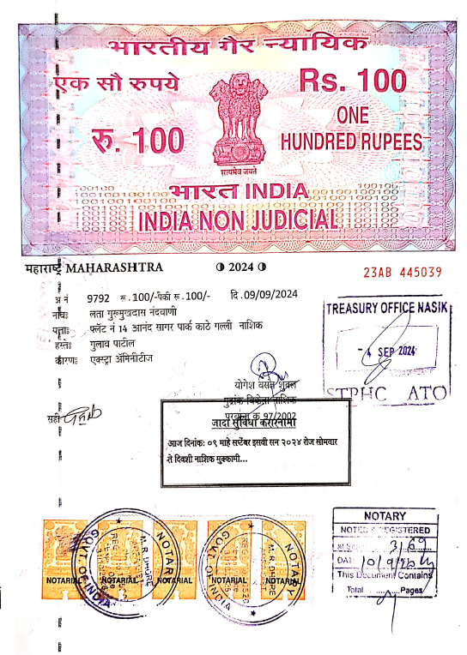
Agreement for Extra Amenities
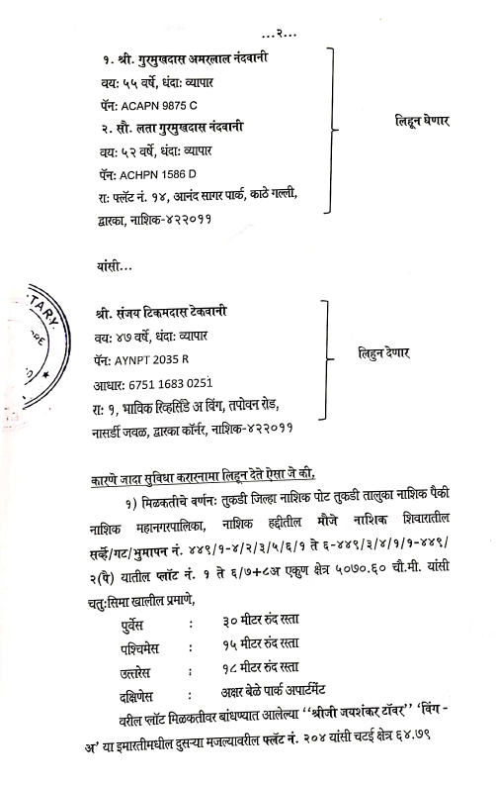

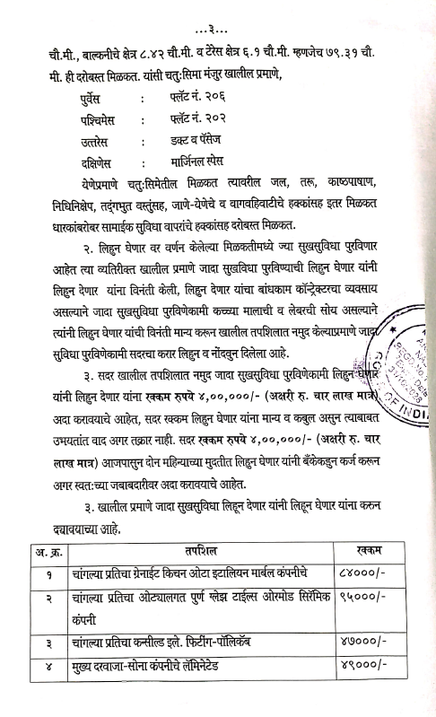
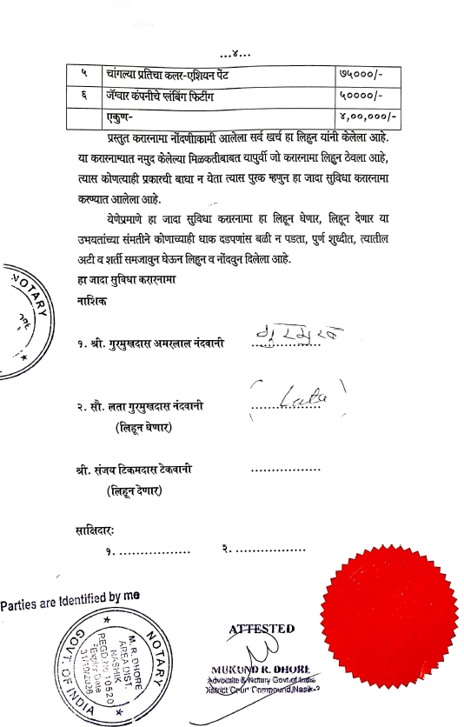

The Extra Amenities amount is Rs.4,00,000/- (Rupees Four Lakh Only.)

