Vastu/Nashik/09/2024/011130/2308108
10/15-114-CCBS
Date: 10.09.2024

To,
The Assistant General Manager,
Bank of Baroda
Regional Office
BSNL Building, Datta Mandir Road, Nashik Road,
Nashik, PIN – 422 101, State - Maharashtra, Country - India.

Sub: Vetting of Estimate

Sir,

With reference to above subject, we have evaluated the Estimate for Residential Land and Proposed Bungalow on Plot No.20, Ground + First Floor, Survey No.10/2/2, Behind Nayara Petrol Pump, At –Trimbakeshwar, Taluka – Trimbakeshwar, District – Nashik,Pin Code – 422 222, State - Maharashtra, Country – India belongs to Shri.Rupeshkumar Madhoprasad Tiware.

We have verified the rates quoted as per current market rates. Details of Estimate considered as per copy of Estimate Provided by Architect Nitin.S.Pawar received on dated.10.09.2024. The Estimate amount is Rs.21,40,000/- (Rupees Twenty-One Lakh Forty Thousand Only.)

Note:1) The said Cost Vetting Certificate is valid upto next 6 months Only.
2) Estimate Submitted for Verification is Much More in Cost with Respective prevailing Market Rate.
3) The Rate of Construction Given in The Report is As Per the Specification To be Provided and With
Respect to Prevailing Market Rate.

Thanking you

Sincerely yours

Manoj B. Chalikwar
Registered Valuer
Chartered Engineer (India)
Reg. No. CAT-I-F-1763
Reg. No. IBBI/RV/07/2018/10366
BOB Empanelment No.: ZO:MZ:ADV:46:941
Encl: Valuation Report

Estimate
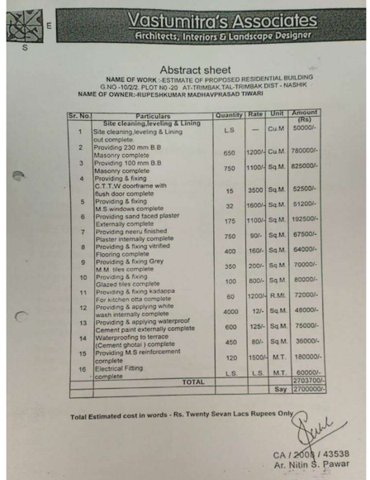

The Estimate amount is Rs.21,40,000/- (Rupees Twenty-One Lakh Forty Thousand Only.)

