Vastu/Nashik/09/2024/011095/2308083
06/18-89-RPBS
Date: 06.09.2024

To, `
The Branch Manager,
Bank of Baroda
Regional Office Nashik Road Branch
BSNL Building, Datta Mandir Road, Nashik Road,
Nashik -422 101, State - Maharashtra, Country - India.

Sub: Vetting of Extra Amenities

Sir,

With reference to above subject, we have evaluated the Extra Amenities for Residential Flat No. C-204, 2nd Floor, Wing - C, Significant, Opp. to Mahda Building, Indira Nagar, Param Pujya Ravishankarji Marg, Village - Wadala, District - Nashik, Nashik, 422 006, State - Maharashtra, India belongs to Mr. Vasim Akram Jahid Khan & Mrs. Sima Wasim Akram Khan.

We have verified the rates quoted as per current market rates. Details of work and Extra Amenities considered as per copy of Agreement for Extra Amenities issued by to Mr. Vasim Akram Jahid Khan & Mrs. Sima Wasim Akram Khan (First Party) and Shri. Mustafa Tajuddin Sayyed (Second Party) received on dated 02.07.2024. The Extra Amenities amount is Rs.5,84,000/- (Rupees Five Lakh Eighty-Four Thousand Only.)

The said Cost Vetting Certificate is valid upto next 6 months Only.

Thanking you

Sincerely yours

Manoj B. Chalikwar
Registered Valuer
Chartered Engineer (India)
Reg. No. CAT-I-F-1763
Reg. No. IBBI/RV/07/2018/10366
BOB Empanelment No.: ZO:MZ:ADV:46:941
Encl: Valuation report.
\

Agreement for Extra Amenities
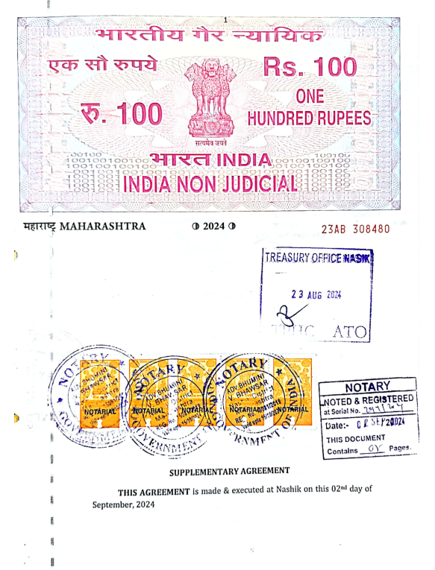
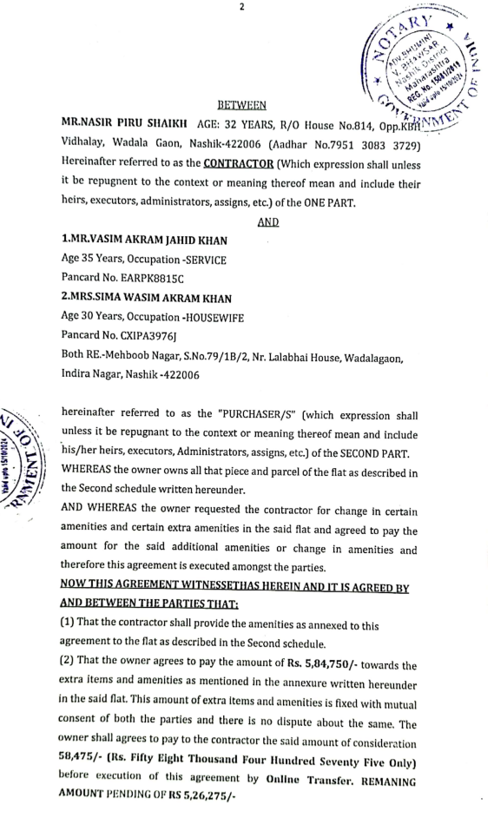

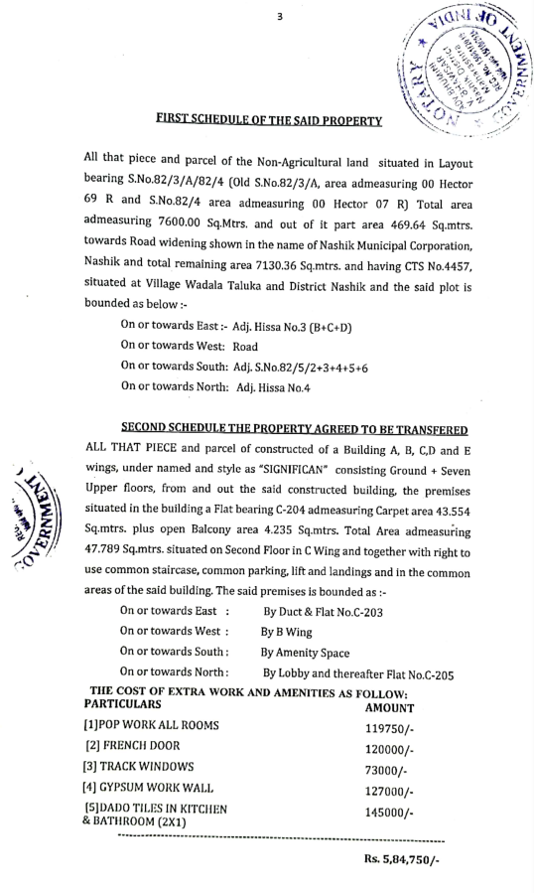
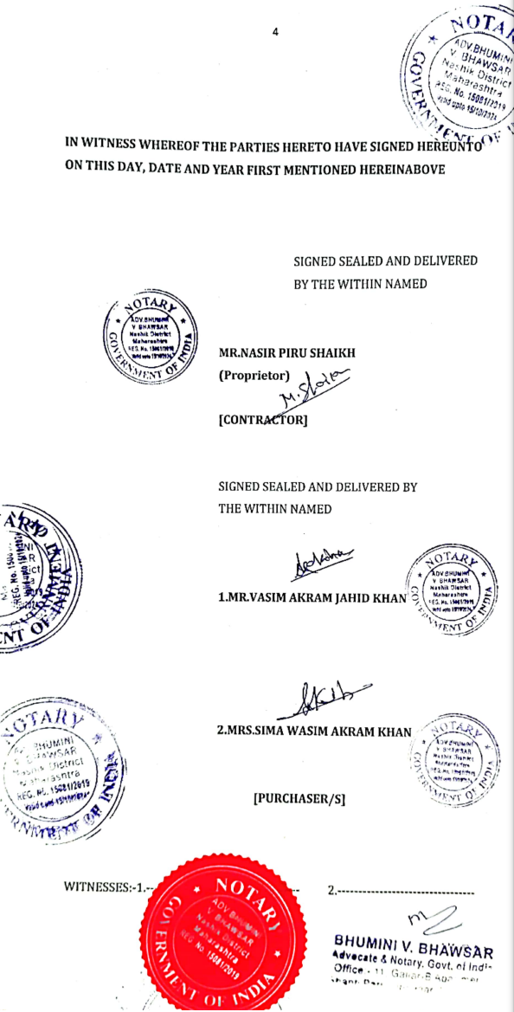

The Extra Amenities amount is Rs.5,84,000/- (Rupees Five Lakh Eighty-Four Thousand Only.)

