Valuation Report of the Immovable Property

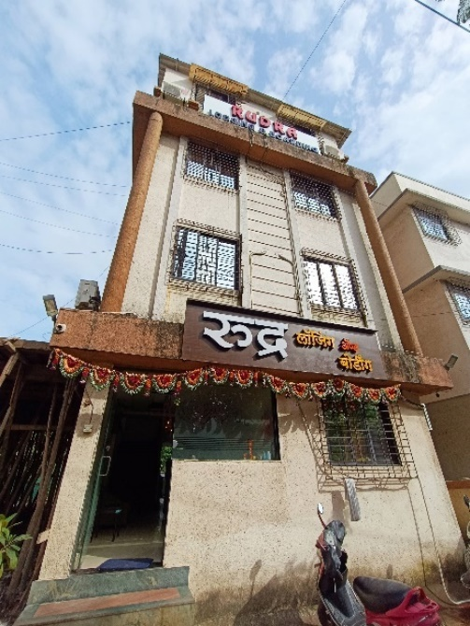

**Details of the property under consideration:**

Name of Owner: **Mr. Satyanarayan Gangaram Goud & Mr. A. Venkataramana**

**Commercial Land & Hotel Building** on PAP Plot No. RP-121, M.I.D.C. Industrial Area, Village – Asde Golavali,

Taluka – Kalyan, District -Thane, Dombivli (East), PIN Code – 421 203,

State - Maharashtra, Country – India.

# Latitude Longitude - 19°12'56.7"N 73°06'27.3"E

# 

**Valuation Prepared for:**

**Cosmos Bank**

**Dombivli (East) Branch**

Sindhudurg C.H.S., Ground Floor, Tilak Chowk, Tilak Nagar, Dombivli (East), Taluka Kalyan, District Thane,

PIN Code - 400605, State - Maharashtra, Country - India

Vastu/Thane/09/2024/11026/2308229

19/3-235-PSRJBS Date: 19.09.2024

# VALUATION OPINION REPORT

The property bearing Commercial Land & Hotel Building on PAP Plot No. RP-121, M.I.D.C. Commercial Area, Village – Asde Golavali, Taluka – Kalyan, District -Thane, Dombivli (East), PIN Code – 421 203, State - Maharashtra, Country - India belongs to **Mr. Satyanarayan Gangaram Goud & Mr. A. Venkataramana.**

|  |  |  |
| --- | --- | --- |
| **Boundaries of the property.** | | |
| North | : | Internal Road | |
| South | : | Open Plot | |
| East | : | Plot No. RP – 122 | |
| West | : | Plot No. RP – 120 | |

Considering various parameters recorded, existing economic scenario, and the information that is available with reference to the development of neighborhood and method selected for valuation, we are of the opinion that, the property premises can be assessed and valued for banking purpose as below –

|  |  |  |  |  |
| --- | --- | --- | --- | --- |
| **Particulars** | **Fair Market Value In (`)** | **Realizable Value In (`)** | **Distress Sale Value In (`)** | **Insurable Value In**  **(`)** |
| Commercial Land & Hotel Building | **92,00,354.00** | **82,80,319.00** | **73,60,283.00** | **22,95,300.90** |

The valuation of the property is based on the documents produced by the concern. Legal aspects have not been taken into considerations while preparing this valuation report.

Hence certified

## Manoj B. Chalikwar

Registered Valuer

Chartered Engineer (India)

Reg. No. IBBI / RV / 07/2018/10366

Reg. No. CAT-I-F-1763

Valuation Report of **Commercial Land & Hotel Building** on PAP Plot No. RP-121, M.I.D.C. Commercial Area, Village – Asde Golavali, Taluka – Kalyan, District -Thane, Dombivli (East), PIN Code – 421 203, State - Maharashtra, Country - India

*Form 0-1*

*(See Rule 8 D)*

REPORT OF VALUATION OF IMMOVABLE PROPERTY (OTHER THAN AGRICULTURAL LANDS, PLANTATIONS, FORESTS, MINES AND QUARRIES)

GENERAL:

|  |  |  |  |
| --- | --- | --- | --- |
| 1 | Purpose for which the valuation is made | | To assess the Fair Market Value as on 19.09.2024 for Bank loan Purpose |
| 2 | Date of inspection | | 05.09.2024 |
|  | Name of the owner/ owners | | **Mr. Satyanarayan Gangaram Goud &**  **Mr. A. Venkataramana** |
| 4 | If the property is under joint ownership / co-ownership, share of each such owner. Are the shares undivided? | | Joint Ownership  Details about ownership share is not available |
| 5 | Brief description of the property | | **Commercial Land & Hotel Building** on PAP Plot No. RP-121, M.I.D.C. Industrial Area, Village – Asde Golavali, Taluka – Kalyan, District -Thane, Dombivli (East), PIN Code – 421 203, State - Maharashtra, Country - India |
| 6 | Location, street, ward no | | Savitribai Phule Road |
| 7 | Survey/ Plot no. of land | | PAP Plot No. RP-121 |
| 8 | Is the property situated in residential/ commercial/ mixed area/ industrial area? | | Commercial area |
| 9 | Classification of locality-high class/ middle class/poor class | | Middle Class |
| 10 | Proximity to civic amenities like schools, Hospitals, Offices, market, cinemas etc. | | All the amenities are available in the vicinity |
| 11 | Means and proximity to surface communication by which the locality is served | | Served by Buses and Private cars |
|  | *LAND* | |  |
| 12 | Area of land supported by documentary proof. Shape, dimension and physical features | | Plot area – 100.00 Sq. M.  (Area as per Deed of Transfer) |
| 13 | Roads, Streets or lanes on which the land is abutting | | Savitribai Phule Road |
| 14 | If freehold or leasehold land | | Leasehold of MIDC |
| 15 | If leasehold, the name of Lessor/lessee, nature of lease, date of commencement and termination of lease and terms of renewal of lease. | | Not applicable |
| (i) Initial premium | | Not applicable |
| (ii) Ground rent payable per annum | | Not applicable |
| (iii) Unearned increase payable to the Lessor in the event of sale or transfer | | Not applicable |
| 16 | Is there any restriction covenant in regard to use of land? If so attach a copy of the covenant. | | Commercial purpose |
| 17 | Are there any agreements of easements? If so, attach a copy of the covenant | | Information not available |
| 18 | Does the land fall in an area included in any Town Planning Scheme or any Development Plan of Government or any statutory body? If so, give Particulars. | | No |
| 19 | Has any contribution been made towards development or is any demand for such contribution still outstanding? | | Information not available |
| 20 | Has the whole or part of the land been notified for acquisition by government or any statutory body? Give date of the notification. | | No |
| 21 | Attach a dimensioned site plan | | Yes |
|  | *IMPROVEMENT* | |  |
| 22 | Attach plans and elevations of all structures standing on the land and a lay-out plan. | | Attached |
| 23 | Furnish technical details of the building on a separate sheet (The Annexure to this form may be used) | | Attached |
| 24 | Is the building owner occupied/tenanted/both? | | Owner Occupied |
|  | If the property owner occupied, specify portion and extent of area under owner-occupation | | Owner Occupied |
| 25 | What is the Floor Space Index permissible and Percentage actually utilized? | | FSI – 1 |
| 26 | *RENTS* | |  |
|  | (i) | Names of tenants/ lessees/ licensees, etc. | N.A. |
|  | (ii) | Portions in their occupation | N.A. |
|  | (iii) | Monthly or annual rent/ compensation / license fee, etc. paid by each | N.A. |
|  | (iv) | Information not available | N.A. |
| 27 | Are any of the occupants related to, or close to business associates of the owner? | | N.A. |
| 28 | Is separate amount being recovered for the use of fixtures, like fans, geysers, refrigerators, cooking ranges, built-in wardrobes, etc. or for services charges? If so, give details | | N.A. |
| 29 | Give details of the water and electricity charges, if any, to be borne by the owner | | Information not available |
| 30 | Has the tenant to bear the whole or part of the cost repairs and maintenance? Give particulars | | N.A. |
| 31 | If a lift is installed, who is to bear the cost of maintenance and operation- owner or tenant? | | No lift |
| 32 | If a pump is installed, who is to bear the cost of maintenance and operation- owner or tenant? | | N.A. |
| 33 | Who has to bear the cost of electricity charges for lighting of common space like entrance hall, stairs, passage, compound, etc. owner or tenant? | | N.A. |
| 34 | What is the amount of property tax? Who is to bear it? Give details with documentary proof | | Information not available |
| 35 | Is the building insured? If so, give the policy no., amount for which it is insured and the annual premium | | Information not available |
| 36 | Is any dispute between landlord and tenant regarding rent pending in a court of rent? | | N.A. |
| 37 | Has any standard rent been fixed for the premises under any law relating to the control of rent? | | As per MIDC norms |
|  | *SALES* | |  |
| 38 | Give instances of sales of immovable property in the locality on a separate sheet, indicating the Name and address of the property, registration No., sale price and area of land sold. | | As per sub registrar of assurance |
| 39 | Land rate adopted in this valuation | | ` 65,000.00 per Sq. M. |
| 40 | If sale instances are not available or not relied up on, the basis of arriving at the land rate | | Online Price Indicators, Location, development of surrounding area, type of land and construction, construction specifications, age of building, condition of the premises & building, facilities provided and its prevailing market rate. |
|  | *COST OF CONSTRUCTION* | |  |
| 41 | Year of commencement of construction and year of completion | | 2019 (As per Occupancy Certificate) |
| 42 | What was the method of construction, by contract / By employing Labour directly / both? | | Information not available |
| 43 | For items of work done on contract, produce copies of agreements | | Information not available |
| 44 | For items of work done by engaging Labour directly, give basic rates of materials and Labour supported by documentary proof. | | Information not available |

*PART II- VALUATION*

GENERAL:

Under the instruction of Cosmos Bank, Naupada Branch, to assess fair market value as on **19th September 2024** for **Commercial Land & Hotel Building** on PAP Plot No. RP-121, M.I.D.C. Industrial Area, Village – Asde Golavali, Taluka – Kalyan, District -Thane, Dombivli (East), PIN Code – 421 203, State - Maharashtra, Country - India belongs to **Mr. Satyanarayan Gangaram Goud & Mr. A. Venkataramana.**

We are in receipt of the following documents:

|  |  |
| --- | --- |
|  | Copy of Deed of Transfer dated 31.01.2020 between Smt. Sharada Abasaheb Phalke (Transferor / Seller) and Mr. Satyanarayan Gangaram Goud & Mr. A. Venkataramana (Transferees / Purchasers). |
|  | Copy of Occupancy Certificate No. EE / SPA / DMB / RP – 121 / B-96678 / 2019 dated 13.06.2019 issued by MIDC. |
|  | Copy of Approved plan No.D08645 dated 12.09.2018 issued by MIDC. |

**Property:**

The property is **Commercial Land & Hotel Building bearing** on PAP Plot No. RP-121, Village – Asde Golavali, Taluka – Kalyan, District -Thane, Dombivli (East), PIN Code – 421 203, State - Maharashtra, Country - India. The Property falls in Industrial Zone. It is a Lodging & Boarding. It is at 2.3 KM. travelling distance from Dombivli Railway station. The surrounding locality is Commercial.

**Building:**

The building under reference is having Ground + 2nd floor + Terrace. It is a R.C.C. framed structure with 9" thick external walls and 6" thick internal brick walls. The walls are having sand faced plaster from outside. The staircase is of R.C.C. with R.C.C. trades and risers with chequered tiles floor finish. The external condition of building is good. The building is used for Commercial purpose of lodging & boarding.

The composition of building is as below –

Ground Floor – Reception + 2 Rooms + 2 Toilets

First Floor – 3 Rooms + 3 Toilets + Staircase.

Second Floor – 3 Rooms + 3 Toilets + Staircase

Terrace - 3 Rooms + 3 Toilets

The building is ﬁnished with Vitrified tiles flooring, Glass door, Powder coated Aluminium sliding windows, Concealed wiring etc.

Area as per Measurement are as follows: -

|  |  |
| --- | --- |
| **Particular** | **Measured Area (Sq. M.)** |
| Ground floor RCC structure | 542.00 |
| 1st floor RCC structure | 542.00 |
| 2nd floor RCC structure | 542.00 |
| Terrace | 542.00 |

**Area as per Deed of Transfer Plot area is 100.00 Sq. M., which is considered for valuation**

**VALUATION OF THE PROPERTY:**

1. **Value of Land:**

|  |  |
| --- | --- |
| Plot area | 100.00 Sq. M. |
| Rate adopted for valuation | ` 65,000.00 per Sq. M. |
| **Value** | **`** **65,00,000.00** |

**As per agreement, the Built-up area of Commercial Building is as below –**

|  |  |  |
| --- | --- | --- |
| **Particulars** | **Built up area**  **in Sq. M.** | **Built up area**  **in Sq. Ft.** |
| Ground Floor | 16.33 | 175.00 |
| First Floor | 40.49 | 436.00 |
| Second Floor | 40.49 | 436.00 |
| **Total** | **97.31** | **1047.00** |

1. **Value of Structures:**

The Built-up area of the building : As per valuation table below

**Deduct Depreciation:**

Year of Construction of the building : 2019 (As per Occupancy Certificate)

Expected total life of building : 55 years

Age of the building as on 2024 : 5 years

Cost of Construction : `30,000.00 per Sq. M.

**Structure Value (as per approved plan)**

|  |  |  |  |  |  |  |  |  |
| --- | --- | --- | --- | --- | --- | --- | --- | --- |
| **Structure No.** | **Built Up Area** | **Year Of Const.** | **Valuation Year** | **Total Life of Structure** | **Estimated Replacement Rate** | **Final Depreciated Rate to be considered** | **Final Depreciated Value to be considered** | **Estimated Replacement Cost / Insurable Value** |
|  | **(Sq. M)** |  |  |  | **(`)** | **(`)** | **(`)** | **(`)** |
| Ground Floor | 16.33 | 2019 | 2024 | 60.00 | 30,000.00 | 27,750.00 | 4,53,158.00 | 4,89,900.00 |
| First Floor | 40.49 | 2019 | 2024 | 60.00 | 30,000.00 | 27,750.00 | 11,23,598.00 | 12,14,700.00 |
| Second | 40.49 | 2019 | 2024 | 60.00 | 30,000.00 | 27,750.00 | 11,23,598.00 | 12,14,700.00 |
|  | **97.31** |  |  |  |  | - | **27,00,354.00** | **29,19,300.00** |

**Government Value**

|  |  |  |  |
| --- | --- | --- | --- |
| **Particulars** | **Area in Sq. M.** | **Rate in `** | **Value in `** |
| Land | 100.00 | 43,670.00 | 43,67,000.00 |
| Structure | As per valuation table | | 27,00,354.00 |
| **Total** |  |  | **70,67,354.00** |

**TOTAL VALUE OF THE PROPERTY:**

|  |  |
| --- | --- |
| **Particulars** | **Value (`)** |
| Cost of Land | 65,00,000.00 |
| Cost of Buildings | 27,00,354.00 |
| **Total Fair Market Value** | **92,00,354.00** |
| **Realizable Value** | **82,80,319.00** |
| **Distress Sale Value** | **73,60,283.00** |
| **Insurance Value** | **22,95,301.00** |

Taking into consideration above said facts, we can evaluate the value of **Commercial Land & Building on** PAP Plot No. RP-121, M.I.D.C. Industrial Area, Village – Asde Golavali, Taluka – Kalyan, District -Thane, Dombivli (East), PIN Code – 421 203, State - Maharashtra, Country - India for this particular purpose at **` 92,00,354.00 ( Rupees Ninety Two Lakh Three Hundred Fifty Four Only)** as on **19th September 2024.**

**NOTES**

1. I, Manoj B. Chalikwar with my experience and ability to judgment I am of the considered opinion that the fair market value of the property as on 19th September 2024 is ` 92,00,354.00 (Rupees Ninety-Two Lakh Three Hundred Fifty-Four Only).
2. Value varies with time and purpose and hence this value should not be referred for any purpose other than mentioned in this report.
3. This valuation is done on the basis of information, which the valuer has obtained by information provided by the client about the premises and location of the surrounding area and also prevailing rates in the surrounding area, and further subject to document as mentioned in valuation report.
4. This valuer should not be held responsible for authentication of documents, clear title and other such related matters. For that purpose, Latest Legal Opinion should be sought.

*PART III- DECLARATION*

I hereby declare that

* + 1. The information furnished in part I is true and correct to the best of my knowledge and belief;
    2. I have no direct or indirect interest in the property valued:

ANNEXURE TO FORM 0-1

Technical details Main Building

|  |  |  |
| --- | --- | --- |
| 1. | No. of floors and height of each floor | As per brief description |
| 2. | Plinth area floor wise as per IS- 1225 | Plot Area = 100.00 Sq. M.  Structure - As per valuation table |
| 3 | Year of construction | Year – 2019  (As per Occupancy Certificate) |
| 4 | Estimated future life | 55 Years Subject to proper, preventive periodic maintenance and structural repairs. |
| 5 | Type of construction- load bearing walls/RCC frame/ steel frame | RCC framed structure |
| 6 | Type of foundations | R.C.C. slab |
| 7 | Walls | All external walls are 9” thick and partition walls are 6” thick. |
| 8 | Partitions | 6” thick brick wall |
| 9 | Doors and Windows | Teak wood door frame with MS safety door, Powder coated aluminum sliding windows |
| 10 | Flooring | Vitrified tiles flooring |
| 11 | Finishing | Cement plastering POP finishing |
| 12 | Roofing and terracing | RCC slabs |
| 13 | Special architectural or decorative features, if any | POP false ceiling in office area |
| 14 | |  |  | | --- | --- | | (i) | Internal wiring – surface or conduit | | (ii) | Class of fittings: Superior/ Ordinary/ Poor. | | Concealed wiring  Ordinary |
| 15 | Sanitary installations   |  |  | | --- | --- | | (i) | No. of water closets | | (ii) | No. of lavatory basins | | (iii) | No. of urinals | | (iv) | No. of sinks |   Class of fittings: Superior colored / superior white/ordinary. | As per requirement  Ordinary |
| 16 | Compound wall  Height and length  Type of construction | Compound wall of R.C.C. columns with Brick Masonry wall |
| 17 | No. of lifts and capacity | No lift |
| 18 | Underground sump – capacity and type of construction | R.C.C. |
| 19 | Over-head tank Location, capacity Type of construction | R.C.C. |
| 20 | Pumps- no. and their horse power | Information not available |
| 21 | Roads and paving within the compound approximate area and type of paving | Concrete cement finish in open spaces, etc. |
| 22 | Sewage disposal – whereas connected to public sewers, if septic tanks provided, no. and capacity | Connected to local sewer line |

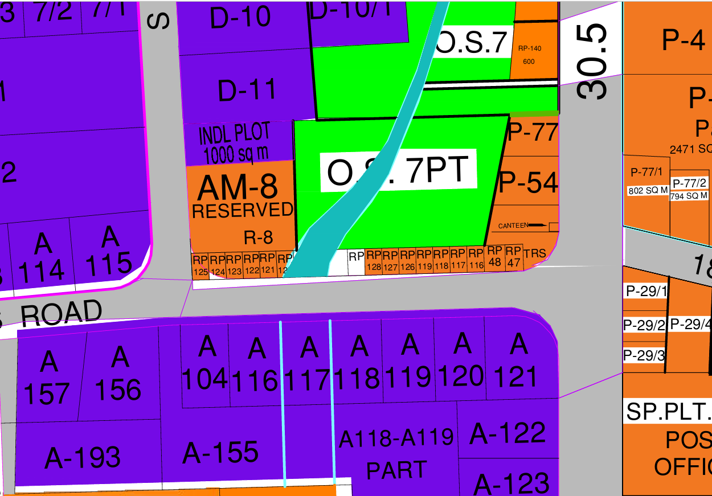**MIDC Map**

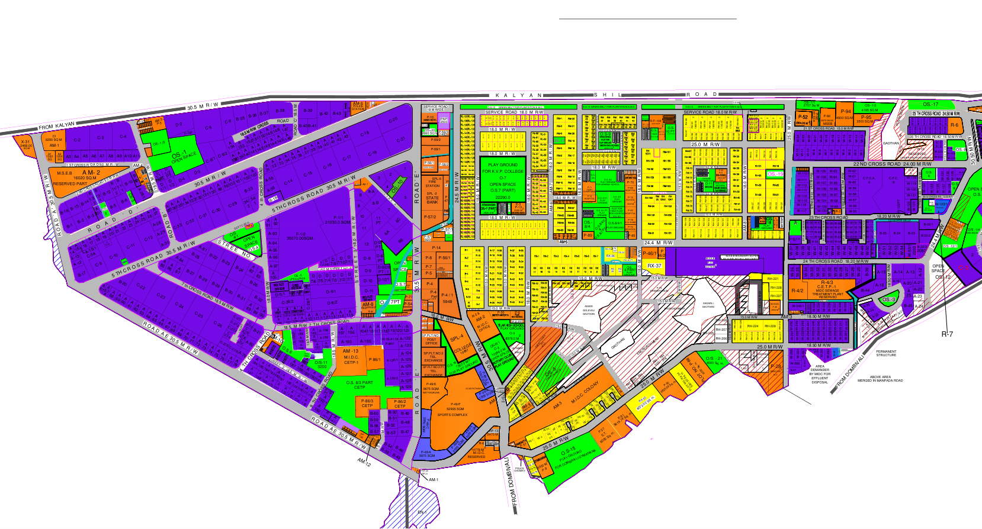

**Occupancy Certificate**

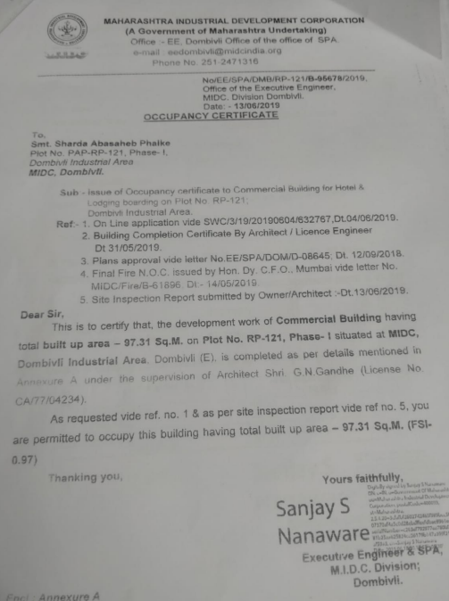

**Approved plan**

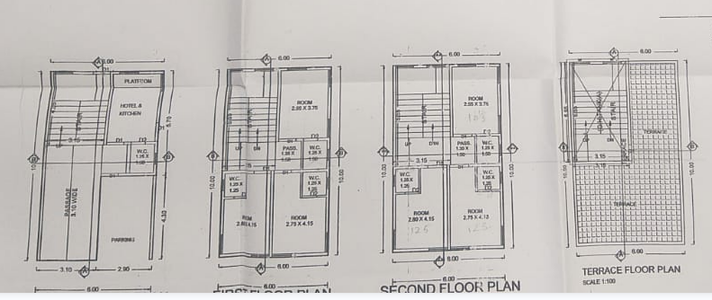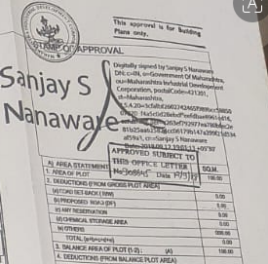

**Actual site photographs**

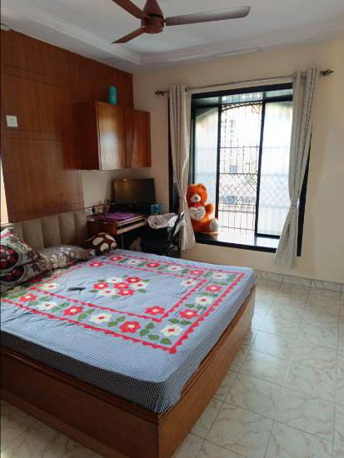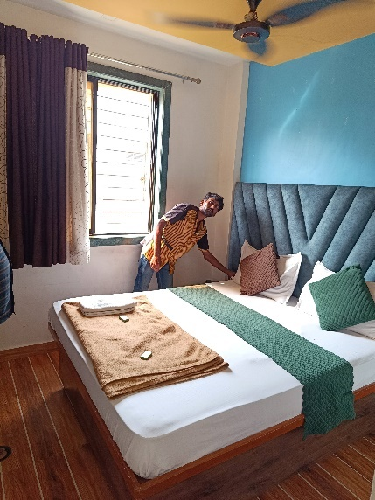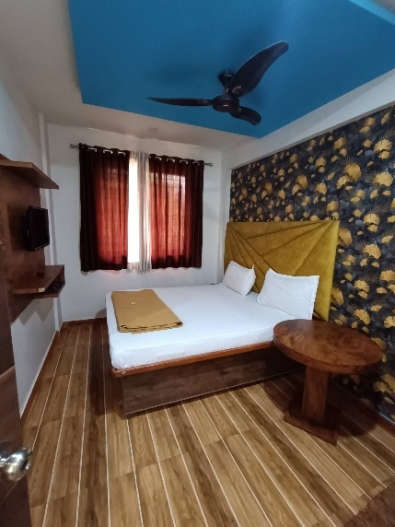

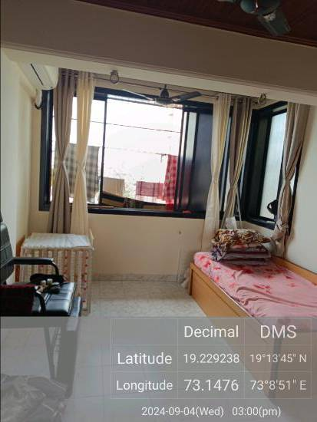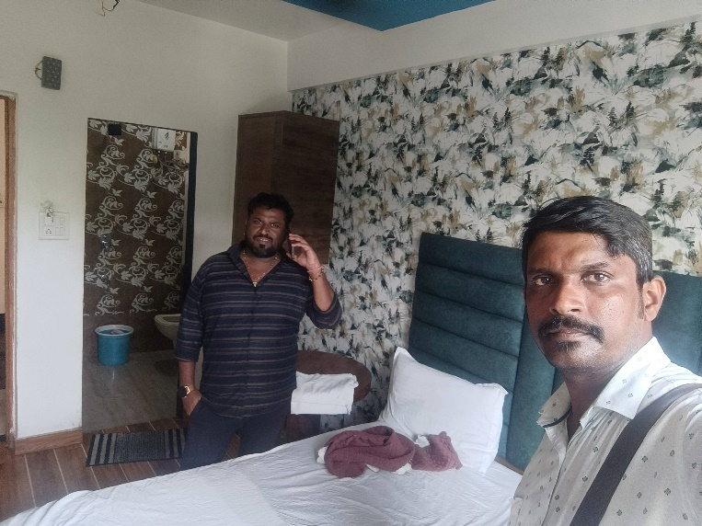

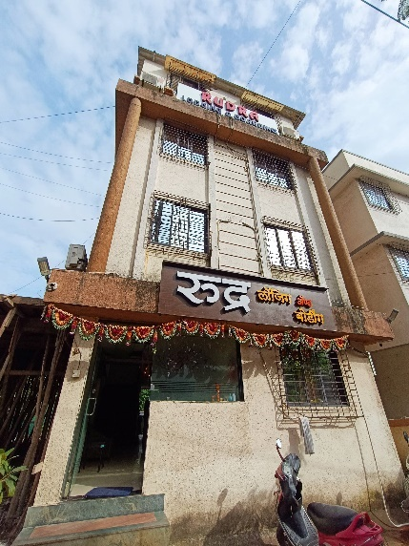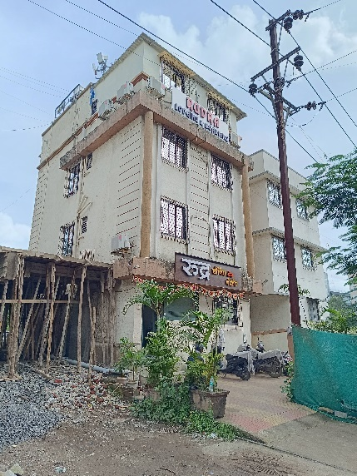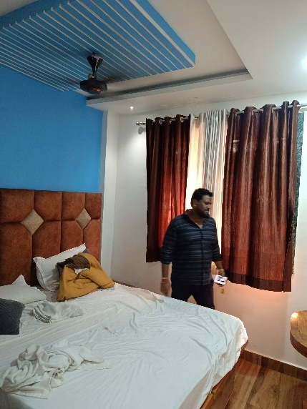

**Route Map of the property**

**Site u/r**

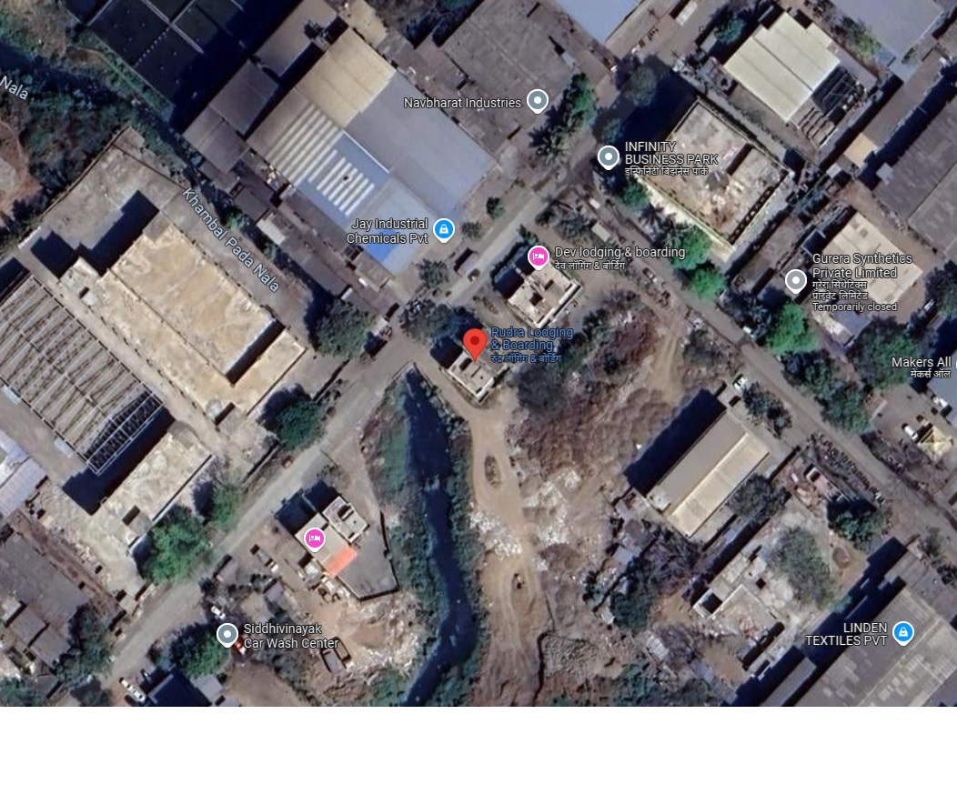

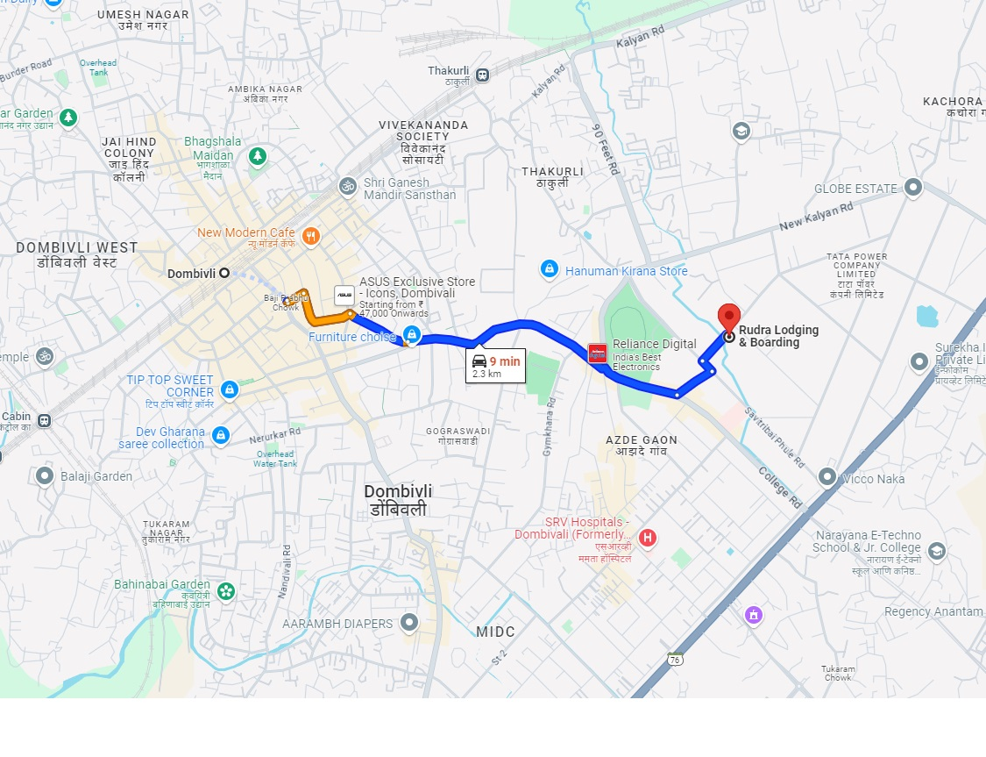

# Latitude Longitude - 19°12'56.7"N 73°06'27.3"E

# Note: The Blue line shows the route to site from nearest Railway Station (Dombivli – 2.3 KM.)

**MIDC RATE**

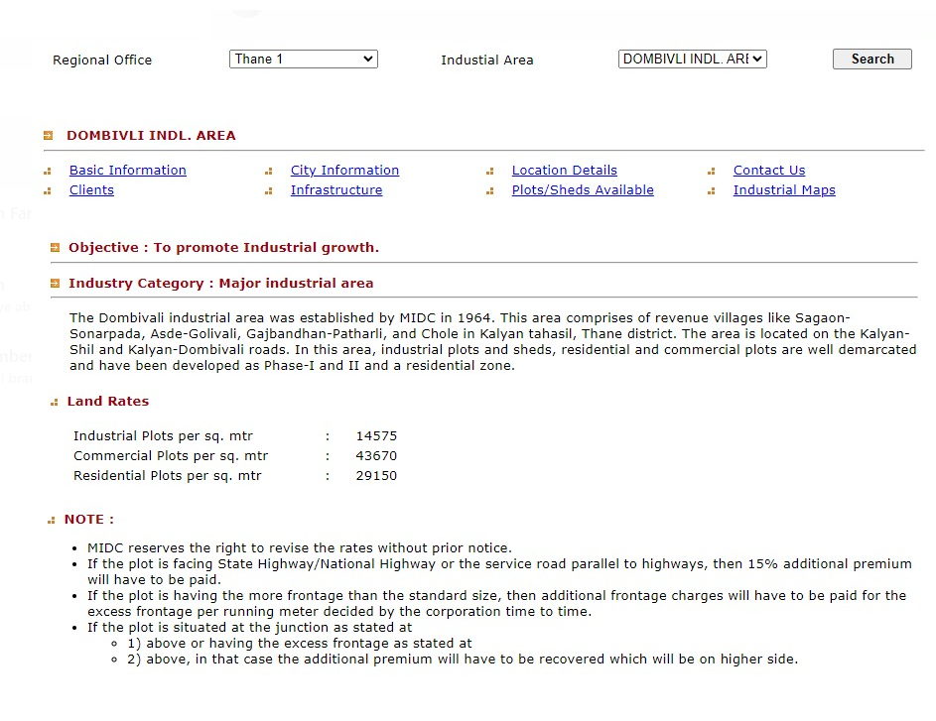

**Price Indicators**

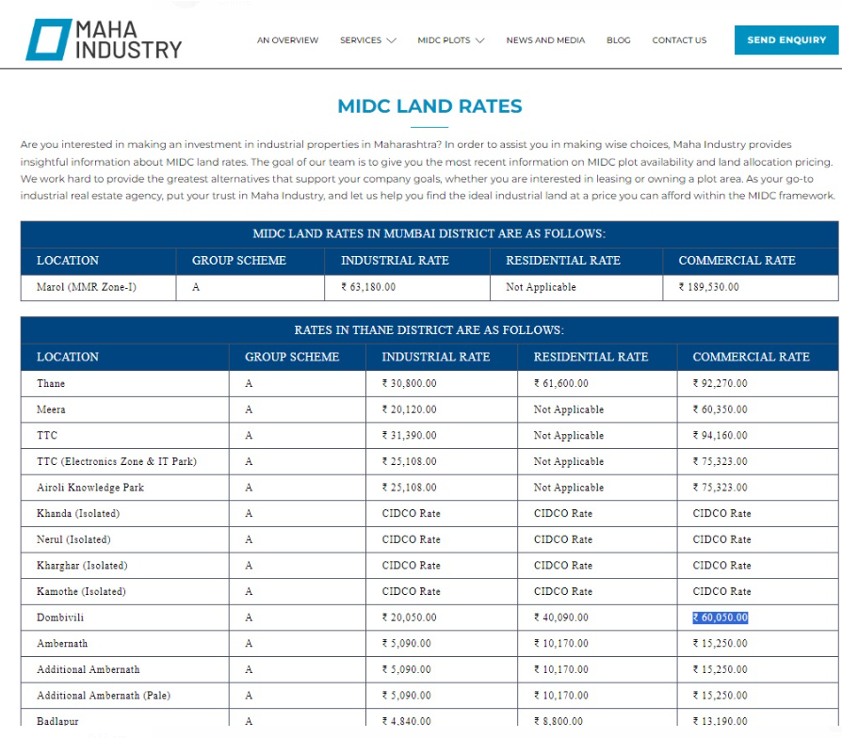

**DEFINITION OF VALUE FOR THIS SPECIFIC PURPOSE**

This exercise is to assess **Fair Market Value** of the property under reference as on **19th September 2024.**

The term **Fair Market Value** is defined as

*“The most probable price, as of a specified date, in cash, terms equivalent to cash, or in other precisely revealed terms for which the specified property rights would sell after reasonable exposure in a competitive market under all conditions requisite to a fair sale, with the buyer and seller each acting prudently knowledgeably and for self-interest assuming that neither is under undue duress”.*

Fundamental assumptions and conditions presumed in this definition are:

1. Buyer and seller are motivated by self-interest.

2. Buyer and seller are well informed and are acting prudently.

3. The property is exposed for a reasonable time on the open market.

4. Payment is made in cash or equivalent or in specified financing terms.

#### UNDER LYING ASSUMPTIONS

1. We assume no responsibility for matters of legal nature affecting the property appraised or the title thereto, nor do we render our opinion as to the title, which is assumed to be good and marketable.

2. The property is valued as though under responsible ownership.

3. It is assumed that the property is free of liens and encumbrances.

4. It is assumed that there are no hidden or unapparent conditions of the subsoil or structure that would render it more or less valuable. No responsibility is assumed for such conditions or for engineering that might be required to discover such factors.

5. There is no direct/ indirect interest in the property valued

6. The rates for valuation of the property are in accordance with the Govt. approved rates and prevailing market rates.

## Sharadkumar B. Chalikwar

Govt. Reg. Valuer

Chartered Engineer (India)

Reg. No. (N) CCIT/1-14/52/2008-09