Vastu/Nashik/08/2024/010634/2307731
17/3-209 -RPBS
Date: 02.09.2024

To, `
The Branch Manager,
Bank of Baroda
Regional Office Nashik Road Branch
BSNL Building, Datta Mandir Road, Nashik Road,
Nashik -422 101, State - Maharashtra, Country - India.

Sub: Vetting of Extra Amenities

Sir,

With reference to above subject, we have evaluated the Extra Amenities for Residential Row House No. 21, Ground Floor, Type-D, Jadhav Park, Survey No.179/2+179/3,CTS No. 6482 ( P), Behind Manish Hardware, Bajrang Nagar, Prof.Gorakhe Nagar, Keval Park Road, Village - Satpur, Taluka - Nashik, District - Nashik, PIN Code – 422 007, State – Maharashtra, Country –India belongs to Shri.Rajkumar Gautam Pandit & Suman Devi Bechu Pandit ( Before Marriage ) Sau.Suman Devi Bechu Pandit ( After Marriage )

We have verified the rates quoted as per current market rates. Details of work and Extra Amenities considered as per copy of Agreement for Extra Amenities issued by Shri.Rajkumar Gautam Pandit & Suman Devi Bechu Pandit ( Before Marriage ) Sau.Suman Devi Bechu Pandit ( After Marriage ). (First Party) and Shri. Amarjeet Shriram Yadav (Second Party) received on dated 29.08.2024. The Extra Amenities amount is Rs.3,00,000/- (Rupees Three Lakh Only.)

The said Cost Vetting Certificate is valid upto next 6 months Only.

Thanking you

Sincerely yours

Manoj B. Chalikwar
Registered Valuer
Chartered Engineer (India)
Reg. No. CAT-I-F-1763
Reg. No. IBBI/RV/07/2018/10366
BOB Empanelment No.: ZO:MZ:ADV:46:941
Encl: Valuation report.
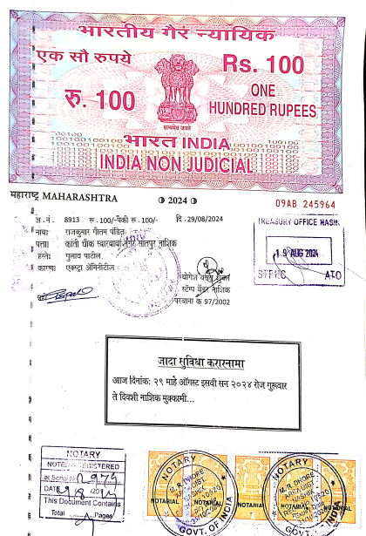
Agreement for Extra Amenities
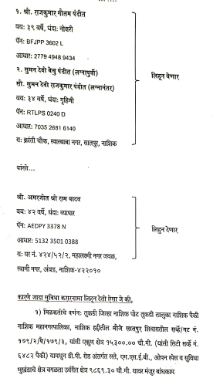

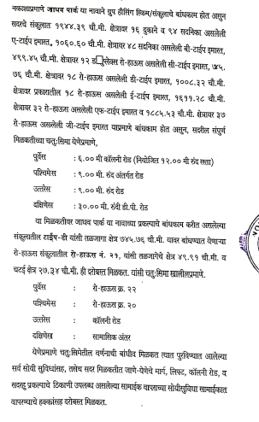
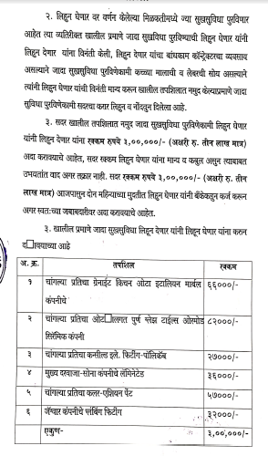

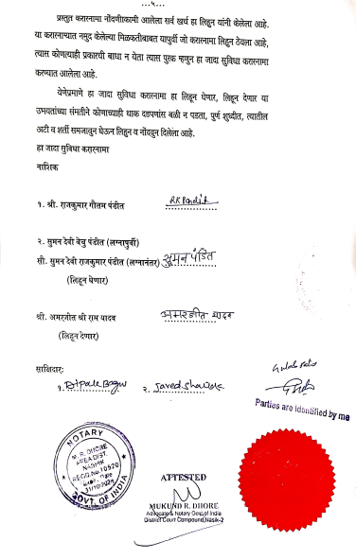

The Extra Amenities amount is Rs.3,00,000/- (Rupees Three Lakh Only.)

