# Valuation Report of the Immovable Property

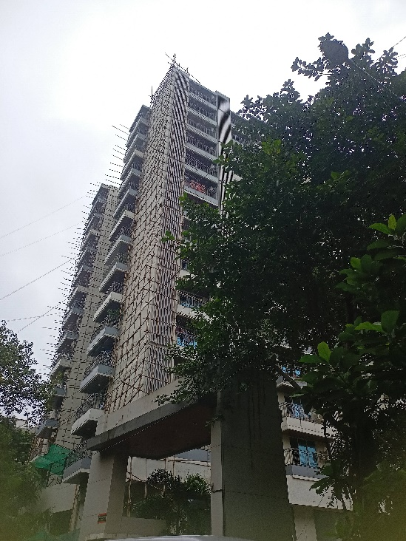

**Details of the property under consideration:**

Name of Client: **Mr. Ghanshyam Dhanjibhai Dholakia**

Residential Flat No. 503, 5th Floor, Wing -B, **“Insignia Building”**, CST Road, Santacruz Chembur Link Road, Santacruz (East), Mumbai, Pin – 400 058, State – Maharashtra, Country – India

# **Latitude Longitude: 19°04'19.3"N 72°52'05.5"E**

Vastu/Mumbai/09/2024/11003/2308029

03/15-35-VVSUM

Date: 03.09.2024

# **VALUATION OPINION REPORT**

This is to certify that the property bearing Residential Flat No. 503, 5th Floor, Wing -B, **“Insignia Building”**, CST Road, Santacruz Chembur Link Road, Santacruz (East), Mumbai, Pin – 400 058, State – Maharashtra, Country – India belongs to **Mr. Ghanshyam Dhanjibhai Dholakia.**

|  |  |  |
| --- | --- | --- |
| Boundaries of the property. | | |
| North | : | Santacruz – Chembur Link Road & Kabra Centroid Building | |
| South | : | Hotel BKC Garden | |
| East | : | C- Wing & Swadeshi Mill Road | |
| West | : | A – Wing & Slum Area | |
|  |  |  | |

Considering various parameters recorded, existing economic scenario, and the information that is available with reference to the development of neighborhood and method selected for valuation, we are of the opinion that, the property premises can be assessed for **Fair Market Value in the year 2017 at** **`** **2,08,46,592.00 (Rupees Two Crore Eight Lakh Forty Six Thousand Five Hundred Ninety Two Only).**

The valuation of the property is based on the prevailing market rates in respective years. Legal aspects have not been taken into considerations while preparing this valuation report.

Hence certified

**Sharadkumar B. Chalikwar**

Govt. Reg. Valuer

Chartered Engineer (India)

Reg. No. (N) CCIT/1-14/52/2008-09

Encl: Valuation report

|  |  |  |  |  |
| --- | --- | --- | --- | --- |
|  |  |  | |  |
| **Vastukala Consultants (I) Pvt. Ltd.**  B1-001, U/B Floor, Boomerang, Chandivali Farm Road, Andheri (E), Mumbai - 400 072  **VALUATION REPORT (IN RESPECT OF FLAT)**   |  |  |  |  |  |  |  | | --- | --- | --- | --- | --- | --- | --- | | I | **General** | | | | | | | 1. | Purpose for which the valuation is made | | | : | To assess Fair Market Value of the property in the year 2017 | | | 2. | a) | Date of inspection | | : | 03.09.2024 | | |  | b) | Date on which the valuation is made | | : |  | | | 3. | **List of documents produced for perusal:**   1. Copy of Agreement for sale dated 14.12.2017 b/w. Ultra Space Developers Pvt. Ltd. (as Promoters) And Mr. Ghanshyam Dhanjibhai Dholakia (the Allottee / Purchaser) 2. Copy of MAHARERA Registration Certificate of Project No. P51800002313 issued by Maharashtra Real Estate Regulatory Authority date 09. 09. 2021 3. Copy of Modified Letter of Allotment date 23.12.2016 4. Copy of Possession Acceptance date 19.04.2022 5. Copy of Commencement Certificate No. CE / 9501 / BSII / CHE / H/K/ 337 (New) date 01.07.2010 issued by Municipal Corporation of Greater Mumbai 6. Revised Copy of Commencement Certificate No. CE / 9501 / BSII / AH date 13.02.2017 issued by Municipal Corporation of Greater Mumbai 7. Copy of Amended Plans Letter No. CE / 9501 / BSII / AH date 17.04.2017 issued by Municipal Corporation of Greater Mumbai 8. Copy of Full Occupancy Certificate No. CE / 9501 / BSII / AH / OCC / 1 / NEW date 06.09.2021 issued by Municipal Corporation of Greater Mumbai | | | | | | | 4. | Name of the owner(s) and his / their address (es) with Phone no. (details of share of each owner in case of joint ownership) | | | : | **Mr. Ghanshyam Dhanjibhai Dholakia**  **Address:** Residential Flat No. 503, 5th Floor, Wing -B, **“Insignia Building”**, CST Road, Santacruz Chembur Link Road, Santacruz (East), Mumbai, Pin – 400 058, State – Maharashtra, Country – India  **Contact Person:**  Mr. Pranay Modi (Company Staff)  Mobile No.: 9004377362  Sole ownership | | | 5. | Brief description of the property (Including Leasehold / freehold etc.) | | | : |  | | |  | The Flat under valuation is situated on the 5th Floor. The composition of property is Living Room + 4 Bedrooms + Kitchen + 5 Toilets + Store Room + + Dry Balcony + Passage (i.e. 4 BHK). It is at 4.5 Km. travel distance from Santacruz Railway Station on Western Railway line.  **History :**   * Mr. Ghanshyam Dhanjibhai Dholakia (The client) booked Flat No. 1502-A Wing of under construction Insignia Building at CST Road, Santacruz Chembur Link Road, Santacruz (East), Mumbai, Pin – 400for the aggregate consideration of Rs. 2,55,00,000/- (Rupees Two Crore Fifty Five Lakh Only) exclusive of all other deposits, legal charge and cost of formation of co-operative society, stamp duty, registration charges, and development charges. Out of the said agreed consideration, the client has paid the amount of aggregating to Rs. 1,61,05,789/- (Rupees One Crore Sixty One Lakh Five Thousand Seven Hundred Eighty Nine only) Including Service Tax as advance in respect of the said Old Flat vide different payment modes mentioned in modified Letter of Allotment. * Due to change in Development Control Regulation for Greater Mumbai, 1991, the developers were constrained to alter/amend the building plans. As per the revised building plans the building got permission upto 12th floor only hence booking done by our client for 15th floor flat was stood void. In view of the same, developer have requested the client to accept allotment of another flat on a lower floor of INSIGNIA in place and instead of the said Old Flat on 15th floor. * Pursuant to discussions and negotiations between client and developer, it has been mutually agreed to allot Flat No. 503 on 5th floor in B Wing, in "INSIGNIA" ("said New Flat"). | | | | | | | 6. | Location of property | | | : |  | | |  | a) | | Plot No. / Survey No. | : | **-** | | |  | b) | | Door No. | : | Residential Flat No. 503 | | |  | c) | | C.T.S. No. / Village | : | CTS No. 5530A, 5530A/1 to 3, Village Kole-Kalyan | | |  | d) | | Ward / Taluka | : | Ward – H/E | | |  | e) | | Mandal / District | : | District – Mumbai Suburban | | |  | f) | | Date of issue of layout of approved map / plan. | : | Full Occupancy Certificate No. CE / 9501 / BSII / AH / OCC / 1 / NEW date 06.09.2021 issued by Municipal Corporation of Greater Mumbai | | |  | g) | | Approved map / plan issuing authority | : | | 7. | Postal address of the property | | | : | Residential Flat No. 503, 5th Floor, Wing -B**, “Insignia Building”**, CST Road, Santacruz Chembur Link Road, Santacruz (East), Mumbai, Pin – 400 058, State – Maharashtra, Country – India | | | 8. | City / Town | | | : | Mumbai | | |  | Residential area | | | : | Yes | | |  | Commercial area | | | : | No | | |  | Industrial area | | | : | No | | | 9. | Classification of the area | | | : |  | | |  | i) High / Middle / Poor | | | : | Medium Class | | |  | ii) Urban / Semi Urban / Rural | | | : | Urban | | | 10. | Coming under Corporation limit / Village Panchayat / Municipality | | | : | Village – Kole - Kalyan  Municipal Corporation of Greater Mumbai | | | 11. | Whether covered under any State / Central Govt. enactments (e.g., Urban Land Ceiling Act) or notified under agency area/ scheduled area / cantonment area | | | : | No | | | 12. | **Boundaries of the property** | | |  | **As per Site** | **As per documents** | |  | North | | | : | Santacruz – Chembur Link Road & Kabra Centroid Building | CST Road | |  | South | | | : | Hotel BKC Garden | Bandra Kurla Complex Side CTS No. 4207 | |  | East | | | : | C- Wing & Swadeshi Mill Road | CTS No. 5544(P), 5542 (P), 7012 & 7046 | |  | West | | | : | A – Wing & Slum Area | CTS Nos. 5550, 5555, 5569, 5561 and Amenity Space (CTS No. 5530/A/). | | 13 | Dimensions of the site | | |  | N. A. as property under consideration is a flat in an apartment building. | | | 14. | Extent of the site | | | : | Carpet Area = 121.20 Sq. M. i.e. 1,305.00 Sq. Ft.  (Area as per Agreement for sale)  Built up area = 145.44 Sq. M. i.e. 1,566.00 Sq. Ft.  **(As per Index No. II)** | | | 14.1 | Latitude, Longitude & Co-ordinates of Flat | | | : | 19°04'19.3"N 72°52'05.5"E | | | 15. | Extent of the site considered for Valuation (least of 13A& 13B) | | | : | Built up area = 145.44 Sq. M. i.e. 1,566.00 Sq. Ft.  **(As per Index No. II)** | | | 16 | Whether occupied by the owner / tenant? If occupied by tenant since how long? Rent received per month. | | | : | Building was under construction in year 2017. Presently the flat is occupied by the owner. | | | **II** | **APARTMENT BUILDING** | | |  |  | | |  | Nature of the Apartment | | | : | Residential | | |  | Location | | | : |  | | |  | C.T.S. No. | | | : | CTS No. 5530A, 5530A/1 to 3, Village Kole-Kalyan | | |  | Block No. | | | : | - | | |  | Ward No. | | | : | - | | |  | Village / Municipality / Corporation | | | : | Village – Kole - Kalyan  Municipal Corporation of Greater Mumbai | | |  | Door No., Street or Road (Pin Code) | | | : | Residential Flat No. 503, 5th Floor, Wing -B, **“Insignia Building”**, CST Road, Santacruz Chembur Link Road, Santacruz (East), Mumbai, Pin – 400 058, State – Maharashtra, Country – India | | |  | Description of the locality Residential / Commercial / Mixed | | | : | Residential | | |  | Year of Construction | | | : | 2021 (As per Full Occupancy Certificate) | | |  | Number of Floor | | | : | 3 Level Basements + Lower Ground + Upper Ground + 1st Podiums + 2nd to 13th upper floors | | |  | Type of Structure | | | : | R.C.C. Framed Structure | | |  | Number of Dwelling units in the building | | | : | 4 Flats on 5th Floor | | |  | Quality of Construction | | | : | Good | | |  | Appearance of the Building | | | : | Good | | |  | Maintenance of the Building | | | : | Good | | |  | Facilities Available | | | : |  | | |  | Lift | | | : | 2 lifts | | |  | Protected Water Supply | | | : | Municipal Water supply | | |  | Underground Sewerage | | | : | Connected to Municipal Sewerage System | | |  | Car parking - Open / Covered | | | : | Covered Car Parking | | |  | Is Compound wall existing? | | | : | Yes | | |  | Is pavement laid around the building | | | : | Yes | | | **III** | **FLAT** | | |  |  | | | 1 | The floor in which the Flat is situated | | | : | 5th Floor | | | 2 | Door No. of the Flat | | | : | Residential Flat No. 503 | | | 3 | Specifications of the Flat | | | : |  | | |  | Roof | | | : | R.C.C. Slab | | |  | Flooring | | | : | Marble flooring | | |  | Doors | | | : | Teakwood door frame with safety door | | |  | Windows | | | : | Aluminum sliding window with powder coating & MS grills | | |  | Fittings | | | : | Concealed plumbing with C.P. fittings. Electrical wiring with Concealed. | | |  | Finishing | | | : | Cement Plastering | | | 4 | House Tax | | | : |  | | |  | Assessment No. | | | : | Details not available | | |  | Tax paid in the name of: | | | : | Details not available | | |  | Tax amount: | | | : | Details not available | | | 5 | Electricity Service connection No.: | | | : | Details not available | | |  | Meter Card is in the name of: | | | : | Details not available | | | 6 | How is the maintenance of the Flat? | | | : | Good | | | 7 | Sale Deed executed in the name of | | | : | **Mr. Ghanshyam Dhanjibhai Dholakia** | | | 8 | What is the undivided area of land as per Sale Deed? | | | : | Details not available | | | 9 | What is the plinth area of the Flat? | | | : | Built up area = 145.44 Sq. M. i.e. 1,566.00 Sq. Ft.  **(As per Index No. II)** | | | 10 | What is the floor space index (app.) | | | : | As per MCGM norms | | | 11 | What is the Carpet Area of the Flat? | | | : | Carpet Area = 121.20 Sq. M. i.e. 1,305.00 Sq. Ft.  (Area as per Agreement for sale) | | | 12 | Is it Posh / I Class / Medium / Ordinary? | | | : | Higher class | | | 13 | Is it being used for Residential or Commercial purpose? | | | : | Residential purpose | | | 14 | Is it Owner-occupied or let out? | | | : | Owner occupied as on date. | | | **IV** | **MARKETABILITY** | | | : |  | | | 1 | How is the marketability? | | | : | Poor in the year 2017. | | | 2 | What are the factors favouring for an extra Potential Value? | | | : | Nil | | | 3 | Any negative factors are observed which affect the market value in general? | | | : | As below | | |  | **As per resident’s inputs in Insignia Building:**  The construction of the building was started in the year 2010. Due to change in Development Control Regulations for Greater Mumbai, there was considerable delay in completion of project. | | | | | | | **V** | **Rate** | | | : |  | | | 1 | After analyzing the comparable sale instances, what is the composite rate for a similar flat with same specification in the adjoining locality? – (Along with details / reference of at -least two latest deals / transactions with respect to adjacent properties in the areas) | | |  | Registered sale instances in year 2017 – 2018 are attached as below: | |  |  |  |  |  |  |  |  |  |  | | --- | --- | --- | --- | --- | --- | --- | --- | --- | | **Sr.** | **Flat No. / Floor /** | **Index II** | **Date** | **Built up area** | **Agreement value (`)** | **Transaction Rate / Sq.Ft. (`)** | **Ready Reckoner / guideline Value**  **(`)** | **RR rate / Sq.Ft.**  **(`)** | | 1 | 1202, 12th Floor, Wing – C | 354/2017 | 19.01.2017 | 1614.16 | 2,06,64,000.00 | 12,802.00 | 2,75,80,500.00 | 17,087.00 | | 2 | 203, 2nd Floor, Wing – B | 3532/2017 | 03.05.2017 | 1453.24 | 1,32,70,000.00 | 9,131.00 | 2,62,52,500.00 | 18,065.00 | | 3 | 1102, 11th Floor, Wing – E | 1818/2017 | 31.03.2017 | 1688.33 | 1,94,15,046.00 | 11,500.00 | 2,94,45,550.00 | 17,441.00 | | 4 | 1303, 13th Floor, Wing – C | 1819/2017 | 31.03.2017 | 1131.08 | 1,57,28,496.00 | 13,906.00 | 2,01,40,100.00 | 17,806.00 | | 5 | 204, 2nd Floor, Wing – B | 6445/2017 | 11.09.2017 | 1554.10 | 1,79,94,452.00 | 11,579.00 | 2,73,41,000.00 | 17,593.00 | | 6 | 1202, 12th Floor, Wing – B | 7099/2017 | 06.10.2017 | 1720.19 | 2,23,76,100.00 | 13,008.00 | 3,32,13,500.00 | 19,308.00 | | 7 | 1002, 10thFloor, Wing – C | 8459/2017 | 24.11.2017 | 1728.26 | 2,26,07,400.00 | 13,081.00 | 3,25,26,500.00 | 18,820.00 | | 8 | 1204, 12th Floor, Wing – B | 8463/2017 | 24.11.2017 | 1554.10 | 1,83,90,625.00 | 11,834.00 | 2,93,65,500.00 | 18,896.00 | | 9 | 402, 4th Floor, Wing – G | 5951/2018 | 11.06.2018 | 1706.43 | 2,95,15,100.00 | 17,296.00 | 3,06,02,200.00 | 17,933.00 | | 10 | 803,8th Floor, Wing – B | 8499/2018 | 21.08.2018 | 1565.51 | 2,28,92,125.00 | 14,623.00 | 2,95,91,000.00 | 18,902.00 | | 11 | 304,3rd Floor, Wing – B | 191/2018 | 01.01.2018 | 1554.10 | 2,79,78,125.00 | 18,003.00 | 2,79,86,000.00 | 18,008.00 | | 12 | 303,3rd Floor, Wing – B | 3533/2017 | 03.05.2017 | 1453.24 | 1,32,70,000.00 | 9,131.00 | 2,62,52,500.00 | 18,065.00 | | 13 | 1104,11th Floor, Wing – A | 1264/2017 | 23.02.2017 | 1486.50 | 2,55,12,000.00 | 17,162.00 | 2,60,75,500.00 | 17,542.00 | |  |  |  |  |  | **Average Rate** | **13,312.00** |  |  | |  | **Most of the transactions in the year 2017-18 are of below Government Ready Reckoner Rates. All the values are inclusive of car parking charges.** | | | | | | | |  |  |  |  |  | | --- | --- | --- | --- | | 2 | Guideline rate obtained from the Registrar’s Office |  | ` 1,84,900.00 per Sq. M. | |  |  |  | |  |  | | --- | --- | | **Ready Reckoner Rate - 2017** | | |  | **` in Sq. M.** | | Residential Flat | 1,84,900.00 | | Increased 5% for Higher floor  (5th -10th Floor) | 9,245.00 | | **Guideline Rate** | **1,94,145.00** | | **Rate in Sq. Ft.** | **18,036.00** | | | 3 | Age of building | : | Building was under construction in the year 2017 | | 4 | Life of the building estimated | : | 60 years post completion of construction work subject to proper, preventive periodic maintenance and structural repairs. |   **Value as on 2017: Based on Registered Sale transactions in same building / locality as per table attached as above**   |  |  |  |  |  | | --- | --- | --- | --- | --- | | **Sr. No.** | **Description** | **Built up area**  **(Sq. Ft.)** | **Average Rate / Sq. Ft.** | **Fair Market Value (`)** | | 1 | Value of the flat | 1,566.00 | 13,312.00 | **2,08,46,592.00** |   The sales comparison approach uses the market data of sale prices to estimate the value of real estate property. Property valuation in this method is done by comparing a property to other similar properties that have been recently sold. Comparable properties, also known as comparable, or cops, mush share certain features with the property in question. Some of these include physical features such as square footage, number of rooms, condition and age of the building, however the most important factor is no doubt the location of the property. Adjustments are usually needed to account for differences as no tow properties are exactly the same. To make proper adjustments when comparing properties, real estate appraisers must know the differences between the comparable properties and how to value these differences. The sales comparison approach is commonly used for residential flat, where there area typically many comparable available to analyze. As the property is residential flat, we have adopted Sale comparison Approach Method for the purpose of valuation. The price for similar type of property in the nearby vicinity is in the range of **` 9,000.00 to ` 18,000.00 per sq. ft.** on Built up area considering the rate with attached report, current market conditions, demand and supply position, flat size, upswing in real estate prices, sustained demand for residential flat, all round development of commercial and residential application in the locality etc. We estimate average rate **` 13,312.00 per sq. ft.** for the property under valuation.  For **Vastukala Consultants (I) Pvt. Ltd.**  **Sharadkumar B. Chalikwar**  Govt. Reg. Valuer  Chartered Engineer (India)  Reg. No. (N) CCIT/1-14/52/2008-09 | | |
|  | | |

**Actual site photographs (As on 02.09.2024)**

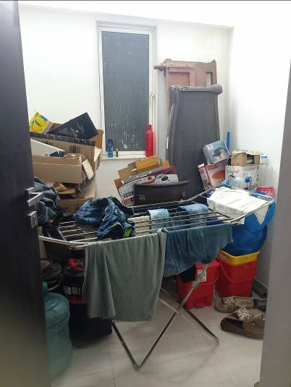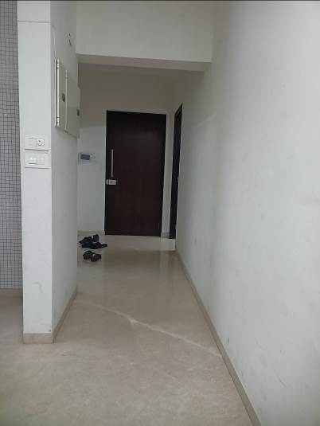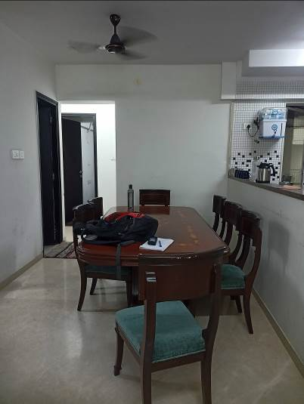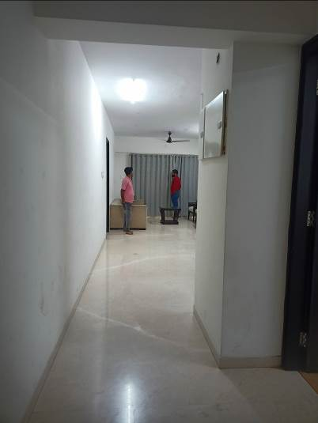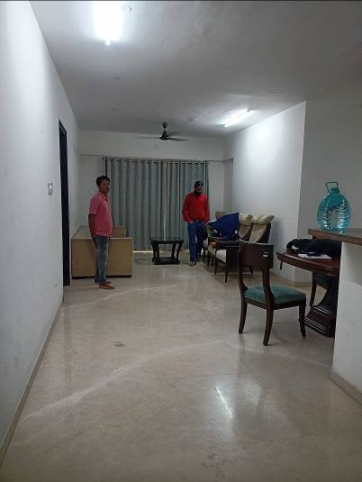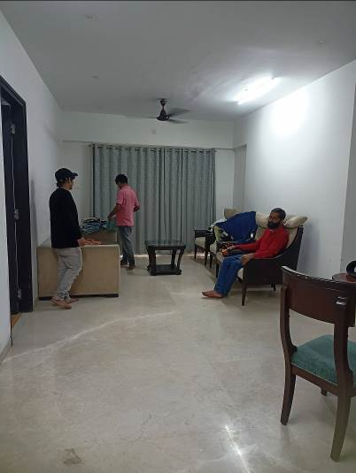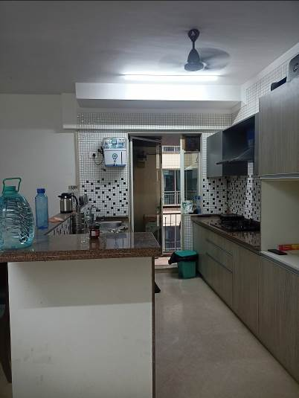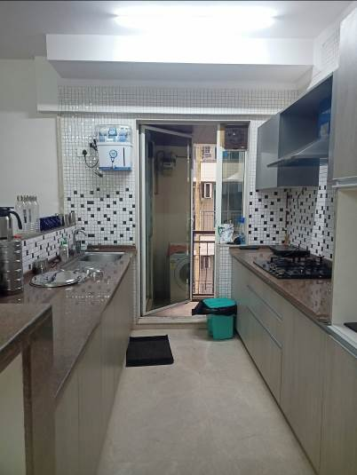 **Actual site photographs (As on 02.09.2024)**

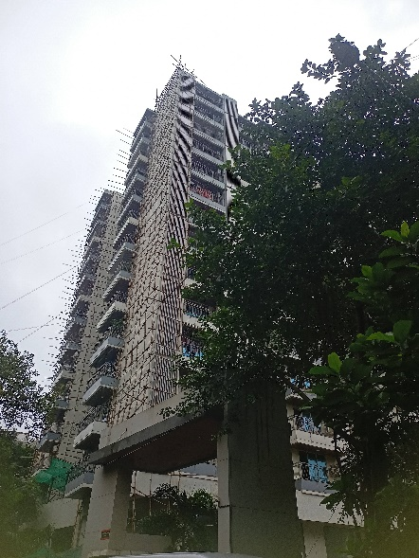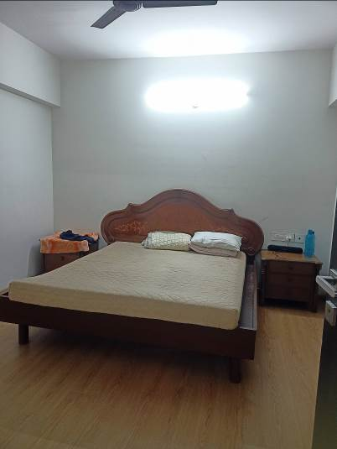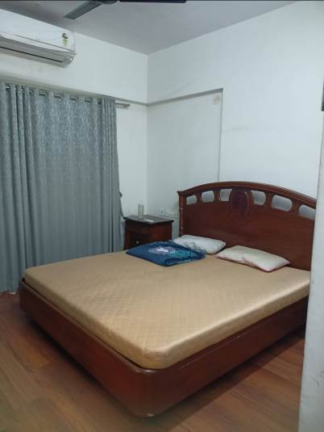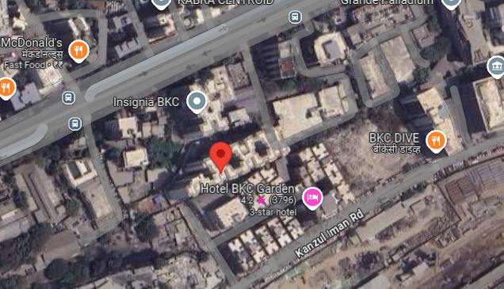**Route Map of the property**

**Site u/r**

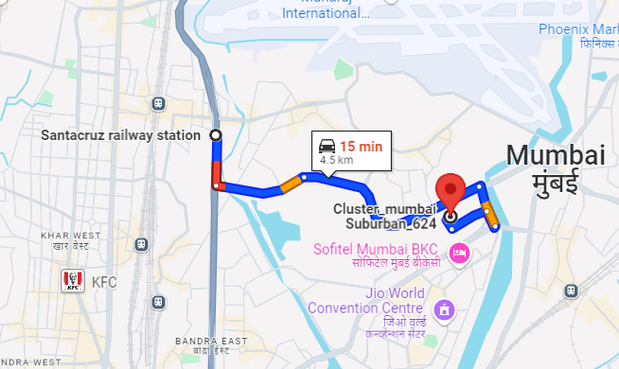

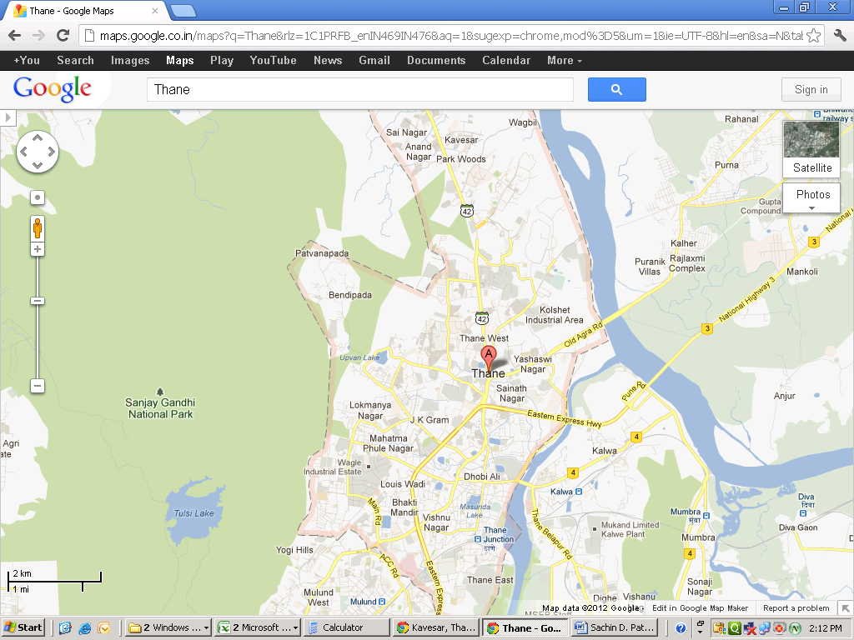



# **Latitude Longitude: 19°04'19.3"N 72°52'05.5"E**

# **Note:** The Blue line shows the route to site from nearest Railway station (Santacruz – 4.5 Km.)

**Ready Reckoner Rate – 2017**

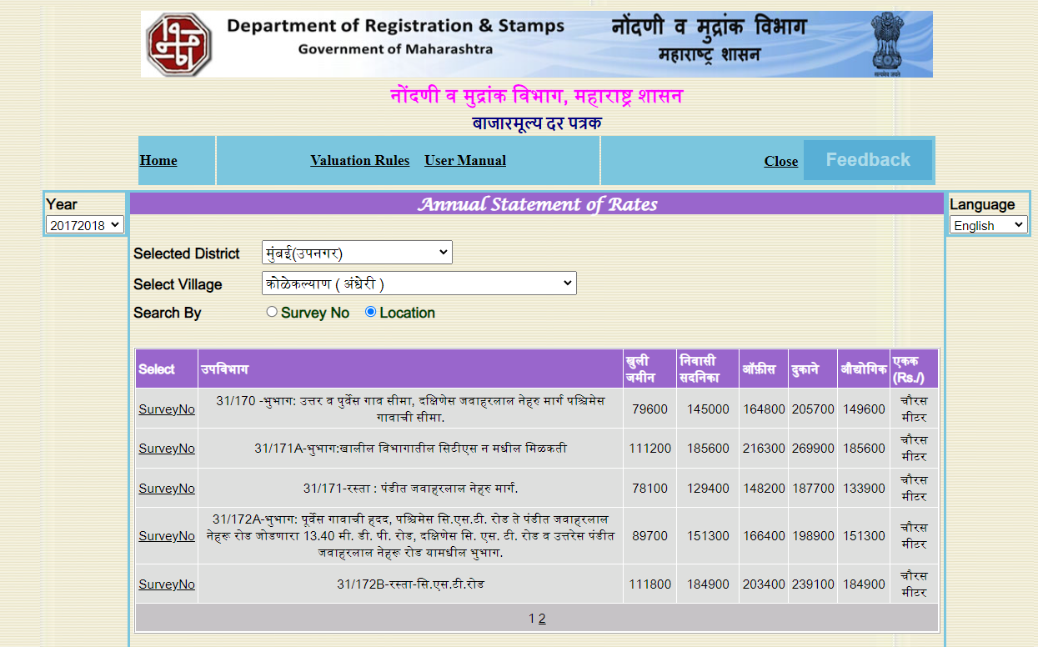

**Sale Instances - Summary**

|  |  |  |  |  |  |  |  |  |
| --- | --- | --- | --- | --- | --- | --- | --- | --- |
| **Sr.** | **Flat No. / Floor /** | **Index II** | **Date** | **Built up area** | **Agreement value (`)** | **Transaction Rate / Sq.Ft. (`)** | **Ready Reckoner / guideline Value**  **(`)** | **RR rate / Sq.Ft.**  **(`)** |
| 1 | 1202, 12th Floor, Wing – C | 354/2017 | 19.01.2017 | 1614.16 | 2,06,64,000.00 | 12,802.00 | 2,75,80,500.00 | 17,087.00 |
| 2 | 203, 2nd Floor, Wing – B | 3532/2017 | 03.05.2017 | 1453.24 | 1,32,70,000.00 | 9,131.00 | 2,62,52,500.00 | 18,065.00 |
| 3 | 1102, 11th Floor, Wing – E | 1818/2017 | 31.03.2017 | 1688.33 | 1,94,15,046.00 | 11,500.00 | 2,94,45,550.00 | 17,441.00 |
| 4 | 1303, 13th Floor, Wing – C | 1819/2017 | 31.03.2017 | 1131.08 | 1,57,28,496.00 | 13,906.00 | 2,01,40,100.00 | 17,806.00 |
| 5 | 204, 2nd Floor, Wing – B | 6445/2017 | 11.09.2017 | 1554.10 | 1,79,94,452.00 | 11,579.00 | 2,73,41,000.00 | 17,593.00 |
| 6 | 1202, 12th Floor, Wing – B | 7099/2017 | 06.10.2017 | 1720.19 | 2,23,76,100.00 | 13,008.00 | 3,32,13,500.00 | 19,308.00 |
| 7 | 1002, 10thFloor, Wing – C | 8459/2017 | 24.11.2017 | 1728.26 | 2,26,07,400.00 | 13,081.00 | 3,25,26,500.00 | 18,820.00 |
| 8 | 1204, 12th Floor, Wing – B | 8463/2017 | 24.11.2017 | 1554.10 | 1,83,90,625.00 | 11,834.00 | 2,93,65,500.00 | 18,896.00 |
| 9 | 402, 4th Floor, Wing – G | 5951/2018 | 11.06.2018 | 1706.43 | 2,95,15,100.00 | 17,296.00 | 3,06,02,200.00 | 17,933.00 |
| 10 | 803,8th Floor, Wing – B | 8499/2018 | 21.08.2018 | 1565.51 | 2,28,92,125.00 | 14,623.00 | 2,95,91,000.00 | 18,902.00 |
| 11 | 304,3rd Floor, Wing – B | 191/2018 | 01.01.2018 | 1554.10 | 2,79,78,125.00 | 18,003.00 | 2,79,86,000.00 | 18,008.00 |
| 12 | 303,3rd Floor, Wing – B | 3533/2017 | 03.05.2017 | 1453.24 | 1,32,70,000.00 | 9,131.00 | 2,62,52,500.00 | 18,065.00 |
| 13 | 1104,11th Floor, Wing – A | 1264/2017 | 23.02.2017 | 1486.50 | 2,55,12,000.00 | 17,162.00 | 2,60,75,500.00 | 17,542.00 |
|  |  |  |  |  | **Average Rate** | **13,312.00** |  |  |
|  | **Most of the transactions in the year 2017-18 are of below Government Ready Reckoner Rates. All the values are inclusive of car parking charges.** | | | | | | | |

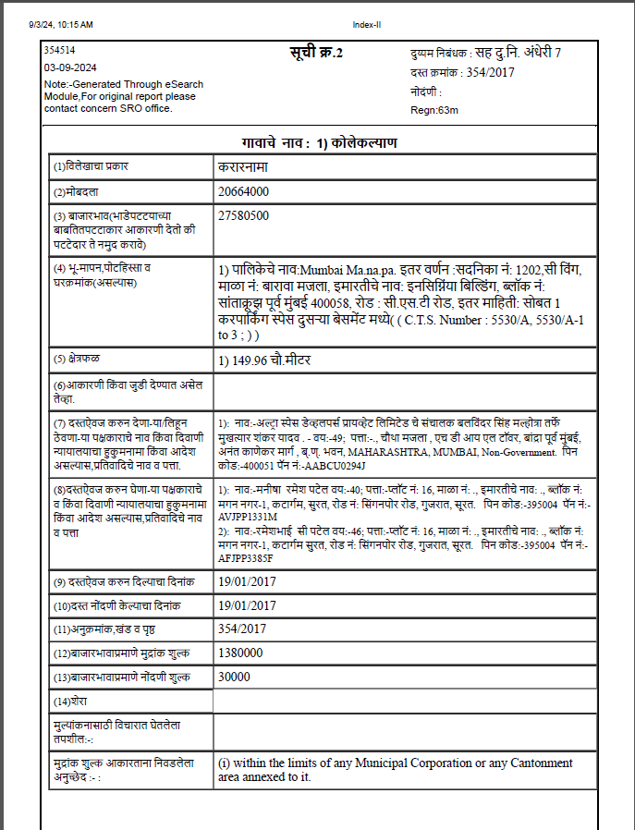**Sale Instance - 1**

**Sale Instance – 2**

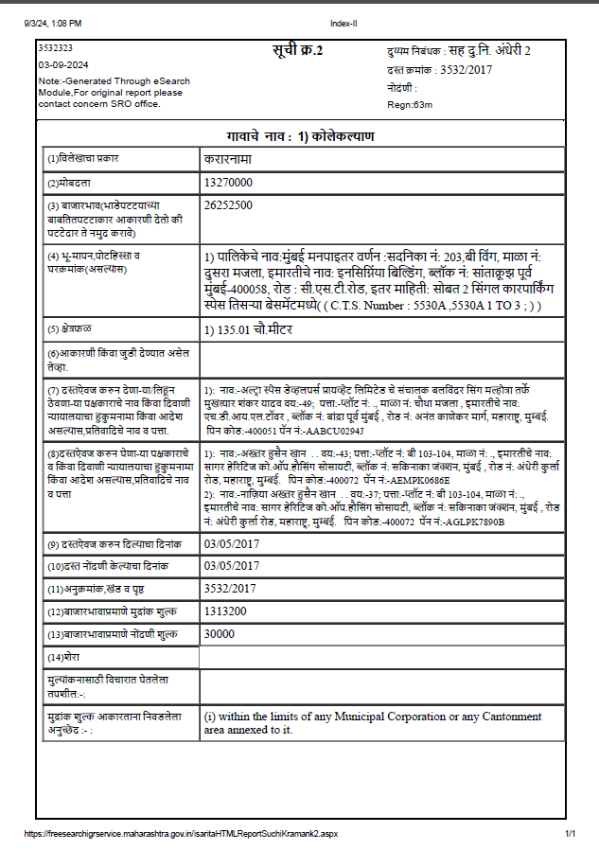

**Sale Instance – 3**

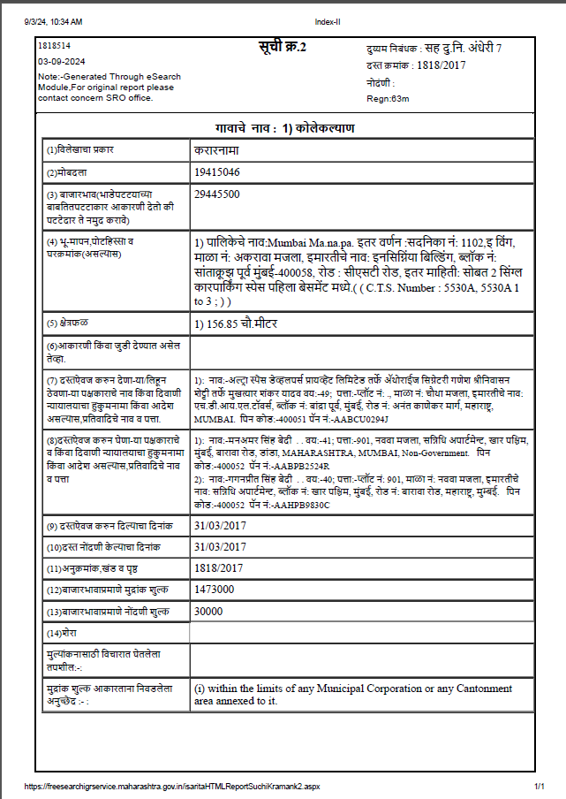

**Sale Instance – 4**

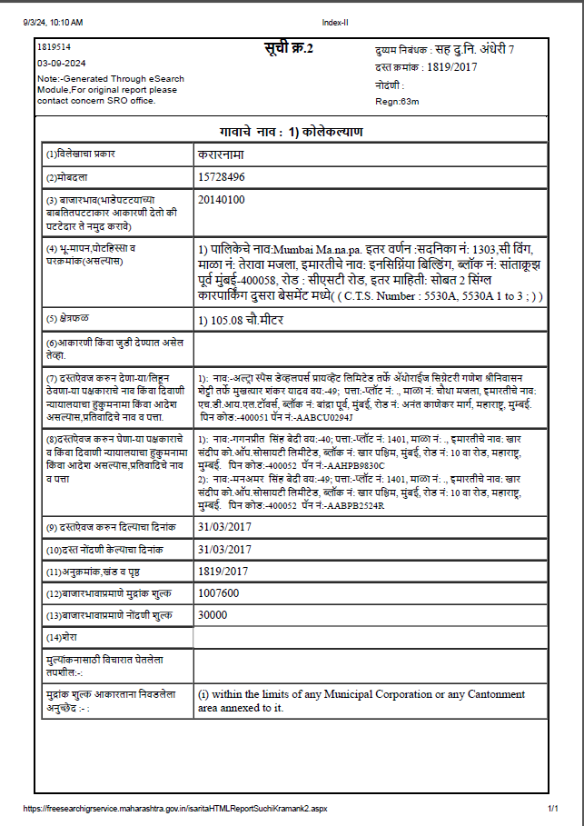

**Sale Instance – 5**

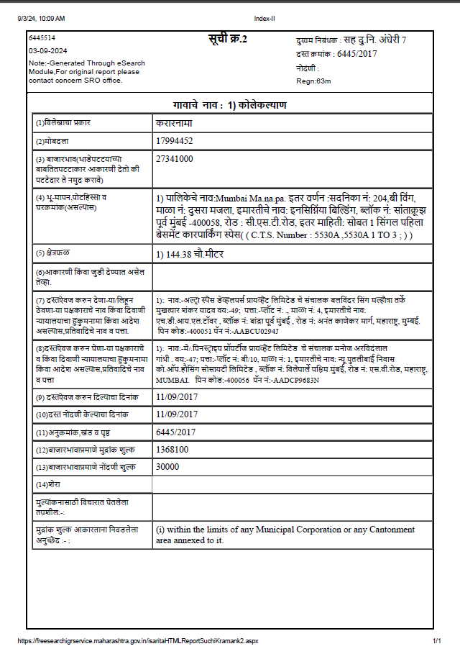**Sale Instance – 6**

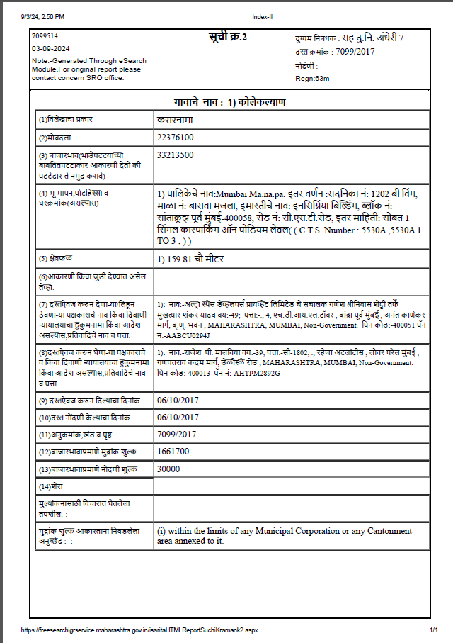

**Sale Insance – 7**

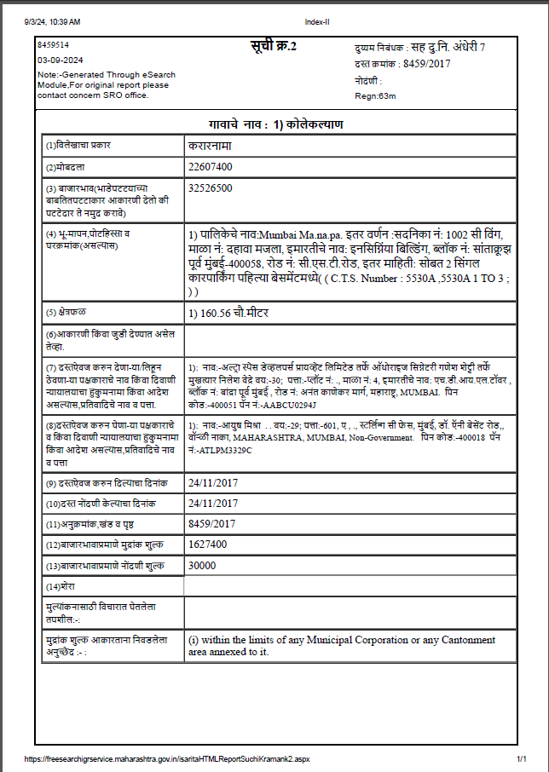

**Sale Instance – 8**

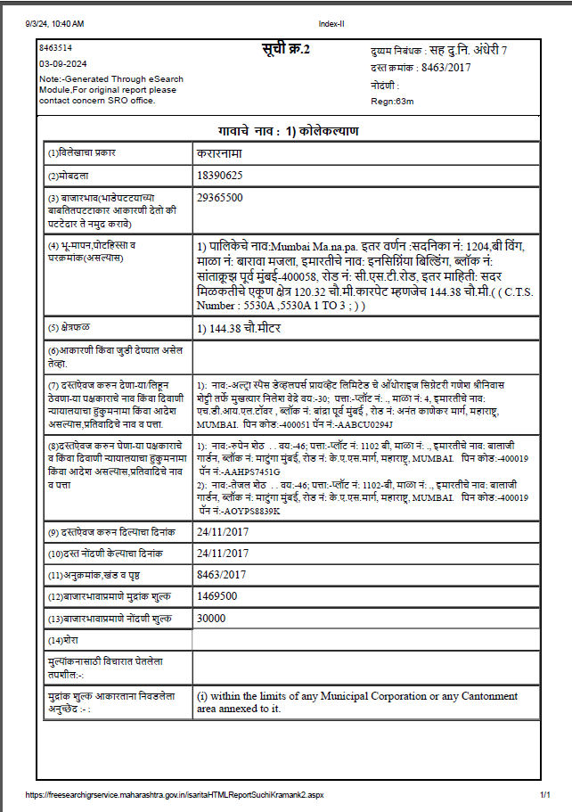

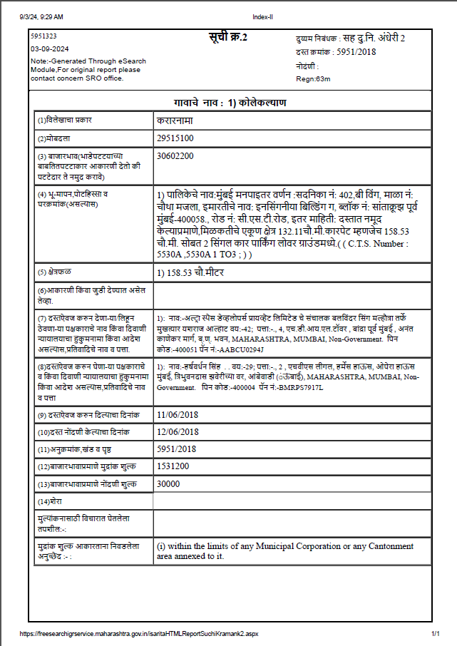**Sale Instance - 9**

**Sale Instance – 10**

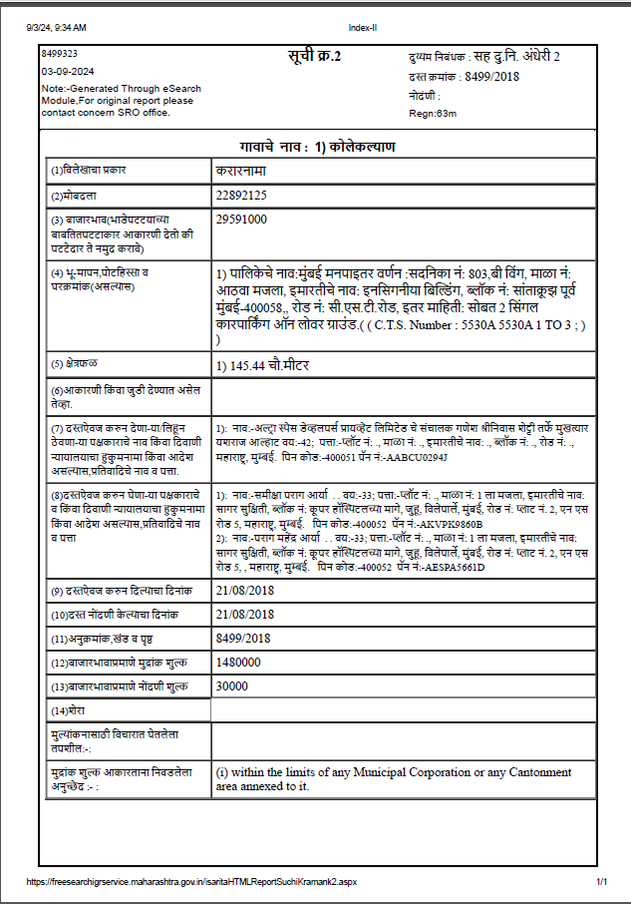

**Sale Instance – 11**

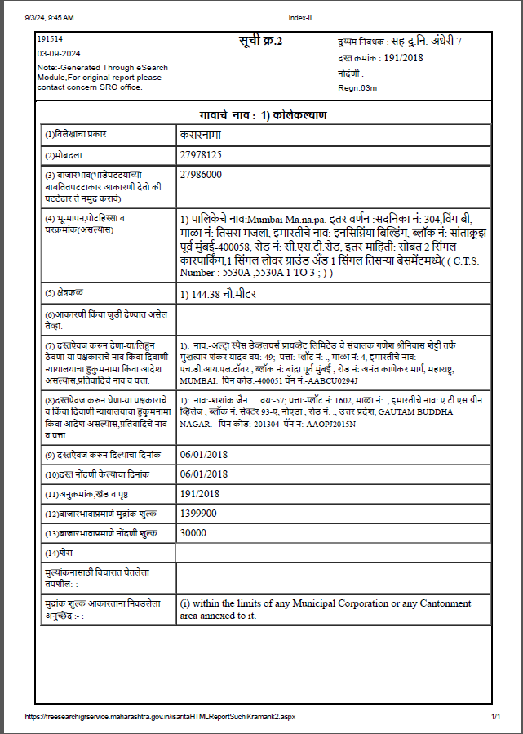

**Sale Instance – 12**

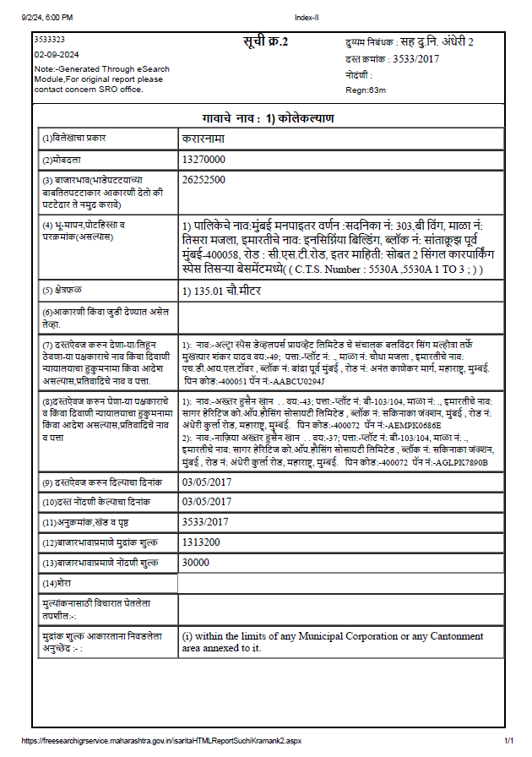**Sale Instance - 13**

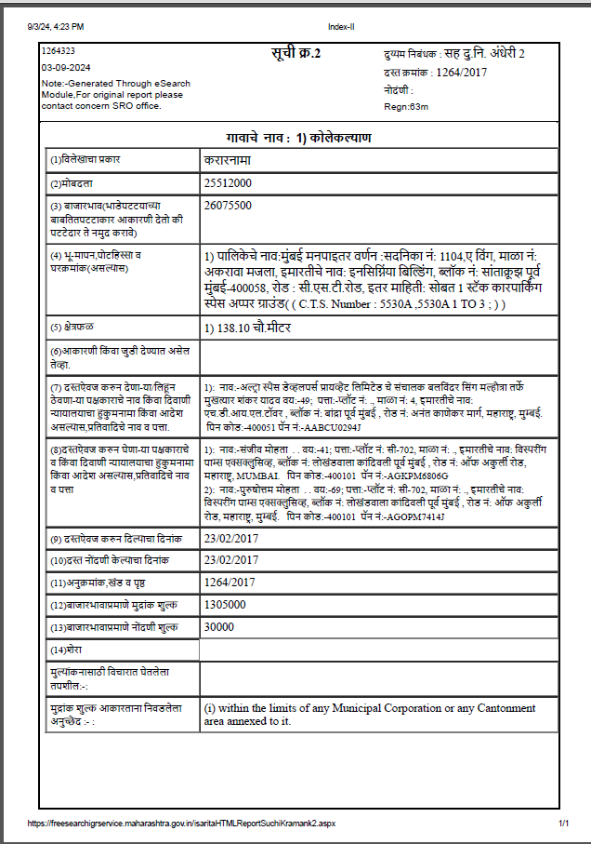

|  |  |  |
| --- | --- | --- |
| **Sr.** | **Particulars** | **Valuer comment** |
|  | Background information of the asset being valued; | The property under consideration is purchased by Mr. Ghanshyam D. Dholakia from M/s. Ultra Space Developers Pvt. Ltd. as per Sale Deed dated 14.12.2017 |
|  | Purpose of valuation and appointing authority | To assess Market value of the property in the year 2017. |
|  | Identity of the valuer and any other experts involved in the valuation; | Sharadkumar B. Chalikwar – Govt. Regd. Valuer  Manoj B. Chalikwar – Regd. Valuer  Bhavika Chavan – Valuation Engineer  Vaishali Sarmalkar – Technical Manager  Vinita Surve – Technical Officer |
|  | Disclosure of valuer interest or conflict, if any; | We have no interest, either direct or indirect, in the property valued. Further to state that we do not have relation or any connection with property owner / applicant directly or indirectly. Further to state that we are an independent Valuer and in no way related to property owner / applicant |
|  | Date of appointment, valuation date and date of  report; | Date of Appointment – 30.08.2024  Valuation Date – 03.09.2024  Date of Report – 03.09.2024 |
|  | Inspections and/or investigations undertaken; | Physical Inspection done on 03.09.2024 |
|  | Nature and sources of the information used or relied upon; | * Market survey at the time of site visit. * Ready Reckoner Rates / Circle Rates * Online search for Registered Transactions * Documents / information provided by client. * Existing data of valuation assignments carried out by us. |
|  | Procedures adopted in carrying out the valuation and valuation standards followed; | Comparable Sales Method / Market Approach |
|  | Restrictions on use of the report, if any; | This valuation is for the use of the party to whom it is addressed and for no other purpose. No responsibility is accepted to any third party who may use or rely on the whole or any part of this valuation. The valuer has no pecuniary interest that would conflict with the proper valuation of the property. |
|  | Major factors that were taken into account during the valuation; | Market conditions as on 2017, delay in construction of the said project due to regulatory changes, demand and supply position, Residential Flat size, location, demand for Residential Flats etc. |
|  | Caveats, limitations and disclaimers to the extent they explain or elucidate the limitations faced by valuer, which shall not be for the purpose of limiting his responsibility for the valuation report. | Attached |

# **Assumptions, Disclaimers, Limitations & Qualifications**

**Value Subject to Change**

The subject appraisal exercise is based on prevailing market dynamics as on **14th December 2017** and does not take into account any unforeseeable developments which could impact the same in the future.

**Our Investigations**

We are not engaged to carry out all possible investigations in relation to the subject property. Where in our report we identify certain limitations to our investigations, this is to enable the reliant party to instruct further investigations where considered appropriate or where we recommend as necessary prior to reliance. Vastukala Consultants India Pvt. Ltd. (VCIPL) is not liable for any loss occasioned by a decision not to conduct further investigations

**Assumptions**

Assumptions are a necessary part of undertaking valuations. VCIPL adopts assumptions for the purpose of providing valuation advise because some matters are not capable of accurate calculations or fall outside the scope of our expertise, or out instructions. The reliant party accepts that the valuation contains certain specific assumptions and acknowledge and accept the risk of that if any of the assumptions adopted in the valuation are incorrect, then this may have an effect on the valuation.

**Information Supplied by Others**

The appraisal is based on the information provided by the client. The same has been assumed to be correct and has been used for appraisal exercise. Where it is stated in the report that another party has supplied information to VCIPL, this information is believed to be reliable but VCIPL can accept no responsibility if this should prove not to be so.

**Future Matters**

To the extent that the valuation includes any statement as to a future matter, that statement is provided as an estimate and/or opinion based on the information known to VCIPL at the date of this document. VCIPL does not warrant that such statements are accurate or correct.

**Map and Plans**

Any sketch, plan or map in this report is included to assist the reader while visualising the property and assume no responsibility in connection with such matters.

**Site Details**

Based on inputs received from Client and site visit conducted, we understand that the subject property is Residential Flat, admeasuring **Built up Area of 1,566.00 Sq. Ft.** in the name of **Mr. Ghanshyam Dhanjibhai Dholakia.** Further, VCIPL has assumed that the subject property is free from any encroachment and is available as on the date of the appraisal.

**Property Title**

Based on our discussion with the Client, we understand that the subject property is owned by **Mr. Ghanshyam Dhanjibhai Dholakia.** For the purpose of this appraisal exercise, we have assumed that the subject property has a clear title and is free from any encumbrances, disputes and claims. VCIPL has made no further enquiries with the relevant local authorities in this regard and does not certify the property as having a clear and marketable title. Further, no legal advice regarding the title and ownership of the subject property has been obtained for the purpose of this appraisal exercise. It has been assumed that the title deeds are clear and marketable.

**Environmental Conditions**

We have assumed that the subject property is not contaminated and is not adversely affected by any existing or proposed environmental law and any processes which are carried out on the property are regulated by environmental legislation and are properly licensed by the appropriate authorities.

**Area**

Based on the information provided by the Client, we understand that the Residential Flat, admeasuring **Built up Area of 1,566.00 Sq. Ft.**

**Condition & Repair**

In the absence of any information to the contrary, we have assumed that there are no abnormal ground conditions, nor archaeological remains present which might adversely affect the current or future occupation, development or value of the property. The property is free from rat, infestation, structural or latent defect. No currently known deleterious or hazardous materials or suspect techniques will be used in the construction of or subsequent alteration or additions to the property and comments made in the property details do not purport to express an opinion about, or advise upon, the condition of uninspected parts and should not be taken as making an implied representation or statement about such parts

**Valuation Methodology**

For the purpose of this valuation exercise, the valuation methodology used is Direct Comparison Approach / Method and proposed Current use / Existing use premise is considered for this assignment.

The Direct Comparison Approach involves a comparison of the property being valued to similar properties that have actually been sold in arms - length transactions or are offered for sale. This approach demonstrates what buyers have historically been willing to pay (and sellers willing to accept) for similar properties in an open and competitive market and is particularly useful in estimating the value of the Flat and properties that are typically traded on a unit basis.

In case of inadequate recent transaction activity in the subject micro-market, the appraiser would collate details of older transactions. Subsequently, the appraiser would analyse rental / capital value trends in the subject micro-market in order to calculate the percentage increase / decrease in values since the date of the identified transactions. This percentage would then be adopted to project the current value of the same.

Where reliance has been placed upon external sources of information in applying the valuation methodologies, unless otherwise specifically instructed by Client and/or stated in the valuation, VCIPL has not independently verified that information and VCIPL does not advise nor accept it as reliable. The person or entity to whom the report is addressed acknowledges and accepts the risk that if any of the unverified information in the valuation is incorrect, then this may have an effect on the valuation.

**Not a Structural Survey**

We state that this is a valuation report and not a structural survey

**Other**

All measurements, areas and ages quoted in our report are approximate

**Legal**

We have not made any allowances with respect to any existing or proposed local legislation relating to taxation on realization of the sale value of the subject property. VCIPL is not required to give testimony or to appear in court by reason of this appraisal report, with reference to the property in question, unless arrangement has been made thereof. Further, no legal advice on any aspects has been obtained for the purpose of this appraisal exercise

**Property specific assumptions**

Based on inputs received from the client and site visit conducted, we understand that the subject property is Residential Flat, admeasuring **Built up Area of 1,566.00 Sq. Ft.**

**ASSUMPTIONS, CAVEATS, LIMITATION AND DISCLAIMERS**

1. We assume no responsibility for matters of legal nature affecting the property appraised or the title thereto, nor do we render our opinion as to the title, which is assumed to be good and marketable.

2. The property is valued as though under responsible ownership.

3. It is assumed that the property is free of liens and encumbrances.

4. It is assumed that there are no hidden or unapparent conditions of the subsoil or structure that would render it more or less valuable. No responsibility is assumed for such conditions or for engineering that might be required to discover such factors.

5. There is no direct/ indirect interest in the property valued.

6. The rates for valuation of the property are in accordance with the Govt. approved rates.

**Sharadkumar B. Chalikwar**

Govt. Reg. Valuer

Chartered Engineer (India)

Reg. No. (N) CCIT/1-14/52/2008-09