4th LENDER’S INDEPENDENT ENGINEER REPORT

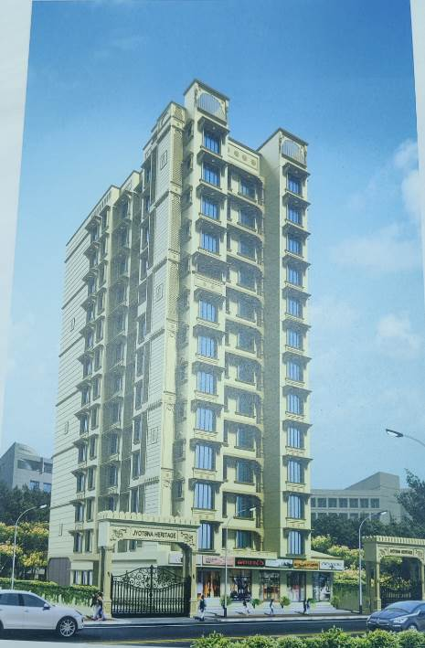

**Details of the property under consideration:**

**Name of Project: Jysotna Heritage**

**"Jysotna Hertiage", Proposed Redevelopment of building name “The Dahisar R. K. Nayak Niwasi CHS Ltd.”, on Plot bearing C.T.S. No. 1069, R/ N Ward, Maratha Colony Road, Opp. Movie Time Cinema, Village – Dahisar, Dahisar (East), Mumbai – 400 068, State – Maharashtra, Country – India**

**Latitude Longitude: 19°15'04.7"N 72°51'47.1"E**

Intended User:

State Bank of India

SME Chembur Branch

Unit No. 11, Building No. 11, Ground Floor, Corporate Park, Sion Trombay Road,

Chembur, Mumbai, Pin Code – 400 071, State - Maharashtra, Country – India

Vastu/SBI/Mumbai/08/2024/10984/2307983

31/20-461-PY

Date: - 31.08.2024

FOURTH LENDER’S INDEPENDENT ENGINEER REPORT

**To,**

**State Bank of India**

Unit No. 11, Building No. 11, Ground Floor,

Corporate Park, Sion Trombay Road, Chembur,

Mumbai, Pin Code – 400 071,

State - Maharashtra, Country – India.

Subject: Construction of Proposed Redevelopment of building name “The Dahisar R. K. Nayak Niwasi CHS Ltd.”, on Plot bearing C.T.S. No. 1069, R/ N Ward, Maratha Colony Road, Opp. Movie Time Cinema, Village – Dahisar, Dahisar (East), Mumbai – 400 068, State – Maharashtra, Country – India

**Ref:** You’re Request for Lender’s Independent Engineer Report of under Construction Building.

**Dear Sir,**

**The Construction work as per approved plan was in progress during the site visit on 10th July 2024. Total expenditure occurred as on 30/06/2024 on this project by M/s. Shree Sainamah Homes LLP is ` 21.95 Cr. & as per CA Certificate actual total expenditure occurred as on 30/06/2024 is ` 21.24 Cr.**

**DECLARATION**

1. The information furnished in the report is based on our 4th site visit Dated 10/07/2024 & Document Provided by Client.
2. Vastukala 3rd LIE Report of the project dated 09.05.2024.
3. I have no direct and indirect interest in the property examined for report.
4. I have not been found guilty of misconduct in my professional capacity.

**Manoj B. Chalikwar**

Registered Valuer

Chartered Engineer (India)

Reg. No. IBBI/RV/07/2018/10366

Encl.: LIE report

# Purpose & Methodology

• State Bank of India Banks and financial institutions require monitoring & an independent review of the progress of the sanctioned projects

**VCIPL** undertakes such study to independently review the progress of the project and put forward a comprehensive analysis

# Advantages:

* Assurance on present practices
* Identification of risk
* Analyzing the performance of third parties
* Recommendations

# The Methodology

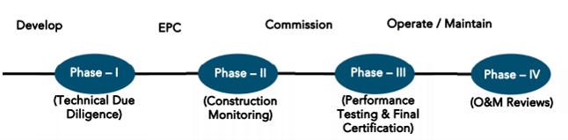

**FOURTH LENDER’S INDEPENDENT ENGINEER REPORT**

**OF**

**"JYSOTNA HERITAGE"**

**"Jysotna Hertiage",** Proposed Redevelopment of building name “The Dahisar R. K. Nayak Niwasi CHS Ltd.”, on Plot bearing C.T.S. No. 1069, R/ N Ward, Maratha Colony Road, Opp. Movie Time Cinema, Village – Dahisar, Dahisar (East), Mumbai – 400 068, State – Maharashtra, Country – India.

**Latitude Longitude: 19°15'04.7"N 72°51'47.1"E**

**NAME OF DEVELOPER: M/s. Shree Sainamah Homes LLP**

|  |
| --- |
| Pursuant to instructions from State of India, SME Chembur Branch, Chembur we have duly visited, inspected, surveyed & assessed the above said property on **10th July 2024** to determine the fair & reasonable market value of the said property/project as on Quarter ending **30th June 2024** for LIE purpose.  **1. Location Details:**  Proposed Redevelopment of building name “The Dahisar R. K. Nayak Niwasi CHS Ltd.”, on Plot bearing C.T.S. No. 1069, R/ N Ward, Maratha Colony Road, Opp. Movie Time Cinema, Village – Dahisar, Dahisar (East), Mumbai – 400 068. It is about 600 M. travelling distance from Dahisar (East) Railway station. Surface transport to the property is by buses, taxis & private vehicles. The property is in developed locality. All the amenities like shops, banks, hotels, markets, schools, hospitals, etc. are all available in the surrounding locality. The area is higher middle class & developed. |

**2. Developer Details:**

|  |  |
| --- | --- |
| **Name of builder** | **M/s. Shree Sainamah Homes LLP** |
| **Project Rera Registration Number** | **P51800047220** |
| **Registered office address** | Office No.1, 1st Floor, Sun Moon CHS Ltd, Bldg. No.13 Rajendra Nagar, Dattapada Road, Borivali (East) Mumbai, Pin Code – 400 066, State - Maharashtra, Country – India |
| **Contact details** | **Contact Person:**  Mr. Shailesh Ingale (Site Engineer)  Mb. No. 7709000769  Mr. Dipesh Mahyavanshi (Accountant)  Mb. No. 8830313144  Mr. Kailash Sinari (Consultants)  Mb. No. 9820950342 |
| **E – mail ID and website** |  |

**3. Boundaries of the Property:**

|  |  |
| --- | --- |
| **Direction** | **Particulars** |
| **On or towards North** | Maratha Colony Road |
| **On or towards South** | Sanjivani Hospital and Sai Mandir |
| **On or towards East** | Amit Apartment |
| **On or towards West** | Open Plot |

# Introduction

**As per Information on site M/s. Shree Sainamah Homes LLP** has acquired land by Developer Agreement dated 16.02.2022 registered vide No. BRl-3-1904-2022 dated 16.02.2022 admeasuring **area 1,056.70 Sq. M.** bearing **CTS No. 1069.** For the Proposed Residential Building.

# Area Statement:

# Land:

|  |  |  |
| --- | --- | --- |
| **Date** | **Particular** | **Area in Sq. M.** |
| 16.02.2022 | CTS No. 1069 | 1,056.70 |
| TOTAL | | 1,056.70 |

1. Copy of Development Agreement dated 16.02.2022 between M/s. The Dahisar R. K. Nayak Niwasi Co-operative Housing Society Limited (The Society) and M/s. Shree Sainamah Homes LLP (The Developer) registered vide No. BRl-3-1904-2022 dated 16.02.2022.
2. Copy of Power of Attorney Agreement dated 16.02.2022 M/s. The Dahisar R. K. Nayak Niwasi Co-operative Housing Society Limited (The First Party) and M/s. Shree Sainamah Homes LLP (The Second Party) registered vide No. BRL-3-1904-2022 dated 16.02.2022.

# Building Area As per Approved Plan:

| **A** | **Area Statement** | | | | **Sq. M.** |
| --- | --- | --- | --- | --- | --- |
| **1** | Area of Plot (As Per P.R.C.) | | | | 1056.7 |
| Plot area not in possession | | | | 97.78 |
| a) | Area of reservation in plot | | | NIL |
| b) | Area of road set back in plot | | | 90.75 |
| c) | Area of D.P. Road in plot | | | NIL |
| **2A** | Deduction for Reservation / Road Area | | | |  |
| a) | Road set back Area to be Handed over to M.C.G.M. as per Reg. No. 16 of D.C.P.R. 2034 | | | 90.75 |
| b) | Proposed D. P. Road to be handed over to M.C.G.M. as per Reg. No. 16 of D.C.P.R. 2034 | | | NIL |
| c) | Reservation Area to be handed over to M.C.G.M. as per Reg. No. 17 of D.C.P.R. 2034 | | | NIL |
| d) | Reservation Area to be handed over to M.C.G.M. as per Reg. No. 17 of D.C.P.R. 2034 under accommodation reservation | | | NIL |
| **2B** | Deduction for Amenity Area | | | |  |
| a) | Area of amenity plot to be handed over to M.C.G.M as per Reg. No. 14(A) of D.C.P.R. 2034 | | | NIL |
| b) | Area of amenity plot to be handed over to M.C.G.M as per Reg. No. 14(B) of D.C.P.R. 2034 | | | NIL |
| c) | Area of amenity plot to be handed over to M.C.G.M as per Reg. No. 35 of D.C.P.R. 2034 | | | NIL |
| **2C** | Deduction for existing built-up area to be retained / land component of existing built-up area | | | | NIL |
| **3** | Total Deduction (1A+2A+2B+2C) (97.78+90.75) | | | | 188.53 |
| **4** | Balance Area of Plot (1-3) | | | | 868.17 |
| **5** | Plot area under development (1-3) | | | | 868.17 |
| **6** | Zonal (Basic) FSI as per Reg. No. 30A, Table No.12, of M.C.G.M. | | | | 1 |
| **7** | Built up Area as per zonal (Basic) F.S.I (5×6) | | | | 1 |
| **8** | Built-up Area Equal to road setback already handed over to M.C.G.M and advantage granted earlier in past | | | | NIL |
| **9** | Additional F.S.I for redevelopment existing residential housing society as per Reg. No. 33(7)(B) of D.C.P.R. 2034 (Total Tenants 18×10 = 180.00 Sq. M.) | | | | 180 |
| **10** | Built up Area due to 50% additional F.S.I. on payment of premium as per Reg. No. 30(A), Table No. 12 of D.C.P.R. 2034 (868.17 × 0.50 = 434.08) | | | |  |
|  | Already Claimed | Now Claimed | Total |  |
|  | 434.08 | 0 | 434.08 | 434.08 |
| **11** | a) | Built up Area due to admissible T.D.R i.e., Road set back benefit in T.D.R. component only (90.75 × 2 = 181.50) | | | 181.5 |
| **12** | Permissible Built-up Area (7+8+9+10+11a) | | | | 2091.47 |
| **12A** | Permissible Built-up Area | | | | 2090.53 |
| **13** | Proposed Built up Area | | | | 1663.74 |
| **14** | T.D.R. generated as per Reg. No. 30(A) & Reg. No. 32 of D.C.P.R. 2034 | | | | NIL |
| **15** | Fungible Compensatory area as per Reg. No. (31)3 of D.C.P.R. 2034 | | | |  |
| a | Permissible fungible compensatory area for RESI + COM. rehab component without charging premium | | | ------ |
|  | Already Claimed | Now Claimed | Total | 315.93 |
| RES | 273.42 | 0 | 273.42 |
| COM | 42.51 | 0 | 42.51 |
| b | Permissible fungible compensatory area for RESI + COM. rehab component without charging premium | | |  |
|  | Already Claimed | Now Claimed | Total | 315.93 |
| RES | 273.42 | 0 | 273.42 |
| COM | 42.51 | 0 | 42.51 |
| C | Permissible fungible compensatory area for sale component with charging premium 567.07 - 315.93 | | |  |
|  | Already Claimed | Now Claimed | Total | 415.76 |
| RES | 273.42 | 163.31 | 400.96 |
| COM | 14.44 | 0.36 | 14.80 |
|  | Total Proposed Fungible compensatory area 15b + 15c | | | | 731.69 |
| **16** | Total Built up Area proposed including fungible compensatory area (13 + 15b + 15c) | | | | 2822.22 |
| **17** | F.S.I. Consume 13/4 | | | | 2.40 |
| **(II)** | **Other Requirements** | | | |  |
| **A** | Reservation / Designation | | | |  |
| a | Name of Reservation | | | NIL |
| b | Name of Reservation Affecting the plot | | | NIL |
| c | Area of reservation land to be handed over to M.C.G.M as per Reg. No. 17 of D.C.P.R. 2034 | | | NIL |
| d | Built up Area of amenity to be handed over to M.C.G.M. as per Reg. No. 17 of D.C.P.R. 2034 | | | NIL |
| e | Built up Area of designation | | | NIL |
| **B** | Plot Area / built up Amenity to be handed over to M.C.G.M | | | | NIL |
| a | As per Reg. No. 14(A) of D.C.P.R. 2034 | | | NIL |
| b | As per Reg. No. 14(B) of D.C.P.R. 2034 | | | NIL |
| c | As per Reg. No. 15 of D.C.P.R. 2034 | | | NIL |
| **C** | Requirement of Recreational open space in layout / Plot as per Reg. No. 27 of D.C.P.R. 2034 | | | |  |
| **D** | **Tenement Statement** | | | |  |
| a | Proposed Built Up Area | | | 2822.22 |
| b | Less Deduction of Non-Residential Area (Shop ETC.) | | | 221.04 |
| c | Area Available for Tenements | | | 2601.18 |
| d | Tenements Permissible (450 / Hector) | | | 117 Nos. |
| e | Tenements Proposed | | | 51 Nos. |
| f | Existing Tenants | | |  |
| g | Total Number of Tenements Proposed on the Plot | | | 29 Nos. |
| **E** | **Parking Statement As per Reg. 44 of DCPR 2034** | | | |  |
|  | a | Parking required for Cars | | | 21.00 Nos. |
| b | Parking required for Scooter / Motors | | |  |
| c | Parking required for outsiders (Visitors) | | |  |
| d | Covered Garage Permissible | | |  |
| e | Additional Parking 50% | | | 05 Nos. |
| f | Parking Proposed for Cars | | |  |
| g | Parking Proposed for Scooter / Motors Cycle | | | 04 Nos. |
| h | Parking Proposed for outsiders (Visitors) | | |
| i | Total Parking Provided | | | 38 Nos. |
| **F** | **Transport Vehicles Parking** | | | |  |
|  | a | Required Number of Parking Spaces for Transport Vehicles | | | N. A |
|  | b | Total Number of Parking Spaces for Transport vehicle Provided | | | N. A |

# List of Approvals:

1. Copy of Approved Plan No. P-9914/2021/(1069)/R/N Ward/Dahisar R/N/337/1/New dated 11.05.2022 issued by Municipal Corporation of Greater Mumbai

**Approved upto: Basement (Part) + Ground Floor + 1st to 10th Upper Residential Floor + Parking Tower**

1. Copy of 1st Amended Approved Plan No. P-9914/2021/(1069)/R/N Ward/Dahisar R/N/337/1/New dated 12.08.2022 issued by Municipal Corporation of Greater Mumbai

**Approved upto: Basement (Part) + Ground Floor + 1st to 10th Upper Residential Floor + Parking Tower**

1. Copy of 2nd Amended Approved Plan No. P-9914/2021/(1069)/R/N Ward/Dahisar R/N/337/1/New dated 10.08.2023 issued by Municipal Corporation of Greater Mumbai

**Approved upto: Basement (Part) + Ground Floor + 1st to 13th Upper Residential Floor + Parking Tower**

1. Copy of 1st Commencement Certificate No. P-9914/2021/(1069)/R/N Ward/Dahisar/R/N/CC/1/New dated 18.07.2022 valid upto 17.07.2023 issued by Municipal Corporation of Greater Mumbai.

**(This CC is endorsed for the work upto plinth level as per aprroved plan dated 11.05.2022)**

1. Copy of 2nd Commencement Certificate No. P-9914/2021/(1069)/R/N Ward/Dahisar/R/N/FCC/3/Amend dated 29.08.2022 valid upto 28.08.2023 issued by Municipal Corporation of Greater Mumbai.

**(This CC is endorsed for the work upto plinth level as per aprroved plan dated 12.08.2022)**

1. Copy of 3rd Commencement Certificate No. P-9914/2021/(1069)/R/N Ward/Dahisar/R/N/FCC/4/Amend dated 26.12.2022 valid upto 25.12.2023 issued by Municipal Corporation of Greater Mumbai.

**(This CC is endorsed for the work for Basement (Part) + Ground Floor + 1st to 8th Upper Floor + Parking Tower)**

1. Copy of 4th Commencement Certificate No. P-9914/2021/(1069)/R/N Ward/Dahisar/R/N/FCC/5/Amend dated 24.07.2023 valid upto 17.04.2024 issued by Municipal Corporation of Greater Mumbai.

**(This CC is endorsed for the work for Basement (Part) + Ground Floor + 1st to 9th Upper Floor + LMR/OHT + Parking Tower as per approved amended plan dated 12.08.2022)**

1. Copy of 5th Commencement Certificate No. P-9914/2021/(1069)/R/N Ward/Dahisar/R/N/FCC/6/Amend dated 18.08.2023 valid upto 17.08.2024 issued by Municipal Corporation of Greater Mumbai.

**(This CC is endorsed for the work for Basement (Part) + Ground Floor + 1st to 12th Upper Floor + LMR/OHT + Parking Tower as per approved amended plan dated 10.08.2023)**

1. Copy of 6th Commencement Certificate No. P-9914/2021/(1069)/R/N Ward/Dahisar/R/N/FCC/7/Amend dated 20.09.2023 valid upto 17.07.2024 issued by Municipal Corporation of Greater Mumbai.

**(This CC is endorsed for the work for Basement (Part) + Ground Floor + 1st to 13th Upper Floor + LMR/OHT + Parking Tower as per approved amended plan dated 10.08.2023)**

# LEVEL OF COMPLETION:

# Rehab cum Sales Building (Wing A & B)

| Sr. No | Floor No. | Construction Area in Sq. M. | Completed Area in Sq. M. | Work Completion 3rd Report as on 04.01.2024 | Work Completion as on 10.07.2024 |
| --- | --- | --- | --- | --- | --- |
| 1 | Excavation & Shore Piling | | | Work is completed | Work is completed |
| 2 | Basement | 51.85 | 51.85 | Slab Work. Blockwork, Internal Plaster work, Electric work, Sanitary work, Door & Window frames are Completed. | Slab Work. Blockwork, Internal Plaster work, Electric work, Sanitary work, Door & Window frames, Waterproofing are Completed. Door Installation, fire fighting & Lift work is in progress. |
| 3 | Ground Floor | 246.44 | 246.44 | Slab Work. Blockwork, Internal Plaster work, Electric work, Sanitary work, Door & Window frames are Completed. | Slab Work. Blockwork, Internal Plaster work, Electric work, Sanitary work, Door & Window frames, Waterproofing are Completed. Door Installation, fire fighting & Lift work is in progress. |
| 4 | 1st Floor | 241.65 | 241.65 | Slab Work. Blockwork, Internal Plaster work, Electric work, Sanitary work, Door & Window frames are Completed. Flooring, Kitchen & Toilet Tiling work and Gypsum plaster work is in progress. | Slab Work. Blockwork, Internal Plaster work, Electric work, Sanitary work, Door & Window frames Flooring, Grill Work, Kitchen Platform, Waterproofing are Completed. Door Installation, fire fighting & Lift work is in progress. |
| 5 | 2nd Floor | 241.65 | 241.65 | Slab Work. Blockwork, Internal Plaster work, Electric work, Sanitary work, Door & Window frames are Completed. Flooring, Kitchen & Toilet Tiling work and Gypsum plaster work is in progress. | Slab Work. Blockwork, Internal Plaster work, Electric work, Sanitary work, Door & Window frames Flooring, Grill Work, Kitchen Platform, Waterproofing are Completed. Door Installation, fire fighting & Lift work is in progress. |
| 6 | 3rd Floor | 241.65 | 241.65 | Slab Work. Blockwork, Internal Plaster work, Electric work, Sanitary work, Door & Window frames are Completed. Flooring, Kitchen & Toilet Tiling work and Gypsum plaster work is in progress. | Slab Work. Blockwork, Internal Plaster work, Electric work, Sanitary work, Door & Window frames Flooring, Grill Work, Kitchen Platform, Waterproofing are Completed. Door Installation, fire fighting & Lift work is in progress. |
| 7 | 4th Floor | 241.65 | 241.65 | Slab Work. Blockwork, Internal Plaster work, Electric work, Sanitary work, Door & Window frames are Completed. Flooring, Kitchen & Toilet Tiling work and Gypsum plaster work is in progress. | Slab Work. Blockwork, Internal Plaster work, Electric work, Sanitary work, Door & Window frames Flooring, Grill Work, Kitchen Platform, Waterproofing are Completed. Door Installation, fire fighting & Lift work is in progress. |
| 8 | 5th Floor | 241.65 | 241.65 | Slab Work. Blockwork, Internal Plaster work, Electric work, Sanitary work, Door & Window frames are Completed. Flooring, Kitchen & Toilet Tiling work and Gypsum plaster work is in progress. | Slab Work. Blockwork, Internal Plaster work, Electric work, Sanitary work, Door & Window frames Flooring, Grill Work, Kitchen Platform, Waterproofing are Completed. Door Installation, fire fighting & Lift work is in progress. |
| 9 | 6th Floor | 241.65 | 241.65 | Slab Work. Blockwork, Internal Plaster work, Electric work, Sanitary work, Door & Window frames are Completed. Flooring, Kitchen & Toilet Tiling work and Gypsum plaster work is in progress. | Slab Work. Blockwork, Internal Plaster work, Electric work, Sanitary work, Door & Window frames Flooring, Grill Work, Kitchen Platform, Waterproofing are Completed. Door Installation & Lift work is in progress. |
| 10 | 7th Floor | 241.65 | 241.65 | Slab Work. Blockwork, Internal Plaster work, Electric work, Sanitary work, Door & Window frames are Completed. Flooring, Kitchen & Toilet Tiling work and Gypsum plaster work is in progress. | Slab Work. Blockwork, Internal Plaster work, Electric work, Sanitary work, Door & Window frames Flooring, Grill Work, Kitchen Platform, Waterproofing are Completed. Door Installation, fire fighting & Lift work is in progress. |
| 11 | 8th Floor | 241.65 | 241.65 | Slab Work. Blockwork, Internal Plaster work, Electric work, Sanitary work, Door & Window frames are Completed. Flooring, Kitchen & Toilet Tiling work and Gypsum plaster work is in progress. | Slab Work. Blockwork, Internal Plaster work, Electric work, Sanitary work, Door & Window frames Flooring, Grill Work, Kitchen Platform, Waterproofing are Completed. Door Installation, fire fighting & Lift work is in progress. |
| 12 | 9th Floor | 241.65 | 241.65 | Slab Work. Blockwork, Internal Plaster work, Electric work, Sanitary work, Door & Window frames are Completed. Flooring, Kitchen & Toilet Tiling work and Gypsum plaster work is in progress. | Slab Work. Blockwork, Internal Plaster work, Electric work, Sanitary work, Door & Window frames Flooring, Grill Work, Kitchen Platform, Waterproofing are Completed. Door Installation, fire fighting & Lift work is in progress. |
| 13 | 10th Floor | 241.65 | 241.65 | Slab Work. Blockwork, Internal Plaster work, Electric work, Sanitary work, Door & Window frames are Completed. Flooring, Kitchen & Toilet Tiling work and Gypsum plaster work is in progress. | Slab Work. Blockwork, Internal Plaster work, Electric work, Sanitary work, Door & Window frames Flooring, Grill Work, Kitchen Platform, Waterproofing are Completed. Door Installation, fire fighting & Lift work is in progress. |
| 14 | 11th Floor | 241.65 | 241.65 | Slab Work. Blockwork, Internal Plaster work, Electric work, Sanitary work, Door & Window frames are Completed. Kitchen & Toilet Tiling work and Gypsum plaster work is in progress. | Slab Work. Blockwork, Internal Plaster work, Electric work, Sanitary work, Door & Window frames Flooring, Grill Work, Kitchen Platform, Waterproofing are Completed. Door Installation, fire fighting & Lift work is in progress. |
| 15 | 12th Floor | 241.65 | 241.65 | Slab Work. Blockwork, Internal Plaster work, Electric work, Sanitary work, Door & Window frames are Completed. Kitchen & Toilet Tiling work and Gypsum plaster work is in progress. | Slab Work. Blockwork, Internal Plaster work, Electric work, Sanitary work, Door & Window frames Flooring, Grill Work, Kitchen Platform, Waterproofing are Completed. Door Installation, fire fighting & Lift work is in progress. |
| 16 | 13th Floor | 241.65 | 241.65 | Slab Work. Blockwork, Internal Plaster work, Electric work, Sanitary work, Door & Window frames are Completed. Kitchen & Toilet Tiling work and Gypsum plaster work is in progress. | Slab Work. Blockwork, Internal Plaster work, Electric work, Sanitary work, Door & Window frames Flooring, Grill Work, Kitchen Platform, Waterproofing are Completed. Door Installation, fire fighting & Lift work is in progress. |
| 17 | Terrace Floor | 38.89 | 38.89 | Slab Work, Block work & Internal Plaster work, door frame & window frame work is completed | Slab Work, Block work & Internal Plaster work, door frame & window frame, Over Head Tank, Plumbing, Water Proofing, Parapet Wall work is completed. Lift work is in progress. |
| Total | | **3,237.00** | **3,237.00** |  |  |
| Stack Parking | | **34.00** | **-** |  |  |

* **As per site inspection, slab work is completed upto 13th Floor.**
* **Building approval drawings submitted to us has building permission upto 13th Floor only.**
* **Bank has sanctioned the loan upto 12th floor only.**
* **Accordingly, we have considered construction area upto 12th Floor only for present LIE report.**

# Details of the Project as Financed By SBI:

# Project Cost: (as per C.A. Certificate)

|  |  |  |  |  |
| --- | --- | --- | --- | --- |
| **Particulars** | **Estimated Cost (in Cr.)** | **Incurred Cost (In Cr.) till 30.06.2024 dated 09.07.2024 by M/s. Shyam Prajapati & Associates** | **Incurred Cost (In Cr.) till 31.03.2024 dated 05.05.2024 by M/s. Naveen Tripathi & Chartered Accountant** |  |
| Land Cost | 0.34 | 0.34 | 0.34 | - |
| Rent Cost | 1.84 | 1.76 | 1.55 | 0.21 |
| TDR Cost | 0.61 | 1.08 | 1.08 | - |
| Construction cost of Building | 11.41 | 12.14 | 11.50 | 0.64 |
| Approval / Premium Cost / FSI / GOM Charges / fees / security Deposits | 4.50 | 4.62 | 4.60 | 0.02 |
| Architect Cost, RCC & Other Professional Cost | 0.34 | 1.00 | 0.98 | 0.02 |
| Administrative Cost | 0.46 |
| Marketing Cost | 0.55 |
| Interest Cost | 0.85 | 0.30 | 0.27 | 0.03 |
| Contingency Cost | 0.23 | - | - | - |
| **Total** | **21.13** | **21.24** | **20.32** | **0.92** |

* **The Builder has incurred about 1.76 Cr. Rent Cost, 12.14 Cr. as construction cost, 4.62 Cr. for approval cost, 1.00 Cr. for on-site expenditure, 0.30 Cr. for interest cost in last quarter till 30.06.2024 as per C.A. certificate issued by M/s. Shyam Prajapati & Associates dated 09.07.2024.**

# Project Cost: (as per Bills):

|  |  |  |  |
| --- | --- | --- | --- |
| **Particulars** | **Incurred Cost (in Cr.)** | | |
| **30.06.2024 as per Bill (Inclusive GST)** | **31.03.2024 as per Bill (Inclusive GST)** | **Net** |
| Land Cost | 0.34 | 0.34 | - |
| Rent Cost | 1.75 | 1.55 | 0.20 |
| TDR Cost | 1.08 | 1.08 | - |
| Construction cost of Building | 11.51 | 9.83 | 1.68 |
| Premium Cost / FSI / GOM Charges / fees / security Deposits | 5.70 | 5.70 | - |
| Architect Cost, RCC & Other Professional Cost | 0.69 | 0.60 | 0.09 |
| Administrative Cost | 0.54 | 0.39 | 0.15 |
| Marketing Cost | 0.03 | 0.03 | - |
| Interest Cost | 0.30 | 0.22 | 0.08 |
| Contingency Cost | - | - | - |
| **Total** | **21.95** | **19.74** | **2.21** |

Note:

# Land Cost:

|  |  |  |  |  |  |
| --- | --- | --- | --- | --- | --- |
| Sr. No. | Agreement Name | Date | Particulars | Total Cost in ` | Incurred Cost in ` |
| 1 | Development Agreement | 16.02.2022 | Stamp Duty | 33,25,725.00 | 33,25,725.00 |
| 2 | Reg. Fees | 30,000.00 | 30,000.00 |
| 3 | 1,500.00 | 1,500.00 |
|  | **TOTAL** | | | **33,57,225.00** | **33,57,225.00** |

As per developer agreement.

|  |  |  |  |  |  |  |
| --- | --- | --- | --- | --- | --- | --- |
| **Summary of Bills** | | | | | | |
| **Sr. No.** | **Particulars** | **Amount in `**  **(Till 31.03.2024)** | **Amount in ` (in Cr.)** | **Amount in `**  **(Till 31.03.2024)** | **Amount in ` (in Cr.)** | **Net in ` (in Cr.)** |
| **1** | TDR Cost | 1,08,16,962.00 | 1.08 | 1,08,16,962.00 | 1.08 | - |
| **2** | Construction Cost | 11,51,44,092.00 | 11.51 | 9,83,40,427.00 | 9.83 | 1.68 |
| **3** | Rent Cost | 1,75,23,770.00 | 1.75 | 1,55,36,746.00 | 1.55 | 0.20 |
| **4** | Premium Cost / FSI / GOM Charges / fees / security Deposits | 5,70,09,949.00 | 5.70 | 5,69,96,599.00 | 5.70 | 0.00 |
| **5** | Professional Cost | 69,29,854.00 | 0.69 | 59,60,850.00 | 0.60 | 0.10 |
| **6** | Administrative Cost | 54,27,975.00 | 0.54 | 39,31,187.00 | 0.35 | 0.15 |
| **7** | Marketing Cost | 2,88,100.00 | 0.03 | 2,68,100.00 | 0.03 | 0.00 |
| **8** | Contingency Cost | - | - | - | - | - |
| **TOTAL** | | **21,31,40,702.00** | **21.31** | **19,18,50,871.00** | **19.19** | **2.13** |

Note: Bills were provided by the client up to 30.06.2024

# Interest Cost:

|  |  |  |  |  |  |  |
| --- | --- | --- | --- | --- | --- | --- |
| **Sr. No** | **Particulars** | **Estimate Amount in `** | **Incurred Amount in ` (till 30.06.2024)** | **Incurred Amount in ` (till 31.03.2024)** | **Net** | **Balance Amount in `** |
| **1** | Interest Cost | 85,00,000.00 | 30,10,793.00 | 22,32,034.00 | 7,78,759.00 | 54,89,207.00 |
| **TOTAL** | | **85,00,000.00** | **30,10,793.00** | **22,32,034.00** | **7,78,759.00** | **54,89,207.00** |

Interest Cost is based on discussion with the client.

# Cost of Construction as on 10th July 2024:

|  |  |  |  |  |  |  |  |
| --- | --- | --- | --- | --- | --- | --- | --- |
| Sr. No. | Floor | Total Construction Area in Sq. M. | Completed Area in Sq. M. | Rate per Sq. M. | Full Value after completion | Percentage of work completed | Actual Expenditure till date in ` |
| 1 | Basement | 51.85 | 51.85 | 30,000.00 | 15,55,500.00 | 70% | 10,88,850.00 |
| 2 | Ground | 246.44 | 246.44 | 30,000.00 | 73,93,200.00 | 75% | 55,44,900.00 |
| 3 | 1st | 241.65 | 241.65 | 30,000.00 | 72,49,500.00 | 81% | 58,72,095.00 |
| 4 | 2nd | 241.65 | 241.65 | 30,000.00 | 72,49,500.00 | 81% | 58,72,095.00 |
| 5 | 3rd | 241.65 | 241.65 | 30,000.00 | 72,49,500.00 | 81% | 58,72,095.00 |
| 6 | 4th | 241.65 | 241.65 | 30,000.00 | 72,49,500.00 | 81% | 58,72,095.00 |
| 7 | 5th | 241.65 | 241.65 | 30,000.00 | 72,49,500.00 | 81% | 58,72,095.00 |
| 8 | 6th | 241.65 | 241.65 | 30,000.00 | 72,49,500.00 | 81% | 58,72,095.00 |
| 9 | 7th | 241.65 | 241.65 | 30,000.00 | 72,49,500.00 | 81% | 58,72,095.00 |
| 10 | 8th | 241.65 | 241.65 | 30,000.00 | 72,50,100.00 | 81% | 58,72,581.00 |
| 11 | 9th | 241.65 | 241.65 | 30,000.00 | 72,49,500.00 | 81% | 58,72,095.00 |
| 12 | 10th | 241.65 | 241.65 | 30,000.00 | 72,49,500.00 | 81% | 58,72,095.00 |
| 13 | 11th | 241.65 | 241.65 | 30,000.00 | 72,49,500.00 | 81% | 58,72,095.00 |
| 14 | 12th | 241.65 | 241.65 | 30,000.00 | 72,49,500.00 | 81% | 58,72,095.00 |
| 19 | OHT / LMR | 38.89 | 38.89 | 30,000.00 | 11,66,700.00 | 81% | 9,45,027.00 |
| Sub - Total (A) | | **3,237.00** | **3,237.00** |  | **9,71,10,000.00** |  | **7,80,44,403.00** |
| STACK PARKING Nos. | | **34.00** | **-** | **5,00,000.00** | **1,70,00,000.00** |  | **-** |
| TOTAL COST OF CONSTRUCTION (A + B) | | | | | **11,41,10,000.00** | **68%** | **7,80,44,403.00** |

##### Note:

##### Details of work completed is as per site visit dated 10.07.2024 but report is prepared for 30th June quarter 2024.

##### As per site inspection, slab work is completed upto 13th Floor.

##### Building approval drawings submitted to us has building permission upto 13th Floor only.

##### Bank has sanctioned the loan upto 12th floor only.

##### Accordingly, we have considered construction area upto 12th Floor only for present LIE report.

|  |  |  |  |  |  |
| --- | --- | --- | --- | --- | --- |
| **Particulars** | **Estimated Cost**  **(In Cr.)** | **Incurred Cost (in Cr.)** | | | **Net** |
| **Issued dated 09.07.2024 till 30.06.2024 as per CA** | **As per Bills upto 30.06.2024** | **As per 2nd LIE Report Bills upto 31.03.2024** |
| Land Cost | 0.34 | 0.34 | 0.34 | 0.34 | - |
| Rent Cost | 1.84 | 1.76 | 1.75 | 1.55 | 0.20 |
| TDR Cost | 0.61 | 1.08 | 1.08 | 1.08 | - |
| Construction cost of Building | 11.41 | 12.14 | 11.51 | 9.83 | 1.68 |
| Premium Cost / FSI / GOM Charges / fees / security Deposits | 4.50 | 4.62 | 5.70 | 5.70 | - |
| Architect Cost, RCC & Other Professional Cost | 0.34 | 1.00 | 0.69 | 0.60 | 0.09 |
| Administrative Cost | 0.46 | 0.54 | 0.39 | 0.15 |
| Marketing Cost | 0.55 | 0.03 | 0.03 | - |
| Interest Cost | 0.85 | 0.30 | 0.30 | 0.22 | 0.08 |
| Contingency Cost | 0.23 | - | - | - | - |
| **Total** | **21.13** | **21.24** | **21.95** | **19.74** | **2.21** |

Note:

We have considered Other Expenses, Printing & Stationery, and Water Bills cost is considered in on-site expenditure cost header but CA has considered them in cost of construction header .

We have considered Stamp Duty, Registration Charges and Brokerage for sale flat in marketing cost header.

As per site inspection, 68% of total work is completed, which amounts to ` 7.80 Cr. However, as per data provided by client, they have incurred the cost of ` 12.14 Cr. till 30.06.2024 which consits of adavnces to vendors and cost incurred for on site matertial.

# Comparison of Cost incurred on dated 30.06.2024 & 31.03.2024

|  |  |  |  |  |
| --- | --- | --- | --- | --- |
| Particulars | 30.06.2024 as per Bill | 31.03.2024 as per Bill | Net | % of net amount |
| Land Cost | 0.34 | 0.34 | - | 0.00% |
| Rent Cost | 1.75 | 1.55 | 0.20 | 0.91% |
| TDR Cost | 1.08 | 1.08 | - | 0.00% |
| Construction cost of Building | 11.51 | 9.83 | 1.68 | 7.65% |
| Premium Cost / FSI / GOM Charges / fees / security Deposits | 5.70 | 5.70 | - | 0.00% |
| Architect Cost, RCC & Other Professional Cost | 0.69 | 0.60 | 0.09 | 0.46% |
| Administrative Cost | 0.54 | 0.39 | 0.15 | 0.68% |
| Marketing Cost | 0.03 | 0.03 | - | 0.00% |
| Interest Cost | 0.30 | 0.22 | 0.08 | 0.36% |
| Contingency Cost | - | - | - | 0.00% |
| Total | **21.95** | **19.74** | **2.21** | **10.07%** |

# % of Fund Utilised till 30th June 2024

|  |  |  |  |  |
| --- | --- | --- | --- | --- |
| Particulars | Estimated Project Cost  (in Cr.) | Incurred cost as on 31.03.2024 | % of Incurred Cost | % of Estimated Project Cost |
| Land Cost | 0.34 | 0.34 | 98.74% | 1.59% |
| Rent Cost | 1.84 | 1.75 | 95.24% | 8.29% |
| TDR Cost | 0.61 | 1.08 | 177.33% | 5.12% |
| Construction cost of Building | 11.41 | 11.51 | 100.92% | 54.49% |
| Premium Cost / FSI / GOM Charges / fees / security Deposits | 4.50 | 5.70 | 126.69% | 26.98% |
| Architect Cost, RCC & Other Professional Cost | 0.34 | 0.69 | 203.82% | 3.28% |
| Administrative Cost | 0.46 | 0.54 | 118.00% | 2.57% |
| Marketing Cost | 0.55 | 0.03 | 5.24% | 0.14% |
| Interest Cost | 0.85 | 0.30 | 35.42% | 1.42% |
| Contingency Cost | 0.23 | - | 0.00% | 0.00% |
| Total | **21.13** | **21.95** | **103.88%** | **103.88%** |

Based on above Calculation it is found that total Project cost incurred is 103.88% of the Total Project Cost.

# Means of Finance:

|  |  |  |
| --- | --- | --- |
| **Sr. No.** | **Particulars** | **Exp. Cumulative (Cr.)** |
|  | Equity share capital / Quassi Loan from Promoter | 5.14 |
|  | Sales (Advance from customer) | 12.51 |
|  | Bank Laon Amount | 3.59 |
|  | Unsecured Loan amount | - |
|  | **Total** | **21.24** |

The Details of the Means of Finance are provided by Client as on 30.06.2024.

# Mandatory Arrangements:

|  |  |  |
| --- | --- | --- |
| **Sr. No.** | **Particulars** | **Status** |
|  | Rainwater Harvesting | To be executed after RCC Structure |
|  | Firefighting System | To be executed after RCC Structure |
|  | Solid Waste Management | To be executed after RCC Structure |

# Quality of Construction:

|  |  |  |
| --- | --- | --- |
| **Sr. No.** | **Particulars** | **Status** |
|  | Soundness of Structures | Executing as per approved Structural Design |
|  | Look of Structures | Good |
|  | Quality of Material Used | Good |
|  | Safety Measures for Construction/labour | Taken Care by Contractor |

# Schedule V/s. Actual Progress:

| Activity | Date of Implementation | Date of Completion | Status |
| --- | --- | --- | --- |
| Land |  |  | Completed |
| Development of Land |  |  | Completed |
| Foundation Work |  |  | Completed |
| Ground Floor Slab |  |  | Slab work is Completed |
| 1st Floor Slab |  |  | Slab work is Completed |
| 2nd Floor Slab |  |  | Slab work is Completed |
| 3rd Floor Slab |  |  | Slab work is Completed |
| 4th Floor Slab |  |  | Slab work is Completed |
| 5th Floor Slab |  |  | Slab work is Completed |
| 6th Floor Slab |  |  | Slab work is Completed |
| 7th Floor Slab |  |  | Slab work is Completed |
| 8th Floor Slab |  |  | Slab work is Completed |
| 9th Floor Slab |  |  | Slab work is Completed |
| 10th Floor Slab |  |  | Slab work is Completed |
| 11th Floor Slab |  |  | Slab work is Completed |
| 12th Floor Slab |  |  | Slab work is Completed |
| Block work / Internal Plaster work |  |  | Blockwork & Internal Plaster work is completed |
| Terrace Parapet wall / Overhead water tank / Lift Machine room / compound wall / External Plaster work |  |  | Terrace Parapet wall, OHT work is completed |
| Electric Work |  |  | Work is completed |
| Water Proofing |  |  | Work is completed |
| Plumbing Work |  |  | Work is completed |
| Tiling / Marble Flooring |  |  | Work is completed |
| Door Frames |  |  | Work is completed |
| Window Installation |  |  | Work is completed |
| Staircase Flooring |  |  | Work is completed |
| Staircase Railing |  |  | Work is in progress |
| Refuge Area Flooring |  |  | Work is completed |
| Internal Painting |  |  | Work is completed |
| External Painting |  |  | Work is in progress |
| Lift Work |  |  | Work is in progress |
| Fire Fighting Installation |  |  | Work is in progress |
| Stack Parking |  |  | Work is in progress |
| CP Fitting & Sanitary Work |  |  | Work is in progress |
| Final Finishing & Fitting |  |  | Work is in progress |

Developer has not provided the work schedule.

# Action initiated to complete the project in time:

**For Rehab Cum Sales Building:** Terrace Slab work, Block work & Internal plaster work is completed. External Plaster work, flooring is in progress.

# Comments related to cost overrun if any:

Project cost is over run by ` 0.82 Cr. the total project cost incurred till 30.06.2024 is ` 21.95 Cr. and estimated cost of project was ` 21.13 Cr.

# Balance investment required for completion of project:

We opinion that approx. amount of **` 4.50 Cr.** will be required to complete the Project in which 3.60 Cr. will be required for construction cost and other amount for Admin, Professional, Marketing & Interest cost.

# Mandatory Approval Status:

| **Sr. No.** | **Particulars** | **Name of Department** | **Status** | **Order Details** |
| --- | --- | --- | --- | --- |
| **1** | IOD of Building | Municipal Corporation of Greater Mumbai (MCGM). | Obtained and available at site | P-9914/2021/(1069)/R/N Ward/Dahisar R/N/337/1/New dated 11.05.2022 |
| **1A** | 1st Amended | Municipal Corporation of Greater Mumbai (MCGM). | Obtained and available at site | P-9914/2021/(1069)/R/N Ward/Dahisar R/N/337/1/New dated 12.08.2022 |
| **1B** | 2nd Amended | Municipal Corporation of Greater Mumbai (MCGM). | Obtained and available at site | P-9914/2021/(1069)/R/N Ward/Dahisar R/N/337/1/New dated 10.08.2023 |
| **2A** | First C.C. | Municipal Corporation of Greater Mumbai (MCGM). | Obtained and available at site | P-9914/2021/(1069)/R/N Ward/Dahisar/R/N/CC/1/New dated 18.07.2022 valid upto 17.07.2023 (This CC is endorsed for the work upto plinth level as per approved plan dated 11.05.2022) |
| **2B** | Second C.C. | Municipal Corporation of Greater Mumbai (MCGM). | Obtained and available at site | P-9914/2021/(1069)/R/N Ward/Dahisar/R/N/FCC/3/Amend dated 29.08.2022 valid upto 28.08.2023.(This CC is endorsed for the work upto plinth level as per approved plan dated 12.08.2022) |
| **2C** | Third C.C. | Municipal Corporation of Greater Mumbai (MCGM). | Obtained and available at site | P-9914/2021/(1069)/R/N Ward/Dahisar/R/N/FCC/4/Amend dated 26.12.2022 valid upto 25.12.2023. (This CC is endorsed for the work for Basement (Part) + Ground Floor + 1st to 8th Upper Floor + Parking Tower) |
| **2D** | Fourth C.C. | Municipal Corporation of Greater Mumbai (MCGM). | Obtained and available at site | P-9914/2021/(1069)/R/N Ward/Dahisar/R/N/FCC/5/Amend dated 24.07.2023 valid upto 17.04. (This CC is endorsed for the work for Basement (Part) + Ground Floor + 1st to 9th Upper Floor + LMR/OHT + Parking Tower) |
| **2E** | Fifth C.C. | Municipal Corporation of Greater Mumbai (MCGM). | Obtained and available at site | P-9914/2021/(1069)/R/N Ward/Dahisar/R/N/FCC/6/Amend dated 18.08.2023 valid upto 17.08.2024 issued by Municipal Corporation of Greater Mumbai. (This CC is endorsed for the work for Basement (Part) + Ground Floor + 1st to 12th Upper Floor + LMR/OHT + Parking Tower as per approved amended plan dated 10.08.2023) |
| **2F** | Sixth C.C. | Municipal Corporation of Greater Mumbai (MCGM). | Obtained and available at site | P-9914/2021/(1069)/R/N Ward/Dahisar/R/N/FCC/7/Amend dated 20.09.2023 valid upto 17.07.2024 issued by Municipal Corporation of Greater Mumbai. (This CC is endorsed for the work for Basement (Part) + Ground Floor + 1st to 13th Upper Floor + LMR/OHT + Parking Tower as per approved amended plan dated 10.08.2023) |
| **3B** | Occupancy | Municipal Corporation of Greater Mumbai (MCGM). | Pending (Project is not completed) |  |

# Status Insurance Coverage:

Information not provided

# Assumptions & Remarks:

* The adequacy of Engineering / Structural design is beyond the scope of our assignment.
* Estimated project completion date is 30/06/2025 for Rehab cum Sales Building respectively. The cost is certified based on the assumptions that the project will be completed within period. Few assumptions were made regarding inflation & cost rise etc. during construction period.

**Manoj B. Chalikwar**

Registered Valuer

Chartered Engineer (India)

Reg. No. IBBI/RV/07/2018/10366

**About the Project:**

|  |  |  |
| --- | --- | --- |
| **1. Introduction** | |  |
| a) | Project Name  (With Address & Phone Nos.) | **"Jysotna Hertiage",** Proposed Redevelopment of building name “The Dahisar R. K. Nayak Niwasi CHS Ltd.”, on Plot bearing C.T.S. No. 1069, R/ N Ward, Maratha Colony Road, Opp. Movie Time Cinema, Village – Dahisar, Dahisar (East), Mumbai – 400 068, State – Maharashtra, Country – India.  Contact Person:  Mr. Shailesh Ingale (Site Engineer)  Mb. No. 7709000769  Mr. Dipesh Mahyavanshi (Accountant)  Mb. No. 8830313144  Mr. Kailash Sinari (Consultants)  Mb. No. 9820950342 |
| b) | Purpose of Valuation | As per request from State Bank of India, SME Chembur Branch to assess fair market value of the Project for LIE purpose. |
| c) | Date of Inspection of Property | 10.07.2024 |
| d) | Date of LIE Report | 31.08.2024 |
| e) | Name of the Developer of Property  (in case of developer built properties) | M/s. Shree Sainamah Homes LLP  Office No.1, 1st Floor, Sun Moon CHS Ltd, Bldg. No.13 Rajendra Nagar, Dattapada Road, Borivali (East) Mumbai, Pin Code – 400 066, State - Maharashtra, Country – India |
| **2. Physical Characteristics of the Property** | | |
| a) | Location of the Property | **"Jysotna Hertiage",** Proposed Redevelopment of building name “The Dahisar R. K. Nayak Niwasi CHS Ltd.”, on Plot bearing C.T.S. No. 1069, R/ N Ward, Maratha Colony Road, Opp. Movie Time Cinema, Village – Dahisar, Dahisar (East), Mumbai – 400 068, State – Maharashtra, Country – India. |
| Brief description of the property |  |
|  | **TYPE OF THE BUILDING**   1. **Rehab cum Sales Building (Wing A & B)**  |  |  | | --- | --- | | No. of Floors | Basement (Part) + Ground Floor + 1st to 12th Upper Residential Floor | | Building type | Residential Rehab cum Sale building |   Rehab cum Sales Building work is given on contract based for RCC contract. Developer has grant to the contractor do the work of construction and completion includes Concrete work, Reinforcement work, Masonry, Internal Plaster, External Plaster and other miscellaneous work such as repairing, joints b/w concrete and masonry surface, etc. Bill must be paid on measurement of construction area exclusive of Steel, Cement & other construction material.  Lift & lift installation contract is not finalized till now.  Firefighting work contract is not finalized.  **PROPOSED DATE OF COMPLETION & FUTURE LIFE:**  Expected completion date as per RERA is 30th June 2025.  **ABOUT PROJECT:**  Jyotsna Heritage is a residential development in Dahisar, Mumbai. The project is built by Shree Sainamah Homes LLP. They provide 1RK, 1BHK, 2BHK and 3BHK apartments with all necessities. | |
|  | Nearby landmark | Near Ravindra Hotel |
| Postal Address of the Property | **"Jysotna Hertiage",** Proposed Redevelopment of building name “The Dahisar R. K. Nayak Niwasi CHS Ltd.”, on Plot bearing C.T.S. No. 1069, R/ N Ward, Maratha Colony Road, Opp. Movie Time Cinema, Village – Dahisar, Dahisar (East), Mumbai – 400 068, State – Maharashtra, Country – India. |
|  | Area of the plot/land  (Supported by a plan) | Net Plot Area: 868.17 Sq. M. |
| Type of Land: Solid, Rocky, Marsh land, reclaimed land, Water-logged, Land locked. | Solid land |
|  | Independent access/approach to the property etc. | Yes |
| Google Map Location of the Property with a neighborhood layout map | Provided |
|  | Details of roads abutting the property | 13.40 M wide road |
| Description of adjoining property | Located in Higher Middle-class locality |
| Plot No. Survey No. | C.T.S. No. 1069, |
| Ward/Village/Taluka | Village – Dahisar, Taluka – Borivali |
| Sub-Registry/Block | R / N Ward, Borivali |
| District | District - Mumbai Suburban |
| b) | **Boundaries of the Plot** |  |
|  | |  |  |  |  | | --- | --- | --- | --- | |  | **As per Agreement** | **As per RERA Certificate** | **Actual** | | **North** | 13.40 M. wide D. P. Road | 13.40 M. wide D. P. Road | Maratha Colony Road | | **South** | Sai Mandir Building on plot bearing CTS No. 1055 | Sai Mandir Building CTS No. 1055 | Sanjivani Hospital and Sai Mandir | | **East** | Amit Apartment building on plot bearing CTS No. 1071 | Amit Apartment building CTS No. 1071 | Amit Apartment | | **West** | Gawade Chawl on plot bearing CTS No. 1068 & 1066 | Gawade Chawl CTS No. 1068 & 1066 | Open Plot | | |

|  |  |
| --- | --- |
| **4. Document Details and Legal Aspects of Property:** | |
| a) | Ownership Documents (**Building Permission, Commencement Certificate & Status of Plan)** |
|  | Sale Deed, Gift Deed, Lease Deed |
| 1. Copy of Development Agreement dated 16.02.2022 between M/s. The Dahisar R. K. Nayak Niwasi Co-operative Housing Society Limited (The Society) and M/s. Shree Sainamah Homes LLP (The Developer) registered vide No. BRl-3-1904-2022 dated 16.02.2022. |
| 1. Copy of Power of Attorney Agreement dated 16.02.2022 M/s. The Dahisar R. K. Nayak Niwasi Co-operative Housing Society Limited (The First Party) and M/s. Shree Sainamah Homes LLP (The Second Party) registered vide No. BRL-3-1904-2022 dated 16.02.2022. |
| 1. Copy of Approved Plan No. P-9914/2021/(1069)/R/N Ward/Dahisar R/N/337/1/New dated 11.05.2022 issued by Municipal Corporation of Greater Mumbai   **Approved upto: Basement (Part) + Ground Floor + 1st to 10th Upper Residential Floor + Parking Tower** |
| 1. Copy of 1st Amended Approved Plan No. P-9914/2021/(1069)/R/N Ward/Dahisar R/N/337/1/New dated 12.08.2022 issued by Municipal Corporation of Greater Mumbai   **Approved upto: Basement (Part) + Ground Floor + 1st to 10th Upper Residential Floor + Parking Tower** |
| 1. Copy of 2nd Amended Approved Plan No. P-9914/2021/(1069)/R/N Ward/Dahisar R/N/337/1/New dated 10.08.2023 issued by Municipal Corporation of Greater Mumbai   **Approved upto: Basement (Part) + Ground Floor + 1st to 13th Upper Residential Floor + Parking Tower** |
| 1. Copy of 1st Commencement Certificate No. P-9914/2021/(1069)/R/N Ward/Dahisar/R/N/CC/1/New dated 18.07.2022 valid upto 17.07.2023 issued by Municipal Corporation of Greater Mumbai.   **(This CC is endorsed for the work upto plinth level as per aprroved plan dated 11.05.2022)** |
| 1. Copy of 2nd Commencement Certificate No. P-9914/2021/(1069)/R/N Ward/Dahisar/R/N/FCC/3/Amend dated 29.08.2022 valid upto 28.08.2023 issued by Municipal Corporation of Greater Mumbai.   **(This CC is endorsed for the work upto plinth level as per aprroved plan dated 12.08.2022)** |
| 1. Copy of 3rd Commencement Certificate No. P-9914/2021/(1069)/R/N Ward/Dahisar/R/N/FCC/4/Amend dated 26.12.2022 valid upto 25.12.2023 issued by Municipal Corporation of Greater Mumbai.   **(This CC is endorsed for the work for Basement (Part) + Ground Floor + 1st to 8th Upper Floor + Parking Tower)** |
| 1. Copy of 4th Commencement Certificate No. P-9914/2021/(1069)/R/N Ward/Dahisar/R/N/FCC/5/Amend dated 24.07.2023 valid upto 17.04.2024 issued by Municipal Corporation of Greater Mumbai.   **(This CC is endorsed for the work for Basement (Part) + Ground Floor + 1st to 9th Upper Floor + LMR/OHT + Parking Tower)** |
| 1. Copy of Concession Drawing Plan No. P-9914/2021/(1069)/R/N Ward/Dahisar R/N/337/1/New dated 07.03.2022 issued by Municipal Corporation of Greater Mumbai   **Approved upto: Basement (Part) + Ground Floor + 1st to 12th Upper Residential Floor + Parking Tower** |
| 1. Copy of Fire NOC Certificate No. P-9914/2021/(1069)/R/N Ward/Dahisar R/N-CFO/1/New dated 09.02.2022 issued by Municipal Corporation of Greater Mumbai of Mumbai Fire Brigade. |
| 1. Copy of Title Certificate dated 19.02.2022 issued by Mr. Vikas R. Hirlekar. |
| 1. Copy of RERA Certificate No. P5180047220 dated 12.10.2022 issued by Maharashtra Real Estate Regulatory Authority. |
| 1. Copy of Solid Waste NOC Certificate No. P-9914/2021/(1069)/R/N Ward/Dahisar R/N/SWM/1/Amend/0/2022/R/N/WSII dated 21.07.2022 issued by Municipal Corporation of Greater Mumbai of Solid Waste Management Department. |
| Copy of Hydraulic Engineer NOC Certificate No. PHE/002335/2022/R/N/WSII dated 06.07.2022 issued by Municipal Corporation of Greater Mumbai of Hydraulic Engineer’s Department. |
|  | 1. Copy of Bills till 31.07.2023 |
|  | 1. Copy of CA Certificate dated 02.08.2023 issued by M/s. Naveen Tripathi & Chartered Accountant |
|  | 1. Copy of 5th Commencement Certificate No. P-9914/2021/(1069)/R/N Ward/Dahisar/R/N/FCC/6/Amend dated 18.08.2023 valid upto 17.08.2024 issued by Municipal Corporation of Greater Mumbai.   (**This CC is endorsed for the work for Basement (Part) + Ground Floor + 1st to 12th Upper Floor + LMR/OHT + Parking Tower as per approved amended plan dated 10.08.2023)** |
|  | 1. Copy of 6th Commencement Certificate No. P-9914/2021/(1069)/R/N Ward/Dahisar/R/N/FCC/7/Amend dated 20.09.2023 valid upto 17.07.2024 issued by Municipal Corporation of Greater Mumbai.   **(This CC is endorsed for the work for Basement (Part) + Ground Floor + 1st to 13th Upper Floor + LMR/OHT + Parking Tower as per approved amended plan dated 10.08.2023)** |
|  | 1. Copy of CA Certificate dated 20.02.2024 issued by M/s. Naveen Tripathi & Chartered Accountant. |
|  | 1. Copy of Bills From 01.08.2023 to 31.12.2023 |
|  | 1. Copy of CA Certificate dated 05.05.2024 issued by M/s. Shyam Prajapati & Associates. |
|  | 1. Copy of Bills From 01.01.2024 to 31.03.2024 |
|  | 1. Copy of CA Certificate (Form 3) dated 15.04.2024 issued by M/s. Bharat Kataria & Co. |
|  | 1. Copy of Engineer’s Certificate dated 15.04.2024 issued by Ar. Devendra Gehalot |
|  | 1. Copy of Architect’s Certificate dated 31.03.2024 issued by M/s. Creative Consultants & Designers |

|  |  |
| --- | --- |
| b) | **Documents verified for present LIE report** |
|  | 1. Copy of CA Certificate dated 09.07.2024 issued by M/s. Shyam Prajapati & Associates. |
| 1. Copy of Bills From 01.04.2024 to 30.06.2024 |
| 1. Copy of Engineer’s Certificate dated 10.07.2024 issued by Ar. Devendra Gehalot |
| 1. Copy of Architect’s Certificate dated 30.06.2024 issued by M/s. Creative Consultants & Designers |

**Actual Site Photographs as on 10.07.2024**

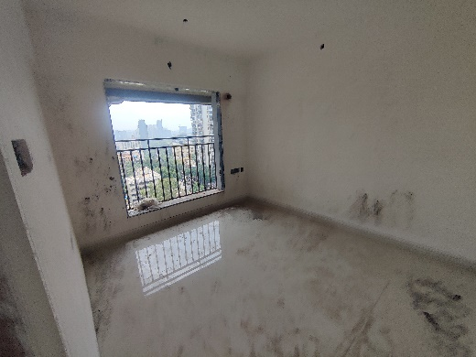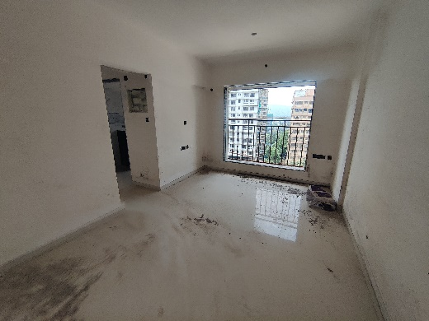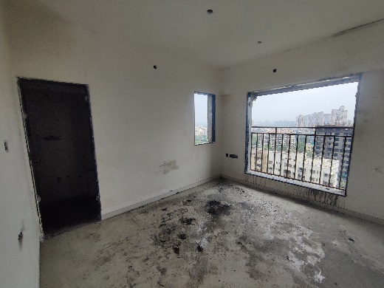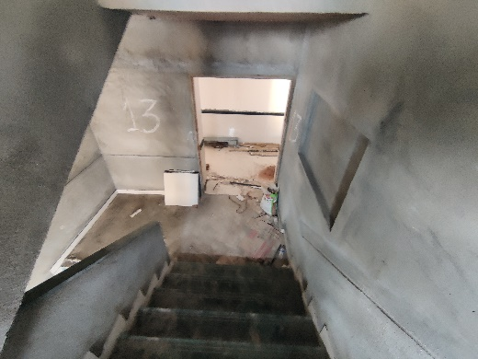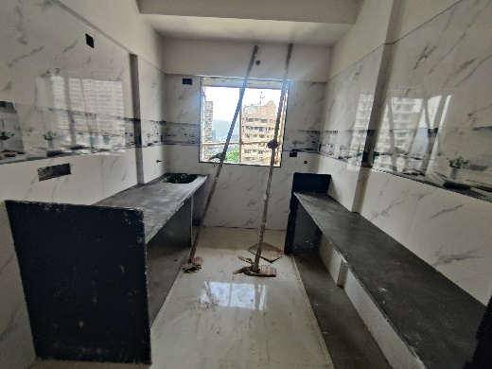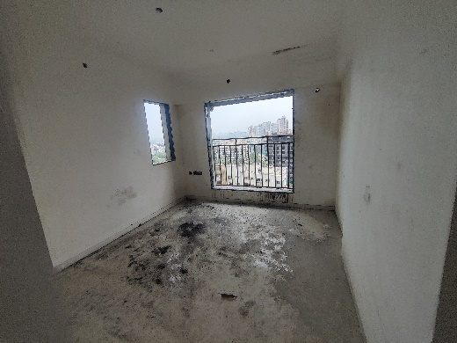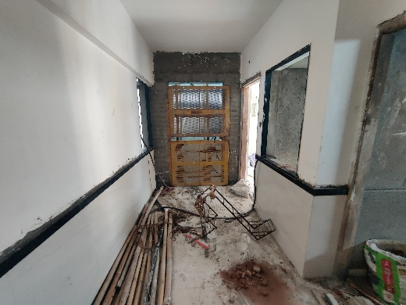

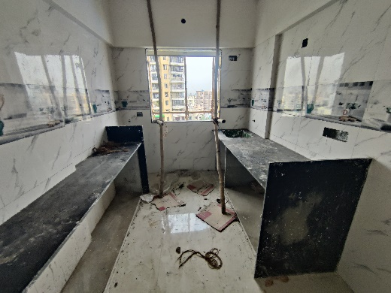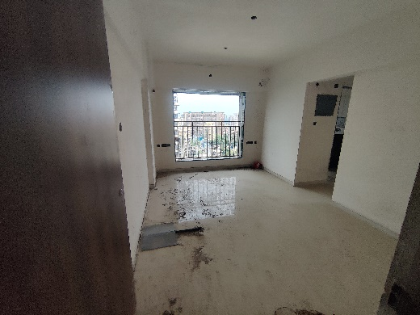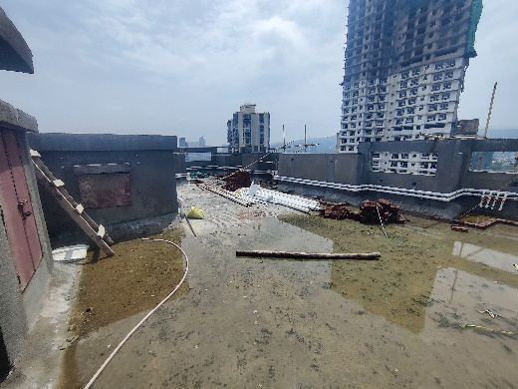

**Actual Site Photographs as on 10.07.2024**

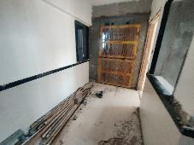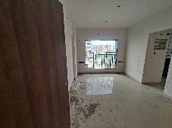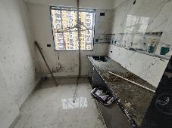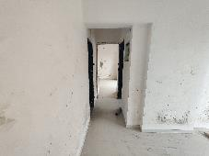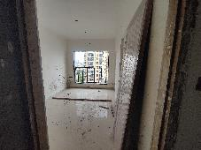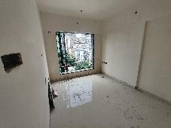

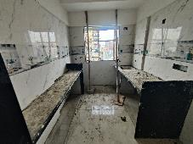

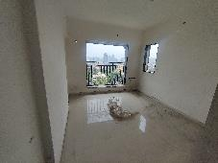

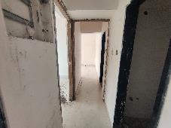

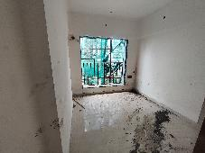

**Actual Site Photographs as on 10.07.2024**

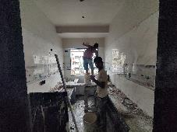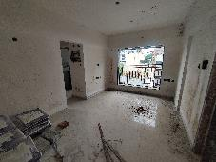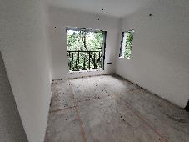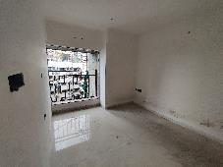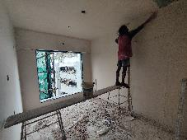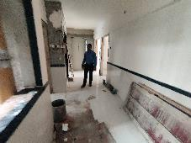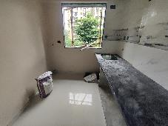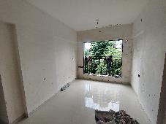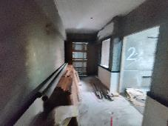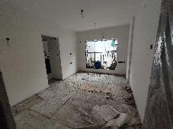

**Actual Site Photographs as on 10.07.2024**

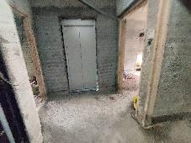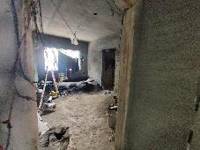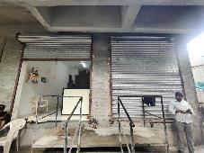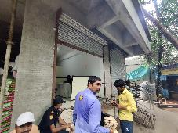

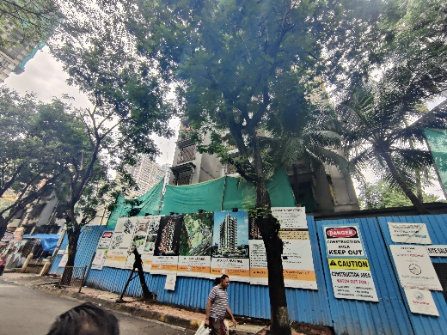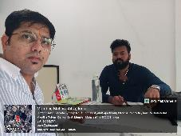

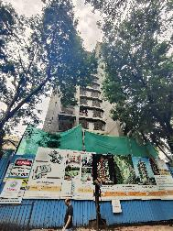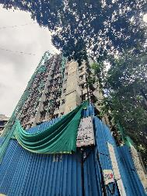

**Route Map of the property**

**Site u/r**

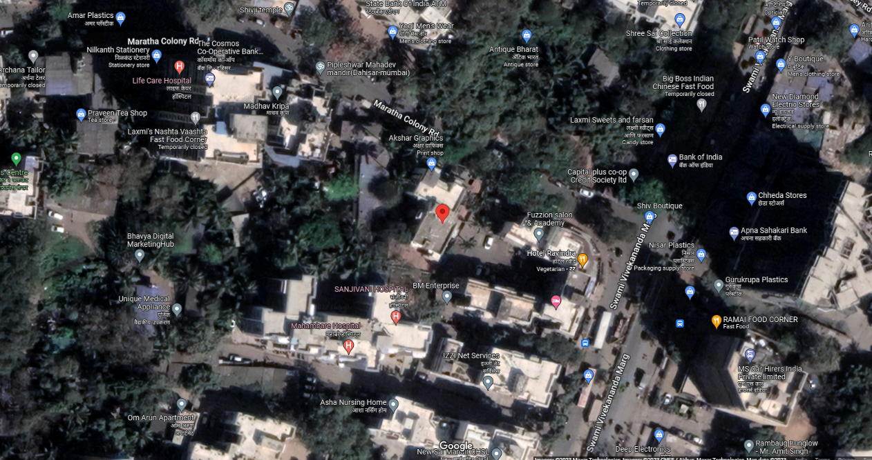

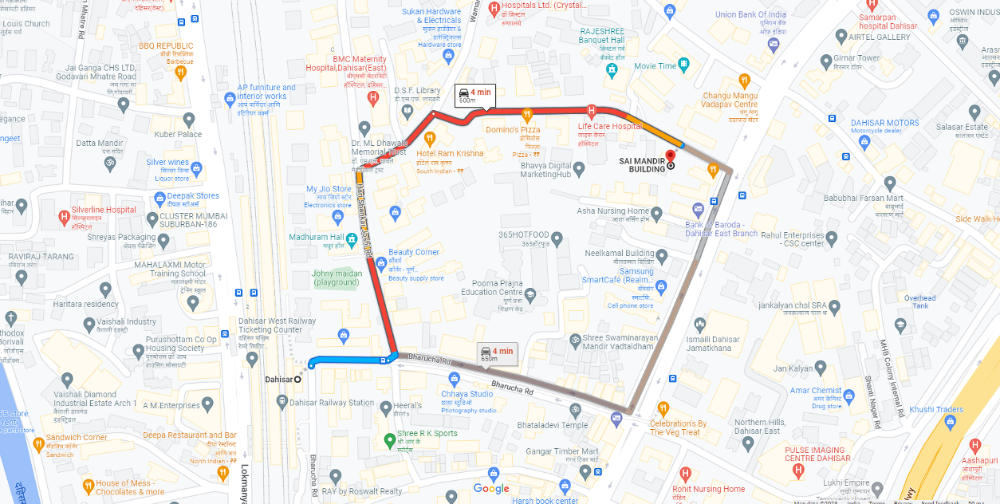

## Latitude Longitude: 19°15'04.7"N 72°51'47.1"E

Note: The Blue line shows the route to site from nearest railway station (Dahisar – 600 M.)

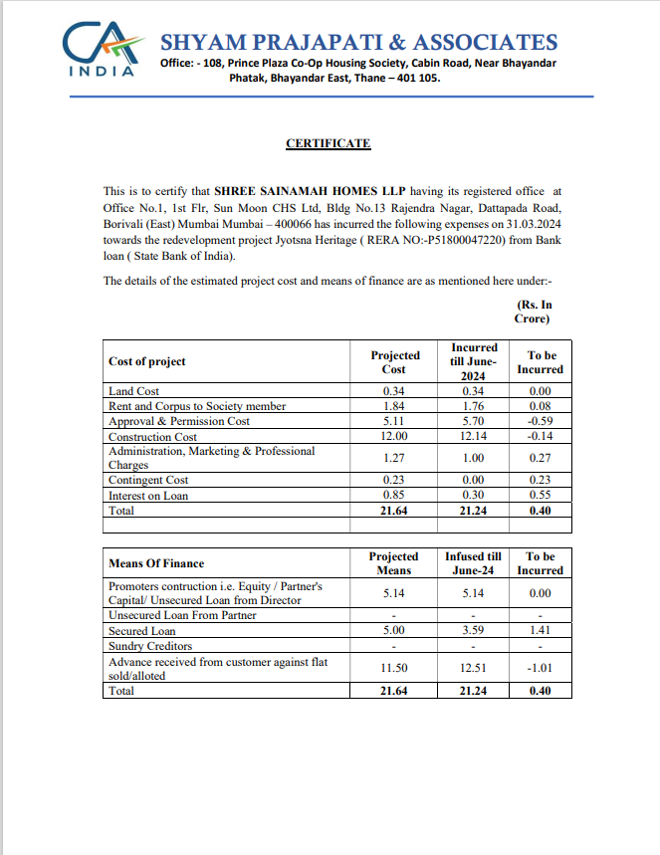**CA Certificate Dated 09.07.2024 till 30.06.2024**

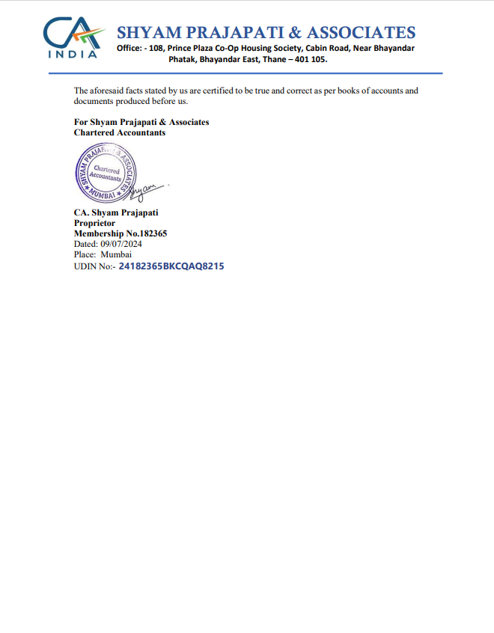**CA Certificate Dated 09.07.2024 till 30.06.2024**