To,
The Branch Manager,
State Bank of India
Madam Cama Road Branch Mumbai
Ground Floor State Bank Annexe Madam Kama Road,
Nariman Point, Mumbai - 40002,
State - Maharashtra, Country - India

SBI/Madam Cama Road Branch/ Mumbai/ 2024 / 340
Date: 02.09.2024

VALUATION REPORT (IN RESPECT OF FLAT)
I | General
 | Name & Address of Branch |  |  | : | State Bank of India, Madam Cama Road Branch Mumbai
1. | Purpose for which the valuation is made |  |  | : | To assess Fai Market Value of the property for Housing Loan Purpose.
2. | a) |  | Date of inspection | : | 02.09.2024
 | b) |  | Date on which the valuation is made | : | 02.09.2024
3. | List of documents produced for perusal |  |  | :
- Copy of Agreement for Sale Document No.15467/2024 Dated 21.08.2024 between M/s. Dosti Enterprises (The Promoter) And Tejashree Mayuresh Karandikar & Mayuresh Ajit Karandikar (The purchaser).
- Copy of RERA Certificate Document No. P51700054424 Dated 19.01.2024
- Copy of Commencement Certificate Document No. V.P. No. S05 / 0006 / 08 / TMC / TDD / 4472 / 23 Dated 26.09.2023 issued by Thane Municipal Corporation.
4. | Name of the owner(s) and his / their address (es) with Phone no. (details of share of each owner in case of joint ownership) |  |  | : | Name of Owner:  Tejashree Mayuresh Karandikar & Mayuresh Ajit Karandikar  Address: Residential Flat No. 703, 7th Floor, Wing - A, "Dosti Maple Building", Dosti West County - Phase 6 - Dosti Maple, Village - Balkum, Thane (West), Taluka - Thane, District - Thane, PIN Code - 400 608, State - Maharashtra, India.  Contact Person:  Tejashree Mayuresh Karandikar (Owner)  Mobile No. 8082001764  Joint Ownership
5. | Brief description of the property (Including Leasehold / freehold etc.):  The property is a Residential Flat located on 7th Floor.  As per Sale Plan attached to the agreement, the composition of Residential Flat will be 3 Bedrooms + Living Room + Dining + Kitchen + 3 Toilets + Balcony Area.  The property is at 5.9 Km. distance from Thane Railway Station.  At the time of inspection building was under construction.
 | Stage of Construction
 | If under construction, extent of completion
Foundation | Completed | RCC Plinth | Completed
Total | 10% work completed

6. | Location of property |  |  | :
 | a) | Plot No. / Survey No. |  | : | New Survey No - 16/1 to 6, 8A, 9A, 10/A/1, 11A, 12/1A, 12/2A, 17/1 to 6, 7 (A+B), 8, 9, 10 & Others
 | b) | Door No. |  | : | Residential Flat No. 703
 | c) | C. T.S. No. / Village |  | : | Village - Balkum
 | d) | Ward / Taluka |  | : | Taluka - Thane
 | e) | Mandal / District |  | : | District - Thane
 | f) | Date of issue and validity of layout of approved map / plan |  | : | Copy of Approved Building Plan Dated 01.03.2024 Document No. CHE / ES / 2335 / S / 337 (NEW) / IOD / 1 / NEW issued by Municipal Corporation of Greater Mumbai
 | g) | Approved map / plan issuing authority |  | :
 | h) | Whether genuineness or authenticity of approved map/ plan is verified |  | : | N.A., as the building is under construction
 | i) | Any other comments by our empanelled valuers on authentic of approved plan |  |  | N.A.
7. | Postal address of the property |  |  | : | Residential Flat No. 703, 7th Floor, Wing - A, "Dosti Maple Building", Dosti West County - Phase 6 - Dosti Maple, Village - Balkum, Thane (West), Taluka - Thane, District - Thane, PIN Code - 400 608, State - Maharashtra, India
8. | City / Town |  |  | : | Thane
 | Residential area |  |  | : | Yes
 | Commercial area |  |  | : | No
 | Industrial area |  |  | : | No
9. | Classification of the area |  |  | :
 | i) High / Middle / Poor |  |  | : | Middle Class
 | ii) Urban / Semi Urban / Rural |  |  | : | Urban
10. | Coming under Corporation limit / Village Panchayat / Municipality |  |  | : | Village - Balkum  Thane Municipal Corporation
11. | Whether covered under any State / Central Govt. enactments (e.g., Urban Land Ceiling Act) or notified under agency area/ scheduled area / cantonment area |  |  | : | No
12. | Boundaries of the property |  |  |  | As per Site |  | As per Document
 | North |  |  | : | Open Plot & Dosti Cedar Building |  | Details not available
 | South |  |  | : | Balkum Pipeline Road |  | Details not available
 | East |  |  | : | EuroSchool Balkum (Under  Construction Building) |  | Details not available
 | West |  |  | : | Dosti Westwood Phase 3  (Under Construction Building) |  | Details not available
13 | Dimensions of the site
 |  |  |  |  | A As per the Deed | B Actuals
 | North |  |  | : | Marginal Space | Building is under  Construction
 | South |  |  | : | Staircase & Flat No. 704 | Building is under  Construction
 | East |  |  | : | Marginal Space | Building is under  Construction
 | West |  |  | : | Lifts & Flat No. 702 | Building is under  Construction
14. | Extent of the site |  |  | : | RERA Carpet Area in Sq. Ft. = 936.00  Open Balcony Area in Sq. Ft. = 37.00  Total Carpet Area in Sq. Ft. = 973.00  (Area as per Agreement for Sale)  Built Up Area in Sq. Ft. = 1070.30  (Carpet Area + 10%)
14.1 | Latitude, Longitude & Co-ordinates of property |  |  | : | 19°13'37.2"N 72°59'43.6"E
15. | Extent of the site considered for Valuation (least of 13A&13B) |  |  | : | RERA Carpet Area in Sq. Ft. = 936.00  Open Balcony Area in Sq. Ft. = 37.00  Total Carpet Area in Sq. Ft. = 973.00  (Area as per Agreement for Sale)
16 | Whether occupied by the owner / tenant? If occupied by tenant since how long? Rent received per month. |  |  | : | Building under construction
II | APARTMENT BUILDING
 | Nature of the Apartment |  |  | : | Residential
 | Location |  |  | :
 | C.T.S. No. |  |  | : | -
 | Block No. |  |  | : | -
 | Ward No. |  |  | : | -
 | Village / Municipality / Corporation |  |  | : | Village – Balkum  Thane Municipal Corporation
 | Door No., Street or Road (Pin Code) |  |  | : | Residential Flat No. 703, 7th Floor, Wing - A, "Dosti Maple Building", Dosti West County - Phase 6 - Dosti Maple, Village - Balkum, Thane (West), Taluka - Thane, District - Thane, PIN Code - 400 608, State - Maharashtra, India
 | Description of the locality Residential / Commercial / Mixed |  |  | : | Residential
 | Year of Construction |  |  | : | Building is under construction
 | Number of Floors |  |  | : | Proposed Ground + 2 Podium + 1 Amenity Floor + 33 Upper Floors
 | Type of Structure |  |  | : | Proposed R.C.C. Framed Structure
 | Number of Dwelling units in the building |  |  | : | Proposed 6 Flats on 7th Floor
 | Quality of Construction |  |  | : | Building is under construction
 | Appearance of the Building |  |  | : | Building is under construction
 | Maintenance of the Building |  |  | : | Building is under construction
 | Facilities Available |  |  | :
 | Lift |  |  | : | Proposed 4 Lifts
 | Protected Water Supply |  |  | : | Proposed Municipal Water supply
 | Underground Sewerage |  |  | : | Proposed Connected to Municipal Sewerage System
 | Car parking - Open / Covered |  |  | : | Proposed Along with 1 (one) Stack Car Parking space bearing No. 1192 - 1193 for parking of 2 (Two) Car at Ground level
 | Is Compound wall existing? |  |  | : | Proposed, Yes
 | Is pavement laid around the building |  |  | : | Proposed, Yes
III | FLAT
1 | The floor in which the flat is situated |  |  | : | 7th Floor
2 | Door No. of the flat |  |  | : | Residential Flat No. 703
3 | Specifications of the flat |  |  | :
 | Roof |  |  | : | Proposed R.C.C. Slab
 | Flooring |  |  | : | Proposed Vitrified Tiles flooring
 | Doors |  |  | : | Proposed Teak wood door frame with flush doors
 | Windows |  |  | : | Proposed Powder Coated Aluminium Sliding Windows
 | Fittings |  |  | : | Proposed Concealed plumbing with C.P. fittings & Proposed Concealed Electrical Wiring.
 | Finishing |  |  | : | Proposed Cement Plastering
4 | House Tax |  |  | :
 | Assessment No. |  |  | : | Information not available
 | Tax paid in the name of: |  |  | : | Information not available
 | Tax amount: |  |  | : | Information not available
5 | Electricity Service connection No.: |  |  | : | Information not available
 | Meter Card is in the name of: |  |  | : | Information not available
6 | How is the maintenance of the Flat? |  |  | : | Building is under construction
7 | Sale Deed executed in the name of |  |  | : | Tejashree Mayuresh Karandikar & Mayuresh Ajit Karandikar
8 | What is the undivided area of land as per Sale Deed? |  |  | : | Information not available
9 | What is the plinth area of the flat? |  |  | : | Built Up Area in Sq. Ft. = 1070.30  (Carpet Area + 10%)
10 | What is the floor space index (app.) |  |  | : | As per TMC norms
11 | What is the Carpet Area of the flat? |  |  | : | RERA Carpet Area in Sq. Ft. = 936.00  Open Balcony Area in Sq. Ft. = 37.00  Total Carpet Area in Sq. Ft. = 973.00  (Area as per Agreement for Sale)
12 | Is it Posh / I Class / Medium / Ordinary? |  |  | : | Medium
13 | Is it being used for Residential or Commercial purpose? |  |  | : | Residential purpose
14 | Is it Owner-occupied or let out? |  |  | : | Building is under construction
15 | If rented, what is the monthly rent? |  |  | : | Rs. 37,500/- Expected rental income per month after building completion
IV | MARKETABILITY |  |  | :
1 | How is the marketability? |  |  | : | Good
2 | What are the factors favouring for an extra Potential Value? |  |  | : | Located in developed area
3 | Any negative factors are observed which affect the market value in general? |  |  | : | No
V | Rate |  |  | :
1 | After analyzing the comparable sale instances, what is the composite rate for a similar flat with same specifications in the adjoining locality? - (Along with details / reference of at - least two latest deals / transactions with respect to adjacent properties in the areas) |  |  | : | Rs. 17,000/- to Rs. 20,000/- Sq. Ft. on Carpet Area
2 | Assuming it is a new construction, what is the adopted basic composite rate of the flat under valuation after comparing with the specifications and other factors with the flat under comparison (give details). |  |  | : | Rs. 18,500/- Sq. Ft. on Carpet Area
3 | Break – up for the rate |  |  | :
 | I. Building + Services |  |  | : | Rs. 2,800/- Sq. Ft.
 | II. Land + others |  |  | : | Rs. 15,700/- Sq. Ft.
4 | Guideline rate obtained from the Registrar's office (an evidence thereof to be enclosed) |  |  | : | Rs. 1,08,780/- per Sq. M. i.e. Rs. 10,106/-per Sq. Ft.
5 | In case of variation of 20% or more in the valuation proposed by the Valuer and the Guideline value provided in the State Govt. notification or Income Tax Gazette justification on variation has to be given |  |  | : | It is a foregone conclusion that market value is always more than the RR price. As the RR Rates area Fixed by respective State Government for computing Stamp Duty / Rgstn. Fees. Thus the differs from place to place and Location, Amenities per se as evident from the fact than even RR Rates Decided by Government Differs.
VI | COMPOSITE RATE ADOPTED AFTER DEPRECIATION
a | Depreciated building rate |  |  | :
 | Replacement cost of flat with Services (v(3)i) |  |  | : | Rs. 2,800/- Sq. Ft.
 | Age of the building |  |  | : | Building is under construction
 | Life of the building estimated |  |  | : | 60 years after completion Subject to proper, preventive periodic maintenance & structural repairs
 | Depreciation percentage assuming the salvage value as 10% |  |  | : | N.A. the building is under construction
 | Depreciated Ratio of the building |  |  | :
b | Total composite rate arrived for Valuation |  |  | :
 | Depreciated building rate VI (a) |  |  | : | Rs. 2,800/- Sq. Ft.
 | Rate for Land & other V (3) ii |  |  | : | Rs. 15,700/- Sq. Ft.
 | Total Composite Rate |  |  | : | Rs. 18,500/- Sq. Ft.
 | Remarks:

Details of Valuation:
Sr. No. | Description | Qty. | Rate per  unit (Rs.) | Estimated  Value (Rs.)
1 | Present value of the flat | 973.00 Sq. Ft. | 18,500/- | 1,80,00,500/-
 | Total / Fair Market value of the property (After completion) |  |  | 1,80,00,500/-
 | Realizable value of the property |  |  | 1,76,40,490/-
 | Distress Value of the property |  |  | 1,44,00,400/-
 | Insurable value of the property |  |  | 29,96,840/-
 | Guideline Value of the Property |  |  | 1,08,16,452/-

For the purpose of valuation Sale Comparison Approach Method used. The rate for same type of property in the nearby area is in the range of Rs. 17,000/- to Rs. 20,000/- Sq. Ft. on Carpet Area, Market conditions, demand and supply factor, size of property, location etc. considered while valuing the property. For the purpose of valuation. We have considered rate of Rs. 18,500/- Sq. Ft. on Carpet Area.

Impending threat of acquisition by government for road widening / publics service purposes, sub merging & applicability of CRZ provisions (Distance from sea-cost / tidal level must be incorporated) and their effect on
- Saleability | Good
- Likely rental values in future in | As per valuation table
- Any likely income it may generate | Rs. 37,500/- Expected rental income per month after building completion

Place: Mumbai
Date: 02.09.2024

Yogesh R. Vankar
Govt. Reg. Valuer
Building Planner & Chartered Engineer (India)

Actual Site Photographs
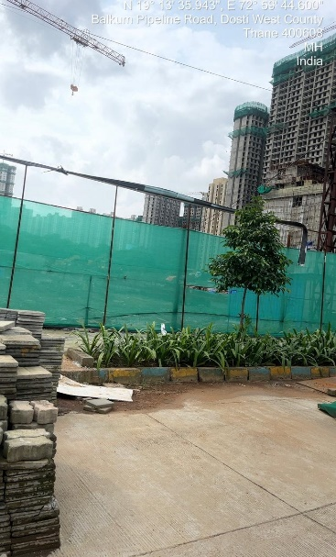
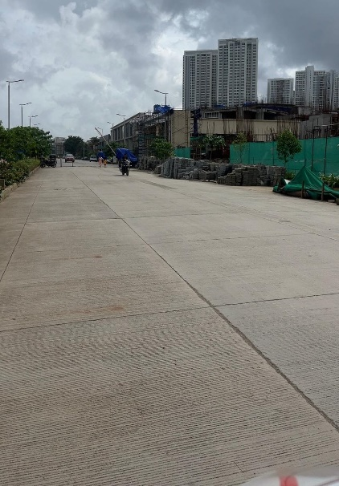

Route Map of the property

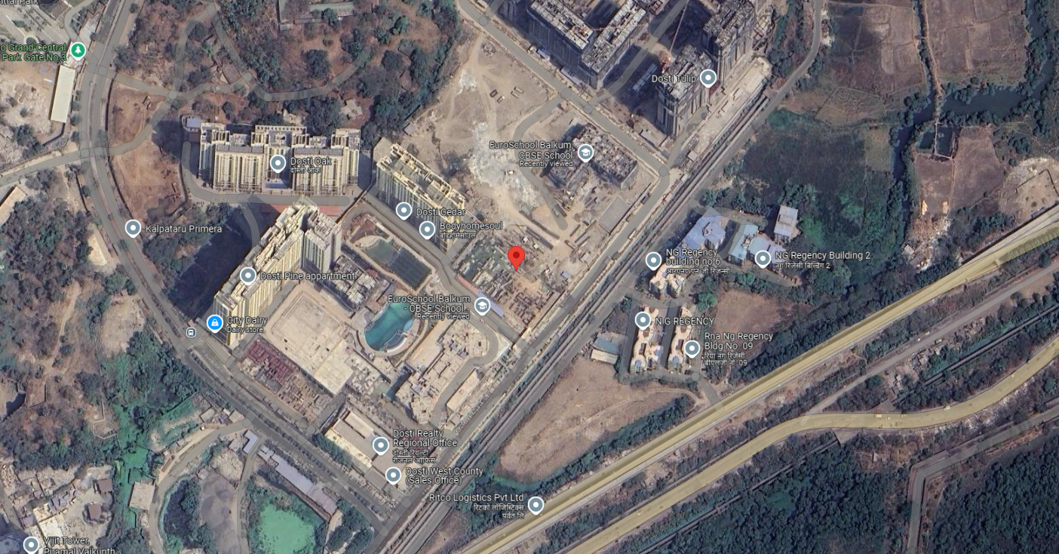

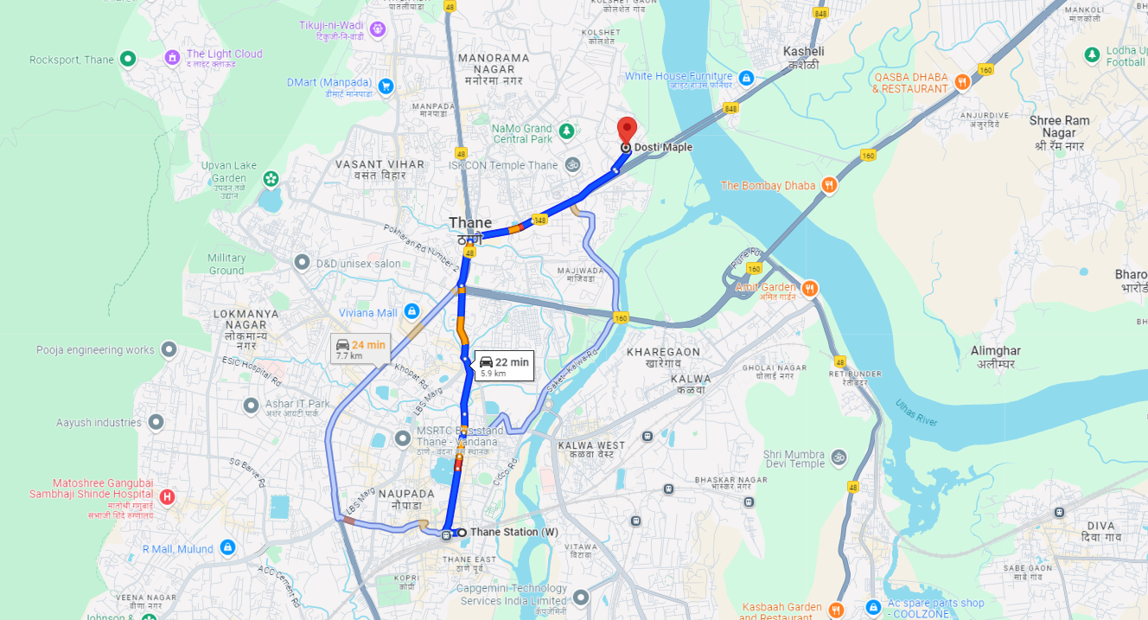

Ready Reckoner Rate

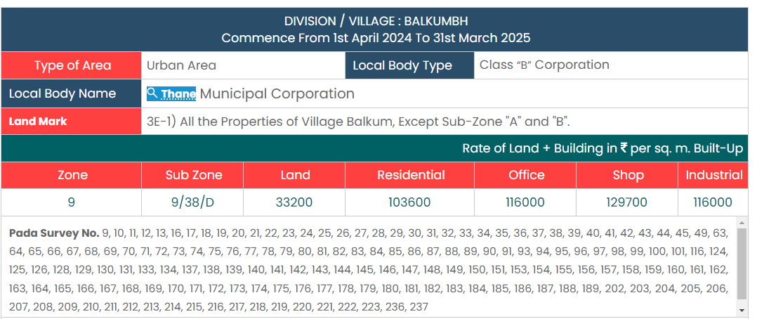

Price Indicators
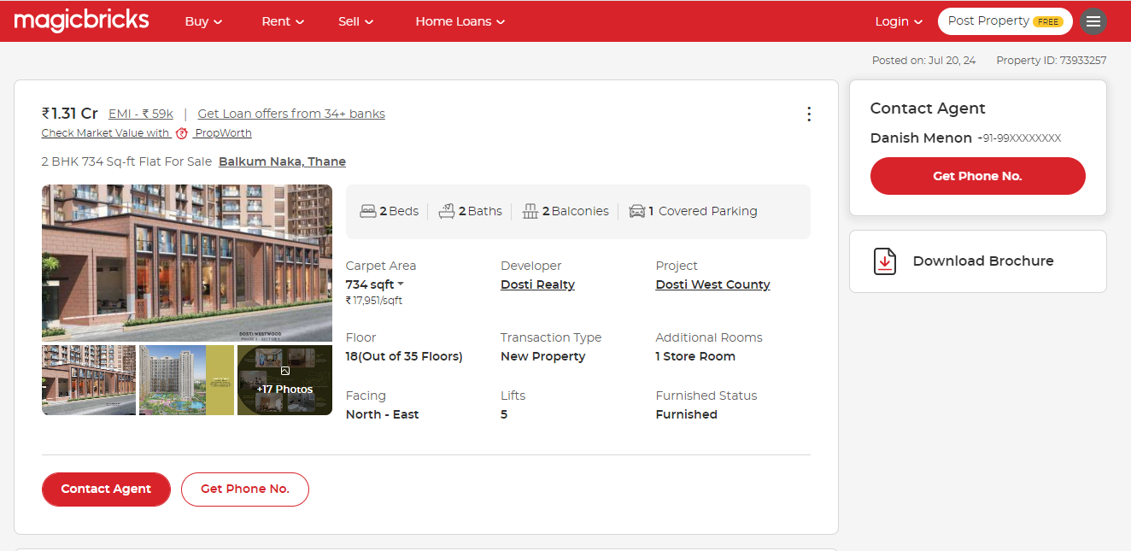

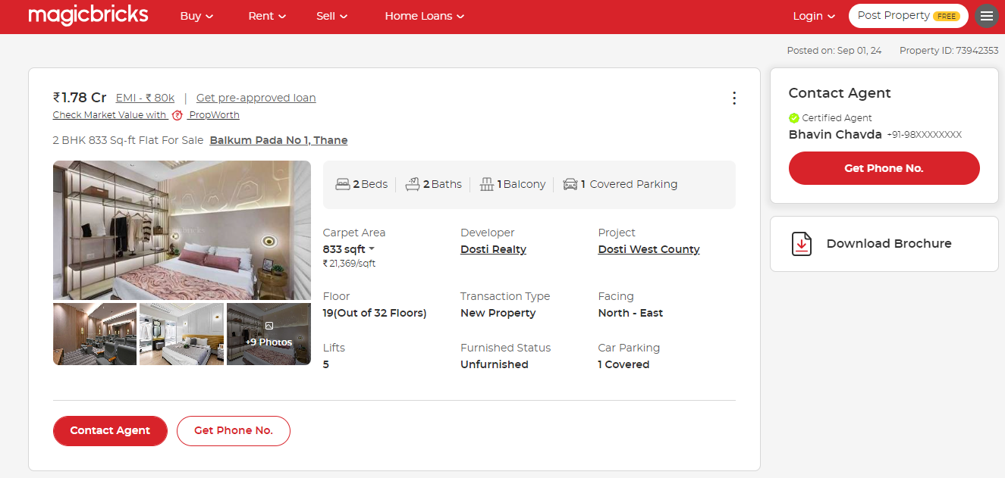

Price Indicators
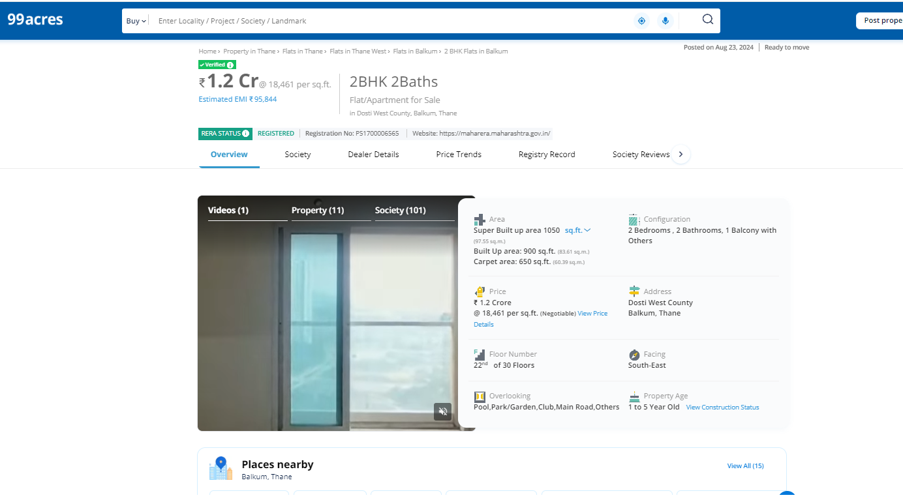

Sale Instances

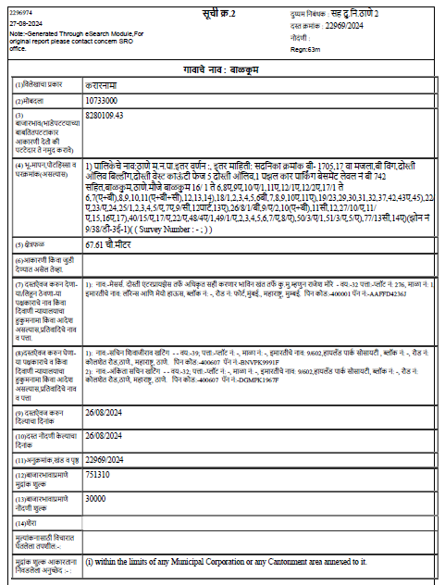

As a result of my appraisal and analysis, it is my considered opinion that the present fair market value of the above property in the prevailing condition with aforesaid specifications are as under:

Rs. 1,80,00,500/- (Rupees One Crore Eighty Lakh Five Hundred Only). The Realisable Value of the property is Rs. 1,76,40,490/- (Rupees One Crore Seventy Six Lakhs Forty Thousand Four Hundred Ninety Only). The Distress Value of the property is Rs. 1,44,00,400/- (Rupees One Crore Forty Four Lakhs Four Hundred Only.) As per Site Inspection 10% Construction Work is Completed.

Place: Mumbai
Date: 02.09.2024

Yogesh R. Vankar
Govt. Reg. Valuer
Building Planner & Chartered Engineer (India)

The undersigned has inspected the property detailed in the Valuation Report dated _______________________

on ____________________. We are satisfied that the fair and reasonable market value of the property is_________________________ (Rupees ________________________________________________________

________________________________________only).

Date
Signature
(Name & Designation of the Inspecting Official/s)

Countersigned
(BRANCH MANAGER)
Enclosures
 | Declaration-cum-undertaking from the valuer (Annexure – I) | Attached
 | Model code of conduct for valuer (Annexure– II) | Attached

(Annexure – I)
DECLARATION-CUM-UNDERTAKING
I, Yogesh R. Vankar do hereby solemnly affirm and state that:
- I am a citizen of India.

- I will not undertake valuation of any assets in which I have a direct or indirect interest or become so interested at any time during a period of three years prior to my appointment as valuer or three years after the valuation of assets was conducted by me.

- The information furnished in my valuation report dated 02.09.2024 is true and correct to the best of my knowledge and belief and I have made an impartial and true valuation of the property.

- I/ my authorized representative have personally inspected the property on 02.09.2024. The work is not sub - contracted to any other valuer and carried out by myself.

- Valuation report is submitted in the format as prescribed by the bank.

- I have not been depanelled / delisted by any other bank and in case any such depanelment by other banks during my empanelment with you, I will inform you within 3 days of such depanelment.

- I have not been removed / dismissed from service / employment earlier.

- I have not been convicted of any offence and sentenced to a term of imprisonment

- I have not been found guilty of misconduct in my professional capacity.

- I have not been declared to be unsound mind

- I am not an un-discharged bankrupt, or has not applied to be adjudicated as a bankrupt;

- I am not an un-discharged insolvent.

- I have not been levied a penalty under section 271J of Income-tax Act, 1961 (43 of 1961) and time limit for filing appeal before Commissioner of Income-tax (Appeals) or Income-tax Appellate Tribunal, as the case may be has expired, or such penalty has been confirmed by Income-tax Appellate Tribunal, and five years have not elapsed after levy of such penalty

- I have not been convicted of an offence connected with any proceeding under the Income Tax Act 1961, Wealth Tax Act 1957 or Gift Tax Act 1958 and My PAN Card number as applicable isACUPV9792L

- I undertake to keep you informed of any events or happenings which would make me ineligible for empanelment as a valuer

- I have not concealed or suppressed any material information, facts and records and I have made a complete and full disclosure

- I have read the Handbook on Policy, Standards and procedure for Real Estate Valuation, 2011 of the IBA and this report is in conformity to the "Standards" enshrined for valuation in the Part - B of the above handbook to the best of my ability.

- I have read the International Valuation Standards (IVS) and the report submitted to the Bank for the respective asset class is in conformity to the "Standards" as enshrined for valuation in the IVS in "General Standards" and "Asset Standards" as applicable. The valuation report is submitted in the prescribed format of the bank.

- I abide by the Model Code of Conduct for empanelment of valuer in the Bank. (Annexure V - A signed copy of same to be taken and kept along with this declaration)

- I am registered under Section 34 AB of the Wealth Tax Act, 1957.

- I am valuer registered with Insolvency & Bankruptcy Board of India (IBBI)

- My CIBIL Score and credit worthiness is as per Bank's guidelines.

- I am Chairman & Managing Director of the company, who is competent to sign this valuation report.

- I will undertake the valuation work on receipt of Letter of Engagement generated from the system (i.e. LLMS / LOS) only.

- Further, I hereby provide the following information.

Sr.  No. | Particulars | Valuer Comment
 | Background information of the asset being valued; | The property under consideration is purchased by Tejashree Mayuresh Karandikar & Mayuresh Ajit Karandikar from M/s. Dosti Enterprises vide Agreement For Sale dated 21.08.2024.
 | Purpose of valuation and appointing authority | As per the request from State Bank of India, Madam Cama Road Branch Mumbai to assess fair market value of the property for Banking purpose
 | Identity of the valuer and any other experts involved in the valuation; | Yogesh R. Vankar – Regd. Valuer
 | Disclosure of valuer interest or conflict, if any; | We have no interest, either direct or indirect, in the property valued. Further to state that we do not have relation or any connection with property owner / applicant directly or indirectly. Further to state that we are an independent Valuer and in no way related to property owner / applicant
 | Date of appointment, valuation date and date of report; | Date of Appointment – 02.09.2024  Valuation Date – 02.09.2024  Date of Report – 02.09.2024
 | Inspections and/or investigations undertaken; | Physical Inspection done on 02.09.2024
 | Nature and sources of the information used or relied upon; | - Market Survey at the time of site visit  - Ready Reckoner rates / Circle rates  - Online search for Registered Transactions  - Online Price Indicators on real estate portals  - Enquiries with Real estate consultants  - Existing data of Valuation assignments carried out by us
 | Procedures adopted in carrying out the valuation and valuation standards followed; | Sales Comparison Method
 | Restrictions on use of the report, if any; | This valuation is for the use of the party to whom it is addressed and for no other purpose. No responsibility is accepted to any third party who may use or rely on the whole or any part of this valuation. The valuer has no pecuniary interest that would conflict with the proper valuation of the property.
 | Major factors that were taken into account during the valuation; | current market conditions, demand and supply position, Residential Flat size, location, upswing in real estate prices, sustained demand for Residential Flat, all-round development of commercial and residential application in the locality etc.
 | Caveats, limitations and disclaimers to the extent they explain or elucidate the limitations faced by valuer, which shall not be for the purpose of limiting his responsibility for the valuation report. | Yes

Date: 02.09.2024
Place: Mumbai

Yogesh R. Vankar
Govt. Reg. Valuer
Building Planner & Chartered Engineer (India)
(Annexure – II)

MODEL CODE OF CONDUCT FOR VALUERS

Integrity and Fairness
- A valuer shall, in the conduct of his/its business, follow high standards of integrity and fairness in all his/its dealings with his/its clients and other valuers.
- A valuer shall maintain integrity by being honest, straightforward, and forthright in all professional relationships.
- A valuer shall endeavour to ensure that he/it provides true and adequate information and shall not misrepresent any facts or situations.
- A valuer shall refrain from being involved in any action that would bring disrepute to the profession.
- A valuer shall keep public interest foremost while delivering his services.

Professional Competence and Due Care
- A valuer shall render at all times high standards of service, exercise due diligence, ensure proper care and exercise independent professional judgment.
- A valuer shall carry out professional services in accordance with the relevant technical and professional standards that may be specified from time to time.
- A valuer shall continuously maintain professional knowledge and skill to provide competent professional service based on up-to-date developments in practice, prevailing regulations / guidelines and techniques.
- In the preparation of a valuation report, the valuer shall not disclaim liability for his/its expertise or deny his/its duty of care, except to the extent that the assumptions are based on statements of fact provided by the company or its auditors or consultants or information available in public domain and not generated by the valuer.
- A valuer shall not carry out any instruction of the client insofar as they are incompatible with the requirements of integrity, objectivity and independence.
- A valuer shall clearly state to his client the services that he would be competent to provide and the services for which he would be relying on other valuers or professionals or for which the client can have a separate arrangement with other valuers.

Independence and Disclosure of Interest
- A valuer shall act with objectivity in his/its professional dealings by ensuring that his/its decisions are made without the presence of any bias, conflict of interest, coercion, or undue influence of any party, whether directly connected to the valuation assignment or not.
- A valuer shall not take up an assignment if he/it or any of his/its relatives or associates is not independent in terms of association to the company.
- A valuer shall maintain complete independence in his/its professional relationships and shall conduct the valuation independent of external influences.
- A valuer shall wherever necessarily disclose to the clients, possible sources of conflicts of duties and interests, while providing unbiased services.
- A valuer shall not deal in securities of any subject company after any time when he/it first becomes aware of the possibility of his / its association with the valuation, and in accordance with the Securities and Exchange Board of India (Prohibition of Insider Trading) Regulations,2015 or till the time the valuation report becomes public, whichever is earlier.
- A valuer shall not indulge in "mandate snatching" or offering "convenience valuations" in order to cater to a company or client's needs.
- As an independent valuer, the valuer shall not charge success fee.
- In any fairness opinion or independent expert opinion submitted by a valuer, if there has been a prior engagement in an unconnected transaction, the valuer shall declare the association with the company during the last five years.

Confidentiality
- A valuer shall not use or divulge to other clients or any other party any confidential information about the subject company, which has come to his / its knowledge without proper and specific authority or unless there is a legal or professional right or duty to disclose.

Information Management
- A valuer shall ensure that he/ it maintains written contemporaneous records for any decision taken, the reasons for taking the decision, and the information and evidence in support of such decision. This shall be maintained so as to sufficiently enable a reasonable person to take a view on the appropriateness of his /its decisions and actions.
- A valuer shall appear, co-operate and be available for inspections and investigations carried out by the authority, any person authorised by the authority, the registered valuers organization with which he/it is registered or any other statutory regulatory body.
- A valuer shall provide all information and records as may be required by the authority, the Tribunal, Appellate Tribunal, the registered valuers organisation with which he/it is registered, or any other statutory regulatory body.
- A valuer while respecting the confidentiality of information acquired during the course of performing professional services, shall maintain proper working papers for a period of three years or such longer period as required in its contract for a specific valuation, for production before a regulatory authority or for a peer review. In the event of a pending case before the Tribunal or Appellate Tribunal, the record shall be maintained till the disposal of the case.

Gifts and hospitality:
25) A valuer or his / its relative shall not accept gifts or hospitality which undermines or affects his independence as a valuer.
Explanation: For the purposes of this code the term 'relative' shall have the same meaning as defined in clause (77) of Section 2 of the Companies Act, 2013 (18 of 2013).
26) A valuer shall not offer gifts or hospitality or a financial or any other advantage to a public servant or any other person with a view to obtain or retain work for himself / itself, or to obtain or retain an advantage in the conduct of profession for himself / itself.

Remuneration and Costs.
27) A valuer shall provide services for remuneration which is charged in a transparent manner, is a reasonable reflection of the work necessarily and properly undertaken, and is not inconsistent with the applicable rules.
28) A valuer shall not accept any fees or charges other than those which are disclosed in a written contract with the person to whom he would be rendering service.

Occupation, employability and restrictions.
29) A valuer shall refrain from accepting too many assignments, if he/it is unlikely to be able to devote adequate time to each of his/ its assignments.
30) A valuer shall not conduct business which in the opinion of the authority or the registered valuer organisation discredits the profession.

Miscellaneous
31) A valuer shall refrain from undertaking to review the work of another valuer of the same client except under written orders from the bank or housing finance institutions and with knowledge of the concerned valuer.
32) A valuer shall follow this code as amended or revised from time to time.

Yogesh R. Vankar
Govt. Reg. Valuer
Building Planner & Chartered Engineer (India)

