Vastu/Nashik/07/2024/0010070/2307330
22/7-334-RPBS
Date: 31.08.2024

To, `
The Branch Manager,
Bank of Baroda
Regional Office Nashik Road Branch
BSNL Building, Datta Mandir Road, Nashik Road,
Nashik -422 101, State - Maharashtra, Country - India.

Sub: Vetting of Extra Amenities

Sir,

With reference to above subject, we have evaluated the Extra Amenities for Residential Flat No. 903, 9th Floor, Wing - A, "Millennium Tower", Behind Laxminarayan Yeola Pathaini Sarees, Sai Nagar, Ayodhya Nagari, Sai Nagar Road, Plot No. 1A, Village - Nashik, District - Nashik, Nashik, PIN Code – 422 003, State - Maharashtra, India belongs to MR. Aatish Dilip Dongare & Swati Prabhakar Adole (After Marriage Name) Mrs. Swati Aatish Dongare.

We have verified the rates quoted as per current market rates. Details of work and Extra Amenities considered as per copy of Agreement for Extra Amenities issued by to MR. Aatish Dilip Dongare & Swati Prabhakar Adole (After Marriage Name) Mrs. Swati Aatish Dongare (First Party) and Shri. Mustafa Tajuddin Sayyed (Second Party) received on dated 30.08.2024. The Extra Amenities amount is Rs.8,10,000/- (Rupees Eight Lakh Ten Thousand Only.)

The said Cost Vetting Certificate is valid upto next 6 months Only.

Thanking you

Sincerely yours

Manoj B. Chalikwar
Registered Valuer
Chartered Engineer (India)
Reg. No. CAT-I-F-1763
Reg. No. IBBI/RV/07/2018/10366
BOB Empanelment No.: ZO:MZ:ADV:46:941
Encl: Valuation report.

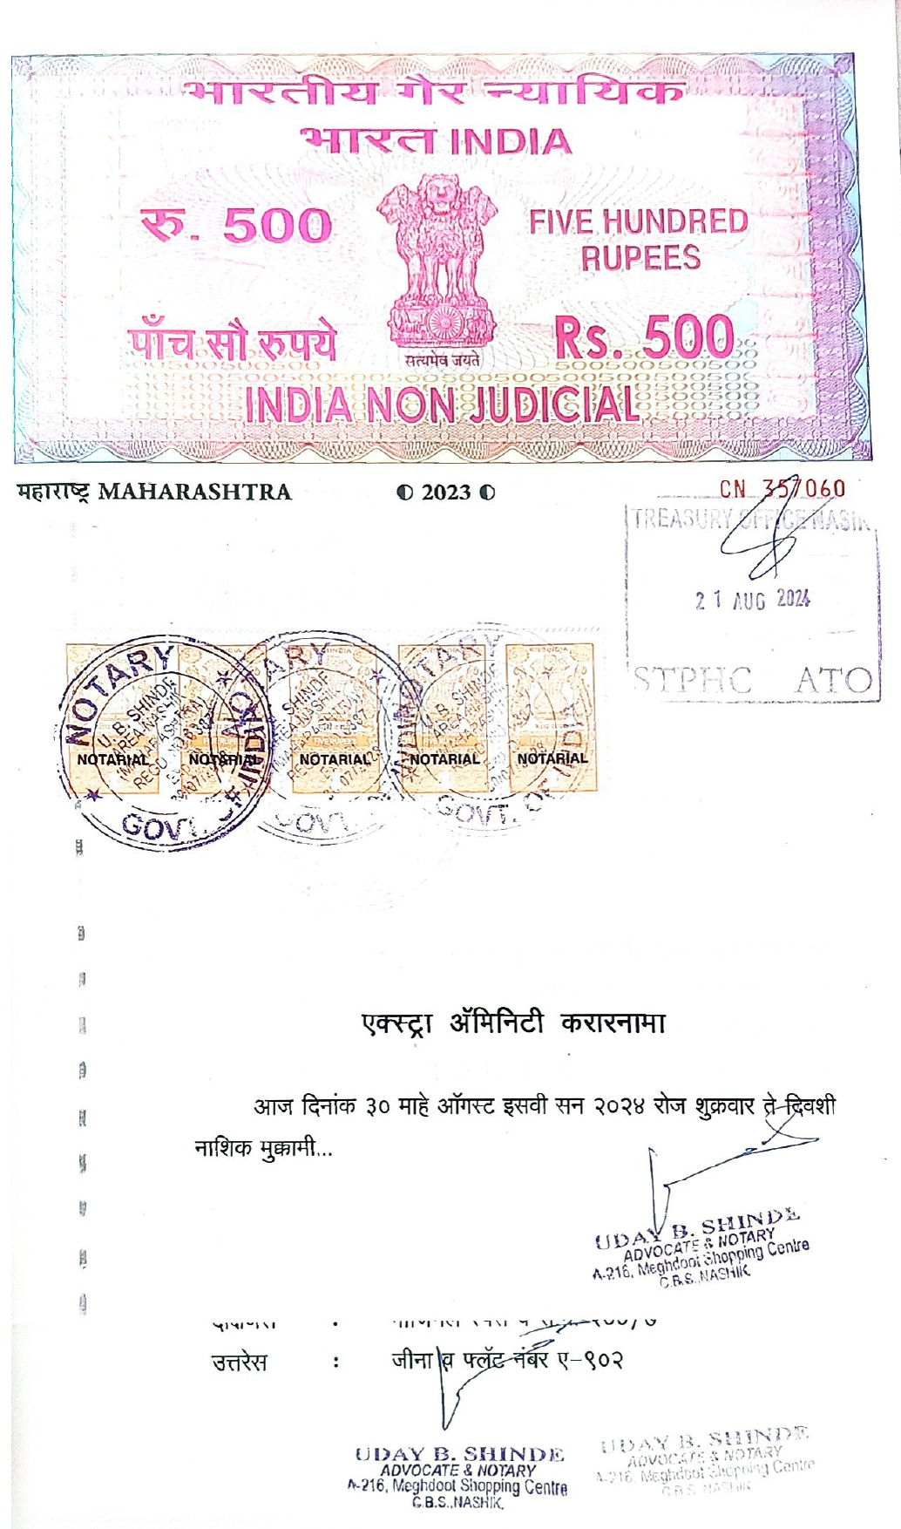
Agreement for Extra Amenities
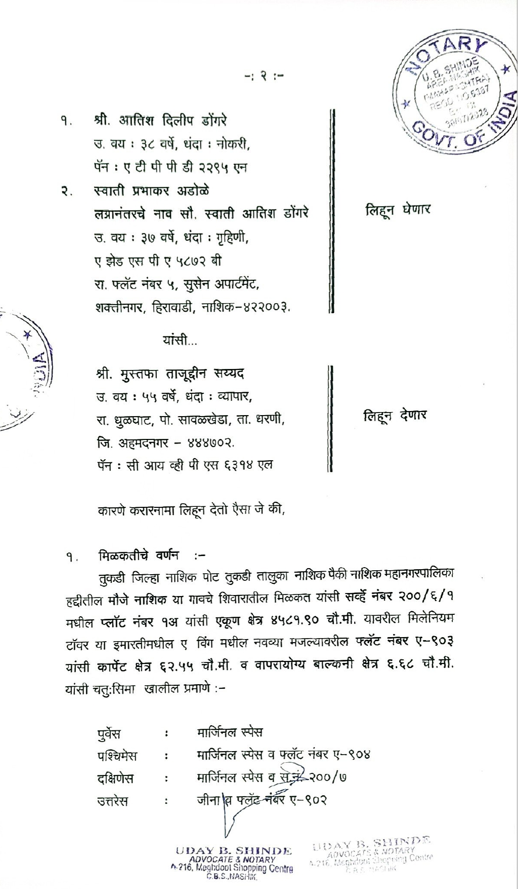

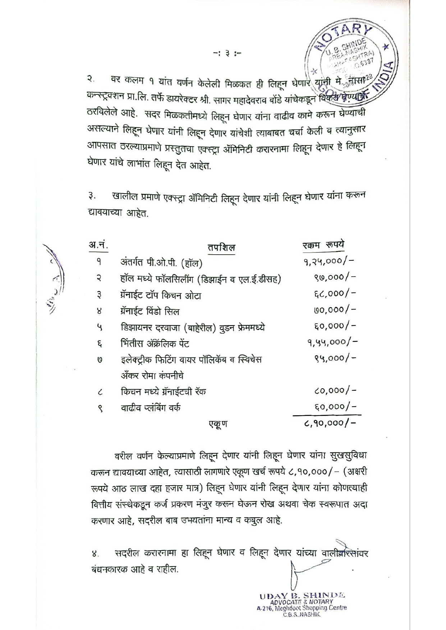
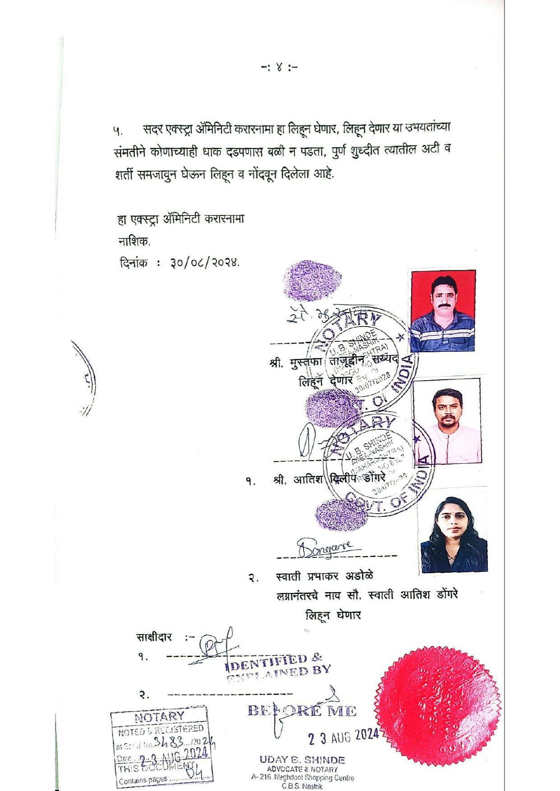

The Extra Amenities amount is Rs.8,10,000/- (Rupees Eight Lakh Ten Thousand Only.)

