3rd LENDER’S INDEPENDENT ENGINEER REPORT

Details of the property under consideration:

Name of Project: “Shankeshwar Heights”

"Shankeshwar Heights", Proposed Slum Rehabilitation Scheme on Plot bearing CTS. No. 576, 576/1 to 15, 578, 578/1 to 11, 579, 579/1 to 15 & 580, Patil Gulli, Purav Marg, Village – Kurla – 3, Chunabhatti, Sion (West), Mumbai – 400 022, State – Maharashtra, Country – India

Latitude Longitude: 19°03'08.4"N 72°52'14.5"E

Intended User:

State Bank of India
SME Chembur Branch
Unit No. 11, Building No. 11, Ground Floor, Corporate Park, Sion Trombay Road,
Chembur, Mumbai, Pin Code – 400 071, State - Maharashtra, Country – India

Vastu/SBI/Mumbai/08/2024/10931/2307944
30/06-422-PY
Date: - 30.08.2024

THIRD LENDER’S INDEPENDENT ENGINEER REPORT

To,
State Bank of India
SME Chembur Branch
Unit No. 11, Building No. 11,
Ground Floor, Corporate Park,
Sion Trombay Road, Chembur,
Mumbai, Pin Code – 400 071,
State - Maharashtra, Country – India

Subject: Construction of Proposed Slum Rehabilitation Scheme on Plot bearing CTS. No. 576, 576/1 to 15, 578, 578/1 to 11, 579, 579/1 to 15 & 580, Patil Gulli, Purav Marg, Village – Kurla – 3, Chunabhatti, Sion (West), Mumbai – 400 022, State – Maharashtra, Country – India.

Ref: You’re Request for Lender’s Independent Engineer Report of under Construction Building.
Dear Sir,
- As per your instruction, we have inspected the under-construction Proposed Slum Rehabilitation Scheme on Plot bearing CTS. No. 576, 576/1 to 15, 578, 578/1 to 11, 579, 579/1 to 15 & 580, Patil Gulli, Purav Marg, Village – Kurla – 3, Chunabhatti, Sion (West), Mumbai – 400 022, State – Maharashtra, Country – India which is being developed by M/s. Siddheshwar Construction Co. in order to give the physical progress at site and to certify cost incurred towards project as on 30/06/2024.
- The Construction work as per approved plan was in progress during the site visit on 09th July 2024.
- Status of work:
- For Sales Building (Wing B & C): 22nd floor slab work is completed, Ground to 13th Floor Blockwork, 1st to 6th Floor plaster work, Door frames & windows frames are completed. Terrace floor slab work, 14th floor block work & 7th to 12th floor plaster work is in progress.
- For Rehab Building (Wing D): 22nd floor slab work is completed, Ground to 15th Floor Blockwork, 1st to 15th floor plaster work, Ground to 15th floor Gypsum work, Door frames & windows frames are completed. Terrace floor slab work, 16th floor block work, Ground to 11th floor Kitchen Platform work is in progress.
- As per cost incurred certificate issued by CA Certificate actual total expenditure occurred as on 30/06/2024 is ` 87.15 Cr. for Sale Building (Wing B & C) & Rehab Building (wing D) is proposed of Ground Floor + 1st to 22nd Upper Floors.
- Overall financial progress as per C.A. certificate including land cost as on 30/06/2024 is 83.03% estimated cost of project.
- Overall Physical progress of the sale building construction as on 09/07/2024 is 62.46% as per physical site inspection.

- Overall Physical progress of the sale building construction including Other Material on Site as on 09/07/2024 is 76.30%.

- Construction Cost of the sale building construction including other material on site & Advance payment to the Vendors till 30/06/2024 is 82.78% as per bills.

DECLARATION
- The information furnished in the report is based on our 3rd site visit Dated 09/07/2024 & Document Provided by Client.
- Vastukala 2nd LIE Report dated 30/05/2024.
- I have no direct and indirect interest in the property examined for report.
- I have not been found guilty of misconduct in my professional capacity.

Manoj B. Chalikwar
Registered Valuer
Chartered Engineer (India)
Reg. No. IBBI/RV/07/2018/10366

Encl.: LIE report

Purpose & Methodology
• State Bank of India Banks and financial institutions require monitoring & an independent review of the progress of the sanctioned projects
VCIPL undertakes such study to independently review the progress of the project and put forward a comprehensive analysis

Advantages:
- Assurance on present practices
- Identification of risk
- Analyzing the performance of third parties
- Recommendations

The Methodology
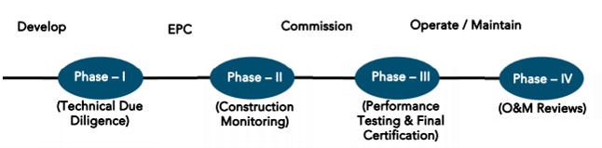
THIRD LENDER’S INDEPENDENT ENGINEER REPORT
OF
"SHANKESHWAR HEIGHTS"

"Shankeshwar Heights", Proposed Slum Rehabilitation Scheme on Plot bearing CTS. No. 576, 576/1 to 15, 578, 578/1 to 11, 579, 579/1 to 15 & 580, Patil Gulli, Purav Marg, Village – Kurla – 3, Chunabhatti, Sion (West), Mumbai – 400 022, State – Maharashtra, Country – India.

Latitude Longitude: 19°03'08.4"N 72°52'14.5"E

NAME OF DEVELOPER: M/s. Siddheshwar Construction Co.
Pursuant to instructions from State of India, SME Chembur Branch, Chembur we have duly visited, inspected, surveyed & assessed the above said property on 09th July 2024 to determine the fair & reasonable market value of the said property/project as on Quarter ending 30th June 2024 for LIE purpose.

1. Location Details:
Proposed Slum Rehabilitation Scheme on Plot bearing CTS. No. 576, 576/1 to 15, 578, 578/1 to 11, 579, 579/1 to 15 & 580, Patil Gulli, Purav Marg, Village – Kurla – 3, Chunabhatti, Sion (West), Mumbai – 400 022. It is about 400 M. travelling distance from Chunnabatti Railway station. Surface transport to the property is by buses, taxis & private vehicles. The property is in developed locality. All the amenities like shops, banks, hotels, markets, schools, hospitals, etc. are all available in the surrounding locality. The area is higher middle class & developed.

2. Developer Details:
Name of builder | M/s. Siddheshwar Construction Co.
Project Rera Registration Number | P519000186161
Registered office address | Shop No. 6, Aditya Hertiage Building, V N Purav Marg, Sion, Chunnabatti, Mumbai – 400 022, State - Maharashtra, Country – India
Contact details | Contact Person:  Mr. Prabudh Khandelwal (Consultants)  Mobile No. 7738001775  Mr. Deep Shah (Consultants)  Mobile No. 7977861026
E – mail ID and website
3. Boundaries of the Property:
Direction | Particulars
On or towards North | Slum Area
On or towards South | Wing A
On or towards East | Patil Galli
On or towards West | RKS House & Slum Area

Introduction
As per Information on site M/s. Siddheshwar Construction Co. has acquired land by Conveyance Deed & multiple Surrender Deed from Tenant’s admeasuring area is 2,163.00 Sq. M. bearing CTS. No. 576, 576/1 to 15, 578, 578/1 to 11, 579, 579/1 to 15 & 580. For the Proposed Residential (Rehab cum Sale) Building.

List of Approvals:
- Copy of Approved Plan No. SRA/ENG/L/PVT/007712018/206/AP dated 17.01.2022 issued by Slum Rehabilitation Authority (SRA)
Approved Upto: - (Wing B, C & D) – Ground Floor + 1st to 22nd Upper Floors
- Copy of 1st Commencement Certificate No. L/PVT/0077/20181206/AP/C dated 17.06.2021 issued by Slum Rehabilitation Authority (SRA)
This is C. C. is granted upto plinth level of sale wing B & C and rehab wing D of composite building as per last approved plan dated 08.02.2021.
- Copy of 2nd Commencement Certificate No. L/PVT/0077/20181206/AP/C dated 01.07.2022 issued by Slum Rehabilitation Authority (SRA)
This is C. C. is granted upto Ground Floor + 1st to 9th floor + OHWT + LMR of sale wing A and Ground Floor + 1st to 17th Upper floors for rehab wing D and sale building wing B & C of composite building as per last approved plan dated 17.01.2022.

LEVEL OF COMPLETION:
- For Sales Building (Wing B & C): 22nd floor slab work is completed, Ground to 13th Floor Blockwork, 1st to 6th Floor plaster work, Door frames & windows frames are completed. Terrace floor slab work, 14th floor block work & 7th to 12th floor plaster work is in progress.
- For Rehab Building (Wing D): 22nd floor slab work is completed, Ground to 15th Floor Blockwork, 1st to 15th floor plaster work, Ground to 15th floor Gypsum work, Door frames & windows frames are completed. Terrace floor slab work, 16th floor block work, Ground to 11th floor Kitchen Platform work is in progress.

Sales Building (Wing B & C)
Sr. | Floor No. | Construction Area in Sq. M. | Completed Area in Sq. M. | Work Completion as on 09.07.2024 | Work Completion as on 2nd LIE Report
1 | Excavation & Shore Piling |  |  | Work is completed | Work is completed
2 | Ground Floor | 279.80 | 279.80 | Slab work is completed | Slab work is completed
3 | 1st Floor | 349.90 | 349.90 | Slab work, block work, plaster work, gypsum work, door & windows frames work are completed | Slab work, block work, plaster work, gypsum work, door & windows frames work are completed
4 | 2nd Floor | 451.11 | 451.11 | Slab work, block work, plaster work, gypsum work, door & windows frames work are completed | Slab work, block work, plaster work, gypsum work, door & windows frames work are completed
5 | 3rd Floor | 451.11 | 451.11 | Slab work, block work, plaster work, gypsum work, door & windows frames work are completed | Slab work, block work, plaster work, gypsum work, door & windows frames work are completed
6 | 4th Floor | 451.11 | 451.11 | Slab work, block work, plaster work, gypsum work, door & windows frames work are completed | Slab work, block work, plaster work, gypsum work, door & windows frames work are completed
7 | 5th Floor | 451.11 | 451.11 | Slab work, block work, plaster work, gypsum work, door & windows frames work are completed | Slab work, block work, plaster work, gypsum work, door & windows frames work are completed
8 | 6th Floor | 451.11 | 451.11 | Slab work, block work, plaster work, gypsum work, door & windows frames work are completed | Slab work, block work, plaster work, gypsum work, door & windows frames work are completed
9 | 7th Floor | 451.11 | 451.11 | Slab work, block work, door & windows frames work are completed, plaster work is in progress | Slab work, block work, door & windows frames work are completed, plaster work is in progress
10 | 8th Floor | 451.11 | 451.11 | Slab work, block work, door & windows frames work are completed, plaster work is in progress | Slab work, block work, door & windows frames work are completed, plaster work is in progress
11 | 9th Floor | 451.11 | 451.11 | Slab work, block work, door & windows frames work are completed, plaster work is in progress | Slab work, block work, door & windows frames work are completed, plaster work is in progress
12 | 10th Floor | 451.11 | 451.11 | Slab work, block work, door & windows frames work are completed, plaster work is in progress | Slab work, block work, door & windows frames work are completed, plaster work is in progress
13 | 11th Floor | 451.11 | 451.11 | Slab work, block work, door & windows frames work are completed, plaster work is in progress | Slab work, block work, door & windows frames work are completed, plaster work is in progress
14 | 12th Floor | 451.11 | 451.11 | Slab work, block work, door & windows frames work are completed, plaster work is in progress | Slab work, block work, door & windows frames work are completed, plaster work is in progress
15 | 13th Floor | 451.11 | 451.11 | Slab work & Block work is completed | Slab work is completed and block work is in progress
16 | 14th Floor | 451.11 | 451.11 | Slab work is completed, block work is in progress | Slab work is completed
17 | 15th Floor | 451.11 | 451.11 | Slab work is completed, block work is in progress | Slab work is completed
18 | 16th Floor | 451.11 | 451.11 | Slab work is completed | Slab work is completed
19 | 17th Floor | 451.11 | 451.11 | Slab work is completed | Slab work is completed
20 | 18th Floor | 451.11 | 451.11 | Slab work is completed | Slab work is completed
21 | 19th Floor | 451.11 | 451.11 | Slab work is completed | Slab work is completed
22 | 20th Floor | 451.11 | 451.11 | Slab work is completed | Slab work is completed
23 | 21st Floor | 451.11 | 451.11 | Slab work is completed | Slab work is completed
24 | 22nd Floor | 451.11 | 451.11 | Slab work is completed | Shuttering work is in progress
25 | Terrace Floor / OHT / LMR | 103.13 |  | Shuttering work is in progress
Total |  | 10,206.14 | 10,103.01

Rehab Building (Wing D)
Sr. | Floor No. | Construction Area in Sq. M. | Completed Area in Sq. M. | Work Completion as on 09.07.2024 | Work Completion as on 2nd LIE Report
1 | Excavation & Shore Piling |  |  | Work is completed | Work is completed
2 | Ground Floor | 486.07 | 486.07 | Slab work is completed | Slab work is completed
3 | 1st Floor | 514.07 | 514.07 | Slab work, block work, plaster, gypsum work, door & windows frames work are completed. Kitchen Platform work is in progress | Slab work, block work, plaster, gypsum work, door & windows frames work are completed. Kitchen Platform work is in progress
4 | 2nd Floor | 514.07 | 514.07 | Slab work, block work, plaster, gypsum work, door & windows frames work are completed. Kitchen Platform work is in progress | Slab work, block work, plaster, gypsum work, door & windows frames work are completed. Kitchen Platform work is in progress
5 | 3rd Floor | 514.07 | 514.07 | Slab work, block work, plaster, gypsum work, door & windows frames work are completed. Kitchen Platform, tiling & dadoing work is in progress | Slab work, block work, plaster, gypsum work, door & windows frames work are completed. Kitchen Platform work is in progress
6 | 4th Floor | 459.08 | 459.08 | Slab work, block work, plaster, gypsum work, door & windows frames work are completed. Kitchen Platform work is in progress | Slab work, block work, plaster, gypsum work, door & windows frames work are completed. Kitchen Platform work is in progress
7 | 5th Floor | 459.08 | 459.08 | Slab work, block work, plaster, gypsum work, door & windows frames work are completed. Kitchen Platform work is in progress | Slab work, block work, plaster, gypsum work, door & windows frames work are completed. Kitchen Platform work is in progress
8 | 6th Floor | 465.64 | 465.64 | Slab work, block work, plaster, gypsum work, door & windows frames work are completed. Kitchen Platform work is in progress | Slab work, block work, plaster, gypsum work, door & windows frames work are completed. Kitchen Platform work is in progress
9 | 7th Floor | 459.08 | 459.08 | Slab work, block work, plaster, gypsum work, door & windows frames work are completed. Kitchen Platform work is in progress | Slab work, block work, plaster, gypsum work, door & windows frames work are completed. Kitchen Platform work is in progress
10 | 8th Floor | 459.08 | 459.08 | Slab work, block work, plaster, gypsum work, door & windows frames work are completed. Kitchen Platform work is in progress | Slab work, block work, door & windows frames work are completed
11 | 9th Floor | 459.08 | 459.08 | Slab work, block work, plaster, gypsum work, door & windows frames work are completed. Kitchen Platform work is in progress | Slab work, block work, door & windows frames work are completed
12 | 10th Floor | 459.08 | 459.08 | Slab work, block work, plaster, gypsum work, door & windows frames work are completed. Kitchen Platform work is in progress | Slab work, block work, door & windows frames work are completed
13 | 11th Floor | 459.08 | 459.08 | Slab work, block work, plaster, gypsum work, door & windows frames work are completed. Kitchen Platform work is in progress | Slab work, block work, door & windows frames work are completed
14 | 12th Floor | 459.08 | 459.08 | Slab work, block work, plaster, gypsum work, door & windows frames work are completed. | Slab work, block work, door & windows frames work are completed
15 | 13th Floor | 465.64 | 465.64 | Slab work, block work, plaster, gypsum work, door & windows frames work are completed. | Slab work is completed, Block work is in progress
16 | 14th Floor | 459.08 | 459.08 | Slab work, block work, plaster, gypsum work, door & windows frames work are completed. | Slab work is completed
17 | 15th Floor | 459.08 | 459.08 | Slab work, block work, plaster, gypsum work, door & windows frames work are completed. | Slab work is completed
18 | 16th Floor | 459.08 | 459.08 | Slab work is completed, Block work is in progress | Slab work is completed
19 | 17th Floor | 459.08 | 459.08 | Slab work is completed | Slab work is completed
20 | 18th Floor | 459.08 | 459.08 | Slab work is completed | Slab work is completed
21 | 19th Floor | 459.08 | 459.08 | Slab work is completed | Slab work is completed
22 | 20th Floor | 468.19 | 468.19 | Slab work is completed | Slab work is completed
23 | 21st Floor | 459.08 | 459.08 | Slab work is completed | Slab work is completed
24 | 22nd Floor | 459.08 | 459.08 | Slab work is completed | Shuttering work is in progress
25 | Terrace Floor / OHT / LMR | 32.60 |  | Shuttering work is in progress
Total |  | 5,888.74 | 5,888.74

Details of the Project as Financed By SBI:

Estimated Project Cost: (As per Cost Vetting Report)
Particulars | Estimated Cost (in Cr.)
Land & Stamp Cost | 6.37
Rent Cost | 16.31
Construction Cost of Rehab cum Sale Building | 57.79
Approval Cost including Premium Cost / FSI / GOM Charges / fees & TDR Cost | 5.29
Architect Cost, RCC & Other Professional Cost | 2.31
Administrative Cost | 2.89
Marketing Cost | 2.55
Interest Cost (Bank Loan) | 9.72
Contingency Cost | 1.73
Total | 104.96

Project Cost: (as per C.A. Certificate)
Particulars | Incurred Cost (In Cr.) till 30.06.2024 by M/s. S M Bhat & Associates | Incurred Cost (In Cr.) till 31.03.2024 by M/s. S M Bhat & Associates | Net
Land & Stamp Cost | 6.53 | 6.53 | -
Rent Cost | 11.21 | 10.64 | 0.57
Construction Cost of Rehab cum Sale Building | 46.94 | 43.77 | 3.17
Approval Cost including Premium Cost / FSI / GOM Charges / fees & TDR Cost | 5.00 | 5.00 | -
Architect Cost, RCC & Other Professional Cost | 2.26 | 2.11 | 0.15
Administrative Cost | 2.40 | 2.20 | 0.20
Marketing Cost | 2.45 | 2.30 | 0.15
Interest Cost (Bank Loan) | 3.92 | 3.15 | 0.77
Contingency Cost | 1.21 | 0.91 | 0.30
Advances to vendors | 5.23 | 3.95 | 1.28
DSRA | 2.47 | 1.87 | 0.60
Total | 89.62 | 82.43 | 7.19
- The Builder has incurred about 11.21 Cr. as Rent Cost, 46.94 Cr. as construction cost of Rehab cum Sale building, 2.26 Cr. for professional cost, 2.40 Cr. for admin cost, 2.45 Cr. for market cost, 3.92 Cr. for Interest Cost, 1.21 Cr. for contingency cost, 5.23 Cr. for advances to vendor till 30.06.2024 as per C.A. certificate issued by M/s. S M Bhat & Associates dated 06.08.2024.

Project Cost: (as per Bills):
Particulars | Incurred Cost in ` Cr.
 | 30.06.2024 as per Bill (Inclusive GST) | 31.03.2024 as per Bill (Inclusive GST) | Net
Land Cost | 6.37 | 6.37 | -
Rent Cost | 11.21 | 10.64 | 0.57
Construction cost of Rehab cum Sale Building | 47.84 | 44.26 | 3.58
Approval Cost including Premium Cost / FSI / GOM Charges / fees & TDR Cost | 5.00 | 5.00 | -
Architect Cost, RCC & Other Professional Cost | 2.26 | 2.11 | 0.15
Administrative Cost | 2.40 | 2.20 | 0.20
Marketing Cost | 2.45 | 2.30 | 0.15
Interest Cost | 3.92 | 3.15 | 0.77
Contingency Cost | 1.21 | 0.91 | 0.30
Total | 82.66 | 76.94 | 5.71
Note:.

Land Cost:
Land Cost:
Agreement Type | Date | Survey No. | Area in Sq. M. | Particulars | Total Land Cost in ` | Incurred in `
Deed of conveyance | 23-12-2020 | 576, 576/1-15 | 702.50 | Stamp Duty | 5,08,290.00 | 5,08,290.00
Deed of conveyance | 06-10-2015 | 578, 578/1 to 11, 579, 579/1 to 15 & 580 | 1,460.60 | Purchase Cost | 3,77,00,000.00 | 3,77,00,000.00
 |  |  |  | Stamp Duty | 18,85,000.00 | 18,85,000.00
 |  |  |  | Reg. Cost | 33,560.00 | 33,560.00
 |  |  |  | Other Charges | 1,20,000.00 | 1,20,000.00
Total land cost for CTS No. 576, 578, 579 & 580 |  |  | 2,163.10 | - | 4,02,46,850.00 | 4,02,46,850.00
Less: Plot area relating to Wing-A which consist of CTS No. 580 |  | 580 | 395.60 | Purchase Cost | 1,02,10,954.00 | 1,02,10,954.00
 |  |  |  | Stamp Duty | 5,10,548.00 | 5,10,548.00
 |  |  |  | Reg. Cost | 9,090.00 | 9,090.00
 |  |  |  | Other Charges | 32,502.00 | 32,502.00
TOTAL DEDUCTION AMOUNT |  |  |  |  | 1,07,63,094.00 | 1,07,63,094.00
Net Land cost for CTS No. 576, 578 & 579 (relating to Building- B, C and D) |  |  | 2,558.70 |  | 2,94,83,756.00 | 2,94,83,756.00

Surrender Agreement:
Agreement Type | Date | Particulars | Total Cost in ` | Incurred in `
Deed of Surrender of Lease Agreement | 25-08-2020 | Purchase Cost | 1,30,00,000.00 | 1,30,00,000.00
 |  | Stamp Duty | 11,62,750.00 | 11,62,750.00
 |  | Reg. Cost | 30,000.00 | 30,000.00
 |  | Other Charges | 4,240.00 | 4,240.00
Deed of Surrender of Lease Agreement | 30-12-2021 | Purchase Cost | 40,00,000.00 | 40,00,000.00
 |  | Stamp Duty | 4,23,100.00 | 4,23,100.00
 |  | Reg. Cost | 30,000.00 | 30,000.00
 |  | Other Charges | 2,000.00 | 2,000.00
Deed of Surrender of Lease Agreement | 16-06-2021 | Purchase Cost | 65,00,000.00 | 65,00,000.00
 |  | Stamp Duty | 4,73,790.00 | 4,73,790.00
 |  | Reg. Cost | 30,000.00 | 30,000.00
 |  | Other Charges | 2,120.00 | 2,120.00
Deed of Surrender of Lease Agreement | 16-06-2021 | Purchase Cost | 17,00,000.00 | 17,00,000.00
 |  | Stamp Duty | 4,18,425.00 | 4,18,425.00
 |  | Reg. Cost | 30,000.00 | 30,000.00
 |  | Other Charges | 1,920.00 | 1,920.00
Deed of Surrender of Lease Agreement | 16-06-2021 | Purchase Cost | 15,00,000.00 | 15,00,000.00
 |  | Stamp Duty | 75,000.00 | 75,000.00
 |  | Reg. Cost | 30,000.00 | 30,000.00
 |  | Other Charges | 1,520.00 | 1,520.00
Deed of Surrender of Lease Agreement |  | Purchase Cost | 9,57,000.00 | 9,57,000.00
Deed of Surrender of Lease Agreement |  | Purchase Cost | 36,88,000.00 | 36,88,000.00
Deed of Surrender of Lease Agreement |  | Purchase Cost | 1,50,000.00 | 1,50,000.00
TOTAL |  |  | 3,42,09,865.00 | 3,42,09,865.00

Summary:
Particulars | Total Cost in ` | Incurred in `
Net Land Cost as per Conveyance Deed | 2,94,83,756.00 | 2,94,83,756.00
Surrender Cost as per Surrender Lease Agreement | 3,42,09,865.00 | 3,42,09,865.00
Total | 6,36,93,621.00 | 6,36,93,621.00
As per agreement.
Summary of Bills
Sr. No. | Particulars | Amount in `  (till 30.06.2024) | Amount in ` (in Cr.) | Amount in `  (till 31.03.2024) | Amount in ` (in Cr.) | Net in ` (in Cr.)
1 | Construction Cost of Rehab cum Sale Building | 47,83,74,265.00 | 47.84 | 44,26,00,045.00 | 44.26 | 3.58
2 | Rent Cost | 11,21,00,000.00 | 11.21 | 10,64,00,320.00 | 10.64 | 0.57
3 | Premium Cost / FSI / GOM Charges / fees / security Deposits & TDR Cost | 5,00,04,215.00 | 5.00 | 5,00,04,215.00 | 5.00 | 0.11
4 | Professional Cost | 2,25,94,750.00 | 2.26 | 2,11,00,675.00 | 2.11 | 0.15
5 | Administrative Cost | 2,40,00,550.00 | 2.40 | 2,20,45,654.00 | 2.20 | 0.20
6 | Marketing Cost | 2,44,97,500.00 | 2.45 | 2,30,25,672.00 | 2.30 | 0.15
7 | Contingency Cost | 1,20,98,000.00 | 1.21 | 91,00,000.00 | 0.91 | 0.30
TOTAL |  | 72,36,70,055.00 | 72.37 | 67,42,76,581.00 | 67.43 | 4.94
Note: Bills were provided by the client up to 31.03.2024

Interest Cost:
Sr. No | Particulars | Estimate Amount in ` | Incurred Amount in ` (till 30.06.2024) | Incurred Amount in ` (till 31.03.2024) | Difference | Balance Amount in `
1 | Interest Cost | 9,72,00,000.00 | 3,15,00,120.00 | 3,15,00,120.00 | 76,89,230.00 | 5,80,10,650.00
TOTAL |  | 9,72,00,000.00 | 3,91,89,350.00 | 3,15,00,120.00 | 76,89,230.00 | 5,80,10,650.00

Cost of Construction as on 09th July 2024

Sales Building (Wing B & C)
Sr. No | Floor | Construction Area in Sq. M. | Completed Area in Sq. M. | Rate per Sq. M. | Full Value After Completion | % of work completed | Actual Expenditure till date in `
1 | Excavation |  |  |  | 3,06,18,420.00 | 100% | 30,618,420.00
2 | Ground Floor | 279.80 | 279.80 | 30,000.00 | 83,94,000.00 | 50% | 41,97,000.00
3 | 1st Floor | 349.90 | 349.90 | 30,000.00 | 1,04,97,000.00 | 70% | 73,47,900.00
4 | 2nd Floor | 451.11 | 451.11 | 30,000.00 | 1,35,33,300.00 | 70% | 94,73,310.00
5 | 3rd Floor | 451.11 | 451.11 | 30,000.00 | 1,35,33,300.00 | 70% | 94,73,310.00
6 | 4th Floor | 451.11 | 451.11 | 30,000.00 | 1,35,33,300.00 | 70% | 94,73,310.00
7 | 5th Floor | 451.11 | 451.11 | 30,000.00 | 1,35,33,300.00 | 70% | 94,73,310.00
8 | 6th Floor | 451.11 | 451.11 | 30,000.00 | 1,35,33,300.00 | 70% | 94,73,310.00
9 | 7th Floor | 451.11 | 451.11 | 30,000.00 | 1,35,33,300.00 | 70% | 94,73,310.00
10 | 8th Floor | 451.11 | 451.11 | 30,000.00 | 1,3,533,300.00 | 70% | 94,73,310.00
11 | 9th Floor | 451.11 | 451.11 | 30,000.00 | 1,35,33,300.00 | 70% | 94,73,310.00
12 | 10th Floor | 451.11 | 451.11 | 30,000.00 | 1,35,33,300.00 | 70% | 94,73,310.00
13 | 11th Floor | 451.11 | 451.11 | 30,000.00 | 1,35,33,300.00 | 60% | 81,19,980.00
14 | 12th Floor | 451.11 | 451.11 | 30,000.00 | 1,35,33,300.00 | 60% | 81,19,980.00
15 | 13th Floor | 451.11 | 451.11 | 30,000.00 | 1,35,33,300.00 | 60% | 81,19,980.00
16 | 14th Floor | 451.11 | 451.11 | 30,000.00 | 1,35,33,300.00 | 60% | 81,19,980.00
17 | 15th Floor | 451.11 | 451.11 | 30,000.00 | 1,35,33,300.00 | 50% | 67,66,650.00
18 | 16th Floor | 451.11 | 451.11 | 30,000.00 | 1,35,33,300.00 | 50% | 67,66,650.00
19 | 17th Floor | 451.11 | 451.11 | 30,000.00 | 1,35,33,300.00 | 50% | 67,66,650.00
20 | 18th Floor | 451.11 | 451.11 | 30,000.00 | 1,35,33,300.00 | 50% | 67,66,650.00
21 | 19th Floor | 451.11 | 451.11 | 30,000.00 | 1,35,33,300.00 | 50% | 67,66,650.00
22 | 20th Floor | 451.11 | 451.11 | 30,000.00 | 1,35,33,300.00 | 50% | 67,66,650.00
23 | 21st Floor | 451.11 | 451.11 | 30,000.00 | 1,35,33,300.00 | 50% | 67,66,650.00
24 | 22nd Floor | 451.11 | 451.11 | 30,000.00 | 1,35,33,300.00 | 50% | 67,66,650.00
25 | Terrace / OHT / LMR | 103.13 |  | 30,000.00 | 30,93,900.00 |  | -
SUB - TOTAL |  | 10,206.14 | 10,103.01 |  | 30,61,84,200.00 | 69.90% | 21,40,36,230.00
Stack Parking |  | 84.00 |  | 4,50,000.00 | 3,78,00,000.00 | 0.00%
TOTAL |  |  |  |  | 34,39,84,200.00 | 62.22% | 21,40,36,230.00

Rehab Building (Wing D)
Sr. No | Floor | Construction Area in Sq. M. | Completed Area in Sq. M. | Rate per Sq. M. | Full Value After Completion | % of work completed | Actual Expenditure till date in `
1 | Excavation |  |  |  | 1,76,66,220.00 | 100% | 1,76,66,220.00
2 | Ground Floor | 107.32 | 107.32 | 30,000.00 | 32,19,600.00 | 50% | 16,09,800.00
3 | 1st Floor | 261.31 | 261.31 | 30,000.00 | 78,39,300.00 | 70% | 54,87,510.00
4 | 2nd Floor | 261.31 | 261.31 | 30,000.00 | 78,39,300.00 | 70% | 54,87,510.00
5 | 3rd Floor | 261.31 | 261.31 | 30,000.00 | 78,39,300.00 | 75% | 58,79,475.00
6 | 4th Floor | 261.31 | 261.31 | 30,000.00 | 78,39,300.00 | 78% | 61,14,654.00
7 | 5th Floor | 261.31 | 261.31 | 30,000.00 | 78,39,300.00 | 78% | 61,14,654.00
8 | 6th Floor | 261.31 | 261.31 | 30,000.00 | 78,39,300.00 | 78% | 61,14,654.00
9 | 7th Floor | 261.31 | 261.31 | 30,000.00 | 78,39,300.00 | 78% | 61,14,654.00
10 | 8th Floor | 261.31 | 261.31 | 30,000.00 | 78,39,300.00 | 78% | 61,14,654.00
11 | 9th Floor | 261.31 | 261.31 | 30,000.00 | 78,39,300.00 | 78% | 61,14,654.00
12 | 10th Floor | 261.31 | 261.31 | 30,000.00 | 78,39,300.00 | 78% | 61,14,654.00
13 | 11th Floor | 261.31 | 261.31 | 30,000.00 | 78,39,300.00 | 78% | 61,14,654.00
14 | 12th Floor | 261.31 | 261.31 | 30,000.00 | 78,39,300.00 | 78% | 61,14,654.00
15 | 13th Floor | 261.31 | 261.31 | 30,000.00 | 78,39,300.00 | 78% | 61,14,654.00
16 | 14th Floor | 261.31 | 261.31 | 30,000.00 | 78,39,300.00 | 78% | 61,14,654.00
17 | 15th Floor | 261.31 | 261.31 | 30,000.00 | 78,39,300.00 | 50% | 39,19,650.00
18 | 16th Floor | 261.31 | 261.31 | 30,000.00 | 78,39,300.00 | 50% | 39,19,650.00
19 | 17th Floor | 261.31 | 261.31 | 30,000.00 | 78,39,300.00 | 50% | 39,19,650.00
20 | 18th Floor | 261.31 | 261.31 | 30,000.00 | 78,39,300.00 | 50% | 39,19,650.00
21 | 19th Floor | 261.31 | 261.31 | 30,000.00 | 78,39,300.00 | 50% | 39,19,650.00
22 | 20th Floor | 261.31 | 261.31 | 30,000.00 | 78,39,300.00 | 50% | 39,19,650.00
23 | 21st Floor | 261.31 | 261.31 | 30,000.00 | 78,39,300.00 | 50% | 39,19,650.00
24 | 22nd Floor | 261.31 | 261.31 | 30,000.00 | 78,39,300.00 | 50% | 39,19,650.00
25 | Terrace / OHT / LMR | 32.60 |  | 30,000.00 | 9,78,000.00 |  | -
SUB - TOTAL |  | 5,888.74 | 5,856.14 |  | 17,66,62,200.00 | 76.27% | 13,47,48,909.00
Stack Parking |  | 84.00 |  | 4,50,000.00 | 3,78,00,000.00 | 0.00%
TOTAL |  |  |  |  | 21,44,62,200.00 | 62.83% | 13,47,48,909.00

SUMMARY
Sr. No. | Particulars | Construction Area in Sq. M. | Full Value After Completion | % of work completed | Actual Expenditure till date in `
1 | Wing B & C | 10,206.14 | 30,61,84,200.00 | 69.90% | 21,40,36,230.00
2 | Wing D | 5,888.74 | 17,66,62,200.00 | 76.27% | 13,47,48,909.00
Sub Total of construction Cost |  | 16,094.88 | 48,28,46,400.00 | 72.24% | 34,87,85,139.00
3 | Stack Parking in Wing B & C | 84.00 | 3,78,00,000.00 | 0.00% | -
4 | Stack Parking in Wing D | 20.00 | 3,78,00,000.00 | 0.00% | -
Sub Total of Stack Parking |  | 104.00 | 7,56,00,000.00 | 0.00% | -
TOTAL Cost of Construction |  |  | 55,84,46,400.00 | 62.46% | 34,87,85,139.00

Note: Details of work completed is as per site visit dated 09.07.2024 but report is prepared for 30th June 2024.
18th to 22nd floor Slab casting of Rehab building Wing D and Sale Building Wing B & C are constructed without further commencement certificate (C. C.) for the MHADA authority.

Particulars | Estimated Cost  (In Cr.) | Incurred Cost (in Cr.)
 |  | Issued dated 06.08.2024 till 30.06.2024 as per CA | As per Bills upto 30.06.2024 | As per Bills upto 31.03.2024 | Net
Land Cost | 6.37 | 6.53 | 6.37 | 6.37 | -
Rent Cost | 16.31 | 11.21 | 11.21 | 10.64 | 0.57
Construction cost of Rehab cum Sale Building | 57.79 | 46.94 | 47.84 | 44.26 | 3.58
Advances to Vendor |  | 5.00
Approval Cost including Premium Cost / FSI / GOM Charges / fees & TDR Cost | 5.29 | 2.26 | 5.00 | 5.00 | -
Architect Cost, RCC & Other Professional Cost | 2.31 | 2.40 | 2.26 | 2.11 | 0.15
Administrative Cost | 2.89 | 2.45 | 2.40 | 2.20 | 0.20
Marketing Cost | 2.55 | 3.92 | 2.45 | 2.30 | 0.15
Interest Cost | 9.72 | 1.21 | 3.92 | 3.15 | 0.77
Contingency Cost | 1.73 | 5.23 | 1.21 | 0.91 | 0.30
DSRA Amount | - | 2.47 | - | - | -
Total | 104.96 | 89.62 | 82.66 | 76.94 | 5.71

Note:
DSRA Amount is not considered in this LIE Report.

As per site inspection, 62.46% of total work, which comes to ` 34.88 Cr. for Rehab cum Sale building. However, as per data provided by client, they have incurred the cost of ` 47.84 Cr. till 30.06.2024 as per bill which conists of advances to vendors and cost incurred for on site material.

Comparison of Cost incurred on dated 30.06.2024 & 31.03.2024
Particulars | 30.06.2024 as per Bill | 31.03.2024 as per Bill | Net | % of net amount
Land Cost | 6.37 | 6.37 | - | 0.00%
Rent Cost | 11.21 | 10.64 | 0.57 | 0.69%
Construction cost of Rehab cum Sale Building | 47.84 | 44.26 | 3.58 | 4.33%
Approval Cost including Premium Cost / FSI / GOM Charges / fees & TDR Cost | 5.00 | 5.00 | - | 0.00%
Architect Cost, RCC & Other Professional Cost | 2.26 | 2.11 | 0.15 | 0.18%
Administrative Cost | 2.40 | 2.20 | 0.20 | 0.24%
Marketing Cost | 2.45 | 2.30 | 0.15 | 0.18%
Interest Cost | 3.92 | 3.15 | 0.77 | 0.93%
Contingency Cost | 1.21 | 0.91 | 0.30 | 0.36%
Total | 82.66 | 76.94 | 5.71 | 6.91%

% of Fund Utilised till 30th June 2024
Particulars | Estimated Cost (in Cr.) | Incurred Cost as on 30.06.2024 | % of Incurred Cost | % of Estimated Project Cost
Land & Stamp Cost | 6.37 | 6.37 | 100.00% | 6.07%
Rent Cost | 16.31 | 11.21 | 68.73% | 10.68%
Construction Cost of Sale Building | 57.79 | 47.84 | 82.78% | 45.58%
Approval Cost including Premium Cost / FSI / GOM Charges / fees & TDR Cost | 5.29 | 5.00 | 94.53% | 4.76%
Architect Cost, RCC & Other Professional Cost | 2.31 | 2.26 | 97.81% | 2.15%
Administrative Cost | 2.89 | 2.40 | 83.05% | 2.29%
Marketing Cost | 2.55 | 2.45 | 96.07% | 2.33%
Interest Cost (Bank Loan) | 9.72 | 3.92 | 40.32% | 3.73%
Contingency Cost | 1.73 | 1.21 | 69.94% | 1.15%
Total | 104.96 | 82.66 | 78.75% | 78.75%
Based on above Calculation it is found that total Project cost incurred is 78.75% of the Total Project Cost.

Means of Finance:
Sr. No. | Particulars | Exp. Cumulative (Cr.)
 | Equity share capital / Quassi Loan from Promoter | 21.15
 | Unsecured Loan | -
 | Sales (Advance from customer) | 37.44
 | Bank Laon Amount | 31.03
 | Total | 89.62
The Details of the Means of Finance are provided by Client as on 30.06.2024.

Mandatory Arrangements:
Sr. No. | Particulars | Status
 | Rainwater Harvesting | To be executed after RCC Structure
 | Firefighting System | To be executed after RCC Structure
 | Solid Waste Management | To be executed after RCC Structure

Quality of Construction:
Sr. No. | Particulars | Status
 | Soundness of Structures | Executing as per approved Structural Design
 | Look of Structures | Good
 | Quality of Material Used | Good
 | Safety Measures for Construction/labour | Taken Care by Contractor

Schedule V/s. Actual Progress:
Activity | Date of Implementation | Date of Completion | Status
Land |  |  | Completed
Development of Land |  |  | Completed
Foundation Work |  |  | Completed
Ground Floor Slab |  |  | Slab work is Completed
1st Floor Slab |  |  | Slab work is Completed
2nd Floor Slab |  |  | Slab work is Completed
3rd Floor Slab |  |  | Slab work is Completed
4th Floor Slab |  |  | Slab work is Completed
5th Floor Slab |  |  | Slab work is Completed
6th Floor Slab |  |  | Slab work is Completed
7th Floor Slab |  |  | Slab work is Completed
8th Floor Slab |  |  | Slab work is Completed
9th Floor Slab |  |  | Slab work is Completed
10th Floor Slab |  |  | Slab work is Completed
11th Floor Slab |  |  | Slab work is Completed
12th Floor Slab |  |  | Slab work is Completed
13th Floor Slab |  |  | Slab work is Completed
14th Floor Slab |  |  | Slab work is Completed
15th Floor Slab |  |  | Slab work is Completed
16th Floor Slab |  |  | Slab work is Completed
17th Floor Slab |  |  | Slab work is Completed
18th Floor Slab |  |  | Slab work is Completed
19th Floor Slab |  |  | Slab work is Completed
20th Floor Slab |  |  | Slab work is Completed
21st Floor Slab |  |  | Slab work is Completed
22nd Floor Slab |  |  | Slab work is Completed
Block work / Internal Plaster work |  |  | 1st Floor + 10th Floor blockwork is completed  1st floor to 6th floor internal plaster work is completed
Terrace Parapet wall / Overhead water tank / Lift Machine room / compound wall / External Plaster work
Electric Work
Water Proofing
Plumbing Work
Tiling / Marble Flooring
Door Frames |  |  | Ground Floor + 11th Floor work is completed
Window Installation
Staircase Flooring
Staircase Railing
Refuge Area Flooring
Internal Painting
External Painting
Lift Work
Fire Fighting Installation
Stack Parking
CP Fitting & Sanitary Work
Final Finishing & Fitting
Developer has not provided the work schedule.

Action initiated to complete the project in time:
- For Sales Building (Wing B & C): 22nd floor slab work is completed, Ground to 13th Floor Blockwork, 1st to 6th Floor plaster work, Door frames & windows frames are completed. Terrace floor slab work, 14th floor block work & 7th to 12th floor plaster work is in progress.
- For Rehab Building (Wing D): 22nd floor slab work is completed, Ground to 15th Floor Blockwork, 1st to 15th floor plaster work, Ground to 15th floor Gypsum work, Door frames & windows frames are completed. Terrace floor slab work, 16th floor block work, Ground to 11th floor Kitchen Platform work is in progress.
Note: 18th to 22nd floor Slab casting of Rehab building Wing D and Sale Building Wing B & C are constructed without further commencement certificate (C. C.) for the MHADA authority.

Comments related to cost overrun if any:
The cost of Project is ` 104.96 Cr.

Balance investment required for completion of project:
We opinion amount of ` 22.30 Cr. Will be required to complete the Project.

Mandatory Approval Status:
Sr. No. | Particulars | Name of Department | Status | Order Details
1 | Amended Rehab cum Sale Building Approved Plan | Slum Rehabilitation Authority (SRA) | Obtained and available at site | SRA/ENG/L/PVT/007712018/206/AP dated 17.01.2022 issued by Approved Upto: - (Wing B, C & D) – Ground Floor + 1st to 22nd Upper Floors
2A | First C.C. of Rehab cum Sale Building | Slum Rehabilitation Authority (SRA) | Obtained and available at site | - No. L/PVT/0077/20181206/AP/C dated 17.06.2021. This is C. C. is granted upto plinth level of sale wing B & C and rehab wing D of composite building as per last approved plan dated 08.02.2021.
2B | Second C.C. of Rehab cum Sale Building | Slum Rehabilitation Authority (SRA) | Obtained and available at site | - No. L/PVT/0077/20181206/AP/C dated 01.07.2022. This is C. C. is granted upto Ground Floor + 1st to 9th floor + OHWT + LMR of sale wing A and Ground Floor + 1st to 17th Upper floors for rehab wing D and sale building wing B & C of composite building as per last approved plan dated 17.01.2022.
2C | Third C.C. of Rehab cum Sale Building | Slum Rehabilitation Authority (SRA) | Pending
3 | Occupancy of Rehab cum Sale Building | Slum Rehabilitation Authority (SRA) | Pending (Project is not completed)

Status Insurance Coverage:
Information not provided

Assumptions & Remarks:
- The adequacy of Engineering / Structural design is beyond the scope of our assignment.
- Estimated project completion date is 30/06/2026 for Rehab cum Sales Building respectively. The cost is certified based on the assumptions that the project will be completed within period. Few assumptions were made regarding inflation & cost rise etc. during construction period.
- 18th to 22nd floor Slab casting of Rehab building Wing D and Sale Building Wing B & C are constructed without further commencement certificate (C. C.) for the MHADA authority.

Manoj B. Chalikwar
Registered Valuer
Chartered Engineer (India)
Reg. No. IBBI/RV/07/2018/10366

About the Project:
1. Introduction
a) | Project Name  (With Address & Phone Nos.) | "Shankeshwar Heights", Proposed Slum Rehabilitation Scheme on Plot bearing CTS. No. 576, 576/1 to 15, 578, 578/1 to 11, 579, 579/1 to 15 & 580, Patil Gulli, Purav Marg, Village – Kurla – 3, Chunabhatti, Sion (West), Mumbai – 400 022, State – Maharashtra, Country – India.  Contact Person:  Mr. Prabudh Khandelwal (Consultants)  Mobile No. 7738001775  Mr. Deep Shah (Consultants)  Mobile No. 7977861026
b) | Purpose of Valuation | As per request from State Bank of India, SME Chembur Branch to assess fair market value of the Project for LIE purpose.
c) | Date of Inspection of Property | 09.07.2024
d) | Date of LIE Report | 30.08.2024
e) | Name of the Developer of Property  (in case of developer built properties) | M/s. Siddheshwar Construction Co.  Shop No. 6, Aditya Hertiage Building, V N Purav Marg, Sion, Chunnabatti, Mumbai – 400 022, State - Maharashtra, Country – India
2. Physical Characteristics of the Property
a) | Location of the Property | "Shankeshwar Heights", Proposed Slum Rehabilitation Scheme on Plot bearing CTS. No. 576, 576/1 to 15, 578, 578/1 to 11, 579, 579/1 to 15 & 580, Patil Gulli, Purav Marg, Village – Kurla – 3, Chunabhatti, Sion (West), Mumbai – 400 022, State – Maharashtra, Country – India.
 | Brief description of the property
TYPE OF THE BUILDING
- Sale Building (Wing B & C) and Rehab Building (Wing D)
No. of Floors | Ground Floor + 1st to 22nd Upper Floors
Building type | Residential of Rehab cum Sale Building

Rehab cum Sale Building work is given on contract based for RCC contract. Developer has grant to the contractor do the work of construction and completion includes Concrete work, Reinforcement work, Masonry, Internal Plaster, External Plaster and other miscellaneous work such as repairing, joints b/w concrete and masonry surface, etc. Bill must be paid on measurement of construction area exclusive of Steel, Cement & other construction material.
Lift & lift installation contract is not finalized till now.
Firefighting work contract is not finalized.

PROPOSED DATE OF COMPLETION & FUTURE LIFE:
Expected completion date as per RERA is 30th June 2026
 | Postal Address of the Property | "Shankeshwar Heights", Proposed Slum Rehabilitation Scheme on Plot bearing CTS. No. 576, 576/1 to 15, 578, 578/1 to 11, 579, 579/1 to 15 & 580, Patil Gulli, Purav Marg, Village – Kurla – 3, Chunabhatti, Sion (West), Mumbai – 400 022, State – Maharashtra, Country – India.
 | Area of the plot/land  (Supported by a plan) | Net Plot area = 1799.00 Sq. M.
 | Type of Land: Solid, Rocky, Marsh land, reclaimed land, Water-logged, Land locked. | Solid land
 | Independent access/approach to the property etc. | Yes
 | Google Map Location of the Property with a neighborhood layout map | Provided
 | Details of roads abutting the property | Proposed road of 12 M wide road
 | Description of adjoining property | Located in Higher Middle-class locality
 | Plot No. Survey No. | CTS. No. 576, 576/1 to 15, 578, 578/1 to 11, 579, 579/1 to 15 & 580
 | Ward/Village/Taluka | Village – Kurla - 3, Taluka – Kurla
 | Sub-Registry/Block | Kurla
 | District | District - Mumbai Suburban

4. Document Details and Legal Aspects of Property:
a) | Ownership Documents (Building Permission, Commencement Certificate & Status of Plan)
 | Sale Deed, Gift Deed, Lease Deed
 | - Copy of Deed of Conveyance dated 23.12.2020 between Creative Construction Co. (The Vendors) and Siddheshwar Construction Co. through registered Doc. No. KRL-1/2467/52021dated 05.02.2021.
 | - Copy of Deed of Conveyance dated 06.10.2015 between A. H. Wadia Trust (The Vendors) and Siddheshwar Construction Co. through registered Doc. No. KRL-1/2793/2021 dated 16.03.2016.
 | - Copy of Deed of Surrender with Structure dated 25.08.2020 between Smt. Isragibai Devadatta Yadav & 3 Others (The Protected Sub – Tenants) and M/s. Creative Construction Co. (The Landlords) through registred Doc. No. KRL-1/5687/2020 dated 25.08.2020.
 | - Copy of Deed of Surrender of Lease dated 16.06.2021 between Mrs. Premadevi Jilajeet Yadav and Siddeshwar Construction Co. (The Developer / Lessor) through registered Doc. No. KRL-1/9140/2021 dated 16.06.2021.
 | - Copy of Deed of Surrender of Lease with Structure dated 16.06.2021 between Mr. Rajpat Ramnarayan Patel & 5 Others (Lessees) and M/s. Siddeshwar Construction Co. (The lessors) through registred Doc. No. KRL-1/9144/2021 dated 16.06.2021.
 | - Copy of Deed of Assignment dated 30.12.2020 between Mr. Rampat Ramnarayan Patel & 2 Others (Assignors) and M/s. Siddheshwar Construction Company (Assignees) through registred Doc. No. KRL-1/1000/2021 dated 15.01.2021.
 | - Copy of Deed of Assignment dated 10.02.2021 between Mr. Umashankar D Yadav & 3 Others (Assignors) and M/s. Siddheshwar Construction Comapnay (Assignees) through registred Doc. No. KRL-1/2818/2021 dated 10.02.2021.
- Copy of Approved Plan No. SRA/ENG/L/PVT/007712018/206/AP dated 17.01.2022 issued by Slum Rehabilitation Authority (SRA)
Approved Upto: - (Wing B, C & D) – Ground Floor + 1st to 22nd Upper Floors
- Copy of 1st Commencement Certificate No. L/PVT/0077/20181206/AP/C dated 17.06.2021 issued by Slum Rehabilitation Authority (SRA)
This is C. C. is granted upto plinth level of sale wing B & C and rehab wing D of composite building as per last approved plan dated 08.02.2021.
- Copy of 2nd Commencement Certificate No. L/PVT/0077/20181206/AP/C dated 01.07.2022 issued by Slum Rehabilitation Authority (SRA)
This is C. C. is granted upto Ground Floor + 1st to 9th floor + OHWT + LMR of sale wing A and Ground Floor + 1st to 17th Upper floors for rehab wing D and sale building wing B & C of composite building as per last approved plan dated 17.01.2022.
 | - Copy of Fire NOC Certificate No. FB/LR/RV/46 dated 21.11.2016 issued by Municipal Corporation of Greater Mumbai, Mumbai Fire Brigade.
 | - Copy of RERA Certificate RERA No. P519000186161 dated 09.09.2021 issued by Maharashtra Real Estate Regulatory Authority (MAHRERA).
 | - Copy of CA Certificate dated 04.01.2024 issued by M/s. S. M. Bhat & Associates.
 | - Bills upto 31.01.2024
 | - Copy of CA Certificate dated 09.05.2024 issued by M/s. S. M. Bhat & Associates.
 | - Copy of Bills from 01.01.2024 to 31.03.2024

b) | Documents verified for present LIE report
 | - Copy of CA Certificate dated 06.08.2024 issued by M/s. S. M. Bhat & Associates.
 | - Copy of Bills from 01.04.2024 to 31.06.2024

Actual Site Photographs as on 09.07.2024

Wing B & C

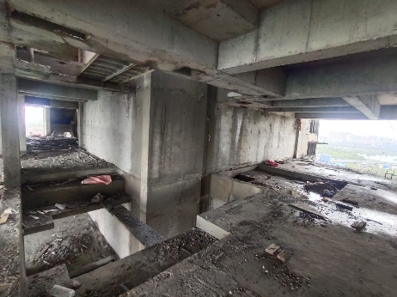
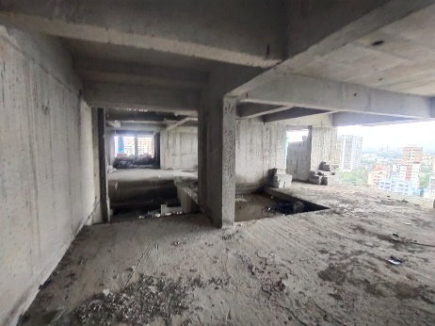
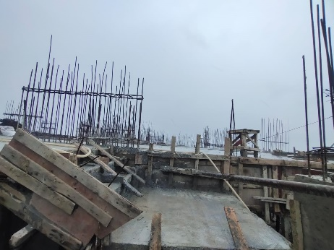
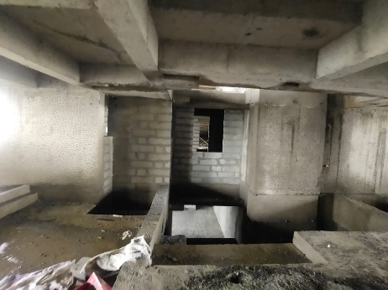
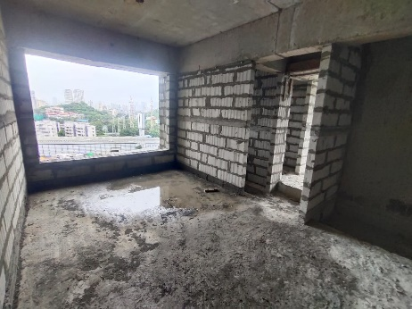
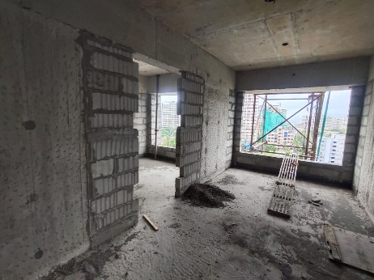
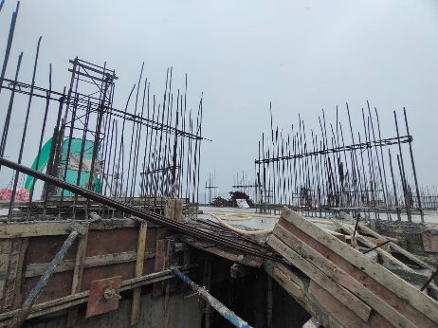
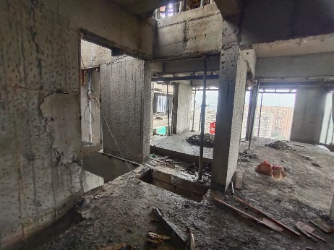
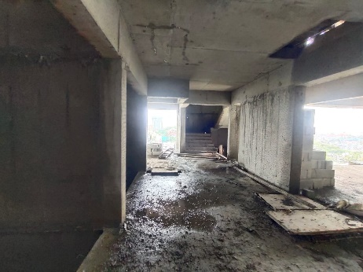
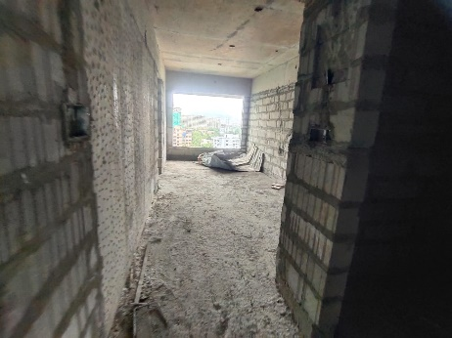
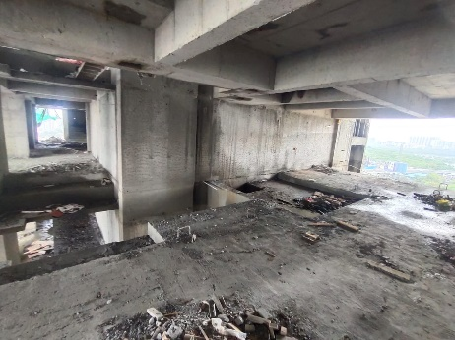
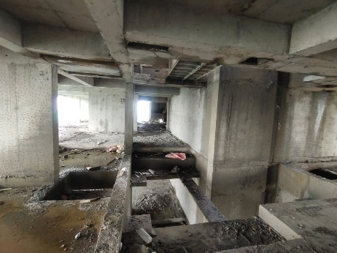
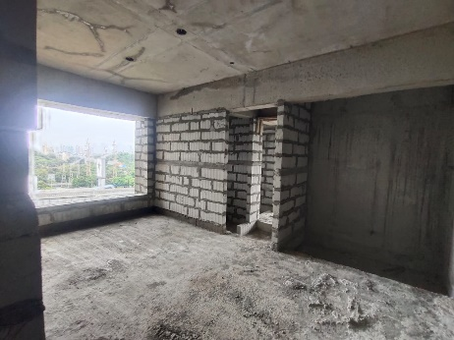
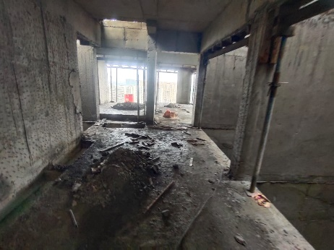
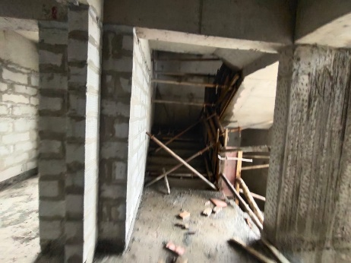

Actual Site Photographs as on 09.07.2024

Wing B & C
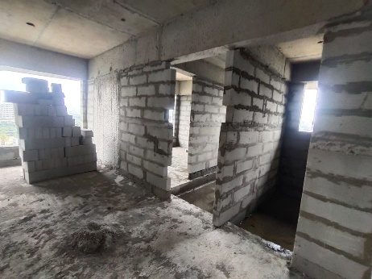
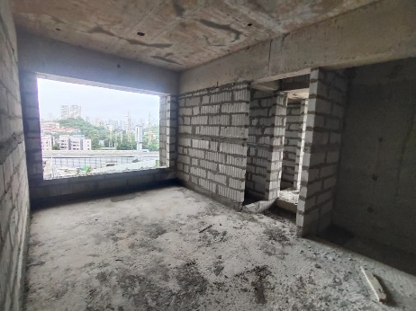
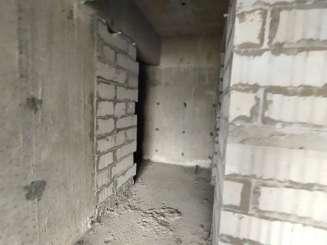
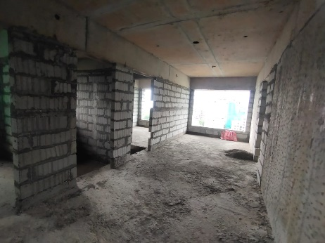
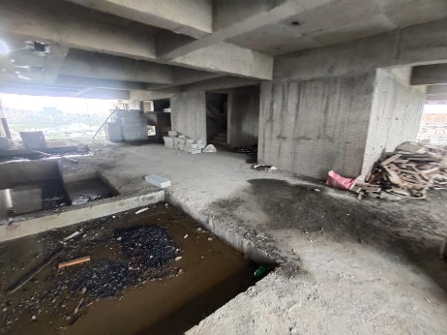
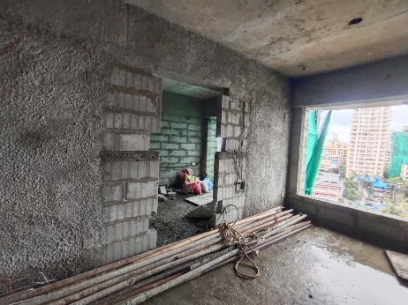
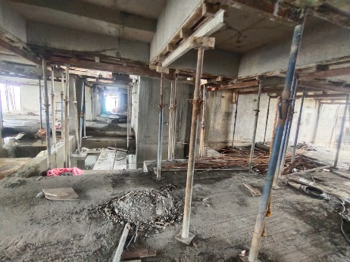
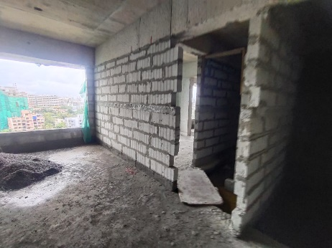
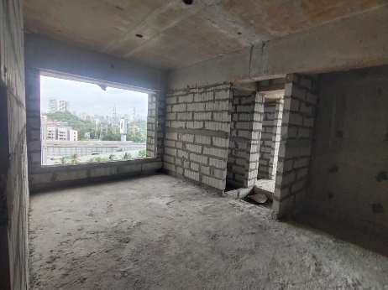
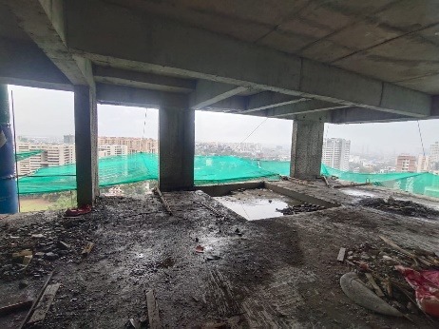
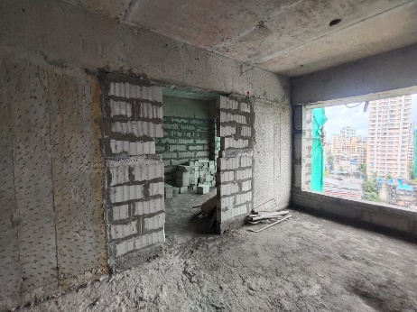
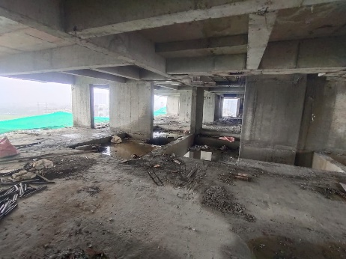
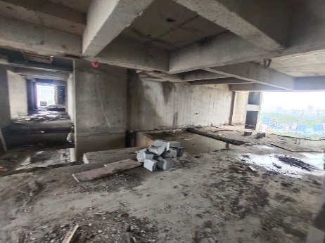
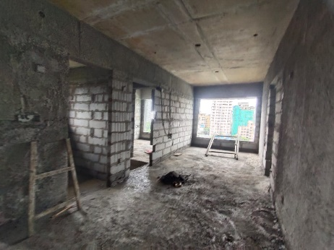
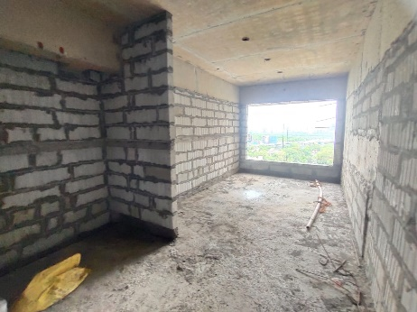

Actual Site Photographs as on 09.07.2024

Wing B & C
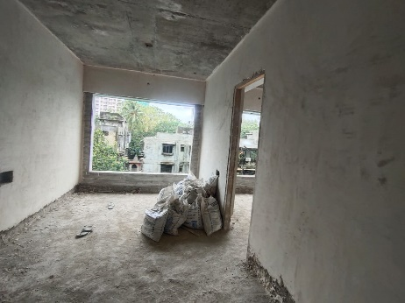
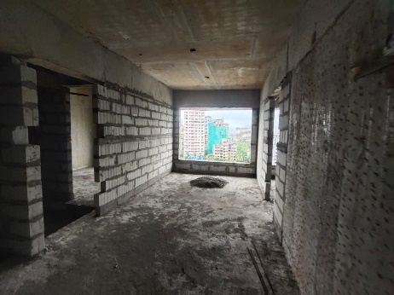
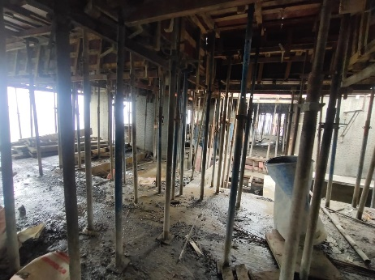
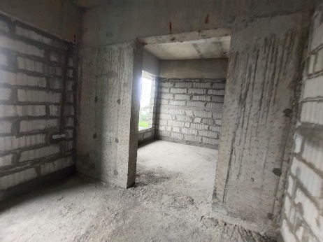
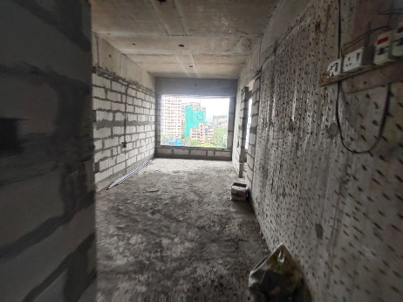
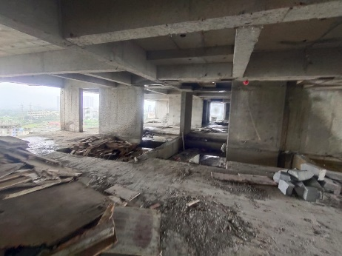
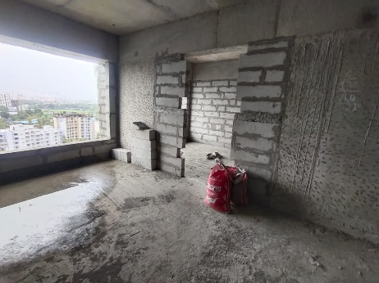
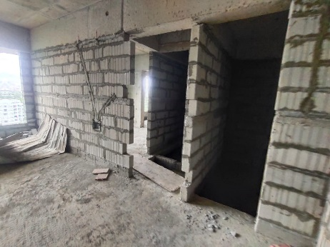
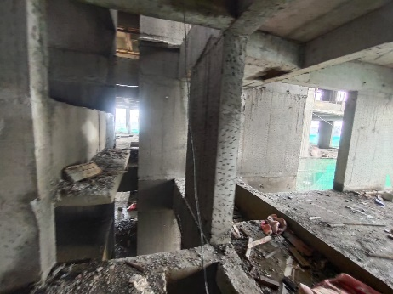
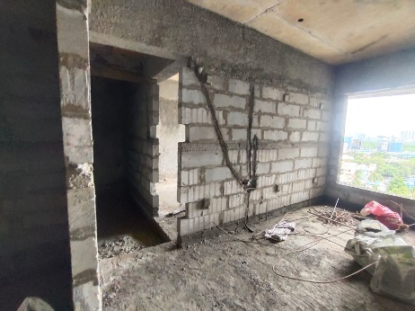
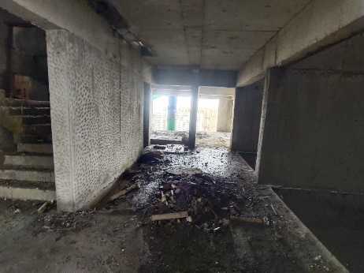
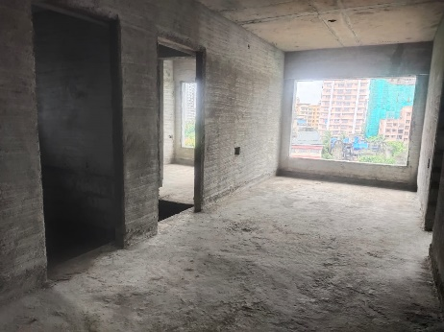
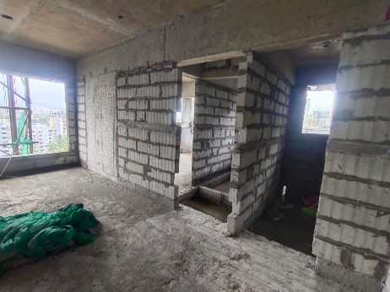
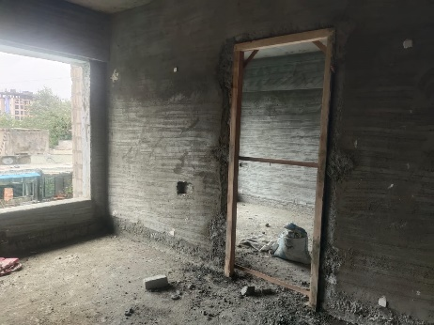
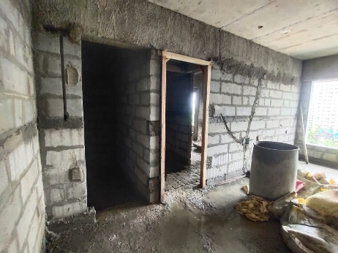

Actual Site Photographs as on 09.07.2024

Wing B & C
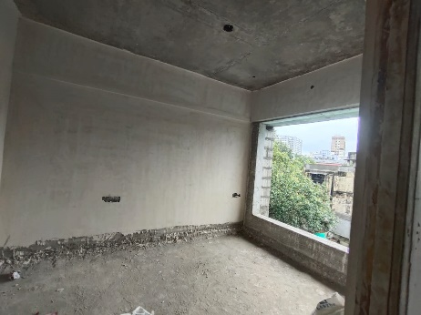
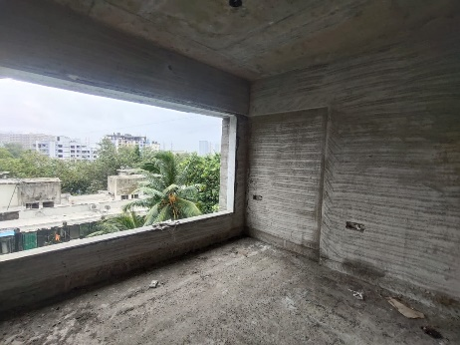
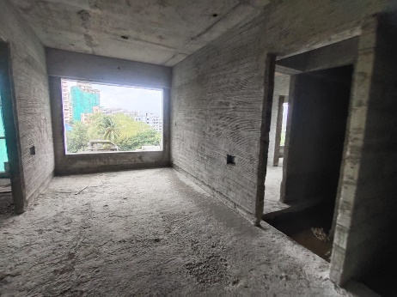
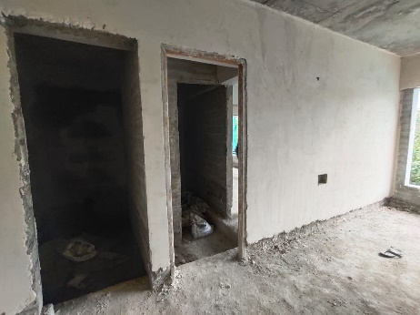
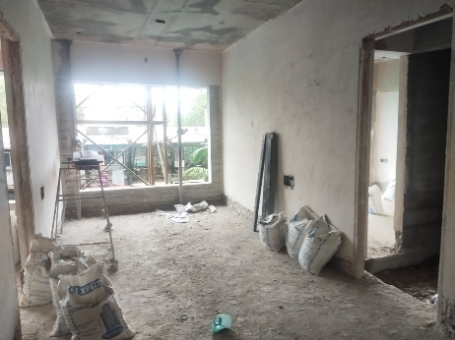
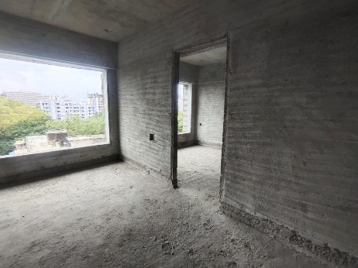
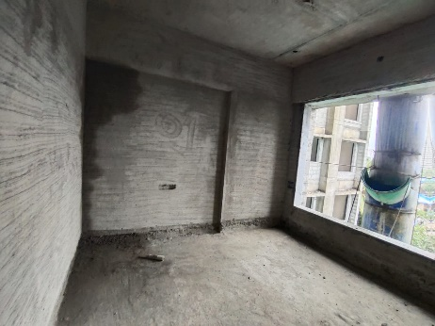
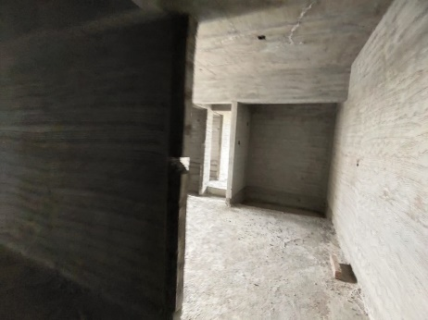
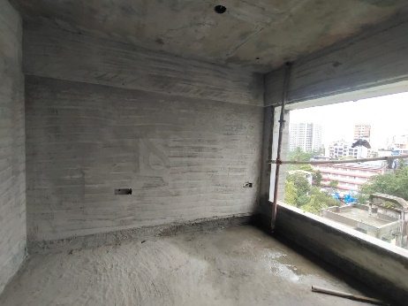
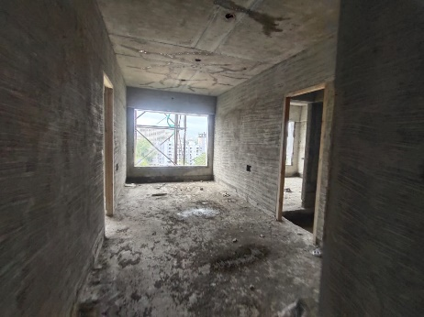
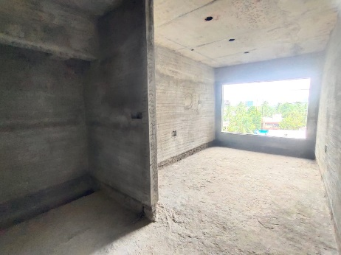
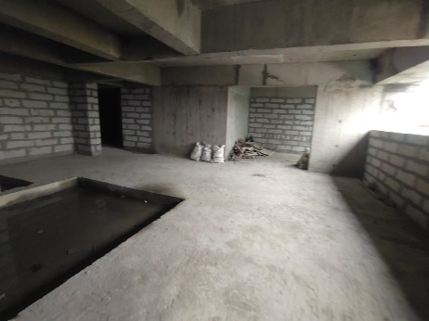
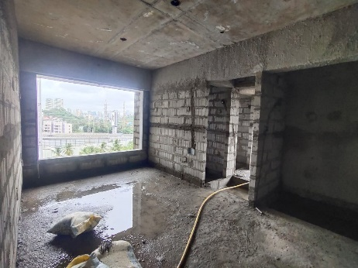
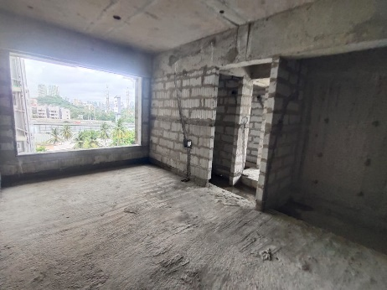
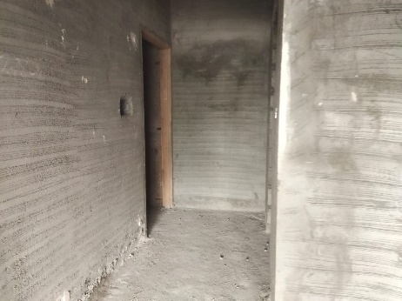

Actual Site Photographs as on 09.07.2024

Wing B & C
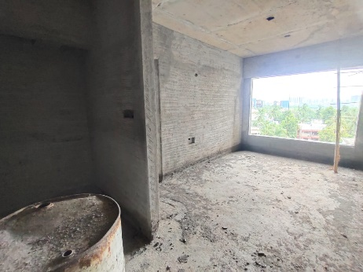
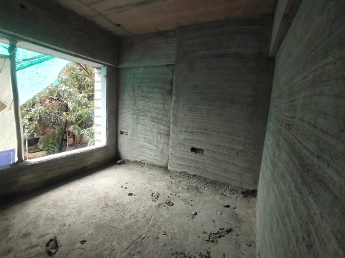
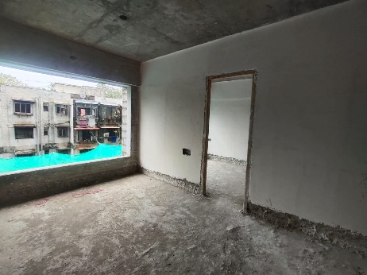
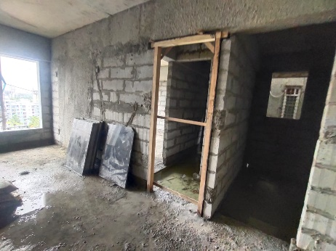
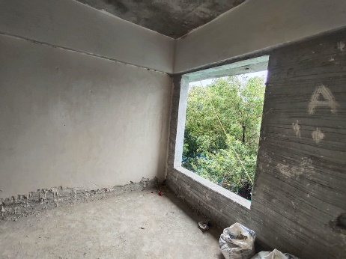
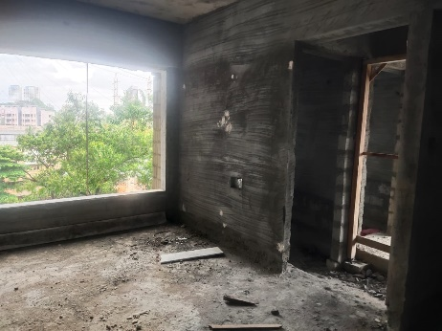
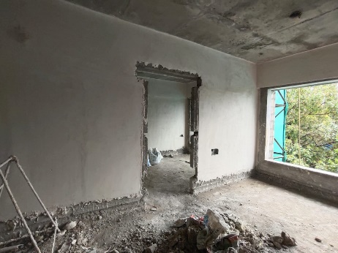
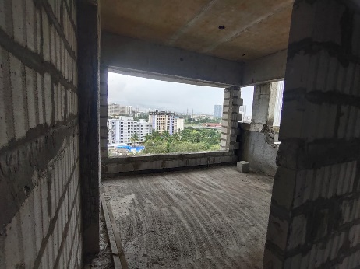
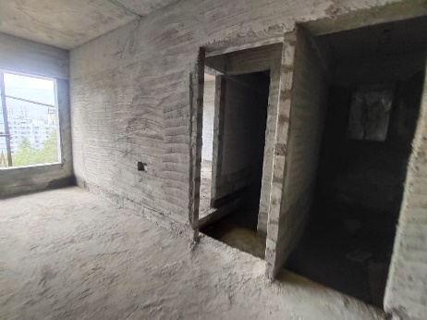
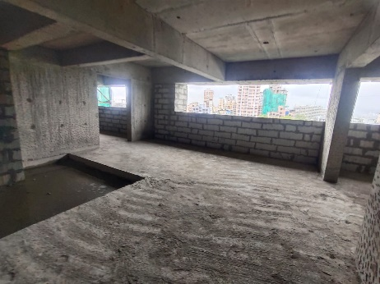
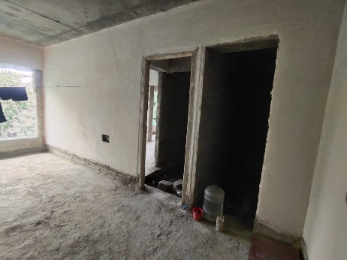
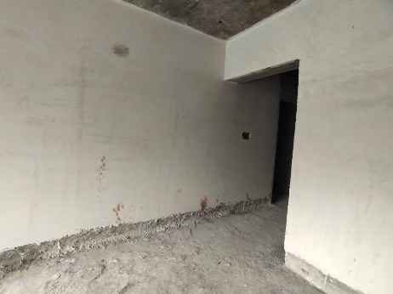

Actual Site Photographs as on 09.07.2024

Wing D
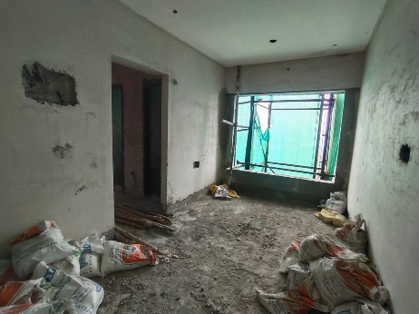
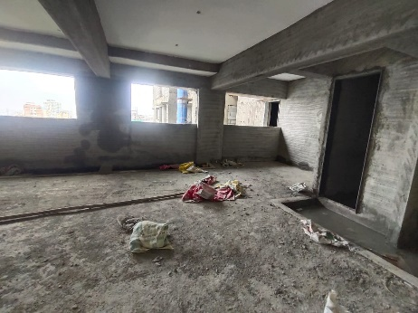
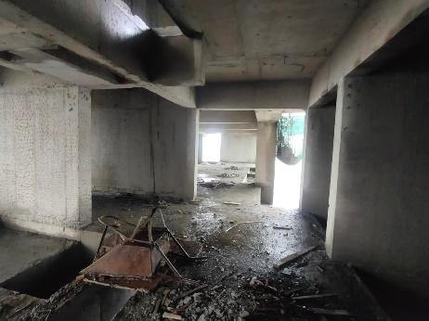
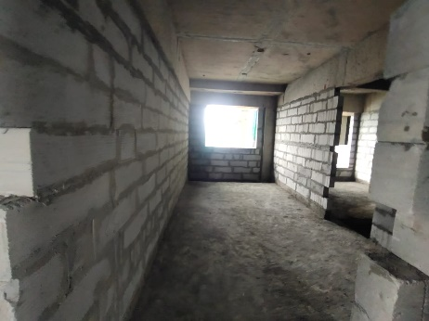
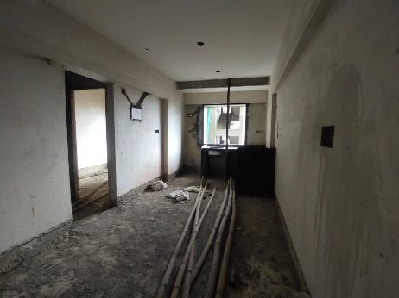
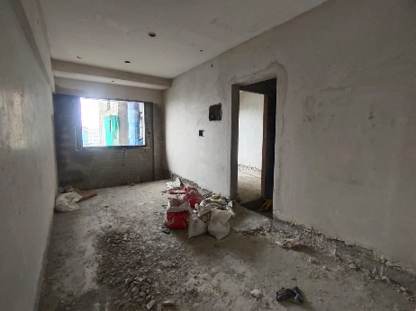
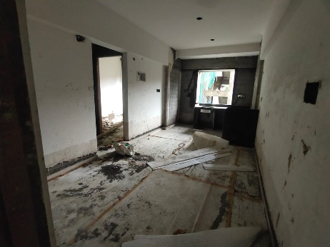
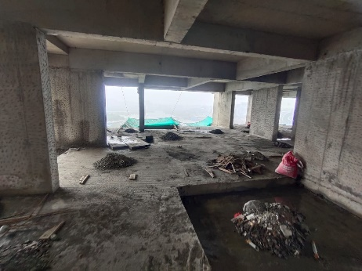
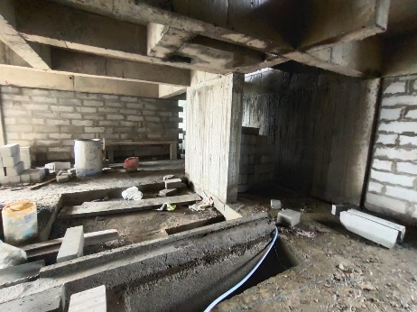
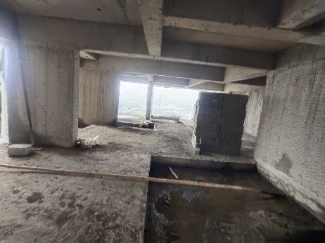
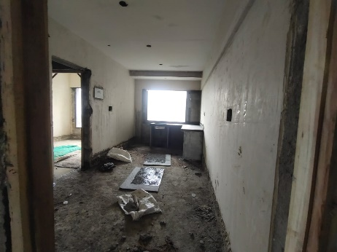
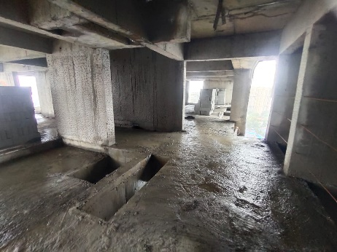
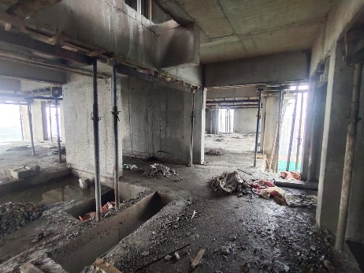
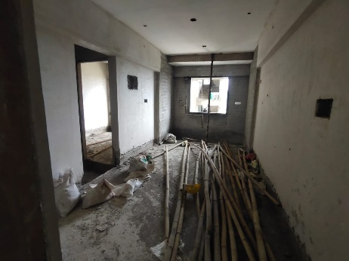
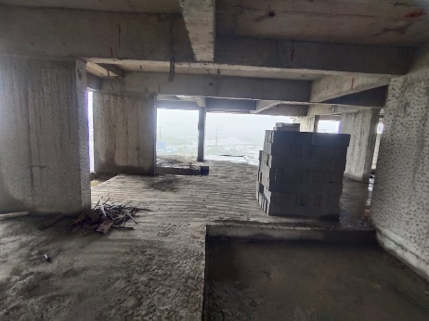

Actual Site Photographs as on 09.07.2024

Wing D
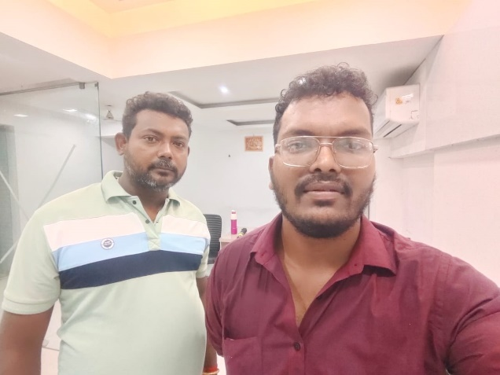
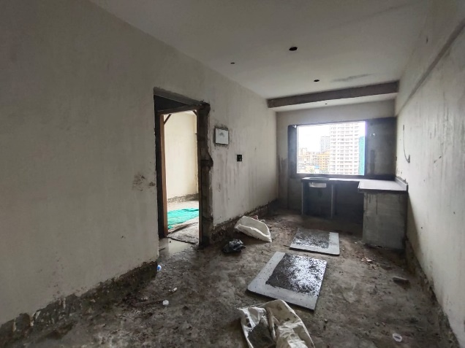
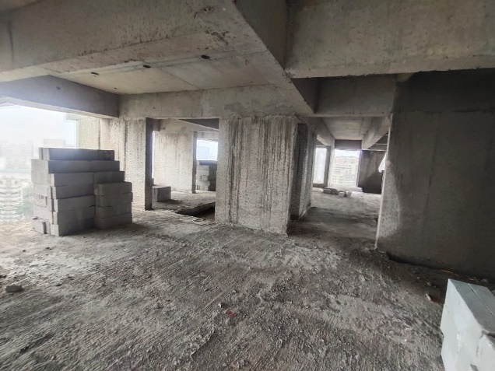
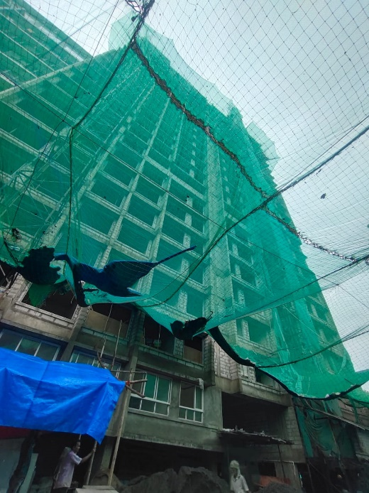
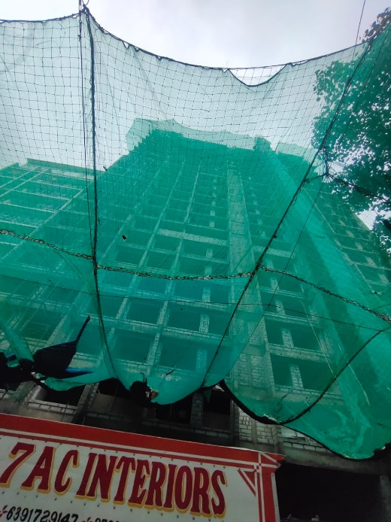
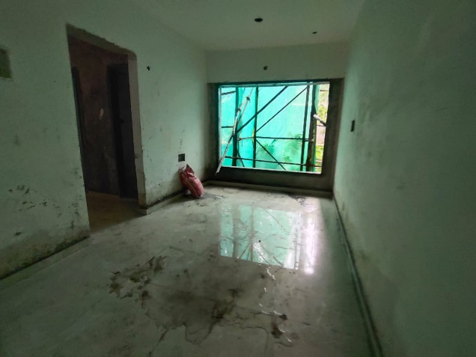
Route Map of the property
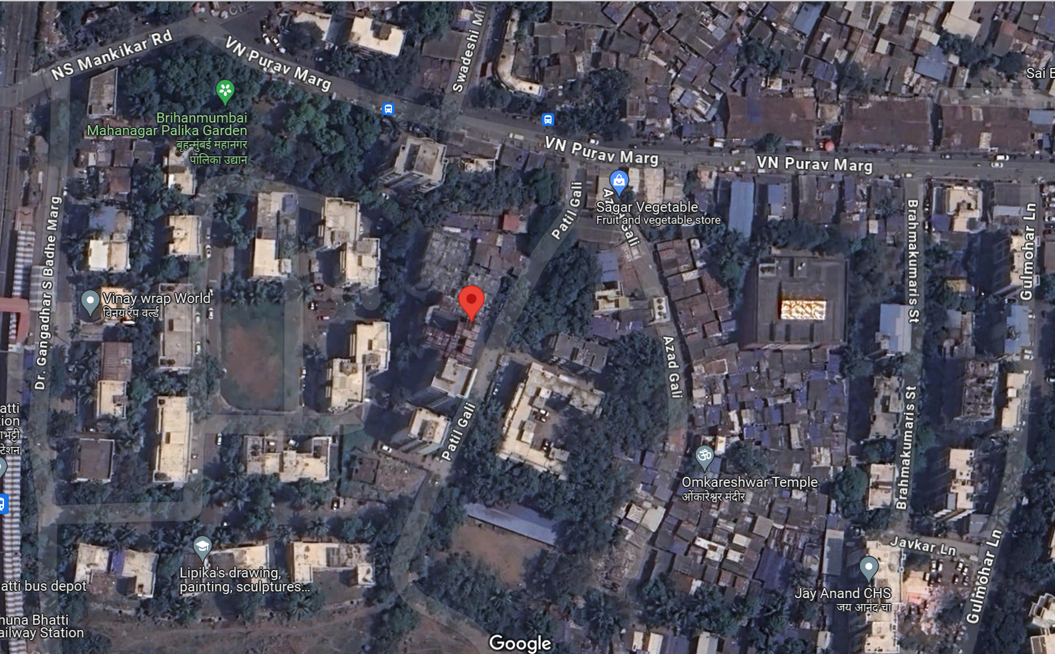
Site u/r

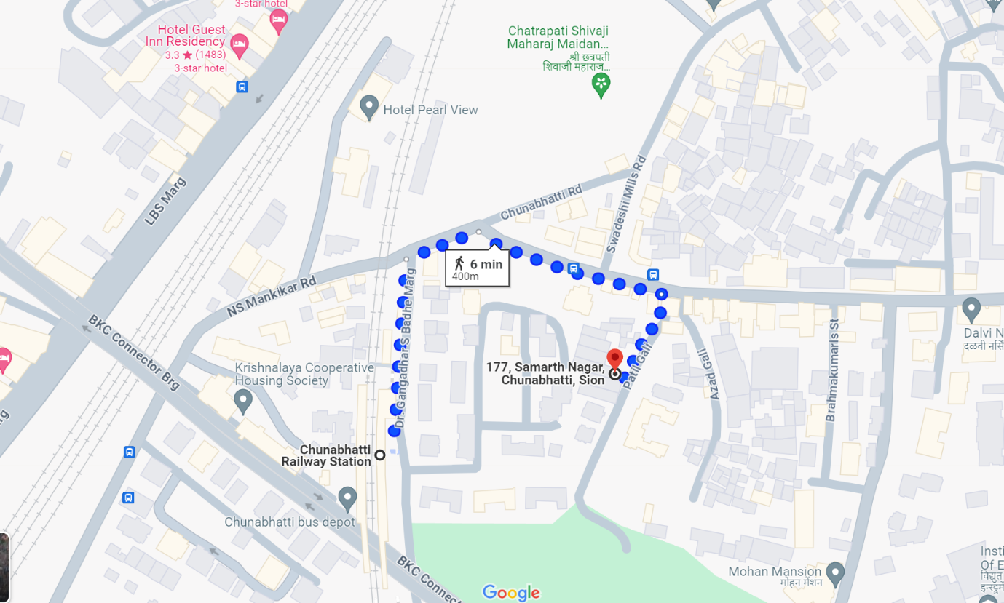

Latitude Longitude: 19°03'08.4"N 72°52'14.5"E

Note: The Blue line shows the route to site from nearest railway station (Chunnbatti – 400 M.)
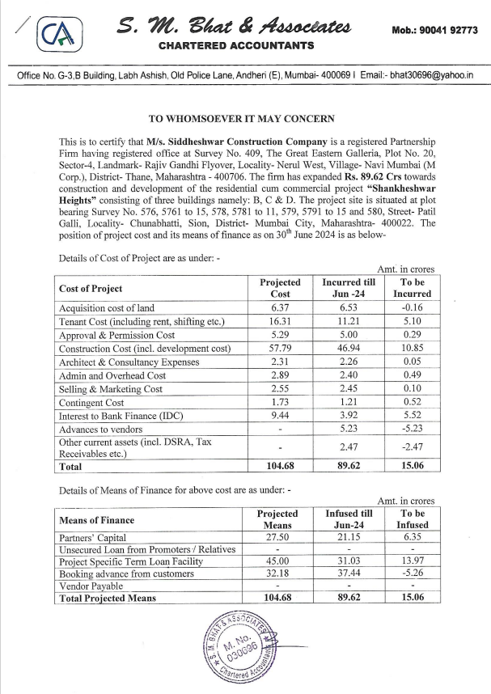
CA Certificate Dated 06.08.2024 till 30.06.2024

CA Certificate Dated 06.08.2024 till 30.06.2024
