Vastu/Nashik/06/32014/2301224
22/20-325-RYBS
Date: 28.08.2024

To,
The Branch Manager,
Union Bank of India
Gangapur Road Branch
Shree Ganesh Avenue, Chunchale Road,
Nashik - 422 013, State – Maharashtra, Country – India.

Sub: Vetting of Extra Work

Sir,

With reference to above subject, we have evaluated the Extra Work for Residential Flat No. 403, Fourth Floor, " Mayuri Heights ", Survey No. 124/ 1, Plot No. 4/ 5/ 35/ 36/ 37/ A, Near Baban Lawns, Dhruv Nagar, Gangapur - Satpur Link Road, Village – Gangapur, Taluka & District - Nashik, PIN Code – 422 007, State – Maharashtra, Country – India. belongs to Name of Proposed Purchaser : Mrs. Rohini Uttam Pawar & Mr. Uttam Ganpat Pawar. Name of Owner: M/s. Mayuri Infrastructure Private Limited.

We have verified the rates quoted as per current market rates. Details of Extra Work considered as per copy of Extra Work Agreement between Mr. Uttam Ganpat Pawar (First Party). Mr. Usha Shravan Shinde (Second Party) received on dated 25.08.2024. The Extra Work amount is Rs. 1,50,000/- (Rupees One Lakh Fifty Thousand Only)

The said Cost Vetting Certificate is valid upto next 6 months Only.

Thanking you

Sincerely yours

Sharadkumar B. Chalikwar
Govt. Reg. Valuer
Chartered Engineer (India)
Reg. No. (N) CCIT/1-14/52/2008-09

Agreement for Extra Work
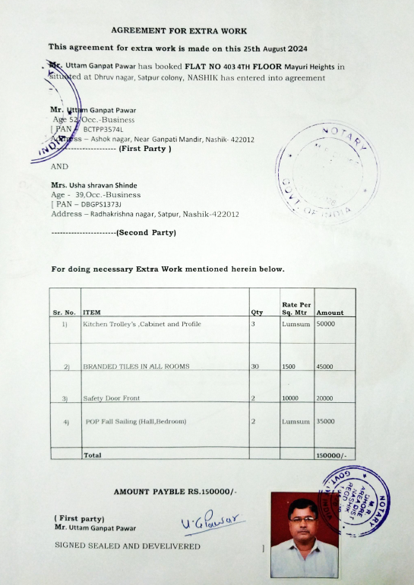
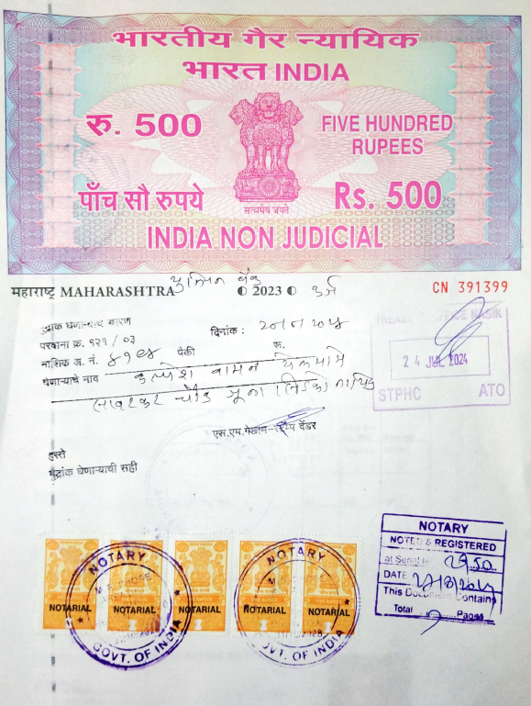

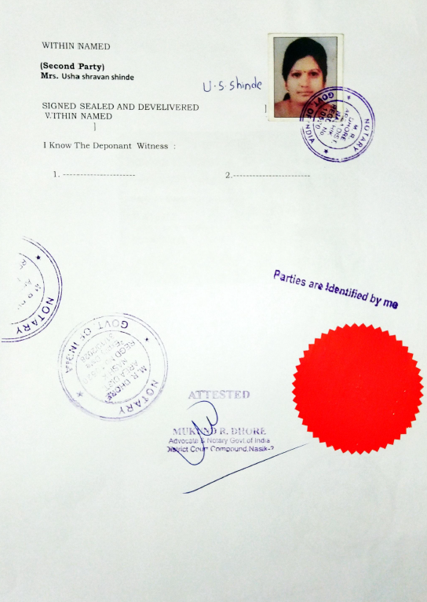

The Extra Work amount is Rs. 1,50,000/- (Rupees One Lakh Fifty Thousand Only)

