Vastu/Nashik/04/2024/008419/2306108
26/11-247-RYBS
Date: 28.08.2024

To,
The Chief Manager,
Bank of Baroda
Regional Office
BSNL Building, Datta Mandir Road, Nashik Road,
Nashik, PIN – 422 101, State - Maharashtra, Country - India.

Sub: Vetting of Estimate

Sir,

With reference to above subject, we have evaluated the Estimate for Residential Land and Proposed House on Plot No. 227, Gat No. 184, Near Vishwakarma Chowk, Shramik Nagar, Village –Pimpalgaon Bahula, Taluka – Nashik, District Nashik, Pin Code – 422 007, State - Maharashtra, Country – India. belongs to Shri. Shashikant Manibhai Patel & Sau.Shubhada Hemant Karandikar Name of Proposed Purchaser: Shri.Lakhan Raghoji Waghmare &
Sau.Pornima Lakhan Waghmare.

We have verified the rates quoted as per current market rates. Details of Estimate considered as per copy of Estimate Provided by The Designers received on dated.14.05.2024. The Estimate amount is Rs.9,00,000/- (Rupees Nine Lakh Only.)

Note:1) The said Cost Vetting Certificate is valid upto next 6 months Only.

Thanking you

Sincerely yours

Manoj B. Chalikwar
Registered Valuer
Chartered Engineer (India)
Reg. No. CAT-I-F-1763
Reg. No. IBBI/RV/07/2018/10366
BOB Empanelment No.: ZO:MZ:ADV:46:941
Encl: Valuation Report

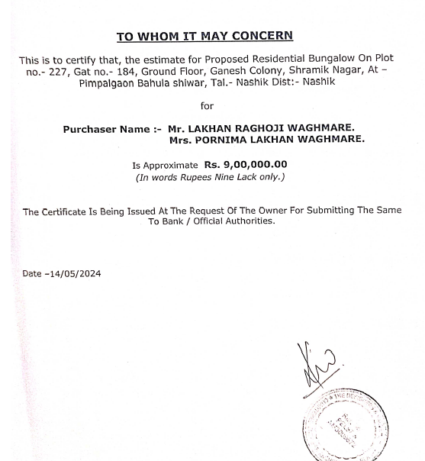
Estimate
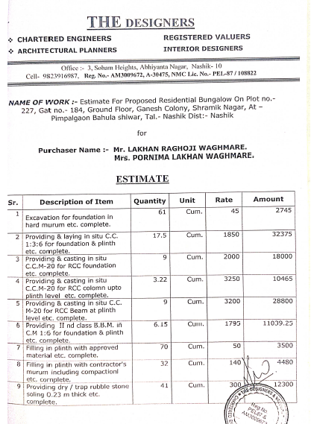

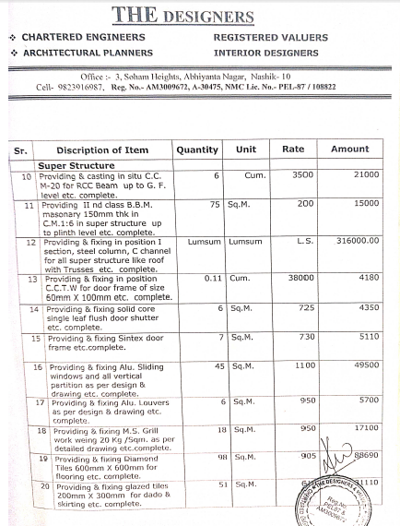
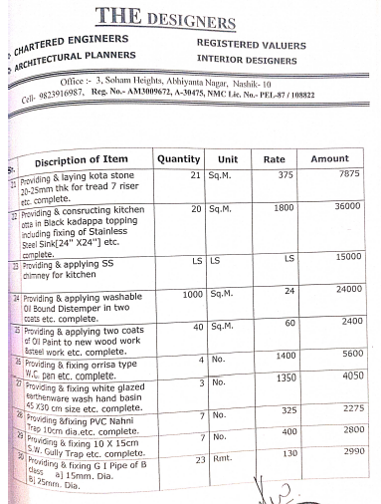

Estimate
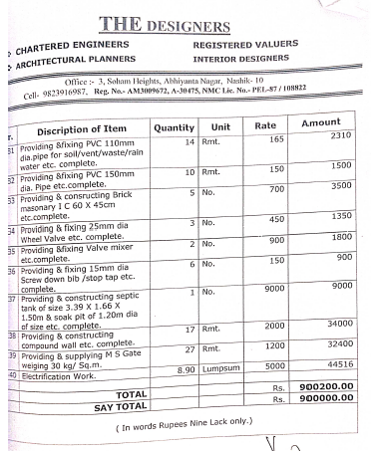

The Estimate amount is Rs.9,00,000/- (Rupees Nine Lakh Only.)

