Vastu/Nashik/02/2024/006731/2304808
03/4-30-RYBS
Date:28.08.2024

To,
The Branch Manager,
Bank of Baroda
Regional Office
BSNL Building, Datta Mandir Road, Nashik Road,
Nashik, PIN – 422 101, State - Maharashtra, Country - India.

Sub: Vetting of Extra Work Agreement

Sir,

With reference to above subject, we have evaluated the Extra Work For Residential Row Bungalow on Plot No. 71, Ground Floor + First Floor, " Kalanagar Row Bungalow ", Survey No. 126/ 3/ 2/ 2, Opp. to Sushil Nagari Co-Op Housing Society, Asha Nagar, Village – Mhasrul, Taluka - Nashik & District - Nashik, PIN Code - 422 003, State - Maharashtra, Country - India. belongs to Name of Proposed Purchaser : Shri. Ganesh Jankiram More & Sau. Dnyaneshwari Ganesh More. Name of Owner : Shri. Karan Rajendra Bhamre.

We have verified the rates quoted as per current market rates. Details of work and Extra Work considered as per copy of Agreement for Extra Work Agreement between Shri. Ganesh Jankiram More & Sau. Dnyaneshwari Ganesh More (First Party) and Shri. Vasant Farika Sonawane. (Second Party) received on dated 27.08.2024. The Extra Work amount is Rs. 6,30,000/- (Rupees Six Lakh Thirty Thousand Only).

The said Cost Vetting Certificate is valid upto next 6 months Only.

Thanking you

Sincerely yours

Manoj B. Chalikwar
Registered Valuer
Chartered Engineer (India)
Reg. No. CAT-I-F-1763
Reg. No. IBBI/RV/07/2018/10366
BOB Empanelment No.: ZO:MZ:ADV:46:941
Encl: Valuation report.

Agreement For Extra Work
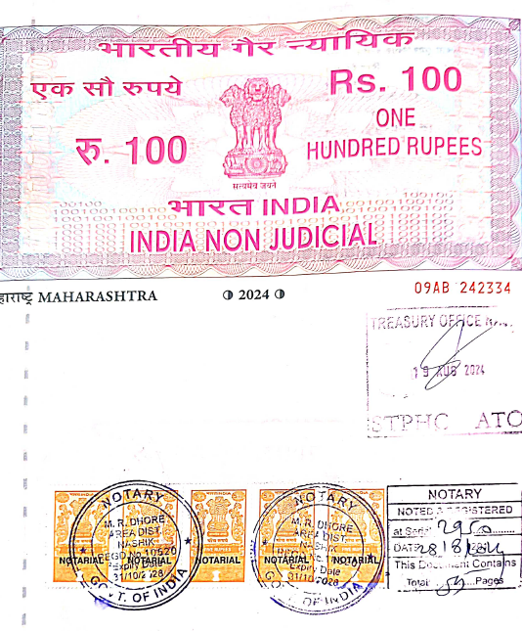
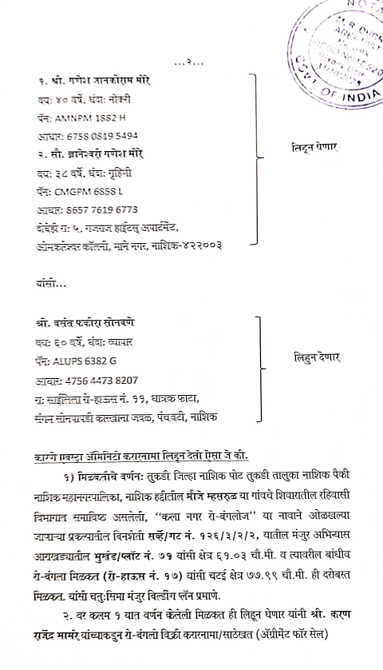

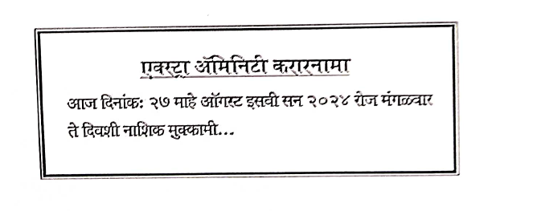

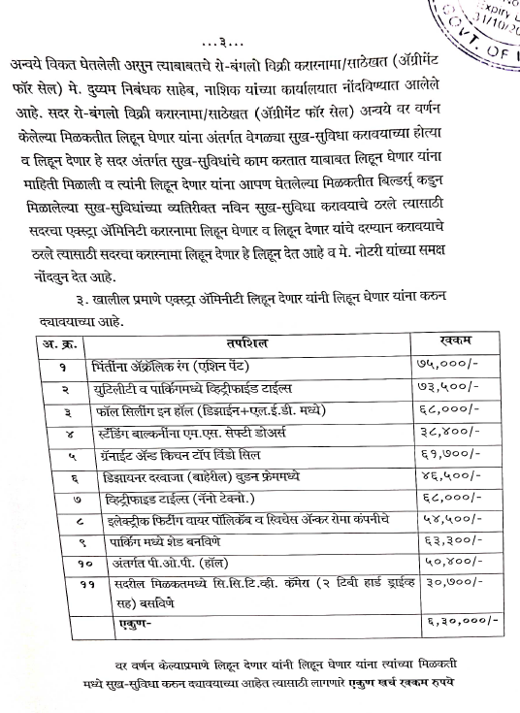
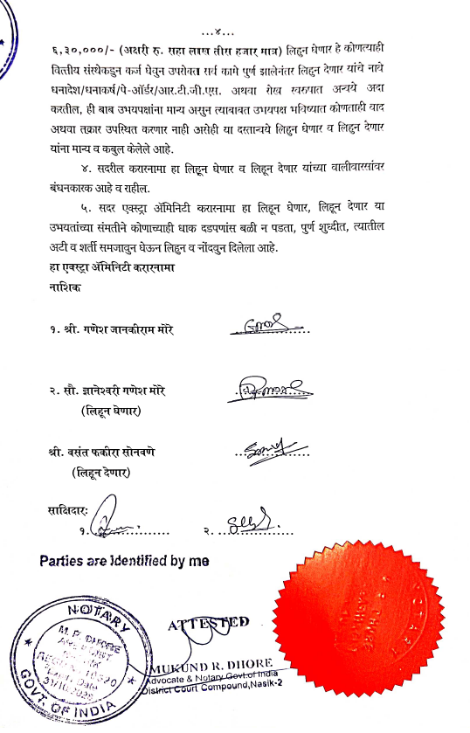

The Extra Work amount is Rs. 6,30,000/- (Rupees Six Lakh Thirty Thousand Only)

