Vastu/Nashik/02/2024/006731/2304808
03/4-30-RYBS
Date:28.08.2024

To,
The Branch Manager,
Bank of Baroda
Regional Office
BSNL Building, Datta Mandir Road, Nashik Road,
Nashik, PIN – 422 101, State - Maharashtra, Country - India.

Sub: Vetting of Extra Work Agreement

Sir,

With reference to above subject, we have evaluated the Extra Work For Residential Flat No. 7, 2nd Floor, Wing - A, " R.K. Building ", Gat No. 181 Part to 184, Plot No. 25 & 30, Near R.K. Memorial Hospital, Viman Nagar, Village - Ozhar, Taluka - Niphad, District - Nashik, Pin Code - 422206, State - Maharashtra, Country - lndia. belongs to Mr. Binod Kumar Sharma.

We have verified the rates quoted as per current market rates. Details of work and Extra Work considered as per copy of Agreement for Extra Work Agreement between Mr. Binod Kumar Sharma (First Party) and Mr. Roshan Rajendra Navgire. (Second Party) received on dated 21.08.2024. The Extra Work amount is Rs. 10,00,000/- (Rupees Four Ten Lakh Only).

The said Cost Vetting Certificate is valid upto next 6 months Only.

Thanking you

Sincerely yours

Manoj B. Chalikwar
Registered Valuer
Chartered Engineer (India)
Reg. No. CAT-I-F-1763
Reg. No. IBBI/RV/07/2018/10366
BOB Empanelment No.: ZO:MZ:ADV:46:941
Encl: Valuation report.

Agreement For Extra Work
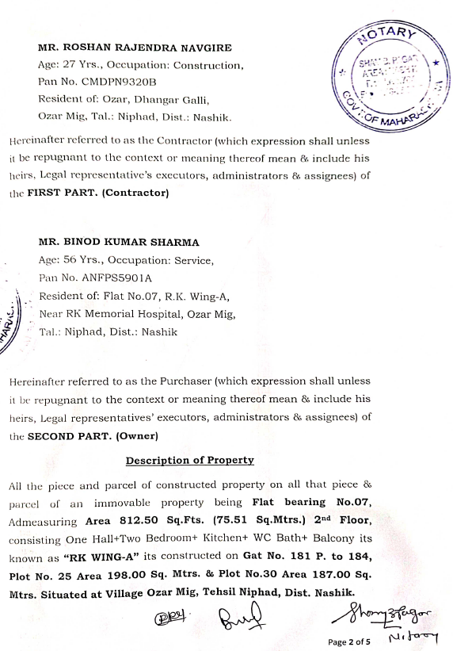
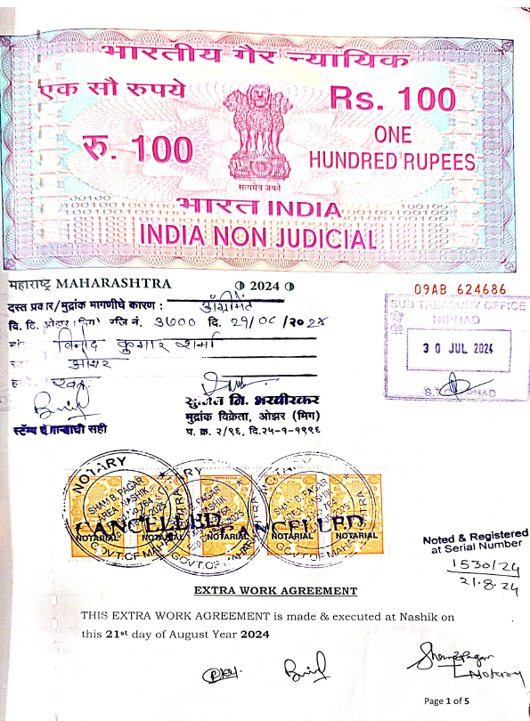

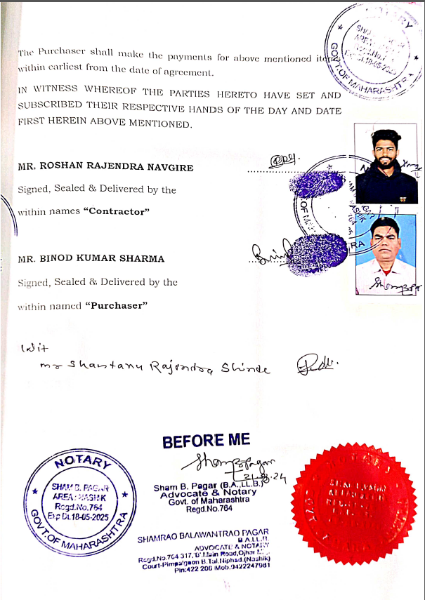
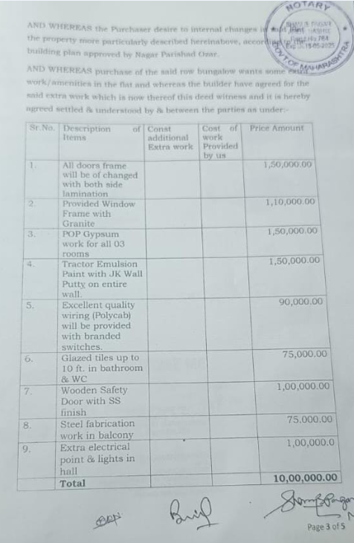

The Extra Work amount is Rs. 10,00,000/- (Rupees Ten Lakh Only)

