Vastu/Nashik/08/2024/010863/2307900
27/19-378-RPBS
Date: 27.08.2024

To, `
The Branch Manager,
State Bank of lndia
RACPC Nashik
1st Floor, Patel Plaza, N.D.Patel Road, Opp BSNL,
Landmark Seawoods Navratna Hotel Nashik-422001.

Sub: Vetting of Extra Amenities

Sir,

With reference to above subject, we have evaluated the Vetting of Extra Amenities Agreement for Residential Flat No. 1, 1st Floor, Shriram, Near Shanti Niketan Udyan, Plot No. 7, Pramod Nagar, Swami Vivekanand Marg, Village - Nashik, Taluka - Nashik, District - Nashik, Nashik, 422013, State - Maharashtra, India belongs to Puja Arun Pati.

We have verified the rates quoted as per current market rates. Details of work and Extra Amenities considered as per copy of Extra Amenities Agreement issued by Puja Arun Pati (First Party) Gaurav Bhausaheb Burhade (Second Party) received on dated 27.08.2024 The Vetting of Extra Amenities amount is Rs.47,93,000/- (Rupees Forty-Seven Lakh Ninety-Three Thousand Only)

The said Cost Vetting Certificate is valid upto next 6 months Only.

Thanking you

Sincerely yours

Manoj B. Chalikwar
Registered Valuer
Chartered Engineer (India)
Reg. No. CAT-I-F-1763
Reg. No. IBBI/RV/07/2018/10366
BOB Empanelment No.: ZO:MZ:ADV:46:941
Encl: Valuation report.

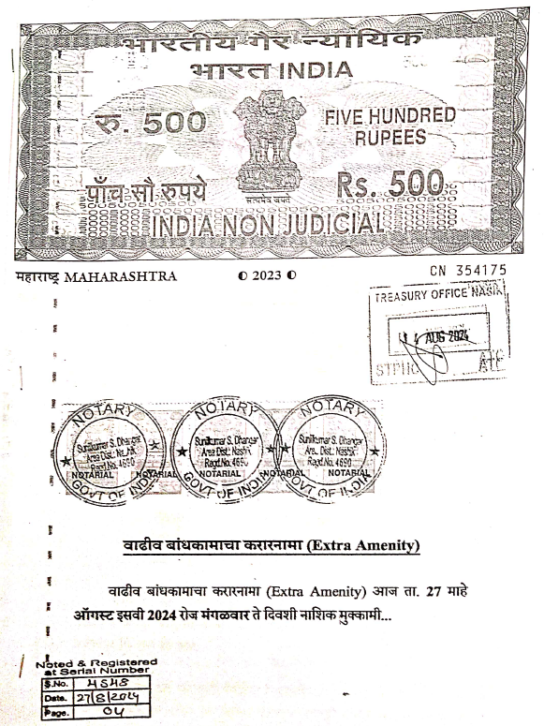
Vetting of Extra Amenities Agreement
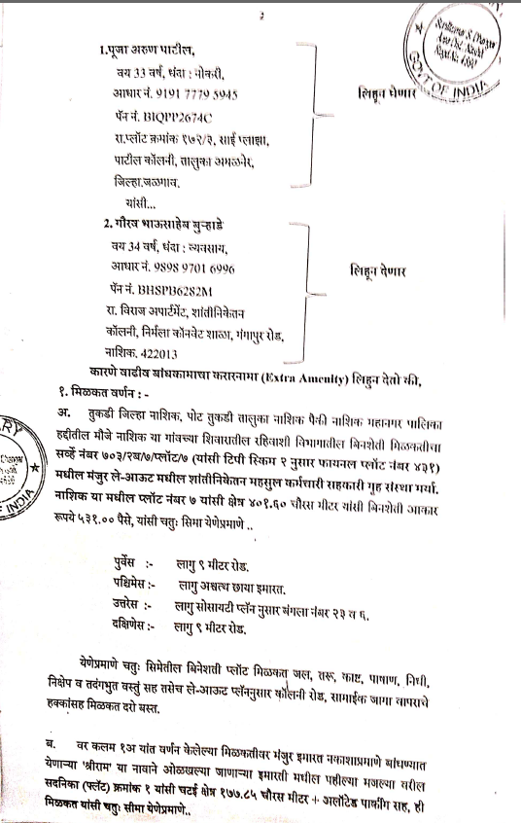

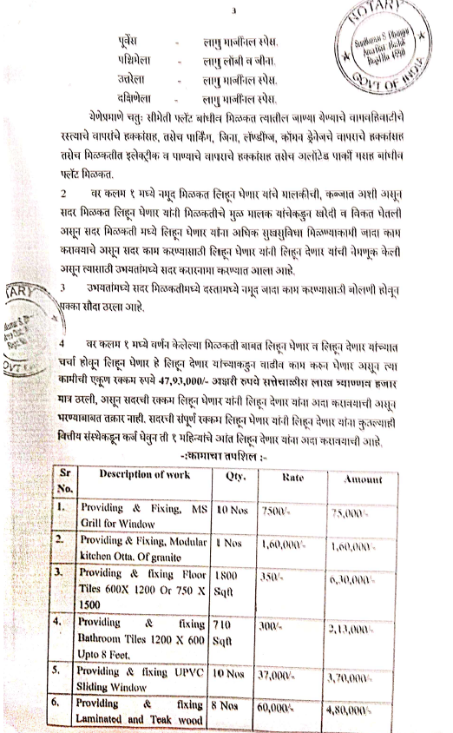
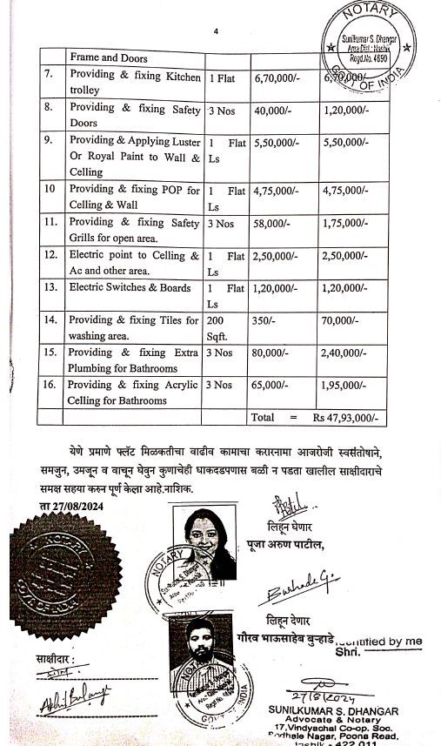

The Extra Amenities amount is Rs.47,93,000/- (Rupees Forty-Seven Lakh Ninety-Three Thousand Only.)

