Vastu/Nashik/08/010813/2307848
24/14-326-RYRJ
Date: 24.08.2024

The Branch Manager,
State Bank of India
RACPC Nashik Branch
1st Floor, Patel Plaza, N.D. Patel Road,
Opp. BSNL, Landmark Seawoods Navratna Hotel,
Nashik - 422001, State – Maharashtra, Country – India.

Sub: Vetting of Extra Amenities

Sir,

With reference to above subject, we have evaluated the Extra Amenities for Residential Flat No. 301, B - Wing, Third Floor, Survey No. 42/ 1/ 1, Plot No. 2, " Samruddhi Tower ", Near Shani Maharaj Mandir, Someshwar Satpur Link Road, Right Canal Road, Village - Gangapur, Taluka & District - Nashik, PIN Code - 422 013, State - Maharashtra, Country - lndia. Belongs to Mr. Swapnil Pandharinath Patil & Mrs. Lalita Swapnil Patil.

We have verified the rates quoted as per current market rates. Details of Extra Amenities considered as per copy of Extra Amenities Agreement between Mr. Swapnil Pandharinath Patil & Mrs. Lalita Swapnil Patil. (First Party). Mr. Abhishek More (Second Party) received on dated 23.08.2024. The Extra Amenities amount is Rs. 5,00,000/- (Rupees Five Lakh Only)

The said Cost Vetting Certificate is valid upto next 6 months Only.

Thanking you

Sincerely yours

Manoj B. Chalikwar
Registered Valuer
Chartered Engineer (India)
Reg. No. CAT-I-F-1763
SBI Empanelment No.: SME/TCC/2021-22/86/3
Encl. Valuation Report

Agreement for Extra Amenities
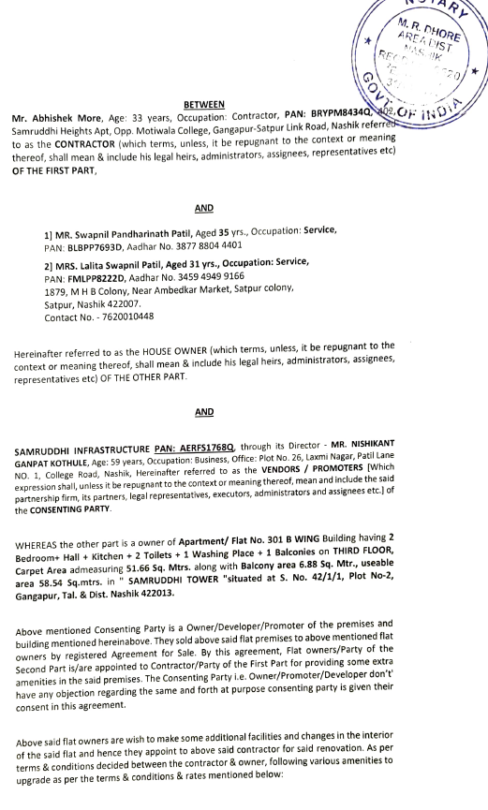
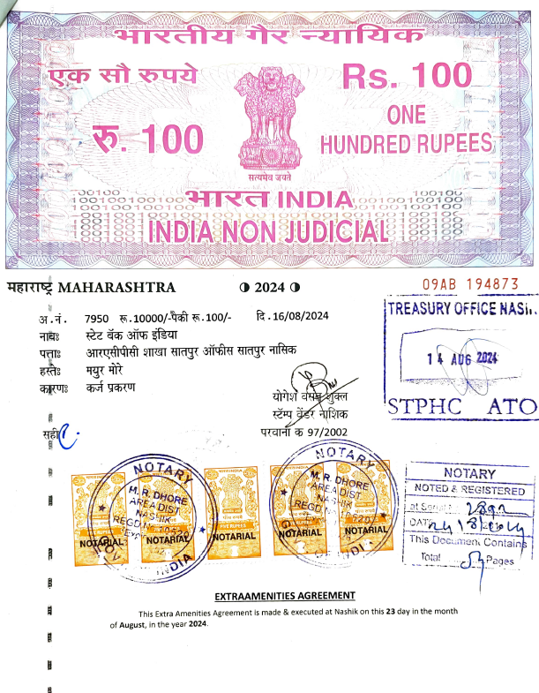

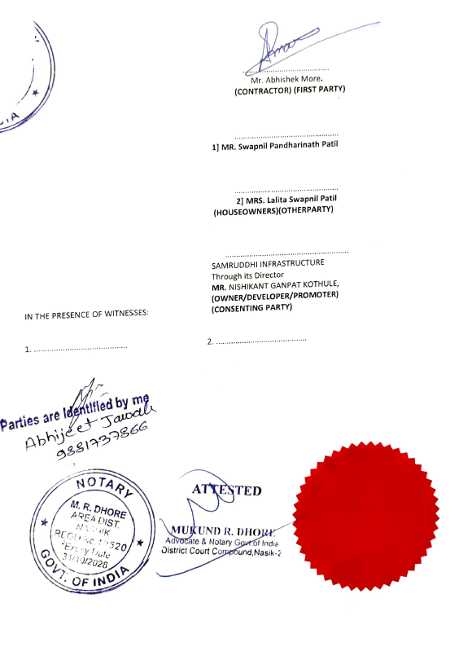
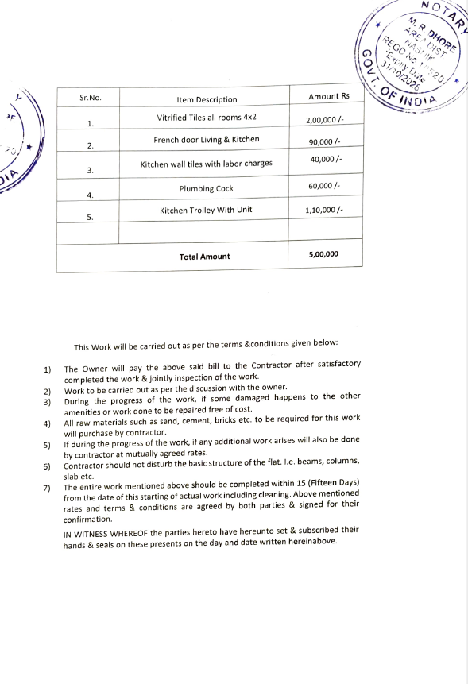

The Extra Amenities amount is Rs. 5,00,000/- (Rupees Five Lakh Only)

