Vastu/Nashik/02/2024/006731/2304808
03/4-30-RYRJ
Date:23.08.2024

To,
The Branch Manager,
Bank of Baroda
Regional Office
BSNL Building, Datta Mandir Road, Nashik Road,
Nashik, PIN – 422 101, State - Maharashtra, Country - India.

Sub: Vetting of Extra Work Agreement

Sir,

With reference to above subject, we have evaluated the Extra Work For Residential Flat No. 306, 3rd Floor, " Shivalik Sagar ", Survey No. 908/ 3/ 3/ 4, Plot No. 3+4, Near Saptashrungi Hospital, Mauli Nagari, Dnyaneshwar Nagar, Pathardi Phata, Vidya Road, Village - Pathardi, Taluka - Nashik, District - Nashik, Nashik - 422010, State - Maharashtra, lndia. belongs to belongs to M/s. Yogeshwar Realtors. Name of Proposed Purchaser is Bharti Vinod Patil.

We have verified the rates quoted as per current market rates. Details of work and Extra Work considered as per copy of Agreement for Extra Work Agreement between Bharti Vinod Patil (First Party) and Shri. Subhash Shravan Mahale. (Second Party) received on dated 12.08.2024. The Extra Work amount is Rs. 4,78,000/- (Rupees Four Lakh Seventy Eight Thousand Only).

The said Cost Vetting Certificate is valid upto next 6 months Only.

Thanking you

Sincerely yours

Manoj B. Chalikwar
Registered Valuer
Chartered Engineer (India)
Reg. No. CAT-I-F-1763
Reg. No. IBBI/RV/07/2018/10366
BOB Empanelment No.: ZO:MZ:ADV:46:941
Encl: Valuation report.

Agreement For Extra Work
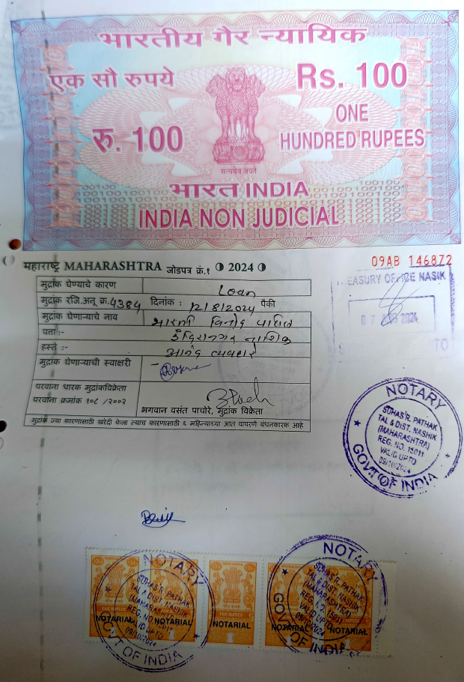
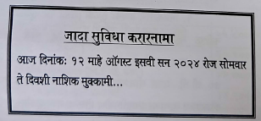

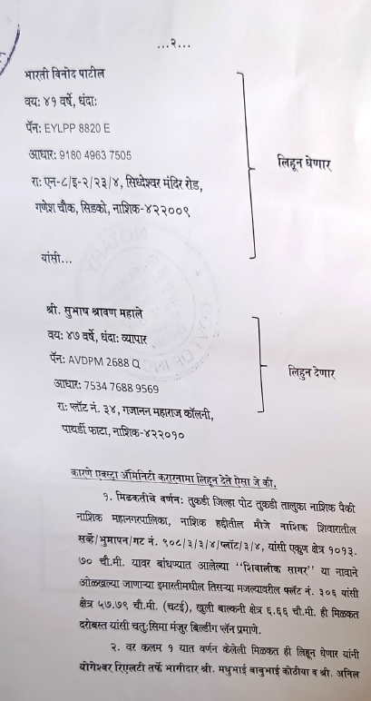

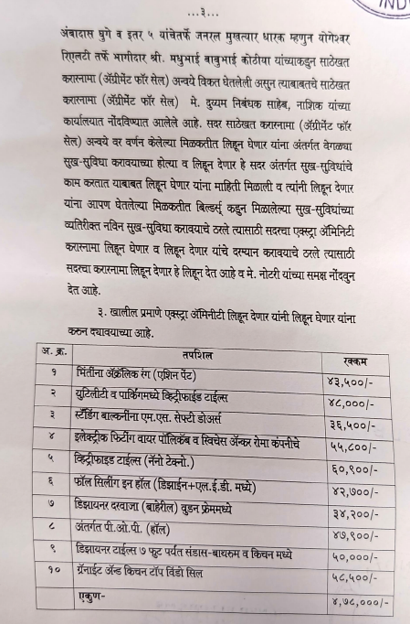
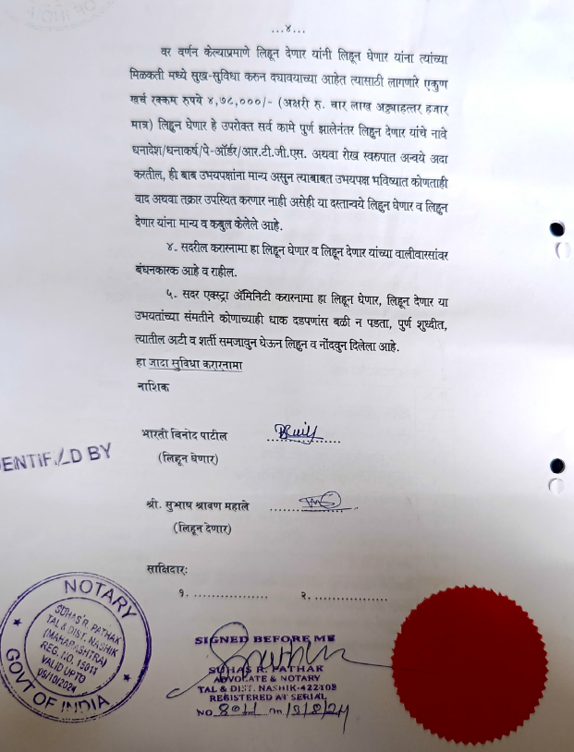

The Extra Work amount is Rs.4,78,000/- (Rupees Four Lakh Seventy Eight Thousand Only)

