Vastu/Nashik/02/2024/006731/2304808
03/4-30-RYBS
Date: 23.08.2024

To,
The Branch Manager,
Bank of Baroda
Regional Office
BSNL Building, Datta Mandir Road, Nashik Road,
Nashik, PIN – 422 101, State - Maharashtra, Country - India.

Sub: Vetting of Extra Work Agreement

Sir,

With reference to above subject, we have evaluated the Extra Work For Residential Flat No. C-502, 5th Floor, Wing - C, " Shree Chintamani Aneex ", Survey No. 159/ 1/ 1B/ 2, Plot No. 1+2, Near Aher Hospital, Sambhaji Chowk, Dr. Nanasaheb Dharmadhikari Marg, Village - Nashik, Taluka - Nashik, District - Nashik, Nashik, 422003, State - Maharashtra, lndia belongs to Shri. Ramhari Sanjay Bornare & Sau. Pratiksha Ramhari Bornare (Alias) Pratiksha Balasaheb Kate.

We have verified the rates quoted as per current market rates. Details of work and Extra Work considered as per copy of Agreement for Extra Work Agreement between Mr. Ramhari Sanjay Bornare & Mrs. Pratiksha Ramhari Bornare (Alias) Pratiksha Balasaheb Kate. (First Party) and Mr. Jay Patel. (Second Party) received on dated 21.08.2024. The Extra Work amount is Rs. 7,00,000/- (Rupees Seven Lakh Only).

The said Cost Vetting Certificate is valid upto next 6 months Only.

Thanking you

Sincerely yours

Manoj B. Chalikwar
Registered Valuer
Chartered Engineer (India)
Reg. No. CAT-I-F-1763
Reg. No. IBBI/RV/07/2018/10366
BOB Empanelment No.: ZO:MZ:ADV:46:941
Encl: Valuation report.

Agreement For Extra Work
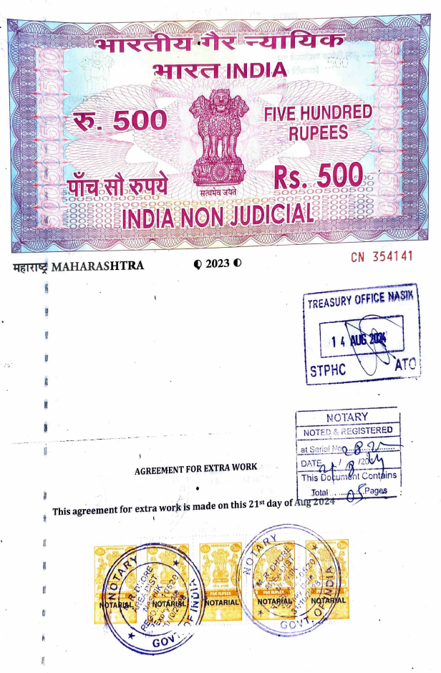
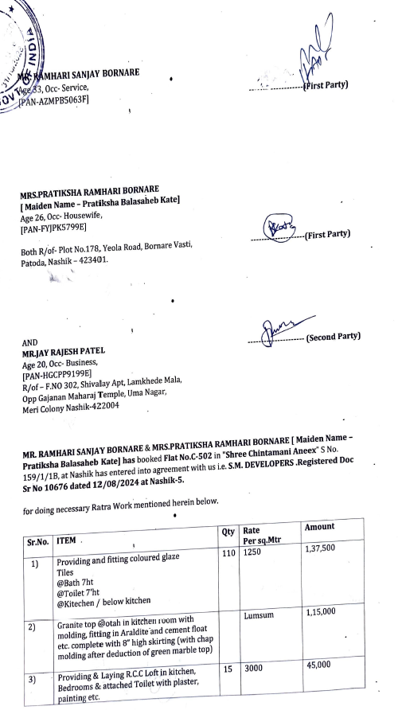

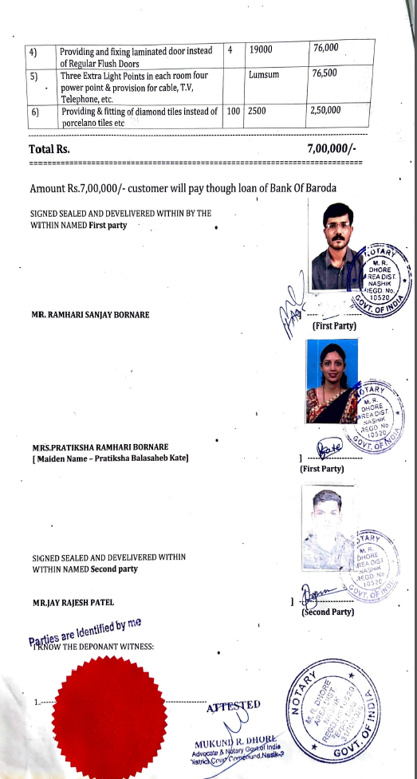

The Extra Work amount is Rs.7,00,000/- (Rupees Seven Lakh Only)

