Vastu/Nashik/07/2024/0010070/2307330
22/7-334-RPBS
Date: 21.08.2024

To, `
The Branch Manager,
Bank of Baroda
Regional Office Nashik Road Branch
BSNL Building, Datta Mandir Road, Nashik Road,
Nashik -422 101, State - Maharashtra, Country - India.

Sub: Vetting of Extra Amenities

Sir,

With reference to above subject, we have evaluated the Extra Amenities for Residential Flat No. 2, 1st Floor, Wing - A, "Arun", Omkar Sankul, Near New Grace Academy - Best English Medium School, Shirish Society, Plot No. 55+56+57+104+105+106/1, Bhorgad, Village - Makhamalabad, Taluka - Nashik, District - Nashik, Nashik, 422004, State - Maharashtra, India belongs to Shri. Shravan Bhiva Girandare & Sau. Kavita Shravan Girandare.

We have verified the rates quoted as per current market rates. Details of work and Extra Amenities considered as per copy of Agreement for Extra Amenities issued by Shri. Shravan Bhiva Girandare & Sau. Kavita Shravan Girandare (First Party) and Shri. Shrikant Baburao Pagar (Second Party) received on dated 30.07.2024. The Extra Amenities amount is Rs.6,30,000/- (Rupees Six Lakh Thirty Thousand Only.)

The said Cost Vetting Certificate is valid upto next 6 months Only.

Thanking you

Sincerely yours

Manoj B. Chalikwar
Registered Valuer
Chartered Engineer (India)
Reg. No. CAT-I-F-1763
Reg. No. IBBI/RV/07/2018/10366
BOB Empanelment No.: ZO:MZ:ADV:46:941
Encl: Valuation report.

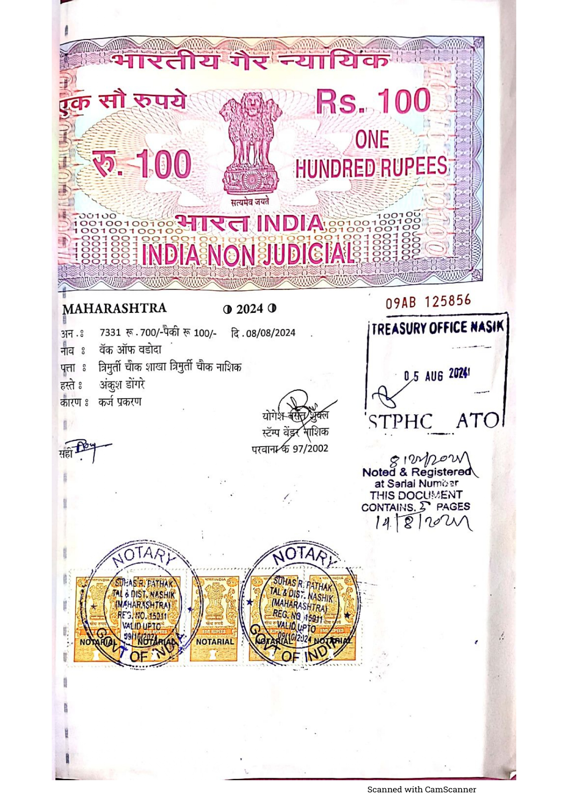
Agreement for Extra Amenities


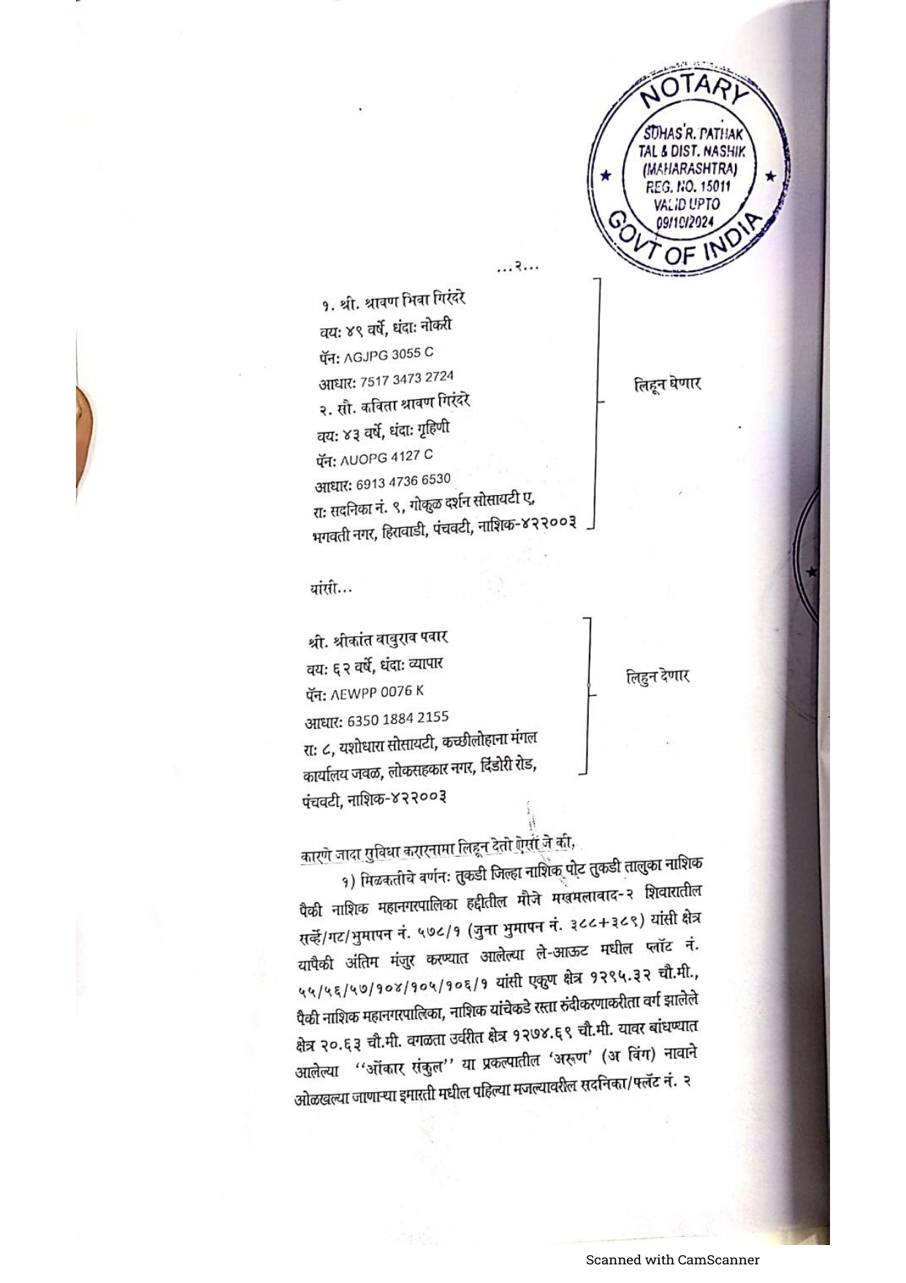

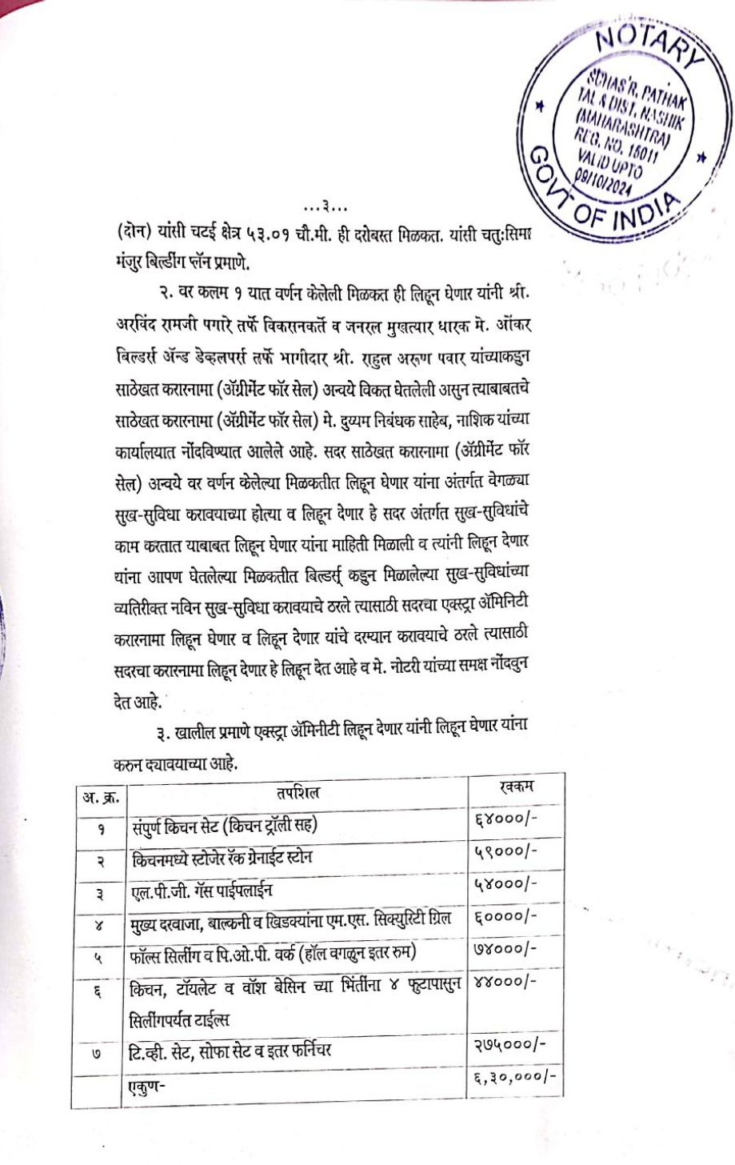
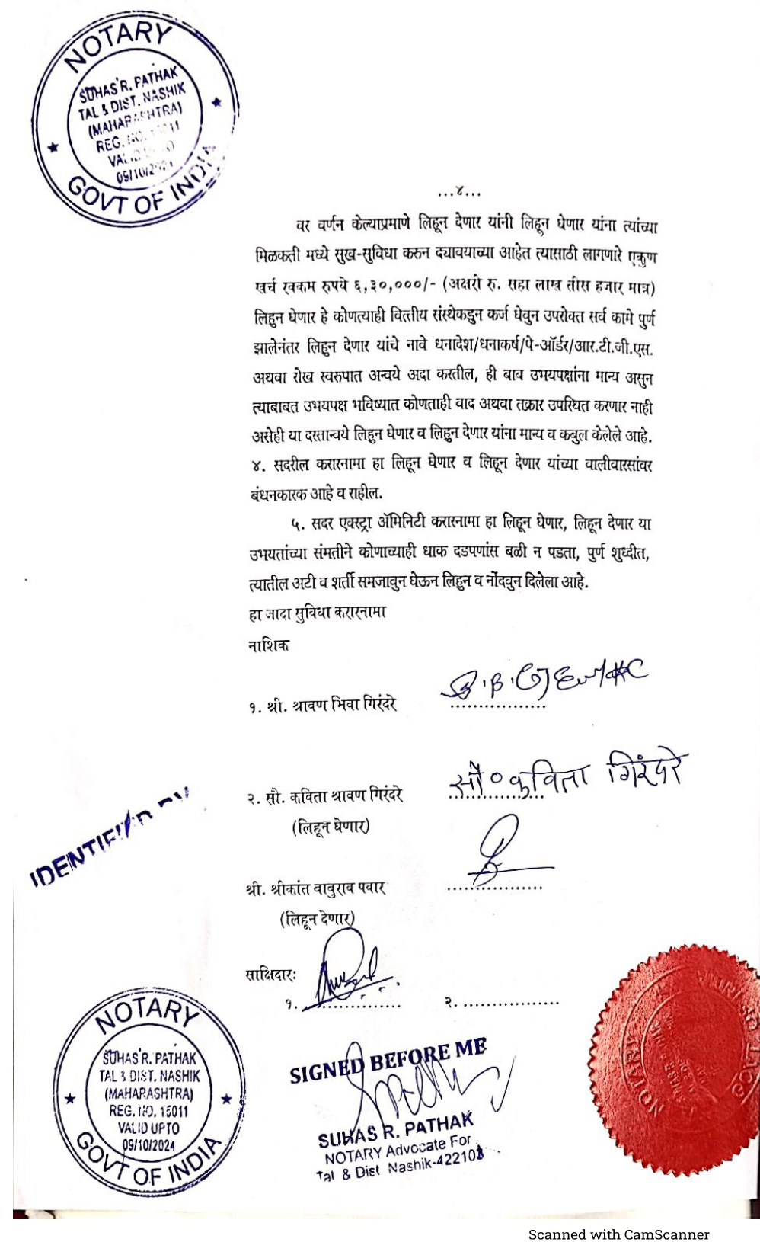

The Extra Amenities amount is Rs.6,30,000/- (Rupees Six Lakh Thirty Thousand Only.)

