Vastu/Nashik/07/2024/0010070/2307330
22/7-334-RPBS
Date: 21.08.2024

To, `
The Branch Manager,
State Bank of lndia
RACPC Nashik
1st Floor, Patel Plaza, N.D.Patel Road, Opp BSNL,
Landmark Seawoods Navratna Hotel Nashik-422001.

Sub: Vetting of Supplementary Agreement

Sir,

With reference to above subject, we have evaluated the Vetting of Supplementary Agreement for Residential Flat No. 306, 3rd Floor, Wing - B, Daksh Skyway Apartment , Near Motiwala Medical College, Dhruv Nagar, Gangapur - Satpur Link Road, Village - Gangapur, Taluka - Nashik, District - Nashik, Nashik, 422 007, State - Maharashtra, India belongs to Mrs. Pryianka Mangesh Chaudhari & Mr. Mangesh Shivaji Chaudhari.

We have verified the rates quoted as per current market rates. Details of work and Extra Amenities considered as per copy of Supplementary Agreement issued by Mrs. Pryianka Mangesh Chaudhari & Mr. Mangesh Shivaji Chaudhari (Second Party) received on dated 2024 The Supplementary Agreement amount is Rs.9,00,000/- (Rupees Nine Lakh Only.)

The said Cost Vetting Certificate is valid upto next 6 months Only.

Thanking you

Sincerely yours

Manoj B. Chalikwar
Registered Valuer
Chartered Engineer (India)
Reg. No. CAT-I-F-1763
Reg. No. IBBI/RV/07/2018/10366
BOB Empanelment No.: ZO:MZ:ADV:46:941
Encl: Valuation report.

Supplementary Agreement
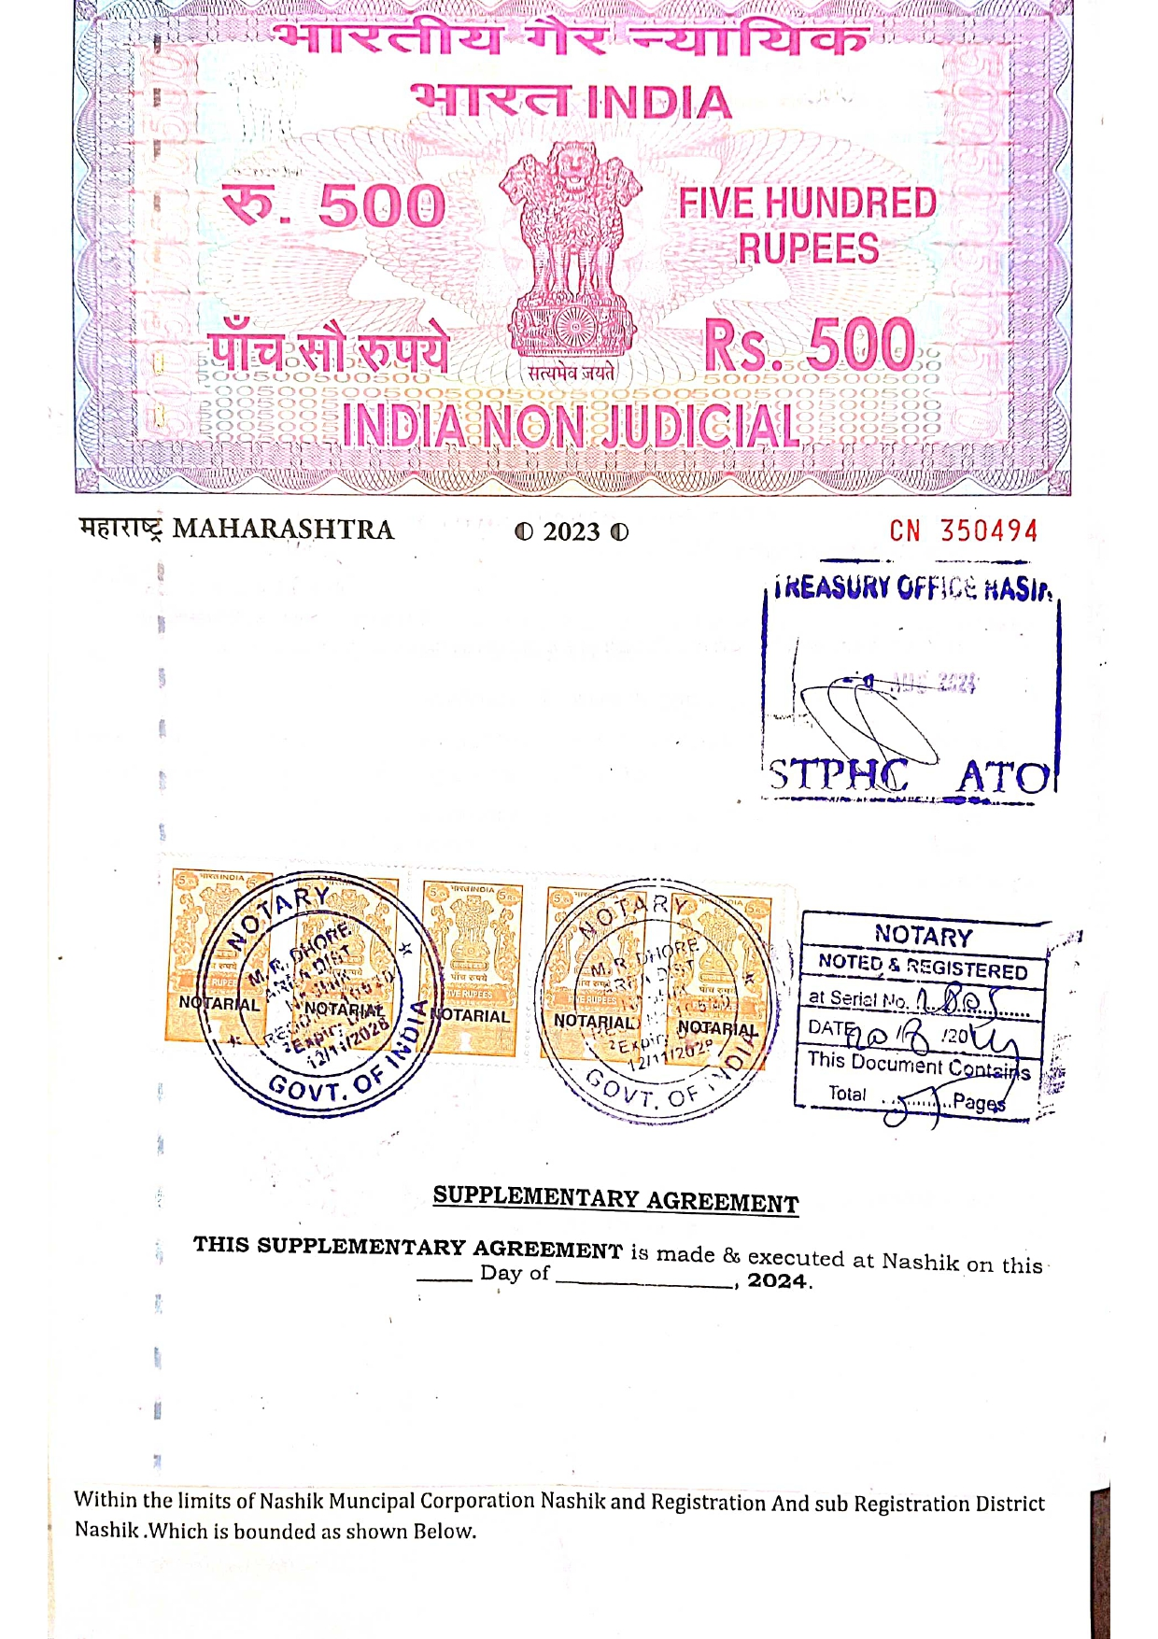
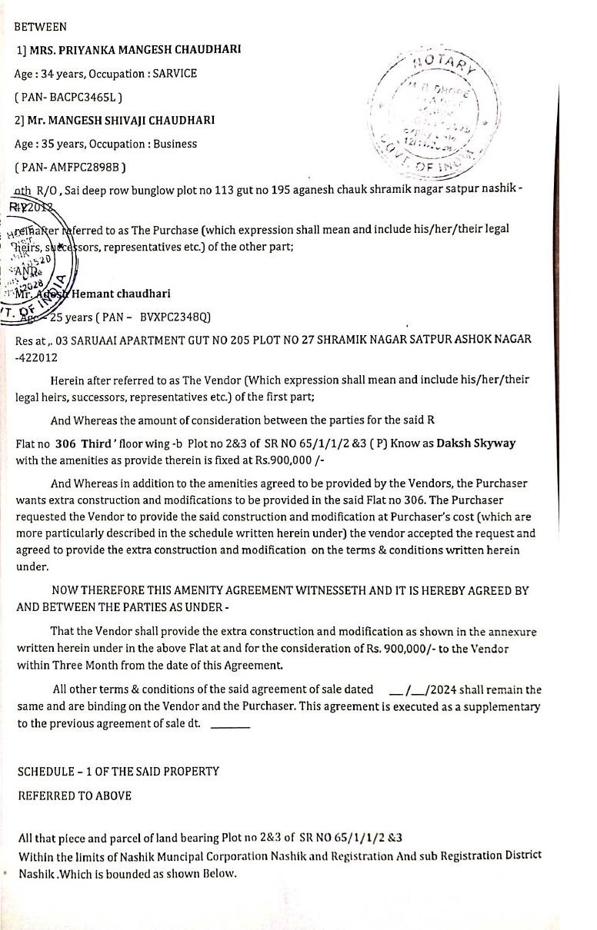

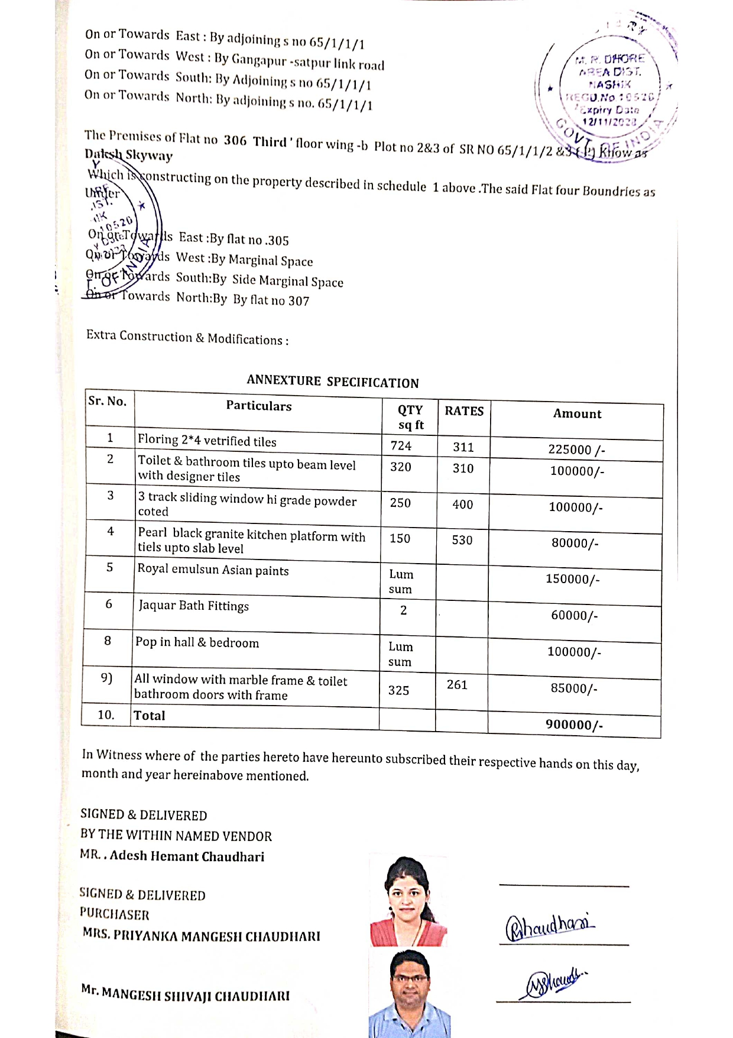
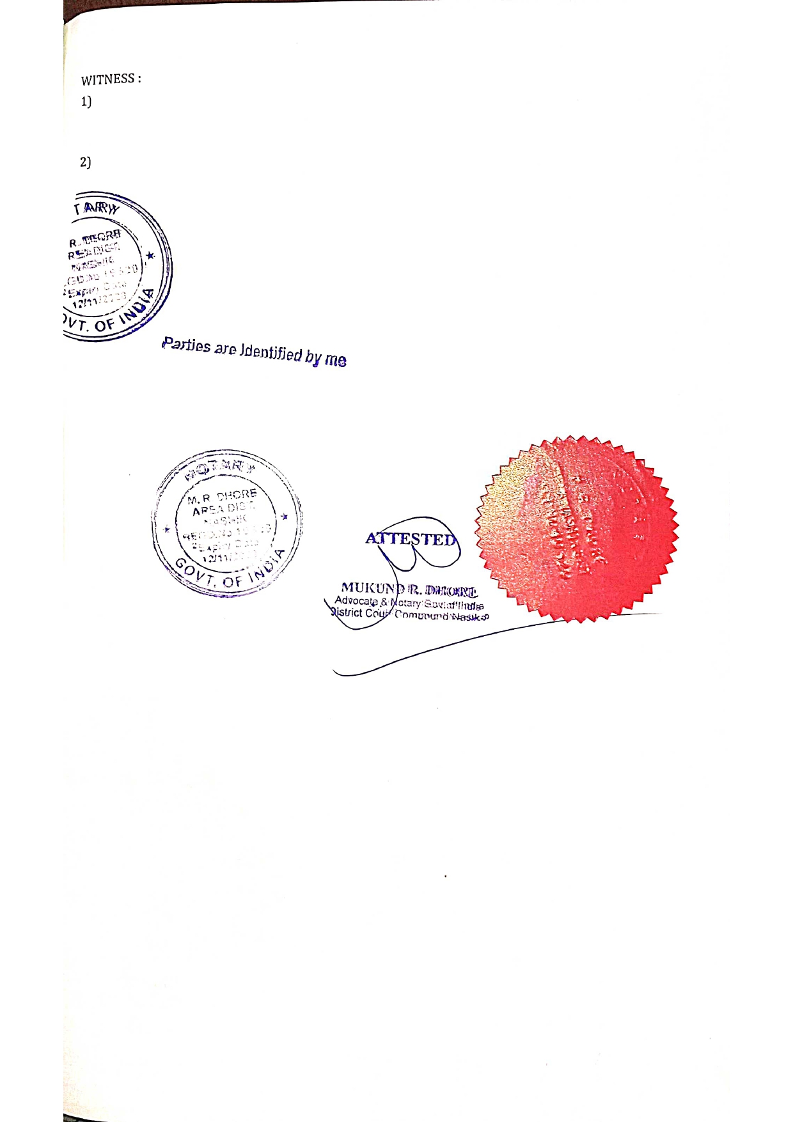

The Extra Amenities amount is Rs.9,00,000/- (Rupees Nine Lakh Only.)

