1st LENDERS INDEPENDENT ENGINEER REPORT
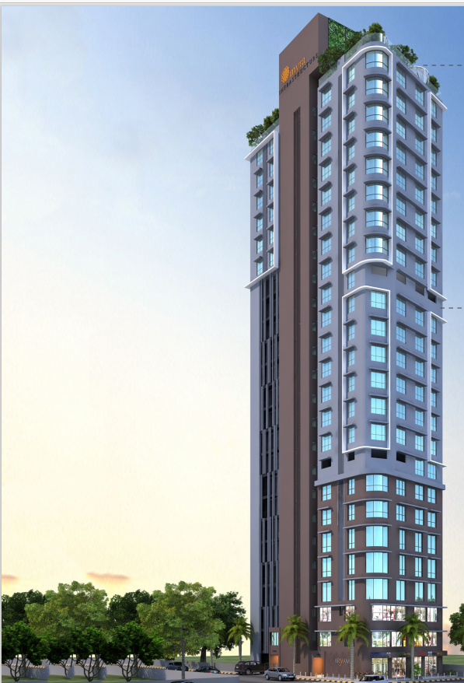

Details of the property under consideration:

Name of Project: Aryam

"Aryam", Proposed Redevelopment of Residential cum Commercial building No. 19 on Plot bearing C. S. No. 969, C Ward, Ward No. C – 3018 – 23, Street No. 21 – 29, Bhuleshwar Division, Popatwadi, Kalbadevi, Mumbai – 400 002, State – Maharashtra, Country – India
Latitude Longitude: 18°56'46.6"N 72°49'41.4"E

Intended User:

State Bank of India
Commercial Branch (Vile Parle) Branch
Parle Square Building, 3rd Floor, B.N. Agarwal Commercial Complex,
Monghibai Road, Vile Parle (East), Mumbai – 400 057, State - Maharashtra, Country – India

Vastu/SBI/Mumbai/11/2024/10688/2305834
30/15-582-PY
Date: - 06.11.2024

FIRST LENDERS INDEPENDENT ENGINEER REPORT

To,
State Bank of India
Commercial Branch (Vile Parle) Branch
Parle Square Building, 3rd Floor,
B.N. Agarwal Commercial Complex,
Monghibai Road,
Vile Parle (East), Mumbai - 400 057,
State - Maharashtra, Country – India

Subject: Construction of Proposed Redevelopment of Residential cum Commercial building No. 19 on Plot bearing C. S. No. 969, C Ward, Ward No. C – 3018 – 23, Street No. 21 – 29, Bhuleshwar Division, Popatwadi, Kalbadevi, Mumbai – 400 002, State – Maharashtra, Country – India

Ref: You’re Request for Lenders Independent Engineer Report of under Construction Building.
Dear Sir,
- As per your instruction, we have inspected the under-construction Rehab and Sale Building project situated on plot bearing C. S. No. 969, C Ward, Ward No. C – 3018 – 23, Street No. 21 – 29, Bhuleshwar Division, Popatwadi, Kalbadevi, Mumbai – 400 002, State – Maharashtra, Country – India which is being developed by M/s. Myra Infrastructure in order to give the physical progress at site and to certify cost incurred towards project as on 30/06/2024.
- The Construction work as per approved plan was in progress during the site visit on 17th August 2024.
- Status of work:
- For Rehab Cum Sale Building: Till 8th Floor Slab work, 1st to 4th floor blockwork, plaster work, gypsum, door & windows frame work, 1st to 3rd floor flooring, waterproofing work are completed. 9th Floor Shuttering Work & 5th floor Block Work is in progress.
- As per cost incurred certificate issued by CA Certificate actual total expenditure occurred as on 30/06/2024 is ` 23.26 Cr. for Rehab cum Sale Building & overall financial progress is 50.53% estimated cost of project.
- As per bills actual total expenditure occurred as on 30/06/2024 is ` 21.74 Cr. for Residential of Rehab cum Sale Building & overall financial progress is 47.23% estimated cost of project.
- Overall Physical progress of the rehab building construction as on 17/08/2024 is 23.88% as per physical site inspection.

DECLARATION

- The information furnished in the report is based on our 1st site visit Dated 17/08/2024 & Document Provided by Client.
- Vastukala Project Report of the project dated 29/12/2023.
- Vastukala Cost Vetting Report of the project dated 29/12/2023.
- I have no direct and indirect interest in the property examined for report.
- I have not been found guilty of misconduct in my professional capacity.

Manoj B. Chalikwar
Registered Valuer
Chartered Engineer (India)
Reg. No. IBBI/RV/07/2018/10366
Encl.: LIE report

Purpose & Methodology
• State Bank of India Banks and financial institutions require monitoring & an independent review of the progress of the sanctioned projects
VCIPL undertakes such study to independently review the progress of the project and put forward a comprehensive analysis

Advantages:
- Assurance on present practices
- Identification of risk
- Analyzing the performance of third parties
- Recommendations

The Methodology
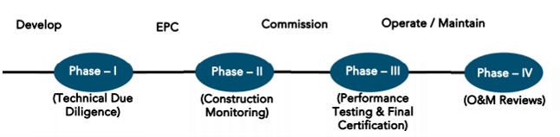
FIRST LENDERS INDEPENDENT ENGINEER REPORT
OF
"ARYAM"
"Aryam", Proposed Redevelopment of Residential cum Commercial building No. 19 on Plot bearing
C. S. No. 969, C Ward, Ward No. C – 3018 – 23, Street No. 21 – 29, Bhuleshwar Division, Popatwadi, Kalbadevi, Mumbai – 400 002, State – Maharashtra, Country – India

Latitude Longitude: 18°56'46.6"N 72°49'41.4"E

NAME OF DEVELOPER: M/s. Myra Infrastructure
Pursuant to instructions from State of India, Commercial Vile Parle Branch, we have duly visited, inspected, surveyed & assessed the above said property on 17th August 2024 to determine the fair & reasonable market value of the said property/project as on Quarter ending 30th June 2024 for LIE purpose.

1. Location Details:
Proposed Redevelopment of Residential cum Commercial building No. 19 on Plot bearing C. S. No. 969, C Ward, Ward No. C – 3018 – 23, Street No. 21 – 29, Bhuleshwar Division, Popatwadi, Kalbadevi, Mumbai – 400 002. It is about 1.00 Km. travelling distance from Marine Lines Railway station. Surface transport to the property is by buses, taxis & private vehicles. The property is in developed locality. All the amenities like shops, banks, hotels, markets, schools, hospitals, etc. are all available in the surrounding locality. The area is higher middle class & developed.
2. Developer Details:
Name of builder | M/s. Myra Infrastructure
Project Rera Registration Number | P51900052888
Registered office address | 1001, 14th Floor, Shree Villa, Plot No. 17, Near Tardeo Bus Depot, Wadia Street, Mumbai – 400 034, State - Maharashtra, Country – India
Contact details | Contact Person:  Mr. Shubham (Accountant)  Mobile No. +91 8369831472  CA. Sandip Patel (Consultant)  Mobile No. +91 9638370838  Mr. Chana Parsi (Supervisor)  Mobile No. +91 6350506979
E – mail ID and website
3. Boundaries of the Property:
Direction | Particulars
On or towards North | Popatwadi Lane
On or towards South | Haroon Building
On or towards East | Gold Mohar Building
On or towards West | Maheshwari Bhuvan

Introduction
As per Information on site M/s. Myra Infrastructure has acquired land by Deed of Agreement and Transfer dated 03.09.2021 registered vide No. BBE-1/7239/2021 dated 03.09.2021 admeasuring area 536.78 Sq. M. bearing C. S. No. 969. For the Proposed Redevelopment of Residential cum Commercial Building.

Area Statement:

Land:
Date | Particular | Area in Sq. M.
03.09.2021 | C. S. No. 969 | 536.78
TOTAL |  | 536.78

- Copy Deed of Agreement and Transfer dated 03.09.2021 between M/s. Deekay Developer (The Assignors) and M/s. Myra Infrastructure (The Assignees) through registered agreement vide No. BBE-1/7239/2021 dated 03.09.2021.

Building Area As per Approved Plan:
Area Statement
1) | Area of Plot | 531.78 SQ. MT
2) | Deduction For | 100.91 Sq. Mt.
 | a) Road set-back area
 | b) Proposed Road
 | c) Any reservation (sub plot)
 | d) _% amenity space as per DCR 56/57 (sub plot) Other
3) | Balance Area of Plot (1 minus 2) | 430.87 Sq. Mt.
4) | Deduction for 10% | NIL
5) | Net area of plot (3 minus 4) | 430.87 Sq. Mt.
6) | Addition for floor space index | NIL
 | 2 (a) 100% for D. P. Road
 | 2 (b) 100% for set-back
7) | Total Areas (5 minus 6) | 430.87 Sq. Mt.
8) | Floor Space Index permissible | As per statement
9) | 9a) Floor Space Index credit available by Development Rights (Restricted to _% of the balance area vide 3 above) | NIL
 | DRC No._
 | DRC No._
 | Addition for floor space index | NIL
 | 9(b) 33% as per DCR 32
 | 9(C) _% as per DCR 33 ()
 | 9(d) Other
10) | Permissible Floor Area | 3701.64 Sq. mt.
11) | Existing floor area
12) | Proposed built up area
13) | Excess balcony area taken in Floor Space Index | NIL
14) | Total Built-up Proposed (11+12+13) (As per old approved plan dt. _ prior to 06-01-2012) | 3701.64 Sq. mt.
15) | FSI consumed on net holding = 14/3 | 8.59
B | Details of FSI availed as per DCR 35 (4) | Permissible | Proposed
1) | Fungible Built Up Area component Proposed vide DCR 35(4) (14Ax0.35) | 1,295.57 | 242.65
2) | Total Gross Built Up Area proposed (14+B.3) | 4,997.21 | 3,944.29
C | Tenement Statement
i) | Proposed area (item 12 above) | 3944.29 Sq. Mt.
ii) | Less deduction of Non-Residential area (Shop etc.) | 558.36 Sq. Mt.
iii) | Area available for tenements ((i) minus (ii)) | 3385.93 Sq. Mt.
iv) | Tenement permissible (Density of tenements / hectare) | -
v) | Tenements Proposed | 55 Nos.
vi) | Tenements existing
 | Total tenements on the plot
D | Parking Statement
i) | Parking required by Regulation for Car (As per full potential) | 53 Nos.  (As per statement)
ii) | Covered garage permissible | NIL
iii) | Covered garage proposed car / Scooter / Motor Cycle Outsider (Visitors) | NIL
 | Total parking provided | 53 Nos.
E | Transport Vehicles Parking
i) | Spaces for transport vehicles parking required by Regulations | NIL
ii) | Total no. transport vehicles parking spaces provided | NIL

List of Approvals:
- Copy of Approved Plan No. P-10646/2022/(969)/C Ward/BHULESHWAR/IOD/1/New C Ward dated 30.09.2022 issued by Municipal Corporation of Greater Mumbai (MCGM)
Approved upto: Basement + Ground Floor + 1st & 2nd Commercial Floor + 3rd to 20th Upper Residential Floors
- Copy of Amended Approved Plan No. P-10646/2022/(969)/C Ward/BHULESHWAR/337/2/AMEND dated 16.02.2024 issued by Municipal Corporation of Greater Mumbai (MCGM)
Approved upto: Basement + Ground Floor + 1st & 2nd Commercial Floor + 3rd to 23rd Upper Residential Floors
- Copy of 1st Commencement Certificate No. P-10646/2022/(969)/C Ward/BHULESHWAR/CC/1/New dated 17.07.2023 valid upto 16.07.2024 issued by Municipal Corporation of Greater Mumbai (MCGM).
(This CC is endorsed for the work upto Plinth Level as per issued approved plan dated 30.09.2022)
- Copy of 2nd Commencement Certificate No. P-10646/2022/(969)/C Ward/BHULESHWAR/CC/1/Amend dated 28.02.2024 valid upto 27.02.2025 issued by Municipal Corporation of Greater Mumbai (MCGM).
(This CC is endorsed for the work upto Plinth Level as per issued approved plan dated 16.02.2024)
- Copy of 3rd Commencement Certificate No. P-10646/2022/(969)/C Ward/BHULESHWAR/FCC/1/Amend dated 04.04.2024 valid upto 16.07.2025 issued by Municipal Corporation of Greater Mumbai (MCGM).
(This CC is endorsed for the work up to top of 21st Floor alongwith parking tower upto 64.10 M. height above ground level, with LMR + OHT as per last amended approved plans dated 16.02.2024).

LEVEL OF COMPLETION:

Rehab cum Sales Building
Sr. No | Floor No. | Construction Area in Sq. M. | Completed Area in Sq. M. | Work Completion as on 17.08.2024
1 | Excavation & Shore Piling |  |  | Work is Completed
2 | Basement | 299.86 | 299.86 | Slab Work is completed
3 | Ground Floor | 298.43 | 298.43 | Slab Work is completed
4 | 1st Floor | 297.99 | 297.99 | Slab Work, blockwork, plaster work, door & window frame work, flooring, waterproofing work is completed
5 | 2nd Floor | 294.21 | 294.21 | Slab Work, blockwork, plaster work, door & window frame work, flooring, waterproofing work is completed
6 | 3rd Floor | 293.12 | 293.12 | Slab Work, blockwork, plaster work, door & window frame work, flooring is completed
7 | 4th Floor | 293.69 | 293.69 | Slab Work, blockwork, plaster work, door & window frame work is completed
8 | 5th Floor | 293.69 | 293.69 | Slab Work is completed, Block work is in progress
9 | 6th Floor | 303.77 | 303.77 | Slab Work is completed
10 | 7th Floor | 304.01 | 304.01 | Slab Work is completed
11 | 8th Floor | 298.30 | 298.30 | Slab Work is completed
12 | 9th Floor | 301.25
13 | 10th Floor | 303.42
14 | 11th Floor | 301.24
15 | 12th Floor | 302.53
16 | 13th Floor | 303.29
17 | 14th Floor | 300.60
18 | 15th Floor | 291.39
19 | 16th Floor | 299.57
20 | 17th Floor | 253.56
21 | 18th Floor | 313.23
22 | 19th Floor | 307.89
23 | 20th Floor | 211.57
24 | Terrace Floor | 58.30
Total |  | 6,524.98 | 2,977.11
Stack Parking |  | 53.00 | -
- Revised building approval drawings for rehab cum sale building was submitted to us and has building permission upto 23rd Floor only.
- As bank has sanctioned the loan upto 20th floor of rehab cum sale building.
- Hence for the LIE Report we have considered as following for Plinth Calculation.
Rehab cum Sale Building – Basement + Ground Floor + 1st & 2nd Commercial Floor + 3rd to 20th Upper Residential Floors

Details of the Project as Financed By SBI:

Estimated Project Cost: (As per Cost Vetting Report)
Particulars | Estimated Cost (in Cr.)
Land & Stamp Cost | 7.03
Rent Cost | 3.32
Construction Cost of Rehab cum Sale Building | 22.22
Approval Cost | 5.66
Professional Cost | 1.11
Administrative Cost | 1.33
Marketing Cost | 1.16
Interest Cost (Bank Loan) | 3.53
Contingency Cost | 0.67
Total | 46.03

Project Cost: (as per C.A. Certificate)
Particulars | Incurred Cost (In Cr.) till 30.06.2024 dated 03.09.2024 by M/s. Rashmi Modi & Co.
Land & Stamp Cost | 7.03
Rent Cost | 1.72
Construction Cost of Rehab cum Sale Building | 7.26
Approval Cost | 5.92
Professional Cost | 0.60
Administrative Cost | 0.72
Marketing Cost | 0.01
Interest Cost (Bank Loan) | -
Contingency Cost | -
Total | 23.26

- The Builder has incurred about 7.03 Cr. as land cost, 1.72 Cr. Rent Cost, 7.26 Cr. as construction cost, 5.92 Cr. for approval cost, 0.60 Cr. for professional cost, 0.72 Cr. for admin cost, 0.01 Cr. for marketing cost in last quarter till 30.06.2024 as per C.A. certificate issued by M/s. Rashmi Modi Vora & Co. dated 03.09.2024.

Project Cost: (as per Bills):
Particulars | Incurred Cost (in Cr.)
 | 30.06.2024 as per Bill (Inclusive GST)
Land & Stamp Cost | 7.03
Rent Cost | 1.29
Construction Cost of Rehab cum Sale Building | 5.14
Approval Cost | 6.74
Professional Cost | 0.93
Administrative Cost | 0.45
Marketing Cost | -
Interest Cost (Bank Loan) | 0.15
Contingency Cost | -
Total | 21.74
Note:

Land Cost:
Sr. | Agreement Name | Date | Particulars | Total Cost in ` | Incurred Cost in `
1 | Deed of Assignment and Transfer | 03.09.2021 | Purchase | 6,69,18,500.00 | 6,69,18,500.00
2 |  |  | Stamp Duty | 33,45,925.00 | 33,45,925.00
3 |  |  | Reg. Fees | 30,000.00 | 30,000.00
4 |  |  |  | 2,500.00 | 2,500.00
TOTAL |  |  |  | 7,02,96,925.00 | 7,02,96,925.00
As per Deed of Assignment and Transfer agreement.
Summary of Bills
Sr. No. | Particulars | Amount in `  (till 30.06.2024) | Amount in ` (in Cr.)
1 | Construction Cost | 5,14,28,856.00 | 5.14
2 | Rent Cost | 1,29,34,509.00 | 1.29
3 | Approval Cost | 6,74,22,312.00 | 6.74
4 | Professional Cost | 92,70,969.00 | 0.96
5 | Administrative Cost | 45,39,298.00 | 0.45
6 | Marketing Cost | - | -
7 | Contingency Cost | - | -
TOTAL |  | 14,55,95,944.00 | 14.56
Note: Bills were provided by the client up to 30.06.2024

Interest Cost:
Sr. No | Particulars | Estimate Amount in ` | Incurred Amount in ` (till 30.06.2024) | Balance Amount in `
1 | Interest Cost | 3,53,00,000.00 | 15,17,291.00 | 3,37,82,709.00
TOTAL |  | 3,53,00,000.00 | 15,17,291.00 | 3,37,82,709.00
Interest Cost is based on discussion with the client.

Cost of Construction as on 17th August 2024:
S. No. | Floor | Total Construction Area in Sq. M. | Completed Area in Sq. M. | Rate per Sq. M. | Full Value after completion | % of work completed | Actual Expenditure till date in `
1 | Excavation Cost |  |  |  |  | 100% | -
2 | Basement | 299.86 | 299.86 | 30,000.00 | 89,95,920.00 | 60% | 53,97,552.00
3 | Ground Floor | 298.43 | 298.43 | 30,000.00 | 89,53,020.00 | 50% | 44,76,510.00
4 | 1st Floor | 297.99 | 297.99 | 30,000.00 | 89,39,820.00 | 75% | 67,04,865.00
5 | 2nd Floor | 294.21 | 294.21 | 30,000.00 | 88,26,420.00 | 75% | 66,19,815.00
6 | 3rd Floor | 293.12 | 293.12 | 30,000.00 | 87,93,720.00 | 75% | 65,95,290.00
7 | 4th Floor | 293.69 | 293.69 | 30,000.00 | 88,10,820.00 | 70% | 61,67,574.00
8 | 5th Floor | 293.69 | 293.69 | 30,000.00 | 88,10,820.00 | 50% | 44,05,410.00
9 | 6th Floor | 303.77 | 303.77 | 30,000.00 | 91,13,220.00 | 50% | 45,56,610.00
10 | 7th Floor | 304.01 | 304.01 | 30,000.00 | 91,20,420.00 | 50% | 45,60,210.00
11 | 8th Floor | 298.30 | 298.30 | 30,000.00 | 89,49,120.00 | 40% | 35,79,648.00
12 | 9th Floor | 301.25 |  | 30,000.00 | 90,37,620.00 |  | -
13 | 10th Floor | 303.42 |  | 30,000.00 | 91,02,720.00 |  | -
14 | 11th Floor | 301.24 |  | 30,000.00 | 90,37,320.00 |  | -
15 | 12th Floor | 302.53 |  | 30,000.00 | 90,76,020.00 |  | -
16 | 13th Floor | 303.29 |  | 30,000.00 | 90,98,820.00 |  | -
17 | 14th Floor | 300.60 |  | 30,000.00 | 90,18,120.00 |  | -
18 | 15th Floor | 291.39 |  | 30,000.00 | 87,41,820.00 |  | -
19 | 16th Floor | 299.57 |  | 30,000.00 | 89,87,220.00 |  | -
20 | 17th Floor | 253.56 |  | 30,000.00 | 76,06,800.00 |  | -
21 | 18th Floor | 313.23 |  | 30,000.00 | 93,96,900.00 |  | -
22 | 19th Floor | 307.89 |  | 30,000.00 | 92,36,700.00 |  | -
23 | 20th Floor | 211.57 |  | 30,000.00 | 63,47,100.00 |  | -
24 | Terrace / OHT | 58.30 |  | 30,000.00 | 17,49,000.00 |  | -
Sub - Total (A) |  | 6,524.98 | 2,977.11 |  | 19,57,49,460.00 |  | 5,30,63,484.00
STACK PARKING Nos. |  | 53.00 |  | 5,00,000.00 | 2,65,00,000.00 |  | -
TOTAL COST OF CONSTRUCTION (A + B) |  |  |  |  | 22,22,49,460.00 | 23.88% | 5,30,63,484.00

Note: Details of work completed is as per site visit dated 17.08.2024 but report is prepared for 30th June quarter 2024.

Particulars | Estimated Cost  (In Cr.) | Incurred Cost (in Cr.) |  | Net
 |  | Issued dated 03.09.2024 till 30.06.2024 as per CA | As per Bills upto 30.06.2024
Land & Stamp Cost | 7.03 | 7.03 | 7.03 | -
Rent Cost | 3.32 | 1.72 | 1.29 | -0.43
Construction Cost of Rehab cum Sale Building | 22.22 | 7.26 | 5.14 | -2.12
Approval Cost | 5.66 | 5.92 | 6.74 | 0.82
Professional Cost | 1.11 | 0.60 | 0.93 | 0.33
Administrative Cost | 1.33 | 0.72 | 0.45 | -0.27
Marketing Cost | 1.16 | 0.01 | - | -0.01
Interest Cost (Bank Loan) | 3.53 | - | 0.15 | 0.15
Contingency Cost | 0.67 | - | - | -
Total | 46.03 | 23.26 | 21.74 | -1.52
Note:
We have considered Other Expenses, Printing & Stationery, and Water Bills cost is consider in administrative cost header but CA has considered them in cost of construction header .
We have considered PAA Agreement stamp duty cost is consider in rent cost header but CA has cosnidered them in cost of construction header.
We have considered professional bill is consider in professional cost header but CA has cosnidered them in cost of construction header.
We have considered interest cost for secured loan is consider in interest cost header but CA has cosnidered them in administrative cost header.
We have not considered the interest cost on unsecured loan but CA has considered them in administrative cost header.
As per plinth area, calculation the work completed is up to 23.88% of total work, which comes to ` 5.31 Cr. However, company has incurred cost of ` 5.14 Cr. till 30.06.2024 as per bill .
Revised building approval drawings for rehab cum sale building was submitted to us and has building permission upto 23rd Floor only.
As bank has sanctioned the loan upto 20th floor of rehab cum sale building.
Hence for the LIE Report we have considered as following for Plinth Calculation.
Rehab cum Sale Building – Basement + Ground Floor + 1st & 2nd Commercial Floor + 3rd to 20th Upper Residential Floors

Comparison of Cost incurred on dated 30.06.2024 & CA Certificate
Particulars | 30.06.2024 as per Bill | As per CA Certiifcate | Net | % of net amount
Land & Stamp Cost | 7.03 | 7.03 | - | 0.00%
Rent Cost | 1.29 | 1.72 | -0.43 | -1.98%
Construction Cost of Rehab cum Sale Building | 5.14 | 7.26 | -2.12 | -9.75%
Approval Cost | 6.74 | 5.92 | 0.82 | 3.77%
Professional Cost | 0.93 | 0.60 | 0.33 | 1.52%
Administrative Cost | 0.45 | 0.72 | -0.27 | -1.24%
Marketing Cost | - | 0.01 | -0.01 | -0.05%
Interest Cost (Bank Loan) | 0.15 | - | 0.15 | 0.69%
Contingency Cost | - | - | - | 0.00%
Total | 21.74 | 23.26 | -1.52 | -6.99%

% of Fund Utilised till 30th June 2024
Particulars | Estimated Project Cost (in Cr.) | Incurred cost as on 30.06.2024 | % of Incurred Cost | % of Estimated Project Cost
Land & Stamp Cost | 7.03 | 7.03 | 100.00% | 15.27%
Rent Cost | 3.32 | 1.29 | 38.96% | 2.81%
Construction Cost of Rehab cum Sale Building | 22.22 | 5.14 | 23.15% | 11.17%
Approval Cost | 5.66 | 6.74 | 119.12% | 14.65%
Professional Cost | 1.11 | 0.93 | 83.52% | 2.01%
Administrative Cost | 1.33 | 0.45 | 34.13% | 0.99%
Marketing Cost | 1.16 | - | 0.00% | 0.00%
Interest Cost (Bank Loan) | 3.53 | 0.15 | 4.30% | 0.33%
Contingency Cost | 0.67 | - | 0.00% | 0.00%
Total | 46.03 | 21.74 | 47.23% | 47.23%
Based on above Calculation it is found that total Project cost incurred is 47.23% of the Total Project Cost.

Means of Finance:
Sr. No. | Particulars | Exp. Cumulative (Cr.)
 | Equity share capital / Quassi Loan from Promoter | 6.77
 | Sales (Advance from customer) | 2.85
 | Bank Laon Amount | 2.91
 | Unsecured Loan amount | 10.73
 | Total | 23.26
The Details of the Means of Finance are provided by Client as on 30.06.2024.

Mandatory Arrangements:
Sr. No. | Particulars | Status
 | Rainwater Harvesting | To be executed after RCC Structure
 | Firefighting System | To be executed after RCC Structure
 | Solid Waste Management | To be executed after RCC Structure

Quality of Construction:
Sr. No. | Particulars | Status
 | Soundness of Structures | Executing as per approved Structural Design
 | Look of Structures | Good
 | Quality of Material Used | Good
 | Safety Measures for Construction/labour | Taken Care by Contractor

Schedule V/s. Actual Progress:
Activity | Date of Implementation | Date of Completion | Status
Land |  |  | Completed
Development of Land | 11/09/2023 | 31/03/2024 | Completed
Foundation Work |  |  | Completed
Basment Floor |  |  | Slab work is Completed
Ground Floor Slab | 01/04/2024 | 30/06/2024 | Slab work is Completed
1st Floor Slab |  |  | Slab work is Completed
2nd Floor Slab |  |  | Slab work is Completed
3rd Floor Slab |  |  | Slab work is Completed
4th Floor Slab | 01/07/2024 | 31/10/2024 | Slab work is Completed
5th Floor Slab |  |  | Slab work is Completed
6th Floor Slab |  |  | Slab work is Completed
7th Floor Slab | 01/11/2024 | 31/01/2025 | Slab work is Completed
8th Floor Slab |  |  | Slab work is Completed
9th Floor Slab |  |  | Slab work is in progress
10th Floor Slab | 01/02/2025 | 30/04/2025
11th Floor Slab
12th Floor Slab
13th Floor Slab | 01/05/2025 | 31/08/2025
14th Floor Slab
15th Floor Slab
16th Floor Slab | 01/09/2025 | 30/11/2025
17th Floor Slab
18th Floor Slab
19th Floor Slab | 01/12/2025 | 28/02/2026
20th Floor Slab
Block work / Internal Plaster work | 04/04/2024 | 31/10/2026 | 1st to 4th floor blockwork is completed
Terrace Parapet wall / Overhead water tank / Lift Machine room / compound wall / External Plaster work | 01/02/2026 | 31/03/2026
Electric Work | 25/06/2024 | 31/12/2026
Water Proofing
Plumbing Work
Tiling / Marble Flooring | - | 31/05/2027
Door Frames
Window Installation
Staircase Flooring
Staircase Railing
Refuge Area Flooring
Internal Painting | - | 30/06/2027
External Painting
Lift Work | - | 31/03/2027
Fire Fighting Installation
Stack Parking
CP Fitting & Sanitary Work | 25/06/2024 | 31/12/2026
Final Finishing & Fitting |  | 30/09/2027

Action initiated to complete the project in time:
For Rehab Cum Sale Building: Till 8th Floor Slab work, 1st to 4th floor blockwork, plaster work, gypsum, door & windows frame work, 1st to 3rd floor flooring, waterproofing work are completed. 9th Floor Shuttering Work & 5th floor Block Work is in progress

Comments related to cost overrun if any:
The cost of Sales Building is ` 46.03 Cr., Approval cost has been overrun in this quarter

Balance investment required for completion of project:
We opinion amount of ` 21.74 Cr. Will be required to complete the Project.

Mandatory Approval Status:
Sr. No. | Particulars | Name of Department | Status | Order Details
1A | Approved Plan | Municipal Corporation of Greater Mumbai (MCGM). | Obtained and available at site | P – 10646 / 2022 / (969) / C Ward / BHULESHWAR / IOD / 1 / New C Ward dated 30.09.2022  Approved upto: Basement + Ground Floor + 1st & 2nd Commercial Floor + 3rd to 20th Upper Residential Floors
1B | Amended Approved Plan | Municipal Corporation of Greater Mumbai (MCGM). | Obtained and available at site | P – 10646 / 2022 / (969) / C Ward / BHULESHWAR / 337 / 2 / AMEND dated 16.02.2024  Approved upto: Basement + Ground Floor + 1st & 2nd Commercial Floor + 3rd to 23rd Upper Residential Floors
2A | First C.C. | Municipal Corporation of Greater Mumbai (MCGM). | Obtained and available at site | P – 10646 / 2022 / (969) / C Ward / BHULESHWAR / CC / 1 / New dated 17.07.2023 valid upto 16.07.2024  (This CC is endorsed for the work upto Plinth Level as per issued approved plan dated 30.09.2022)
2B | Second C.C. | Municipal Corporation of Greater Mumbai (MCGM). | Obtained and available at site | P – 10646 / 2022 / (969) / C Ward / BHULESHWAR / CC / 1 / Amend dated 28.02.2024 valid upto 27.02.2025  (This CC is endorsed for the work upto Plinth Level as per issued approved plan dated 16.02.2024)
2C | Third C.C. | Municipal Corporation of Greater Mumbai (MCGM). | Obtained and available at site | P – 10646 / 2022 / (969) / C Ward / BHULESHWAR / FCC / 1 / Amend dated 04.04.2024 valid upto 16.07.2025 (This CC is endorsed for the work up to top of 21st Floor alongwith parking tower upto 64.10 M. height above ground level, with LMR + OHT as per last amended approved plans dated 16.02.2024).
2D | Fourth C. C. | Municipal Corporation of Greater Mumbai (MCGM). | Pending
3B | Occupancy | Municipal Corporation of Greater Mumbai (MCGM). | Pending (Project is not completed)

Status Insurance Coverage:
Information not provided

Assumptions & Remarks:
- The adequacy of Engineering / Structural design is beyond the scope of our assignment.
- As per Bank sanctioned letter Rehab cum sale building estimated project completion date is 31/12/2027.
- We opinion that the project will be completed as per schedule or timeline proposed by the client.
- As per RERA Certificate estimated project completion date is 31/12/2027.
- The cost is certified based on the assumptions that the project will be completed within period. Few assumptions were made regarding inflation & cost rise etc. during construction period.

Manoj B. Chalikwar
Registered Valuer
Chartered Engineer (India)
Reg. No. IBBI/RV/07/2018/10366

About the Project:
1. Introduction
a) | Project Name  (With Address & Phone Nos.) | "Aryam", Proposed Redevelopment of Residential cum Commercial building No. 19 on Plot bearing C. S. No. 969, C Ward, Ward No. C – 3018 – 23, Street No. 21 – 29, Bhuleshwar Division, Popatwadi, Kalbadevi, Mumbai – 400 002, State – Maharashtra, Country – India  Contact Person:  Mr. Shubham (Accountant)  Mobile No. +91 8369831472  CA. Sandip Patel (Consultant)  Mobile No. +91 9638370838  Mr. Chana Parsi (Supervisor)  Mobile No. +91 6350506979
b) | Purpose of Valuation | As per request from State Bank of India, Commercial Vile Parle Branch to give the physical progress at site and to certify cost incurred towards project as on 30/06/2024 of the Project for LIE purpose.
c) | Date of Inspection of Property | 17.08.2024
d) | Date of LIE Report | 06.11.2024
e) | Name of the Developer of Property  (in case of developer built properties) | M/s. Myra Infrastructure  1001, 14th Floor, Shree Villa, Plot No. 17, Near Tardeo Bus Depot, Wadia Street, Mumbai – 400 034, State - Maharashtra, Country – India
2. Physical Characteristics of the Property
a) | Location of the Property | "Aryam", Proposed Redevelopment of Residential cum Commercial building No. 19 on Plot bearing C. S. No. 969, C Ward, Ward No. C – 3018 – 23, Street No. 21 – 29, Bhuleshwar Division, Popatwadi, Kalbadevi, Mumbai – 400 002, State – Maharashtra, Country – India
 | Brief description of the property
TYPE OF THE BUILDING
Rehab cum Sales Building

No. of Floors | Basement + Ground Floor + 1st & 2nd Commercial Floor + 3rd to 20th Upper Residential Floors
Building type | Residential Rehab cum Sale building

Rehab cum Sales Building work is given on contract based for RCC contract. Developer has grant to the contractor do the work of construction and completion includes Concrete work, Reinforcement work, Masonry, Internal Plaster, External Plaster and other miscellaneous work such as repairing, joints b/w concrete and masonry surface, etc. Bill must be paid on measurement of construction area exclusive of Steel, Cement & other construction material.
Lift & lift installation contract is not finalized till now.
Firefighting work contract is not finalized.

PROPOSED DATE OF COMPLETION & FUTURE LIFE:
Expected completion date as per RERA is 31st December 2027.
 | Nearby landmark
 | Postal Address of the Property | "Aryam", Proposed Redevelopment of Residential cum Commercial building No. 19 on Plot bearing C. S. No. 969, C Ward, Ward No. C – 3018 – 23, Street No. 21 – 29, Bhuleshwar Division, Popatwadi, Kalbadevi, Mumbai – 400 002, State – Maharashtra, Country – India
 | Area of the plot/land  (Supported by a plan) | Net Plot Area: 430.87 Sq. M.
 | Type of Land: Solid, Rocky, Marsh land, reclaimed land, Water-logged, Land locked. | Solid land
 | Independent access/approach to the property etc. | Yes
 | Google Map Location of the Property with a neighborhood layout map | Provided
 | Details of roads abutting the property | 9 M wide road
 | Description of adjoining property | Located in Higher Middle-class locality
 | Plot No. Survey No. | C. S. No. 969
 | Ward/Village/Taluka | C Ward, Bhuleshwar Division, Taluka – Mumbai
 | Sub-Registry/Block | Bhuleshwar
 | District | District - Mumbai
b) | Boundaries of the Plot
 | As per Agreement | As per RERA Certificate | Actual
North | By the Popatwadi Lane | By the Popatwadi Lane | Popatwadi Lane
South | By the properties bearing 967 and 961 | By the properties bearing 967 and 961 | Haroon Building
East | By the property bearing C. S. No. 970 of Bhuleshwar Division | By the property bearing C. S. No. 970 of Bhuleshwar Division | Gold Mohar Building
West | By the property bearing C. S. No. 968 of Bhuleshwar Division | By the property bearing C. S. No. 968 of Bhuleshwar Division | Maheshwari Bhuvan

4. Document Details and Legal Aspects of Property:
a) | Ownership Documents (Building Permission, Commencement Certificate & Status of Plan)
 | Sale Deed, Gift Deed, Lease Deed
 | - Copy Deed of Agreement and Transfer dated 03.09.2021 between M/s. Deekay Developer (The Assignors) and M/s. Myra Infrastructure (The Assignees) through registered agreement vide No. BBE-1/7239/2021 dated 03.09.2021.
 | - Copy of No Objection Certificate for Height Clearance NOC ID No. NAVI/WEST/B/081122/688949 dated 06.10.2022 valid upto 05.10.2023 issued by Airports Authority of India.
 | - Copy of CA Certificate (Form 3) dated 08.11.2023 issued by M/s. Gopal Heda & Associates
 | - Copy of CA Certificate dated 26.12.2023 issued by M/s. Sandip V. Patel & Co.
 | - Copy of RERA Certificate No. P51900052888 dated 05.10.2023 issued by Maharashtra Real Estate Regulatory Authority (MAHRERA).
 | - Copy of Legal Title Report dated 28.07.2023 issued by M/s. Kirti Nagda & Associates.
Copy of Approved Plan No. P-10646/2022/(969)/C Ward/BHULESHWAR/IOD/1/New C Ward dated 30.09.2022 issued by Municipal Corporation of Greater Mumbai (MCGM)
Approved upto: Basement + Ground Floor + 1st & 2nd Commercial Floor + 3rd to 20th Upper Residential Floors
- Copy of Amended Approved Plan No. P-10646/2022/(969)/C Ward/BHULESHWAR/337/2/AMEND dated 16.02.2024 issued by Municipal Corporation of Greater Mumbai (MCGM)
Approved upto: Basement + Ground Floor + 1st & 2nd Commercial Floor + 3rd to 23rd Upper Residential Floors
- Copy of 1st Commencement Certificate No. P-10646/2022/(969)/C Ward/BHULESHWAR/CC/1/New dated 17.07.2023 valid upto 16.07.2024 issued by Municipal Corporation of Greater Mumbai (MCGM).
(This CC is endorsed for the work upto Plinth Level as per issued approved plan dated 30.09.2022)
- Copy of 2nd Commencement Certificate No. P-10646/2022/(969)/C Ward/BHULESHWAR/CC/1/Amend dated 28.02.2024 valid upto 27.02.2025 issued by Municipal Corporation of Greater Mumbai (MCGM).
(This CC is endorsed for the work upto Plinth Level as per issued approved plan dated 16.02.2024)
- Copy of 3rd Commencement Certificate No. P-10646/2022/(969)/C Ward/BHULESHWAR/FCC/1/Amend dated 04.04.2024 valid upto 16.07.2025 issued by Municipal Corporation of Greater Mumbai (MCGM).
(This CC is endorsed for the work up to top of 21st Floor alongwith parking tower upto 64.10 M. height above ground level, with LMR + OHT as per last amended approved plans dated 16.02.2024).
 | - Copy of Bills till 30.06.2024
 | - Copy of CA Certificate dated 03.09.2024 issued by M/s. Rashmi Modi & Co.
 | - Copy of Bank Arrangement Letter (SME – 1) / Bank Sanction Letter dated 08.01.2024 between State Bank of India, Vile Parle Branch (Mortgagee) and M/s. Myra Infrastructure.
Actual Site Photographs as on 17.08.2024
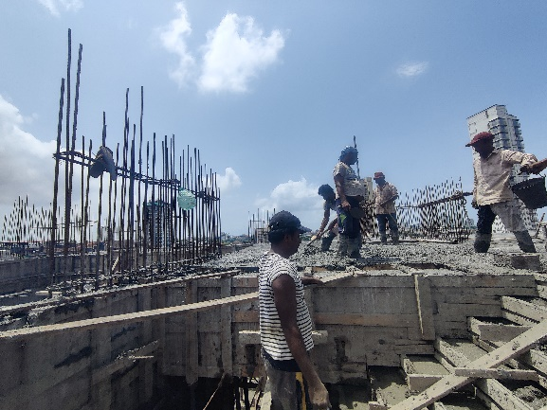
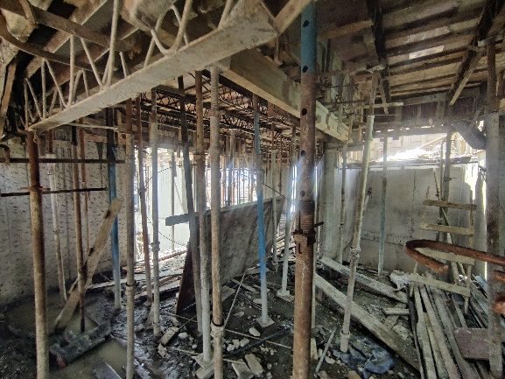
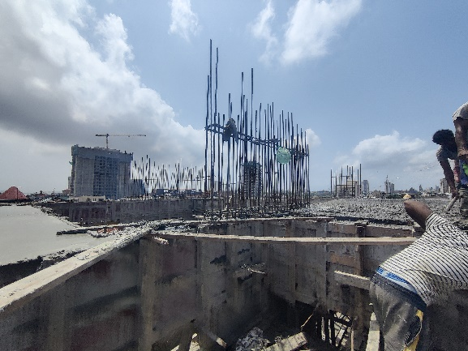
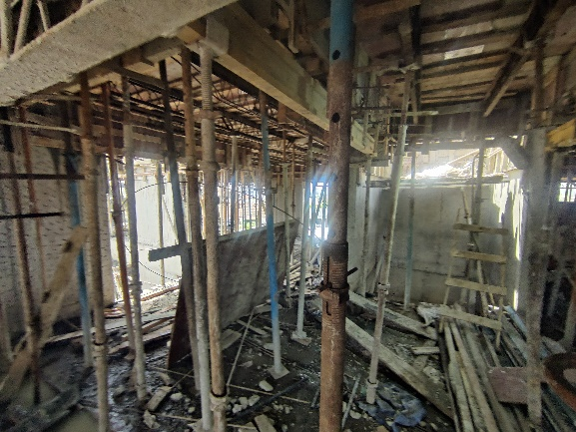
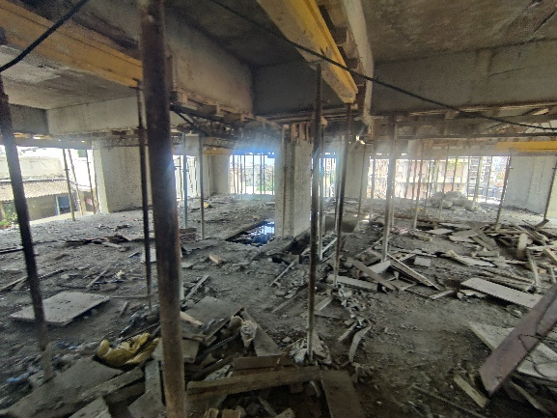
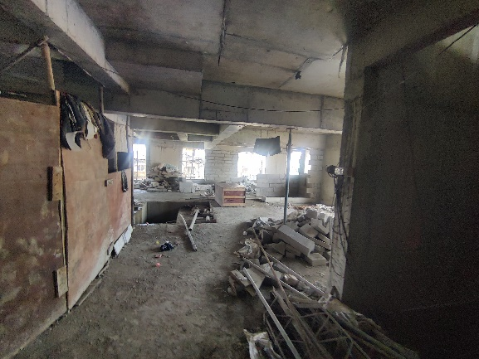
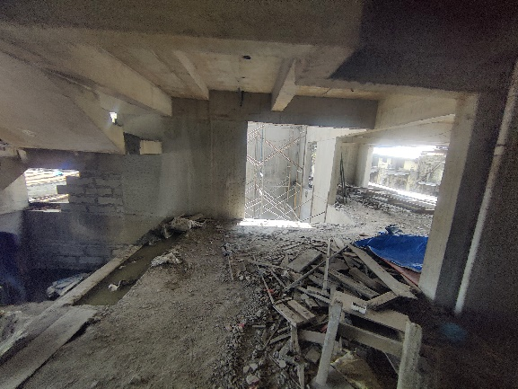
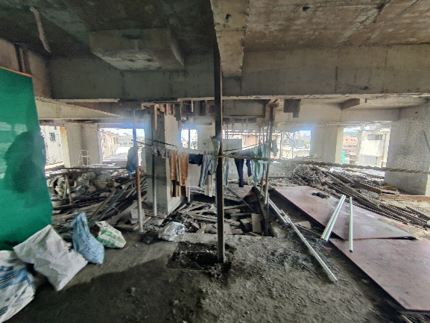
Actual Site Photographs as on 17.08.2024
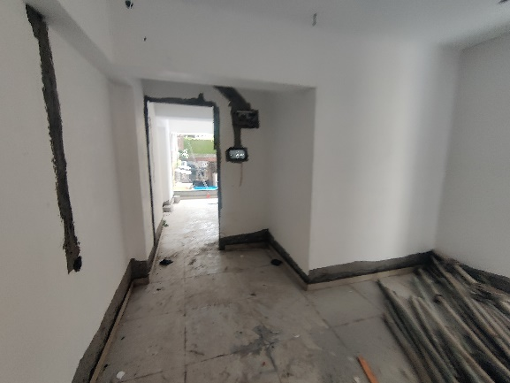
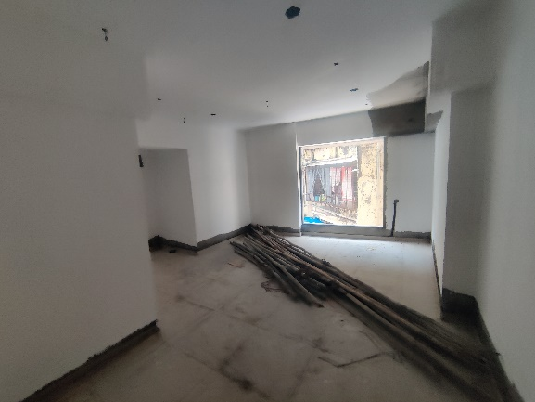
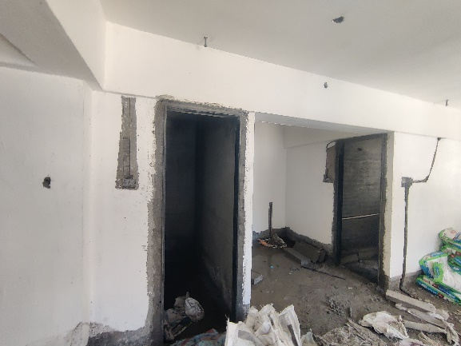
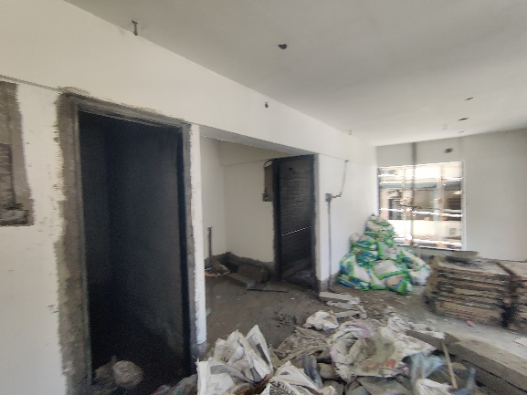
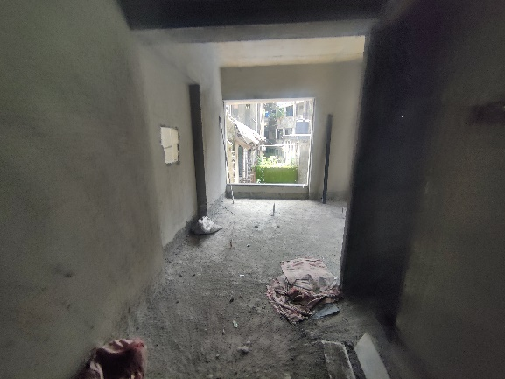
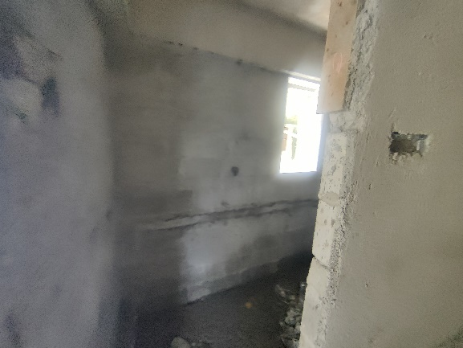
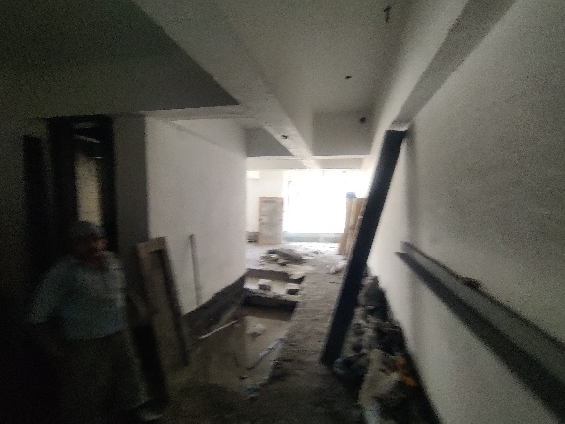
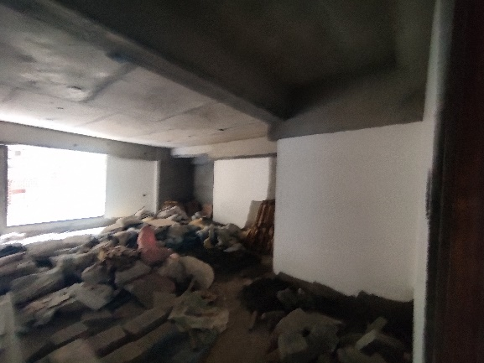
Actual Site Photographs as on 17.08.2024
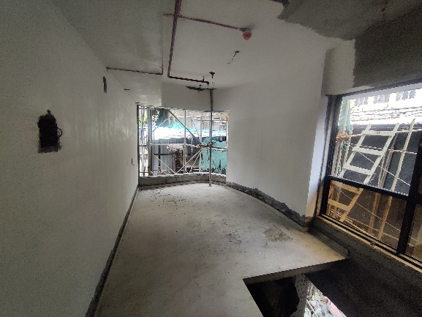
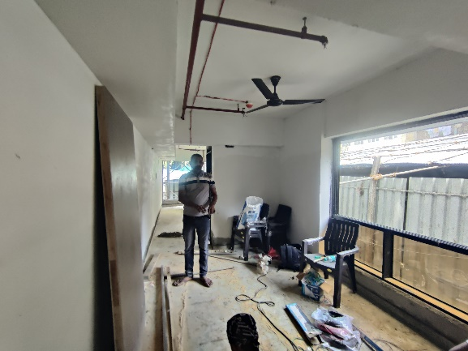
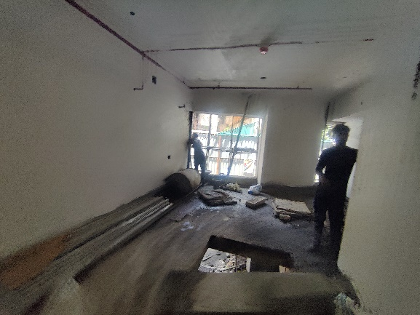
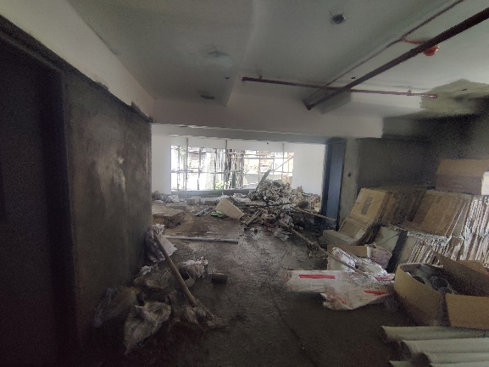
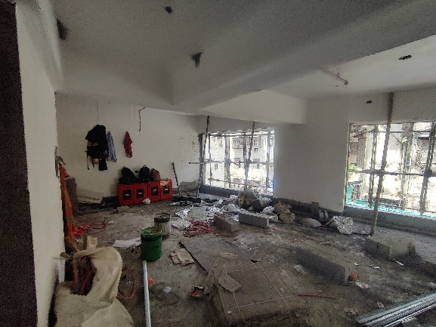
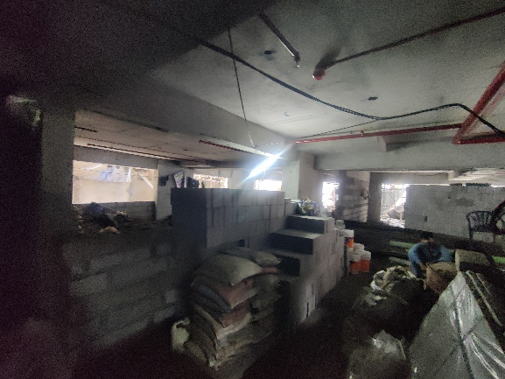
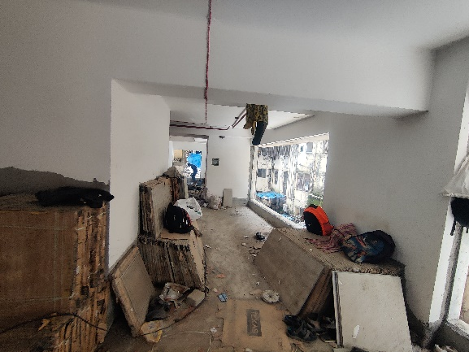
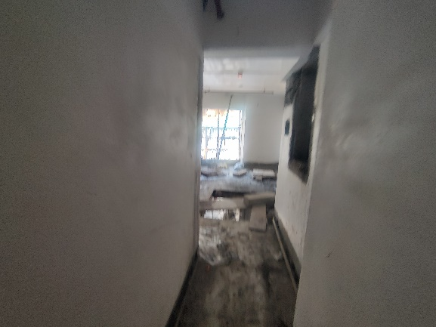
Actual Site Photographs as on 17.08.2024
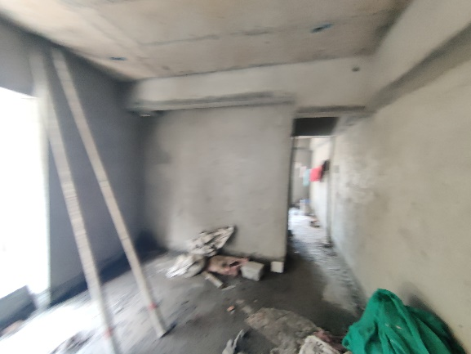
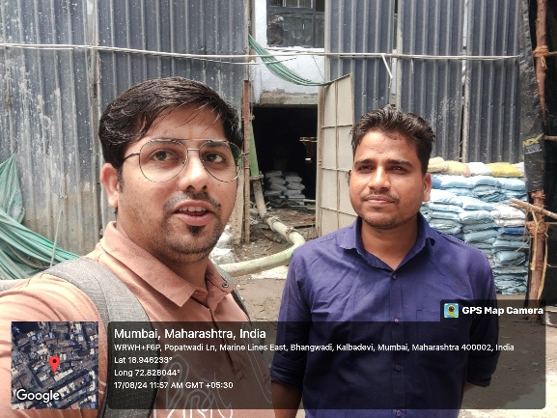

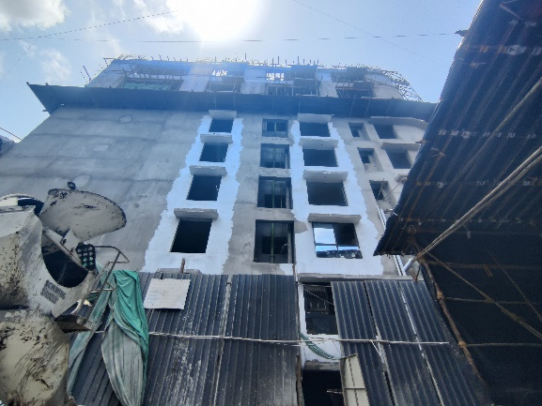
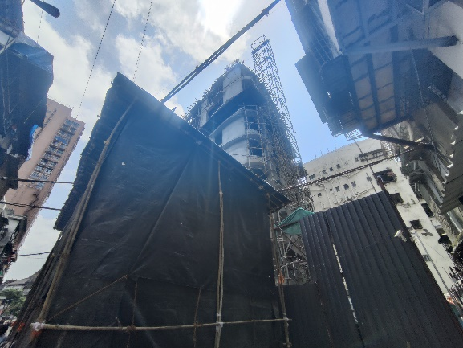
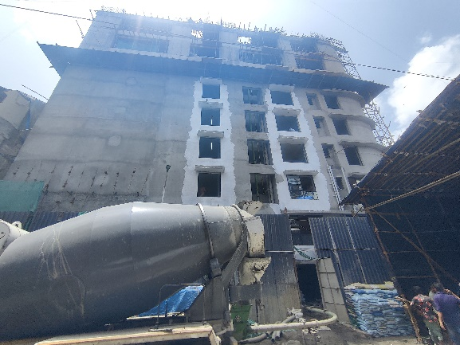
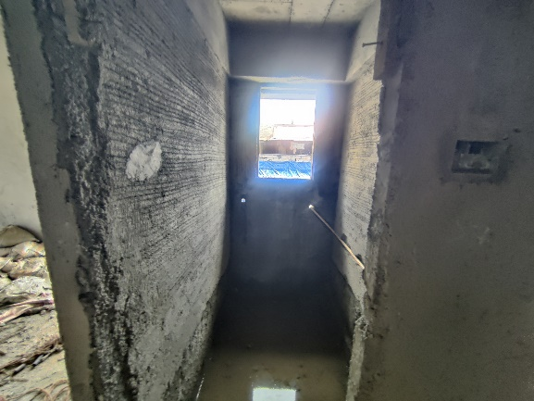
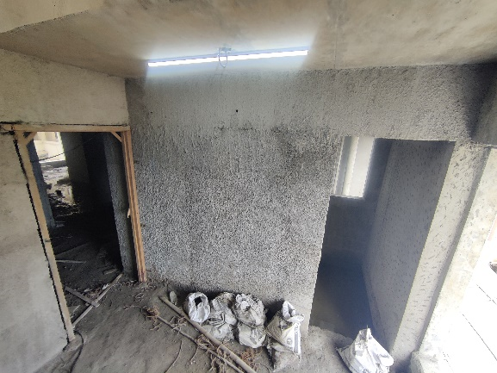
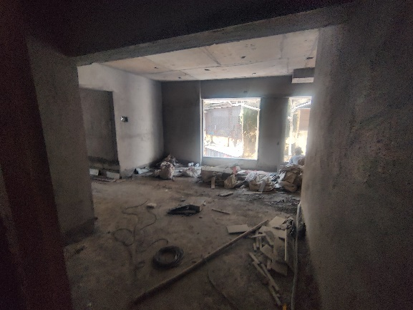
Route Map of the property
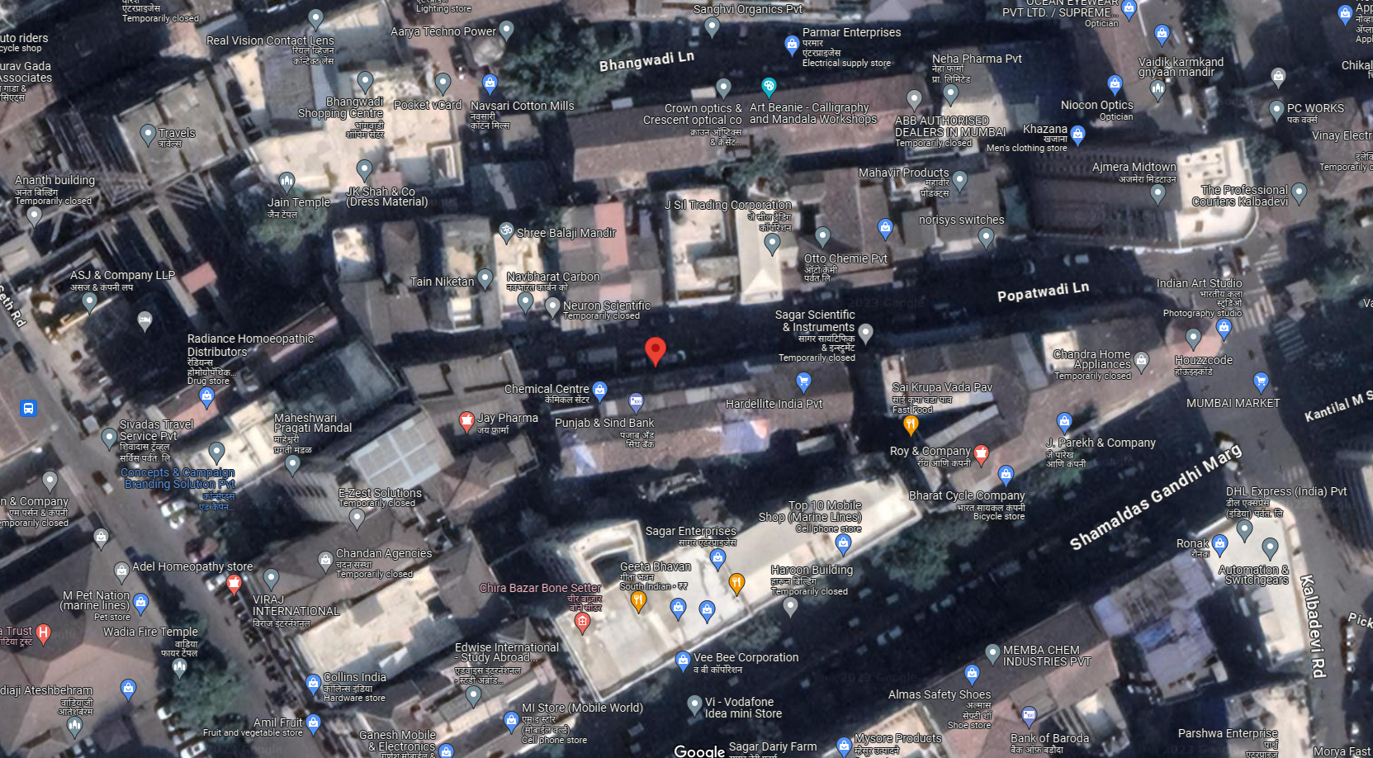
Site u/r

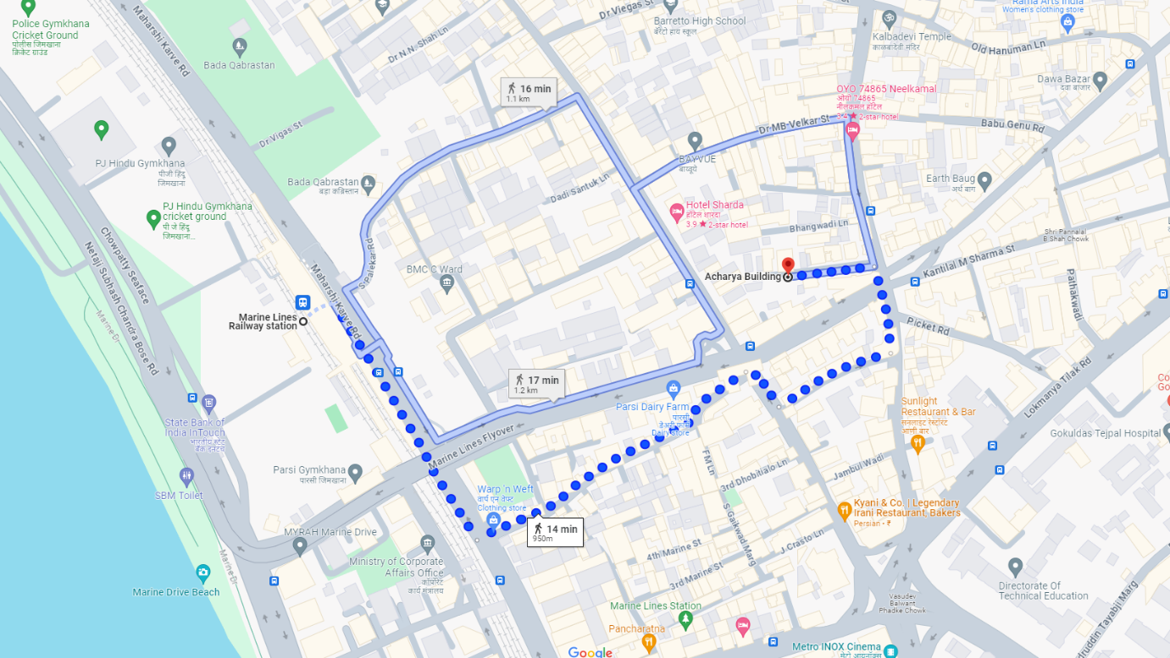

Latitude Longitude: 18°56'46.6"N 72°49'41.4"E

Note: The Blue line shows the route to site from nearest railway station (Marnies Lines – 1.0 Km.)
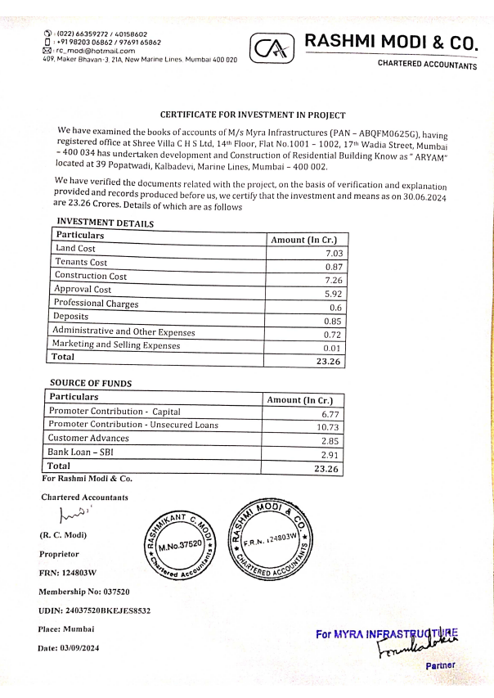
CA Certificate Dated 03.09.2024 till 30.06.2024

