Valuation Report of the Immovable Property
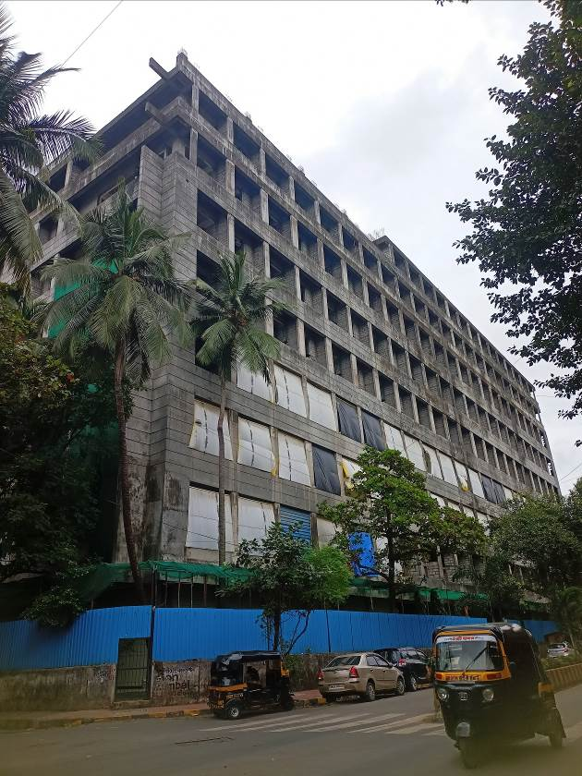

Details of the property under consideration:

Name of Owner: Mr. Paresh Kumar G. Suru & Mr. Ashok Kumar G. Suru

Industrial Gala No. 20, 7th Floor, “Kandivali Co-operative Industrial Estate Limited”, Kamla industrial Park, Plot No. 138 to 141, CTS No. 349, 350, 351 & 352, Government Industrial Estate, Charkop, Village – Kandivli, Kandivli (West), Taluka – Borivali, District – Mumbai Suburban, Pin – 400 067, State – Maharashtra, Country – India.

Latitude Longitude: 19°12'38.2"N 72°49'28.2"E

Intended User:

Punjab National Bank
MCC MW 2 Goregaon
Rajnigandha Shopping Centre, 1st Floor, Krishna Vatika Marg, Opp. Gokuldham
Temple, Goregaon (East), Mumbai - 400063

Vastu/Mumbai/08/2024/010636/2307878
26/24-356-PRBSNR
Date: 26.08.2024

VALUATION OPINION REPORT

This is to certify that the under construction property bearing Industrial Gala No. 20, 7th Floor, “Kandivali Co-operative Industrial Estate Limited”, Kamla industrial Park, Plot No. 138 to 141, CTS No. 349, 350, 351 & 352, Government Industrial Estate, Charkop, Village – Kandivli, Kandivli (West), Taluka – Borivali, District – Mumbai Suburban, Pin – 400 067, State – Maharashtra, Country – India belongs to Mr. Paresh Kumar G. Suru & Mr. Ashok Kumar G. Suru.
Boundaries |  | Building | Gala
North | : | Internal Road & Residential Building | Building is under Construction
South | : | Shree Hanuman Mandir Road | Building is under Construction
East | : | Vishnu Kutiya CHSL | Building is under Construction
West | : | Residential Building & RSC Road No. 3 | Building is under Construction
Considering various parameters recorded, existing economic scenario, and the information that is available with reference to the development of neighborhood and method selected for valuation, we are of the opinion that, the property premises can be assessed for this particular purpose as follows:
Sr. | Particulars | Value After Completion | Value As on date
1 | Fair Market Value | ` 76,80,000.00 | ` 51,45,600.00
2 | Realizable Value | ` 69,12,000.00 | ` 46,31,040.00
3 | Distress Sale Value | ` 61,44,000.00 | ` 41,16,480.00

The valuation of the property is based on the documents produced by the concerned. Legal aspects have not been taken into consideration while preparing this valuation report.

Hence certified.

Sharadkumar B. Chalikwar
Govt. Reg. Valuer
Chartered Engineer (India)
Reg. No. (N) C.C.I.T/1-14/52/2008-09
Punjab National Bank Empanelment No.: REF: ZO: SAMD:1138
Valuation Report of Immovable Property

S. No. | Particulars |  |  |  | Content
I | Introduction
1 | Name and Address of Valuer |  |  |  | Sharadkumar B. Chalikwar  Vastukala Consultants (I) Pvt. Ltd.  B1-001, U/B Floor, Boomerang, Chandivali Farm Road, Powai, Andheri (East), Mumbai – 400 072
2 | Date of Inspection |  |  |  | 23.08.2024
 | Title Deed Number and Date |  |  |  | 9319/2012 dated 17.10.2012
 | Date of Valuation |  |  |  | 26.08.2024
3 | Purpose of Valuation |  |  |  | As per the request from Punjab National Bank, MCC MW 2 Goregaon to assess fair market value of the property for Banking purpose
4 | Name of Property Owner/s  (Details of share of each owner  in case of joint & Co-ownership) |  |  |  | Mr. Paresh Kumar G. Suru & Mr. Ashok Kumar G. Suru  Joint Ownership  Details of ownership share is not available  Address – Industrial Gala No. 20, 7th Floor, “Kandivali Co-operative Industrial Estate Limited”, Kamla industrial Park, Plot No. 138 to 141, CTS No. 349, 350, 351 & 352, Government Industrial Estate, Charkop, Village – Kandivli, Kandivli (West), Taluka – Borivali, District – Mumbai Suburban, Pin – 400 067, State – Maharashtra, Country – India.  Contact Details  Mr. Paresh Kumar G. Suru (Owner)  Contact No. - +91 9892205900
5 | Name of Bank/FI as applicable |  |  |  | Punjab National Bank
6 | Name of the Developer of Property (in case of developer-built properties) |  |  |  | Metallica Industries Limited
7 | Whether occupied by the owner / tenant?  If occupied by tenant, since how long? |  |  |  | Under Construction Building
II | Physical Characteristics of the Asset
1 | Location of the Property |  |  |  | Industrial Gala No. 20, 7th Floor, “Kandivali Co-operative Industrial Estate Limited”, Kamla industrial Park, Plot No. 138 to 141, CTS No. 349, 350, 351 & 352, Government Industrial Estate, Charkop, Village – Kandivli, Kandivli (West), Taluka – Borivali, District – Mumbai Suburban, Pin – 400 067, State – Maharashtra, Country – India.
1 | Plot No. / Survey No. |  |  |  | Plot No. 138 to 141
1 | Door No. |  |  |  | Industrial Gala No. 20
1 | C. T.S. No. / Village |  |  |  | CTS No. 349, 350, 351 & 352, Village Kandivli
1 | Ward / Taluka |  |  |  | Taluka Borivali
1 | Mandal / District |  |  |  | District Mumbai Suburban
1 | Brief description of the property |  |  |  | The property is an Industrial Gala located on 7th Floor. The Composition of Industrial Gala is Working Area only. The property is 1.4 KM. distance from Dahanukarwadi Metro Station.  At the time of inspection building was under construction.
1 | Stage of Construction
1 | If under construction, extent of completion
1 | RCC Footing / Foundation |  | Complete |  |  | RCC Plinth |  |  | Complete
1 | Full Building RCC |  | Complete |  |  | Internal Brick Work |  |  | Complete
1 | External Brick Work |  | Complete |  |  | Internal Plastering |  |  | Completed upto 1st floor
1 | External Plastering |  | Completed upto 1st floor |  |  | Door |  |  | Completed upto 1st floor
1 | Window |  | Completed upto 1st floor |  |  | Flooring, Tilling, Kitchen Platform |  |  | Completed upto 1st floor
1 | Internal Painting |  | Completed upto 1st floor |  |  | External Painting |  |  | Completed upto 1st floor
1 | Electrification, Plumbing, Sanitary Installation |  | Completed upto 1st floor
1 | Total |  | 67% work completed
1 | Nearby landmark
2. | Municipal Ward No. |  |  |  | R- South Ward
3. | City / Town |  |  |  | Kandivli
 | Residential area |  |  |  | No
 | Commercial area |  |  |  | No
 | Industrial area |  |  |  | Yes
4. | Classification of the area
 | i) High / Middle / Poor |  |  |  | Middle Class
 | ii) Metro / Urban / Semi Urban / Rural |  |  |  | Semi Urban
5. | Coming under Corporation limit / Village Panchayat / Municipality |  |  |  | Village – Kandivli  Municipal Corporation of Greater Mumbai
6. | Postal address of the property |  |  |  | Industrial Gala No. 20, 7th Floor, “Kandivali Co-operative Industrial Estate Limited”, Kamla industrial Park, Plot No. 138 to 141, CTS No. 349, 350, 351 & 352, Government Industrial Estate, Charkop, Village – Kandivli, Kandivli (West), Taluka – Borivali, District – Mumbai Suburban, Pin – 400 067, State – Maharashtra, Country – India.
7. | Latitude, Longitude and Coordinates of the site |  |  |  | 19°12'38.2"N 72°49'28.2"E
8. | Area of the plot/land (supported by a plan) |  |  |  | N.A. the property under consideration is Industrial Gala Only.
9. | Layout plan of the area in which the property is located |  |  |  | M.C.G.M. Approved Layout
10. | Development of surrounding areas |  |  |  | Developing Area
11. | Details of Roads abutting the property |  |  |  | 12.00 M. wide B.T. Road
12. | Whether covered under any State / Central Govt. enactments (e.g., Urban Land Ceiling Act) or notified under agency area / scheduled area / cantonment area |  |  |  | -
13. | In case it is an agricultural land, any conversion to house site plots is contemplated |  |  |  | N.A. the property under consideration is Industrial Gala Only.
14. | Boundaries of the Property
 | As per Documents
 | Building | North |  | South |  |  | East |  |  |  | West
 | Building | Existing Road & beyond that CTS No. 353 & 348 of the said estate |  | CTS No. 353 & 348 (Plot No. 140 & 139) of the said Estate. |  |  | Existing Road & beyond that CTS NO. 342 & 353 of the said estate. |  |  | CTS No. 359 & 358 of the said estate.
 | Actual Boundaries
 | Building | North |  | South |  |  | East |  |  |  | West
 | Building | Internal Road & Residential Building |  | Shree Hanuman Mandir Road |  |  | Vishnu Kutiya CHSL |  |  |  | Residential Building & RSC Road No 3
 | Extent of the site considered for valuation (least of 14 A & 14 B) |  |  |  | Carpet Area in Sq.ft. = 385.30  (Area as per site Measurement)  Carpet Area in Sq.Ft. = 320.00  (Area as per Agreement for sale)  Built up Area in Sq.ft. = 352.00  (Carpet Area + 10%)
15. | Description of Adjoining properties
 | North |  |  |  | Internal Road & Residential Building
 | South |  |  |  | Shree Hanuman Mandir Road
 | East |  |  |  | Vishnu Kutiya CHSL
 | West |  |  |  | Residential Building & RSC Road No. 3
16. | Survey no. if any |  |  |  | -
17 | Type of Building (Residential/ Commercial/ Industrial) |  |  |  | Proposed Industrial Building
18. | Details of the building/buildings and other improvements in terms of area, height, no. of floors, plinth area floor wise, year of construction, year of making alterations/additional constructions with details, full details of specifications to be appended along with building plans and elevations |  |  |  | As per Brief description
19. | Plinth Area, Carpet Area and Saleable Area to be mentioned separately and clarified |  |  |  | As per Brief description
20. | Any other aspect |  |  |  | -
III | Town Planning parameters
1. | Master plan provisions related to the property in terms of land use |  |  |  | Industrial Use
2. | Date of issue and validity of layout of approved map / plan |  |  |  | Copy of Approved plan No. CHE/A – 4446 / BP (WS) / AR dated 19.03.2011 issued by Municipal Corporation of Greater Mumbai.
3. | Approved map / plan issuing authority
4. | Whether genuineness or authenticity of approved map / plan is verified |  |  |  | Yes
5. | Any other comments by our empaneled valuers on authentic of approved plan |  |  |  | No
6. | Planning area/zone |  |  |  | Industrial Zone
7. | Development controls |  |  |  | MCGM
8. | Zoning regulations |  |  |  | Industrial Purpose
9. | FAR/FSI permitted and consumed |  |  |  | -
10. | Ground coverage |  |  |  | -
11. | Transferability of development rights if any, Building bye- law provisions as applicable to the property viz. setbacks, height restrictions, etc. |  |  |  | No information provided.
12. | Comment on surrounding land uses and adjoining properties in terms of usage. |  |  |  | Residential & Industrial
13. | Comment on unauthorized constructions if any |  |  |  | No
14. | Comment on demolition proceedings if any |  |  |  | No
15. | Comment on compounding / regularization proceedings |  |  |  | No
16. | Comment on whether OC has been issued or not |  |  |  | No, building construction work is in progress
17. | Any other aspect |  |  |  | -
IV. | Legal Aspects
1. | Ownership Documents
 | - Copy of Agreement for Sale Reg. Doc. No. 9319/2012 dated 17.10.2012 between M/s. Metallica Industrial Ltd. (The Vendor) AND Mr. Paresh Kumar G. Suru & Mr. Ashok Kumar G. Suru (The Purchasers).
 | - Copy of Approved Plan No. CHE / A – 4446 / BP(WS) / AR dated 19.03.2011, issued by MCGM.
 | - Copy of Amended Commencement Certificate No. CHE / A – 4446 / BP(WS) / AR dated 21.02.2013, issued by MCGM.
 | TIR Verification |  |  |  | Not Provided
2. | Name of the Owner/s |  |  |  | Mr. Paresh Kumar G. Suru & Mr. Ashok Kumar G. Suru
3. | Comment on dispute/issues of landlord with tenant/statutory body/any other agencies if any regarding immovable property. |  |  |  | Information not available
4. | Comment on whether the IP is independently accessible? |  |  |  | Yes
5. | Title verification, |  |  |  | As per Agreement for sale
6. | Details of leases if any, |  |  |  | No
7. | Ordinary status of freehold or leasehold including restrictions on transfer |  |  |  | N.A.
8. | Agreement of easement if any |  |  |  | Not Apparent from the documents provided
9. | Notification of acquisition if any |  |  |  | Not Apparent from the documents provided
10. | Notification of road widening if any |  |  |  | Already considered as per Approved Plan
11. | Possibility of frequent flooding / sub-merging |  |  |  | No
12. | Special remarks, if any, like threat of acquisition of land for public service purposes, road widening or applicability of CRZ provisions etc. (Distance from seacoast / tidal level must be incorporated) |  |  |  | No
13. | Heritage restrictions if any, all legal documents, receipts related to electricity, water tax, property tax and any other building taxes to be verified and copies as applicable to be enclosed with the report. |  |  |  | No
14. | Comment on transferability of the property ownership |  |  |  | Details not available. The bank is requested to independently verify the same
15. | Comment on existing mortgages / charges / encumbrances on the property, if any |  |  |  | Details not available. The bank is requested to independently verify the same
16. | Comment on whether the owners of the property have issued any guarantee (personal or corporate) as the case may be |  |  |  | Details not available. The bank is requested to independently verify the same
17. | Building plan sanction, illegal construction if any done without plan sanction/violations. |  |  |  | - Copy of Approved Plan No. CHE / A – 4446 / BP(WS) / AR dated 19.03.2011, issued by MCGM.  - Copy of Amended Commencement Certificate No. CHE / A – 4446 / BP(WS) / AR dated 21.02.2013, issued by MCGM.
18. | Any other aspect |  |  |  | -
V. | Economic Aspects
1. | Details of ground rent payable, |  |  |  | N.A., Building is under Construction
2. | Details of monthly rents being received if any, |  |  |  | N.A., Building is under Construction
3. | Taxes and other outings |  |  |  | N.A., Building is under Construction
4. | Property Insurance |  |  |  | N.A., Building is under Construction
5. | Monthly maintenance charges |  |  |  | N.A., Building is under Construction
6. | Security charges |  |  |  | N.A., Building is under Construction
7. | Any other aspect |  |  |  | N.A., Building is under Construction
VI. | Socio-cultural Aspects of the Property
1. | Description of the location of property in terms of the social structure of the area, population, social stratification, regional origin, age groups, economic level, location of slums, squatter settlements nearby, etc. |  |  |  | Developed Industrial area, Middle Class
VII. | Functional and Utilitarian Aspects
 | Description of the functionality and utility of the assets in terms of:
1. | Space allocation |  |  |  | Provided as per approved plan
2. | Storage Spaces |  |  |  | As per approved plan
3. | Utility of spaces provided within the building |  |  |  | As per approved plan
4. | Any other aspect |  |  |  | Nil
VIII. | Infrastructure Availability
1. | Description of aqua infrastructure availability in terms of
1. | - Water supply |  |  |  | Yes
1. | - Sewerage / sanitation System |  |  |  | Yes
1. | - Storm water drainage |  |  |  | Yes
2. | Description of other physical infrastructure facilities viz.
 | - Solid waste management |  |  |  | No
 | - Electricity |  |  |  | Yes
 | - Road and public transportation connectivity |  |  |  | Connected with public transport like Auto, bus, private vehicles, etc.
 | - Availability of other public utilities nearby |  |  |  | All available nearby
3. | Social infrastructure in terms of  - Schools  - Medical facilities  - Recreational facility in terms of parks and open space |  |  |  | All available nearby
IX. | Marketability
 | Analysis of the market for the property in terms of
1. | Locational attributes |  |  |  | Industrial Area
2. | Scarcity |  |  |  | Average
3. | Demand and supply of the kind of subject property |  |  |  | Average
4. | Comparable sale prices in the locality |  |  |  | Price Indicators attached
X. | Engineering and Technology Aspects of the Property
1. | Type of construction |  |  |  | As per Brief Description
2. | Material & technology used |  |  |  | A Grade
3. | Specifications |  |  |  | Standard
4. | Maintenance issues |  |  |  | No
5. | Age of the building |  |  |  | Under Construction Building
6. | Total life of the building |  |  |  | 60 years (After Completion)
7. | Extent of deterioration |  |  |  | 60 years Subject to proper, preventive periodic Maintenance & structural repairs.
8. | Structural safety |  |  |  | Normal
9. | Protection against natural disaster viz. earthquakes, |  |  |  | Normal
10. | Visible damage in the building if any, |  |  |  | Nil
11. | Common Facilities viz. lift, water pump, lights, security system, etc., |  |  |  | Proposed as per requirement.
12. | System of air-conditioning |  |  |  | Under Construction Building
13. | Provision for firefighting |  |  |  | Proposed as per Approved Plan
14. | Copies of the plan and elevation of the building to be included |  |  |  | Provided
XI. | Environmental Factors
1. | Use of environment friendly building materials, Green Building techniques if any |  |  |  | No
2. | Provision of rainwater harvesting |  |  |  | Information not available
3. | Use of solar heating and lighting systems, etc. Presence of environmental pollution in the vicinity of the property in terms of industries, heavy traffic, etc. |  |  |  | No
XII. | Architectural and aesthetic quality of the Property
 | Descriptive account on whether the building is modern, old fashioned, etc., plain looking or with decorative elements, heritage value if applicable, presence of landscape elements, etc. |  |  |  | Plain Looking
XIII. | In case of valuation of industrial property
1. | Proximity to residential areas |  |  |  | Within 1 km. range
2. | Availability of public transport facilities |  |  |  | All public transport facilities are available.
XIV. | Valuation
 | Here, the procedure adopted for arriving at the  valuation has to be highlighted.  The valuer should consider all the three generics approaches of property valuation and state explicitly the reasons for adoption of rejection of a particular approach and the basis on which the final valuation judgement is arrived at.  A detailed analysis and descriptive account of the approaches, assumptions made, basis adopted, supporting data (in terms of comparable sales), reconciliation of various factors departures, final valuation arrived at has to be presented here. |  |  |  | Sale Comparative Method is used for this valuation report.
 | Prevailing Market Rate/Price trend of the Property in the locality/city from property search sites viz. magickbricks.com, 99acres.com, makaan.com etc. if available |  |  |  | ` 19,412/- to ` 33,334/- per Sq. Ft. Considering the rate with attached report, current market conditions, demand and supply position, Industrial Gala size, location, upswing in real estate prices, sustained demand for industrial gala, all round development of industrial application in the locality etc.
 | Guideline / Circle Rate |  |  |  | Not Applicable. We are doing the Valuation for Single Gala.
 | Building |  |  |  | As per valuation table
 | Summary of Valuation
 | - Guideline Value |  |  |  | Built up Area in Sq. Ft. |  |  | Rate in ` |  |  |  | Value in `
 | Industrial Gala |  |  |  | 352.00 |  |  | 10,011.00 |  |  |  | 35,23,872/-
 | Total |  |  |  |  |  |  |  |  |  |  | 35,23,872/-

 | - Fair Market Value
 | Particulars | Carpet Area | Rate |  | Full Value (B1) | Percentage of Work Completed | Value as on Date (B2)
 |  | (Sq. Ft.) | (`) |  | (`) | (`) | (`)
 | Gala No 20 | 320.00 | 24,000/- |  | 76,80,000/- | 67% | 51,45,600/-
 | Total |  |  |  | 76,80,000/- |  | 51,45,600/-
Remarks –
- As per Site Inspection, measured Carpet area is 385.00 Sq. Ft. which is more than area mentioned in the documents (320.00 Sq.ft.). We have considered lesser area mentioned in the documents for valuation.
- The building construction had halted for many times presently some construction works are under progress.
- Amended Commencement Certificate No. CHE / A – 4446 / BP(WS) / AR Dated 21.02.2013 but the building is still under construction which is a point of concern.

The sales comparison approach uses the market data of sale prices to estimate the value of a real estate property. Property valuation in this method is done by comparing a property to other similar properties that have been recently sold. Comparable properties, also known as comparable, or comps, must share certain features with the property in question. Some of these include physical features such as square footage, number of rooms, condition and age of the building; however, the most important factor is no doubt the location of the property. Adjustments are usually needed to account for differences as no two properties are exactly the same. To make proper adjustments when comparing properties, real estate appraisers must know the differences between the comparable properties and how to value these differences. The sales comparison approach is commonly used for Industrial Gala, where there are typically many comparable available to analyze. As the property is an Industrial Gala, we have adopted Sale Comparison Approach Method for the purpose of valuation. The Price for similar type of property in the nearby vicinity is in the range of ` 19,412.00 to ` 33,334.00 per Sq. Ft. on Carpet Area / ` 17,648.00 to ` 27,778.00 per Sq. Ft. on Built up. Considering the rate with attached report, current market conditions, demand and supply position, Gala size, location, upswing in real estate prices, sustained demand for Industrial Gala, all round development of Industrial and Commercial application in the locality etc. We estimate ` 24,000.00 per Sq. Ft. on Carpet Area for valuation.

As a result of my appraisal and analysis, it is my considered opinion that the present market value of the above property in prevailing condition with aforesaid specifications is
Sr. | Particulars | Value After Completion | Value As on date
1 | Fair Market Value | ` 76,80,000.00 | ` 51,45,600.00
2 | Realizable Value | ` 69,12,000.00 | ` 46,31,040.00
3 | Distress Sale Value | ` 61,44,000.00 | ` 41,16,480.00

- Date of purchase of immovable property | : | 17/10/2012
- Purchase Price of immovable property | : | ` 33,82,500.00
- Book value of immovable property | : | ₹ 35,82,000.00
- Fair Market Value of immovable property after completion | : | ` 76,80,000.00
- Realizable Value of immovable property after completion | : | ` 69,12,000.00
- Distress Sale Value of immovable property after completion | : | ` 61,44,000.00
- Insurable Value (As per Index -II) | : | ` 9,85,600.00
- Guideline Value | : | ` 35,23,872.00

Sharadkumar B. Chalikwar
Govt. Reg. Valuer
Chartered Engineer (India)
Reg. No. (N) C.C.I.T/1-14/52/2008-09
Punjab National Bank Empanelment No.: REF: ZO: SAMD:1138

Enclosures
1. | Declaration from the valuer
2. | Model code of conduct for valuer
3. | Photograph of owner with the property in the background
4. | Screen shot (in hard copy) of Global Positioning System (GPS)/Various Applications (Apps)/Internet sites (e.g., Google earth)/etc.
5. | Any other relevant documents/extracts

Actual Site Photographs
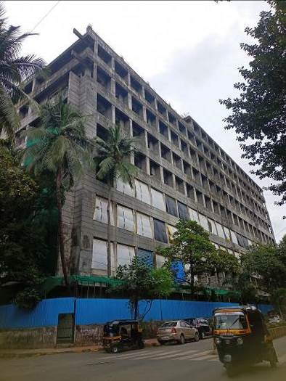
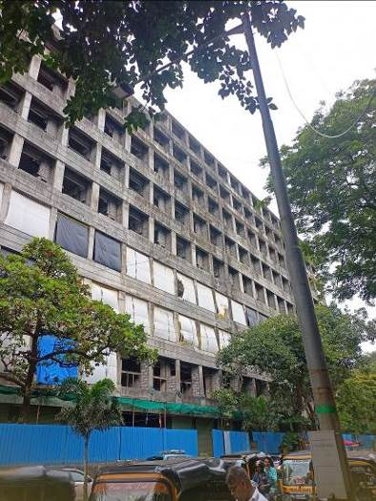
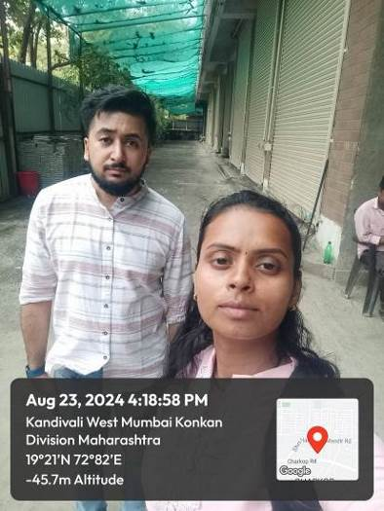

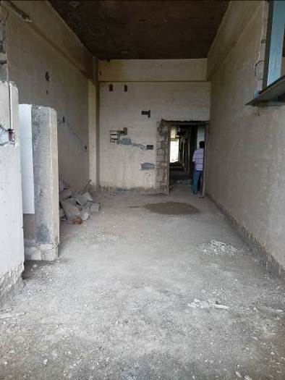
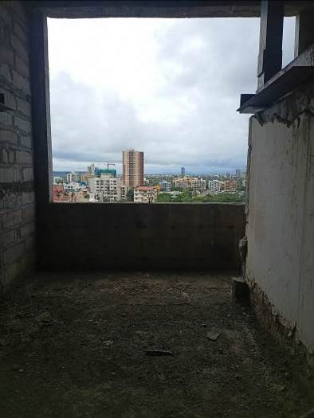
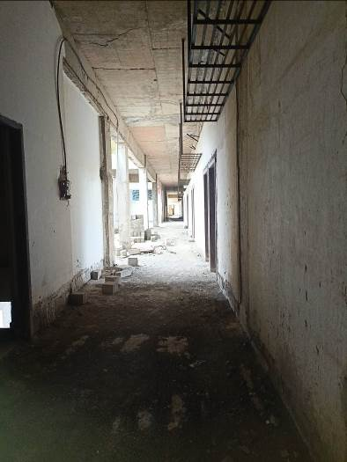
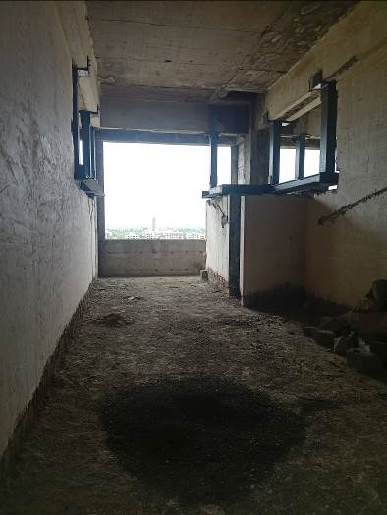
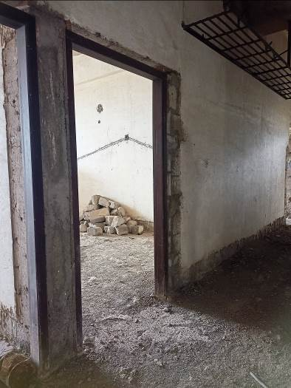
Route Map of the property
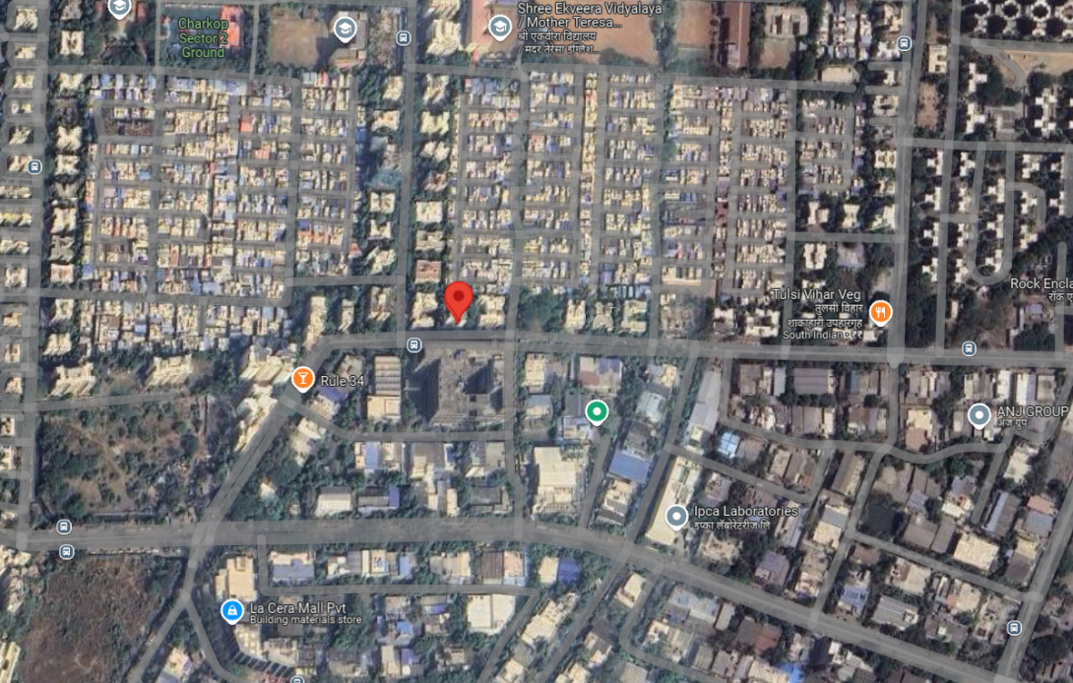

Note: Red marks shows the exact location of the property
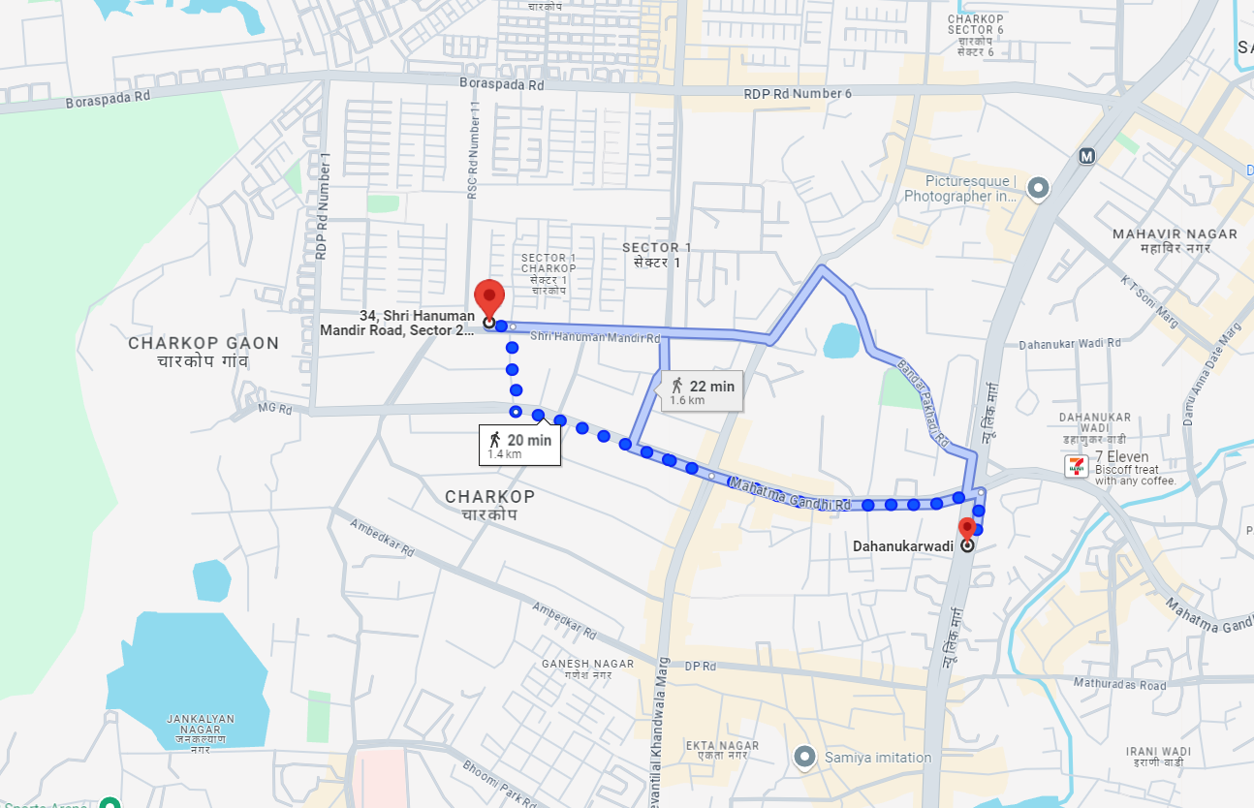

Latitude Longitude: 19°12'38.2"N 72°49'28.2"E
Note: The Blue line shows the route to site from nearest Metro station (Dahanukarwadi– 1.4 KM.)
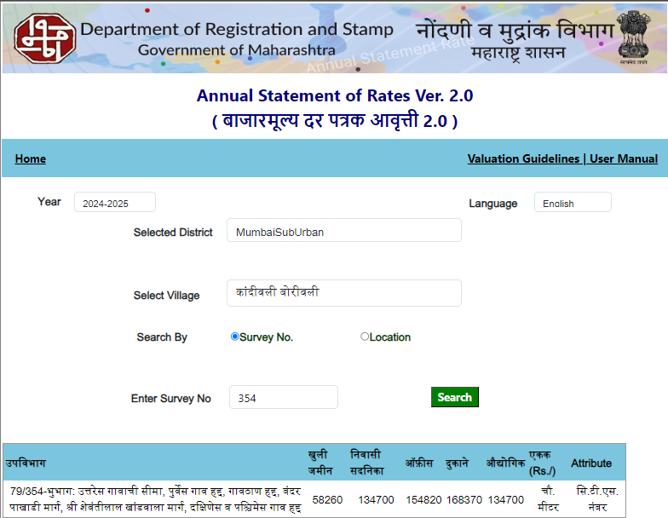
Ready Reckoner Rate

Stamp Duty Ready Reckoner Market Value Rate for Industrial Unit (A) | 1,34,700.00 | Sq. Mtr. | 12,514.00 | Sq. Ft.
Stamp Duty Ready Reckoner Market Value Rate for Land (B) | 58,260.00 | Sq. Mtr. | 5,412.00 | Sq. Ft.
The difference between land rate and building rate (A – B = C) | 76,440.00
Depreciation Percentage as per table (D) [100% - 14%]  (Age of the Building – 14 Years) | 100%
Rate to be adopted after considering depreciation [B + (C x D)] | 1,07,760.00 | Sq. Mtr. | 10,011.00 | Sq. Ft.

Multi-Storied building with Lift
For residential premises / commercial unit / office on above floor in multistoried building, the rate mentioned in the ready reckoner will be increased as under:
 | Location of Flat / Commercial Unit in the building | Rate
a) | On Ground to 4 Floors | No increase for all floors from ground to 4 floors
b) | 5 Floors to 10 Floors | Increase by 5% on units located between 5 to 10 floors
c) | 11 Floors to 20 Floors | Increase by 10% on units located between 11 to 20 floors
d) | 21 Floors to 30 Floors | Increase by 15% on units located between 21 to 30 floors
e) | 31 Floors and above | Increase by 20% on units located on 31 and above floors
Table – D: Depreciation Percentage Table

Completed Age of Building in Years | Value in percent after depreciation
 | R.C.C. Structure / other Pukka Structure | Cessed Building, Half or Semi – Pukka Structure & Kaccha Structure.
0 to 2 Years | 100% | 100%
Above 2 & up to 5 Years | 95% | 95%
Above 5 Years | After initial 5 year for every year 1% depreciation is to be considered. However maximum deduction available as per this shall be 70% of Market Value rate | After initial 5 year for every year 1.5% depreciation is to be considered. However maximum deduction available as per this shall be 85% of Market Value rate

Price Indicator

Property | Gala
Source | https://www.magicbricks.com/
Floor | -
 | Carpet | Built Up | Saleable
Area | 463.64 | 510.00 | 612.00
Percentage | - | 10% | 20%
Rate Per Sq.Ft. | ₹ 19,412.00 | ₹ 17,647.00 | ₹ 14,706.00
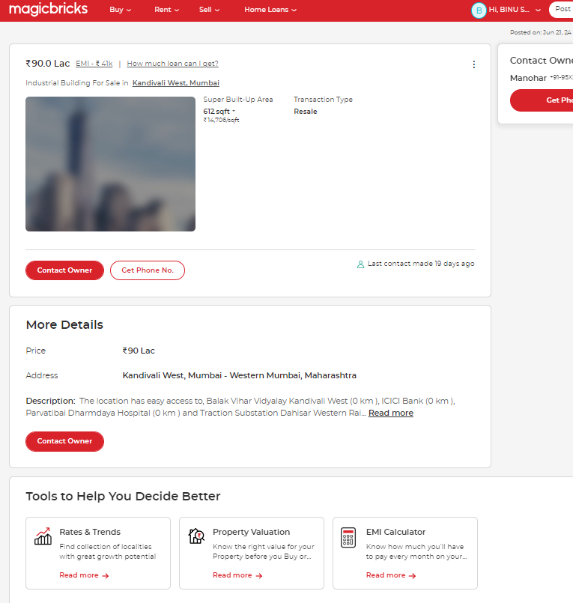

Price Indicator

Property | Gala
Source | https://www.nobroker.com/
Floor | -
 | Carpet | Built Up | Saleable
Area | 818.18 | 900.00 | 1,080.00
Percentage | - | 10% | 20%
Rate Per Sq.Ft. | ₹ 19,556.00 | ₹ 17,778.00 | ₹ 14,815.00
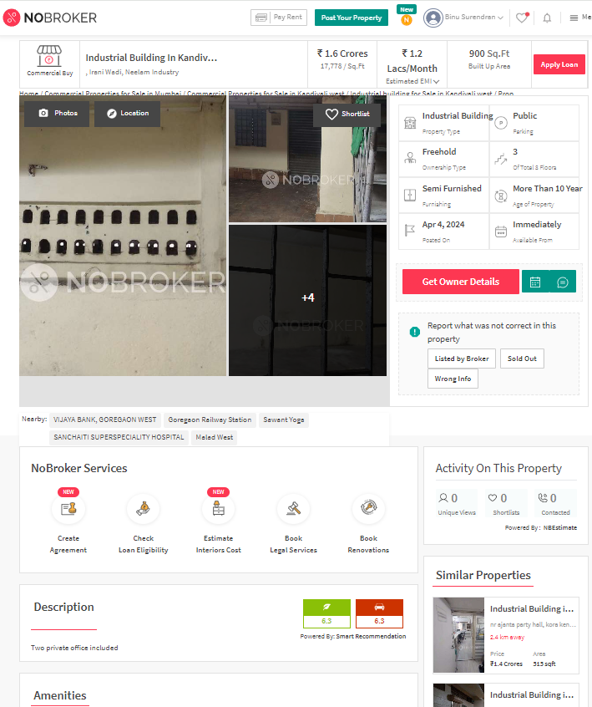

Sales Instances

Property | Gala
Source | Index No. 2
Floor | -
 | Carpet | Built Up | Saleable
Area | 2,250.00 | 2,700.00 | 3,240.00
Percentage | - | 10% | 20%
Rate Per Sq.Ft. | ₹ 33,333.00 | ₹ 27,778.00 | ₹ 23,148.00
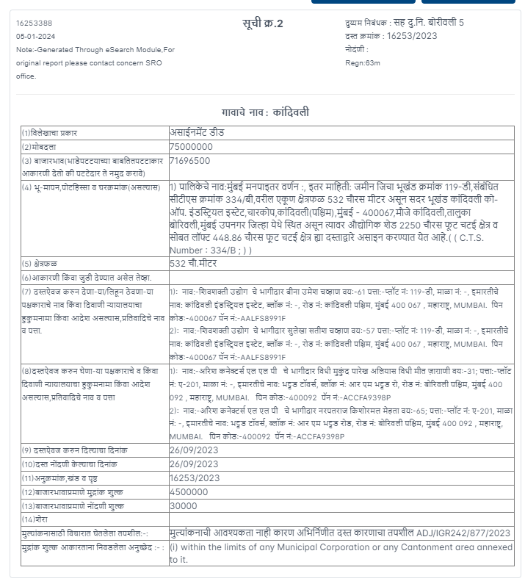

Sales Instances

Property | Gala
Source | Index No 2
Floor | -
 | Carpet | Built Up | Saleable
Area | 2,625.94 | 3,151.13 | 3,781.36
Percentage | - | 10% | 20%
Rate Per Sq.Ft. | ₹ 24,753.00 | ₹ 20,628.00 | ₹ 17,190.00
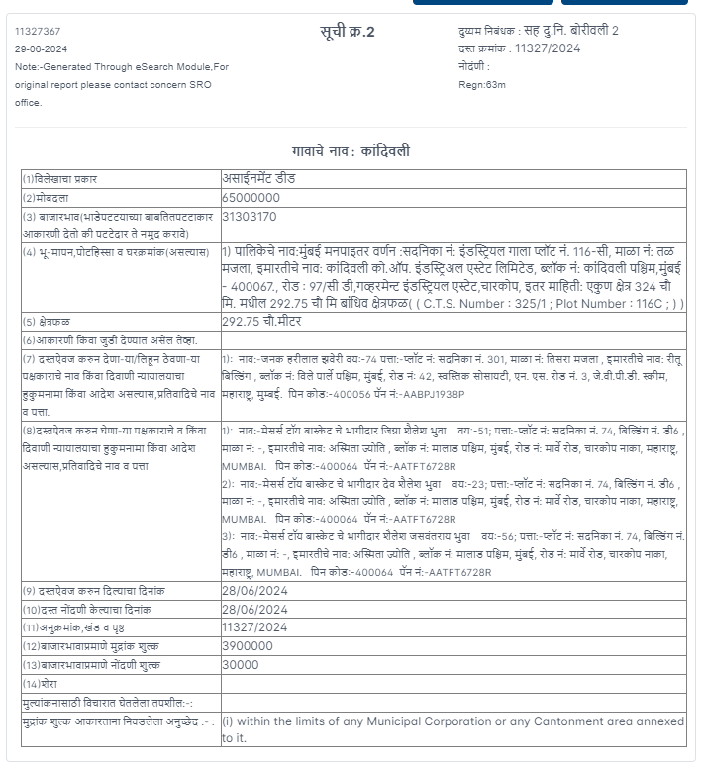

Justification for price /rate

The Market Value of the property is based on facts of markets discovered by us during our enquiries, however the government rate value in this case is less than the market value arrived by us. We are of the opinion that the value arrive by us will prove to be correct if an Auction of the subject property is carried out. As far as Market Value in Index II is concerned, it is not possible to comment on same, may be government rates are fixed by sampling during same point of time in part and whereas, Market values change every month.
In most of the cases the actual deal amount or Transaction value is not reflected in Index II because of various Market practices. As Valuer, we always try to give a value which is correct reflection of actual transaction value irrespective of any factors in market.
APPENDIX V

DECLARATION FROM VALUERS

I hereby declare that-

- The information furnished in my valuation report dated 26.08.2024 is true and correct to the best of my knowledge and belief and I have made an impartial and true valuation of the property.

- I have no direct or indirect interest in the property valued;

- I/ my authorized representative has personally visited the property on 16.08.2024. The work is not sub- contracted to any other valuer and carried out by myself.

- I have not been convicted of any offence and sentenced to a term of Imprisonment.

- I have not been found guilty of misconduct in my professional capacity.

- I have read the Handbook on Policy, Standards and procedure for Real Estate Valuation, 2011 of the IBA and this report is in conformity to the "Standards" as enshrined for valuation in the Part - B of the above handbook to the best of my ability.

- I have read the International Valuation Standards (IVS) and the report submitted to the Bank for the respective asset class is in conformity to the "Standards" as enshrined for valuation in the IVS in "General Standards" and "Asset Standards" as applicable. The valuation report is submitted in the prescribed format of the bank.

- I abide by the Model Code of Conduct for empanelment of valuer in the Bank. (Annexure III - A signed copy of same to be taken and kept along with this declaration)

- I am registered under Section 34 AB of the Wealth Tax Act, 1957.

- I am the proprietor / partner / authorized official of the firm / company, who is competent to sign this valuation report.

- Further, I hereby provide the following information.

Sr. No. | Particulars | Valuer comment
 | Background information of the asset being valued; | The Property under consideration is purchased by Mr. Paresh Kumar G. Suru & Mr. Ashok Kumar G. Suru. From M/s. Metallica Industries Ltd. Vide Agreement for sale dated 17.10.2012.
 | Purpose of valuation and appointing authority | As per the request from Punjab National Bank, MCC MW2 Goregaon, to assess fair market value of the property for Bank Lone purpose
 | Identity of the valuer and any other experts involved in the valuation; | Sharadkumar B. Chalikwar – Regd. Valuer  Bhavika Chavan – Valuation Engineer  Binumon Moozhickal – Technical Manager  Pradnya Rasam – Technical Officer
 | Disclosure of valuer interest or conflict, if any; | We have no interest, either direct or indirect, in the property valued. Further to state that we do not have relation or any connection with property owner / applicant directly or indirectly. Further to state that we are an independent Valuer and in no way related to property owner / applicant
 | Date of appointment, valuation date and date of report; | Date of Appointment – 16.08.2024  Valuation Date – 26.08.2024  Date of Report – 26.08.2024
 | Inspections and/or investigations undertaken; | Physical Inspection done on date 23.08.2024.
 | Nature and sources of the information used or relied upon; | - Market Survey at the time of site visit  - Ready Reckoner rates / Circle rates  - Online search for Registered Transactions  - Online Price Indicators on real estate portals  - Enquiries with Real estate consultants  - Existing data of Valuation assignments carried out by us
 | Procedures adopted in carrying out the valuation and valuation standards followed; | Sales Comparative Method
 | Restrictions on use of the report, if any; | This valuation is for the use of the party to whom it is addressed and for no other purpose. No responsibility is accepted to any third party who may use or rely overall or any part of this valuation. The valuer has no pecuniary interest that would conflict with the proper valuation of the property.
 | Major factors that were taken into account during the valuation; | current market conditions, demand and supply position, Industrial Factory size, location, upswing in real estate prices, sustained demand for Industrial Factory / Land, all round development of industrial and commercial application in the locality etc.
 | Caveats, limitations, and disclaimers to the extent they explain or elucidate the limitations faced by valuer, which shall not be for the purpose of limiting his responsibility for the valuation report. | Attached

APPENDIX VI
MODEL CODE OF CONDUCT FOR VALUERS

{Adopted in line with Companies (Registered Valuers and Valuation Rules, 2017)}
All valuers empanelled with bank shall strictly adhere to the following code of conduct:

Integrity and Fairness
- A valuer shall, in the conduct of his/its business, follow high standards of integrity and fairness in all his/its dealings with his/its clients and other valuers.
- A valuer shall maintain integrity by being honest, straightforward, and forthright in all professional relationships.
- A valuer shall endeavour to ensure that he/it provides true and adequate information and shall not misrepresent any facts or situations.
- A valuer shall refrain from being involved in any action that would bring disrepute to the profession.
- A valuer shall keep public interest foremost while delivering his services.
Professional Competence and Due Care
- A valuer shall render at all times high standards of service, exercise due diligence, ensure proper care and exercise independent professional judgment.
- A valuer shall carry out professional services in accordance with the relevant technical and professional standards that may be specified from time to time.
- A valuer shall continuously maintain professional knowledge and skill to provide competent professional service based on up-to-date developments in practice, prevailing regulations / guidelines and techniques.
- In the preparation of a valuation report, the valuer shall not disclaim liability for his/its expertise or deny his/its duty of care, except to the extent that the assumptions are based on statements of fact provided by the company or its auditors or consultants or information available in public domain and not generated by the valuer.
- A valuer shall not carry out any instruction of the client insofar as they are in compatible with the requirements of integrity, objectivity and independence.
- A valuer shall clearly state to his client the services that he would be competent to provide and the services for which he would be relying on other valuers or professionals or for which the client can have a separate arrangement with other valuers.
Independence and Disclosure of Interest
- A valuer shall act with objectivity in his/its professional dealings by ensuring that his/its decisions are made without the presence of any bias, conflict of interest, coercion, or undue influence of any party, whether directly connected to the valuation assignment or not.
- A valuer shall not take up an assignment if he/it or any of his/its relatives or associates is not independent in terms of association to the company.
- A valuer shall maintain complete independence in his/its professional relationships and shall conduct the valuation independent of external influences.
- A valuer shall wherever necessary disclose to the clients, possible sources of conflicts of duties and interests, while providing unbiased services.
- A valuer shall not deal in securities of any subject company after any time when he/it first becomes aware of the possibility of his / its association with the valuation, and in accordance with the Securities and Exchange Board of India (Prohibition of Insider Trading)Regulations,2015 or till the time the valuation report becomes public, whichever is earlier.
- A valuer shall not indulge in "mandate snatching" or offering "convenience valuations" in order to cater to a company or client's needs.
- As an independent valuer, the valuer shall not charge success fee (Success fees may be defined as a compensation / incentive paid to any third party for successful closure of transaction. In this case, approval of credit proposals).
- In any fairness opinion or independent expert opinion submitted by a valuer, if there has been a prior engagement in an unconnected transaction, the valuer shall declare the association with the company during the last five years.
Confidentiality
- A valuer shall not use or divulge to other clients or any other party any confidential information about the subject company, which has come to his / its knowledge without proper and specific authority or unless there is a legal or professional right or duty to disclose.
Information Management
- A valuer shall ensure that he/ it maintains written contemporaneous records for any decision taken, the reasons for taking the decision, and the information and evidence in support of such decision. This shall be maintained so as to sufficiently enable a reasonable person to take a view on the appropriateness of his /its decisions and actions.
- A valuer shall appear, co-operate and be available for inspections and investigations carried out by the authority, any person authorised by the authority, the registered valuers organisation with which he/it is registered or any other statutory regulatory body.
- A valuer shall provide all information and records as may be required by the authority, the Tribunal, Appellate Tribunal, the registered valuers organisation with which he/it is registered, or any other statutory regulatory body.
- A valuer while respecting the confidentiality of information acquired during the course of performing professional services, shall maintain proper working papers for a period of three years or such longer period as required in its contract for a specific valuation, for production before a regulatory authority or for a peer review. In the event of a pending case before the Tribunal or Appellate Tribunal, the record shall be maintained till the disposal of the case.
Gifts and hospitality:
- A valuer or his / its relative shall not accept gifts or hospitality which undermines or affects his independence as a valuer.
Explanation, - For the purposes of this code the term 'relative' shall have the same meaning as defined in clause (77) of Section 2 of the Companies Act, 2013 (18 of 2013).
- A valuer shall not offer gifts or hospitality or a financial or any other advantage to a public servant or any other person with a view to obtain or retain work for himself / itself, or to obtain or retain an advantage in the conduct of profession for himself / itself.
Remuneration and Costs.
- A valuer shall provide services for remuneration which is charged in a transparent manner, is a reasonable reflection of the work necessarily and properly undertaken, and is not inconsistent with the applicable rules.
- A valuer shall not accept any fees or charges other than those which are disclosed in a written contract with the person to whom he would be rendering service.

Occupation, employability, and restrictions.
- A valuer shall refrain from accepting too many assignments, if he/it is unlikely to be able to devote adequate time to each of his/ its assignments.
- A valuer shall not conduct business which in the opinion of the authority or the registered valuer organisation discredits the profession.

APPENDIX VII
UNDERTAKING

I, Sharadkumar Chalikwar son of Shri. Baburao Chalikwar do hereby solemnly affirm and state that:

- I am a citizen of India.
- I have not been removed / dismissed from service / employment earlier.
- I have not been convicted of any offence and sentenced to a term of imprisonment.
- I have not been found guilty of misconduct in my professional capacity.
- I am not an undischarged insolvent.
- I have not been convicted of an offence connected with any proceeding under the Income Tax Act 1961, Wealth Tax Act 1957, or Gift Tax Act 1958 and
- My PAN Card number as applicable is AEAPC0117Q.
- Our Company’s PAN Card number as applicable is AADCV4303R (Vastukala Consultants (I) Private Limited).
- I have read and understood the ‘Handbook on Policy, Standards and Procedures for real Estate Valuation by Banks and HFI in India 2010’ of the IBA and fulfil all the conditions of criteria for Empanelment as listed therein.
- I undertake to keep you informed of any events or happenings which would make me ineligible for empanelment as a valuer.
- I have not concealed or suppressed any material information, facts and record and I have made a complete and full disclosure.
- I have not been found guilty of misconduct in professional capacity. In case I am found guilty of misconduct/adoption of unethical practices/submission of under or overvalued valuation reports, in professional capacity, in Punjab National Bank OR in some other Bank/Institution and brought to the notice of Punjab National Bank, by IBA/Central Bureau of Investigation (CBI)/ Reserve Bank of India (RBI)/Any other Govt. Agency/Body, my empanelment will stand cancelled with Punjab National Bank, without referring to Grievances Redressal System of the Bank. PNB will be free to report to the IBA, Institute of Valuers etc. about the misconduct/adoption of unethical practices and may take appropriate legal action for deficiency in services.

Sharadkumar B. Chalikwar
Govt. Reg. Valuer
Chartered Engineer (India)
Reg. No. (N) C.C.I.T/1-14/52/2008-09
Punjab National Bank Empanelment No.: REF: ZO: SAMD:1138

