Vastu/Nashik/08/2024/010634/2307731
17/3-209 -RPBS
Date: 17.08.2024

To, `
The Branch Manager,
Bank of Baroda
Regional Office Nashik Road Branch
BSNL Building, Datta Mandir Road, Nashik Road,
Nashik -422 101, State - Maharashtra, Country - India.

Sub: Vetting of Extra Amenities

Sir,

With reference to above subject, we have evaluated the Extra Amenities for Residential Flat No. 704, 7th Floor, Wing - B, "Sagar Tower", Opposite Myron English School, Plot No. 8 to 11, 18 to 21, Gulshan Colony, Pakhal Road, Taluka - Nashik, District - Nashik, Nashik, 422214, State - Maharashtra, India belongs to Shri.Riyaz Khan Jabbar Khan & Sau.Vahida Riyaz Khan Name of Proposed Purchaser is Shri. Mohammad Junaid Shamshuddin Inamdar & Miss.Nuren Mirzha Munnavar Baig

We have verified the rates quoted as per current market rates. Details of work and Extra Amenities considered as per copy of Agreement for Extra Amenities issued by Shri. Mohammad Junaid Shamshuddin Inamdar & Miss.Nuren Mirzha Munnavar Baig. (First Party) and Shri. Mirzha Munnavar Baig (Second Party) received on dated 14.08.2024. The Extra Amenities amount is Rs.3,50,000/- (Rupees Three Lakh Fifty Thousand Only.)

The said Cost Vetting Certificate is valid upto next 6 months Only.

Thanking you

Sincerely yours

Manoj B. Chalikwar
Registered Valuer
Chartered Engineer (India)
Reg. No. CAT-I-F-1763
Reg. No. IBBI/RV/07/2018/10366
BOB Empanelment No.: ZO:MZ:ADV:46:941
Encl: Valuation report.

Agreement for Extra Amenities
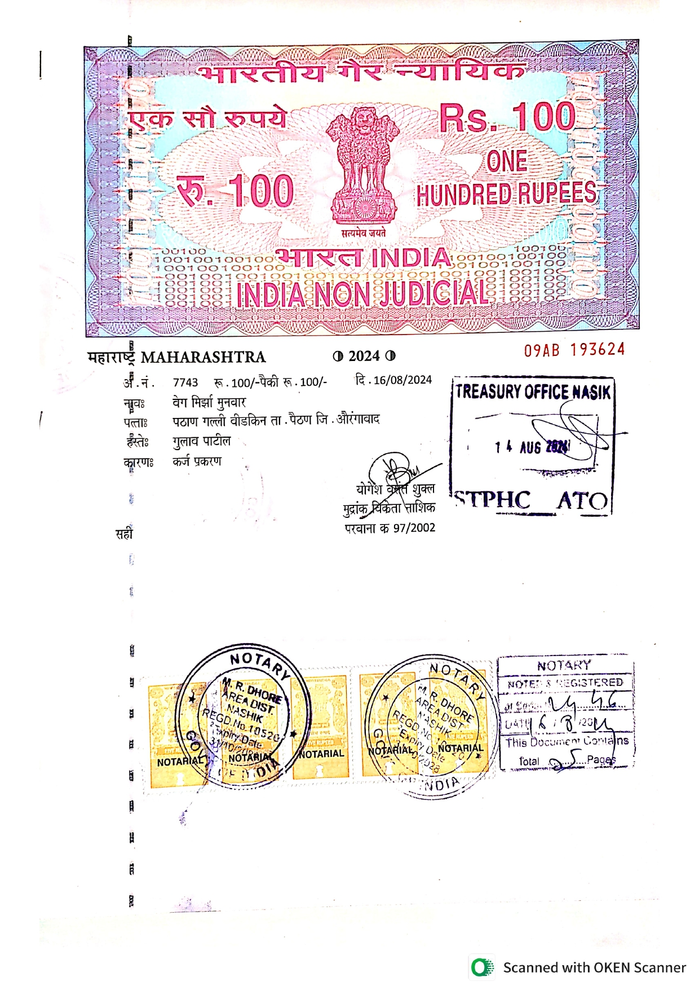
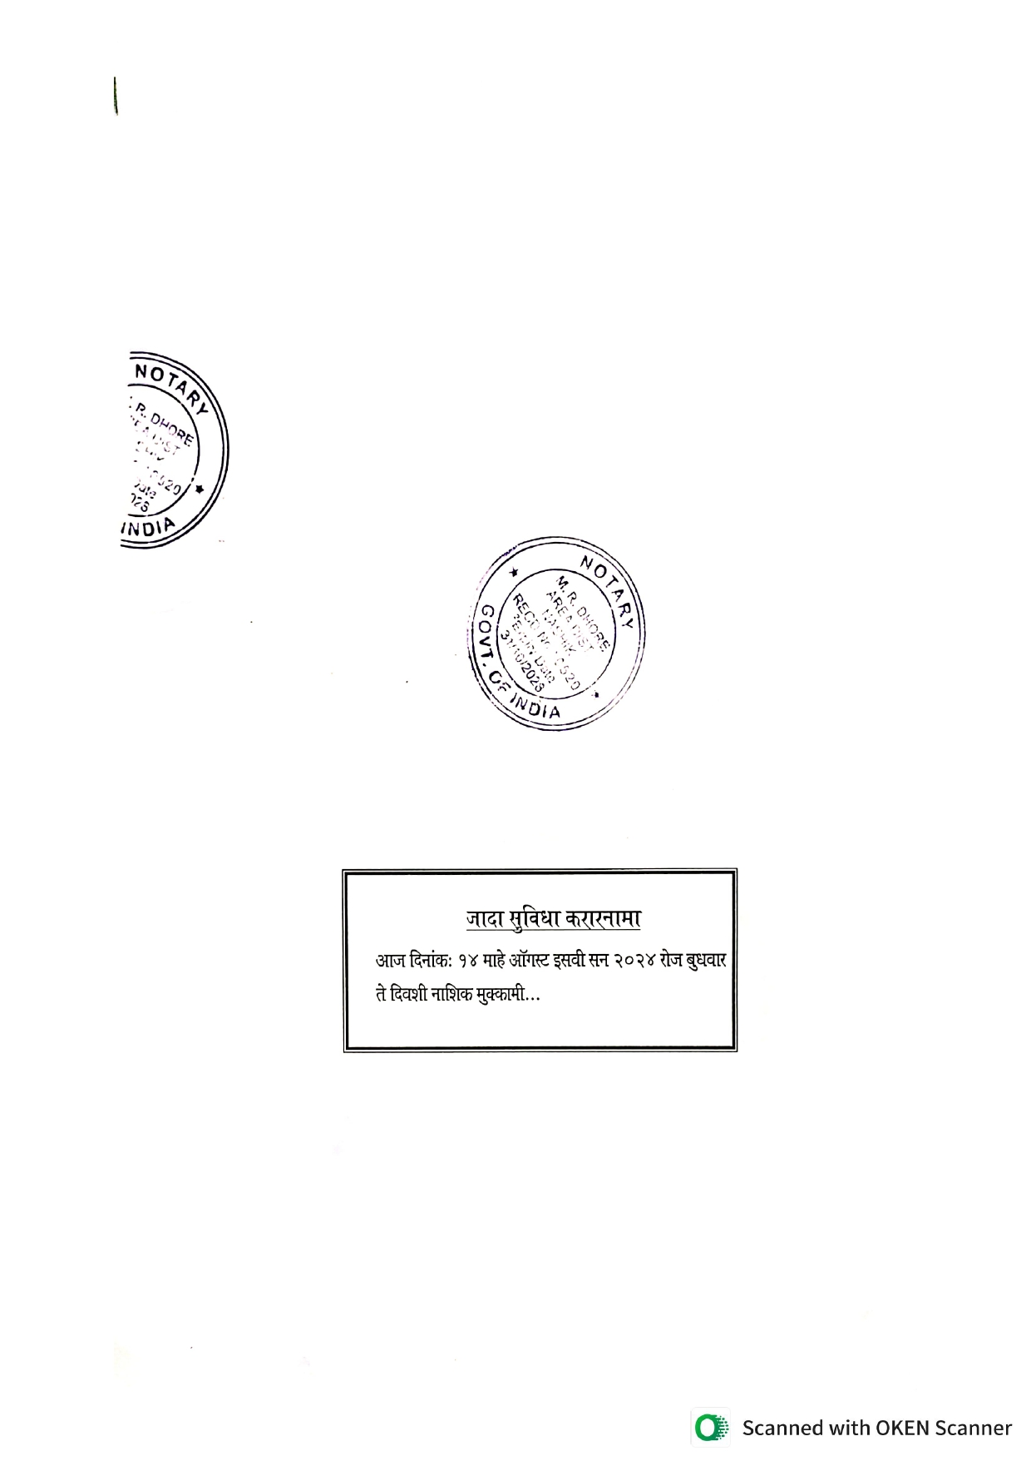

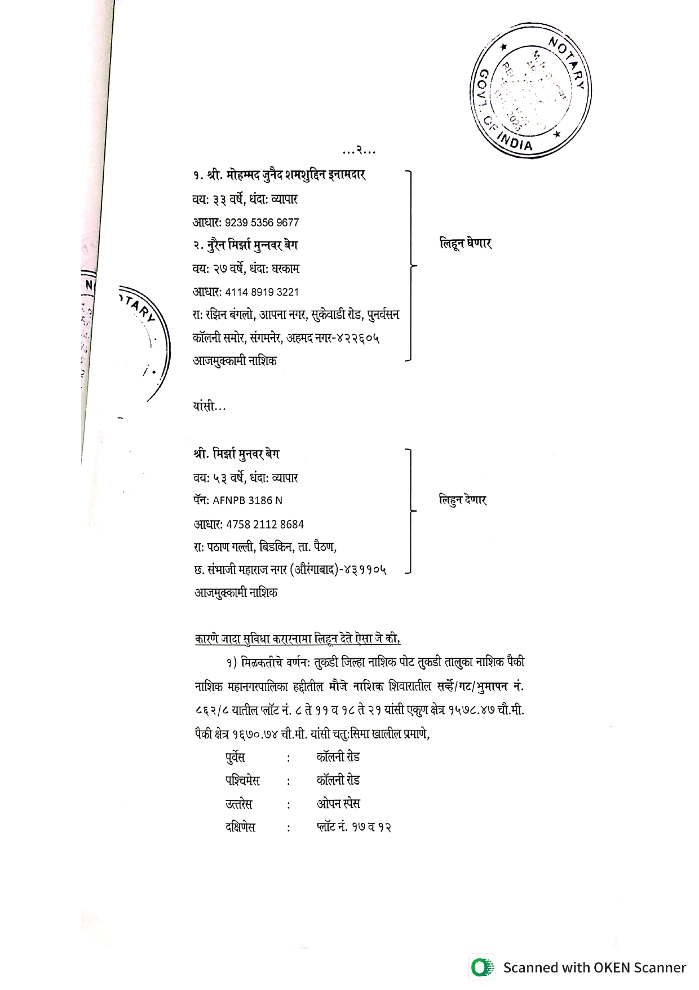

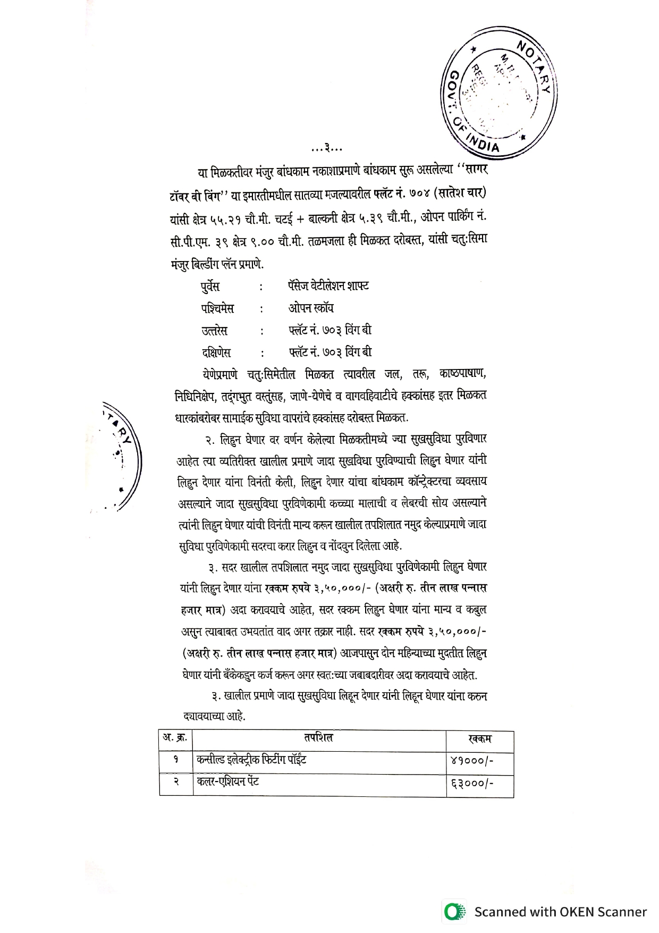
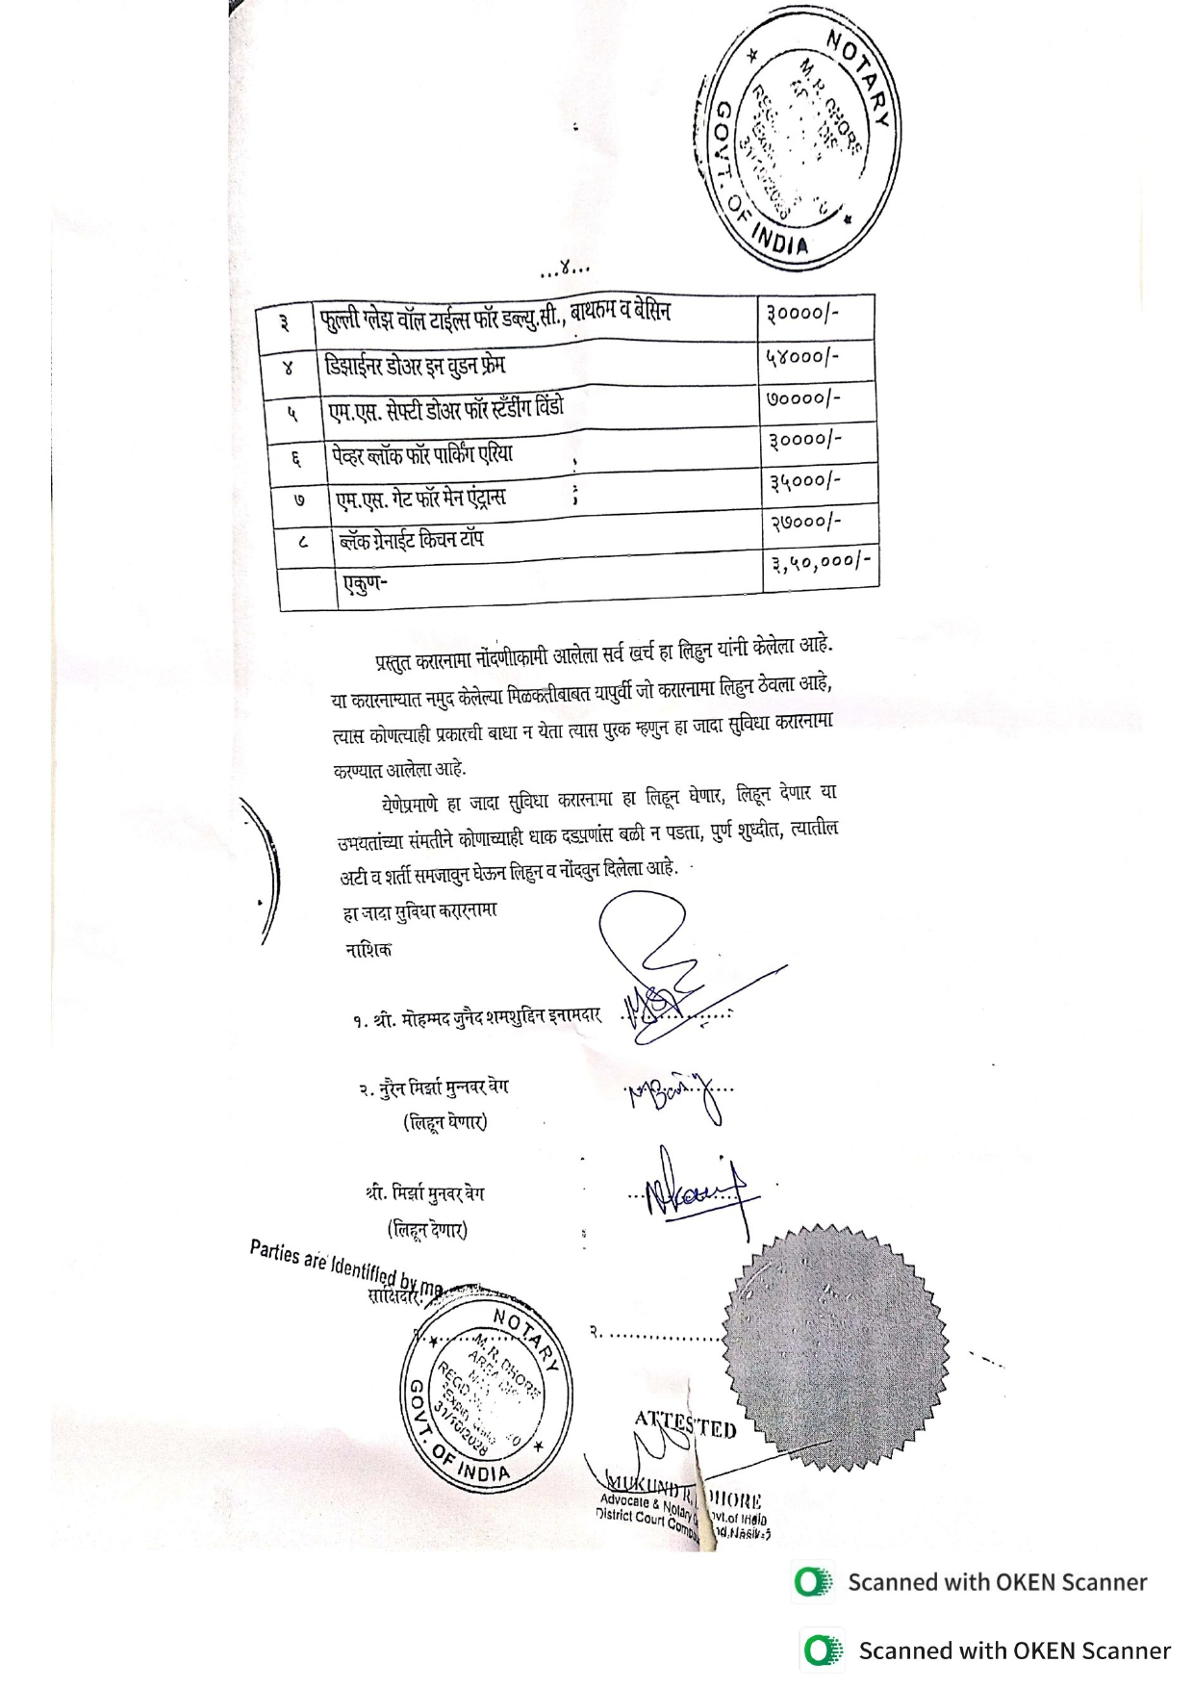

The Extra Amenities amount is Rs.3,50,000/- (Rupees Three Lakh Fifty Thousand Only.)

