Valuation Report of the Immovable Property

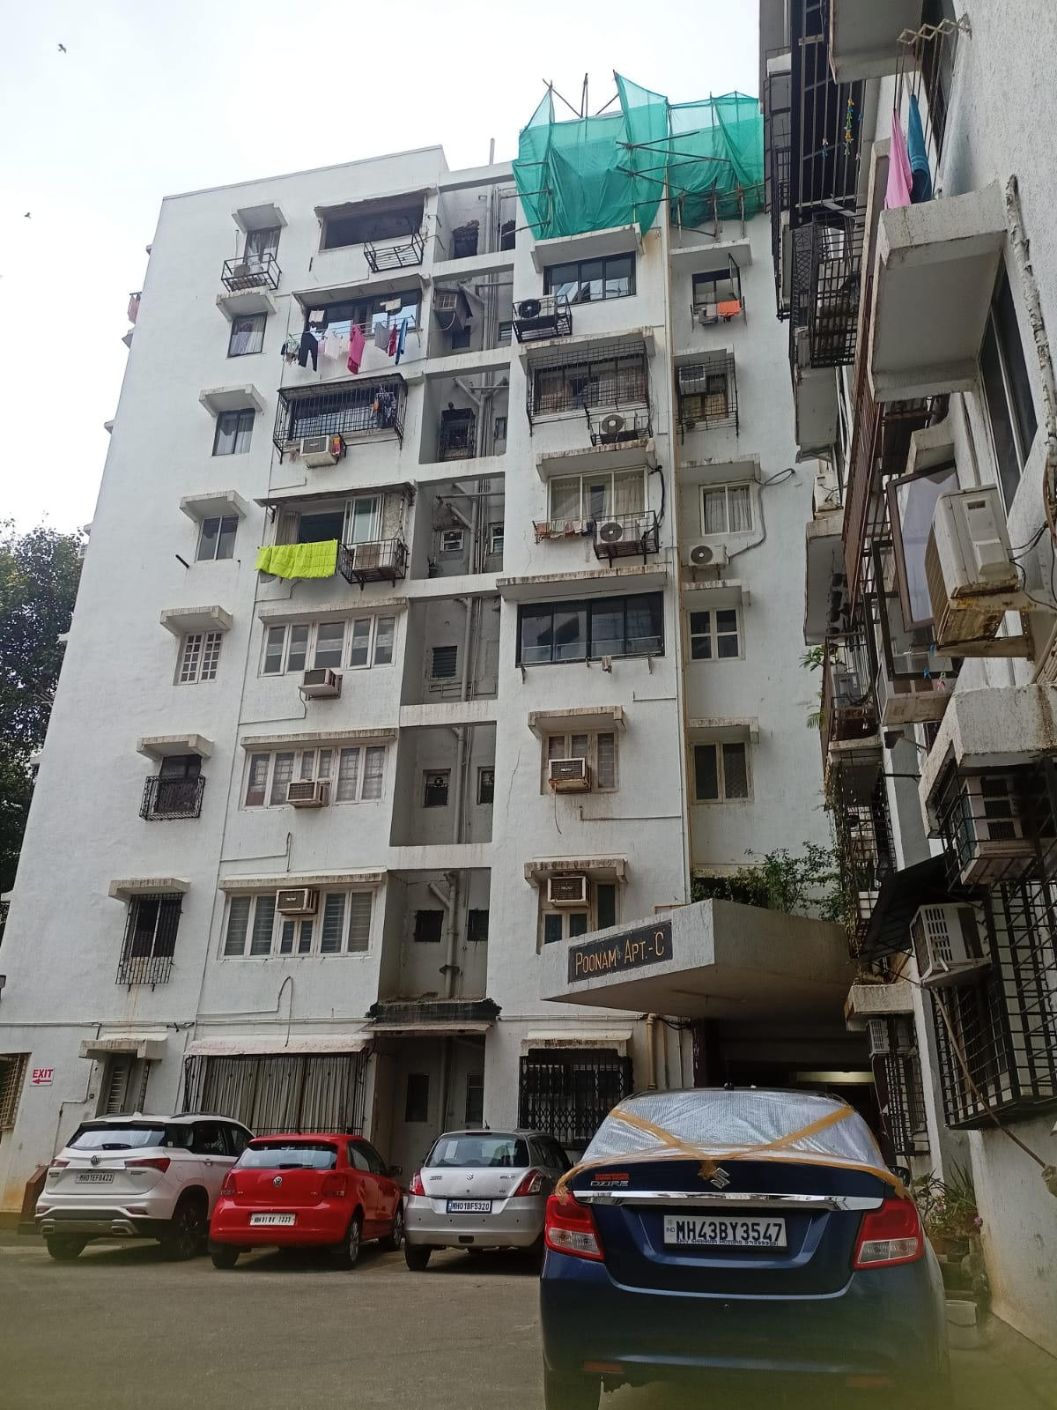

Details of the property under consideration:

Name of Owner: Shri. Bhagwan D. Rathod

Residential Flat No. 505 & 506, 5th Floor, C Wing, “Poonam Apartments”, Poonam Property Co-op. Hsg. Soc. Ltd., Shiv Sagar Estate, Dr. Annie Besant Road, Worli, Mumbai – 400018, State – Maharashtra, Country – India.

Latitude Longitude: 18°59’22.6”N 72°48’46.8”E

Intended User:

India SME Asset Reconstruction Company Limited
MIDC Andheri Branch
India SME Asset Reconstruction Company Limited, Arena House, 2nd Floor, Gate No.3, Plot No.103,
Road No.12, MIDC, Andheri (East), Mumbai – 400 093, State – Maharashtra, Country – India.

VASTU/ /Mumbai/08/2024/10624/2307807
22/20-285-SKVSU
Date: 22.08.2024

VALUATION OPINION REPORT

This is to certify that the property bearing Residential Flat No. 505 & 506, 5th Floor, C Wing, “Poonam Apartments”, Poonam Property Co-op. Hsg. Soc. Ltd., Shiv Sagar Estate, Dr. Annie Besant Road, Worli, Mumbai – 400018, State – Maharashtra, Country – India belongs to Shri. Bhagwan D. Rathod.

Boundaries of the property

North | : | B Wing
South | : | D Wing
East | : | Internal Road
West | : | A Wing
Considering various parameters recorded, existing economic scenario, and the information that is available with reference to the development of neighbourhood and method selected for valuation, we are of the opinion that, the property premises can be assessed and valued for SARFAESI Securitisation and Reconstruction of Financial Assets and Enforcement of Security Interest Act, 2002 purpose at
Particulars | Fair Market Value In (`) | Realizable Value In (`) | Distress Sale Value In (`) | Insurable Value In (`)
Residential Flats | 5,43,75,000.00 | 4,62,18,750.00 | 3,80,62,500.00 | 39,15,000.00

The valuation of the property is based on the documents produced by the concern. Legal aspects have not been taken into considerations while preparing this valuation report.

Hence certified

Sharadkumar B. Chalikwar
Govt. Reg. Valuer
Chartered Engineer (India)
Reg. No. (N) CCIT/1-14/52/2008-09
Encl: Valuation report.
Valuation Report of Immovable Property

- Introduction
 | Name of Valuer | Sharadkumar B. Chalikwar  Vastukala Consultants (I) Pvt. Ltd.  B1-001, U/B Floor, Boomerang, Chandivali Farm Road, Powai, Andheri (East), Mumbai – 400 072
 | Date of Valuation | 22.08.2024
 | Purpose of Valuation | As per request from India SME Asset Reconstruction Company Limited, MIDC Andheri, to assess fair market value of the property for SARFAESI Securitisation and Reconstruction of Financial Assets and Enforcement of Security Interest Act, 2002 purpose.
 | Name of Borrower/Customer | Shri. Bhagwan D. Rathod
 | Name of the Property Owner / Lessor  (with address & phone nos.) | Name of Owner  Shri. Bhagwan D. Rathod  Residential Flat No. 505 & 506, 5th Floor, C Wing, “Poonam Apartments”, Poonam Property Co-op. Hsg. Soc. Ltd., Shiv Sagar Estate, Dr. Annie Besant Road, Worli, Mumbai – 400018, State – Maharashtra, Country – India.  Contact Person:  Mr. Ashok Keer (Bank Officer)  Contact No. 877975079
 | Name of Bank & Branch | India SME Asset Reconstruction Company Limited, MIDC Andheri Branch
 | Name of the Developer of Property  (in case of developer-built properties) | M/s. Poonam Property Constructions Co. Ltd.
 | Date of Inspection of Property | 20.08.2024
 | Name(s) of the person(s) visiting the property | Bhavika Chavan
- Physical Characteristics of the Property
 | Location of the Property | Residential Flat No. 505 & 506, 5th Floor, C Wing, “Poonam Apartments”, Poonam Property Co-op. Hsg. Soc. Ltd., Shiv Sagar Estate, Dr. Annie Besant Road, Worli, Mumbai – 400018, State – Maharashtra, Country – India.
 | Municipal Ward No. | C Ward
 | Postal Address of the Property | Residential Flat No. 505 & 506, 5th Floor, C Wing, “Poonam Apartments”, Poonam Property Co-op. Hsg. Soc. Ltd., Shiv Sagar Estate, Dr. Annie Besant Road, Worli, Mumbai – 400018, State – Maharashtra, Country – India.
 | Area of the plot/land (supported by a plan) | Details not available
 | Layout plan of the layout in which the property is located. | Not provided
 | Details of roads abutting the property | 20’0” Wide B.T. Road
 | Demarcation of the property under valuation on a neighbourhood layout map. | Google Map Location Provided
 | Description of adjoining property | Located in Upper Middle-class locality
 | Nearby landmark | Near Atria Mall
 | Boundaries of the property | As per actual site
 | North | B Wing
 | South | D Wing
 | East | Internal Road
 | West | A Wing
 | Survey No. if any | Plot No. H1, H2 & H3, C.T.S. No. 2 (Part)
 | Ward/Village/Taluka | Worli Division
 | Sub-Registry/Block | Mumbai
 | District | Mumbai
 | Details of the building/buildings and other improvements in terms of area, height, No. of floors, plinth area floor wise, year of construction, year of making alterations/additional constructions with details, full details of specifications to be appended along with building plans and elevations. | The property is a Residential Flat located on 5th Floor. As per site inspection, Flat No. 505 & 506 are internally amalgamated to form a single unit having single entrance door. The composition of Amalgamated Flat is 3 Bedroom + Living Room + Dining + Store Room + Kitchen + 3 Toilets (i.e. 3BHK). The property is at 3.2 Km. travelling distance from nearest railway station of Mumbai Central.  The building is of Ground + 7 Upper Floor. It is a R.C.C. Framed Structure with RCC beams, columns, slabs and RCC staircase provide for access to the upper floor.
 | Plinth Area, and saleable are to be mentioned separately and clarified | Carpet Area in Sq. Ft. = 1,264.00  (Area as per actual site measurement for Flat No. 505 & 506)  As per Society Maintenance Bill, Built Up Area are as under:
  Flat No. | Built Up Area in Sq. Ft.
  505 | 575.00
  506 | 875.00
  Total Built Up Area | 1,450.00
 | Any other aspect | -
- Town Planning parameters
 | Master Plan provisions related to property in terms of land use | Residential
 | Planning area/zone | Residential
 | Developmental controls | Municipal Corporation of Greater Mumbai
 | Zoning regulations | As per Development Control Regulation
 | FAR- Floor Area Rise/FSI- Floor Space Index permitted & consumed | Copy of approved building plans were not provided and not verified
 | Ground coverage
 | Transferability of developmental rights if any, Building by-laws provision as applicable to the property viz. setbacks, height restriction etc. | Easily transferable as per local norms
 | Comment on the surrounding land uses and adjoining properties in terms of uses | Residential
 | Comment on unauthorized constructions if any | No
 | Comment on demolition proceedings if any | Information not available
 | Comment on compounding / regularization proceedings | As per local norms
 | Comment on whether OC- Occupancy Certificate has been issued or not | Copy of Occupancy Certificate were not provided and not verified
 | Any other Aspect | None
- Document Details and Legal Aspects of Property
 | Ownership Documents
 | Sale Deed, Gift Deed, Lease Deed
- Copy of Maintenance Bill No. PA/189/23-24 dated 01.04.2023 in the name of Shri. Bhagwan D. Rathod for Flat No. 505.
- Copy of Maintenance Bill No. PA/190/23-24 dated 01.04.2023 in the name of Shri. Bhagwan D. Rathod for Flat No. 506.
- Copy of Agreement for Sale dated 27.03.1973 between M/s. Poonam Property Construction Co. Ltd. (the Builders) AND Kum. Rajani Rasiklal Trivedi (the Purchasers) for Flat No. 505.
- Copy of Agreement for Sale dated 22.02.1973 between M/s. Poonam Property Construction Co. Ltd. (the Builders) AND Shri. Bhagwan D. Rathod (the Purchasers) for Flat No. 506.
 | TIR of the Property | Copy of TIR not provided
 | Name of the Owner/s | Shri. Bhagwan D. Rathod
 | Details of leases if any | N.A.
 | Ordinary status of freehold or leasehold including restrictions on transfer | Freehold land
 | Notification of road widening if any | Not Apparent from the documents provided
 | All legal documents, receipts related to electricity, Water tax, Municipal tax and other building taxes to be verified and copies as applicable to be enclosed with the report. | Provided documents are enclosed with the valuation report.
 | Comment on existing mortgages/charges/encumbrances on the property, if any | Details not available. The bank is requested to independently verify the same.
 | Comment on whether the owners of the property have issued any guarantee (personal or corporate) as the case may be | Details not available. The bank is requested to independently verify the same
 | Building plan sanction, illegal constructions if any done without plan sanction/violations | Copy of approved building plans were not provided and not verified
 | Whether the property is SARFAESI compliant | Yes
 | Any other aspect | -
- Economic Aspects of the Property
 | Reasonable letting value | N.A.
 | Details of ground rent payable | N.A.
 | Whether the property is rented & details of monthly rents being received / monthly maintenance charges if any | Vacant
 | Number of tenants | N.A.
 | Since how long (tenant- wise) | N.A.
 | Status of tenancy right | N.A.
 | Rent received per month (tenant-wise) with a comparison of existing market rent | N.A.
 | Taxes and other outings | Information not available
 | Property Insurance | Information not available
 | Monthly maintenance charges | Self - Maintained
 | Security charges | Self - Maintained
 | Any other aspect | -
- Socio-cultural Aspects of the Property
 | Descriptive account of the location of the property in terms of social structure of the area, population, social stratification, regional origin, economic level, location of slums, squatter settlements nearby, etc. | Developed Residential Area, Upper Middle Class
 | Whether property belongs to social infrastructure like hospital, school, old age homes etc. | No
- Functional and Utilitarian Aspects of the Property
 | Description of the functionality and utility of the property in terms of:
 | Space allocation | Yes
 | Storage Spaces | Yes
 | Utility spaces provided within the building | Yes
 | Car Parking facility | Open Car Parking subject to allotment
 | Balconies, etc. | Yes
 | Any other aspect | NIL
- Infrastructure Availability
a) | Description of aqua infrastructure availability in terms of
 | Water supply | MCGM Water supply
 | Sewerage/sanitation System Underground or Open | Underground Sewerage connected to MCGM line
 | Storm water drainage | Yes
b) | Description of other physical infrastructure facilities viz.
 | Solid waste management | Yes
 | Electricity | Available
 | Road and public transport connectivity | All well connected with public transport like Bus, Taxi, Private vehicles etc.
 | Availability of other public utilities nearby | Available nearby
c) | Social infrastructure in terms of | Available nearby
 | School
 | Medical facilities
 | Recreational facility in terms of parks and open space
- Marketability of the Property
a) | Marketability of the property in terms of
 | Locational attributes | Developed Residential area
 | Scarcity | Good
 | Demand and supply of the kind of subject property | Good
 | Comparable sale prices in the locality | Yes
 | Any other aspect which has relevance on the value or marketability of the property | Nil
- Engineering and Technology Aspects of the Property
 | Type of construction | R.C.C. Slab
 | Material & technology used | Standard
 | Specifications, | Good
 | Maintenance issues | Well Maintained
 | Age of the building | 1972 (Approx.)  Age of the building – 52 Years
 | Total life of the building | 60 Years
 | Extent of deterioration | 8 Years (Subject to proper, preventive periodic Maintenance & structural repairs)
 | Structural safety | Information not available
 | Protection against natural disaster viz. earthquakes, etc. | Information not available
 | Visible damage in the building | Not found
 | System of air-conditioning | Not found
 | Provision of firefighting | Yes
 | Copies of the plan and elevation of the building to be included | Copy of approved building plans were not provided and not verified
- Environmental Factors
 | Use of environment friendly building materials, Green Building techniques if any | Information not available
 | Provision of rain water harvesting | Information not available
 | Use of solar heating and lightening systems, etc., | Information not available
 | Presence of environmental pollution in the vicinity of the property in terms of industry, heavy traffic etc. | No
- Architectural and aesthetic quality of the Property
 | Descriptive account on whether the building is modern, old fashioned, plain looking or decorative, heritage value, presence of landscape elements etc. | Plain looking
- Valuation
a) | Methodology of valuation – Procedures adopted for arriving at the valuation. Valuers may consider various approaches and state explicitly the reason for adopting particular approach and assumptions made, basis adopted with supporting data, comparable sales, and reconciliation of various factors on which final value judgment is arrived at. | Composite Method is used for this valuation report.
b) | Prevailing Market Rate/Price trend of the Property in the locality/city from property search sites viz magickbricks.com, 99acres.com, makaan.com etc. if available | ` 37,000.00 to ` 38,000.00 per Sq. Ft. on Built Up Area Considering the rate with attached report, current market conditions, demand and supply position, residential land size, building area, location, upswing in real estate prices, sustained demand for residential land, all round development of residential application in the locality etc. We estimate ` 37,500.00 per Sq. Ft. on Built Up Area.
c) | Guideline rate obtained from the Registrar's Office | ` 4,31,162.00 per Sq. M.  i.e., ` 40,056.00 per Sq. Ft.
 | Guideline rate (after deprecation) | ` 3,16,511.00 per Sq. M.  i.e., ` 29,405.00 per Sq. Ft.
d) | Summary of Valuation
 | - Guideline Value | As Per Ready Reckoner Rate
 | Particulars | Built up Area in Sq. Ft. |  | Rate in ` |  |  | Value in `
 | Residential Flats | 1,450.00 |  | 29,405.00 |  |  | 4,26,37,250.00
 | Total |  |  |  |  |  | 4,26,37,250.00
 | - Fair Market Value
 | Particulars | Built up Area in Sq. Ft. |  | Rate in ` |  |  | Fair Market Value in `
 | Residential Flats | 1,450.00 |  | 37,500.00 |  |  | 5,43,75,000.00
 | Summary of Valuation
 | Total Value of the Property | ` 5,43,75,000.00
 | Realizable Value | ` 4,62,18,750.00
 | Forced/ Distress Sale value. | ` 3,80,62,500.00
 | Insurable value of the property | ` 39,15,000.00
 | Comments on variance between market value and the valuation as per Govt. approved rates | Justification on variation has given.
 | Details of last transactions in the locality/area to be provided, if available. | Yes Available.
 | General Remark | - As per site inspection, Flat No. 505 & 506 are internally amalgamated to form a single unit having single entrance door.  - Agreement of Present Ownership not have been provided hence we have considered the Ownership and area as per Society Maintenance Bill for the purpose of valuation.

- Declaration
I hereby declare that:
- The information provided is true and correct to the best of my knowledge and belief.
- The analysis and conclusions are limited by the reported assumptions and conditions.
- I have read the Handbook on Policy, Standard and Procedures for Real Estate Valuation by Banks and HFIs in India, 2011, issued by IBA and NHB, fully understood the provisions of the same and followed the provisions of the same to the best of my ability and this report is in conformity to the Standards of Reporting enshrined in the above Handbook.
- I have no direct or indirect interest in the above property valued.
- I/ my authorized representative, has inspected the subject property on 20.08.2024
- I am a registered Valuer under Section 34AB of Wealth Tax Act, 1957, Category-I for valuing property up to no limit
- I am an approved Valuer under SARFAESI ACT-2002 and am approved by the Bank.

Sharadkumar B. Chalikwar
Govt. Reg. Valuer
Chartered Engineer (India)
Wealth Tax Reg. No.: (N) CCIT/1-14/52/2008-09

Address:
Vastukala Consultants (I) Pvt. Ltd.
B1-001, U/B Floor, Boomerang, Chandivali Farm Road, Powai, Andheri (East), Mumbai – 400 072.
Name of Valuer association of which I am a bonafide member in good standing: Institution of Valuers & Practicing Valuers Association of India.
Date: 22.08.2024
Tel No. - +91 22 28371324 /25
Mobile No. - +91 98195 97579
Email Id – mumbai@vastukala.org

- Enclosures
a) | Layout plan sketch of the area in which the property is located with latitude and longitude | Latitude and longitude provided along with satellite image of the building
b) | Building Plan | Yes provided
c) | Floor Plan | Yes provided
d) | Site Photograph of the property | Yes provided
e) | Certified copy of the approved / sanctioned plan wherever applicable from the concerned office | Yes provided
f) | Google Map location of the property | Yes provided
g) | Price trend of the Property in the locality/city from property search sites viz Magickbricks.com, 99Acres.com, Makan.com etc. | Yes provided
h) | Any other relevant documents/ extracts | Yes provided

[

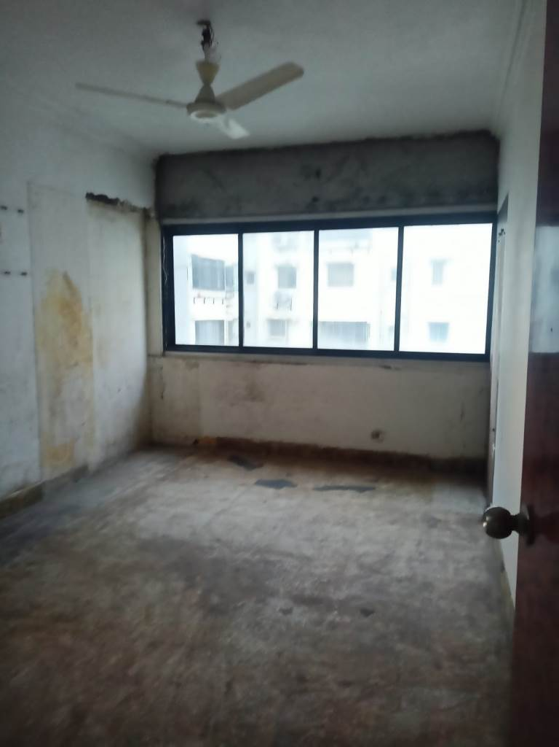
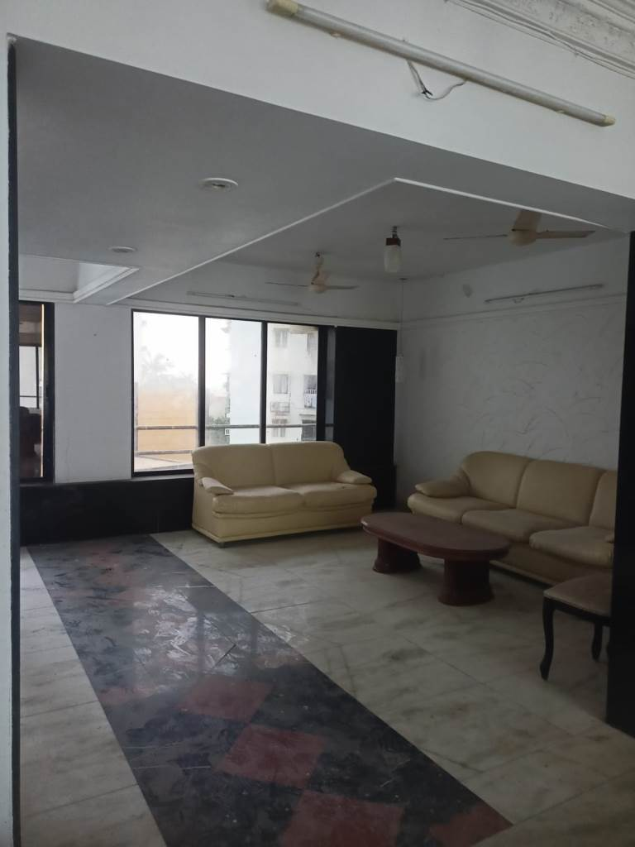
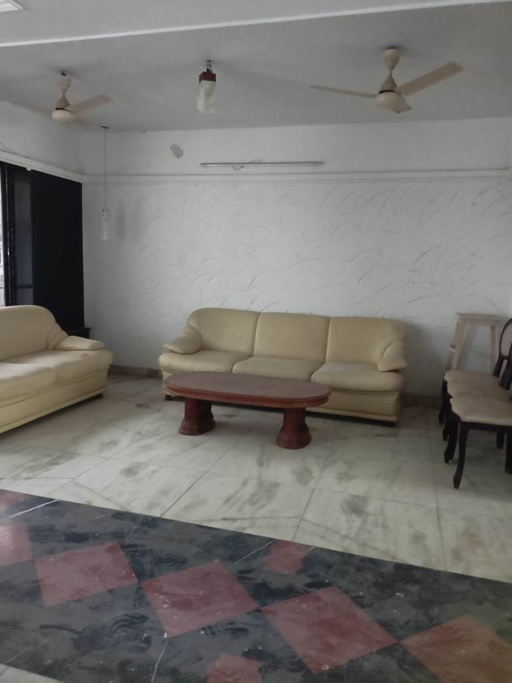
Actual Site Photographs

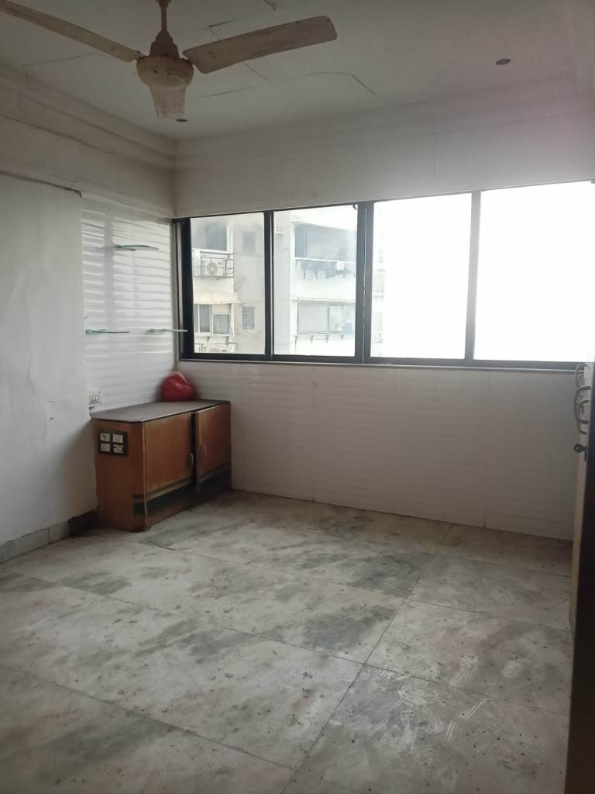
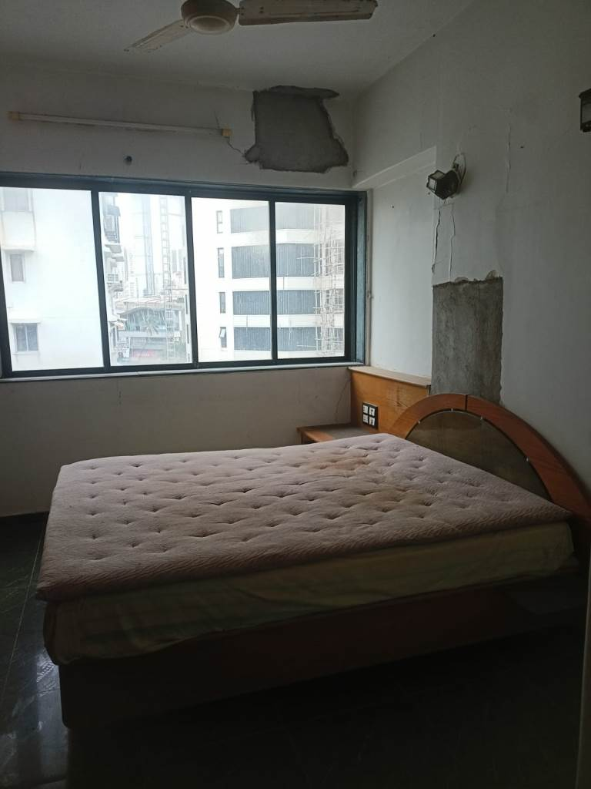
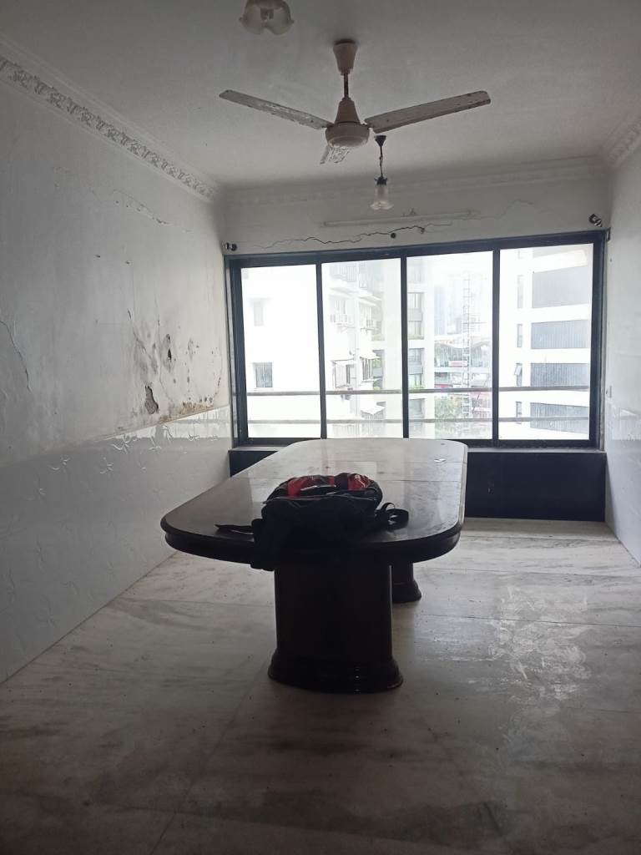
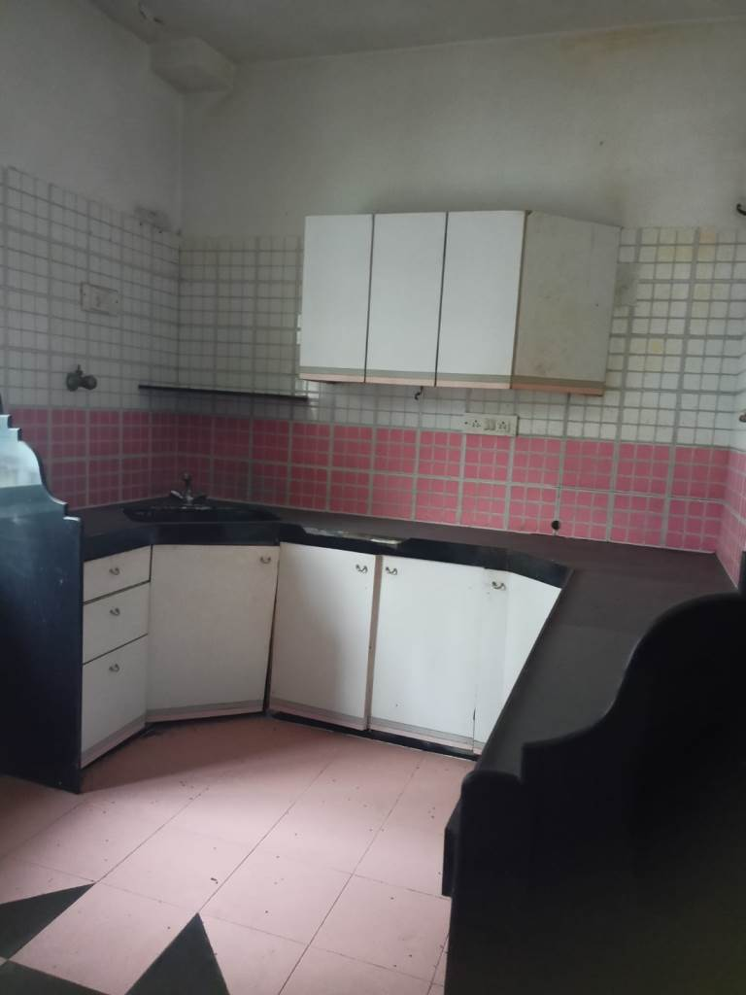
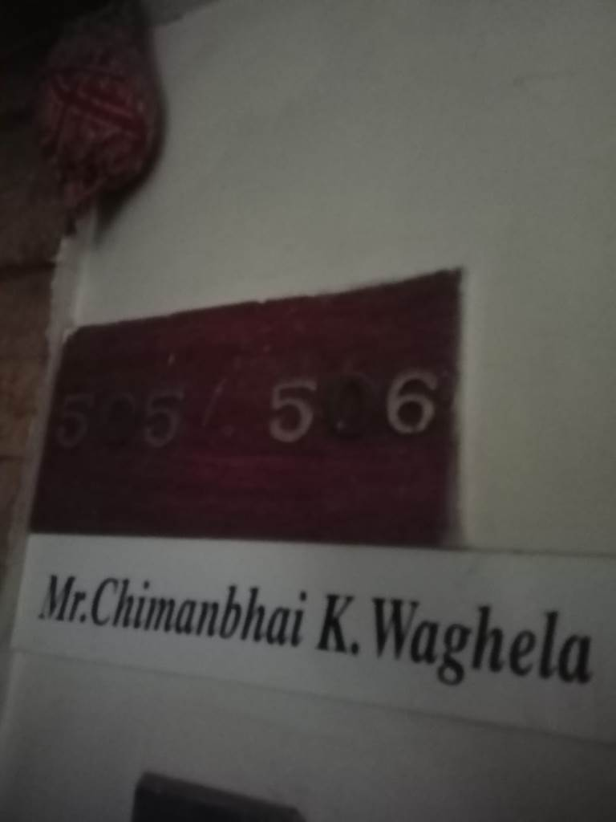
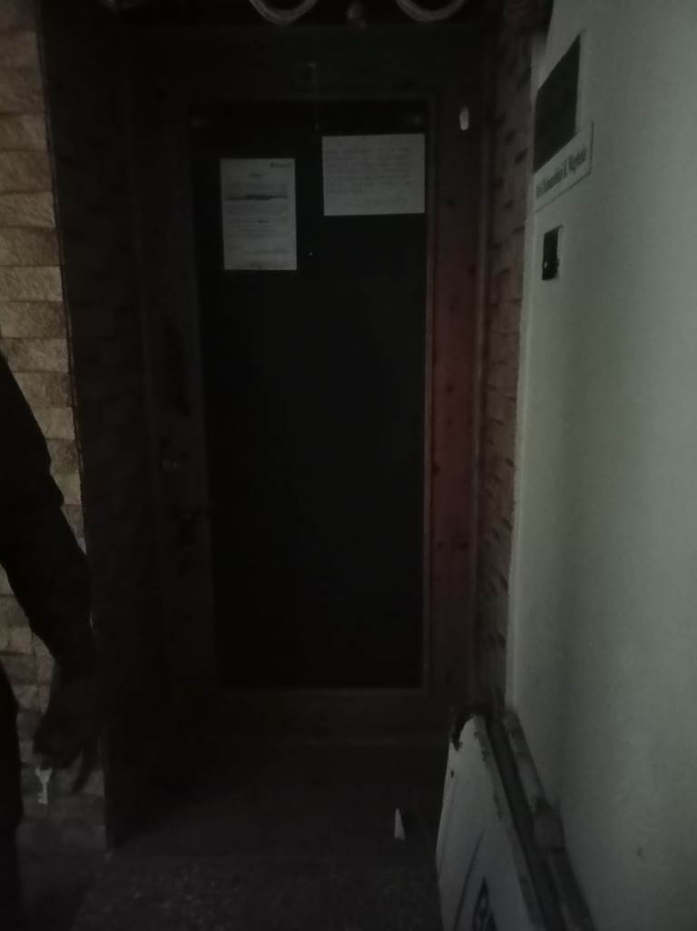
Actual Site Photographs
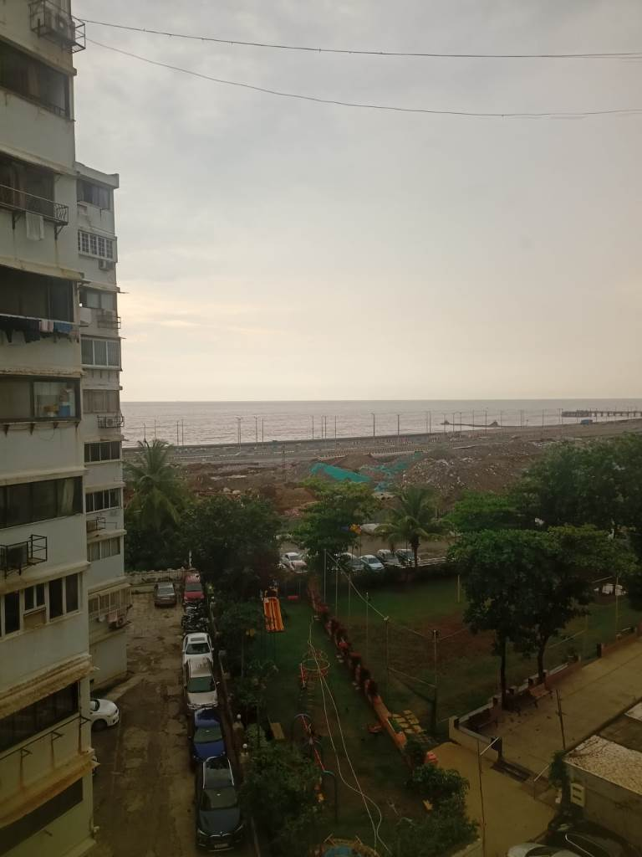
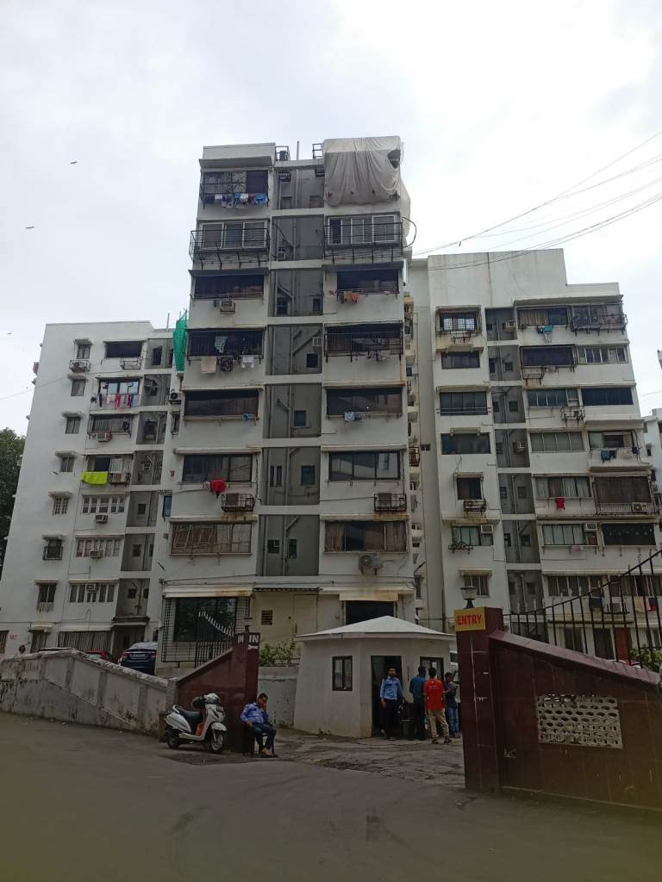
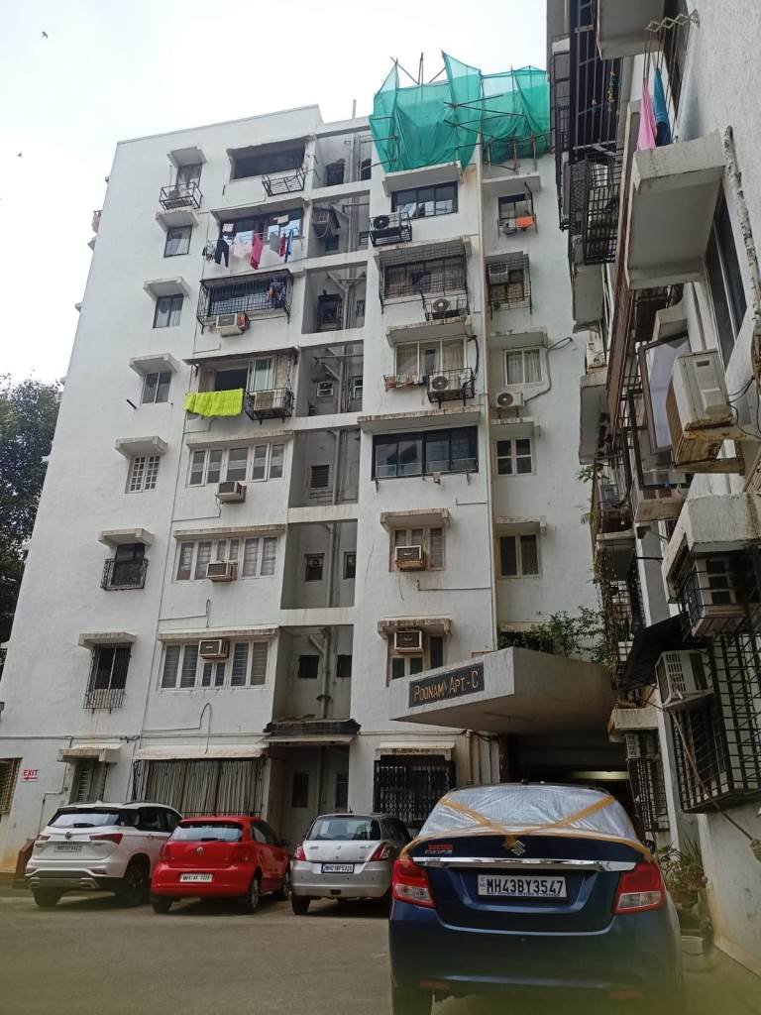

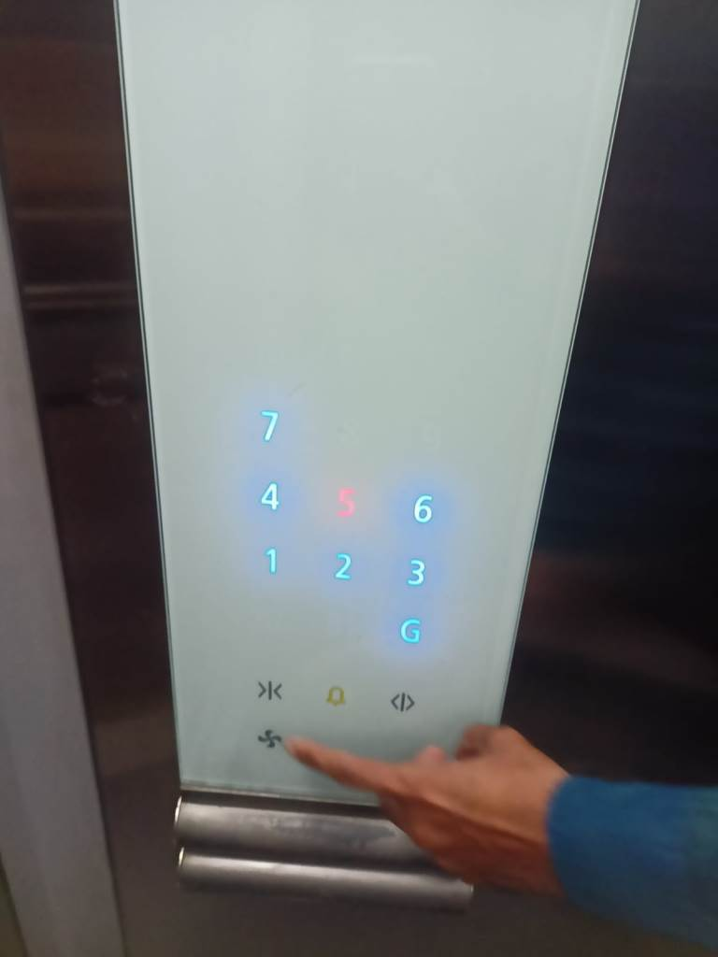
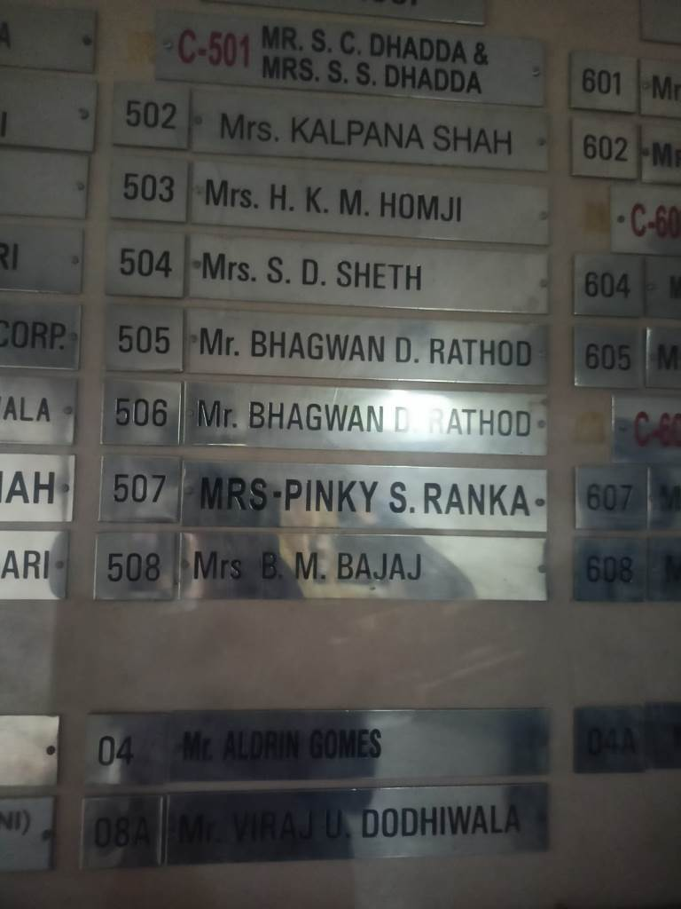
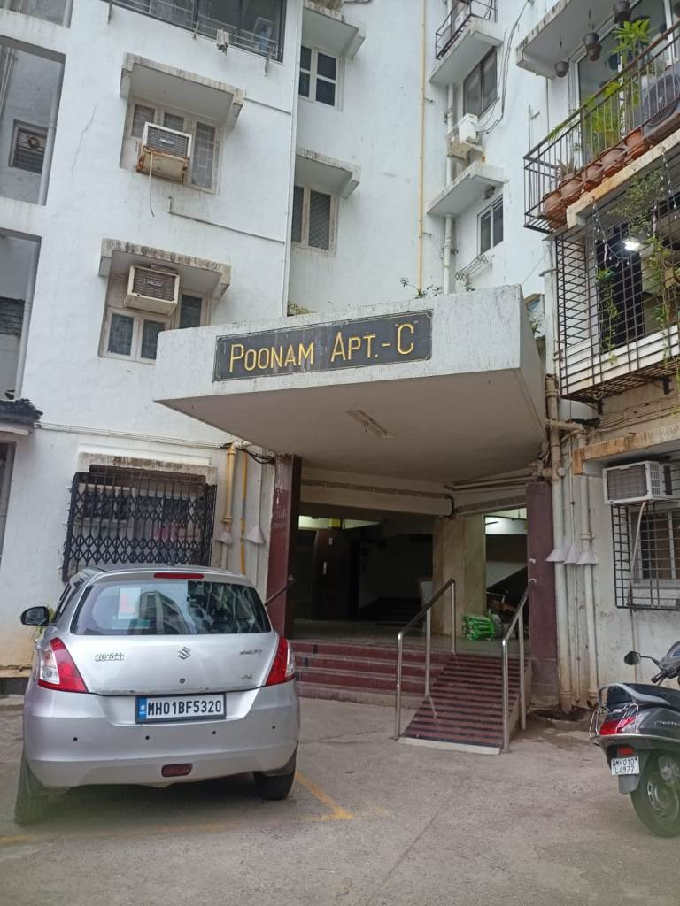

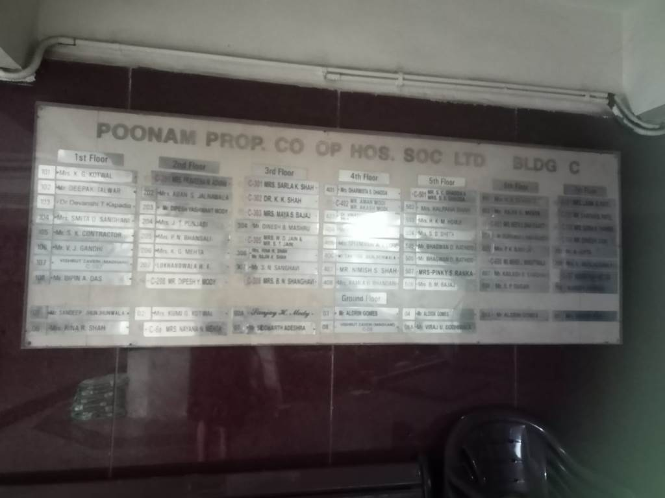

Route Map of the Property
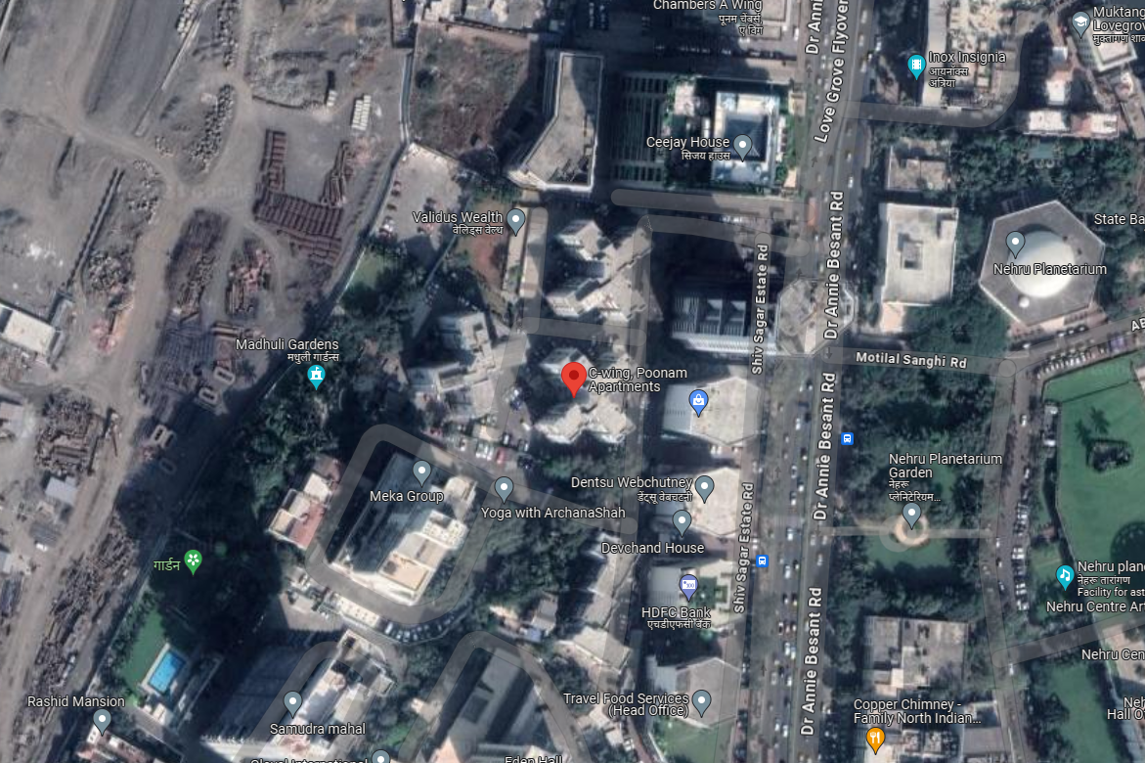
Site u/r

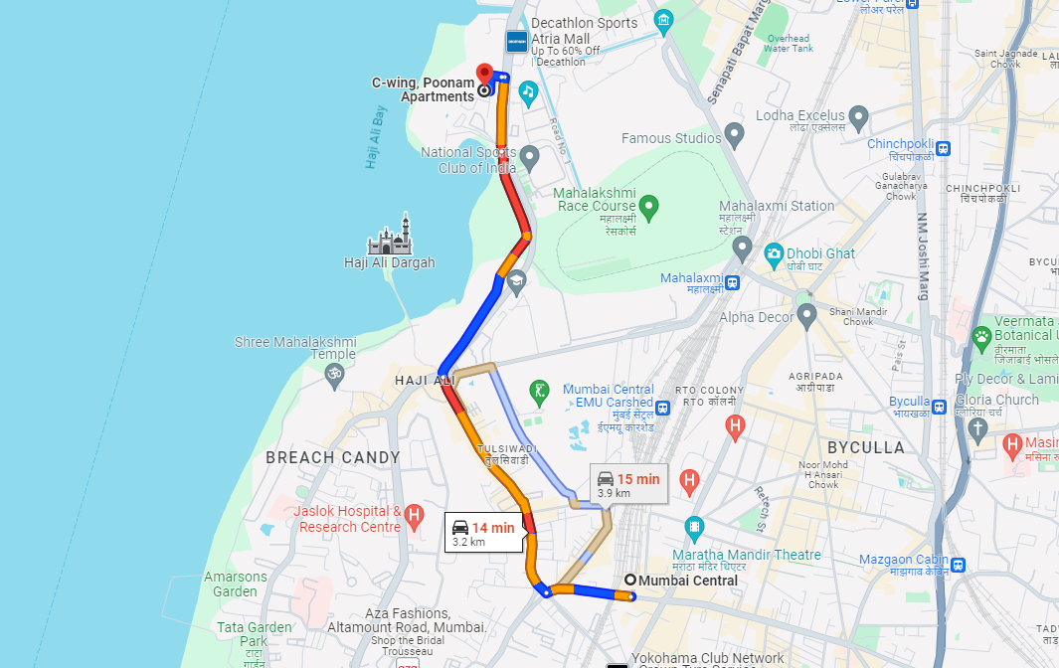

Longitude Latitude: 18°59’22.6”N 72°48’46.8”E
Note: The Blue line shows the route to site from nearest railway station (Mumbai Central – 3.2 Km.)

Ready Reckoner Rate
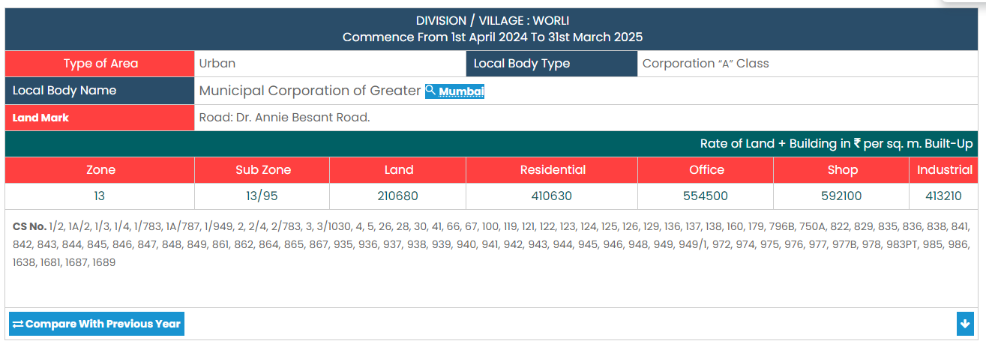

Stamp Duty Ready Reckoner Market Value Rate for Residential Flat | 4,10,630.00
Increase by 5% on units located between 5 to 10 floors | 20,532.00
Stamp Duty Ready Reckoner Market Value Rate (After Increase) (A) | 4,31,162.00 | Sq. Mt. | 40,056.00 | Sq. Ft.
Stamp Duty Ready Reckoner Market Value Rate for Land (B) | 2,10,680.00
The difference between land rate and building rate (A – B = C) | 2,20,482.00
Depreciation Percentage as per table (D) [100% - 52%]  (Age of the Building – 52 Years) | 48%
Rate to be adopted after considering depreciation [B + (C x D)] | 3,16,511.00 | Sq. Mt. | 29,405.00 | Sq. Ft.

Multi-Storied building with Lift
For residential premises / commercial unit / Unit on above floor in multistoried building, the rate mentioned in the ready reckoner will be increased as under:

 | Location of Flat / Commercial Unit in the building | Rate
a) | On Ground to 4 Floors | No increase for all floors from ground to 4 floors
b) | 5 Floors to 10 Floors | Increase by 5% on units located between 5 to 10 floors
c) | 11 Floors to 20 Floors | Increase by 10% on units located between 11 to 20 floors
d) | 21 Floors to 30 Floors | Increase by 15% on units located between 21 to 30 floors
e) | 31 Floors and above | Increase by 20% on units located on 31 and above floors

Table – D: Depreciation Percentage Table

Completed Age of Building in Years | Value in percent after depreciation
 | R.C.C. Structure / other Pukka Structure | Cessed Building, Half or Semi – Pukka Structure & Kaccha Structure.
0 to 2 Years | 100% | 100%
Above 2 & up to 5 Years | 95% | 95%
Above 5 Years | After initial 5 year for every year 1% depreciation is to be considered. However maximum deduction available as per this shall be 70% of Market Value rate | After initial 5 year for every year 1.5% depreciation is to be considered. However maximum deduction available as per this shall be 85% of Market Value rate

Sale Instance
Property | Flat
Source | Index II
Floor | 1st Floor
 | Carpet | Built Up | Saleable
Area | 508.00 | 610.00 | -
Percentage | - | 20% | -
Rate Per Sq. Ft. | ₹ 45,276.00 | ₹ 37,705.00 | -
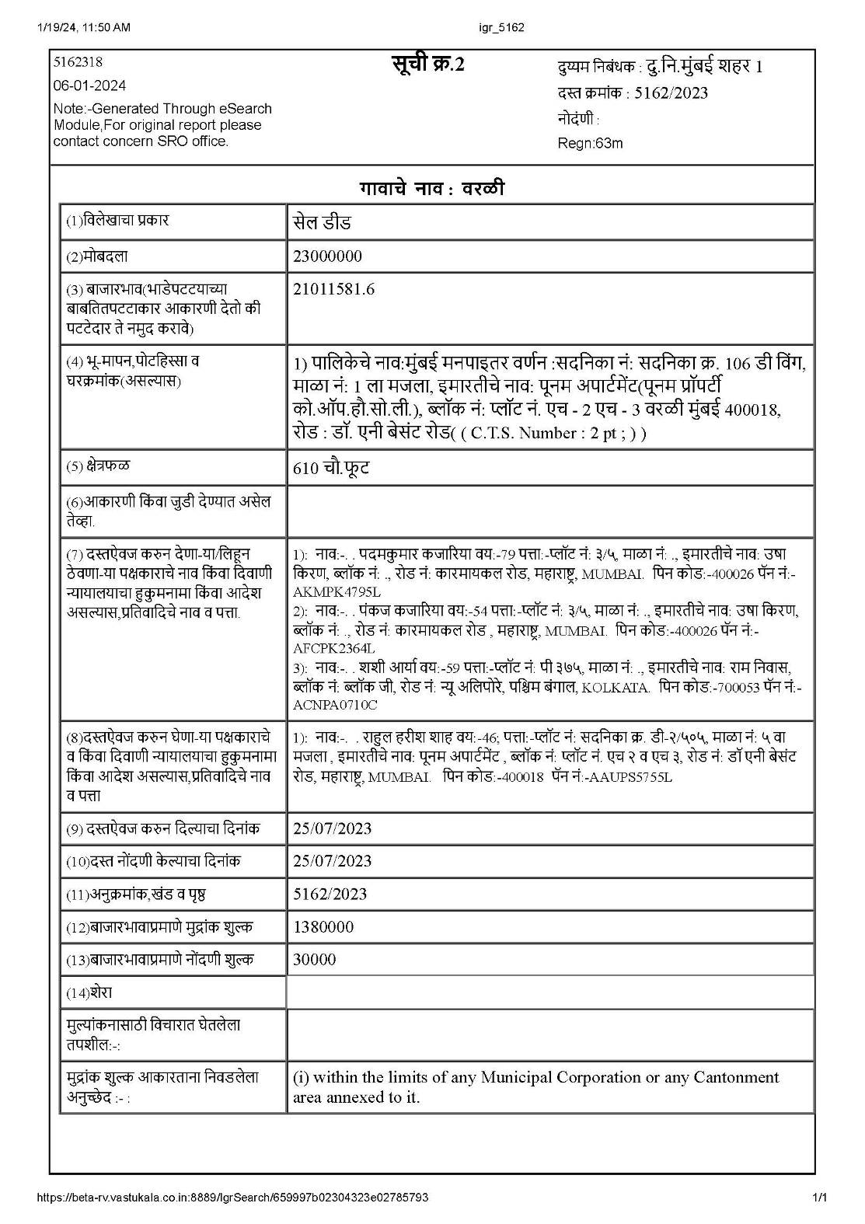

Sale Instance
Property | Flat
Source | Index II
Floor | 1st Floor
 | Carpet | Built Up | Saleable
Area | 513.00 | 615.00 | -
Percentage | - | 20% | -
Rate Per Sq. Ft. | ₹ 44,834.00 | ₹ 37,398.00 | -
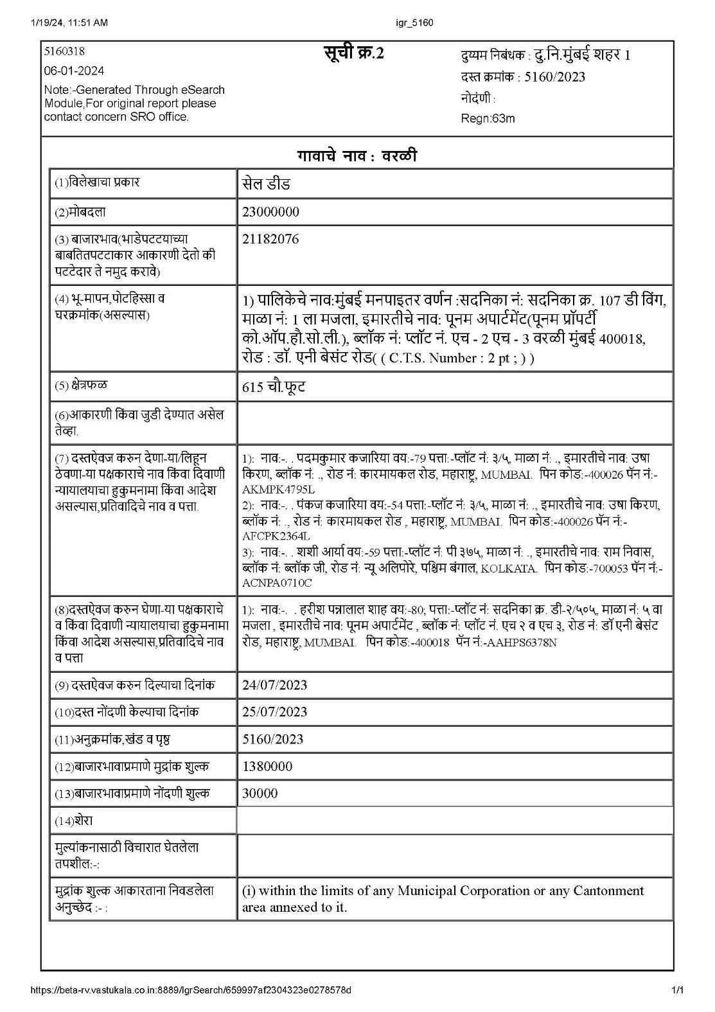

Sale Instance

Property | Flat
Source | Index II
Floor | 1st Floor
 | Carpet | Built Up | Saleable
Area | 498.00 | 597.00 | -
Percentage | - | 20% | -
Rate Per Sq. Ft. | ₹ 40,161.00 | ₹ 33,500.00 | -
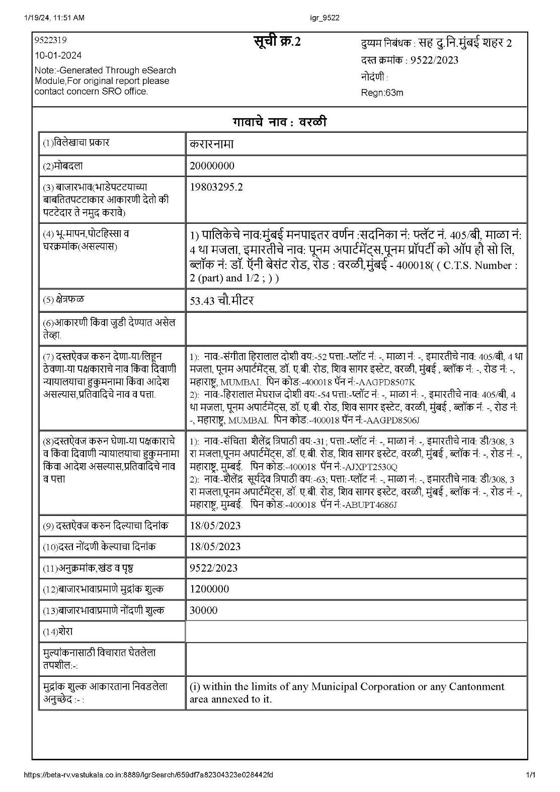

Price Indicators

Property | Flat
Source | Nobroker.com
Floor
 | Carpet | Built Up | Saleable
Area | 563.00 | 675.00 | -
Percentage | - | 20% | -
Rate Per Sq. Ft. | ₹ 44,405.00 | ₹ 37,037.00 | -
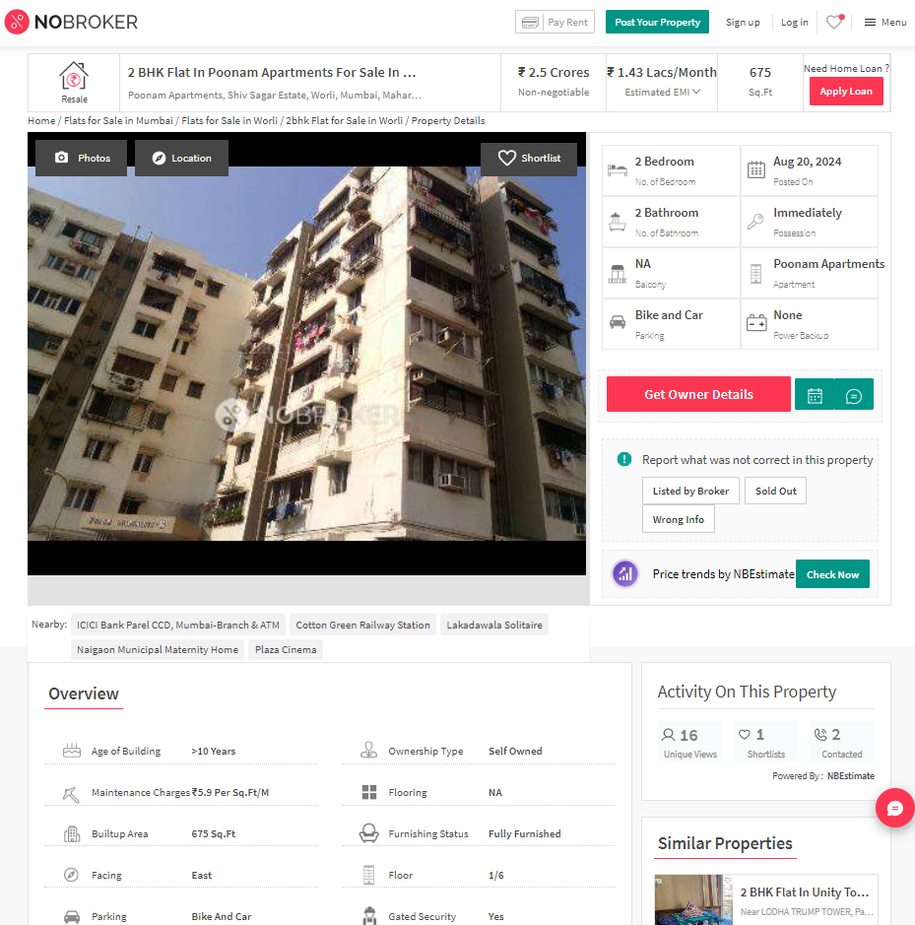

Price Indicators

Property | Flat
Source | Magicbricks.com
Floor
 | Carpet | Built Up | Saleable
Area | 875.00 | 1050.00 | -
Percentage | 20% | - | -
Rate Per Sq. Ft. | ₹ 51,429.00 | ₹ 42,857.00 | -
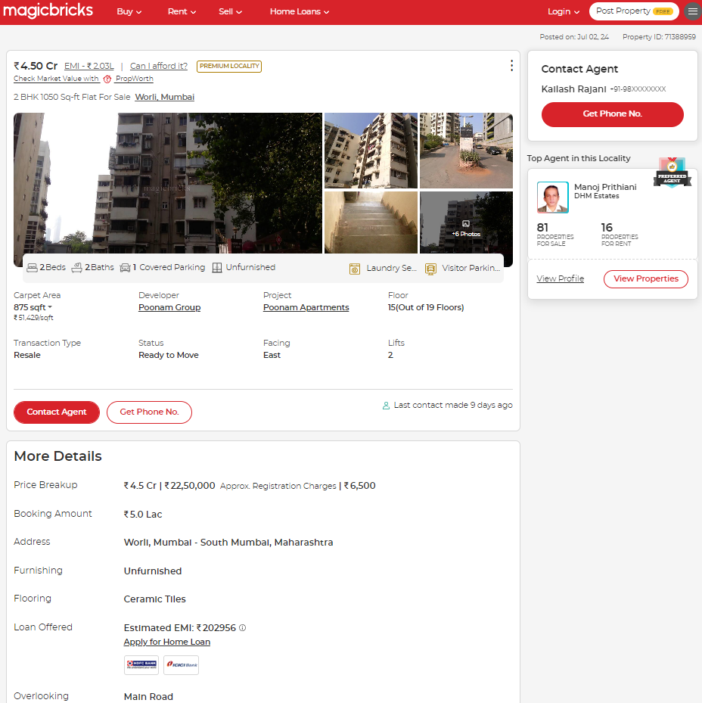
Justification for price / rate
The Market Value of the property is based on facts of markets discovered by us during our enquiries, however the government rate value in this case is less than the market value arrived by us. We are of the opinion that the value arrive by us will prove to be correct if an Auction of the subject property is carried out. As far as Market Value in Index II is concerned, it is not possible to comment on same, may be government rates are fixed by sampling during same point of time in part and whereas, Market values change every month.
In most of the cases the actual deal amount or Transaction value is not reflected in Index II because of various Market practices. As Valuer, we always try to give a value which is correct reflection of actual transaction value irrespective of any factors in market.

DEFINITION OF VALUE FOR THIS SPECIFIC PURPOSE

This exercise is to assess Fair Market Value of the property under reference for SARFAESI Securitisation and Reconstruction of Financial Assets and Enforcement of Security Interest Act, 2002 purpose as on dated 22nd August 2024.

The term Fair Market Value is defined as

"The most probable price, as of a specified date, in cash, terms equivalent to cash, or in other precisely revealed terms for which the specified property rights would sell after reasonable exposure in a competitive market under all conditions requisite to a fair sale, with the buyer and seller each acting prudently knowledgeably and for self-interest assuming that neither is under undue duress"

Fundamental assumptions and conditions presumed in this definition are:

- Buyer and seller are motivated by self-interest.

- Buyer and seller are well informed and are acting prudently.

- The property is exposed for a reasonable time on the open market.

- Payment is made in cash or equivalent or in specified financing terms.

ASSUMPTIONS, CAVEATS, LIMITATION AND DISCLAIMERS
- We assume no responsibility for matters of legal nature affecting the property appraised or the title thereto, nor do we render our opinion as to the title, which is assumed to be good and marketable.
- The property is valued as though under responsible ownership.
- It is assumed that there are no hidden or unapparent conditions of the subsoil or structure that would render it more or less valuable. No responsibility is assumed for such conditions or for engineering that might be required to discover such factors.
- There is no direct/ indirect interest in the property valued.
- The rates for valuation of the property are in accordance with the Govt. approved rates and prevailing market rates.

DECLARATION OF PROFESSIONAL FEES CHARGED

We hereby declare that, our professional fees are not contingent upon the valuation findings. However, if the statute AND/OR clients demands that, the fees should be charged on the percentage of assessed value then, with the full knowledge of the AND/OR end user, it is being charged accordingly.

VALUATION OF THE PROPERTY PREMISES

Considering various parameters recorded, existing economic scenario, and the information that is available with reference to the development of neighbourhood and method selected for valuation, we are of the opinion that, the property premises can be assessed and valued for SARFAESI Securitisation and Reconstruction of Financial Assets and Enforcement of Security Interest Act, 2002 purpose at
Particulars | Fair Market Value In (`) | Realizable Value In (`) | Distress Sale Value In (`) | Insurable Value In (`)
Residential Flats | 5,43,75,000.00 | 4,62,18,750.00 | 3,80,62,500.00 | 39,15,000.00

Sharadkumar B. Chalikwar
Govt. Reg. Valuer
Chartered Engineer (India)
Reg. No. (N) CCIT/1-14/52/2008-09

