Valuation Report of the Immovable Property

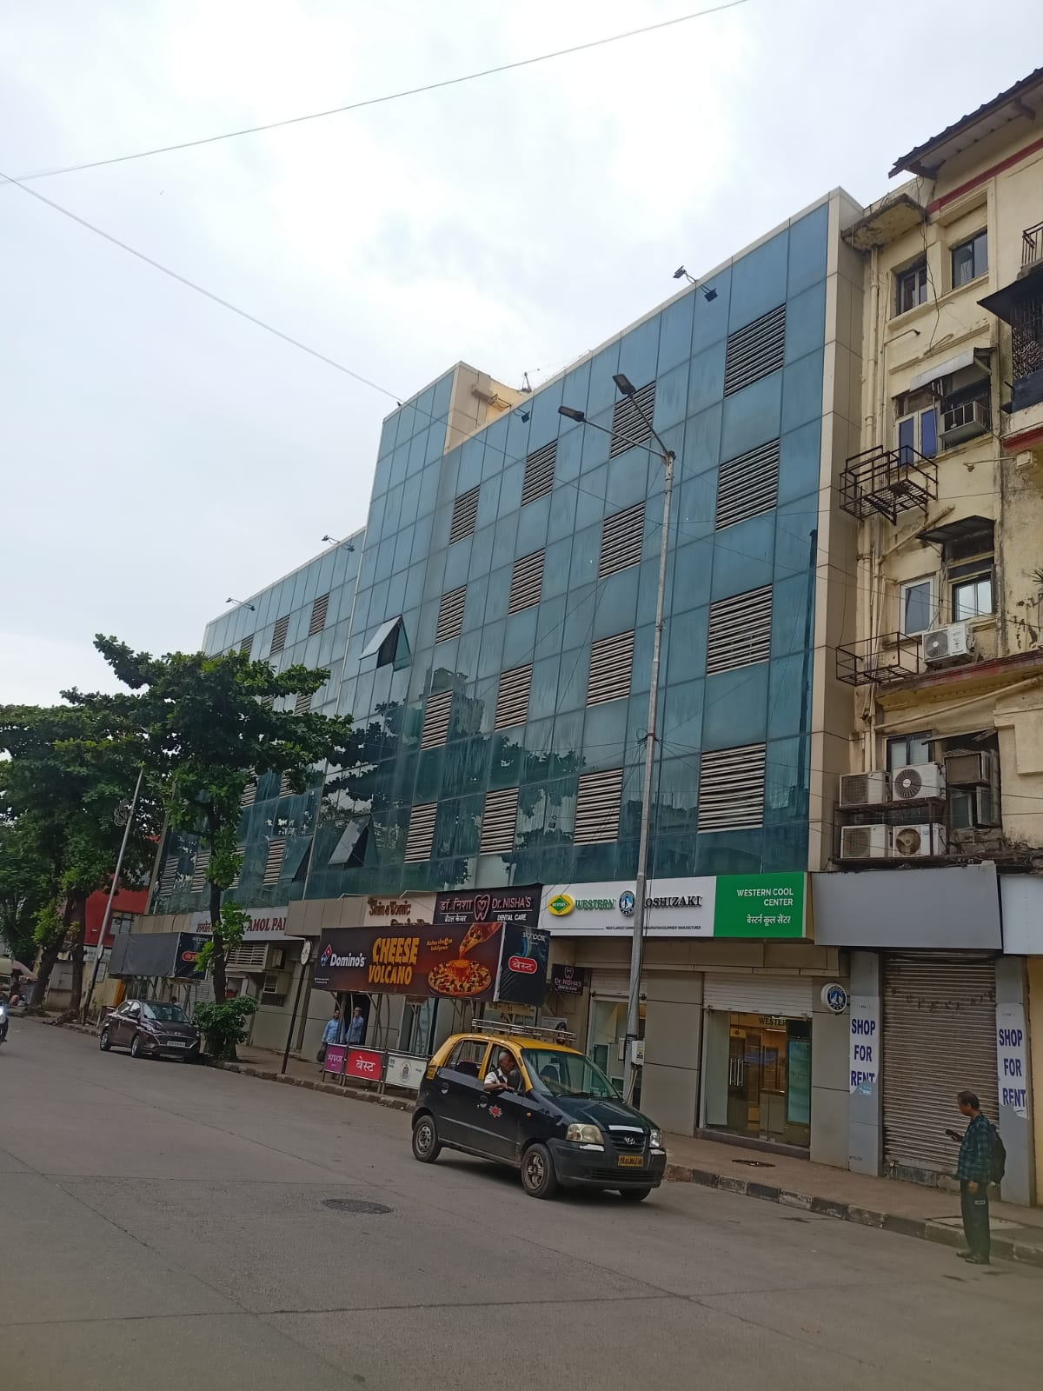

Details of the property under consideration:

Name of Owner: Shri. Bhagwan D. Rathod

Commercial Office No. 202, 2nd Floor, “Ready Money Terrace”, Readymoney Premises Co-op. Soc. Ltd.,
167, Dr. Annie Besant Road, Worli Naka, Worli, Mumbai – 400018, State - Maharashtra, Country – India.

Latitude Longitude - 18°59’49.3”N 72°49’00.6”E

Intended User:

India SME Asset Reconstruction Company Limited
MIDC Andheri Branch
India SME Asset Reconstruction Company Limited, Arena House, 2nd Floor, Gate No.3, Plot No.103,
Road No.12, MIDC, Andheri (East), Mumbai – 400 093, State – Maharashtra, Country – India.

Vastu/ISARC/Mumbai/08/2024/010622/2305077
21/15-299-SKAU

Date: 22.08.2024

VALUATION OPINION REPORT

This is to certify that the property bearing Commercial Office No. 202, 2nd Floor, “Ready Money Terrace”, Readymoney Premises Co-op. Soc. Ltd., 167, Dr. Annie Besant Road, Worli Naka, Worli, Mumbai – 400018, State - Maharashtra, Country – India belongs to Shri. Bhagwan D. Rathod.

Considering various parameters recorded, existing economic scenario, and the information that is available with reference to the development of neighbourhood and method selected for valuation, we are of the opinion that, the property premises can be assessed and valued for SARFAESI Securitisation and Reconstruction of Financial Assets and Enforcement of Security Interest Act, 2002 purpose at
Boundaries of the property.

North | : | Worli Naka Municipal School B.M.C School
South | : | Ready Money Residential Building
East | : | Harmony Building
West | : | Dr. Annie Besant Road
Particulars | Fair Market Value In (`) | Realizable Value In (`) | Distress Sale Value In (`) | Insurable Value In (`)
Commercial Office | 51,74,400.00 | 43,98,240.00 | 36,22,080.00 | 4,99,500.00

The valuation of the property is based on the documents produced by the concern. Legal aspects have not been taken into considerations while preparing this valuation report.

Hence certified

Sharadkumar B. Chalikwar
Govt. Reg. Valuer
Chartered Engineer (India)
Reg. No. (N) CCIT/1-14/52/2008-09
Encl: Valuation report.
Valuation Report of Immovable Property

1. | Customer Details
 | Name(s) of the owner(s). |  |  |  |  |  |  |  | Shri. Bhagwan D. Rathod
 | Date of Valuation. |  |  |  |  |  |  |  | 22.08.2024
 | Branch Name |  |  |  |  |  |  |  | MIDC Andheri Branch
2 | Property Details
 | Address |  |  |  |  |  |  |  |  |  |  |  | Commercial Office No. 202, 2nd Floor, “Ready Money Terrace”, Readymoney Premises Co-op. Soc. Ltd., 167, Dr. Annie Besant Road, Worli Naka, Worli, Mumbai – 400018, State - Maharashtra, Country – India.
 | Nearby Landmark / Google Map Independent access to the property |  |  |  |  |  |  |  |  |  |  |  | Landmark: Worli Naka  Latitude Longitude - 18°59’49.3”N 72°49’00.6”E
3 | Document Details |  |  |  |  |  |  |  |  |  | Name of Approving Authority
 | Layout Plan |  | No |  |  |  |  |  |  | - |  |  |  |  |  |  |  |  |  |  |  |  | Approval No. |  |  |  |  |  |  |  |  | -
 | Building Plan |  | No |  |  |  |  |  |  | - |  |  |  |  |  |  |  |  |  |  |  |  | Approval No. |  |  |  |  |  |  |  |  | -
 | Construction Permission |  | No |  |  |  |  |  |  | - |  |  |  |  |  |  |  |  |  |  |  |  | Approval No. |  |  |  |  |  |  |  |  | -
 | Legal Documents |  | Yes |  |  |  |  |  |  | - Copy of Society NOC to Mortgage vide Ref. No. RPCS / 2 / 2004-05 dated 11.12.2004 issued by Readymoney Premises Co-op. Soc. Ltd. in the name of Shri. Bhagwan D. Rathod  - Copy of Agreement dated 22.11.1990 between Mr. Harinder Singh Patheja & Mr. behalf of Ms. Sonia Patheja (Minor) & M/s. Panatron throughs its Partners Mr. Kamlesh R. Nihalani & Mr. Rakesh R. Nihalani (the Purchasers).  - Copy of Agreement dated 12.07.1972 between The Readymoney Premises Co-op. Soc. Ltd. (the Society) AND General Fibre Dealers Pvt. Ltd. (the Company).
4. | Physical Details
 | Adjoining Properties |  | East |  |  |  |  |  |  |  |  |  |  |  |  | West |  |  |  |  |  |  |  |  |  |  | North |  |  |  |  |  |  |  | South
 | As on site |  | Harmony Building |  |  |  |  |  |  |  |  |  |  |  |  | Dr. Annie Besant Road |  |  |  |  |  |  |  |  |  |  | Worli Naka Municipal School B.M.C School |  |  |  |  |  |  |  | Ready Money Residential Building
 | As per document |  | Details not available |  |  |  |  |  |  |  |  |  |  |  |  | Details not available |  |  |  |  |  |  |  |  |  |  | Details not available |  |  |  |  |  |  |  | Details not available
 | Matching of Boundaries |  | - |  |  |  |  |  |  |  |  |  |  | Plot Demarcated |  |  |  | Yes |  |  |  |  |  |  | Approved land use |  |  |  | Commercial |  |  |  |  | Type of Property |  |  |  |  |  | Commercial
 | No. of rooms |  | - |  |  |  | - |  |  |  |  |  |  | - |  |  |  | - |  |  |  |  |  |  | - |  |  |  | - |  |  |  |  | - |  |  |  |  |  | -
 | Car Parking Facility |  | No
 | Composition of the Property |  | The property is located on 2nd Floor. The composition of commercial office is Working Area + Cabin. The property is located at 2.9 Km. travelling distance from Mahalaxmi Railway Station.
 | Total no. of Floors | Ground + 4 Upper Floors |  |  |  |  |  | Floor on which the property is located |  |  |  |  |  | 2nd Floor |  |  |  |  | Approx. Age of the property |  |  |  |  |  |  | 59 Years |  |  |  |  | Residual age of the property |  |  |  |  | 5-10 Years |  |  |  | Type of structure: - Load Bearing Structure with structural cladding work
5 | Tenure / Occupancy Details – Owner Occupied
 | Status of Tenure |  |  |  | N.A. |  |  |  |  |  |  |  |  |  | No. of years of Occupancy |  |  |  |  |  |  | N.A. |  |  |  |  |  |  |  | Relationship of tenant or owner |  |  |  |  |  |  | N.A.
6. | Stage of Construction
 | Stage of construction |  |  |  | Completed |  |  |  |  |  |  |  |  |  | If under construction, extent of completion |  |  |  |  |  |  |  |  |  |  |  |  |  |  | N. A.
7. | Violations if any observed
 | Nature and extent of violations |  |  |  |  |  |  |  |  |  |  |  |  |  |  |  | -
8 | Area Details of the Property
 | Site Area |  |  | Carpet Area in Sq. Ft. = 156.00  (Area as per actual site measurement)
 | Plinth Area |  |  | Built Up Area in Sq. Ft. = 185.00  (Carpet Area as per Society NOC Letter + 20%)
 | Carpet Area |  |  | Carpet Area in Sq. Ft. = 154.00  (Area as per Society Letter NOC)
 | Saleable Area |  |  | -
 | Remarks |  |  | Agreement of Present Ownership not have been provided hence we have considered the Ownership and area as per Society NOC Letter for the purpose of valuation.
9 | Date of visit to the property |  |  |  |  |  |  |  |  |  |  | 20.08.2024 |  |  |  |  |  |  |  |  | Name(s) of the person(s) visiting the property |  |  |  |  |  |  |  |  |  |  |  | Bhavika Chavan
10 | Valuation
 | - Mention the value as per Government Approved Rates also
 | Guideline rate obtained from the Stamp Duty Ready Reckoner (New Property) |  |  |  |  |  |  |  |  |  |  |  |  |  |  |  |  |  |  | ` 4,66,120.00 per Sq. M. i.e. ` 43,304.00 per Sq. Ft.
 | Guideline rate obtained from the Stamp Duty Ready Reckoner (After Depreciation) |  |  |  |  |  |  |  |  |  |  |  |  |  |  |  |  |  |  | ` 3,20,089.00 per Sq. M. i.e. ` 29,737.00 per Sq. Ft.
 | - In case of variation of 20% or more in the valuation proposed by the valuer and the Guideline value provided in the State Govt. notification or Income Tax Gazette justification on variation has to be given.
 | Considering the above indicator of sale, current market conditions, demand and supply position, Commercial Office size, location, upswing in real estate prices, sustained demand for Commercial Office, all round development of commercial and residential application in the locality etc. We estimate ` 33,600.00 rate per Sq. Ft. on Carpet Area.
 | Summary of Valuation
 | - Guideline Value
 |  |  |  |  |  |  |  |  |  |  |  |  |  |  |  |  |  |  |  | Area in Sq. Ft. |  |  |  |  |  |  |  | Rate in ` |  |  |  |  |  |  |  |  |  | Value in `
 | Built up area |  |  |  |  |  |  |  |  |  |  |  |  |  |  |  |  |  |  | 185.00 |  |  |  |  |  |  |  | 29,737.00 |  |  |  |  |  |  |  |  |  | 55,01,345.00
 | - Fair Market Value of the Property
 | Carpet area |  |  |  |  |  |  |  |  |  |  |  |  |  |  |  |  |  |  | 154.00 Sq. Ft.
 | Prevailing market rate |  |  |  |  |  |  |  |  |  |  |  |  |  |  |  |  |  |  | ` 33,600.00 Sq. Ft.
 | Total Value of the Property |  |  |  |  |  |  |  |  |  |  |  |  |  |  |  |  |  |  | ` 51,74,400.00
 | - Realizable Value of the Property |  |  |  |  |  |  |  |  |  |  |  |  |  |  |  |  |  |  | ` 43,98,240.00
 | - Distress / Force Sale Value |  |  |  |  |  |  |  |  |  |  |  |  |  |  |  |  |  |  | ` 36,22,080.00
 | - Insurable Value of the Assets |  |  |  |  |  |  |  |  |  |  |  |  |  |  |  |  |  |  | ` 4,99,500.00
11 | Assumptions /Remarks
 | - Qualiﬁcation in TIR / Mitigation Suggested, if any |  |  |  |  |  |  |  |  |  |  |  |  | TIR not provided
 | - Property is SARFAESI compliant |  |  |  |  |  |  |  |  |  |  |  |  | Yes
 | - Whether property belongs to social infrastructure like hospital, school, old age home etc. |  |  |  |  |  |  |  |  |  |  |  |  | No
 | - Whether entire piece of land on which the unit is set up/property is situated has been mortgaged or to be mortgaged |  |  |  |  |  |  |  |  |  |  |  |  | Information not available
 | - Details of last transaction in the locality / area to be provided, if available |  |  |  |  |  |  |  |  |  |  |  |  | Details Attached
 | - Any other aspect which has relevance on the value or marketability of the property |  |  |  |  |  |  |  |  |  |  |  |  | Location, development of surrounding area, type of construction, construction speciﬁcations, age of building, condition of the premises & building, facilities provided and its prevailing market rate.
12 | Comments on variance between market value and the valuation as per Govt. approved rates |  |  |  |  |  |  |  |  |  |  |  |  | Justification on variation has given.
 | Details of last transactions in the locality/area to be provided, if available. |  |  |  |  |  |  |  |  |  |  |  |  | Yes Available.
13 | Declaration |  |  |  |  |  |  |  |  |  |  |  |  | - The property was inspected by my authorized representative personally on 20.08.2024.  - The undersigned does not have any direct / indirect interest in the above property.  - The information furnished herein is true and correct to the best of our knowledge.  - I have submitted Valuation report directly to the Bank.
14 | Name, address & signature of valuer |  |  |  |  | Vastukala Consultants (I) Pvt. Ltd.  121, 1st Floor, Ackruti Star, Central Road, MIDC, Andheri (E), Mumbai - 400 093
14 |  |  |  |  |  |  |  |  |  |  |  |  |  |  |  |  |  | Sharadkumar B. Chalikwar  Govt. Reg. Valuer  Chartered Engineer (India)  Reg. No. (N) CCIT/1-14/52/2008-09 |  |  |  |  |  |  |  |  |  |  |  |  |  |  |  |  |  |  |  |  | Date of valuation:  22.08.2024
15 | List of Documents enclosed |  |  |  |  | - Valuation Report  - Satellite Location Map  - Location cum Route Map from Nearest Railway Station
16 | List of Photos enclosed |  |  |  |  | Attached below

Actual site photographs
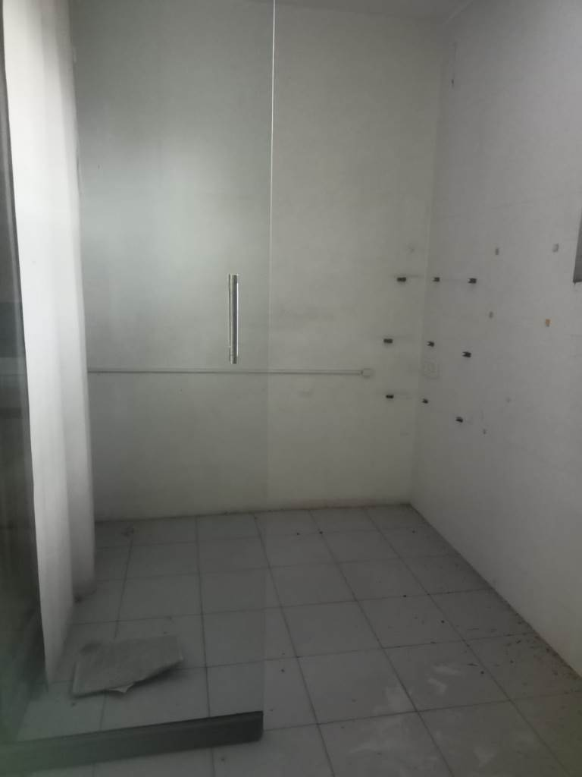
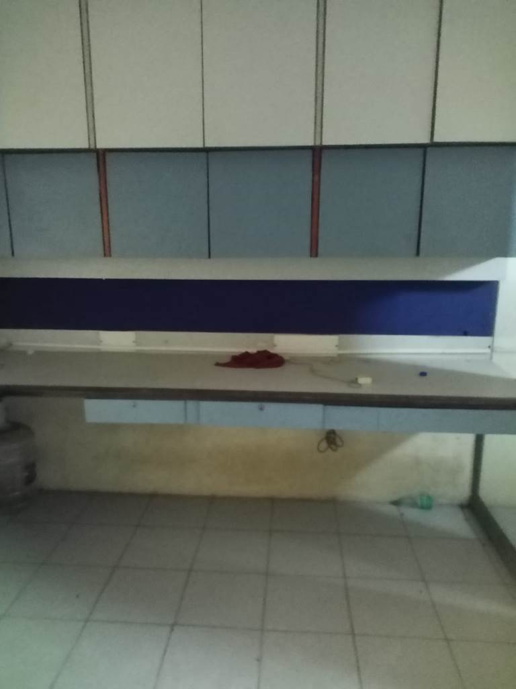
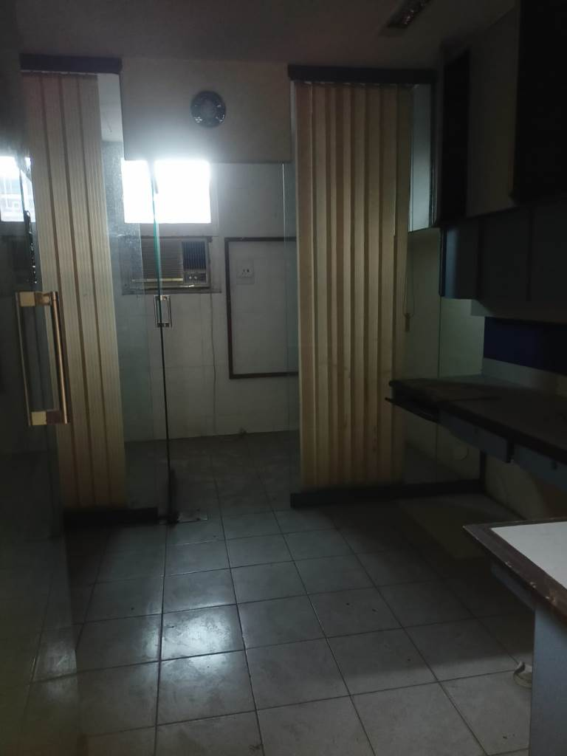

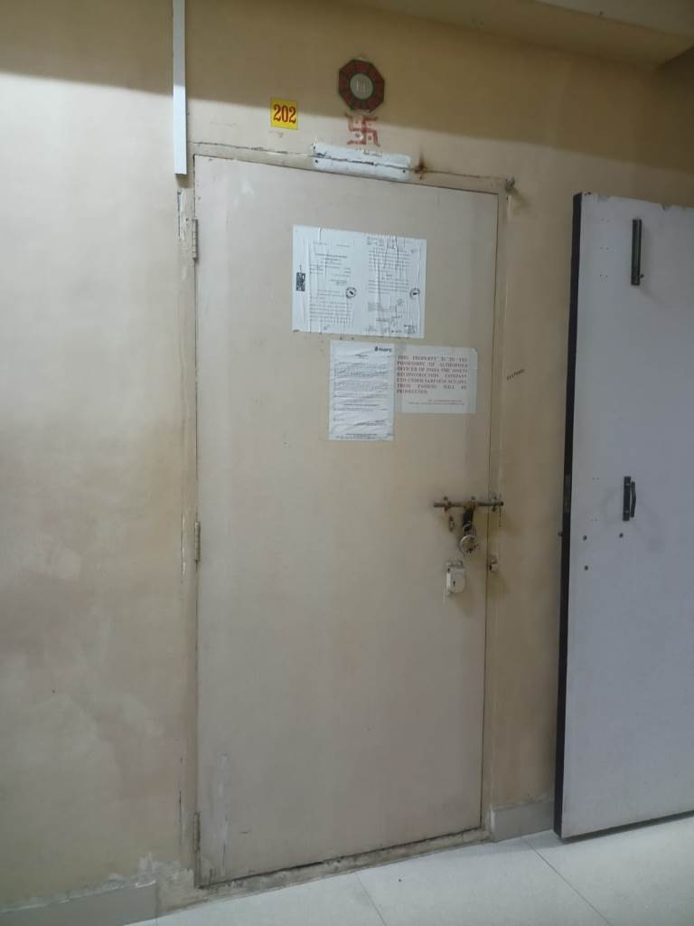
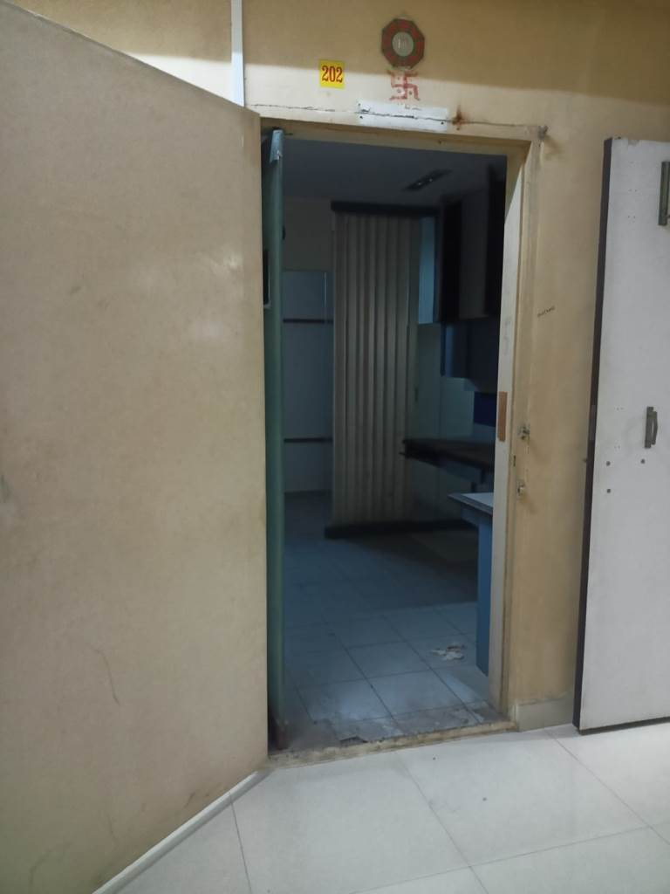
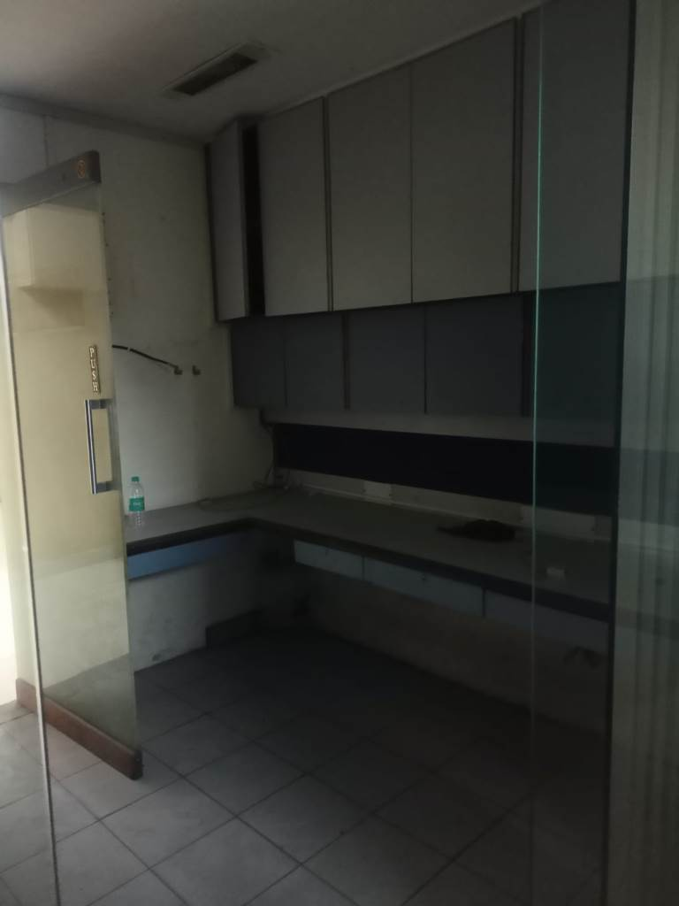

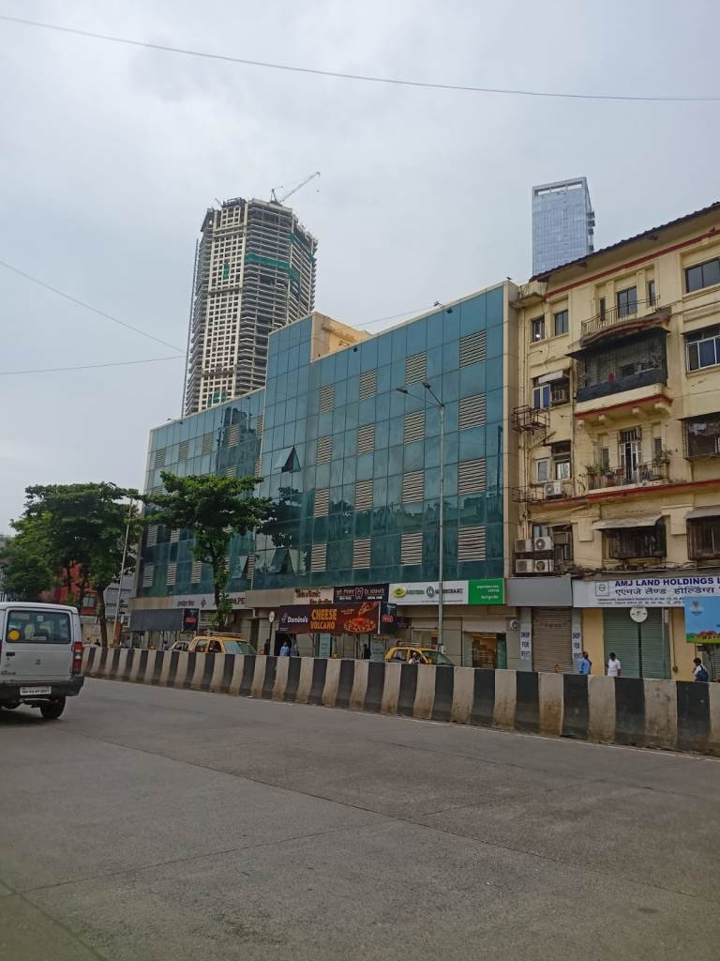
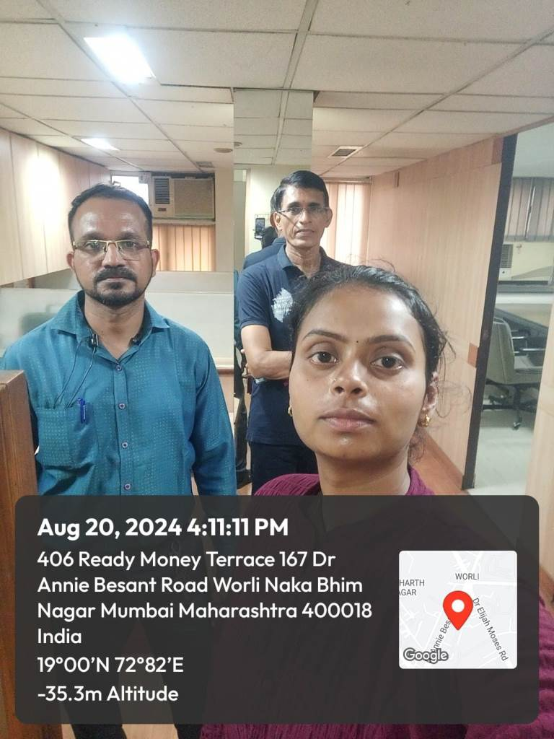

Route Map of the property
Site u/r
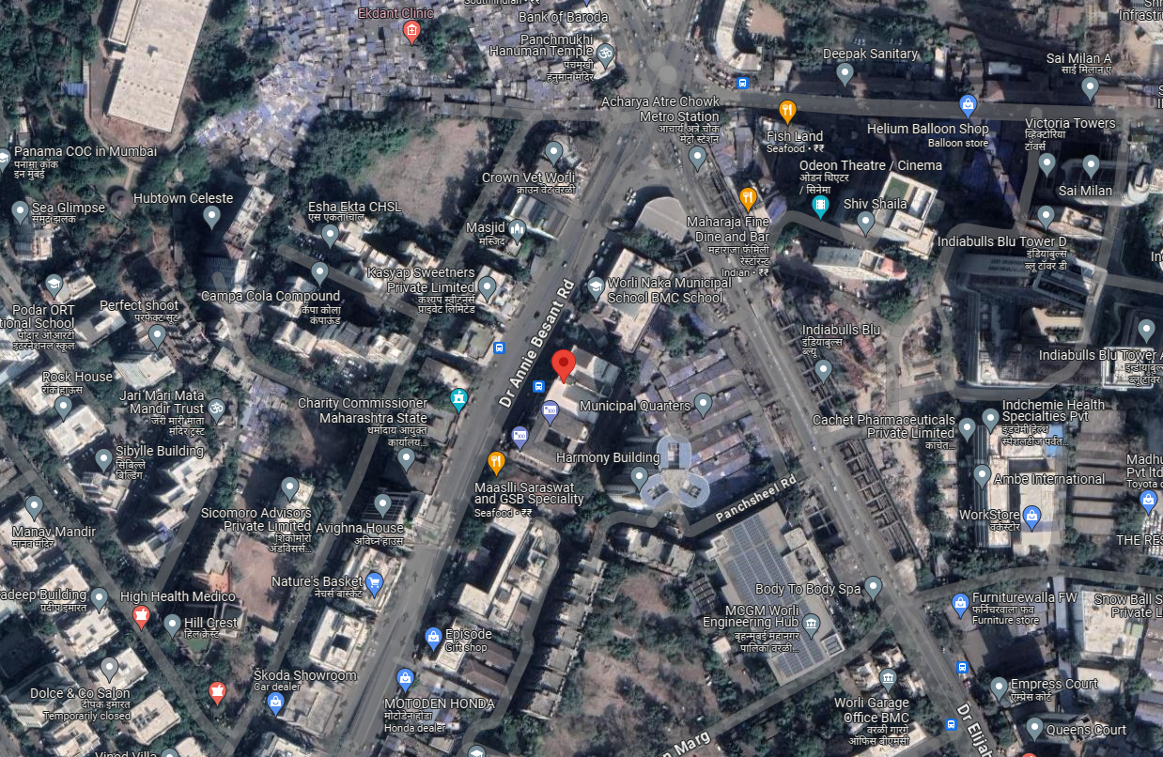
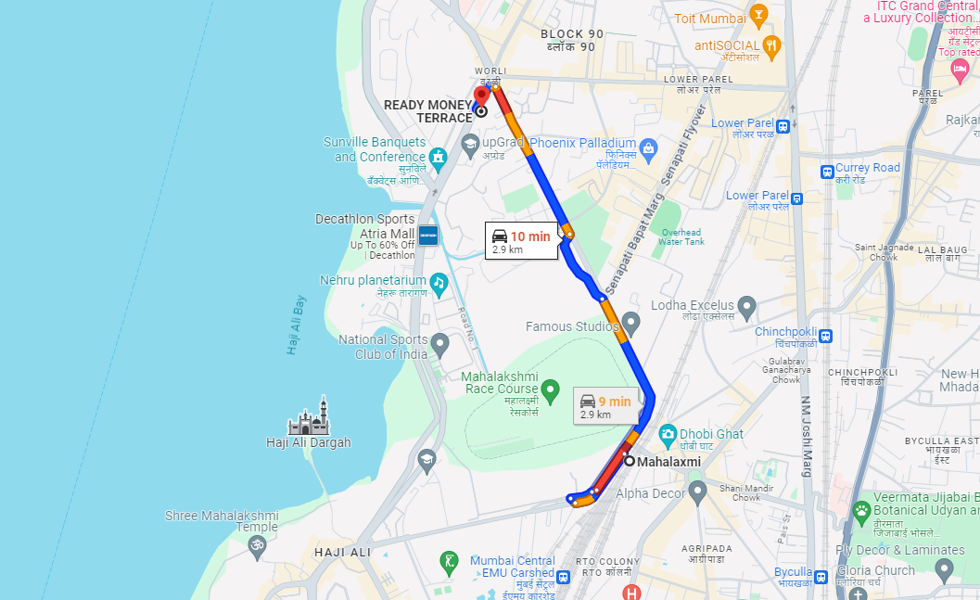



Latitude Longitude - 18°59’49.3”N 72°49’00.6”E

Note: The Blue line shows the route to site from nearest railway station (Mahalaxmi – 2.9 KM.)
Ready Reckoner Rate
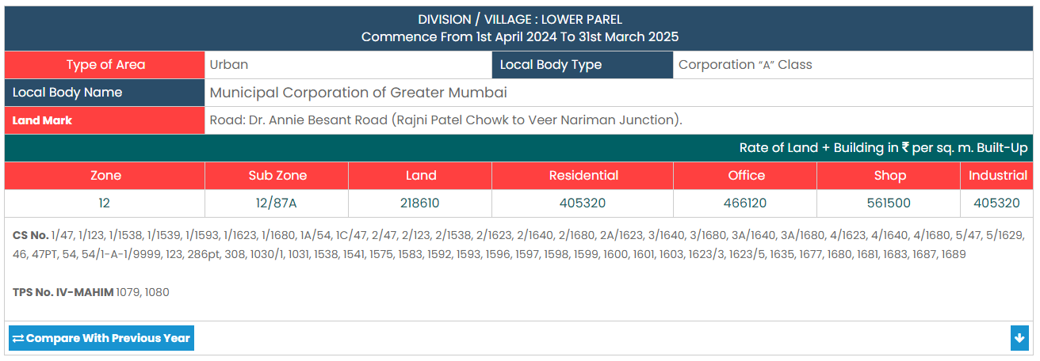

Stamp Duty Ready Reckoner Market Value Rate for Commercial Office | 4,66,120.00
No increase for all floors from ground to 4 floors | 0.00
Stamp Duty Ready Reckoner Market Value Rate (After Increase) (A) | 4,66,120.00 | Sq. Mt. | 43,304.00 | Sq. Ft.
Stamp Duty Ready Reckoner Market Value Rate for Land (B) | 2,18,610.00
The difference between land rate and building rate (A – B = C) | 2,47,510.00
Depreciation Percentage as per table (D) [100% - 59%]  (Age of the Building – 59 Years) | 41%
Rate to be adopted after considering depreciation [B + (C x D)] | 3,20,089.00 | Sq. Mt. | 29,737.00 | Sq. Ft.

Multi-Storied building with Lift
For residential premises / commercial unit / Unit on above floor in multistoried building, the rate mentioned in the ready reckoner will be increased as under:

 | Location of Flat / Commercial Unit in the building | Rate
a) | On Ground to 4 Floors | No increase for all floors from ground to 4 floors
b) | 5 Floors to 10 Floors | Increase by 5% on units located between 5 to 10 floors
c) | 11 Floors to 20 Floors | Increase by 10% on units located between 11 to 20 floors
d) | 21 Floors to 30 Floors | Increase by 15% on units located between 21 to 30 floors
e) | 31 Floors and above | Increase by 20% on units located on 31 and above floors

Table – D: Depreciation Percentage Table

Completed Age of Building in Years | Value in percent after depreciation
 | R.C.C. Structure / other Pukka Structure | Cessed Building, Half or Semi – Pukka Structure & Kaccha Structure.
0 to 2 Years | 100% | 100%
Above 2 & up to 5 Years | 95% | 95%
Above 5 Years | After initial 5 year for every year 1% depreciation is to be considered. However maximum deduction available as per this shall be 70% of Market Value rate | After initial 5 year for every year 1.5% depreciation is to be considered. However maximum deduction available as per this shall be 85% of Market Value rate

Sale Instance
Property | Office
Source | Index II
Floor | 4th Floor
 | Carpet | Built Up | Saleable
Area | 295.00 | 354.00 | -
Percentage | - | 20% | -
Rate Per Sq. Ft. | ₹ 30,508.00 | ₹ 25,424.00 | -
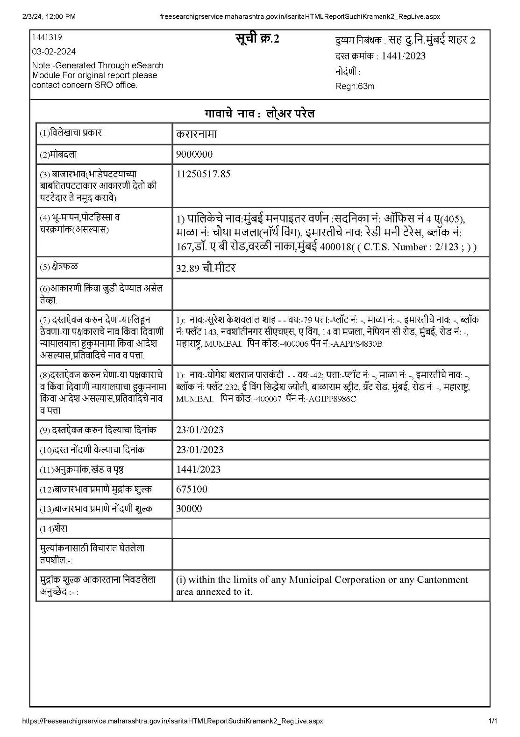

Price Indicators

Property | Office
Source | 99acres.com
Floor
 | Carpet | Built Up | Saleable
Area | 623.00 | 748.00 | -
Percentage | 20% | - | -
Rate Per Sq. Ft. | ₹ 36,116.00 | ₹ 30,080.00 | -

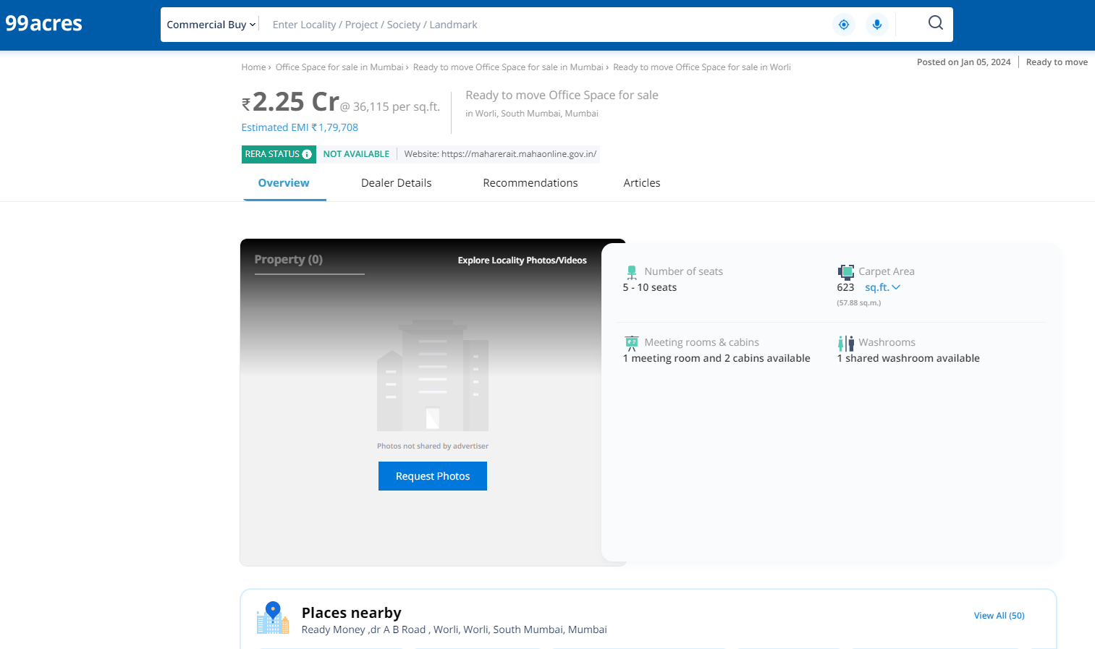
Price Indicators

Property | Office
Source | Nobroker.com
Floor
 | Carpet | Built Up | Saleable
Area | 266.00 | 319.00 | -
Percentage | - | 20% | -
Rate Per Sq. Ft. | ₹ 35,714.00 | ₹ 29,781.00 | -
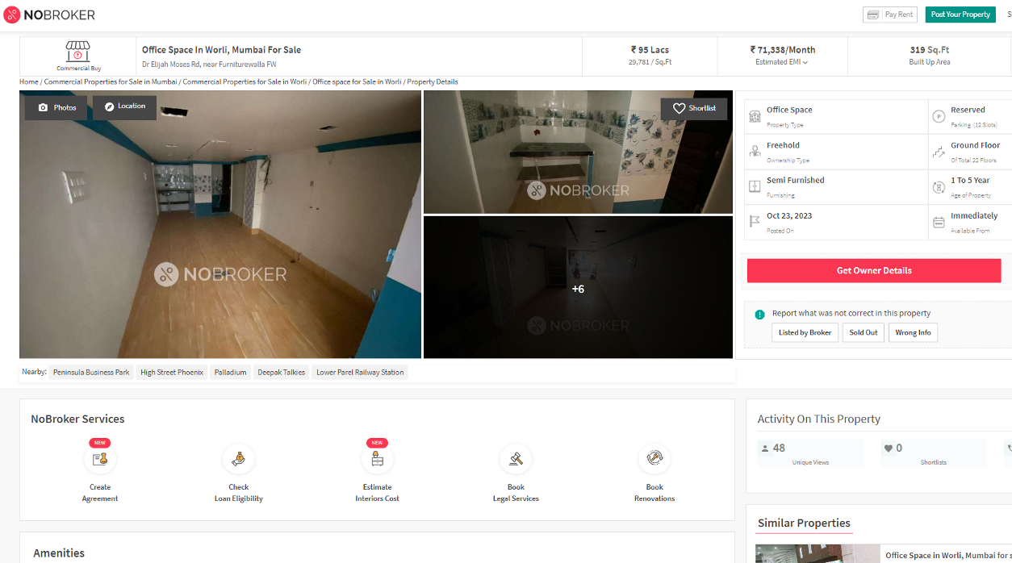
Justification for price / rate
The Market Value of the property is based on facts of markets discovered by us during our enquiries, however the government rate value in this case is less than the market value arrived by us. We are of the opinion that the value arrive by us will prove to be correct if an Auction of the subject property is carried out. As far as Market Value in Property documents is concerned, it is not possible to comment on same, may be government rates are fixed by sampling during same point of time in part and whereas, Market values change every month.
In most of the cases the actual deal amount or Transaction value is not reflected in Property documents because of various Market practices. As Valuer, we always try to give a value which is correct reflection of actual transaction value irrespective of any factors in market.

DEFINITION OF VALUE FOR THIS SPECIFIC PURPOSE

This exercise is to assess Fair Market Value of the property under reference for SARFAESI Securitisation and Reconstruction of Financial Assets and Enforcement of Security Interest Act, 2002 purpose as on dated 21st February 2024.

The term Fair Market Value is defined as

"The most probable price, as of a specified date, in cash, terms equivalent to cash, or in other precisely revealed terms for which the specified property rights would sell after reasonable exposure in a competitive market under all conditions requisite to a fair sale, with the buyer and seller each acting prudently knowledgeably and for self-interest assuming that neither is under undue duress"

Fundamental assumptions and conditions presumed in this definition are:

- Buyer and seller are motivated by self-interest.

- Buyer and seller are well informed and are acting prudently.

- The property is exposed for a reasonable time on the open market.

- Payment is made in cash or equivalent or in specified financing terms.

ASSUMPTIONS, CAVEATS, LIMITATION AND DISCLAIMERS
- We assume no responsibility for matters of legal nature affecting the property appraised or the title thereto, nor do we render our opinion as to the title, which is assumed to be good and marketable.
- The property is valued as though under responsible ownership.
- It is assumed that there are no hidden or unapparent conditions of the subsoil or structure that would render it more or less valuable. No responsibility is assumed for such conditions or for engineering that might be required to discover such factors.
- There is no direct/ indirect interest in the property valued.
- The rates for valuation of the property are in accordance with the Govt. approved rates and prevailing market rates.

DECLARATION OF PROFESSIONAL FEES CHARGED

We hereby declare that, our professional fees are not contingent upon the valuation findings. However, if the statute AND/OR clients demands that, the fees should be charged on the percentage of assessed value then, with the full knowledge of the AND/OR end user, it is being charged accordingly.

VALUATION OF THE PROPERTY PREMISES

Considering various parameters recorded, existing economic scenario, and the information that is available with reference to the development of neighbourhood and method selected for valuation, we are of the opinion that, the property premises can be assessed and valued for SARFAESI Securitisation and Reconstruction of Financial Assets and Enforcement of Security Interest Act, 2002 purpose at
Particulars | Fair Market Value In (`) | Realizable Value In (`) | Distress Sale Value In (`) | Insurable Value In (`)
Commercial Office | 51,74,400.00 | 43,98,240.00 | 36,22,080.00 | 4,99,500.00

Sharadkumar B. Chalikwar
Govt. Reg. Valuer
Chartered Engineer (India)
Reg. No. (N) CCIT/1-14/52/2008-09

