Vastu/Nashik/08/2024/010290/2307540
02/09-18-CHV
Date: 16.08.2024

To,
The Assistant General Manager,
Union Bank of India
Mumbai Naka Branch
Ground Floor of Dr. Torane Hospital Opp. Suyash Hospital
Ahilyabai Holkar Marg,Behind Mahamarg Bus Stand,
Mumbai Naka, Nashik - 422 001,
State – Maharashtra, Country – India.

Sub: Vetting of Estimate

Sir,

With reference to above subject, we have evaluated the Estimate for Residential Land and Proposed Bungalow on Plot No.3, Survey No.21/2,Near Riyan International School, Siddhart Nagar, Kalpataru Nagar,Bankar Mala Marg, Village – Wadala, Taluka & District - Nashik,PIN - 422 214, State - Maharashtra, Country – India belongs to Shri.Anand Tulshiram Aher ( Patil ) & Jyoti Bhalchandra Sonawane.

We have verified the rates quoted as per current market rates. Details of Estimate considered as per copy of Estimate Provided by a for Architecture received on dated.16.08.2024. The Estimate amount is Rs.1,27,10,000/- (Rupees One Crore Twenty Seven Lakh Ten Thousand Only)

Note:1) The said Cost Vetting Certificate is valid upto next 6 months Only.

Thanking you

Sincerely yours

Sharadkumar B. Chalikwar
Govt. Reg. Valuer
Chartered Engineer (India)
Reg. No. (N) CCIT/1-14/52/2008-09
Encl: Vetting report

Estimate
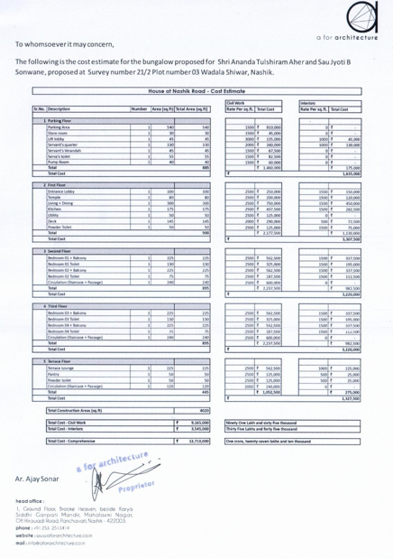

The Estimate amount is Rs.1,27,10,000/- (Rupees One Crore Twenty Seven Lakh Ten Thousand Only)

