Vastu/Nashik/06/32014/2301224
22/20-325-RYBS
Date: 14.08.2024

To,
The Branch Manager,
State Bank of India
RACC Nashik Branch
RBO.2, The Wave Building, 1 st Floor, Opposite Shell Petrol Pump, Pathardi Road,
Nashik – 422 010, State – Maharashtra, Country – India.

Sub: Vetting of Extra Aminities

Sir,

With reference to above subject, we have evaluated the Extra Aminities for Residential Flat No. 13, Fifth Floor, " Raj Avenue Apartment ", Survey No. 319/ 1/ B/ 1/ A, Plot No. 03, Behind RK Lawns & Hall, Near Sai Baba Mandir, Prashant Nagar, Pathardi Phata Road, Village - Pathardi, Taluka & District - Nashik, PIN Code – 422 010, State – Maharashtra, Country – India. belongs to Name of Proposed Purchaser: Shri. Chandrakant Bhaurao Mahale & Sau. Surekha Chandrakant Mahale. Name of Owner: Shri. Rajendra Omkar Jawale.

We have verified the rates quoted as per current market rates. Details of Extra Aminities considered as per copy of Extra Aminities Agreement between Mr. Chandrakant Bhaurao Mahale & Mrs. Surekha Chandrakant Mahale (First Party). Mr. Suraj Bansilal Vasaikar (Second Party) received on dated 01.08.2024. The Extra Aminities amount is Rs. 1,12,000/- (Rupees One Lakh Twelve Thousand Only)

The said Cost Vetting Certificate is valid upto next 6 months Only.

Thanking you

Sincerely yours

Manoj B. Chalikwar
Registered Valuer
Chartered Engineer (India)
Reg. No. CAT-I-F-1763
SBI Empanelment No.: SME/TCC/2021-22/86/3
Encl. Valuation Report

Agreement for Extra Aminities
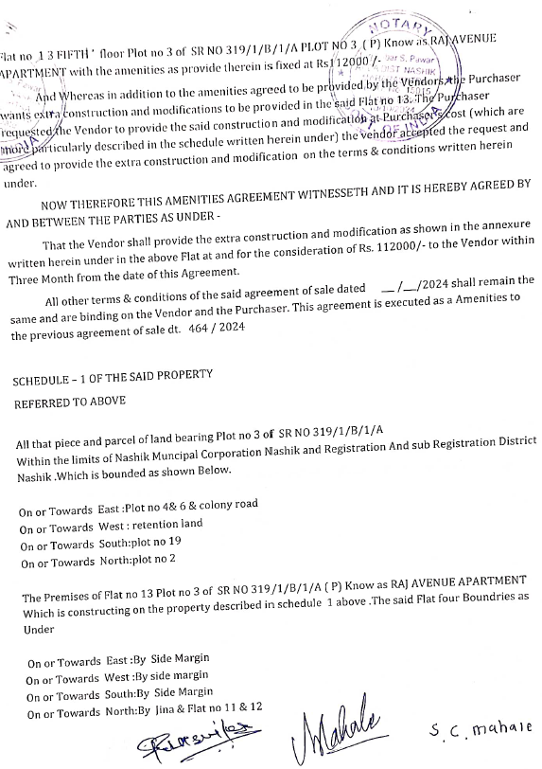
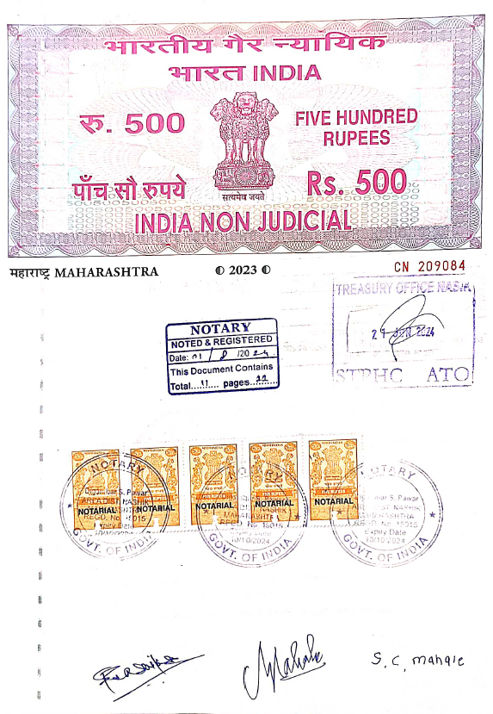

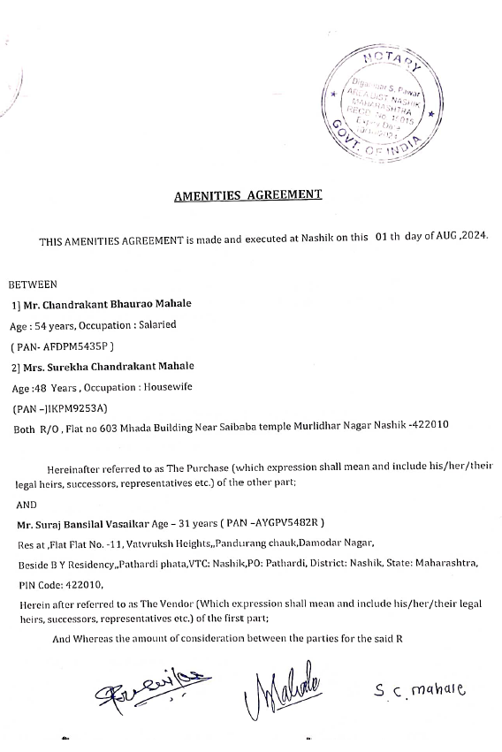

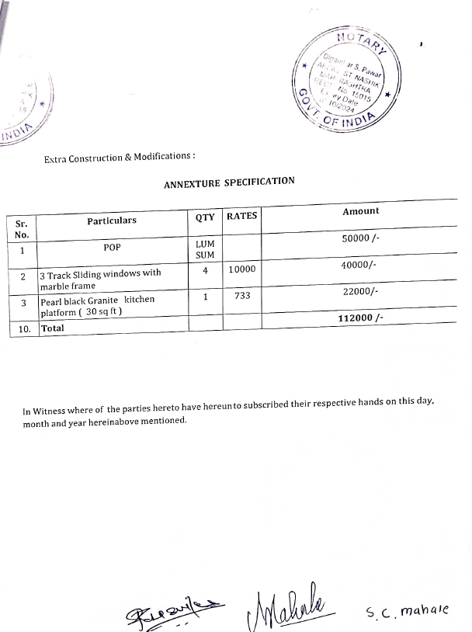
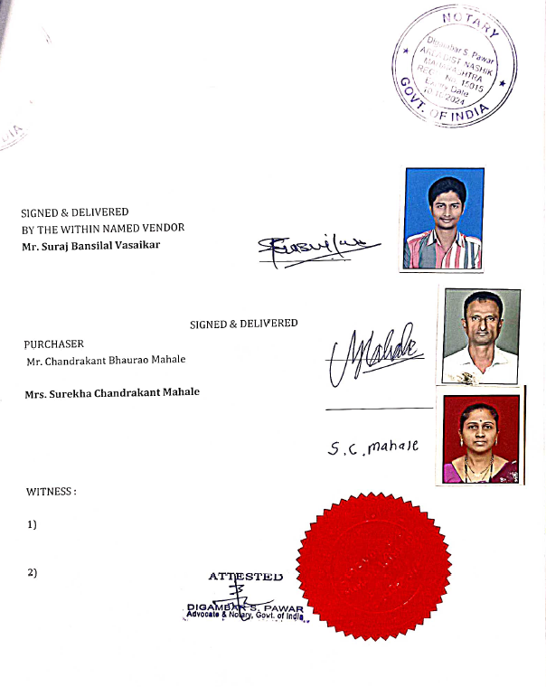

The Extra Aminities amount is Rs. 1,12,000/- (Rupees One Lakh Twelve Thousand Only)

