Vastu/Nashik/08/2024/010598/2307708
14/11-186-RYBS
Date: 14.08.2024

To,
The Branch Manager,
State Bank of India
RACC Nashik Branch
RBO.2, The Wave Building, 1 st Floor, Opposite Shell Petrol Pump, Pathardi Road,
Nashik – 422 010, State – Maharashtra, Country – India.

Sub: Vetting of Extra Amenities

Sir,

With reference to above subject, we have evaluated the Extra Amenities for Residential Flat No. 13, Fifth Floor, " Raj Avenue Apartment ", Survey No. 319/ 1/ B/ 1/ A, Plot No. 03, Behind RK Lawns & Hall, Near Sai Baba Mandir, Prashant Nagar, Pathardi Phata Road, Village - Pathardi, Taluka & District - Nashik, PIN Code – 422 010, State – Maharashtra, Country – India. belongs to Name of Proposed Purchaser: Shri. Chandrakant Bhaurao Mahale & Sau. Surekha Chandrakant Mahale. Name of Owner: Shri. Rajendra Omkar Jawale.

We have verified the rates quoted as per current market rates. Details of Extra Amenities considered as per copy of Extra Amenities Agreement between Mr. Chandrakant Bhaurao Mahale & Mrs. Surekha Chandrakant Mahale (First Party). Mr. Suraj Bansilal Vasaikar (Second Party) received on dated 01.08.2024. The Extra Amenities amount is Rs. 1,12,000/- (Rupees One Lakh Twelve Thousand Only)

The said Cost Vetting Certificate is valid upto next 6 months Only.

Thanking you

Sincerely yours

Manoj B. Chalikwar
Registered Valuer
Chartered Engineer (India)
Reg. No. CAT-I-F-1763
SBI Empanelment No.: SME/TCC/2021-22/86/3
Encl. Valuation Report

Agreement for Extra Aminities
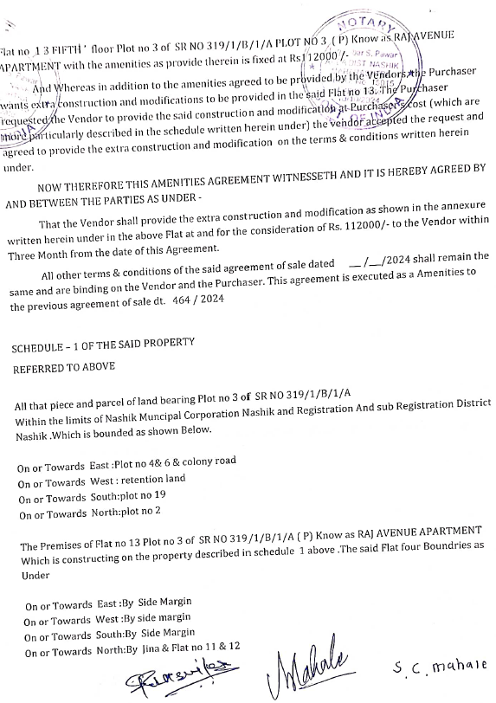
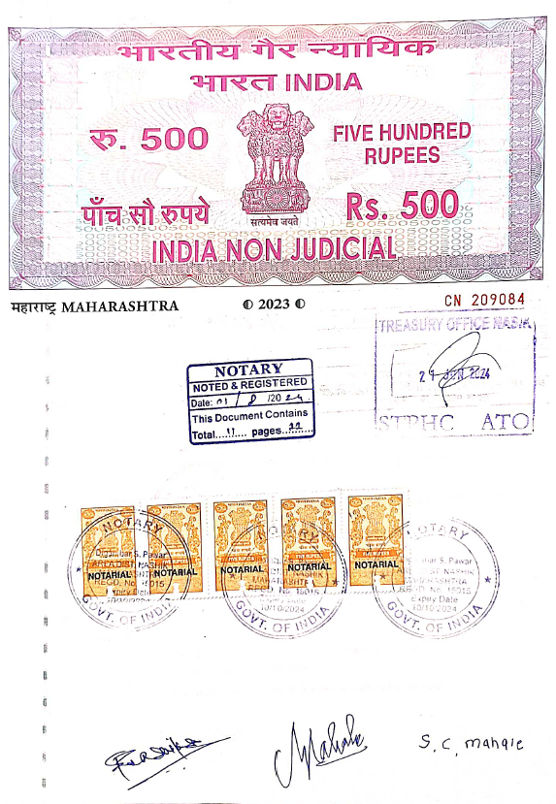

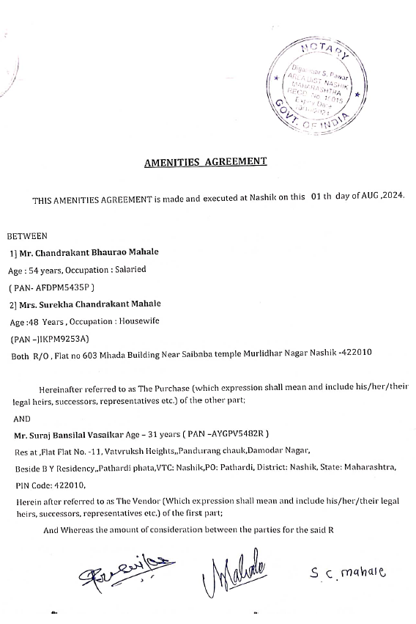

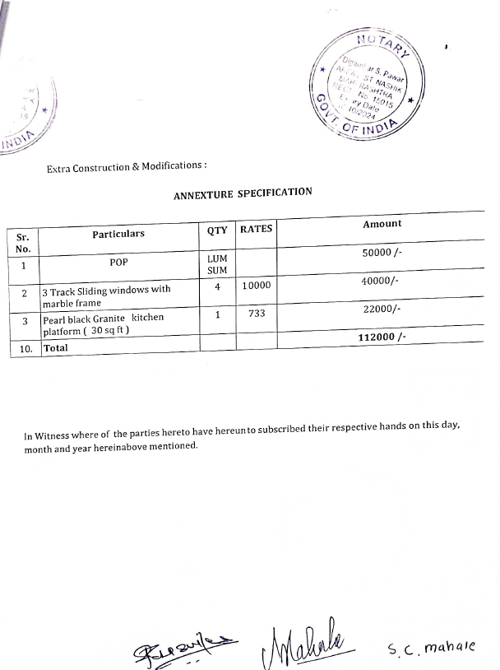
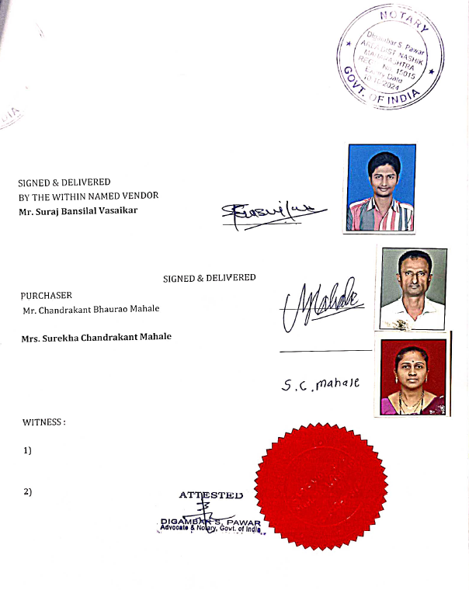

The Extra Amenities amount is Rs. 1,12,000/- (Rupees One Lakh Twelve Thousand Only)

