Vastu/Nashik/08/2024/010581/2307713
16/3-191-RYBS
Date: 16.08.2024

To,
The Branch Manager,
State Bank of India
Satpur Branch
1 st Floor, BSNL CTTC Building,
Plot No. 45-47, D-Road, MIDC, Satpur,
Nashik -422 007, State – Maharashtra, Country – India.

Sub: Vetting of Extra Aminities

Sir,

With reference to above subject, we have evaluated the Extra Aminities for Residential Flat No. 07, 4th Floor, "Mangalmurti Apartment ", Near Navshya Ganapati Parisar, Ganpati Nagar, Gangapur Road, Plot No. 8+9, Village - Anandvalli, Taluka - Nashik,District - Nashik, Nashik, 422 013, State - Maharashtra, India belongs to Sau. Pranjal Nalin Chandak. Name of Proposed Purchaser is Shri. Deepak Anandrao Rokade & Sau. Pallavi Deepak Rokade.

We have verified the rates quoted as per current market rates. Details of Extra Aminities considered as per copy of Extra Aminities Agreement between Mr. Deepak Anandrao Rokade & Smt. Pallavi Deepak Rokade (First Party). Smt. Bharati Ashok Gorhane (Second Party) received on dated 10.08.2024. The Extra Aminities amount is Rs. 11,30,000/- (Rupees Eleven Lakh Thirty Thousand Only)

The said Cost Vetting Certificate is valid upto next 6 months Only.

Thanking you

Sincerely yours

Manoj B. Chalikwar
Registered Valuer
Chartered Engineer (India)
Reg. No. CAT-I-F-1763
SBI Empanelment No.: SME/TCC/2021-22/86/3
Encl. Valuation Report

Agreement for Extra Aminities
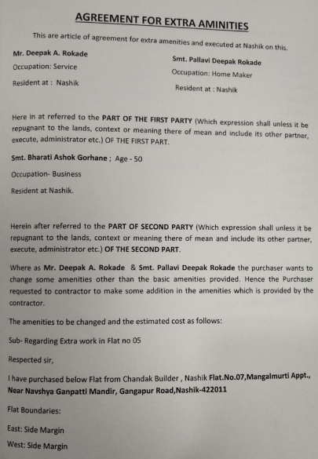
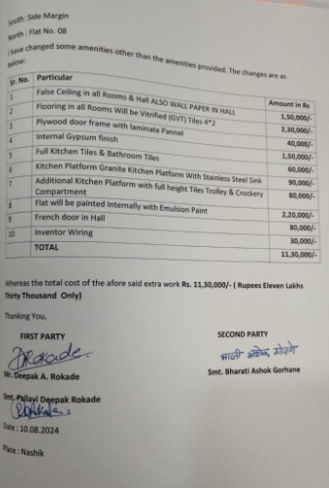

The Extra Aminities amount is Rs. 11,30,000/- (Rupees Eleven Lakh Thirty Thousand Only)

